2) Accountability Mechanisms

2.1 Description of Overall Accountability Architecture
The CCWG-Accountability identifies four building blocks that would form the accountability mechanisms required to improve accountability.

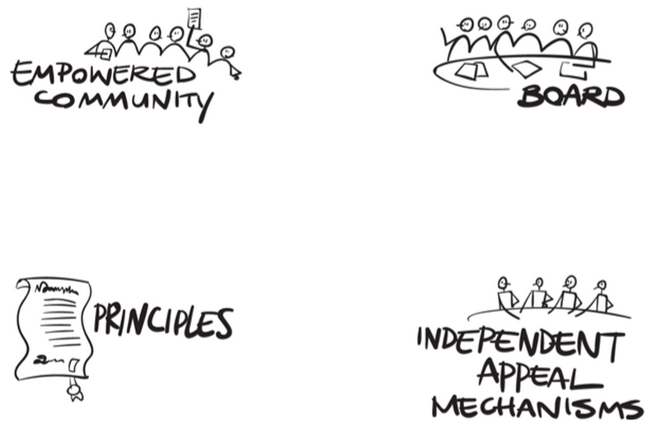

Drawing a state analogy:
  - Empowered community refers to the powers that allow the community (i.e., the people) to hold ICANN accountable for the principles.
    - The group identified powers and associated mechanisms including the ability to:
      - Remove individual directors or recall the entire ICANN Board of Directors;
      - Approve or veto changes to the ICANN Bylaws, including Mission, Commitments and Core Values incorporated in the Bylaws; and
      - Reject Board decisions on Strategic Plan and budgetBudget, where the Board has failed to appropriately consider community input.
  - Principles form the Mission, Commitments and Core Values of the organization (i.e., the Constitution).
    - The group proposes changes that should be made to the Mission, Commitments and Core Values in ICANN's Bylaws. For example, the group discussed how key provisions of the Affirmation of Commitments could be incorporated into the Bylaws.
  - ICANN Board (i.e., the executive) is responsible for directing ICANN’s affairs and is held accountable to the community through the community’s powers
    - The Board also conducts regular Structural Reviews of the various SOs and ACs. These Reviews include an assessment of SO and AC accountability to their respective communities, along with regular participants as well as the wider communities they are designed to represent.
  - Independent Appeals Mechanisms, (i.e., the judiciary), confers the power to review and provide redress, as needed.
    - The group proposes to strengthen the existing Independent Review Process suggesting improvements to its accessibility and affordability, and process design including establishment of a standing panel capable of issuing binding outcomes. The IRP panel decisions would be guided by ICANN's Mission, Commitments and Core Values.

This section of the public comment report details the key recommendations of the CCWG-Accountability.

Summary report:
Litéra® Change-Pro TDC 7.5.0.145 Document comparison done on 7/28/2015 7:46:19 PM
Style name: Sidley Default
Intelligent Table Comparison: Active
Original DMS:iw://SIDLEYDMS/ACTIVE/209401199/1
Modified DMS: iw://SIDLEYDMS/ACTIVE/209401199/2
Changes:
Add | 3
Delete | 3
Move From | 0
Move To | 0
Table Insert | 0
Table Delete | 0
Table moves to | 0
Table moves from | 0
Embedded Graphics (Visio, ChemDraw, Images etc.) | 0
Embedded Excel | 0
Format changes | 0
Total Changes: | 6

