Community Decision Process
Purpose of Group | To describe a method of consensus-style decision making that will replace the voting system in the Second Draft Proposal.
Requirements | - Based on objections from SOs and advice from AC  - No single SO or AC should be able to capture decision-making through a veto right or through lack of broad support/participation  - Flexibility for SOs or ACs to participate in any particular issue, or on all issues  - Recognize that RSSAC and SSAC are appointed by board
Deliverables | - Rules for decision making  - Analyze corner cases  - For each community power, do we have different participation requirements and thresholds for consensus?  - Final step after decision: discourse with board

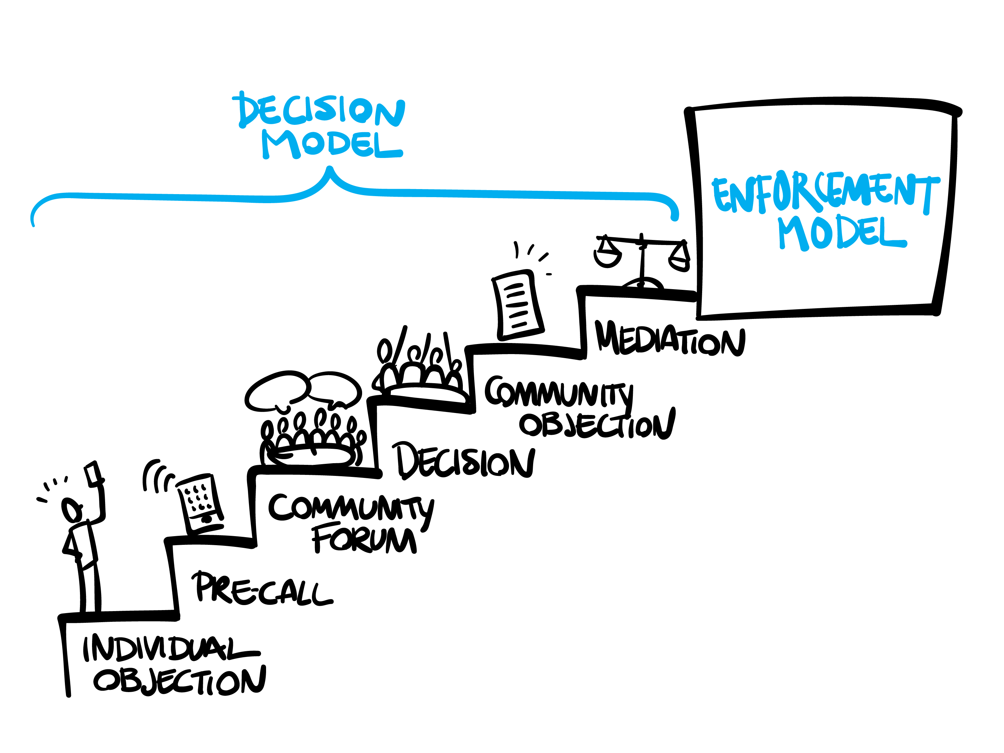
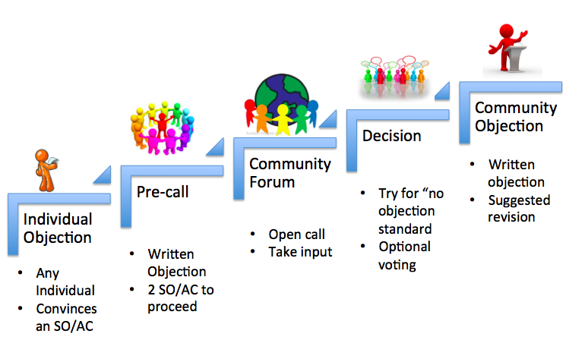

Los Angeles meeting -- First breakout:
Start with a new bylaw: Board must announce it plans to consider a bylaws change, and must wait 30 days to vote.
1. Trigger: any individual can begin an online petition in any AC or SO. Each AC/SO defines its own threshold for petition support. If the threshold is met in any AC or SO, all others are invited to participate in a pre-call to decide whether to have a Community Forum.
2. Pre-call to decide whether to have a Community Forum: The Petitioning ACs/SO(s) circulate written justification for blocking the bylaw. ICANN hosts a conf call with all interested participants. After the call, at least 2 ACs/SOs must indicate they are sufficiently affected that they intend to participate.
3. Decision-making: Debate and Aim for CCNSO-style consensus, as in “no strong objection”. If no consensus, the petitioning AC/SO may ask for voting. Each AC/SO decides its vote using its own methods. To block the bylaw, at least 66% of participating AC/SOs must vote.
4. Outcome: if community decides to block the bylaw, it must publish a statement explaining why, incl any amended language that would overcome the objection, etc. Minority statement could be published by participating AC/SO that did not agree with the decision or explanation.

Los Angeles meeting -- Second breakout:
Note: CCWG has never claimed that any difference with the board must be reconciled. We proposed specific community powers and R&R mechanisms with a strict standard of review.
Precursor for Community-based Challenge (IRP or Reconsideration):
1. Trigger: any individual can begin an online petition in any AC or SO. Each AC/SO defines its own threshold for petition support. If the threshold is met in any AC or SO, all others are invited to participate in a pre-call to decide whether to have a Community Forum.
2. Pre-call to raise awareness of the difference, and decide whether to have a Community Forum: The Petitioning ACs/SO(s) circulate written explanation for the difference with board. Board must send a representative. ICANN hosts a conf call with all interested participants. After the call, there is expected to be continuing calls/emails to reconcile differences. If no reconciliation, at least 2 ACs/SOs could indicate they intend to participate in a Community Forum.
3. ICANN hosts a 1-2 day Community Forum. Goal is to find a mutually acceptable solution. If reconciliation is not evident, the Community Forum turns to the question of whether to request a Community Reconsideration or IRP.

Required Community Powers
1. Block a proposed Operating Plan/Strategic Plan/Budget
2. Approve changes to Fundamental Bylaws and Articles of Incorporation
3. Block changes to regular bylaws
4. Appoint and remove individual board directors
5. Recall the entire board of directors
6. Mechanism for binding IRP where a panel decision is enforceable in any court recognizing international arbitration results
7. Reconsider/reject board decisions relating to reviews of IANA functions, including trigger of PTI separation

