Summary of the Work and Recommendations of the Cross Community Working Group on Enhancing ICANN Accountability: A Preview of the Third Draft Proposal on Work Stream 1 Recommendations
About This Document 3
Background 4
How the CCWG-Accountability Has Conducted its Work 5
List of Requirements 5
Set of Recommendations 5
Introduction 5
Building the Foundations for an Enhanced Accountability Framework for ICANN: Four Key Building Blocks 6
Enhancing the Multistakeholder Model of ICANN 7
The CCWG-Accountability’s Findings, Recommendations and Proposals 8
Redefining ICANN’s Bylaws as ‘Standard Bylaws’ and ‘Fundamental Bylaws’ 8
Sole Designator Model 10
Empowering the Community Through Consensus: Engage, Escalate, Enforce 10
Engagement 10
Escalation 11
Enforcement 13
Ensuring Community Engagement in ICANN Decision-Making: Five New Community Powers 14
Executing the Five Community Powers 15
Enforcement 15
Community Discussion 15
Not a Decision-Making Body 16
The Power to Reject ICANN’s Budget or Strategy/Operating Plans 16
Rejecting the Annual Operating Plan & Budget 16
The IANA Functions Budget 16
The Power to Reject Changes to ICANN’s Standard Bylaws 17
The Power to Remove Individual ICANN Board Directors 17
Overview of the CCWG-Accountability’s Proposed Process for the Removal of a Supporting Organization or Advisory Committee Appointed Director 18
Escalation 18
Overview of the CCWG-Accountability’s Proposed Process for the Removal of a Director Appointed by the Nominating Committee 20
Escalation 20
The Power to Recall the Entire ICANN Board 23
Interim Board 23
Processes 24
Overview of the CCWG-Accountability’s Proposed Process for the Removal of the Board 24
Escalation 24
The Power to Approve Changes to Fundamental Bylaws 27
Process 28
Escalation 28
Changes to ICANN’s Mission, Commitments and Core Values 31
Reinforcing Adherence to Human Rights Protocols 31
Draft Bylaw on Human Rights 32
Operationalizing the Commitment to Human Rights 32
The Independent Review Process (IRP) 33
Request for Reconsideration (RFR) 34
Incorporating the Affirmation of Commitments Reviews in ICANN’s Bylaws 35
Accountability of Supporting Organizations and Advisory Committees 37
Concerns 37
Ensuring Community Accountability Powers Through Stress Testing 38
Committing to Work Stream 2 39
Conclusion 40
Community Powers Are An Effective Replacement of the Safety Net Provided by the U.S Government’s Current IANA Stewardship Role 40

About This Document
This high-level summary of the Cross Community Working Group on Enhancing ICANN Accountability’s (CCWG-Accountability) Work Stream 1 recommendations has been produced with two goals in mind:

To give the community access to the updated Work Stream 1 recommendations 1 as soon as possible.
To ensure the IANA Stewardship Transition can proceed without delay, it is vital for the CCWG-Accountability’s proposal isto be finalized and presented to the ICANN Board by the end of January 2016. However, due to the time needed to update the proposal in its entirety, the CCWG-Accountability is publishing this high-level summary on 15 November 2015 to enable the community to begin its review of the updated recommendations as early as possible.
Draft 3 of the ‘CCWG Accountability Draft Proposal on Work Stream 1 Recommendations,’ is scheduled to go into a public comment phase on 30 November 2015.
Draft 2 of this report can be found here. [Also link to Draft 1?]

To provide an accessible summary of Work Stream 1 recommendations for people who do not have an in-depth understanding of ICANN’s processes and terminology.

Background
On 14 March 2014, the U.S. National Telecommunications and Information Administration (NTIA) announced its intent to transition its stewardship of the Internet Assigned Numbers Authority (IANA) functions to the global multistakeholder community. NTIA asked ICANN to convene an inclusive, global discussion to determine a process for transitioning the stewardship of these functions to the community.
During initial discussions on how to proceed with the transition process, the ICANN multistakeholder community, recognizing the safety net that the NTIA provides as part of its stewardship role of the IANA functions, raised concerns about the impact of the transition on ICANN’s accountability.
To address these concerns, the community requested that ICANN’s existing accountability mechanisms be reviewed as a key part of the transition process. As a result, the Cross Community Working Group on Enhancing ICANN Accountability (CCWG-Accountability) was convened.
The CCWG-Accountability’s work consists of two tracks:
- Work Stream 1: Focused on mechanisms enhancing ICANN accountability that must be in place or committed to within the time frame of the IANA Stewardship Transition.
- Work Stream 2: Focused on addressing accountability topics for which a timeline for developing solutions and full implementation may extend beyond the IANA Stewardship Transition.
The work documented in this high-level summary primarily focuses on Work Stream 1, with some references to related activities that are part of Work Stream 2’s remit.
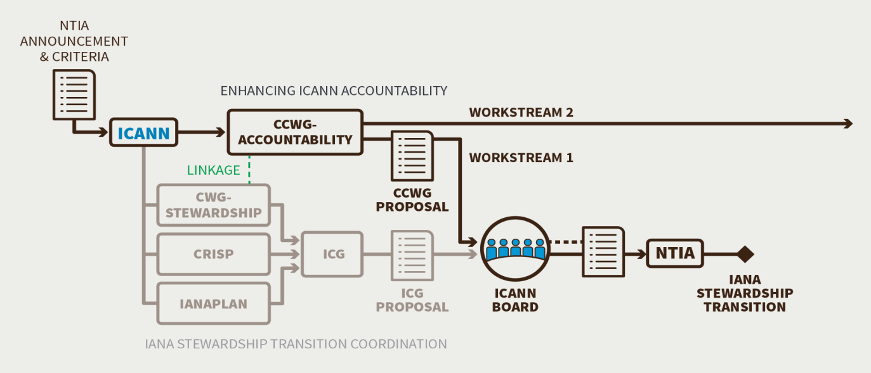
[Consider placement of the negative statement about what is not being recommended. It is awkward to have the negative statement about what is not being recommended before a positive statement about what CCWG-ACCT is recommending.]
The CCWG-Accountability is not recommending that any changes or alterations be made to:
- ICANN’s multistakeholder Policy Development Processes or how the ICANN Board adopts policies.
- The advisory role of the Governmental Advisory Committee (GAC) and its interaction with the ICANN Board.
- The balance of power between the organizations and committees that form the ICANN community, i.e. the ICANN Supporting Organizations (SOs) and Advisory Committees (s).ACs). [Is this accurate? Has CCWG-ACCT resolved to move away from the varied voting power for each AC/SO that was expressed in the First and Second Drafts?]

How the CCWG-Accountability Has Conducted its Work
To fulfill its remit, the CCWG-Accountability began by:
- Analyzing ICANN’s existing accountability mechanisms
- Seeking community input on ICANN’s accountability mechanisms
- Adhering to the requirements identified by the part of the ICANN community responsible for the Naming Related Functions
- Complying with the criteria published in the March 2014 NTIA announcement

List of Requirements
[Under this heading one would expect to find a list of the requirements, including the requirement to satisfy CWG-Stwardship accountability criteria.] Next, the CCWG-Accountability consolidated its findings into a list of requirements that it thought necessary to enhance ICANN’s accountability mechanisms. During this process, the CCWG-Accountability:
- Considered different models and measures to implement and operationalize these requirements
- Sought the advice of independent experts on corporate governance and accountability
- Engaged legal counsel for advice
- Discussed the pros and cons of proposed accountability mechanisms and governance models using established open, transparent and multistakeholder processes

Set of Recommendations
The result was a set of recommended accountability enhancements with built-in safeguards that will:
- Require the minimal amount of organizational change to ICANN’s existing structures necessary to effectuate the community powers sought [Without this or similar qualifying language, this statement in overly broad and without context.]
- In no way modifyAvoid modification of the day-to-day operations of ICANN
- Assess and protect ICANN against any unintended/negative consequences of new recommendations on the safety and stability of the Internet
- Fulfill the accountability requirements outlined above to the best extent possible
These recommendations took into consideration advice from two independent expert law firms. The recommendations have also been successfully “stress tested” against a number of identified contingencies.

Introduction
The proposed accountability enhancements outlined in this document have been designed to provide a framework of enhancing trust. These enhancements define the limits on what ICANN is and is not permitted to do and they further ensure that ICANN adheres to the bottom-up, community-driven multistakeholder approach currently in place.

Building the Foundations for an Enhanced Accountability Framework for ICANN: Four Key Building Blocks
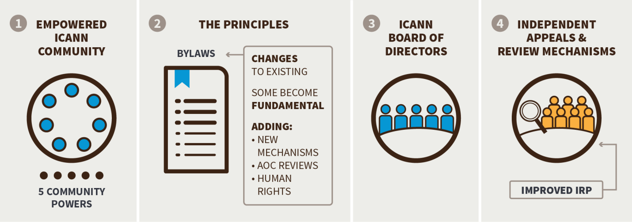
In its early stages of work, the CCWG-Accountability identified four core building blocks that it felt should form the basis of the mechanisms required to improve accountability. These four building blocks are outlined below:
Building Block 1: The ICANN Community (involving the diversity of multistakeholder communities, each of which represents a different interest and expertise in the Internet ecosystem).
The CCWG-Accountability has recommended that five Community Powers that should be in place. They give the community the power to:
- Reject Budget or Strategy/Operating Plans
- Reject changes to ICANN “Standard” Bylaws
- Approve changes to “Fundamental” Bylaws
- RemoveAppoint and remove individual ICANN Board Directors
- Recall the entire ICANN Board
[Concern that there is no reference here or earlier to CWG-Stewardship requirements. The Community Powers need to be understood in the context of what CWG-Stewardship requires. Need to discuss specific powers related to IANA Separation Review.]
Building Block 2: The Principles (the Mission, Core Values and Commitments as outlined in the Bylaws).
The CCWG-Accountability recommends that changes be made to the Mission, Commitments and Core Values as stated in ICANN’s Bylaws to strengthen the current and proposed accountability mechanisms.
Building Block 3: The ICANN Board (a group of Directors elected by the ICANN community to, among other responsibilities, act in the best interests of the organization and the global stakeholder community, and ensure that ICANN operates in an effective, efficient and ethical manner).
The CCWG-Accountability recommends that further mechanisms be put into place to ensure that the ICANN Board remains accountable to the community.
Building Block 4: Independent Appeals Mechanisms
The CCWG-Accountability recommends that several improvements be made to the Independent Review Process and the Request for Reconsideration (RFR) process.

Enhancing the Multistakeholder Model of ICANN
Since ICANN’s inception, the Supporting Organizations (SO) and Advisory Committees (AC) have developed and matured policy development processes that balance the interests of all stakeholders.
To preserve this bottom-up, community-driven multistakeholder approach, the CCWG-Accountability recommends several enhancements be made to ICANN’s accountability framework. The four building blocks outlined above provided a framework for these enhancements, which include:
- Providing the specific Community Powers and the requirements of CWG-Stewardship outlined above through amendments to ICANN’s Articles and Bylaws
- Refining ICANN’s role and mission to make it more robust against change, to avoid ‘mission creep’ and to keep ICANN focused on its current mission
- Establishing Bylaws that offer additional protection for operational continuity
- Reinforcing adherence to Human Rights protocols
- Integrating the key commitments contained in the Affirmation of Commitments (signed with the US Department of Commerce in 2009) into ICANN’s Bylaws to ensure the continuation of the Affirmation of Commitments Reviews. These reviews ensure that ICANN continuous workscontinues to work on improving its accountability
- Enhancing ICANN’s Appeals Mechanisms, including an enhanced Independent Review Process (IRP) that acts as an independent judiciary to assesses whether ICANN is operating in compliance with or in violation of its Articles of Incorporation and/or its Bylaws. The proposed enhancements also ensure that the IRP would not be empowered to circumvent the bottom-up nature of the current processes in place

The CCWG-Accountability’s Findings, Recommendations and Proposals
This section provides an overview of the CCWG-Accountability’s findings and recommendations regarding Work Stream 1 on the following aspects:
- Redefining ICANN’s Bylaws as ‘Standard Bylaws’ and ‘Fundamental Bylaws’
- Establishing a Sole Designator Model for Executing Community Powers
- Empowering the Community Through Consensus: Engage, Escalate, Enforce
- Ensuring Community Engagement in ICANN Decision-Making: Five New Community Powers
- Changing aspects of ICANN’s Mission, Commitments and Core Values
- Reinforcing ICANN’s Adherence to Human Rights Protocols
- Strengthening ICANN’s Independent Review Process (IRP)
- Incorporating the Affirmation of Commitments Reviews in ICANN’s Bylaws
- Fortifying ICANN’s Request for Reconsideration (RFR) Process
- Enhancing the Accountability of Supporting Organizations (SO) and Advisory Committees (AC)
- Ensuring Security, Stability, and Resiliency Through Stress Tests
- Committing to Further Accountability Work in Work Stream 2
The complete overview of all the findings and recommendations will be published in Draft 3 of the ‘CCWG Accountability 2nd Draft Proposal on Work Stream 1 Recommendations’. Draft 3 is scheduled to go into the public comment phase on 30 November 2015. Draft 2 of this report can be found here. [Also provide link to Draft 1?]

Redefining ICANN’s Bylaws as ‘Standard Bylaws’ and ‘Fundamental Bylaws’
ICANN’s Bylaws describe how power is exercised in ICANN, including setting out the organization’s Mission, Commitments and Core Values. Bylaws are an essential part of any organization: they set the scope, determine the operational framework and define working practices. An organization requires its Bylaws to evolve as its activities progress and new initiatives commence.
The CCWG-Accountability believes that it is essential for the set of key Bylaws that are deemed critical or fundamental to the organization’sICANN’s stability and operational continuity mustand the community’s decision rights to be given additional protection from change by requiring community approval of any amendments.
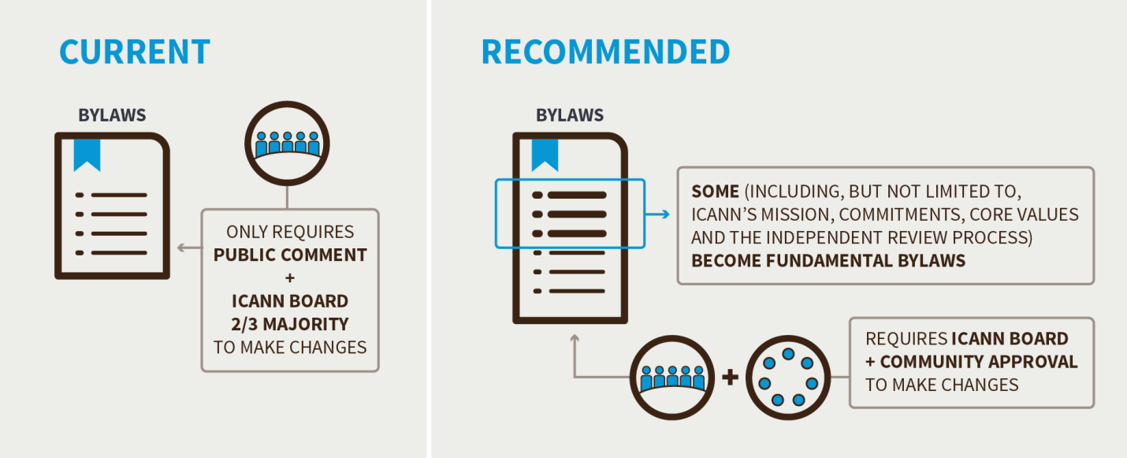
The CCWG-Accountability therefore recommends that ICANN’s Bylaws be split into:
Fundamental Bylaws: thoseThose aspects of the Articles and Bylaws that are deemed critical or fundamental to the organization’s stability and operational continuity, and the community’s decision rights such as:
- The Mission, Commitments and Core Values
- The framework for the Independent Review Process (IRP)
- The process by which Fundamental Bylaws can be amended
- The five proposed Community Powers
- The Community Mechanism as the Sole Designator Model
- The IANA Function Review, Special IANA Function Review and the Separation Process required by the IANA Stewardship Transition proposal
- The Post-Transition IANA Governance and Customer Standing Committee structures that are also required by the IANA Stewardship Transition proposal
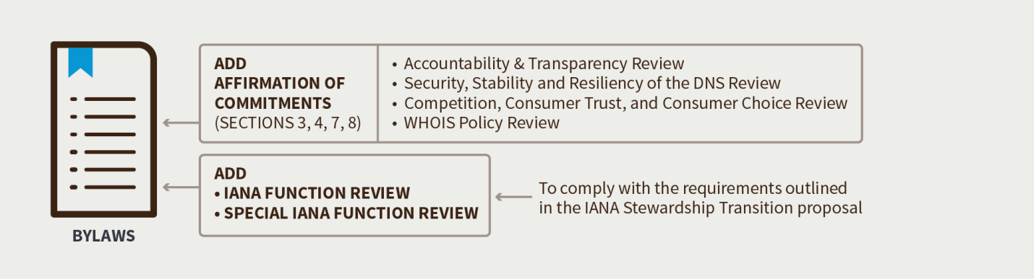
[Note that it the Box above where it says “ADD * IANA FUNCTION REVIEW * SPECIAL IANA FUNCTION REVIEW -- should also include the following bullets: “ *SEPARATION PROCESS
* CUSTOMER STANDING COMMITTEE * POST-TRANSITION IANA GOVERNANCE”]
Standard Bylaws: all other Bylaws that are not deemed to be Fundamental Bylaws
The CCWG-Accountability believes that aspects designated as fundamental should not be amended unless there is strong consensus to do so within the ICANN Board as well as in the community. While ‘mission creep’ needs to be minimized, it is possible that ICANN may need to adjust to a changing environment in the future and provisions must be made for thisfuture changes.

Sole Designator Model
Since the publication of ‘Second Draft Proposal on Work Stream 1 Recommendations’, the CCWG-Accountability has changed its proposed mechanism for ensuring the community can effectively exercise its power of enforcement. The CCWG-Accountability now recommends using a “Sole Designator” model instead of the previously proposed “Sole Member Model”. The Sole Designator model provides the maximum legal set of powers to the community while avoiding the is closer to the current structure of ICANN in which ACs and SOs have rights to designate directors. It also supports the community’s exercise and enforcement of the Community Powers in a manner that avoids certain risks that some commenters expressed concern about in the Second Public Comment Period stated could be introduced by making changes to ICANN’s organizational structure if the Sole Member model was implemented.related to statutory powers of members and the degree of change from the current model associated with a move to a membership-based model.
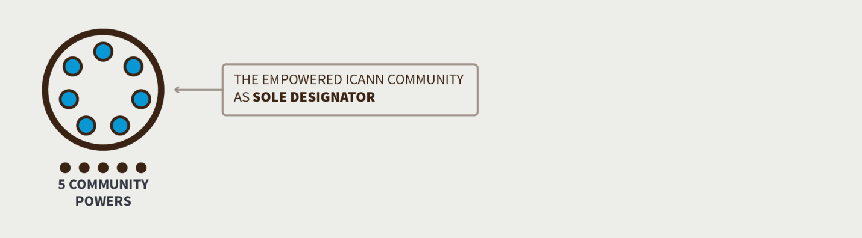
The set of powers that were available in the Second Draft Proposal under the Sole Member model would have been enshrined by statute under California law, and the groupAfter considerable discussion and deliberation, the CCWG-Accountability determined that the Sole Designator model could achieve a very similar set of powers by including them in the ICANN Bylaws. During the development of the proposed Sole Designator model, there were concerns that it would not allow for the same level of enforcement power as the Sole Member model.
the same Community Powers as provided under the Sole Member Model albeit with indirect rather than direct enforceability for certain of the powers. However, with the enhanced communication and escalation processes as between the community and the Board that are proposed in the Sole Designator model, it was felt that the available enforcement powers would beare consistent with the CCWG-Accountability’s requirements.

Empowering the Community Through Consensus: Engage, Escalate, Enforce
Building off of a base assumption that both the community and the ICANN Board are acting in the best interests of the corporation, the CCWG-Accountability determined that disagreements might arise from time to time. When disagreements arise, the CCWG-Accountability is proposing a series of procedures that ensure both sides have had the chance to completely and thoroughly discuss any disagreements between themselves and have multiple opportunities to resolve any such issues without having to resort to the powers of the Sole Designator for accountability or enforceability.
This process is referred to as Engagement, Escalation and Enforcement.

Engagement
The CCWG-Accountability proposes a requirement that the ICANN Board must engage with the community before making anycertain critical decisions. It is expected that this enhanced engagement process should allow for most community concerns to be properly addressed and avoid the need for using the escalation procedureand enforcement procedures.
Currently, the ICANN Board engagement processes are voluntary. The CCWG-Accountability recommends that the engagement processes be made mandatory, and be reinforced in the ICANN Bylaws.

Escalation
The CCWG-Accountability proposes a set of steps for escalation of a concern, which allows both parties to completely and thoroughly discuss any disagreements. The general escalation process is outlined below:
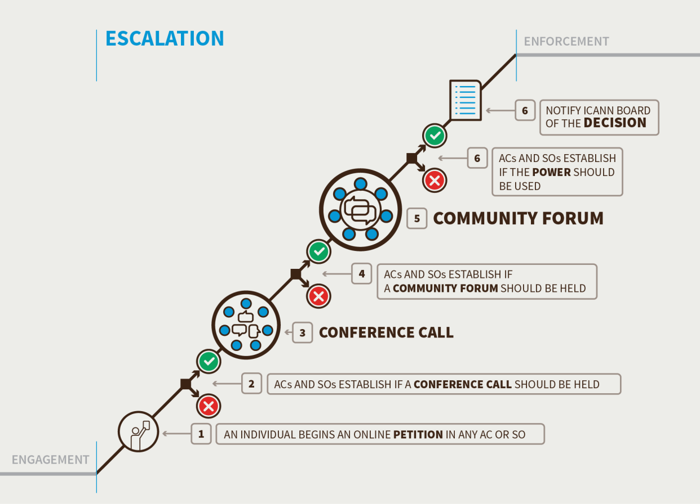
[There is significant redundancy in repeating the processes outlined below in the discussion of each of the Community Powers that follow( in the boxes). Consider describing the steps in the process once and then referring back and noting any particular changes or refinements that may apply to the specific power when that power is discussed.]
Triggering Review by Community Petition (15-days) or by Board Action
- Begin a petition in a Supporting Organization or Advisory Committee
• : Anyone can begin a petition as the first step to eventually using an accountability power.
- Note that there are two exceptions:
- For removal of an individual Director, the petition must begin and be supported by the SO or AC that nominated the Director.
- For approval of an amendment to a Fundamental Bylaw, the community consideration is triggered by the Board’s action to amend the Fundamental Bylaw.
- For the petition to be accepted, the Supporting Organization or Advisory Committee, in accordance with its own mechanisms, must accept the petition
- If the Supporting Organization or Advisory Committee does not approve the petition within the 15 days, the escalation process is terminated
- [Need to address what happens when the review is triggered by Board action to approve a Fundamental Bylaw].
- If the Supporting Organization or Advisory Committee approves the petition, it contacts the other Supporting Organizations or Advisory Committees to ask them to support the petition so a conference call can be organized that will allow the entire community to discuss the issue. At least one additional Supporting Organization or Advisory Committee must support the petition (for a minimum of 2) for a conference call to be organized
- If a minimum of 2 Supporting Organizations or Advisory Committees support the petition within 15-days, a conference call is organized
- If the petition fails to gather the required support for the petition, the escalation procedure is terminated [except for removal of individual director]
- Note 1: for any rejection such as Budget the 15-day period only applies from the time the Board votes on the element to be rejected. If the petition is not successful within 15 days of the Board voting, the rejection mechanism cannot be used
- Note 2: For ICANN Board resolutions which could be rejected by the community mechanisms, the Board would be required to automatically provide a 15-day period before the resolution takes effect to allow for the escalation to be confirmed. If the petition is supported by a minimum of 2 Supporting Organizations or Advisory Committees within the 15-day period then the Board is required to put implementation of the contested resolution on hold until the escalation process is completed. The purpose of this is to avoid having ICANN undo things (if the rejection is approved), which could be potentially very difficult to undo (such as singingsigning contracts etc.)
Conference call (7-days to organize and hold from the date the decision is made to hold the call)
- The petitioning Supporting Organizations and/or Advisory Committees circulate written justification for exercising the community power in preparation for the conference call. Any Supporting Organization or Advisory Committee may contribute preliminary thoughts or questions in writing before the call is held via a specific archived email list set up for this specific issue
- ICANN hosts a conference call open to any interested participants, and the call is to be recorded, transcribed, translated, etc. Representatives of the ICANN Board are expected to attend.
- If the Communitycommunity and the Board can resolve the issue on the conference call the escalation is terminated.
- If the community and the Board cannot resolve the issue the community must decide if it wishes to hold a Community Forum.
Decision to hold a Community Forum (7-days from the end of the conference call)
- The Supporting Organizations and/or Advisory Committees must decide if they want to hold a Community Forum. This would be a one or two day event, possibly face-to-face, where the ICANN community would explore in detail the issue between the Board and the community and the potential avenues for resolution or action.
- If 3 or more Supporting Organizations or Advisory Committees (for some mechanisms only 2) support holding a Community Forum within the 7-day period it, the Community Forum will be organized
- If the proposal to hold a Community Forum cannot obtain the required support during the 7 days the escalation process is terminated
Holding a Community Forum (15-days to organize and hold the event from the date of the decision to hold it)
- The Community Forum would be planned for 1 to 2 days
- The Community Forum would be open to all stakeholders interested participants with remote participation opportunities, and would be recorded, transcribed, translated, etc. Representatives of the ICANN Board are expected to attend
- The purpose of the Community Forum is information sharing (the rationale for the petition, etc.) and airing views on the petition by the community. Accordingly, any Supporting Organization or Advisory Committee may circulate in writing their preliminary views on the exercise of this community power
- The Community Forum will not make decisiondecisions nor seek consensus. It will not decide whether to advance the petition to the decision stage. This decision is up to the Supporting Organizations and/or Advisory Committees to determine after the forum
- The Community Forum should be managed/moderated in a fair and neutral manner
- Should the discussions of the petition require additional time it may extend the forum If the relevant Supporting Organizations or Advisory Committees determine a need for further deliberation, a second and third session of the Community Forum could be held
- Staff will collect and publish a public record of the Forum(s), including all written submissions
- If the community and ICANN Board can resolve the issue in the Community Forum, the escalation is terminated
- If the community and ICANN Board cannot resolve the issue, the community must decide if it wishes to instruct the Sole Designator to use its powertake further action
Decision to instruct the Sole Designator to use its power (15-days from the conclusion of the community forum)
- If 4 or more Supporting Organizations and/or Advisory Committees (for some mechanisms only 1 or 3) support and no more than 1 objects within the 15-day period to instruct the single designatorSole Designator to use its power, the single designatorSole Designator will do so. The community will also publish a detailedan explanation of why it has chosen to do so. [Different ACs and SOs may have different reasons; we assume that the community need not agree on a rationale but the published explanation can reflect the variety of underlying reasons.]
- If the proposal to instruct the single designatorSingle Designator to use its power cannot obtain the required support during the 15-day period, the escalation process is terminated.
- [Consider including a description of how the ACs and SOs instruct the Sole Designator to act including the fact that their instructions once the decision threshold is met automatically become the Sole Designator’s decision.]
Advising the ICANN Board (1 day)
- If the community has instructed the Sole Designator to use its power, the Sole Designator will advise the ICANN Board of the decision and request thatdirect the Board to take any necessary action to comply with the requestdecision.

Enforcement
The CCWG-Accountability proposes that, in the theoretical situation where the ICANN Board would refuse to implementrefuses to comply with a decision by the Sole Designator as required by the Articles or Bylaws, the community would proceed according to one of the following two options:
Option 1: Initiate an escalation process to remove the entire Board.
• If successful, the Sole Designator advises the Board it must step down
- If the requisite threshold of community support is achieved, the Sole Designator removes all of the members of the ICANN Board (except the CEO) and replaces them with an Interim Board until a new Board can be seated.
- If the Board refusesICANN’s staff, outgoing Board or removed directors take any action to attempt to question the legitimacy of the Sole Designator’s requestdecision or block the Interim Board, the Sole Designator may seek enforcement by a court with jurisdiction
Option 2: Initiate mediation and community Independent Review Process procedures
- Representatives from the community and ICANN Board would undertake a formal mediation phase. If the community is satisfied with the results from the mediation phase, the enforcement phase would be terminated. [The mediation phase as distinct from the IRP Process has not been described in detail. Who would mediate? Who chooses the mediators? How does it differ from the IRP?]
- If not, the community will proceed with a community Independent Review Process that could only be initiated using the escalation process described above.
- If the community chooses to begin a community Independent Review Process, representatives from the community and ICANN Board would undertake a formal and binding Independent Review Process.
- If the results of the binding Independent Review Process are in favor of the Board, the enforcement procedure is terminated.
- If the results of the binding Independent Review Process are in favor of the community, it is expected that the Board willmust comply.
- If the Board does not comply with the decision of the Independent Review Process, the Sole Designator can request that a court with jurisdiction enforce the results of the Independent Review Process, or the community can use the escalation process to remove the Board.

Ensuring Community Engagement in ICANN Decision-Making: Five New Community Powers
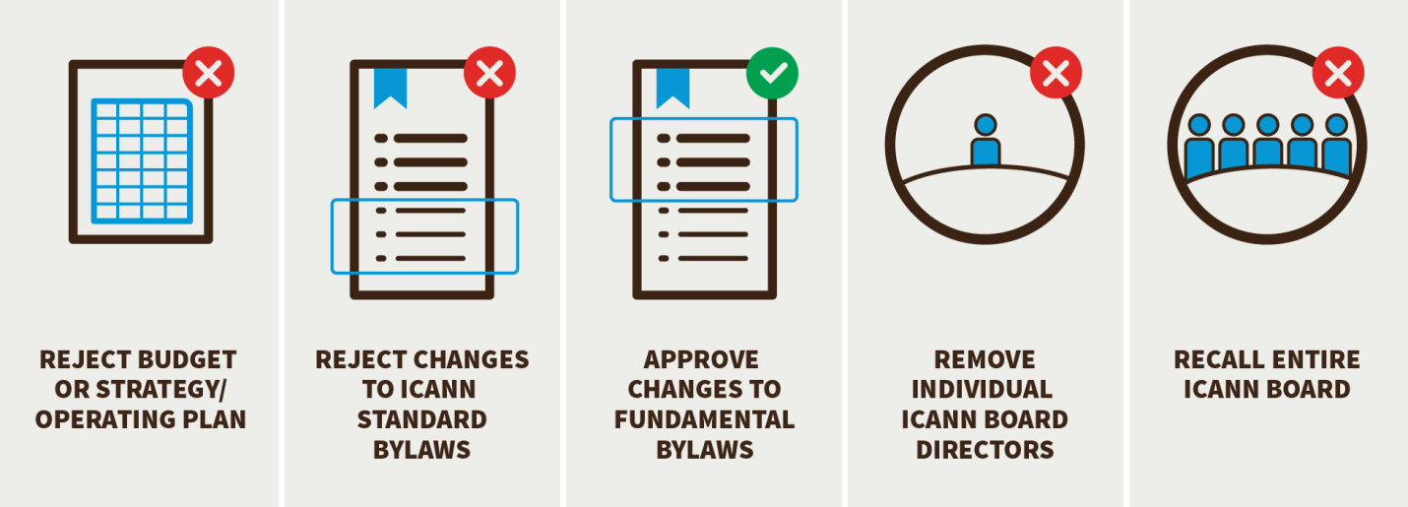
The CCWG-Accountability has proposed a set of five Community Powers designed to empower the community to hold ICANN accountable for the organization’s Principles (the Bylaws, Mission, Commitments, and Core Values). The proposed Community Powers are:
- The Power to Reject ICANN’s Budget or Strategy/Operating Plans
- The Power to Reject Changes to ICANN Standard Bylaws
- The Power to Remove Individual ICANN Board Directors
- The Power to Recall the Entire ICANN Board
- The Power to Approve Changes to Fundamental Bylaws
[Need to discuss Power to Appoint Directors and Power related to IANA Separation Review]

Executing the Five Community Powers
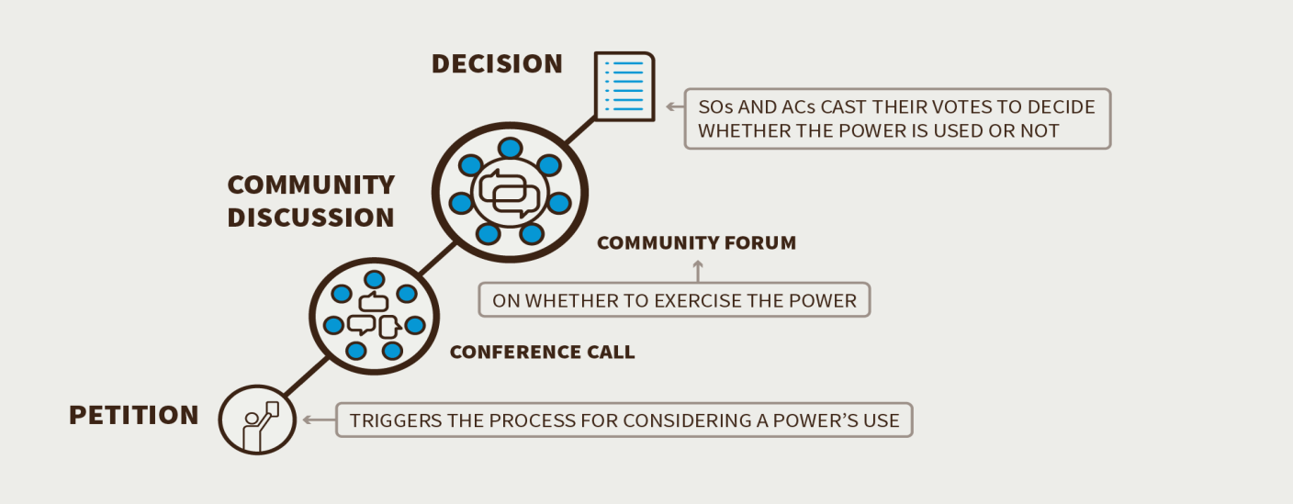
Under no circumstances would any individual section of the community be able to make decisions alone or overturn the bottom-up, consensus-driven policy processes already in place. There are three steps involved in making use of one of the powers:
- Petition: Triggers the process for considering a power’s use
- Discussion: Community discussion on whether to exercise the power via conference calls and a Community Forum
- Decision: Supporting Organization(s) and Advisory Committee(s) cast their votes to decide whether the power is used or not

Enforcement [Is this the appropriate title? This seems to be more about decision thresholds than enforcement. Consider another title and placing after Community Discussion, below.]
For all five of the proposed community powers, the thresholds for support vary but are always based on majority consensus. [What about IANA Separation Review?] While all five of the proposed powers could ultimately be enforced by a court of laweither directly or through the indirect means of Board recall , the CCWG-Accountability has installed various safeguards to make it highly unlikely that this will ever be necessary. The proposed powers and the escalation processes for them have been designed to ensure that no single Supporting Organization or Advisory Committee can singlehandedly exercise a community power or block its use.

Community Discussion
The CCWG-Accountability identified the need for a discussion phase where, once a petition to use a power has been created, the possible use of that power is discussed across the entire ICANN community before the power under consideration is used.
The CCWG-Accountability recommends the creation of a Community Forum to facilitate this discussion. The Community Forum will bring together stakeholders from all Supporting Organizations, Advisory Committees, ICANN Board, staff and any other interested stakeholders to extensively discuss the proposed action(s) and give those concerned an opportunity to voice their rationale or opinion. The objective is to ensure that an informed and balanced decision is made. The Community Forum would require a designated threshold of support for it to convene.

Not a Decision-Making Body
The Community Forum is not a decision-making body. Any discussions taking place in the Community Forum will be open to participation from all sections of the ICANN community and members of the public. Discussions and outputs from the Community Forum will be open, documented and easily accessible to anyone.

The Power to Reject ICANN’s Budget or Strategy/Operating Plans
The right to set budgets and strategic direction is a critical governance power for any organization. By allocating resources and defining the goals to which these resources are directed, strategic plans, operating plans and budgets have a significant impact on what ICANN does and how effectively it fulfills its role. The ICANN community already plays an active role in giving input into these key documents through participation in the existing consultation processes ICANN organizes.
To provide the community with additional accountability safeguards, the CCWG-Accountability has proposed that the community be given the power to reject:
- ICANN’s Five-Year Strategic Plan
- ICANN’s Five-Year Operating Plan
- ICANN’s Annual Operating Plan & Budget
- The IANA Functions Budget
The CCWG-Accountability has determined that a separate petition would be required for each budget or plan being challenged. A Supporting Organization or Advisory Committee petitioning to reject a budget or strategic/operating plan would be required to circulate a rationale and obtain support for its petition from at least one other Supporting Organization or Advisory Committee according to the Escalation Process.
The escalation process adds several safeguards. These safeguards require that the reason(s) for a rejection has been adequately researched [what type of research is anticipated to be required?], discussed by the community and gains the required threshold of support before the power can be used.

Rejecting the Annual Operating Plan & Budget
In a case where the community rejects the Annual Operating Plan & Budget, it is proposed that a ‘Caretaker Budget’ will come into effect to ensure operational continuity. This Caretaker Budget would ensure there is the necessary budget to enable ICANN to perform the functions essential to its daily operations, such as meeting its contractual obligations and paying its staff.

The IANA Functions Budget
Under this power the community will be able to consider the IANA Functions’ Budget as a separate entity. The IANA Functions’ Budget is currently part of ICANN’s Annual Operating Plan & Budget.
The CCWG-Accountability recommends that there should be two distinct processes with respect to the community’s power to reject the IANA Budget and its power to reject the ICANN Budget, meeting the requirements set forward by the IANA Stewardship Transition proposal. The use of the Community Power to reject the ICANN Budget would have no impact on the IANA Budget, and a rejection of the IANA Budget would have no impact on the ICANN Budget.
In addition, to reinforce the bottom up, collaborative approach that ICANN currently uses to enable the community to give input into these documents, the CCWG-Accountability recommends adding the existing consultation process into the ICANN Bylaws.

The Power to Reject Changes to ICANN’s Standard Bylaws
ICANN’s Bylaws describe how power is exercised in ICANN, including setting out the organization’s Mission, Commitments and Core Values.
The CCWG-Accountability recommends that ICANN’s Bylaws be split into:
- Fundamental Bylaws: those aspects of the Bylaws that are deemed critical or fundamental to the organization’s stability and operational continuity
- Standard Bylaws: all other Bylaws that are not deemed to be Fundamental Bylaws
The ICANN Board currently has the ability to change any ICANN Bylaw with a two-thirds majority vote. Although current Board practice is to gather the community’s feedback on any Bylaws amendments, the requirement for the consultation process is not required under current ICANN Bylaws.
To safeguard against the possibility that the ICANN Board could unilaterally amend Bylaws without consulting the community, the CCWG-Accountability recommends that the community be given the power to reject changes to the Standard ICANN Bylaws after the Board approves them, but before the changes come into effect. Any changes approved by the Board would take 15 days to come into effect to enable the community to decide whether a petition to reject the change should be initiated.
This power is a rejection process that is used to tell the ICANN Board that the community does not support a Board-approved change to the Standard Bylaws. It does not enable the community to re-write a Standard Bylaw change that has been proposed by the Board.

The Power to Remove Individual ICANN Board Directors
[The discussion below and the material in the box is very confusing as to whether the nominating AC/SO must get agreement from other ACs and SOs to terminate a director or whether just consultation is required. Our edits below presume that the ultimate decision is for the AC or SO who nominated but that they must attempt to initiate a consultation process. Also, the material in the box is highly redundant of the earlier discussion of the escalation process. Consider streamlining.]
The proposed power to Remove Individual ICANN Board Directors enables thewould enable the nominating SO or AC after community consultation to remove a Director before his or her fixedthe Director’s current term comes to an end. The CCWG-Accountability recommends that the community be given this express power, as currently, the power to remove individual Board Directors is only available to (which arguably already exists under California law as a component of the current power ACs and SOs have to designate Directors). Currently, the Bylaws only address the power of the Board itself to remove individual Directors.
Under this Community Power, a Director could be removed withoutby the nominating SO or AC after community consultation for any reason or cause. The CCWG-Accountability expects that this power would only be used in cases of serious difficulty withconcerns about a particular Director. Various thresholds of support would need to be achieved at each point of the escalation process before this power could be used. The Process to Remove Individual ICANN Board Directors is outlined below:

Overview of the CCWG-Accountability’s Proposed Process for the Removal of a Supporting Organization or Advisory Committee Appointed Director
In cases where the nominating Supporting Organization or Advisory Committee perceives that there is a significant issue with its appointed Director it can use the following escalation process to determine if removal of the Director is recommended. It is important to note that this process can only be used once during a Director’s term. If the process fails for any reason it may not be re-started during the Director’s current term.

Escalation
Petition (15-days)
- Begin a petition in the Supporting Organization or Advisory Committee that nominated the Director. Anyone can begin a petition as the first step to remove the Director. For the petition to be accepted, the Supporting Organization or Advisory Committee that nominated the Director must accept the petition according to its own mechanisms.
- If a petition is accepted, the Chair of the Supporting Organization or Advisory Committee will rapidly meet promptly in private (by phone or in person) with the concerned Director to discuss the approved petition. If no resolution is found, the Supporting Organization or Advisory Committee schedules a Conference Call within 7 days of the petition being accepted. The Conference Call is open, and held to discuss the reasons behind the petition. The concerned Director is invited to participate and present his or her views, ask questions and provide answers to the community. The call must be chaired by an independent party such as the ICANN Ombudsman. [Who else would qualify as an independent party?]
- If the Supporting Organization or Advisory Committee does not approve the petition within 15-days the escalation process is terminated
Conference Call (7-days to organize and hold from the date the decision is made to hold the call)
- The petitioning Supporting Organizations and/or Advisory Committees circulate written justification for exercising the Community Power in preparation for the conference call, which should be circulated with enough advance notice to allow for preparation. Any Supporting Organization or Advisory Committee may contribute preliminary thoughts or questions in writing before the call is held via a specific publicly archived email list set up for this specific issue
- ICANN hosts a conference call open to any interested participants. The call would be recorded, transcribed, translated, etc. The concerned Director and representatives of the ICANN Board are expected to attend
- If the community and the Director can resolve the issue on the conference call, the escalation is terminated.
- If the community and the Director cannot resolve the issue, the community must decide if it wishes to hold a Community Forum.
Deciding to hold a Community Forum (7-days from the end of the conference call)
- The Supporting Organization and/or Advisory Committee must decide if they wish to hold a Community Forum. This would be a one or two day event, possibly face-to-face, where the ICANN community would explore in detail the issue between the ICANN Board and the community and the potential avenues for resolution or action
- If 3 or more Supporting Organizations and/or Advisory Committees support holding a Community Forum within the 7-day period it will be organized
- If the proposal to hold a Community Forum cannot obtain the required support during the 7-day period the escalation process is terminated. [Unclear: If there is not enough support for the Community Forum to be held, is the nominating SO or AC prevented from removing the Director?]
Holding a Community Forum (15-days to organize and hold the event from the date of the decision to hold it)
- The Community Forum would be planned for 1 to 2 days
- The Community Forum would be open to all interested stakeholders and remote participation opportunities will be available. The Community Forum would be recorded, transcribed and translated. The Director and other representatives of the ICANN Board are expected to attend
- The Community Forum is open to all and is held to discuss the reasons behind the petition in a more detailed format than the Conference Call. The Supporting Organization or Advisory Committee must clearly present its case and be ready to answer questions from the community. The concerned Director is invited to participate and present his or her views, ask questions and provide answers to the community. An independent party, such as the ICANN Ombudsman, must chair the Community Forum.
- ICANN staff will collect and publish a public record of the Forum(s), including all written submissions.
- If the community and the Director resolve their issues during the Community Forum, the escalation process is terminated.
- If the community and the Director cannot resolve their issues at the Community Forum, the Supporting Organization or Advisory Committee must decide if it wants to use the community power to remove the Director.
- The Community Forum Chair will issue a formal call for comments and recommendations from the community, and input received will be sent to the concerned Supporting Organization or Advisory Committee and posted publicly within 7 days.
Supporting Organizations and/or Advisory Committees publish their comments and recommendations (7-days)
Deciding to instruct the Sole Designator to use its power (7-days from the conclusion of the community forum)
- If after considering community input, the nominating Supporting Organization or Advisory Committee decides with a supermajority vote to instruct the Sole Designator to use its power the Sole Designator will do so. [Note that this paragraph suggests that it is still up to the SO or AC to make the decision – i.e., that consultation efforts are required but that ultimately the SO or AC that nominated may decide to remove even if no Community Forum takes place because not enough support from others or even if after Community Forum majority of other ACs and SOs disagree.] The community will also publish a detailed explanation of why it has chosen to do so. [What happens if community doesn’t agree on outcome or rationale?]
- [If the proposal to instruct the Sole Designator to use its power cannot obtain the required support during the 7-day period, the escalation process is terminated and the Board Director remains in place. [This paragraph is inconsistent with the paragraph above. Consider replacing with: If the nominating SO or AC instructs the Sole Designator of its decision to remove the Director, that decision shall become the decision of the Sole Designator.]
Advising the ICANN Board (1 day)
- If the community has instructed the Sole Designator is instructed by the nominating SO or AC to use its power, the Sole Designator will advise the ICANN Board of the decision and request thatinform the Director step down so that he or she can be replacedis no longer a Director effective immediately.
Naming a Replacement
- The respective Supporting Organization or Advisory Committee is responsible for filling their vacancy on the ICANN Board through its usual process (as set out in Article VI, Section 12.1 of the Bylaws).
- Replacement Directors will fill the same “seat” and their term will come to an end when the term of the original Director was to end. A Director appointed in such circumstances will not have their remaining time in the role counted against any term limits, to which they would otherwise be subject.

Overview of the CCWG-Accountability’s Proposed Process for the Removal of a Director Appointed by the Nominating Committee
In cases where the community perceives that there is a significant issue with a Director appointed by the Nominating Committee it can use to followingthe engagement and escalation process to decide if it should recommend removing the Director. It is important to note that this process can only be used once during a Director’s current term. If the process fails for any reason it may not be re-started during the Director’s current term.

Escalation
Petition (15-days)
- Begin a petition in aany Supporting Organization or Advisory Committee. Anyone can begin a petition as the first step to remove an ICANN Board Director. For the petition to be accepted, the Supporting Organization or Advisory Committee must accept the petition according to its own mechanisms
- If the Supporting Organization or Advisory Committee does not approve the petition within the 15-days the escalation process is terminated
- If the Supporting Organization or Advisory Committee approves the petition, it contacts the other Supporting Organizations and/or Advisory Committees to ask them to support the petition so that a conference call can be organized that will allow the entire community to discuss the issue. At least one additional Supporting Organization or Advisory Committee must support the petition (for a minimum of 2 in total) for a conference call to be organized
- If a minimum of 2 Supporting Organizations and/or Advisory Committees support the petition within the required time of 15-days a conference call is organized and the ICANN Board is advised
- If the petition fails to gather the required support the escalation procedure is terminated
Conference Call (7-days to organize and hold from the date the decision is made to hold the call)
- The petitioning Supporting Organizations and/or Advisory Committees circulate written justification for exercising the Community Power in preparation for the conference call, which should be circulated with enough advance notice to allow for preparation. Any Supporting Organization or Advisory Committee may contribute preliminary thoughts or questions in writing before the call is held via a specific publicly archived email list set up for this specific issue
- ICANN hosts a conference call open to any interested participants. The call would be recorded, transcribed, translated, etc. The concerned Director and representatives of the ICANN Board are expected to attend
- If the community and the Director can resolve the issue on the conference call, the escalation is terminated.
- If the community and the Director cannot resolve the issue, the community must decide if it wishes to hold a Community Forum.
Deciding to hold a Community Forum (7-days from the end of the conference call)
- The Supporting Organizations and/or Advisory Committees must decide if the wish to hold a Community Forum. This would be a one or two day event, possibly face-to-face, where the ICANN community would explore in detail the issue between the Board and the community and the potential avenues for resolution or action.
- If 2 or more Supporting Organizations and/or Advisory Committees support holding a community forum within 7 days, it will be organized.
- If the proposal to hold a Community Forum cannot obtain the required support within 7 days the escalation process is terminated.
Holding a Community Forum (15 days to organize and hold the event from the date of the decision to hold it)
- The Community Forum would be planned for 1 to 2 days
- The Community Forum would be open to all interested stakeholders and remote participation opportunities will be available. The Community Forum would be recorded, transcribed and translated. The Director and other representatives of the ICANN Board are expected to attend
- The Community Forum is open to all and is held to discuss the reasons behind the petition in a more detailed format than the Conference Call. The Supporting OrganizationOrganizations or Advisory CommitteeCommittees must clearly present itsthe case and be ready to answer questions from the community. The concerned Director is invited to participate and present his or her views, ask questions and provide answers to the community. An independent party, such as the ICANN Ombudsman, must chair the Community Forum. [Who else would qualify?]
- ICANN staff will collect and publish a public record of the Forum(s), including all written submissions.
- If the community and the Director resolve their issues during the Community Forum, the escalation process is terminated.
- If the community and the Director cannot resolve their issues at the Community Forum, the Supporting Organization or Advisory Committee must decide if it wants to use the community power to remove the Director.
- The Community Forum Chair will issue a formal call for comments and recommendations from the community, and input received will be sent to the concerned Supporting Organization or Advisory Committee and posted publicly within 7 days.
Deciding to instruct the Sole Designator to use its power (15-days from the conclusion of the community forum)
- If 3 or more Supporting Organizations and/or Advisory Committees support and no more than 1 objects within the 15-day period to instruct the Sole Designator to use its power, the Sole Designator will do so. The communitySOs and ACs who support the decision will also publish a detailed explanation of why it hasthey have chosen to do so. [This edit is intended to address the problem of what if the community agrees re need for Director to go but does not agree on reason?]
- If the proposal to instruct the Sole Designator to use its power cannot obtain the required support during the 15-day period, the escalation process is terminated and the Board remains in place.
Advising the ICANN Board (1 day)
- If the community has instructed the Sole Designator to use its power, the Sole Designator will advise the ICANN Board of the decision and request thatinform the Director step down sothat he or she can be replacedis no longer a Director effective immediately.
Naming a Replacement
- The Nominating Committee may appoint a new Director. It is expected that the Nominating Committee will amend its procedures so as to have several “reserve” candidates in place.
- Replacement Directors will fill the same “seat” and their term will come to an end when the term of the original Director was to end. A Director appointed in such circumstances will not have their remaining time in the role counted against any term limits, to which they would otherwise be subject.

The Power to Recall the Entire ICANN Board
The CCWG-Accountability believes there may be situations where removing Individual Directors from ICANN’s Board may not be a sufficient accountability remedy for the community.
In cases where the community perceives that a set of problems has become unresolvableincapable of resolution, the community may wish to signal its lack of confidence in the Board by petitioning for a recall (i.e. the removal) of the entire ICANN Board. The power to recall a Board is one of the two statutory powers of Designators under California law(except for the CEO, who is appointed by the Board). The power to recall the Entire ICANN Board is therefore thea critical enforcement mechanism for the community under a Sole Designator Model, because it can be used to support the other Community Powers and provide a final and binding accountability mechanism.
By exercising this power, the entire ICANN Board (except the CEO) could be removed without cause orfor any reason by the community. However, it is unlikely that the community would use this power lightly, and the engagement and escalation pathways are designed to encourage agreement between the Board and the community. (Board removal is a classic accountability mechanism in corporate law and the fact of its availability – without it ever being used -- should help to encourage the Board to attend to the community’s concerns.) If the ICANN Board was recalled, an Interim Board would be put in place. Interim Directors would be named with the exercising of the Community Power to ensure continuity.
The CCWG-Accountability expects that this power would only be exercised as a last resort after all other attempts at resolution have failed. As a recall of the Board would be extremely disruptive for the entire organization, the CCWG-Accountability has included several safeguards in the proposed escalation process to ensure that this decision reaches the maturity and level of support needed before it can be used.

Interim Board
The CCWG-Accountability proposes that a Bylaw be added that states that if the Board is removed the Interim Board will be in place only as long as is required for the selection/election process for the Replacement Board to take place. Under no circumstances will the Interim Board be in place for more than 120 days. The Interim Board will have the same powers and duties as the Board it replaces. Having a Board in place at all times is critical to the operational continuity of ICANN and is required by California law.
The ICANN Bylaws will state that, except in circumstances of where urgent decisions are needed to protect the security, stability and resilience of the DNS, the Interim Board will consult with the community through the Supporting Organization and Advisory Committee leadership before making major decisions. Where relevant, the Interim Board will also consult through the ICANN Community Forum before taking any action that would mean a material change in ICANN’s strategy, policies, or management, including replacement of the serving President and CEO.

Processes [Is this the appropriate heading? Also, the material in this section would be helpful to include at the start of the section on removal of individual directors.]
There are currently 16 Board members. 7 are nominated by ICANN Supporting Organizations (SOs) and At-Large Advisory Committees (ALAC). The Nominating Committee nominates 8. The Board appoints the President and CEO as the 16th member. The President and CEO is not an elected Board member and therefore may not be removed using this power.

Overview of the CCWG-Accountability’s Proposed Process for the Removal of the Board
In cases where the community perceives that a set of problems has become so entrenched into the Board, the community may wish to signal its lack of confidence in the Board by considering a recall (i.e. the removal) of the entire ICANN Board in one decision.

Escalation
Petition (15 days)
- Begin a petition in a Supporting Organization or Advisory Committee. Anyone can begin a petition as the first step to remove an ICANN Board Director. For the petition to be accepted, the Supporting Organization or Advisory Committee must accept the petition according to its own mechanisms
- If the Supporting Organization or Advisory Committee does not approve the petition within the 15-days the escalation process is terminated
- If the Supporting Organization or Advisory Committee approves the petition, it contacts the other Supporting Organizations and/or Advisory Committees to ask them to support the petition so that a conference call can be organized that will allow the entire community to discuss the issue. At least one additional Supporting Organization or Advisory Committee must support the petition (for a minimum of 2 in total) for a conference call to be organized
- If a minimum of 2 Supporting Organizations and/or Advisory Committees support the petition within the required time of 15-days a conference call is organized and the ICANN Board is advised
- If the petition fails to gather the required support the escalation procedure is terminated
Conference call (7 days to organize and hold from the date the decision is made to hold the call)
- The petitioning Supporting Organizations and/or Advisory Committees circulate written justification for exercising the Community Power in preparation for the conference call, which should be circulated with enough advance notice to allow for preparation. Any Supporting Organization or Advisory Committee may contribute preliminary thoughts or questions in writing before the call is held via a specific publicly archived email list set up for this specific issue
- ICANN hosts a conference call open to any interested participants. The call would be recorded, transcribed, translated, etc. Representatives of the ICANN Board are expected to attend
- If the community and the ICANN Board can resolve the issue on the conference call, the escalation is terminated.
- If the community and the ICANN Board cannot resolve the issue, the community must decide if it wishes to hold a Community Forum.
Deciding to hold a Community Forum (7 days from the end of the conference call)
- The Supporting Organization and/or Advisory Committee must decide if they wish to hold a Community Forum. This would be a one or two day event, possibly face-to-face, where the ICANN community would explore in detail the issue between the ICANN Board and the community and the potential avenues for resolution or action
- If 3 or more Supporting Organizations and/or Advisory Committees support holding a Community Forum within the 7-day period it will be organized
- If the proposal to hold a Community Forum cannot obtain the required support during the 7-day period the escalation process is terminated
Holding a Community Forum (15 days to organize and hold the event from the date of the decision to hold it)
- The Community Forum would be planned for 1 to 2 days
- The Community Forum would be open to all interested stakeholdersparticipants and remote participation options will be available. The Community Forum would be recorded, transcribed, translated, etc. Representatives of the ICANN board are expected to attend.
- The purpose of the Community Forum is information sharing (the rationale for the petition, etc.) and airing views on the petition by the community. Accordingly, any Supporting Organization or Advisory Committee may circulate in writing their preliminary views on the exercise of this community power
- The Community Forum will not make decisiondecisions nor seek consensus. It will not decide whether to advance the petition to the decision stage. This decision is up to the Supporting Organizations and/or Advisory Committees to determine after the forum
- The Community Forum should be managed/moderated in a fair and neutral manner
- Should the discussions of the petition require additional time it may extend the forum If the relevant Supporting Organizations or Advisory Committees determine that there is a need for further deliberation, a second and third session of the Community Forum could be held
- Staff will collect and publish a public record of the Forum(s), including all written submissions
- If the community and ICANN Board can resolve the issue in the Community Forum the escalation is terminated
- If the community and ICANN Board cannot resolve the issue the community must decide if it wishes to instruct the Sole Designator to use its power
Deciding to instruct the Sole Designator to use its power (15 days from the conclusion of the community forum).
- • The Supporting Organizations and Advisory Committee that nominate Directors to the ICANN Board would select alternate directors to sit on an interim Board should there be a call for a removal vote. The Nominating Committee, as part of its standard processes, would have two candidates available to sit on an interim Board at all times. The interim Board will come into effect if the community votes to recall the current Board.
- If 4 or more Supporting Organizations and/or Advisory Committees support and no more than 1 objects within the 15-day period, the Sole Designator will use its power. The community will also publish a detailed explanation of why it has chosen to do so.
- If the proposal to instruct the Sole Designator to use its power cannot obtain the required support during the 15-day period the escalation process is terminated and the Board remains in place.
Advising the ICANN Board (1 day)
- If the community has instructed the Sole Designator to use its power the Sole Designator will advise the ICANN Board of the decision and request thatinform the Board step down so the interimthat it has been replaced by an Interim Board can replace it.

The Power to Approve Changes to Fundamental Bylaws
ICANN’s Bylaws describe how power is exercised in ICANN, including setting out the organization’s Mission, Commitments and Core Values.
The CCWG-Accountability recommends that ICANN’s Bylaws be split into:
- Fundamental Bylaws: those aspects of the Bylaws that are deemed critical or fundamental to the organization’s stability and operational continuity
- Standard Bylaws: all other Bylaws that are not deemed to be Fundamental Bylaws
The ICANN Board currently has the ability to change any ICANN Bylaw with a two-thirds majority vote. Although current Board practice is to gather the community’s feedback on any Bylaws amendments, the requirement for the consultation process is not required under current ICANN Bylaws. To safeguard against the possibility that the ICANN Board could unilaterally amend Bylaws without consulting the community, the CCWG-Accountability determined that the community consultation process should be reinforced for Fundamental Bylaws.
The proposed set of Fundamental Bylaws would be harder to change than the Standard Bylaws for two reasons:
- The authority to change Fundamental Bylaws would be shared between the ICANN Board and the ICANN Community
- The required threshold of support to change a Fundamental Bylaw would be significantly higher than the threshold to change a Standard Bylaw
The CCWG-Accountability also emphasized the importance for the ICANN Board and ICANN community to be able to define new Fundamental Bylaws over time, or to change or remove existing ones to ensure that ICANN can adapt to the changing Internet environment.

[This whole box needs to be reworked: Amendment of a Fundamental Bylaw requires community approval, so petition process really isn’t appropriate in the same way.]

Process
In a case where the ICANN Board is requesting a change to Fundamental Bylaws, the change must first be approved by the community using the escalation process. If the escalation process fails to approve the Fundamental Bylaws change for any reason then the Board cannot approve it.
[It isn’t that the Board can’t approve it but that the amendment can’t be effective, since it requires both Board approval AND community approval. Consider following re-write:] In a case where the ICANN Board has voted to amend Fundamental Bylaws, the amendment must be approved by the community using the engagement and escalation process, before the amended Bylaw can go into effect. If the community through the Sole Designator fails to approve the Fundamental Bylaws for any reason, then the Bylaw amendment is not effective.

Escalation
Petition (15-days)
- [There appears to be a major error her since this section is not about removing Directors but rather about Fundamental Bylaw amendments. Needs re-writing. In doing so please consider that the petition method doesn’t really fit here because it is Board action to approve a Fundamental Bylaw change that triggers the community consideration. ]
• Begin a petition in a Supporting Organization or Advisory Committee. Anyone can begin a petition as the first step to remove an ICANN Board Director. For the petition to be accepted, the Supporting Organization or Advisory Committee must accept the petition according to its own mechanisms
• If the Supporting Organization or Advisory Committee does not approve the petition within the 15-days the escalation process is terminated
• If the Supporting Organization or Advisory Committee approves the petition, it contacts the other Supporting Organizations and/or Advisory Committees to ask them to support the petition so that a conference call can be organized that will allow the entire community to discuss the issue. At least one additional Supporting Organization or Advisory Committee must support the petition (for a minimum of 2 in total) for a conference call to be organized
• If a minimum of 2 Supporting Organizations and/or Advisory Committees support the petition within the required time of 15-days a conference call is organized and the ICANN Board is advised
• If the petition fails to gather the required support the escalation procedure is terminated
Conference call (7-days to organize and hold from the date the decision is made to hold the call)
- [Need to tailor the deleted material to the specific issue of Fundamental Bylaw approval]
• The petitioning Supporting Organizations and/or Advisory Committees circulate written justification for exercising the Community Power in preparation for the conference call, which should be circulated with enough advance notice to allow for preparation. Any Supporting Organization or Advisory Committee may contribute preliminary thoughts or questions in writing before the call is held via a specific publicly archived email list set up for this specific issue
• ICANN hosts a conference call open to any interested participants. The call would be recorded, transcribed, translated, etc. The concerned Director and representatives of the ICANN Board are expected to attend
• If the community and the Board agree on the need for a change to the Fundamental Bylaws after the discussion on the conference call, the community must decide if it wishes to hold a Community Forum to discuss the issue further.
• If the community and the Board cannot agree on the need for a change to the Fundamental Bylaws the escalation process is terminated.
Deciding to hold a Community Forum (7-days from the end of the conference call)
- [Need to tailor the deleted material to the specific issue of Fundamental Bylaw approval]
• The Supporting Organizations and/or Advisory Committees must decide if the wish to hold a Community Forum. This would be a one or two day event, possibly face-to-face, where the ICANN community would explore in detail the need for a change to the Fundamental Bylaws.
• If 3 or more Supporting Organizations and/or Advisory Committees support holding a Community Forum within 7 days, it will be organized.
• If the proposal to hold a Community Forum cannot obtain the required support within 7 days, the escalation process is terminated.
Holding a Community Forum (15-days to organize and hold the event from the date of the decision to hold it)
- [Need to tailor what follows to the specific issue of Fundamental Bylaw approval]
- The Community Forum would be planned for 1 to 2 days
- The Community Forum would be open to all interested stakeholders and remote participation options will be available. The Community Forum would be recorded, transcribed, translated, etc. Representatives of the ICANN board are expected to attend.
- The purpose of the Community Forum is information sharing (the rationale for the petition, etc.) and airing views on the petition by the community. Accordingly, any Supporting Organization or Advisory Committee may circulate in writing their preliminary views on the exercise of this community power
- The Community Forum will not make decision nor seek consensus. It will not decide whether to advance the petition to the decision stage. This decision is up to the Supporting Organizations and/or Advisory Committees to determine after the forum
- The Community Forum should be managed/moderated in a fair and neutral manner
- Should the discussions of the petition require additional time it may extend the forum If the relevant Supporting Organizations or Advisory Committees determine need for further deliberation, a second and third session of the Community Forum could be held
- Staff will collect and publish a public record of the Forum(s), including all written submissions
- If the community and the ICANN Board agree on the need for a change to the Fundamental Bylaws after the discussion in the Community Forum, the community must decide if it wishes to approve the change.
- If the community and the ICANN Board cannot agree on the need for a change to the Fundamental Bylaws, the escalation process is terminated.
Deciding to instruct the Sole Designator to use its power (15-days from the conclusion of the community forum)
- If 4 or more Supporting Organizations and/or Advisory Committees support and no more than 1 object to instruct the Sole Designator to use its power to approve changes to the Fundamental Bylaws within 15 days, the Sole Designator will do so. The community will also publish a detailed explanation of why it has chosen to do so. [What if it does not agree on the reason? Why should it have to publish a reason for a change to Fundamental Bylaws that the Board has initiated and approved?]
- If the proposal to instruct the Sole Designator to use its power to approve changes to the Fundamental Bylaws cannot obtain the required support within 15 days, the escalation process is terminated and the Board cannot approve changesamendment to the Fundamental Bylaws has failed.
Advising the ICANN Board (1 day)
- If the community has instructed the Sole Designator to use its power, the Sole Designator will advise the ICANN Board that the community has approved changingthe amendment to the Fundamental Bylaws and that the Boardit can execute the changego into effect.

Changes to ICANN’s Mission, Commitments and Core Values
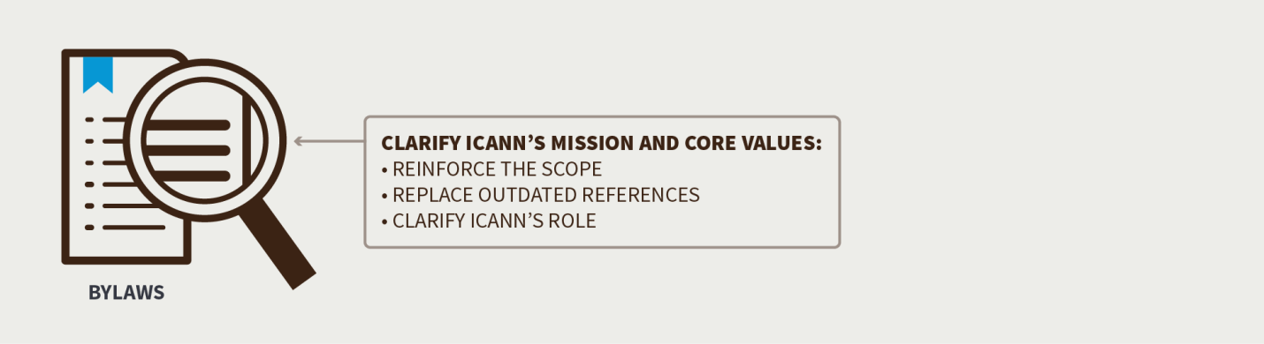
The CCWG-Accountability recommends clarifying ICANN’s Mission and Core Values to:
- Reinforce the scope of ICANN’s organizational activities related to the Domain Name System (DNS)
- ICANN is not to regulate services that use the Internet’s unique identifiers, or the content that such services carry or provide.
- ICANN is to have the ability to enforce agreements with contracted parties (entities that have signed agreements with ICANN in relation to top level domain names)
- Replace out-dated references to ICANN’s role in the assignment and allocation of Internet Protocol (IP) addresses and Autonomous System (AS) numbers with a description of ICANN’s role today
- ICANN assigns and allocates IP addresses and AS numbers at the top level
- Replace out-dated references to ICANN’s role in the assignment and allocation of port numbers with a description of ICANN’s role today
- ICANN collaborates with other bodies to publish core registries needed for the functioning of the Internet
- Clarify ICANN’s roles in policymaking related to the areas of domain names, the DNS root server system, IP addresses and AS numbers, and protocol port and parameter numbers

Reinforcing Adherence to Human Rights Protocols
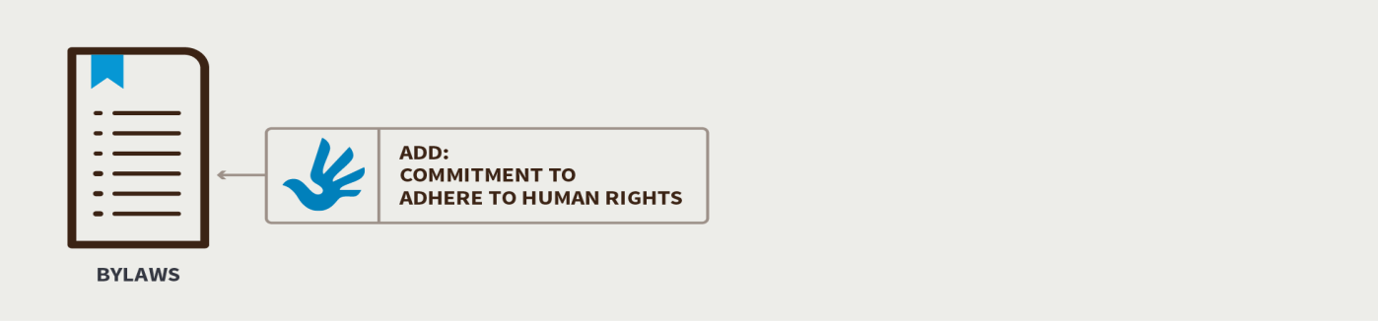
The CCWG-Accountability sought legal advice about whether, upon the termination of the IANA Functions Contract between ICANN and the NTIA, ICANN’s specific Human Rights obligations could be called into question.
Legal experts found that, upon termination of the Contract, there would be no significant impact on ICANN’s obligations on Human Rights. However, the CCWG-Accountability acknowledged the community’s concerns about this. In the ‘CCWG-Accountability Draft 2 Proposal on Work Stream 1 Recommendations’, it proposed two possible solutions for adding Human Rights into ICANN’s Bylaws (Draft 2, paragraph 148).

Draft Bylaw on Human Rights
Responding to public comments received on Second Draft Proposal that expressed concerns about potentially expanding ICANN’s Mission and the risk of appearing to prioritize some Human Rights over others, the CCWG-Accountability presents the following proposed draft Bylaw for consideration:
“Within its mission and in its operations, ICANN will respect internationally recognized human rights. This commitment does not in any way create an obligation for ICANN, or any entity having a relationship with ICANN, to protect or enforce human rights beyond what may be required by applicable law. In particular, this does not create any additional obligation for ICANN to respond to or consider any complaint, request or demand seeking the enforcement of human rights by ICANN.”

Operationalizing the Commitment to Human Rights
The CCWG-Accountability has identified several activities that it recommends be undertaken as part of Work Stream 2 that will fully operationalize ICANN’s commitment to Human Rights. Work Stream 2 focuses on accountability topics for which a timeline for developing solutions and full implementation may extend beyond the IANA Stewardship Transition.
To ensure that these Work Stream 2 activities are implemented, the CCWG-Accountability recommends that a language will be added to the Bylaws be adopted as part of Work Stream 1[Makes no sense].. The new Bylaw, which will only be needed for a transitional phase, will state that the proposed draft Human Rights Bylaw is to be implemented in accordance with the Framework of Interpretation, which will be developed as part of Work Stream 2. The CCWG-Accountability states that the group that will work on developing the Framework of Interpretation must be established as soon as possible so that the framework can be published no later than one year after the Bylaw is adopted.
The Human Rights-related activities to be addressed in Work Stream 2 are:
- Development of a Framework of Interpretation for the Bylaw
- Consider which specific Human Rights conventions or other instruments should be used by ICANN in interpreting and implementing the Bylaw
- Consider the policies and frameworks, if any, that ICANN needs to develop or enhance in order to fulfil its commitment to Human Rights
- Consistent with ICANN’s existing processes and protocols, consider how these new frameworks should be discussed and drafted to ensure broad multistakeholder involvement in the process
- Consider what effect, if any, this Bylaw will have on ICANN’s consideration of advice given by the Governmental Advisory Committee (GAC)
- Consider how, if at all, this Bylaw will affect how ICANN’s operations are carried out
- Consider how the interpretation and implementation of this Bylaw will interact with existing and future ICANN policies and procedures

The Independent Review Process (IRP)
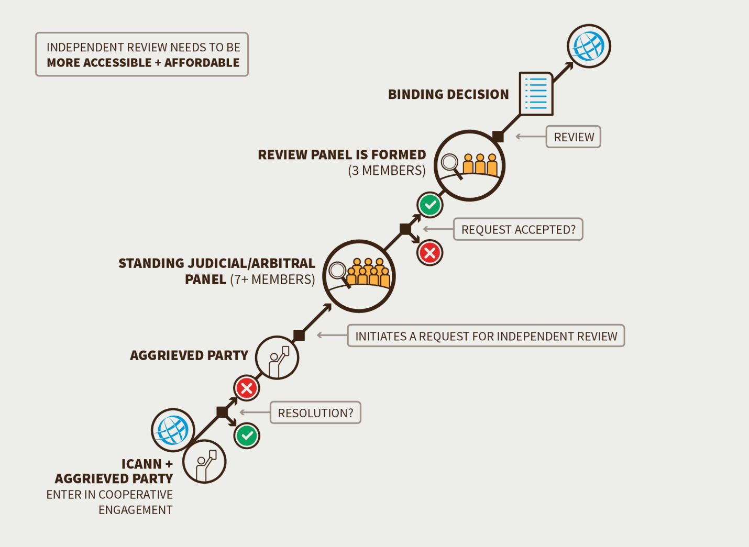
The overall purpose of the Independent Review Process (IRP) is to ensure that ICANN does not exceed the scope of its limited technical mission and complies with both its Articles of Incorporation and Bylaws. The CCWG-Accountability recommends that the existing Independent Review Process be modified to:
- Have a standing judicial/arbitral panel: tasked with reviewing and acting on complaints lodged by individuals, entities, and/or the community who have been materially harmed by ICANN’s action or inaction in violation of the Articles of Incorporation and/or Bylaws
- Be more accessible: Community complainants for example, should be able to use the process on a pro-bono basis [Don’t understand what is meant by pro-bono basis. This is a wrong use of the term. If you mean on a “no cost “ basis isn’t that dealt with in the next bullet below? Do you instead mean "pro se," which is without the assistance of legal counsel?]
- Be more affordable: It is recommended that ICANN cover the administrative costs and panellist fees, while each party covers their own legal fees
- Result in a declaration that an action/failure to act complied or did not comply with ICANN’s Articles of Incorporation and/or Bylaws: To the extent permitted by law, the Independent Review Process decisions would be binding on ICANN. The powers of the Independent Review Process are strictly limited to confirming or rejecting ICANN’s decisions; it has no mandate to enforce specific outcomes on these decisions.
The CCWG-Accountability’s enhancements to the Independent Review Process ensure that the Independent Review Process will not be empowered to circumvent the bottom-up, multistakeholder-driven nature of ICANN’s processes. The powers of the Independent Review Process are strictly limited to confirming or rejecting ICANN’s decisions; it has no mandate to enforce specific outcomes on these decisions.

Request for Reconsideration (RFR)
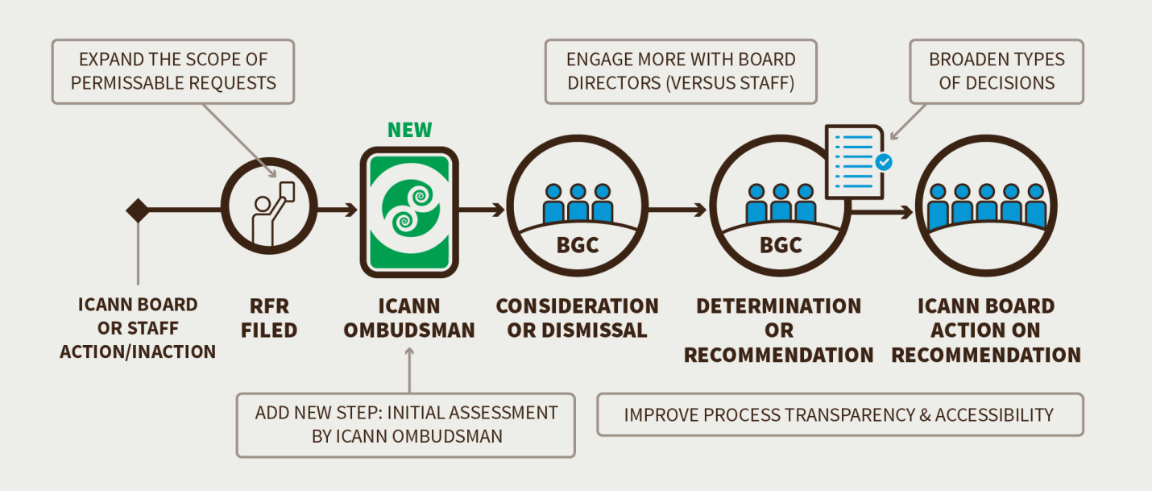
ICANN’s current Request for Reconsideration (RFR) process is a prominent feature of its appeals mechanisms. The RFR is an internal process to ICANN overseen by the Board Governance committee where decisions by the Board which affect a party can be appealed. If the request is found to have merit the BGC could recommend that the Board review its decision. The CCWG-Accountability proposes a number of key reforms to ICANN’s Request for Reconsideration process to increase its effectiveness, whereby the ICANN Board of Directors is obliged to reconsider a recent decision, action or inaction by ICANN’s Board or staff.
The CCWG-Accountability recommends the following enhancements to the current Request for Reconsideration Process:
- Expanding the scope of permissible requests to include actions or inactions by Board or ICANN staff that contradict established policy, ICANN’s Mission, Commitments, or Core Values
- Extending the timeframe for filing a Request for Reconsideration from 15 days to 30 days
- Focusing on having the ICANN Ombudsman performing the initial assessments of Reconsideration Requests in relation to ICANN’s Legal Department.
- Broadening the types of decisions, and providing more transparency in the dismissal process while also providing the Board with reasonable right to dismiss frivolous requests
- Engaging more with the Board Directors instead of with ICANN staff.
- GeneralProviding general transparency enhancements to the Request for Reconsideration request evaluations, Board discussions and rationales for dismissal

Incorporating the Affirmation of Commitments Reviews in ICANN’s Bylaws
The CCWG-Accountability recommends incorporating the reviews specified in the Affirmation of Commitments, a 2009 bilateral agreement between ICANN and the NTIA, in ICANN’s Bylaws. This will ensure that Community Reviews remain a central aspect of ICANN’s accountability and transparency framework.

Proposed sections of the Affirmation of Commitments to be added to the Bylaws
Section 3: Affirmation of Commitments Excerpt: This document affirms key commitments by DOC and ICANN, including commitments to: (a) ensure that decisions made related to the global technical coordination of the DNS are made in the public interest and are accountable and transparent; (b) preserve the security, stability and resiliency of the DNS; (c) promote competition, consumer trust, and consumer choice in the DNS marketplace; and (d) facilitate international participation in DNS technical coordination.
Section 4: Affirmation of Commitments Excerpt: DOC affirms its commitment to a multi-stakeholder, private sector led, bottom-up policy development model for DNS technical coordination that acts for the benefit of global Internet users. A private coordinating process, the outcomes of which reflect the public interest, is best able to flexibly meet the changing needs of the Internet and of Internet users. ICANN and DOC recognize that there is a group of participants that engage in ICANN’s processes to a greater extent than Internet users generally. To ensure that its decisions are in the public interest, and not just the interests of a particular set of stakeholders, ICANN commits to perform and publish analyses of the positive and negative effects of its decisions on the public, including any financial impact on the public, and the positive or negative impact (if any) on the systemic security, stability and resiliency of the DNS.
Section 7: Affirmation of Commitments Excerpt: ICANN commits to adhere to transparent and accountable budgeting processes, fact-based policy development, cross-community deliberations, and responsive consultation procedures that provide detailed explanations of the basis for decisions, including how comments have influenced the development of policy consideration, and to publish each year an annual report that sets out ICANN’s progress against ICANN’s bylaws, responsibilities, and strategic and operating plans. In addition, ICANN commits to provide a thorough and reasoned explanation of decisions taken, the rationale thereof and the sources of data and information on which ICANN relied.
Section 8: Affirmation of Commitments Excerpt: ICANN affirms its commitments to: (a) maintain the capacity and ability to coordinate the Internet DNS at the overall level and to work for the maintenance of a single, interoperable Internet; (b) remain a not for profit corporation, headquartered in the United States of America with offices around the world to meet the needs of a global community; and (c) to operate as a multi-stakeholder, private sector led organization with input from the public, for whose benefit ICANN shall in all events act. ICANN is a private organization and nothing in this Affirmation should be construed as control by any one entity.

Adding these sections into the Bylaws will ensure that key Commitments and Reviews remain in tact. The reviews that are included are:
- The Accountability & Transparency Review
- The Security, Stability and Resiliency of the DNS Review
- The Competition, Consumer Trust, and Consumer Choice Review
- The WHOIS Policy Review
In addition to these Reviews, which are specified in the Affirmation of Commitments, the CCWG-Accountability also recommends adding an IANA Functions Review and Special IANA Functions Review to the Bylaws. This is to comply with the requirements set forward in the IANA Stewardship Transition proposal.
The CCWG-Accountability recommends that after the proposed changes to ICANN’s Bylaws have been made:
- The Affirmation of Commitments is terminated by ICANN and the NTIA. Care should be taken when terminating the Affirmation of Commitments to not disrupt any Affirmation of Commitments Reviews that may currently be in process at that time.
- The Review specified in the Bylaws are applied immediately. Any in-progress reviews will adopt the new rules to the extent practical.

Accountability of Supporting Organizations and Advisory Committees
ICANN Supporting Organizations and Advisory Committees constitute a key component of the ICANN ecosystem. The CCWG-Accountability recommends that a review of Supporting Organizations’ and Advisory Committees’ accountability mechanisms be included as part of these entities’ existing periodic Structural Reviews of (see article IV, section IV of ICANN’s Bylaws).
Structural Reviews are intended to review the performance and operation of ICANN Supporting Organizations and Advisory Committees. The CCWG-Accountability expects Structural Reviews to be added as part of Work Stream 1.

Concerns
During the Public Comment Period on the ‘CCWG-Accountability Draft 2 Proposal on Work Stream 1 Recommendations’, the community presented several concerns and suggestions on how the accountability of the Supporting Organizations and Advisory Committees could be enhanced. As the focus of Work Stream 1 recommendations is to ensure that the accountability enhancements necessary for the IANA Stewardship Transition to occur are in place, the CCWG-Accountability will discuss other aspects of this topic as part of Work Stream 2.

Ensuring Community Accountability Powers Through Stress Testing
The CCWG-Accountability Charter calls for stress testing to assess the adequacy of existing and proposed accountability mechanisms available to the ICANN community, in the face of plausible and problematic scenarios that could confront the organization. A total of 37 stress tests are developed in this proposal, addressing financial crises, legal challenges, failure to meet operational expectations, and failure of ICANN to follow its commitments and bylaws.
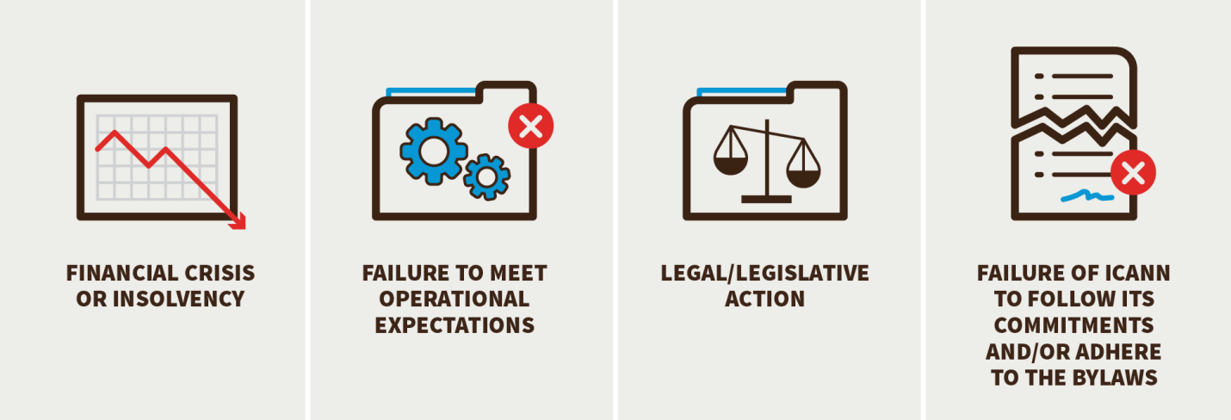
The stress tests addressed the following areas:
- Financial crisis or insolvency
- Failure to meet operational expectations
- Legal/legislative action
- Failure of ICANN to follow its commitments and/or adhere to the Bylaws
Some of the stress tests called for Bylaw changes to enhance the accountability of ICANN to the community it serves. One change suggested by the stress tests is to make parts of the Affirmation of Commitments part of the ICANN’s Bylaws, since ICANN could decide to terminate the Affirmation of Commitments upon the termination of the IANA Functions Contract between ICANN and the NTIA.
Another stress test identified the need to qualify ICANN’s obligation to seek a mutually agreeable solution when rejecting advice from an Advisory Committee. This resulted in a proposed Bylaws change that would ensure that the obligation to seek a mutually agreeable solution only applied for advice that was supported by consensus of the Advisory Committee. This would avoid requiring ICANN to arbitrate between Advisory Committee members with differing views.
The stress test to assess accountability mechanisms (Stress Test 18) looks at how ICANN receives and reacts to advice from the Government Advisory Committee (GAC). ICANN receives advice from its Advisory Committees. With regards to advice from the Governmental Advisory Committee, the ICANN Board is required by current ICANN Bylaws to seek “a mutually acceptable solution” if it chooses not to follow that advice, even if that advice does not have consensus and is opposed by a significant minority of the membership of the Government Advisory Committee. In the case of non-consensus advice, the community would find it difficult to hold the ICANN Board accountable for its actions if it was obliged to seek a negotiated solution with the Governmental Advisory Committee. As a result, the CCWG-Accountability sought a way to provide the ICANN Board with guidance on how it should handle such non-consensus advice.

Committing to Work Stream 2
The CCWG-Accountability Work Stream 2 is focused on addressing those accountability topics for which a timeline for developing solutions may extend beyond the IANA Stewardship Transition.
The community raised concerns that, post-Transition, there may be a lack of incentive for ICANN to implement the proposals arising out of Work Stream 2. To bridge this gap, the CCWG-Accountability recommends that the ICANN Board adopt a transitional Bylaw that would commit ICANN to implementing the CCWG-Accountability Work Stream 2 recommendations.
Further, the CCWG-Accountability proposes that Work Stream 2 is tasked with creating further enhancements to ICANN’s accountability mechanisms and processes, including:
- Enhancing the accountability of ICANN’s Supporting Organizations and Advisory Committees
- Considering improvements to ICANN’s standards for diversity
- Considering a process to review the jurisdiction of ICANN’s head office
- Improving ICANN’s Whistleblower Policy
- Reviewing and updating ICANN’s Documentary Information Disclosure policies
- Enhancing the transparency of ICANN’s interactions with governments
- Developing a framework of interpretation for the proposed Human Rights Bylaw
The CCWG-Accountability expects to begin refining the scope of Work Stream 2 during the upcoming ICANN 55 Meeting taking place in March 2016.

Conclusion
The CCWG-Accountability believes that the set of accountability mechanisms it has proposed, some of which are outlined above, empowers the community through the use of the bottom-up, multistakeholder model by relying on each of the stakeholders within ICANN’s existing and tested community structures. Furthermore, the CCWG-Accountability believes that this community-driven model is the best candidateappropriate for replacing the historical relationship with the U.S. Government.

Community Powers Are An Effective Replacement of the Safety Net Provided by the U.S Government’s Current IANA Stewardship Role
The CCWG-Accountability believes that the five Community Powers, as a package, can effectively replace the safety net that the U.S. Government has provided to date as part of its oversight role. [Need to add something re appointment power and IANA Separation Review powers.] It is recommended that these powers need to be enforced by a court of law only as a last resort. The CCWG-Accountability has based its recommendations on existing structures and recommends:
- Considering the entire community as ICANN’s Sole Designator
- Ensuring no part of the community has more rights than another part, either by having the ability to push through its individual interests or by blocking community consensus. The CCWG-Accountability has ensured that no Community Powers or statutory rights can be exercised singlehandedly
- Ensuring the community can only jointly exercise its powers using a consensus-based model

Summary report:
Litéra® Change-Pro TDC 7.5.0.166 Document comparison done on 11/10/2015 6:20:15 PM
Style name: Sidley Default
Intelligent Table Comparison: Active
Original DMS: iw://SIDLEYDMS/ACTIVE/210875395/1
Description: Summary of the Work and Recommendations of the Cross Community Working Group on Enhancing ICANN Accountability-0 8ToCCWG
Modified DMS: iw://SIDLEYDMS/ACTIVE/210875395/3
Description: Sidley Comments on Summary of the Work and Recommendations of the Cross Community Working Group on Enhancing ICANN Accountability-0 8ToCCWG
Changes:
Add | 201
Delete | 148
Move From | 32
Move To | 32
Table Insert | 0
Table Delete | 0
Table moves to | 0
Table moves from | 0
Embedded Graphics (Visio, ChemDraw, Images etc.) | 0
Embedded Excel | 0
Format changes | 0
Total Changes: | 413

1 Work Stream 1: Focused on mechanisms enhancing ICANN accountability that must be in place or committed to within the time frame of the IANA Stewardship Transition.

