Change list for this version:
- changed the name of the Recommendation (Oked in chat)
- Changed the name of the power (Power to approve changes to Fundamental bylaws and Articles of Incorporation)
- Added a section for Articles of Incorporation
- Redid the Jurisdiction of incorporation section (was unclear to me)
- Re-ordered the presentation of the recommendations in section 3 to match the numbering of recommendations we use overall.
- Added approval of changes to Articles of Incorporation where it was missing.
- Added the actual recommendations as to what should be a fundamental Bylaw in Section 2 (in the right order)
- Added the Special IANA Function Review.
- Added the escalation and enforcement process as a Fundamental Bylaw - need confirmation for this.
- Redid section 4 Changes from Second Draft - now Changes from Third Draft.

Annex 03 – Recommendation #3: Standard Bylaws, Fundamental Bylaws and Articles of Incorporation

1. Summary
- Currently, the Internet Corporation for Assigned Names and Numbers (ICANN) only has one class of Bylaws.
  - All ICANN Bylaws can be changed by a 2/3 vote of the ICANN Board.
  - The Board is not required to consult the ICANN community or the wider public before changing these, but has voluntarily done so up to this point.
- The CCWG-Accountability recommends splitting the ICANN Bylaws into “Fundamental Bylaws” and “Standard Bylaws” where Fundamental Bylaws will be more difficult to change.
- Specifically, the CCWG-Accountability recommends that:
  - Public consultations be required on all changes to ICANN Bylaws, both Fundamental and Standard.
  - The requirement for public consultations is added to the ICANN Bylaws as a Fundamental Bylaw to ensure that ICANN must continue to engage with the community in the future.
  - Any changes to Fundamental Bylaws require approval from both the ICANN Board and community as outlined in the respective Community Power (see Recommendation #4: Ensuring Community Involvement in ICANN Decision-making: Eight New Community Powers).
  - The threshold for ICANN Board approval for changing a Fundamental Bylaw is raised from 2/3 to 3/4.
  - Approval for changes to the Articles of Incorporation use the same process for approving changes to Fundamental Bylaws including public consultations.
- Why is the CCWG-Accountability recommending this?
  - The CCWG-Accountability felt that it was crucial to ensure that ICANN Bylaws that embody the purpose of the organization (Mission, Commitments, and Core Values) and are meant to ensure the accountability of the ICANN Board cannot be changed by the ICANN Board acting alone.

2. CCWG-Accountability Recommendations
- The CCWG-Accountability recommends:
- Splitting the ICANN Bylaws into Fundamental Bylaws and Standard Bylaws.
- The following CWG-Stewardship and CCWG-Accountability Recommendations be made Fundamental Bylaws:
  - The Community Mechanism as the Sole Designator Model including the right of inspection granted Decisional Participants in the Empowered Community as described in Recommendation 1.
  - The escalation and enforcement mechanisms as described in Recommendation 2.
  - The process for amending Fundamental Bylaws and/or Articles of Incorporation as described in Recommendation 3.
  - The eight Community Powers as described in Recommendation 4.
  - The Mission, Commitments, and Core Values as described in Recommendation 5.
  - The framework for the Independent Review Process (IRP) as described in Recommendation 7.
  - The IANA Function Review, Special IANA Function Review and the Separation Process required by the CWG-Stewardship’s Proposal with regards to IANA’s domain name management function.
  - The PTI Governance and Customer Standing Committee (CSC) structures, also required by the CWG-Stewardship’s Proposal.

- Requiring ICANN to conduct public consultations on any proposed changes to Standard Bylaws, Fundamental Bylaws or the Articles of Incorporation.
- Requiring approval for any changes to Fundamental Bylaws and the Articles of Incorporation from both the ICANN Board and the Empowered Community as outlined in the Community Power (see Recommendation #4: Ensuring Community Involvement in ICANN Decision-making: Eight New Community Powers).

- Raising the threshold for ICANN Board approval for changing a Fundamental Bylaw or the Articles of Incorporation from 2/3 to 3/4.

3. Detailed Explanation of Recommendations
- What is a Fundamental Bylaw?
- ICANN Bylaws describe how power is exercised in ICANN, including setting out the organization’s Mission, Commitments, and Core Values. Together with the Articles of Incorporation, the Bylaws are an essential part of ICANN because they set the scope of the organization’s corporate authority, determine its governance framework, and define working practices.
- Today, ICANN Bylaws can be changed by a resolution of the Board upon a 2/3 majority vote. The CCWG-Accountability believes that the set of key Bylaws fundamental to ICANN’s stability and operational continuity and essential for the community’s decisions-rights should be given additional protection from changes by requiring community approval of any amendments. These key Bylaws will be identified as Fundamental Bylaws.
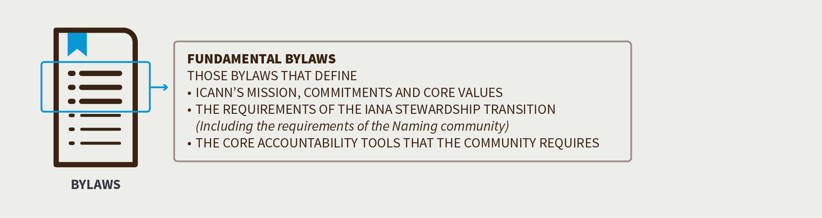

- As such, the CCWG-Accountability proposes to make Fundamental Bylaws harder to change than Standard Bylaws in two ways:
- By sharing the authority to authorize changes between the ICANN Board and the ICANN community (organized through its Supporting Organizations (SOs) and Advisory Committees (ACs) in the Empowered Community outlined in Recommendation #1: Establishing an Empowered Community for Enforcing Community Powers).
- By requiring a higher threshold to authorize changes to Fundamental Bylaws than for Standard Bylaws.
- The establishment of Fundamental Bylaws would indirectly enhance ICANN’s accountability to the global Internet community by sharing the authority of decision-making more widely and increasing the difficulty of amending these key aspects of ICANN.
- This recommendation is important in the context of the IANA Stewardship Transition because the historic contractual relationship with the U.S. Government provided assurance to the community that the fundamental nature of ICANN was unlikely to be changed without widespread agreement. Without that relationship in place, procedural protections and more widely shared decision-rights on core components of ICANN’s scope and authority should help maintain the community’s confidence in ICANN.

- Establishing Fundamental Bylaws
- To implement the establishment of Fundamental Bylaws, a new provision would be added to the Bylaws that sets out:
- Which sections of the Bylaws are Fundamental Bylaws (i.e., a list of the fundamental articles/sections/subsections).
- How new Fundamental Bylaws can be defined and how existing Fundamental Bylaws can be amended or removed.

- Adding New or Amending Existing Fundamental Bylaws
- While the CCWG-Accountability recommends fortifying certain aspects of the ICANN Bylaws, the global public interest would not be served if ICANN could not evolve in response to the changing Internet environment. Therefore, the CCWG-Accountability recognizes the importance of the ability to define new Fundamental Bylaws over time, or to amend or remove existing ones.
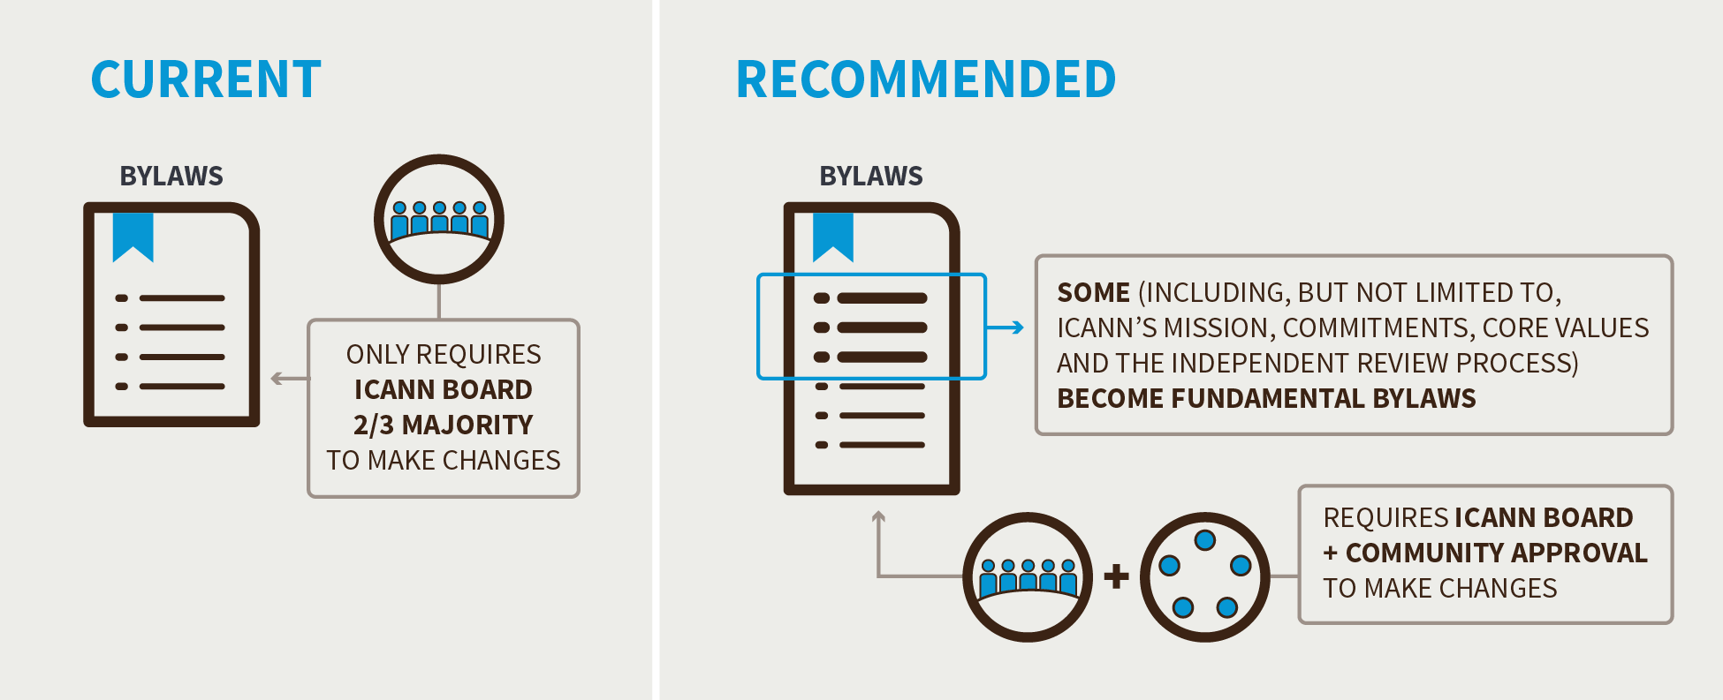

- The following steps would be required to establish a new Fundamental Bylaw or to amend or remove an existing one, where the ICANN Board (or the staff through the ICANN Board) is proposing the addition, amendment or removal:
- The Board proposes a new Fundamental Bylaw, amendment of a Fundamental Bylaw, or removal of a Fundamental Bylaw.
- The Board approves the addition, amendment, or removal of the Fundamental Bylaw with a 3/4 vote of all standing Directors.
- The community approves the addition, amendment, or removal of the Fundamental Bylaw by using its power as an Empowered Community to approve the change (see Recommendation #4: Ensuring Community Involvement in ICANN Decision-making: Eight New Community Powers).

- If the addition, amendment, or removal of the Fundamental Bylaw is agreed upon by both the ICANN Board and the community:
- The new/revised Fundamental Bylaw would be inserted in the Bylaws, and an appropriate reference to the text as a Fundamental Bylaw would be added (if needed) to the part of the Bylaws that lists them.
- In the case of an amendment to existing Bylaws text, the text would be updated.
- In the case of a removal, the text would be removed.

- The CCWG-Accountability does not propose that the community gain the power to directly propose changes to the Bylaws.

- Which of the Current Bylaws Would Become Fundamental Bylaws?
- The CCWG-Accountability suggests that only critical aspects of the ICANN Bylaws be defined in the Fundamental Bylaws to avoid introducing unnecessary rigidity into ICANN’s structures. The CCWG-Accountability concluded that suggesting that all changes to ICANN Bylaws should face the same thresholds that are proposed for Fundamental Bylaws would harm, not help, ICANN’s overall accountability.
- The CCWG-Accountability views “critical aspects” as those that define ICANN’s Mission, Commitments, and Core Values, the requirements of the IANA Stewardship Transition, and the core accountability tools the community requires.
- Accordingly, the CCWG-Accountability recommends that the following aspects be made Fundamental Bylaws as a part of Work Stream 1:
- The Community Mechanism as the Sole Designator Model including the right of inspection is granted to Decisional Participants as described in Recommendation 1.
- The escalation and enforcement mechanisms as described in Recommendation 2.
- The process for amending Fundamental Bylaws and/or Articles of Incorporation as described in Recommendation 3.
- The eight Community Powers as described in Recommendation 4.
- The Mission, Commitments, and Core Values as described in Recommendation 5.
- The framework for the Independent Review Process as described in Recommendation 7.

- The IANA Function Review, Special IANA Function Review and the Separation Process required by the CWG-Stewardship’s Proposal with regards to IANA’s domain name management function.
- The PTI Governance and Customer Standing Committee (CSC) structures, also required by the CWG-Stewardship’s Proposal.

- Articles of Incorporation

- The CCWG-Accountability legal counsel has advised the following when considering changes to the ICANN Articles of Incorporation:
“The constituent documents of a California nonprofit public benefit corporation such as ICANN are its Articles of Incorporation and its Bylaws. There is a hierarchy between these documents—the articles prevail to the extent that there is any conflict between the Articles and the Bylaws. This hierarchical relationship holds even if the conflict is between the Articles and a “fundamental” Bylaw that requires the consent of a third party (in the case of ICANN, the Empowered Community) to be amended.
Under California nonprofit corporation law, if a corporation has no statutory members, amendments to the articles may be adopted by the board. However, the amendment of articles may be made subject to the consent of a third party, just as the amendment of bylaws may be. In the case of ICANN, if the Empowered Community is not provided a right to approve amendments to the Articles, there is a risk that Fundamental Bylaw provisions could be undermined by amendment of the Articles by the ICANN Board, given the hierarchical relationship described above. Thus, we recommend including an approval right with respect to amendments to ICANN’s Articles in favor of the Empowered Community in the same way the Empowered Community has approval rights with respect to Fundamental Bylaws.”

- As such the CCWG-Accountability is recommending that changes to the ICANN Articles of Incorporation follow the same approval process and thresholds described above for approving changes to Fundamental Bylaws.
- It is important to note
- ICANN’s current Articles of Incorporation state that:
“9. These Articles may be amended by the affirmative vote of at least two-thirds of the directors of the Corporation. When the Corporation has members, any such amendment must be ratified by a two-thirds (2/3) majority of the members voting on any proposed amendment.”
- The CCWG-Accountability therefore recommends that the Articles of Incorporation be modified to remove the notion of members and reflect the need for an affirmative vote of at least three quarters of the Directors, as well as ratification by the Empowered Community using the same approval process and thresholds as for approving changes to Fundamental Bylaws.

- Does the location of ICANN’s headquarters (jurisdiction of incorporation) need to be a fundamental Bylaw?
- The issue of the location of ICANN’s headquarters is currently addressed in several ways:
- ICANN’s present Articles of Incorporation state:
“3. This Corporation is a nonprofit public benefit corporation and is not organized for the private gain of any person. It is organized under the California Nonprofit Public Benefit Corporation Law for charitable and public purposes."

- ICANN’s present Bylaws Article XVIII Section 1 state:
“OFFICES. The principal office for the transaction of the business of ICANN shall be in the County of Los Angeles, State of California, United States of America. ICANN may also have an additional office or offices within or outside the United States of America as it may from time to time establish.”

- The Affirmation of Commitments paragraph 8(b) states:
“ICANN affirms its commitments to: (b) remain a not for profit corporation, headquartered in the United States of America with offices around the world to meet the needs of a global community…”

- Replacing the AOC commitment, given the AOC should terminate with the NTIA oversight responsibilities, would not seem to be a requirement given the jurisdiction of incorporation is covered in the Articles of Incorporation and the Bylaws.
- As to the priority between these two statements the previous section is rather clear on this “There is a hierarchy between these documents—the articles prevail to the extent that there is any conflict between the articles and the bylaws. “. As such even if the Bylaw regarding jurisdiction of incorporation were to be changed the Articles of Incorporation would still prevail.
- Additionally, as recommended by the CCWG-Accountability in the above section, the Articles of Incorporation would require that approval of any changes to these use the same process and thresholds required for approving changes to Fundamental Bylaws.
- As such there is no clear need to create a Fundamental Bylaw regarding the jurisdiction of incorporation given this is present in the Articles of Incorporation and that changing these has the same requirements as changing Fundamental Bylaws.

- Community Power: Approve Changes to Fundamental Bylaws and the Articles of Incorporation
- Establishing Fundamental Bylaws would ensure that critical aspects of the powers and processes required to maintain ICANN’s accountability to the community, and the organization’s Mission, Commitments, and Core Values, can only be changed as a result of broad consensus of both the ICANN Board and the community.
- Through the Empowered Community, SOs and ACs would have to give positive assent to any change proposed by the ICANN Board before the change was finalized, as part of a joint decision process between the ICANN Board and the community. By creating this special joint decision process, authority to change fundamental aspects of ICANN’s governing framework is shared more broadly than it is today.
- The CCWG-Accountability is working under the assumption that the Bylaws provisions that are recommended to become Fundamental Bylaws are not likely to change frequently. Where changes are made, they are unlikely to arise on short notice or will be needed to deal with short-term operational situations. The CCWG-Accountability therefore does not believe that this Community Power, as proposed, poses any challenges to ICANN’s ongoing operational viability, stability or efficiency.
- Such changes require a high degree of community assent, as the purpose of this power is to make changing Fundamental Bylaws or the Articles of Incorporation possible only with very wide support from the community.
- For further information about the other community powers recommended by the CCWG-Accountability, see Recommendation #4: Ensuring Community Involvement in ICANN Decision-making: Eight New Community Powers.

4. Changes from the “Third Draft Proposal on Work Stream 1 Recommendations”
- This is a list of key changes from the Second Draft Proposal, which affect this section:
- Clarified that IFR provisions apply only to IANA’s domain name management function (CWG-Stewardship requirement)
- Clarified process for change of Articles of Association to be similar to process for changes to Fundamental Bylaws.
- Added a specific recommendation that the current Articles of Incorporation be modified to remove the notion of members and reflect the need for an affirmative vote of at least three quarters of the Directors, as well as ratification by the Empowered Community.

5. Stress Tests Related to this Recommendation
- N/A

6. How does this meet the CWG-Stewardship Requirements?
- These recommendations meet the CWG-Stewardship requirement that the CCWG-Accountability recommend the creation of Fundamental Bylaws and that these include the following:
- ICANN Budget: Community rights regarding the development and consideration of the ICANN Budget.
- ICANN Board: Community rights regarding the ability to appoint/remove Directors of the ICANN Board, and recall the entire Board.
- ICANN Bylaws: Incorporation of the following into ICANN’s Bylaws: IANA Function Review, Customer Standing Committee, and the Separation Process.
- Independent Review Process: Should be made applicable to IANA Functions and accessible by Managers of top-level domains.

7. How does this address NTIA Criteria?
- Support and enhance the multistakeholder model.
- Ensuring the multistakeholder model accountability mechanisms cannot be modified without the Empowered Community’s approval.

- Maintain the security, stability, and resiliency of the Internet DNS.
- Establishing Fundamental Bylaws that provide additional protections to ICANN Bylaws that are critical to the organization’s stability and operational continuity.

- Meet the needs and expectation of the global customers and partners of the IANA services.
- N/A

- Maintain the openness of the Internet.
- N/A

- NTIA will not accept a proposal that replaces the NTIA role with a government-led or an inter-governmental organization solution.
- N/A

