Annex 04 – Details on Recommendation #4: Ensuring Community Involvement in ICANN Decision-making: Seven New Community Powers
2nd READING CONCLUSIONS on BUDGET :
- Confirmed clarifications requested by CWG regarding transparency, rationale and role of CWG-Stewardship in elaborating a process for IANA Budget (see pages 5 and 6)
- Updated paragraph 22 to reflect IAB input, with specific clarification regarding the need to protect SLAs (see page 6, paragraph 22)
- Guidelines on caretaker budget :
  - current principles in the document provide sufficient guidelines for implementation of the concept of caretaker budget, taking note of the work under way in DT-O within CWG.
  - As proposed by the Board, the CCWG-Accountability also recommends that the caretaker budget approach be embedded in the Fundamental Bylaws, including the responsibility of the CFO to establish the caretaker budget in accordance with the defined approach.
  - Align recommendation in paragraphs 13 and 19 to confirm that caretaker budget applies to Icann budget as well as IANA Budget.
- Budget community power provisions will remain as Fundamental Bylaws (as required by CWG)

Board comment :
The Board supports the revisions provided in the 1st reading document of the CCWG for this provision. The addition of language reflected in paragraph 21 addresses the Board's comments and concerns that any process through which a portion or the whole of the IANA budget is subject to rejection must include the voice of the operational communities served by the IANA functions. Additionally, the Board supports the inclusion of the process ensuring the stable and continuous delivery of the IANA Functions, and proper delivery of contractual service levels to the respective operational communities.
With regards to the caretaker budget (reference in paragraph 13) the Board wants to remind the CCWG of its comments on the ICANN Caretaker budget, and the recommendation that the whole of the caretaker budget approach is embedded in the Fundamental Bylaws, including the responsibility of the CFO to establish the caretaker budget in accordance with the defined approach. The board's proposal can be found on page 10, paragraph 1e of its comments. The language in the redline could be read as a commitment to only include caretaker budget considerations for the IANA budget. Copied here for convenience:
1) e. Board Proposal on ICANN Caretaker Budget

In the event that the process for community power to reject the Operating Plan and Budget is invoked, and after the preceding escalation mechanism (as described in Recommendation #2) has failed to resolve an issue, the rejection is triggered. While the rejection is in effect and being resolved, ICANN needs an operating plan and a budget so that it can continue to operate on a day-to-day basis. The notion of a caretaker Operating Plan and Budget has been defined to address this need. The caretaker budget is in substance a replacement Operating Plan and Budget designed to allow the organization to operate its basic and primary functions, while avoiding "non-indispensable" work during the period of the rejection is in effect. The conceptual definition of the caretaker budget has been formulated, but the more detailed definition of what is "indispensable" or not now must be further documented.
The Board accepts the above described approach to the veto process and corresponding caretaker Operating Plan and Budget. The Board also recommends that the caretaker budget approach be embedded in the Fundamental Bylaws, including the responsibility of the CFO to establish the caretaker budget in accordance with the defined approach. The Board's acceptance of this approach is also predicated on the consistency of the implemented solution with the conceptual definition described above.

1. Summary
- The CCWG-Accountability has recommended seven Community Powers that should be in place to improve accountability and ensure community engagement. These are:
  - Reject Budget or Strategic/Operating Plans.
  - Reject changes to ICANN “Standard Bylaws.”
  - Approve changes to “Fundamental Bylaws” and/or Articles of Incorporation.
  - Remove individual ICANN Board Directors.
  - Recall the entire ICANN Board.
  - Initiate a binding Independent Review Process (IRP) (where a panel decision is enforceable in any court recognizing international arbitration results).
  - Reject ICANN Board decisions relating to reviews of IANA Functions, including the triggering of Post-Transition IANA (PTI) separation.
- The powers and associated processes were designed to ensure that no stakeholder can singlehandedly exercise any power and that under no circumstances would any individual section of the community be able to block the use of a power.

2. CCWG-Accountability Recommendations
- The CCWG-Accountability recommends defining the following community powers as Fundamental Bylaws:
- Reject Budget or Strategic/Operating Plans.
- Reject changes to ICANN Standard Bylaws.
- Approve changes to Fundamental Bylaws and/or Articles of Incorporation.
- Remove individual ICANN Board Directors.
- Recall the entire ICANN Board.
- Initiate a binding IRP (where a panel decision is enforceable in any court recognizing international arbitration results).
- Reject ICANN Board decisions relating to reviews of IANA Functions, including the triggering of PTI separation.
- The CCWG-Accountability proposes that a Bylaw be added that states that if the entire ICANN Board is removed, an Interim Board will be established only as long as is required for the selection/election process for the Replacement Board to take place. Supporting Organizations (SOs), Advisory Committees (ACs), and the Nominating Committee will develop replacement processes that ensure the Interim Board will not be in place for more than 120 days. The Interim Board will have the same powers and duties as the Board it replaces. Having a Board in place at all times is critical to the operational continuity of ICANN and is a legal requirement.
- The ICANN Bylaws will state that, except in circumstances in which urgent decisions are needed to protect the security, stability, and resilience of the DNS, the Interim Board will consult with the community through the SO and AC leadership before making major decisions. Where relevant, the Interim Board will also consult through the ICANN Community Forum before taking any action that would mean a material change in ICANN’s strategy, policies, or management, including replacement of the serving President and CEO.
- Note: Details on what the powers do is presented in greater detail in the following section and the details of how these can be used can be found in Annex 2 – Details on Recommendation #2: Empowering the Community Through Consensus: Engagement, Escalation, Enforcement.
- The CCWG-Accountability proposes that there be an exception to rejecting Standard Bylaws in cases where the Standard Bylaw change is the result of a Policy Development Process. The exception would be as follows:
- Fundamental Bylaws would require that the ICANN Board not combine the approval of Bylaw changes that are the result of a Policy Development Process with any other Bylaw changes.
- Fundamental Bylaws would require the ICANN Board to clearly indicate if a Bylaw change is the result of a Policy Development Process when the Board approves it.
- Fundamental Bylaws dealing with rejection of a Bylaw change would require, if the Bylaws change is the result of a Policy Development Process, the SO that led the Policy Development Process to formally support holding a Community Forum and exercise the power to reject the Bylaw change. If the SO that led the Policy Development Process that requires the Bylaw change does not support holding a Community Forum or exercising the power to reject the Bylaw, then the Community Power to reject the Bylaw cannot be used.

3. Detailed Explanation of Recommendations
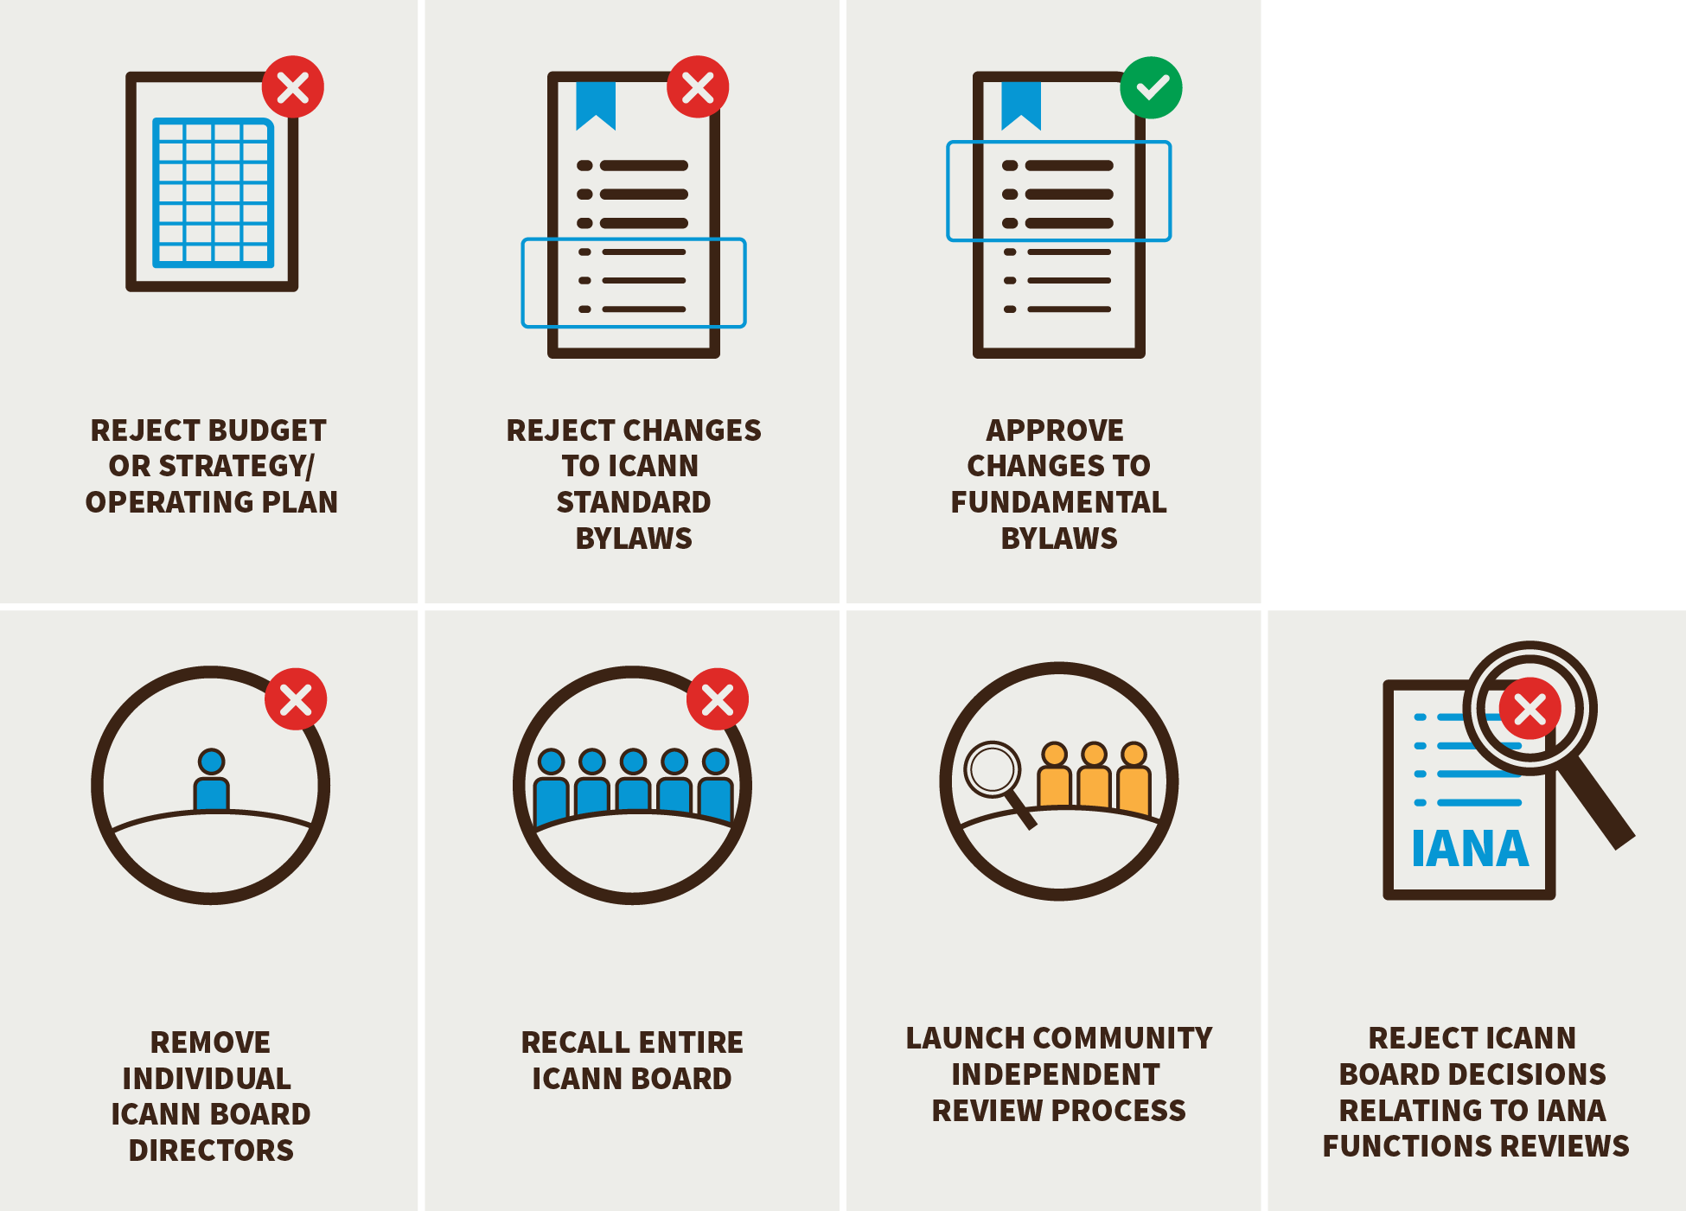
- The CCWG-Accountability has proposed a set of seven Community Powers designed to empower the community to hold ICANN accountable for the organization’s Principles (the Mission, Commitments, and Core Values). The proposed Community Powers are:

The Power to Reject ICANN’s Budget or Strategic/Operating Plans
The Power to Reject Changes to ICANN Standard Bylaws
The Power to Remove Individual ICANN Board Directors
The Power to Recall the Entire ICANN Board
The Power to Approve Changes to Fundamental Bylaws and/or Articles of Incorporation
The Power to Initiate a Binding IRP (Where a Panel Decision is Enforceable in any Court Recognizing International Arbitration Results)
The Power to Reject ICANN Board Decisions Relating to Reviews of IANA Functions, including the Triggering of PTI Separation

- It is important to note that the above powers, as well as the launch of a Separation Cross Community Working Group, (as required by the CWG-Stewardship dependencies), can be enforced by using the community IRP or the power to recall the entire Board.

- The Power to Reject ICANN’s Budget or Strategic/Operating Plans
- The right to set budgets and strategic direction is a critical governance power for any organization. By allocating resources and defining the goals to which these resources are directed, Strategic Plans, Operating Plans, and budgets have a significant impact on what ICANN does and how effectively it fulfills its role. The ICANN community already plays an active role in giving input into these key documents through participation in the existing consultation processes ICANN organizes.
- To provide additional accountability safeguards, the CCWG-Accountability has proposed that the community be given the power to reject:
- ICANN’s Five-Year Strategic Plan
- ICANN’s Five-Year Operating Plan
- ICANN’s Annual Operating Plan & Budget
- The IANA Functions Budget
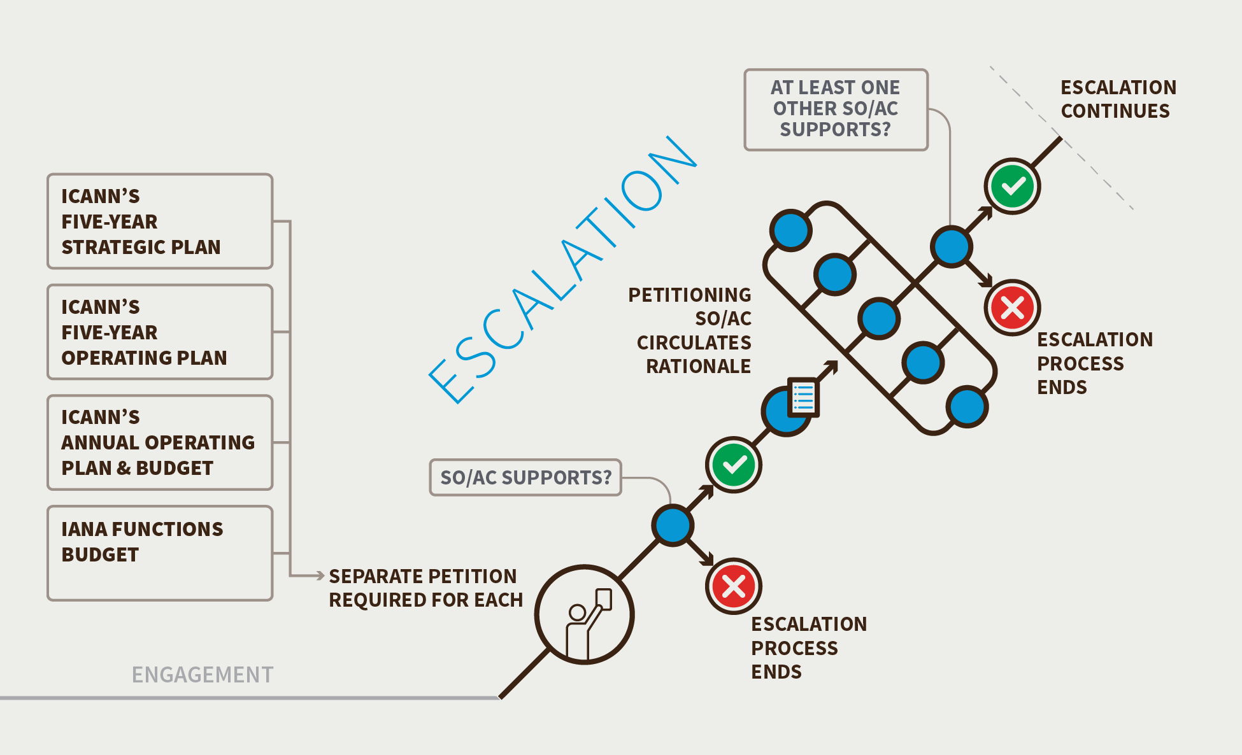

- The CCWG-Accountability has determined that a separate petition would be required for each budget or Strategic/Operating Plan being challenged. A budget or Strategic/Operating Plan could only be challenged if there are significant issue(s) brought up in the engagement process that were not addressed prior to approval.
- To reinforce the bottom-up, transparent and collaborative approach that ICANN currently uses to enable the community to give input into ICANN’s budget documents, the CCWG-Accountability recommends adding such a consultation process into the ICANN Bylaws for both the ICANN Budget and the IANA Functions Budget. The Bylaws must assure that sufficient budget detail is available, in a timely way, for the community to carefully consider Budget matters and provide informed and constructive input – and for this input to be thoroughly considered - prior to the Board making decisions on Budget matters.
- A community decision to reject a Budget or a plan after it has been approved by the ICANN Board will be based on perceived inconsistency with the purpose, Mission and role set out in ICANN’s Articles and Bylaws, the global public interest, the needs of ICANN stakeholders, financial stability or other matters of concern to the community. The rationale for any community veto should be Consensus based. The veto could only concern issues that had been raised in the consultations conducted before the Board approved the budget or plan.
- A SO or AC petitioning to reject a budget or Strategic/Operating Plan would be required to circulate a rationale and obtain support for its petition from at least one other SO or AC according to the escalation process.
- The escalation and enforcement processes for rejecting any Strategic/Operating Plan or Annual Budget would be the detailed process presented in Recommendation #2: Empowering the Community through Consensus: Engagement, Escalation, Enforcement.
- Should the power be used to reject the Annual Budget, a caretaker budget would be implemented. A caretaker budget is one that provides ongoing funding for crucial ICANN functions, while the issue/s that caused the use of the power are resolved. It will be based on current ICANN operations, according to rules developed in the implementation process (which will form a public and transparent “defined approach” to the caretaker budget. The CCWG-Accountability also recommends that the caretaker budget concept be embedded in the Fundamental Bylaws, including the responsibility of the CFO to establish the caretaker budget in accordance with the defined approach.

- The IANA Functions Budget
- Under this power, the community will be able to consider the IANA Functions Budget as a separate budget. The IANA Functions Budget is currently part of ICANN’s Annual Operating Plan & Budget.
- Under the CWG-Stewardship Final Proposal, an itemization of IANA costs as set forth in the IANA Budget would include “Direct Costs for the IANA department”, “Direct Costs for shared resources” and “Support functions allocation”. Furthermore, the CWG-Stewardship Final Proposal states that these costs should be itemized into more specific costs related to each specific function to the project level and below as needed. The IANA Budget requires protection as recommended by the CWG-Stewardship’s Final Proposal. The IANA Functions budget must be managed carefully and not decreased (without public input) regardless of the status of the other portions of the budget.
- The CCWG-Accountability recommends that there should be two distinct processes with respect to the community’s power to reject the IANA Budget and its power to reject the ICANN Budget, meeting the requirements set forward by the IANA Stewardship Transition Proposal. The use of the Community Power to reject the ICANN Budget would have no impact on the IANA Budget, and a rejection of the IANA Budget would have no impact on the ICANN Budget.

- The escalation and enforcement processes for rejecting an IANA Functions Budget would be the detailed process presented in Recommendation #2: Empowering the Community through Consensus: Engagement, Escalation, Enforcement.
Should the power be used to reject the annual IANA Functions Budget, a caretaker budget would be implemented (details regarding the caretaker budget are currently under development as noted above for the ICANN Budget). The CCWG-Accountability recommends that the caretaker budget approach be embedded in the Fundamental Bylaws, including the responsibility of the CFO to establish the caretaker budget in accordance with the defined approach.

- The CCWG-Accountability acknowledges that the CWG-Stewardship (or a successor implementation group) is required to develop a proposed process for the IANA Functions Operations-specific budget establishment and review. This process will be a key input for the implementation of this specific power.
- The CWG-Stewardship may wish to detail the planning process by which the IANA Budget is established as part of its implementation programme of work, including the level of detail required to be provided for community input and the timeframes for consultations and approvals. The CCWG-Accountability limits its requirements to those set out in this Recommendation.
- In implementation, any process through which a portion or the whole of the IANA Budget is subject to rejection should include the voice of the operational communities served by the IANA functions. The process must also be implemented in such a way as to ensure the stable and continuous delivery of the IANA Functions, and that ensures the proper delivery of contractual service levels to the respective operational communities.
- The Power to Reject Changes to ICANN Standard Bylaws
- In addition to the safeguard against the possibility that the ICANN Board could unilaterally amend Fundamental Bylaws without consulting the community, the CCWG-Accountability recommends that the community be given the power to reject changes to Standard ICANN Bylaws after the Board approves them, but before the changes go into effect. Any changes approved by the Board would take 15 days to go into effect to enable the community to decide whether a petition to reject the change should be initiated.
- This power, with respect to Standard Bylaws, is a rejection process that is used to tell the ICANN Board that the community does not support a Board-approved change. It does not enable the community to rewrite a Standard Bylaw change that has been proposed by the Board.
- It is important to note that the CCWG-Accountability has been careful to try not to change ICANN's core policy-making processes. The tools it has proposed to improve accountability are generally aimed at ICANN-wide issues, not policy development in the SOs. However, the power to reject a Standard Bylaw change could interfere with the implementation of a Policy Development Process that requires such a change. To ensure this power does not interfere with ICANN’s bottom-up Policy Development Processes, the CCWG-Accountability has added an exception to the Standard Bylaws rejection power to ensure that a Bylaw change that is the result of a Policy Development Process cannot be rejected after it is approved by the ICANN Board without the approval of the SO that led the Policy Development Process.
- The escalation and enforcement processes for this power are as presented in Recommendation #2: Empowering the Community through Consensus: Engagement, Escalation, Enforcement, with the following exception:
- The CCWG-Accountability proposes that there be an exception to rejecting Standard Bylaws in cases where the Standard Bylaw change is the result of a Policy Development Process. The exception would be as follows:
- Fundamental Bylaws would require that the ICANN Board not combine the approval of Bylaw changes that are the result of a Policy Development Process with any other Bylaw changes.
- Fundamental Bylaws would require the ICANN Board to clearly indicate if a Bylaw change is the result of a Policy Development Process when the Board approves it.
- Fundamental Bylaws dealing with rejection of a Bylaw change would require, if the Bylaws change is the result of a Policy Development Process, the SO that led the Policy Development Process to formally support holding a Community Forum and exercise the power to reject the Bylaw change. If the SO that led the Policy Development Process that requires the Bylaw change does not support holding a Community Forum or exercising the power to reject the Bylaw, then the community power to reject the Bylaw cannot be used.
- The Power to Approve Changes to Fundamental Bylaws and/or Articles of Incorporation
- To safeguard against the possibility that the ICANN Board could unilaterally amend Bylaws and/or Articles of Incorporation without consulting the community, the CCWG-Accountability determined that the community consultation process should be reinforced in Fundamental Bylaws. The proposed set of Fundamental Bylaws would be harder to change than the Standard Bylaws for two reasons:
- The authority to change Fundamental Bylaws and/or Articles of Incorporation would be shared between the ICANN Board and the ICANN community.
- The required threshold of support to change a Fundamental Bylaw would be significantly higher than the threshold to change a Standard Bylaw.

- The CCWG-Accountability emphasizes the importance for the ICANN Board and ICANN community to be able to define new Fundamental Bylaws and/or Articles of Incorporation over time, or to change or remove existing ones to ensure that ICANN can adapt to the changing Internet environment.
- The escalation process for this power is as follows:

- Step 1. The ICANN Board Publishes its Approval of a Change to the Fundamental Bylaws and/or Articles of Incorporation

- Step 2. Conference Call (21 Days to Organize and Hold from the Date the Decision is Made by the ICANN Board to Approve a Change to the Fundamental Bylaws and/or Articles of Incorporation)
- ICANN hosts a conference call open to any interested participants and will provide support services. Representatives of the ICANN Board are expected to attend and be prepared to address the issues raised

- Step 3. Decision to Hold a Community Forum (Seven Days from the End of the Conference Call)
- If three or more SOs or ACs support holding a Community Forum within the seven-day period, the Community Forum will be organized.
- If the proposal to hold a Community Forum does not obtain the required support during the seven-day period, the process goes directly to deciding to use the Community Power.

- Step 4. Holding a Community Forum (15 Days to Organize and Hold the Event from the Date of the Decision to Hold It)
- It is expected that this will only involve remote participation methods, such as teleconferences and Adobe Connect-type meetings over a period of one or two days at most. Unless the timing allows participants to meet at a regularly scheduled ICANN meeting, there is no expectation that participants will meet face to face. The Community Forum would be open to all interested participants and ICANN will provide support services, including the publishing of recordings and transcripts. Representatives of the ICANN Board are expected to attend and be prepared to address the issues raised.
- The purpose of the Community Forum is information-sharing (the rationale for the petition, etc.) and airing views on the petition by the community. Accordingly, any SO or AC may circulate in writing their preliminary views on the exercise of this Community Power.
- The Community Forum will not make decisions nor seek consensus. It will not decide whether to advance the petition to the decision stage. This decision is up to the SOs and/or ACs to determine after the Forum.
- The Community Forum should be managed/moderated in a fair and neutral manner.
- Should the relevant SOs or ACs determine a need for further deliberation, a second and third session of the Community Forum could be held.
- ICANN staff will collect and publish a public record of the Forum(s), including all written submissions.

- Step 5. Decision to use a Community Power as an Empowered Community (15 Days from the Conclusion of the Community Forum)
- If four or more SOs and/or ACs support and no more than one objects within the 15-day period, the Sole Designator will use its power to approve the change to the Fundamental Bylaws.
- If the required thresholds during the 15-day period are not met the escalation ends without the changes to the Fundamental Bylaws being approved.

- Step 6. Advising the ICANN Board (One Day)
- The Empowered Community will advise the Board of its decision.

- The Power to Remove Individual ICANN Board Directors

- The proposed power to Remove Individual ICANN Board Directors would allow for the removal of a Director before the Director’s current term comes to an end. This was a formal requirement from the CWG-Stewardship. Currently, the power to remove Individual Directors is only available to the Board itself as per the existing Bylaws.
- Given ICANN Board Directors can be nominated in two significantly different ways, specific SO or AC nomination or Nomination Committee nomination, the processes for removing each type of Director will be different.
- In cases where the nominating SO or AC perceives that there is a significant issue with its appointed Director, it can use the following escalation process to determine if removal of the Director is recommended. It is important to note that this process can only be used once during a Director’s term if the process reaches the step of holding a community forum or above and then fails to remove the Director.

- Directors Nominated by the Nominating Committee

- Step 1. Triggering Individual ICANN Board Director Removal by Community Petition (15 Days from the Official Posting of the Original Petition)

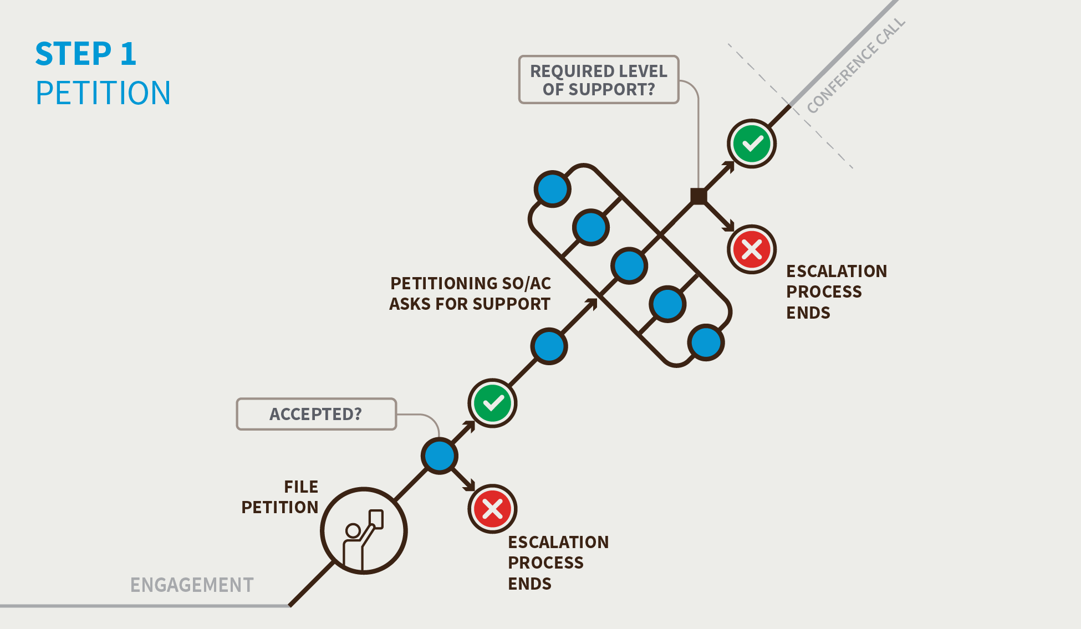

- Begin a petition in a SO or AC.
- Any individual can begin a petition as the first step to using a Community Power.
- For the petition to be accepted, the SO or AC, in accordance with its own mechanisms, must accept the petition.
- If the SO or AC does not approve the petition within 15 days, the escalation process terminates.
- If the SO or AC does approve the petition within the 15-day period, it proceeds to the next step.
- The SO or AC that approved the petition contacts the other SOs or ACs to ask them to support the petition so a conference call can be organized that will allow the entire community to discuss the issue. At least one additional SO and/or AC must support the petition (for a minimum of two) for a conference call to be organized.
- If a minimum of two SOs or ACs support the petition within 15 days, a conference call is organized.
- If the petition fails to gather the required level of support, the escalation process terminates.

- Step 2. Conference Call (Seven Days to Organize and Hold from the Date the Decision is Made to Hold the Call)
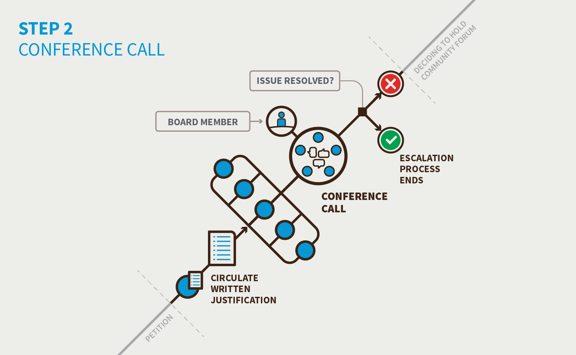
- The petitioning SOs and/or ACs circulate written justification for exercising the Community Power in preparation for the conference call. Any SO or AC may contribute preliminary thoughts or questions in writing before the call is held via a specific archived email list set up for this specific issue.
- ICANN hosts a conference call open to any interested participants and will provide support services. The ICANN Board Director that is the subject of the petition will be invited and is expected to attend and be prepared to address the issues raised.
- If the community and the ICANN Board Director can resolve the issue on the conference call, the escalation terminates.
- If the community and the ICANN Board Director cannot resolve the issue, the community must decide if it wishes to hold a Community Forum.

- Step 3. Decision to hold a Community Forum (Seven Days from the End of the Conference Call)
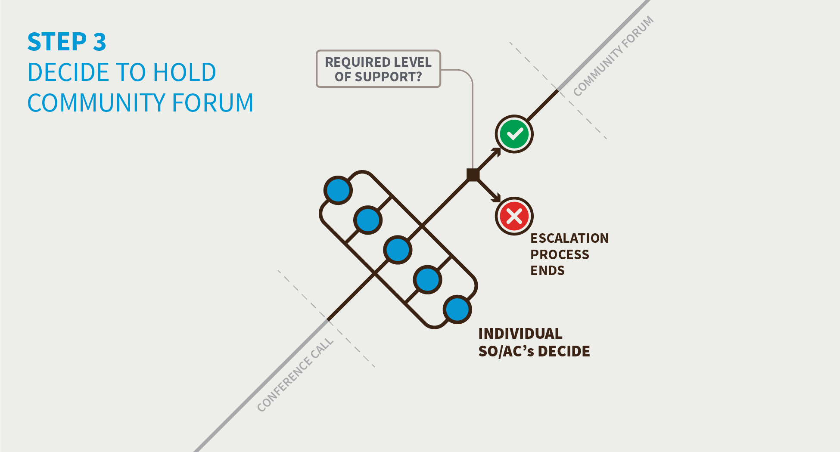
- If the community and the ICANN Board Director cannot resolve the issue on the conference call, the SOs and/or ACs must decide if they want to hold a Community Forum. This would be a one- or two-day event, possibly face-to-face, during which the ICANN community would explore in detail the issue between the ICANN Board Director and the community and the potential avenues for resolution or action.
- If two or more SOs or ACs support holding a Community Forum within the seven-day period, the Community Forum will be organized.
- If the proposal to hold a Community Forum does not obtain the required support during the seven-day period, the escalation process terminates.

- Step 4. Holding a Community Forum (15 Days to Organize and Hold the Event from the Date of the Decision to Hold It)
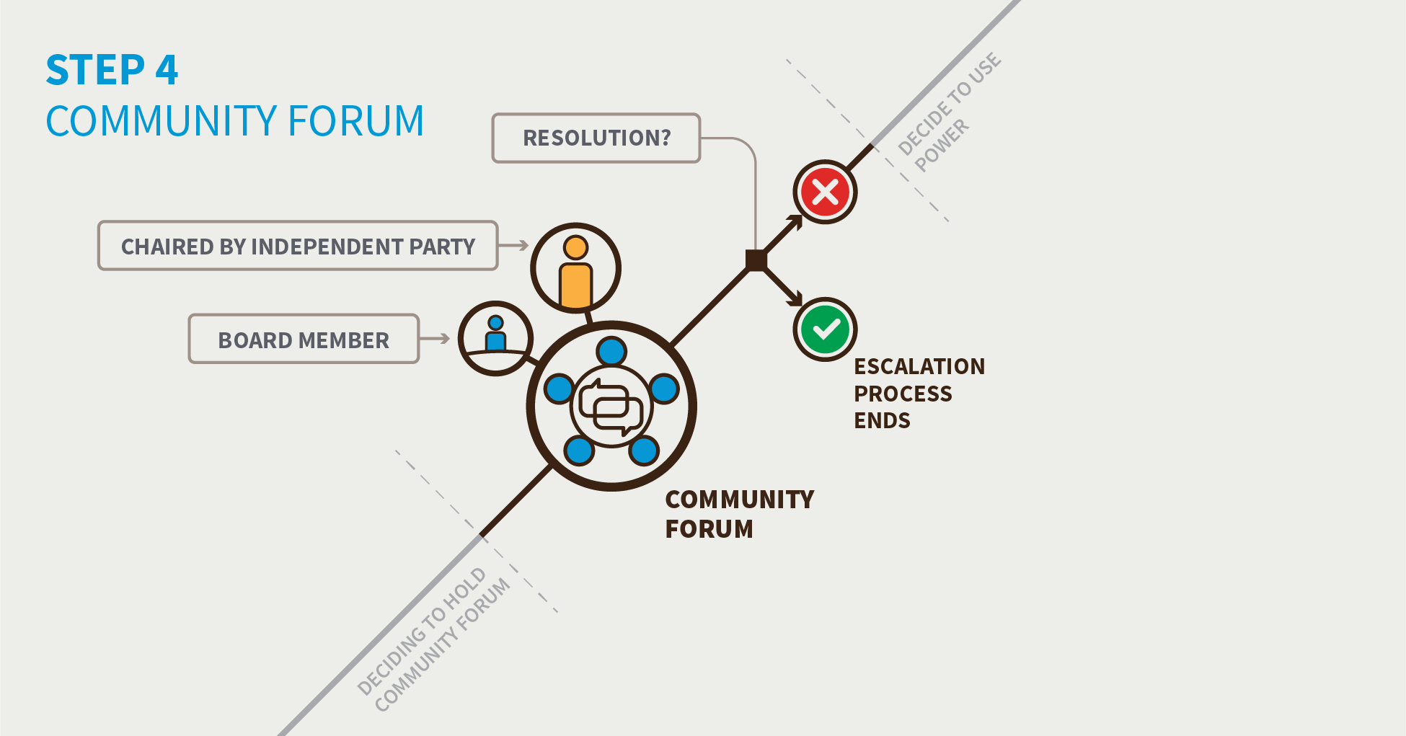
- It is expected that this will only involve remote participation methods, such as teleconferences and Adobe Connect-type meetings over a period of one or two days at most. Unless the timing allows participants to meet at a regularly scheduled ICANN meeting, there is no expectation that participants will meet face to face.
- The Community Forum would be open to all interested participants and ICANN will provide support services. The ICANN Board Director that is the subject of the petition would be invited and expected to attend and be prepared to address the issues raised.
- The purpose of the Community Forum is information-sharing (the rationale for the petition, etc.) and airing views on the petition by the community. Accordingly, any SO or AC may circulate in writing their preliminary views on the exercise of this Community Power.
- The Community Forum will not make decisions nor seek consensus. It will not decide whether to advance the petition to the decision stage. This decision is up to the SOs and/or ACs to determine after the Forum.
- The Community Forum should be managed/moderated in a fair and neutral manner.
- Should the relevant SOs or ACs determine a need for further deliberation, a second and third session of the Community Forum could be held.
- Staff will collect and publish a public record of the Forum(s), including all written submissions.
- If the Empowered Community and the ICANN Board Director can resolve the issue in the Community Forum, the escalation process terminates. Note after this point, this process cannot be used again by the community to remove this specific ICANN Board Director during its current term.
- If the Empowered Community and the ICANN Board Director cannot resolve the issue, the community must decide if it wishes to take further action.

- Step 5. Decision to use a Community Power as an Empowered Community (15 Days from the Conclusion of the Community Forum)
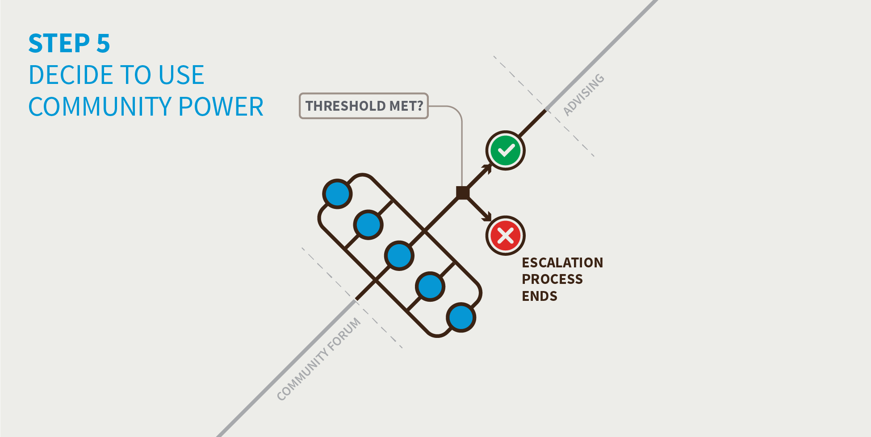
- If three or more SOs and/or ACs support and no more than one objects within the 15-day period, the Sole Designator will use its power. The community will also publish an explanation of why it has chosen to do so. The published explanation can reflect the variety of underlying reasons.
- If the proposal to use a Community Power as the Empowered Community does not meet the required thresholds during the 15-day period, the escalation process terminates.

- Step 6. Advising the ICANN Board (One Day)
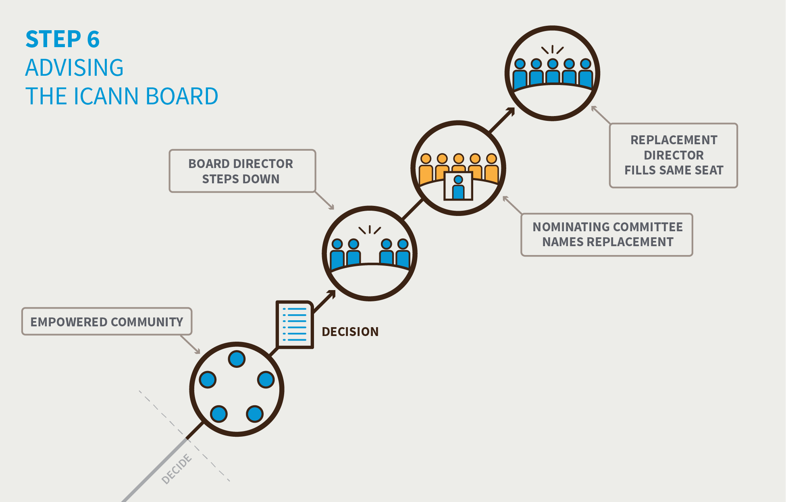

- If the Empowered Community has decided to use its power, it will advise the ICANN Board Director of the decision and direct it to comply with the decision.
- Naming a replacement:
  - The Nominating Committee may instruct the Sole Designator to appoint a new Director. It is expected that the Nominating Committee will amend its procedures so as to have several “reserve” candidates in place.
  - Replacement Directors will fill the same “seat” and their term will come to an end when the term of the original Director was to end.

- Directors Nominated by a Supporting Organization or Advisory Committee
- Step 1. Triggering Individual ICANN Board Director Removal by Community Petition (15 Days from the Official Posting of the Original Petition)
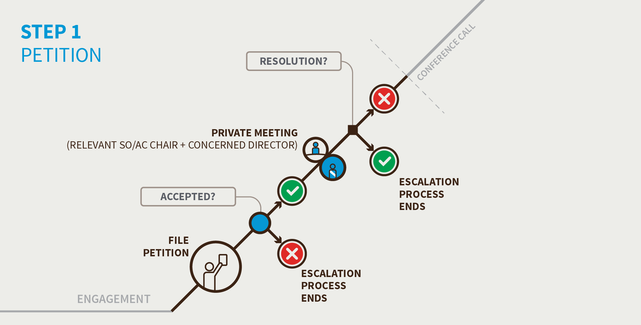
- The petition can only be started in the SO or AC that nominated the Director.
- Any individual can begin a petition as the first step to using a Community Power.
- For the petition to be accepted, the SO or AC, in accordance with its own mechanisms, must accept the petition.
- If the SO or AC does not approve the petition within 15 days, the escalation process terminates.
- If a petition is accepted, the Chair of the relevant SO or AC will meet promptly in private (by phone or in-person) with the concerned Director to discuss the approved petition. If no resolution is found, the SO or AC schedules a conference call within seven days of the petition being accepted.

- Step 2. Conference Call (Seven Days to Organize and Hold from the Date the Petition is Approved)
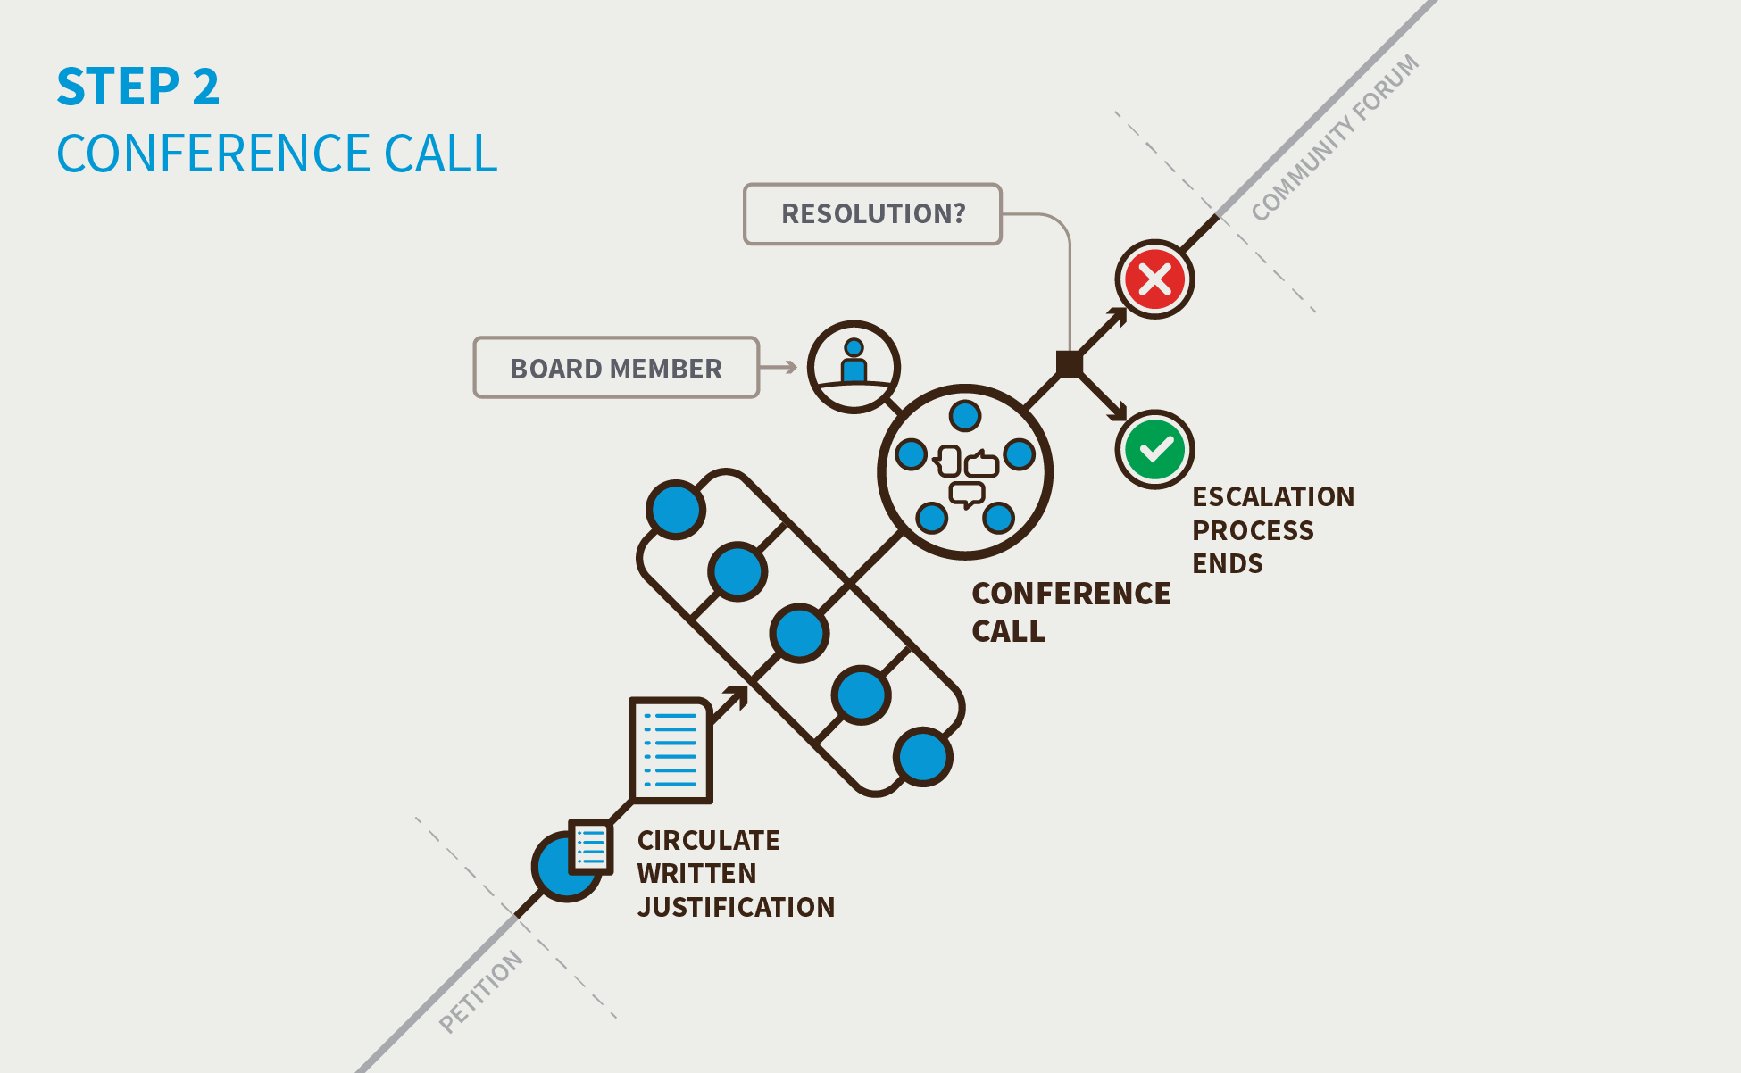

- The petitioning SO and/or AC circulates written justification for exercising the Community Power in preparation for the conference call. Any SO or AC may contribute preliminary thoughts or questions in writing before the call is held via a specific archived email list set up for this specific issue.
- ICANN hosts a conference call open to any interested participants and will provide support services. The ICANN Board Director that is the subject of the petition will be invited and is expected to attend and be prepared to address the issues raised.
- If the community and the ICANN Board Director can resolve the issue on the conference call, the escalation terminates.
- If the community and the ICANN Board Director cannot resolve, the issue progresses automatically to holding a Community Forum.

- Step 3. Holding a Community Forum (15 Days to Organize and Hold the Event from the Date of the Decision to Hold It)
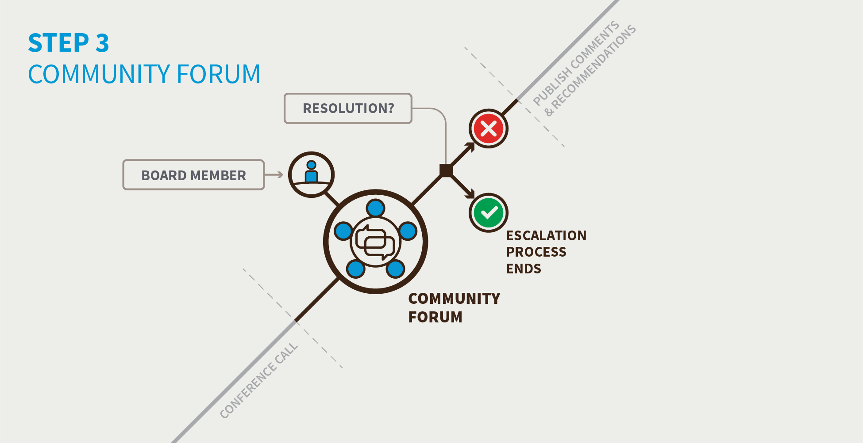

- It is expected that this will only involve remote participation methods, such as teleconferences and Adobe Connect-type meetings over a period of one or two days at most. Unless the timing allows participants to meet at a regularly scheduled ICANN meeting, there is no expectation that participants will meet face to face. The Community Forum would be open to all interested participants and ICANN will provide support services. The ICANN Board Director that is the subject of the petition would be invited and expected to attend and be prepared to address the issues raised.
- The purpose of the Community Forum is information-sharing (the rationale for the petition, etc.) and airing views on the petition by the community. Accordingly, any SO or AC may circulate in writing their preliminary views on the exercise of this Community Power.
- The Community Forum will not make decisions nor seek consensus. It will not decide whether to advance the petition to the decision stage. This decision is up to the SOs and/or ACs to determine after the Forum.
- The Community Forum should be managed/moderated in a fair and neutral manner and cannot involve a representative of the nominating SO or AC.
- Should the relevant SOs or ACs determine a need for further deliberation, a second and third session of the Community Forum could be held.
- Staff will collect and publish a public record of the Forum(s), including all written submissions.
- If the Empowered Community and the ICANN Board Director can resolve the issue in the Community Forum, the escalation process terminates. Note after this point, this process cannot be used again by the community to remove this specific ICANN Board Director during its current term.
- If the Empowered Community and the ICANN Board Director cannot resolve the issue, the community must decide if it wishes to take further action.
  - At the end of the Community Forum, the Community Forum Chair will issue a formal call for comments and recommendations from the community within seven days, and input received will be sent to the relevant SO or AC and posted publicly.

- Step 4. Supporting Organizations and/or Advisory Committees Publish their Comments and Recommendations (Seven Days)
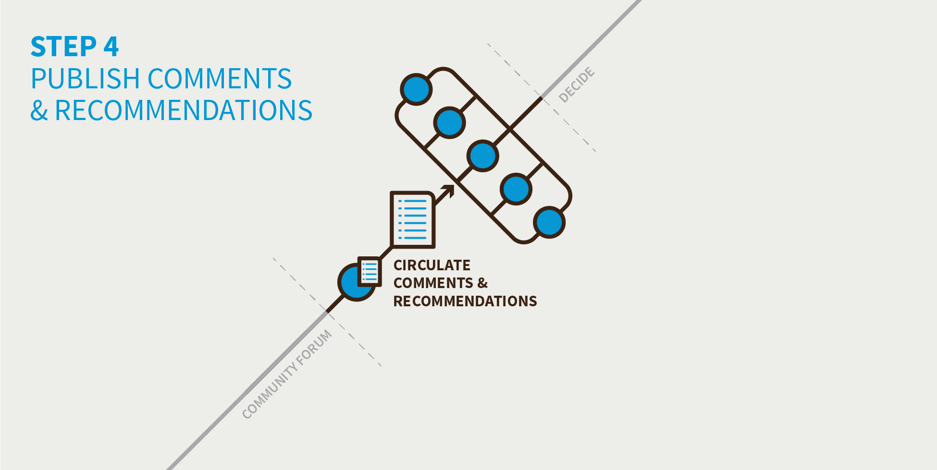

- Step 5. Decision to Use a Community Power as an Empowered Community (Seven Days from the Conclusion of the Period for Supporting Organization and Advisory Committee Comments)
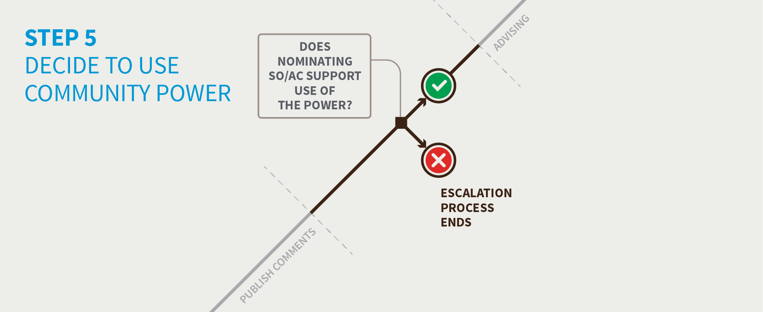

- If the nominating SO or AC supports using the power within the seven-day period, the Sole Designator will use its power. The SO or AC will also publish an explanation of why it has chosen to do so.
- If the nominating SO or AC does no support using the power within the seven-day period, the escalation process terminates.

- Step 6. Advising the ICANN Board (One Day)
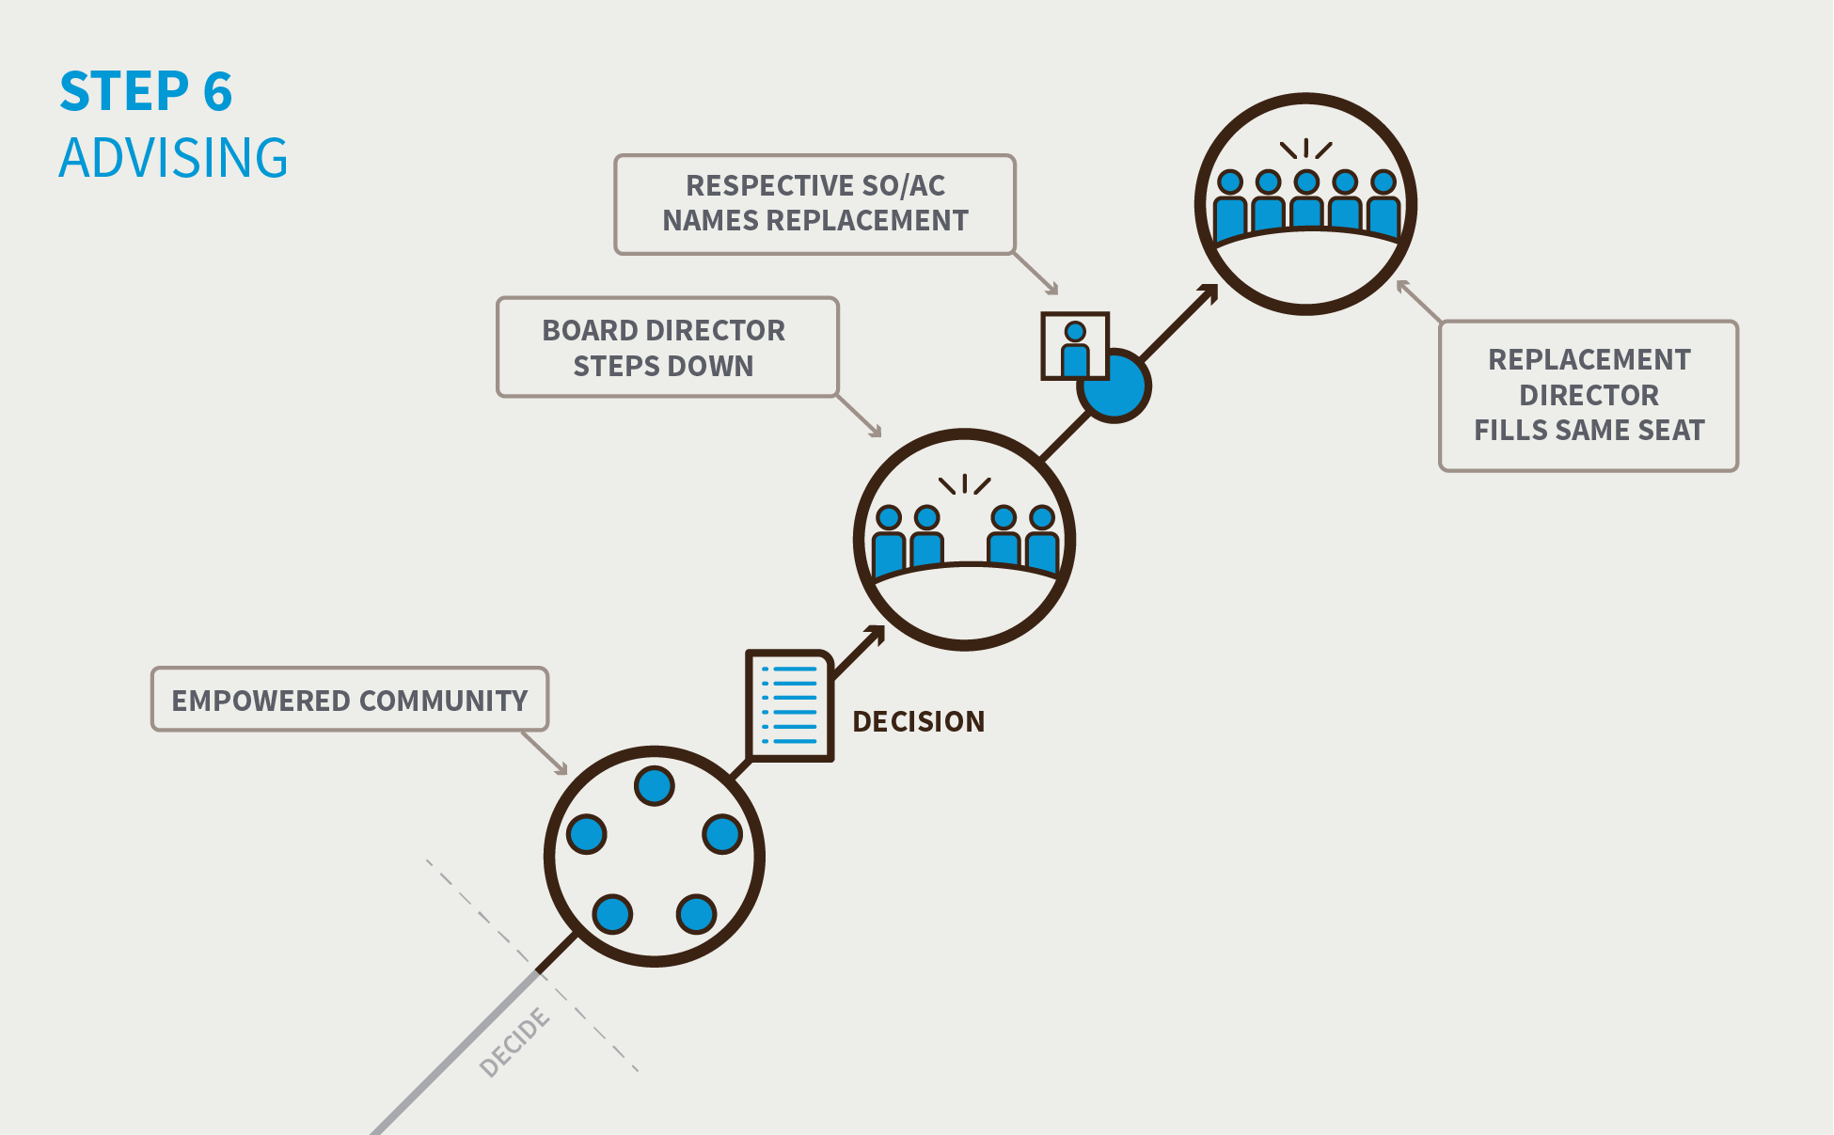

- If the Empowered Community has decided to use its power, it will advise the ICANN Board Director of the decision and direct it to comply with the decision.
- Naming a replacement:
  - The respective SO or AC is responsible for nominating an individual to fill the vacancy on the ICANN Board through its usual process (as set out in Article VI, Section 12.1 of the Bylaws).
  - Replacement Directors will fill the same “seat” and their term will come to an end when the term of the original Director was to end. A Director appointed in such circumstances will not have their remaining time in the role counted against any term limits, to which they would otherwise be subject.

- The Power to Recall the Entire ICANN Board
- The CCWG-Accountability believes there may be situations where removing individual Directors from ICANN’s Board may not be a sufficient accountability remedy for the community.
- In cases where the community perceives that a set of problems has become impossible to resolve, the community may wish to signal its lack of confidence in the Board by petitioning for a recall (i.e., the removal) of the entire ICANN Board (except the CEO, who is appointed by the Board). The power to recall a Board is a critical enforcement mechanism for the community under the Sole Designator model because it can be used to support the other Community Powers and provide a final and binding accountability mechanism.
- By exercising this power, the entire ICANN Board (except the CEO) could be removed by the community. However, it is unlikely that the community would use this power lightly, and the engagement and escalation processes are designed to encourage agreement between the Board and the community. If the ICANN Board were to be recalled, an Interim Board would be put in place. Interim Directors would be named with the exercising of the Community Power to ensure continuity.
- The CCWG-Accountability expects that this power would only be exercised as a last resort after all other attempts at resolution have failed. As a recall of the Board would be extremely disruptive for the entire organization, the CCWG-Accountability has included several safeguards in the proposed escalation process to ensure that this decision reaches the maturity and level of support needed before it can be used.

- Step 1. Triggering Recalling the ICANN Board Directors by Community Petition (15 Days from the Official Posting of the Original Petition)
- Begin a petition in a SO or AC.
- Any individual can begin a petition as the first step to using a Community Power.
- For the petition to be accepted, the SO or AC, in accordance with its own mechanisms, must accept the petition.
- If the SO or AC does not approve the petition within 15 days, the escalation process terminates.
- If the SO or AC does approve the petition within the 15-day period, it proceeds to the next step.

- Step 2. Triggering Removal of ICANN Board by Community Petition Part Two (Six Days from the End of the 15-Day Period of the Previous Step)
- The SO or AC approves the petition and contacts the other SOs or ACs to ask them to support the petition so a conference call can be organized that will allow the entire community to discuss the issue. At least one additional SO and/or AC must support the petition (for a minimum of two) for a conference call to be organized.
- If a minimum of two SOs or ACs support the petition within 15-days, a conference call is organized.
- If the petition fails to gather the required level of support, the escalation process terminates.

- Step 3. Conference Call (Seven Days to Organize and Hold from the Date the Decision is Made to Hold the Call)
- The petitioning SOs and/or ACs circulate written justification for exercising the Community Power in preparation for the conference call. Any SO or AC may contribute preliminary thoughts or questions in writing before the call is held via a specific archived email list set up for this specific issue.
- ICANN hosts a conference call open to any interested participants and will provide support services. The ICANN Board will be invited and is expected to attend and be prepared to address the issues raised
- If the community and the ICANN Board can resolve the issue on the conference call, the escalation terminates.
- If the community and the ICANN Board cannot resolve the issue, the community must decide if it wishes to hold a Community Forum.

- Step 4. Decision to hold a Community Forum (Seven Days from the End of the Conference Call)
- If the community and the ICANN Board cannot resolve the issue on the conference call, the SOs and/or ACs must decide if they want to hold a Community Forum. This would be a one- or two-day event, possibly face-to-face, where the ICANN community would explore in detail the issue between the ICANN Board Director and the community and the potential avenues for resolution or action.
- If three or more SOs or ACs support holding a Community Forum within the seven-day period, the Community Forum will be organized.
- If the proposal to hold a Community Forum does not obtain the required support during the seven days, the escalation process terminates.

- Step 5. Holding a Community Forum
- The power to recall the entire Board would require a face-to-face meeting. The three or more SOs or ACs that approved holding the Community Forum would decide if holding the Community Forum can wait until the next regularly scheduled ICANN meeting or if a special meeting is required to bring participants together. In both of these cases, the three or more SO or ACs that have requested the Community Forum will publish the date for holding the event which will not be subject to the 15-day limitation. In this case, the Community Forum would be considered completed at the end of the face-to-face meeting.
- The Community Forum would be open to all interested participants and ICANN will provide support services. The ICANN Board would be invited and expected to attend and be prepared to address the issues raised.
- The purpose of the Community Forum is information-sharing (the rationale for the petition, etc.) and airing views on the petition by the community. Accordingly, any SO or AC may circulate in writing their preliminary views on the exercise of this Community Power
- The Community Forum will not make decisions nor seek consensus. It will not decide whether to advance the petition to the decision stage. This decision is up to the SOs and/or ACs to determine after the Forum.
- The Community Forum should be managed/moderated in a fair and neutral manner.
- Should the relevant SOs or ACs determine a need for further deliberation, a second and third session of the Community Forum could be held.
- Staff will collect and publish a public record of the Forum(s), including all written submissions.
- If the Empowered Community and the ICANN Board can resolve the issue in the Community Forum, the escalation process terminates.
- If the Empowered Community and the ICANN Board cannot resolve the issue, the community must decide if it wishes to take further action.

- Step 6. Decision to use a Community Power as an Empowered Community (15 Days from the Conclusion of the Community Forum)
- If four or more SOs and/or ACs support and no more than one objects within the 15-day period, the Sole Designator will use its power. The community will also publish an explanation of why it has chosen to do so. The published explanation can reflect the variety of underlying reasons.
- If the proposal to use a Community Power as the Empowered Community does not meet the required thresholds during the 15-day period, the escalation process terminates.

- Step 7. Advising the ICANN Board (One Day)
- If the Empowered Community has decided to use its power, it will advise the ICANN Board Director of the decision and direct it to comply with the decision.
- Naming a replacement:
  - The Nominating Committee may instruct the Sole Designator to appoint a new Director. It is expected that the Nominating Committee will amend its procedures so as to have several “reserve” candidates in place.
  - Replacement Directors will fill the same “seat” and their term will come to an end when the term of the original Director was to end.

- Interim Board
The CCWG-Accountability proposes that a Bylaw be added that states that if the Board is removed, the Interim Board will be in place only as long as is required for the selection/election process for the Replacement Board to take place. SOs, ACs, and the Nominating Committee will develop replacement processes that ensure the Interim Board will not be in place for more than 120 days. The Interim Board will have the same powers and duties as the Board it replaces. Having a Board in place at all times is critical to the operational continuity of ICANN and is a legal requirement.
- The ICANN Bylaws will state that, except in circumstances of where urgent decisions are needed to protect the security, stability, and resilience of the DNS, the Interim Board will consult with the community through the SO and AC leadership before making major decisions. Where relevant, the Interim Board will also consult through the ICANN Community Forum before taking any action that would mean a material change in ICANN’s strategy, policies, or management, including replacement of the serving President and CEO.

- The Power to initiate a Community Independent Review Process
- A community IRP may be launched for reasons outside of enforcing a decision as described in Recommendation #2: Empowering the Community through Consensus: Engagement, Escalation, Enforcement. One example could be to require ICANN to provide documents as required under the right of inspection requirement.
- A community IRP may be launched for any of the following reasons:
- To hear and resolve claims that ICANN, through its Board of Directors or staff, has acted (or has failed to act) in violation of its Articles of Incorporation or ICANN Bylaws (including any violation of the Bylaws resulting from action taken in response to advice/input from any AC or SO).
- To reconcile conflicting decisions of process-specific “expert panels.”
- To hear and resolve claims involving rights of the Empowered Community under the Articles of Incorporation or ICANN Bylaws (subject to voting thresholds).

- The escalation and enforcement processes for rejecting an IANA Functions Budget are detailed in Recommendation #2: Empowering the Community through Consensus: Engagement, Escalation, Enforcement.

- The Power to Reject ICANN Board Decisions Relating to Reviews of IANA Functions, including the Triggering of Post-Transition IANA Separation
- The IANA Functions Review, Special IANA Function Review, and the Separation Cross Community Working Group are all structures that the CWG-Stewardship has requested the CCWG-Accountability constitute in the Fundamental Bylaws to oversee the operations of the IANA Functions Operator. As such, these structures will exist within ICANN and many of their recommendations will require ICANN Board approval before implementation (i.e., change in the Statement of Work for the IANA Functions Operator). The CWG-Stewardship determined it was critical that the recommendations of these various bodies be respected by the ICANN Board, and so further required that the CCWG-Accountability provide mechanisms to ensure that the recommendations from these bodies could be enforced.

- The escalation and enforcement processes for rejecting an IANA Functions Budget are detailed in Recommendation #2: Empowering the Community through Consensus: Engagement, Escalation, Enforcement.

4. Changes from the “Second Draft Proposal on Work Stream 1 Recommendations”
- The powers have not changed since the Second Draft Proposal. The mechanisms for using them (as described in Recommendation #2: Empowering the Community through Consensus: Engagement, Escalation, Enforcement) have.

5. How does this meet the CWG-Stewardship Requirements?
- The Power to Reject ICANN’s Budget or Strategy/Operating Plans directly meets the following CWG-Stewardship requirement:
  - ICANN Budget: Community rights regarding the development and consideration of the ICANN Budget.
- The Power to Remove Individual ICANN Board Directors and The Power to Recall the Entire ICANN Board directly meets the following CWG-Stewardship requirement:
  - ICANN Board: Community rights regarding the ability to appoint/remove Directors of the ICANN Board, and recall the entire Board.
- The Power to Approve Changes to Fundamental Bylaws is directly related to the following CWG-Stewardship requirement:
  - Fundamental Bylaws: All of the foregoing mechanisms are to be provided for in the ICANN Bylaws as Fundamental Bylaws.

6. How does this address NTIA Criteria?
- Support and enhance the multistakeholder model.
- Decentralizing power within ICANN through an Empowered Community.
- Establishing a public Community Forum to ensure that all voices and perspectives are heard before execution of a Community Power.
- Recommending a process where all are welcome to participate in the consultation processes prior to designing the document that will be put for discussion.
- Retaining decision-making based on consensus rather than voting.

- Maintain the security, stability, and resiliency of the Internet DNS.
- Elaborating Community Powers associated with a defined escalation process.
- The multi-step engagement process associated with the escalation process prevents single-step actions and encourages a conciliatory approach.
- The escalation process includes high thresholds for using accountability actions that based on consensus of the entire community. This process provides safeguards to prevent a situation where an SO/AC might initiate a petition to reject with the intention of negatively impacting another SO/AC’s budget by ensuring that no single SO/AC can use a power singlehandedly and no single AC/SO can singlehandedly block the use of a power.

- Meet the needs and expectation of the global customers and partners of the IANA services.
- Including limited timeframes, transparent processes, and associated thresholds to maintain operational viability.

- Maintain the openness of the Internet.
- Establishing a public Community Forum to ensure that all voices and perspectives are heard before execution of a Community Power.
- Preserving policies of open participation in ICANN’s SOs and ACs.
- The escalation process includes the convening of a Community Forum where all would be welcome to participate as a potential step. In addition, all are welcome to participate in the consultation process that organized to elaborate these key documents.

- NTIA will not accept a proposal that replaces the NTIA role with a government-led or an inter-governmental organization solution
- Retaining decision-making based on consensus rather than voting.
- Maintaining the advisory role of governments in the SO and AC structure.

If the CWG-Stewardship’s IANA Function Review determines that a Separation Process is necessary, it will recommend the creation of a Separation Cross Community Working Group. This recommendation will need to be approved by a supermajority of each of the Generic Names Supporting Organization and the Country-Code Names Supporting Organization Councils, according to their normal procedures for determining supermajority, and will need to be approved by the ICANN Board after a Public Comment Period, as well as a Community Mechanism derived from the CCWG-Accountability process.
Consult the CWG-Stewardship Final Report for further details.

