Annex 02 – Recommendation #2: Empowering the Community through Consensus: Engagement, Escalation, Enforcement
List of changes for V0.2
- Clarified that the engagement process will include “(at a minimum, a full public consultation process that complies with ICANN rules for public consultations),” to respond to comments.
- Removed step 3 in the escalation process for producing a rationale after consultation with Jordan. This has now been included in the Community Forum step.
- Have used “Decisional Participants in the Empowered Community” where appropriate.
- Para 14 – Have introduced a definition of resolving the issue as requested in the comments (for lawyer review).
- Para 20 – Have introduced a definition of the Board refusing or failing to comply with a Community Power as requested in the comments (for lawyer review).
- Para 22 – Have introduced suggested language for implementation regarding how to decide if mediation was successful as requested in the comments (for lawyer review).
- Section 4 – Have rewritten for Changes from the Third Draft Proposal vs Second Draft Proposal.
Sidley/Adler Note: We note that the following comments that were submitted by Sidley/Adler on January 18, 2016 do not appear to be reflected in this draft:
- “Clarify that the Empowered Community can seek enforcement by a court of the statutory power to remove directors, and that there is no requirement to use the IRP or recall the entire Board to enforce this power.
- Clarify that the Empowered Community can submit a Request for Reconsideration, the process that must be followed to submit such a Request (e.g., escalation process) and what decisional thresholds apply.”

1. Summary
- Engagement
- Today, the Internet Corporation for Assigned Names and Numbers (ICANN) Board voluntarily consults with the community on a variety of decisions, including the Annual Budget and changes to the ICANN Bylaws. To gather feedback, the ICANN Board uses mechanisms such as public consultations and information sessions to gauge community support and/or identify issues on the topic. These consultation mechanisms are referred to as an “engagement process.”
- The CCWG-Accountability is recommending that engagement processes for specific ICANN Board actions be constituted in the Fundamental Bylaws. Although the ICANN Board engages voluntarily in these processes today, this recommendation would formally require the ICANN Board to undertake an extensive engagement process (including, at a minimum, a full public consultation process that complies with ICANN rules for public consultations) before taking action on any of the following:
  - Approving ICANN’s Five-Year Strategic Plan
  - Approving ICANN’s Five-Year Operating Plan
  - Approving ICANN’s Annual Operating Plan & Budget
  - Approving the Internet Assigned Numbers Authority (IANA) Functions Budget
  - Approving any modifications to Standard or Fundamental Bylaws or the Articles of Incorporation, or approving ICANN’s sale or other disposition of all or substantially all of ICANN’s assets
  - Making ICANN Board decisions relating to reviews of IANA Functions, including the triggering of any Post-Transition IANA (PTI) separation process
- If it is determined that there is divergence between the ICANN Board and the community after the engagement process, the Empowered Community may decide to use a Community Power after the appropriate “escalation process” has been satisfied.
- The Empowered Community may begin an escalation process to:
  - Reject a Five-Year Strategic Plan, Five-Year Operating Plan, Annual Operating Plan & Budget, or the IANA Functions Budget.
  - Reject a change to ICANN Standard Bylaws.
  - Approve changes to Fundamental Bylaws and/or Articles of Incorporation, and/or approve ICANN’s sale or other disposition of all or substantially all of ICANN’s assets.
  - Remove an individual ICANN Board Director.
  - Recall the entire ICANN Board.
  - Initiate a binding community Independent Review Process (IRP) (where a panel decision is enforceable in any court recognizing international arbitration results).
  - Reject an ICANN Board decision relating to reviews of IANA Functions, including the triggering of any PTI separation process.
- Escalation
- The escalation process can differ, sometimes significantly, from one Community Power to another.
- One of the most standardized versions of the escalation process is required for all Community Powers to “reject,” remove individual Nominating Committee-nominated Board Directors, or recall the entire Board.
- This escalation process is comprised of the following steps:
- An individual starts a petition in a Supporting Organization (SO) or Advisory Committee (AC) that is a Decisional Participant in the Empowered Community (see Recommendation #1: Establishing an Empowered Community for Enforcing Community Powers).
- If the petition is approved by that SO or AC, it proceeds to the next step.
- If the petition is not approved by that SO or AC, the escalation process is terminated.
- The SO or AC that approved the petition contacts the other Decisional Participants to ask them to support the petition.
- At least one additional SO and/or AC must support the petition (for a minimum of two) for a Community Forum to be organized to discuss the issue.
  - If the threshold is not met, the escalation process is terminated.
  - If the threshold is met, a Community Forum is organized to discuss the petition.

- An open one- to two-day Community Forum is organized for any interested stakeholder in the community to participate.
- The petitioning SO and/or AC will:
  - Circulate a detailed rationale for proposing to use the Community Power to all Decisional Participants.
  - Designate a representative(s) to liaise with SOs/ACs to answer questions from the SOs/ACs.
  - If desired, request (optional) that ICANN organize a conference call prior to the Community Forum for the community to discuss the issue.
- If the ICANN Board and the Empowered Community can resolve their issues before or in the Community Forum, the escalation process is terminated.
- Otherwise the Empowered Community must decide if it wishes to use its Community Power.
- The Empowered Community considers use of a Community Power.
- If the threshold to use a Community Power is not met, or there is more than one objection, then the escalation process is terminated.
- If the threshold is met for using the Community Power, and there is no more than one objection, the Empowered Community advises the ICANN Board of the decision and directs it to comply with the decision (as outlined in the Fundamental Bylaws for this Community Power).

- The Empowered Community advises the ICANN Board.
- If the Empowered Community has decided to use its power, it will advise the ICANN Board of the decision and direct the Board to take any necessary action to comply with the decision.

- Enforcement
- If the ICANN Board refuses or fails to comply with a decision of the Empowered Community using a Community Power, the Empowered Community must decide if it wishes to begin the enforcement process.
- The enforcement process can proceed in one of two ways:
1. The Empowered Community may initiate mediation and community IRP procedures.
2. The Empowered Community may initiate an escalation process to recall the entire ICANN Board.
- The escalation process may terminate with a resolution or proceed into an enforcement process. The results of the enforcement process is enforceable in court.

2. CCWG-Accountability Recommendations
- Establish a Fundamental Bylaw that requires the ICANN Board to undertake an extensive engagement process (including, at a minimum, a full public consultation process that complies with ICANN rules for public consultations) before taking action on any of the following:
  - Approving ICANN’s Five-Year Strategic Plan.
  - Approving ICANN’s Five-Year Operating Plan.
  - Approving ICANN’s Annual Operating Plan & Budget.
  - Approving the IANA Functions Budget.
  - Approving any modification to Standard or Fundamental Bylaws or the Articles of Incorporation, or approving ICANN’s sale or other disposition of all or substantially all of ICANN’s assets.
  - Making any ICANN Board decision relating to reviews of IANA Functions, including the triggering of any PTI separation process.
- Include the engagement and enforcement processes in the Fundamental Bylaws. Note: The escalation processes for each Community Power are outlined in Recommendation #4: Ensuring Community Involvement in ICANN Decision-making: Eight New Community Powers.

3. Detailed Explanation of Recommendations
- Engagement
- Today, the ICANN Board voluntarily consults with the community on a variety of decisions such as the Annual Budget and changes to the ICANN Bylaws. To gather feedback, the ICANN Board uses mechanisms such as public consultations to gauge community support and/or identify issues on the topic. These consultation mechanisms are referred to as an engagement process.
- The CCWG-Accountability is recommending that this engagement process be constituted in the Fundamental Bylaws. Although the ICANN Board already convenes this process, this recommendation would require the ICANN Board to undertake an extensive engagement process (including, at a minimum, a full public consultation process that complies with ICANN rules for public consultations) before taking action on any of the following:
  - Approving ICANN’s Five-Year Strategic Plan.
  - Approving ICANN’s Five-Year Operating Plan.
  - Approving ICANN’s Annual Operating Plan & Budget.
  - Approving the IANA Functions Budget.
  - Approving any modification to Standard or Fundamental Bylaws or the Articles of Incorporation, or approving ICANN’s sale or other disposition of all or substantially all of ICANN’s assets.
  - Making any ICANN Board decision relating to reviews of IANA Functions, including the triggering of any PTI separation process.
- If it is determined that there is divergence between the ICANN Board and the community during the engagement process, the Empowered Community may decide to use a Community Power after the appropriate escalation process is satisfied.
- The Empowered Community may begin an escalation process to:
  - Reject a Five-Year Strategic Plan, Five-Year Operating Plan, Annual Operating Plan & Budget, or the IANA Functions Budget.
  - Reject a change to ICANN Standard Bylaws.
  - Approve a change to Fundamental Bylaws and/or Articles of Incorporation, and/or approve ICANN’s sale or other disposition of all or substantially all of ICANN’s assets.
  - Remove an individual ICANN Board Director.
  - Recall the entire ICANN Board.
  - Initiate a binding IRP (where a panel decision is enforceable in any court recognizing international arbitration results).
  - Reject an ICANN Board decision relating to reviews of IANA Functions, including the triggering of any PTI separation process.

- Escalation
- The escalation process can differ, sometimes significantly, from one Community Power to another. One of the most standardized versions of the escalation process is required for all Community Powers to “reject,” remove individual Nominating Committee-nominated Board Directors, or recall the entire Board.
- The right to reject an ICANN Board decision relating to IANA Function Reviews (including the triggering of any PTI separation process) may be exercised by the Empowered Community an unlimited number of times.
- Note: The power to approve changes to Fundamental Bylaws and the Articles of Incorporation, and to approve ICANN’s sale or other disposition of all or substantially all of ICANN’s assets, and the power to remove individual Directors nominated by an SO or AC contain special features that are covered in Recommendation #4: Ensuring Community Involvement in ICANN Decision-making: Eight New Community Powers.
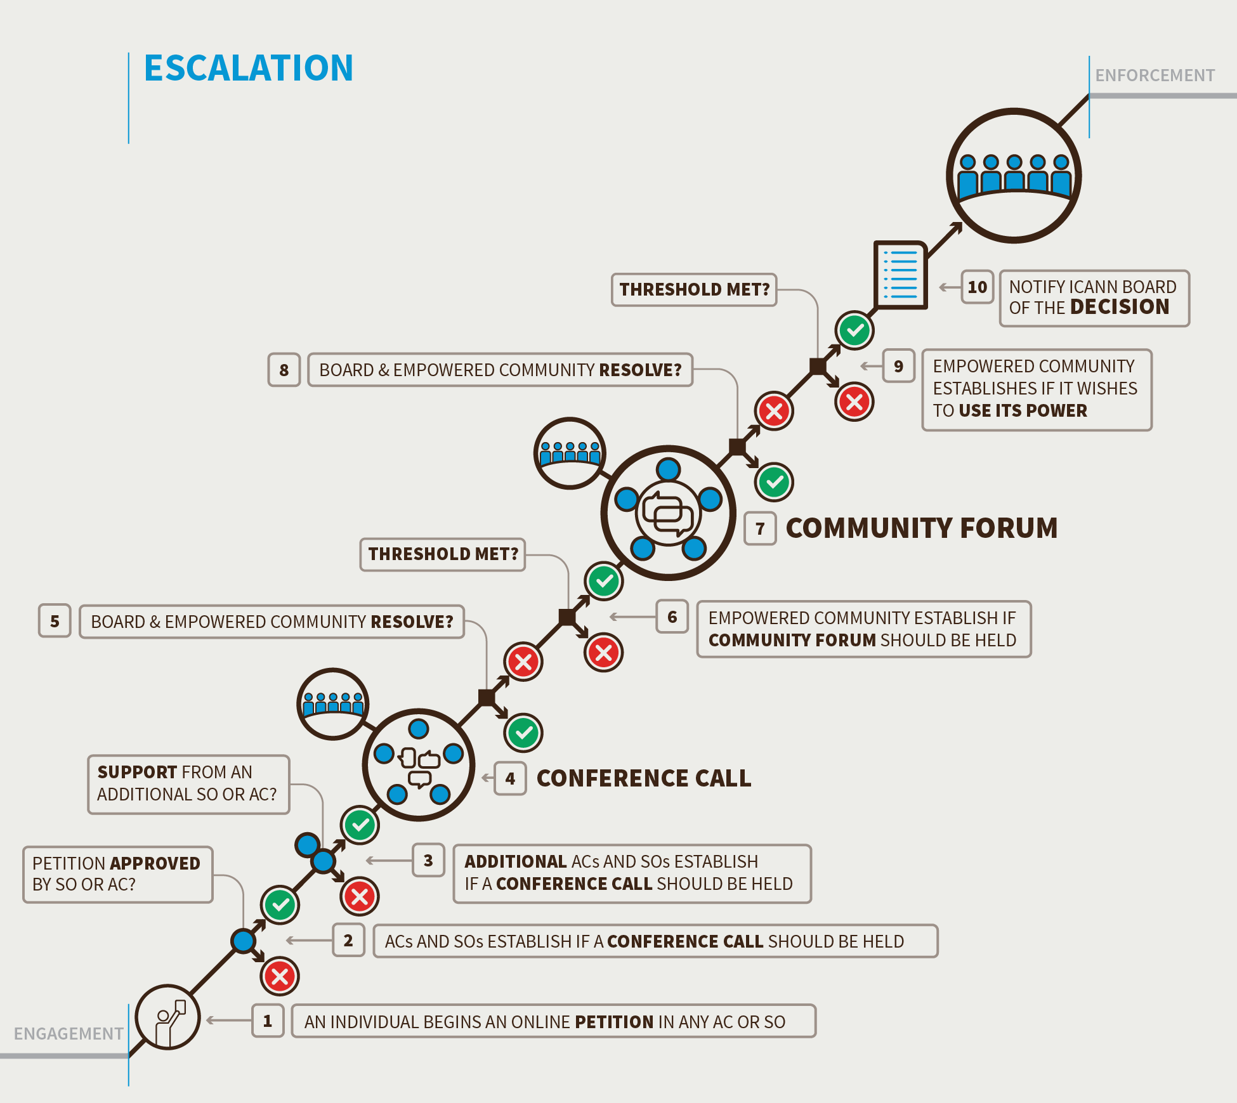

- Step 1. Triggering Review by Community Petition (21 Days)
- Note: To exercise any of the rejection powers, such as rejection of a budget, the 21-day period begins at the time the Board publishes its vote on the element that may be rejected. If the first step of the petition is not successful within 21 days of the Board publication of the vote, the rejection process cannot be used. A petition begins in an SO or AC that is a Decisional Participant in the Empowered Community .
- Any individual can begin a petition as the first step to using a Community Power.
- For the petition to be accepted, the SO or AC, in accordance with its own mechanisms, must accept the petition.
- Decision point:
- If the SO or AC does not approve the petition within 21 days, the escalation process terminates.
- If the SO or AC approves the petition, it can proceed to the next step.

- Step 2. Triggering Review by Community Petition Part Two (Seven Days from the End of the Previous Step)
- The SO or AC that approved the petition contacts the other Decisional Participants in the Empowered Community to ask them to support the petition. At least one additional Decisional Participant must support the petition (for a minimum of two) for a Community Forum to be organized to discuss the issue. To petition for a Community Forum to consider the recall of the entire ICANN Board requires three Decisional Participants to support the petition.
- Decision point:
- If the petition fails to gather the required level of support within six days, the escalation process terminates (except for removal of an individual Director).
- If a minimum of two Decisional Participants support the petition within seven days, a Community Forum is organized.

Note: For ICANN Board resolutions on changes to Standard Bylaws, Annual Budget, and Strategic or Operating Plans, the Board would be required to automatically provide a 28-day period before the resolution takes effect to allow for the escalation to be confirmed. If the petition is supported by a minimum of two Decisional Participants within the 28-day period, the Board is required to put implementation of the contested resolution on hold until the escalation and enforcement processes are completed. The purpose of this is to avoid requiring ICANN to undo things (if the rejection is approved), which could be potentially very difficult.

- Step 3. Holding a Community Forum (21 Days to Organize and Hold the Event from the Date of the Petition Causing It)
- The purpose of the Community Forum is information-sharing (the rationale for the petition, etc.) and airing views on the petition by the community. Accordingly, any SO or AC may circulate in writing their preliminary views on the exercise of this Community Power, before or in the Community Forum.
- The Forum is to be held within 21 days of the successful petition to hold a Community Forum being made.
- Within 24 hours of a petition being approved, the petitioning Decisional Participant will:
  - Circulate a detailed rationale for proposing to use the Community Power to all Decisional Participants. Any SO or AC may contribute preliminary thoughts or questions in writing via a specific publicly archived email list set up for this specific issue.
  - Designate a representative(s) to liaise with Decisional Participants to answer questions from the SOs/ACs.
  - If desired, request (optional) that ICANN organize a conference call for the community to discuss the issue.
- Community Forum format:
  - It is expected that for most powers, this will only involve remote participation methods such as teleconferences and Adobe Connect-type meetings over a period of one or two days at most. Unless the timing allows participants to meet at a regularly scheduled ICANN meeting, there is no expectation that participants will meet face to face. The one exception to this is the power to recall the entire Board, which would require a face-to-face meeting.
  - The Decisional Participants that supported the petition would decide if holding the Community Forum can wait until the next regularly scheduled ICANN meeting or if a special meeting is required to bring participants together (only in the case of Board recall). In both these cases, the Decisional Participants that supported the petition leading to the Community Forum will publish the date for holding the event, which will not be subject to the 21-day limitation. In this case, the Community Forum would be considered completed at the end of the face-to-face meeting. Note: this extension is not available for exercise of the Community Power regarding the ICANN or IANA Budgets, due to the importance of maintaining a timely budget approval process.
  - Open to all interested participants.
  - Managed and moderated in a fair and neutral manner.
  - ICANN to provide support services. ICANN support staff will collect and publish a public record of the Forum(s), including all written submissions.
  - Representatives of the ICANN Board are expected to attend and be prepared to address the issues raised.
  - Should the relevant Decisional Participants determine a need for further deliberation, a second and third session of the Community Forum could be held.
  - The Forum will not make decisions or seek consensus, and will not decide whether to advance the petition to the decision stage; although the issue may be resolved before or in the Community Forum as discussed below.
- Decision point:
- If the Empowered Community and ICANN Board can resolve the issue before or in the Community Forum, the escalation process terminates. Resolving an issue will be confirmed by the Decisional Participants that supported the petition formally agreeing, in accordance with their own mechanisms, that the escalation process should be halted.
- If the Empowered Community and ICANN Board cannot resolve the issue, the community must decide if it wishes to take further action.

- Step 4. Decision to use a Community Power as an Empowered Community (21 Days from the Conclusion of the Community Forum)

- Decision point:
- If four or more (for some powers, three) Decisional Participants support and no more than one objects within the 21-day period, the Empowered Community will use its power. The community will also publish an explanation of why it has chosen to do so. The published explanation can reflect the variety of underlying reasons.
- If the proposal does not meet the required thresholds during the 21-day period, the escalation process terminates.

- Step 5. Advising the ICANN Board (1 day)
- The Empowered Community will advise the ICANN Board of its decision and direct the Board to take any necessary action to comply with the decision.

- Enforcement
- If the ICANN Board refuses or fails to comply with a decision of the Empowered Community to use a Community Power, the Empowered Community must decide if it wishes to begin the enforcement process.
- The ICANN Board will be deemed to have refused or failed to comply with a request by the Empowered Community to use one of its powers if it has not complied with the request within 30 days of being advised of the request by the Empowered Community. The exception to this is removal of Board Directors or the entire Board which should be effective immediately upon notice being provided to the Board.
- The enforcement process can proceed in two ways:
- Option 1: Initiate mediation and community IRP procedures.
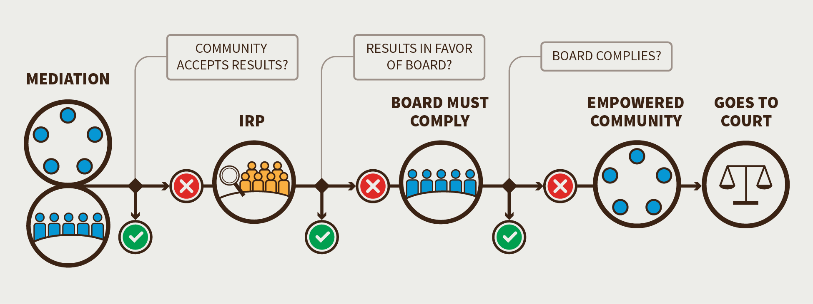
a) Representatives from ICANN Board and community undertake a formal mediation phase.
- If the Empowered Community accepts the results from the mediation phase, the enforcement process would be terminated.
- If the Empowered Community does not accept the results from the mediation phase, the community will proceed with a community IRP.
- Process specification (general guidelines for implementation):
  - The individuals selected by the Decisional Participants to represent them in the Empowered Community will be the community representatives in the mediation process.
  - Once the mediator has determined that mediation efforts are completed, the Empowered Community will produce and publicly post a report with its recommendations within 14 days.
  - The Decisional Participants in the Empowered Community will have 21 days from the report being posted to decide if they wish to proceed with a community IRP procedure (skipping the petitioning and Community Forum steps and proceeding directly to the decision to use this Community Power using the established thresholds for this decision). If the Decisional Participants approve initiating a community IRP to pursue the issue, the ICANN Board is notified of this. If the Decisional Participants fail to approve initiating a community IRP, the Empowered Community will be considered as having accepted the results of the mediation.

b) Representatives from the ICANN Board and community undertake a formal and binding IRP.
- If the results of the community IRP are in favor of the ICANN Board, the enforcement process is terminated.
- If the results of the binding IRP are in favor of the community, then the ICANN Board must comply within 30 days of the ruling

c) If the ICANN Board does not comply with the decision of the IRP, the Empowered Community has two options:
- The Empowered Community can petition a court of valid jurisdiction to enforce the results of the IRP.
- The Empowered Community can use its Community Power to recall the entire ICANN Board.

- Option 2: Initiate an escalation process to recall the entire ICANN Board.
- If the requisite threshold of support of Decisional Participants is achieved, the Empowered Community will remove all of the members of the ICANN Board (except the CEO) and replace them with an Interim Board until a new Board can be seated.
- The Empowered Community may legally enforce the power to recall the entire Board in court.

Table: Required Thresholds for the Various Escalation and Enforcement Processes (Based on a Minimum of Five Decisional Participants in the Empowered Community)
Required Community Powers? | Petition Threshold to convene a Community Forum | Is there consensus support to exercise a Community Power?
- 1. Reject a proposed Operating Plan/Strategic Plan/Budget | - Two SOs/ACs | - Four support rejection, and no more than one objection
- 2. Approve a change to Fundamental Bylaws and Articles of Incorporation, and approve ICANN’s sale or other disposition of all or substantially all of ICANN’s assets | - N/A | - Three] support approval, and no more than one objection
- 3. Reject changes to Standard Bylaws | - Two SOs/ACs | - Three support rejection, and no more than one objection
- 4a. Remove an individual Board Director nominated by a SO or AC (and appointed by the Empowered Community) | - Majority within nominating SO/AC | - Invite and consider comments from all SOs/ACs. 3/4 majority within the nominating SO/AC to remove their director
- 4b. Remove an individual Board Director nominated by the Nominating Committee (and appointed by the Empowered Community) | - Two SOs/ACs | - Three support, and no more than one objection.
- 5. Recall the entire Board of Directors | - Three SOs/ACs | - Four support, and no more than one objection
- 6. Initiate a binding IRP | - Two SOs/ACs | - Three support, and no more than one objection.  - Require mediation before IRP begins
- 7. Reject an ICANN Board decision relating to reviews of IANA Functions, including the triggering of any PTI separation process | - Two SOs/ACs | - Four support, and no more than one objection

- Implementation of the Empowered Community currently anticipates that all of ICANN’s SOs, the At-Large AC and Governmental Advisory Committee (GAC) would participate in the Empowered Community (that is, they will be listed in the Bylaws as the five Decisional Participants).
- The thresholds presented in this document were determined based on this assessment. If fewer than five of ICANN’s SOs and ACs agree to be Decisional Participants, these thresholds for consensus support may be adjusted. Thresholds would also have to be adjusted if ICANN changes to have more SOs or ACs.
- In the event of the creation (or removal) of SOs/ACs, the corresponding percentage could be used as useful guidelines in refining the thresholds. There would however need to be a conscious decision, depending on the circumstances, regarding these adjustments. If such a change were to affect the list of Decisional Participants in the Empowered Community, the change would follow the Fundamental Bylaw change process, which enables such a conscious decision to be undertaken.

4. Changes from the “Third Draft Proposal on Work Stream 1 Recommendations”

- Extended time for certain escalation steps in response to comments. Kept overall timeline similar by combining and removing some steps (mandatory conference call).
- Made it mandatory for petitioning party to reach out to SOs/ACs to socialize relevant information before Community Forum.
- Acknowledged comments regarding the thresholds adjustment in case the number of Decisional Participants is lower (paragraph 60 – page 12 of the Third Draft Proposal), by removing this option and replacing it with a lower threshold for approving changes to Fundamental Bylaws. Since the Fundamental Bylaw change process is a requirement for “approval” and not a “rejection” option, this would preserve the requirement for stronger protection of Fundamental Bylaws.
- The use of the corresponding percentage for thresholds as recommended by the Board can be suggested as a guideline in the event of the creation of new SOs/ACs but there would need to be a conscious decision, depending on the circumstances. If such a new SO/AC were to become a Decisional Participant in the Empowered Community, this change would require a change to the Fundamental Bylaws and would therefore require approval by the Empowered Community.

5. Stress Tests Related to this Recommendation
- ST5, 6, 7, 8, 9, 10, 16, 24, powers
- ST12
- ST13
- ST27
- ST28

6. How does this meet the CWG-Stewardship Requirements?
- The CWG-Stewardship required community empowerment mechanisms that would be able to:
- Appoint and remove members of the ICANN Board and to recall the entire ICANN Board.
- Exercise oversight with respect to key ICANN Board decisions (including with respect to the ICANN Board’s oversight of the IANA Functions) by reviewing and approving (i) ICANN Board decisions with respect to recommendations resulting from an IANA Function Review (IFR) or Special IFR and (ii) the ICANN budget.
- Approve amendments to ICANN’s Fundamental Bylaws.
The defined escalation and decision-making mechanism recommended by the CCWG-Accountability provide the processes needed to meet these requirements.

7. How does this address NTIA Criteria?
- Support and enhance the multistakeholder model.
- Decentralizing power within ICANN through an Empowered Community.
- Solidifying consultation processes between the ICANN Board and community into the ICANN Bylaws.
- Establishing a public Community Forum to ensure that all voices and perspectives are heard before execution of a Community Power.
- Retaining decision-making based on consensus rather than voting.

- Maintain the security, stability, and resiliency of the Internet DNS.
- Proposing a series of procedures that ensure both sides have had the chance to completely and thoroughly discuss any disagreements and have multiple opportunities to resolve any such issues without having to resort to the powers of the Empowered Community for accountability or enforceability.
- Embedding thresholds into procedures to eliminate any risks of capture.

- Meet the needs and expectation of the global customers and partners of the IANA services.
- Including limited timeframes, transparent processes and associated thresholds to maintain operational viability.

- Maintain the openness of the Internet.
- Establishing a public Community Forum to ensure that all voices and perspectives are heard.
- Preserving policies of open participation in ICANN’s SOs and ACs.

- NTIA will not accept a proposal that replaces the NTIA role with a government-led or an inter-governmental organization solution.
- Retaining decision-making based on consensus rather than voting.
- Maintaining the advisory role of governments in the SO and AC structure, including the GAC.
- Enabling all interested stakeholders to join consultations through SOs and ACs or through the Community Forum.

A minority of CCWG-Accountability participants prefer to require five SOs and ACs, or allow one objection to block consensus.

