Annex 07 – Recommendation #7: Strengthening ICANN’s Independent Review Process
2nd READING CONCLUSIONS :
- Discussed comments related to scope of IRP (paragraph 7)
  - Agreed to inclusion of PTI actions or inactions (CWG Requirement) with clarifications on :
    - Scope of appeal being restricted to naming
    - Per CWG-Stewardship Final Proposal, ICANN will enter into contract with PTI that obligates PTI to perform in accordance with CWG requirements. ICANN Bylaws will obligate ICANN to ensure that PTI complies with its contractual obligations. ICANN’s failure to enforce such obligations will be appealable via IRP as a Bylaws violation.
    - ICANN Bylaws will provide that PTI service complaints regarding Naming Related Functions not resolved through mediation may be appealed via IRP, in both cases as provided for in CWG-Stewardship Final Proposal Annex I, Phase 2.
      - Note that CWG-Stewardship Final Proposal Annex I Phase 2 also permits PTI Direct Customers to pursue “other available legal recourse.” ICANN should consider modification of Registry Agreements with gTLD Operators to expand scope of arbitration available thereunder to cover PTI service complaints.
      - Standard of review will be material breach of PTI obligations under contract with ICANN, whether through action or inaction, where the alleged breach has resulted in material harm to the complainant.

    - Discuss whether we would expand the standard of review of the IRP to PTI IANA decisions i.e. in the specific case where a challenge would be upon a PTI action or inaction.
  - Agreed to exclusion of protocol / parameter decisions (IAB comment – paragraph 18) with mention of existing appeals mechanisms for numbering and protocols / parameters for clarification
  - Agreed that challenge of expert panel decisions (Board concern / alternate suggestion) is limited to challenge of whether panel decision is consistent with ICANN’s Bylaws

  - DIDP is a separate appeals mechanism. IRP should be designated avenue for issues that are believed to be against ICANN Bylaws.
- Clarification is required regarding the Empowered Community Legal fees (born by ICANN ?) in case of Community IRP (see paragraph 14 – following Steve del Bianco note in the chat)
- Other comments and suggestions are provided as implementation details for Implement oversight group (see paragraph 37)
- Agreement on carve-out language: Notwithstanding the foregoing and notwithstanding any required threshold for launching a community IRP, no community IRP that challenges the result(s) of a supporting organization’s policy development process (PDP) may be launched without the support of the supporting organization that developed such PDP or, in the case of joint PDPs, without the support of the supporting organizations that developed such PDP.

1. Summary
- The overall purpose of the Independent Review Process (IRP) is to ensure that ICANN does not exceed the scope of its limited technical Mission and complies with its Articles of Incorporation and Bylaws.
- The consultation process undertaken by ICANN produced numerous comments calling for overhaul and reform of ICANN’s existing IRP. Commenters called for ICANN to be held to a substantive standard of behavior rather than just an evaluation of whether or not its action was taken in good faith.
- The CCWG-Accountability therefore proposes several enhancements to the process to ensure that the IRP is:
- Transparent, efficient, and accessible (both financially and from a standing perspective).
- Designed to produce consistent and coherent results that will serve as a guide for future actions.
- The CCWG-Accountability also proposes that the IRP:
- Hear and resolve claims that ICANN through its Board of Directors or staff has acted (or has failed to act) in violation of its Articles of Incorporation or Bylaws (including any violation of the Bylaws resulting from action taken in response to advice/input from any AC or SO).
- Hear and resolve claims that Post Transition IANA (PTI) through its Board of Directors or staff has acted (or has failed to act) in violation of its contract with ICANN and the CWG Requirements for issues related to the naming function.
- Hear and resolve claims that expert panel decisions are inconsistent with Icann’s Bylaws
- Hear and resolve claims involving rights of the Sole Designator under the Articles or Bylaws (subject to voting thresholds).
- implement a Community Independent Review Process - The CCWG-Accountability recommends giving the community the right to have standing with the. In such cases, ICANN will bear the costs associated with the Standing Panel as well as the Community’s legal fees,

- It is important to note that the IRP will only apply to generic Top Level Domains.

2. CCWG-Accountability Recommendations
- Modify the Fundamental Bylaws to implement the modifications associated with this recommendation on the IRP which include:
- Hear and resolve claims that ICANN through its Board of Directors or staff has acted (or has failed to act) in violation of its Articles of Incorporation or Bylaws (including any violation of the Bylaws resulting from action taken in response to advice/input from any AC or SO).
- Hear and resolve claims that Post Transition IANA (PTI) through its Board of Directors or staff has acted (or has failed to act) in violation of its contract with ICANN and the CWG Requirements for issues related to the naming function.
- Hear and resolve claims that expert panel decisions are inconsistent with Icann’s Bylaws
- Hear and resolve claims involving rights of the Sole Designator under the Articles or Bylaws (subject to voting thresholds).
- Standing judicial/arbitral panel - The IRP should have a standing judicial/arbitral panel tasked with reviewing and acting on complaints brought by individuals, entities, and/or the community who have been materially harmed by ICANN’s action or inaction in violation of the Articles of Incorporation and/or Bylaws
  - Composition of Panel and Expertise - Significant legal expertise, particularly international law, corporate governance, and judicial systems/dispute resolution/arbitration is necessary.
  - Diversity - English will be the primary working language with provision of translation services for claimants as needed. Reasonable efforts will be taken to achieve cultural, linguistic, gender, and legal diversity, with an aspirational cap on number of panelists from any single region (based on the number of members of the Standing Panel as a whole).
  - Size of Panel
    - Standing Panel: Minimum of seven panelists.
    - Decisional Panel: Three panelists.
  - Independence - Panel members must be independent of ICANN, including ICANN SOs and ACs.
  - Recall - Appointments made for a fixed term of five (5) years with no removal except for specified cause (corruption, misuse of position for personal use, etc.). The recall process will be developed via the IRP Sub Group.

- Initiation of the Independent Review Process - An aggrieved party would trigger the IRP by filing a complaint with the panel alleging that a specified action or inaction is in violation of ICANN’s Articles of Incorporation and/or Bylaws. Matters specifically reserved to the Sole Member Designator of ICANN in the Articles or Bylaws would also be subject to the IRP review.
- Standing - Any person/group/entity “materially affected” by an ICANN action or inaction in violation of ICANN’s Articles of Incorporation and/or Bylaws shall have the right to file a complaint under the IRP and seek redress.
- Community Independent Review Process - The CCWG-Accountability recommends giving the community the right to have standing with the. In such cases, ICANN will bear the costs associated with the Standing Panel as well as the Community’s legal fees,
- Standard of Review - The IRP Panel, with respect to a particular IRP, shall decide the issue(s) presented based on their own independent interpretation of the ICANN Articles and Bylaws in the context of applicable governing law.
- Accessibility and Cost - The CCWG-Accountability recommends that ICANN would bear all the administrative costs of maintaining the system (including panelist salaries), while each party should bear the costs of their own legal advice. The panel may provide for loser pays/fee shifting in the event it identifies a challenge or defense as frivolous or abusive. ICANN should seek to establish access, for example by access to pro bono representation for community, non-profit complainants and other complainants that would otherwise be excluded from utilizing the process.
- Implementation - The CCWG-Accountability proposes that the revised IRP provisions be adopted as Fundamental Bylaws. Implementation of these enhancements will necessarily require additional, detailed work. Detailed rules for the implementation of the IRP (such as rules of procedure) are to be created by the ICANN community through a CCWG-Accountability (assisted by counsel, appropriate experts, and the Standing Panel when confirmed), and approved by the Board, such approval not to be unreasonably withheld. They may be updated in the light of further experience by the same process, if required. In addition, to ensure that the IRP functions as intended, the CCWG-Accountability proposes to subject the IRP to periodic community review.
- Transparency - The community has expressed concerns regarding the ICANN document/information access policy and implementation. Free access to relevant information is an essential element of a robust IRP, and as such, the CCWG-Accountability recommends reviewing and enhancing the ICANN Documentary Information Disclosure Policy as part of the accountability enhancements in Work Stream 2.

3. Detailed Explanation of Recommendations
- The consultation process undertaken by ICANN produced numerous comments calling for overhaul and reform of ICANN’s existing IRP. Commenters called for ICANN to be held to a substantive standard of behavior rather than just an evaluation of whether or not its action was taken in good faith. Commenters called for a process that was binding rather than merely advisory. Commenters also strongly urged that the IRP be:
- Transparent, efficient, and accessible (both financially and from a standing perspective).
- Designed to produce consistent and coherent results that will serve as a guide for future actions.
The Purpose of the Independent Review Process
- The overall purpose of the IRP is to ensure that ICANN does not exceed the scope of its limited technical Mission and complies with its Articles of Incorporation and Bylaws. The IRP should:
- Empower the community and affected individuals/entities to prevent “Mission creep” and enforce compliance with the Articles and Bylaws through meaningful, affordable, accessible expert review of ICANN actions.
- Ensure that ICANN is accountable to the community and individuals/entities for actions outside its Mission or that violate its Articles or Bylaws.
- Reduce disputes going forward by creating precedent to guide and inform ICANN Board, staff, Supporting Organizations (SOs) and Advisory Committees (ACs), and the community in connection with policy development and implementation.

The Role of the Independent Review Process
- The role of the IRP will be to:
- Hear and resolve claims that ICANN through its Board of Directors or staff has acted (or has failed to act) in violation of its Articles of Incorporation or Bylaws (including any violation of the Bylaws resulting from action taken in response to advice/input from any AC or SO).

- Hear and resolve claims that Post Transition IANA (PTI) through its Board of Directors or staff has acted (or has failed to act) in violation of its contract with ICANN and the CWG Requirements for issues related to the naming function. In line with CWG-Stewardship requirements, such claims relating to actions or inactions of
    - Per CWG-Stewardship Final Proposal, ICANN will enter into contract with PTI that obligates PTI to perform in accordance with CWG requirements. ICANN Bylaws will obligate ICANN to ensure that PTI complies with its contractual obligations. ICANN’s failure to enforce such obligations will be appealable via IRP as a Bylaws violation.
    - ICANN Bylaws will provide that PTI service complaints regarding Naming Related Functions not resolved through mediation may be appealed via IRP, in both cases as provided for in CWG-Stewardship Final Proposal Annex I, Phase 2.
      - Note that CWG-Stewardship Final Proposal Annex I Phase 2 also permits PTI Direct Customers to pursue “other available legal recourse.” ICANN should consider modification of Registry Agreements with gTLD Operators to expand scope of arbitration available thereunder to cover PTI service complaints.
      - Standard of review will be material breach of PTI obligations under contract with ICANN, whether through action or inaction, where the alleged breach has resulted in material harm to the complainant.

- Hear and resolve claims that expert panel decisions are inconsistent with Icann’s Bylaws
- Hear and resolve claims involving rights of the Sole Designator under the Articles or Bylaws (subject to voting thresholds).

A Standing Panel
- The IRP should have a standing judicial/arbitral panel tasked with reviewing and acting on complaints brought by individuals, entities, and/or the community who have been materially harmed by ICANN’s action or inaction in violation of the Articles of Incorporation and/or Bylaws.

Initiation of the Independent Review Process
- An aggrieved party would trigger the IRP by filing a complaint with the panel alleging that a specified action or inaction is in violation of ICANN’s Articles of Incorporation and/or Bylaws. Matters specifically reserved to the Sole Designator of ICANN in the Articles or Bylaws would also be subject to the IRP review.
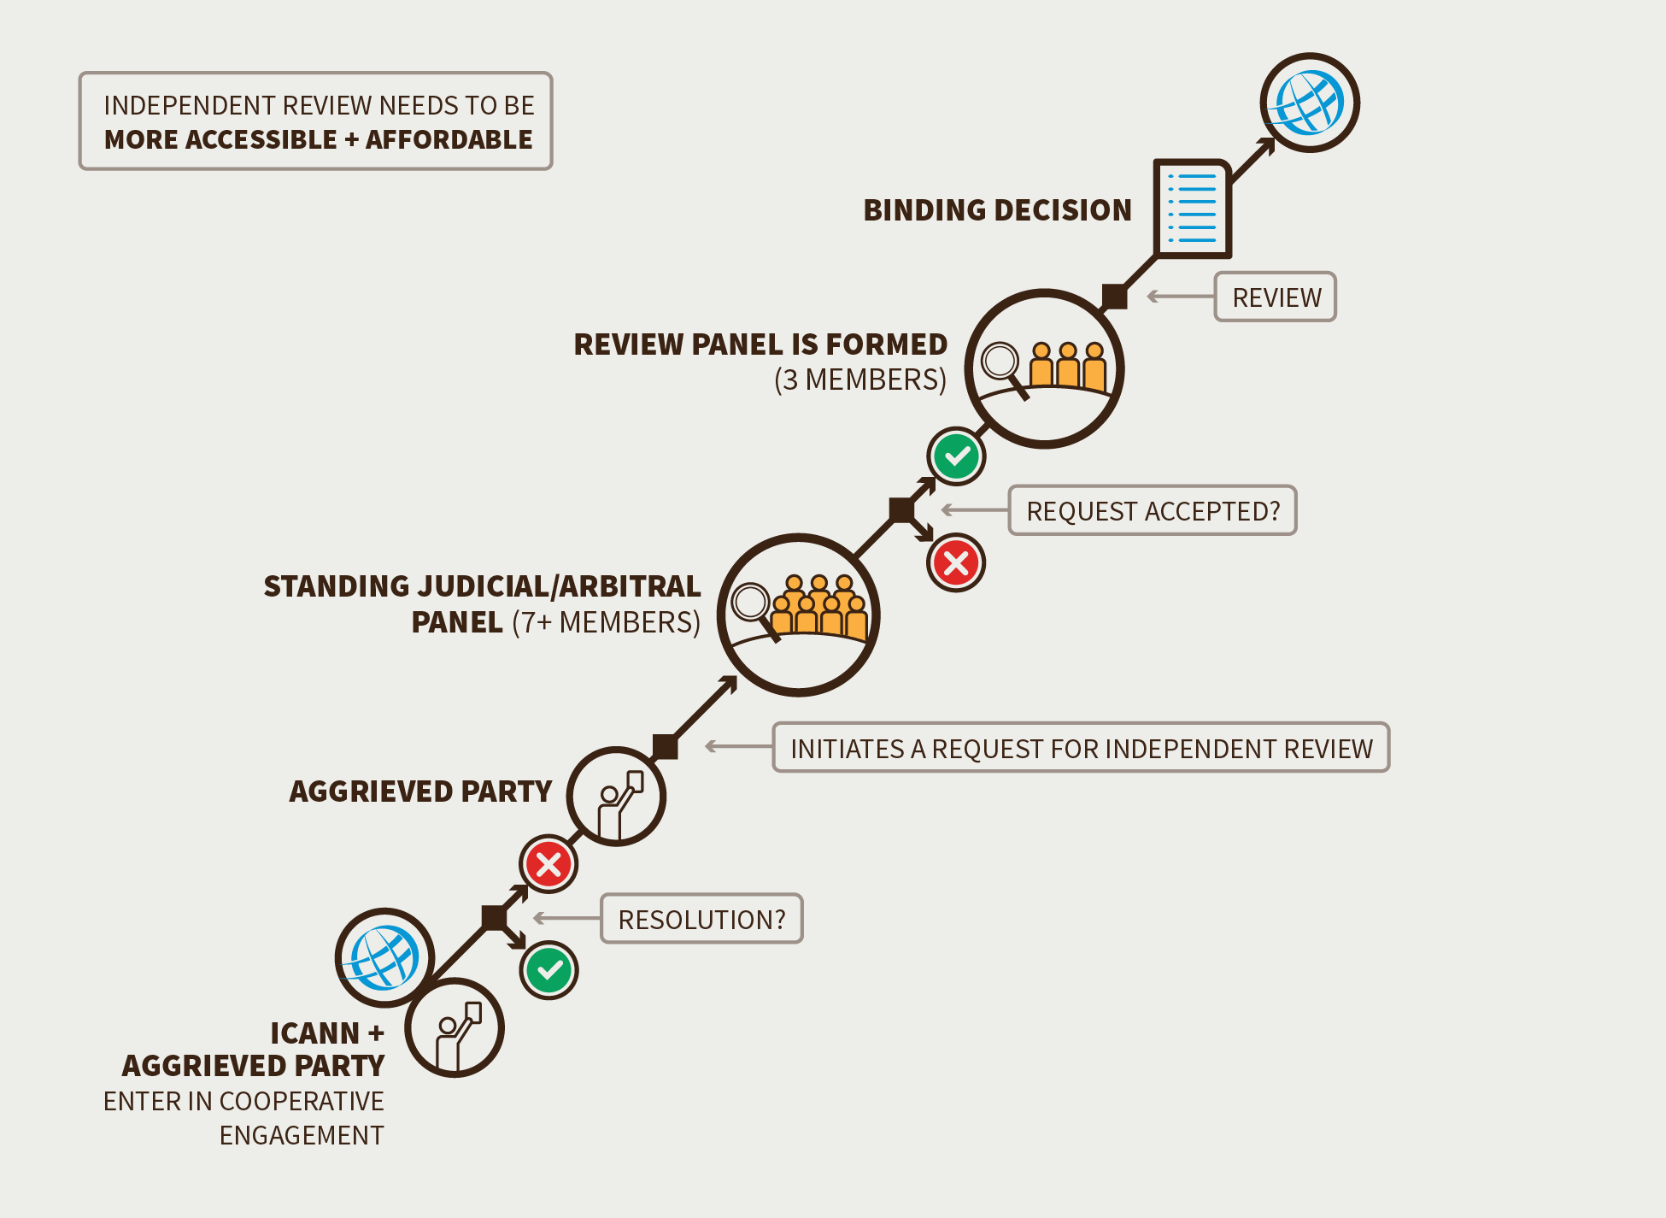

Possible Outcomes of the Independent Review Process
- An IRP will result in a declaration that an action/failure to act complied or did not comply with ICANN’s Articles of Incorporation and/or Bylaws. To the extent permitted by law, IRP decisions should be binding on ICANN.
- Decisions of a three-member Decisional Panel will be appealable to the full IRP Panel sitting en banc, based on a clear error of judgment or the application of an incorrect legal standard. The standard may be revised or supplemented via the IRP Subgroup process, which will be developed.
- This balance between the limited right of appeal and the limitation to the type of decision made is intended to mitigate the potential effect that one key decision of the panel might have on several third parties, and to avoid an outcome that would force the Board to violate its fiduciary duties.
- The limited right to appeal is further balanced by the Seven Community Powers, relevant policy development processes, and advice from ACs, each as set forth in the Bylaws.
- IRP Panelists will consider and may rely on prior decisions of other Independent Review Processes that address similar issues.
- Interim (prospective, interlocutory, injunctive, status quo preservation) relief will be available in advance of Board/management/staff action where a complainant can demonstrate:
  - Harm that cannot be cured once a decision has been taken or for which there is no adequate remedy once a decision has been taken.
  - Either:
    - A likelihood of success on the merits.
    - Sufficiently serious questions going to the merits.
  - A balance of hardships tipping decidedly toward the party seeking the relief.

- Standing
- Any person/group/entity “materially affected” by an ICANN action or inaction in violation of ICANN’s Articles of Incorporation and/or Bylaws shall have the right to file a complaint under the IRP and seek redress. They must do so within [number of days to be determined by the IRP Subgroup] days of becoming aware of the alleged violation and how it allegedly affects them. The Sole Designator has standing to bring claims involving its rights under the Articles and Bylaws. Issues relating to joinder and intervention will be determined by the IRP Subgroup, assisted by experts and the initial Standing Panel, based on consultation with the community.

- Community Independent Review Process
- The CCWG-Accountability recommends giving the community the right to have standing with the IRP (see Recommendation #4 – Community IRP power). In such cases, ICANN will bear the costs associated with the Standing Panel as well as the Community’s legal fees, although the IRP Subgroup may recommend filing or other fees to the extent necessary to prevent abuse of the process.

- Exclusions:

- Challenges the result(s) of a Supporting Organization’s policy development process (PDP)
Notwithstanding the foregoing and notwithstanding any required threshold for launching a community IRP, no community IRP that challenges the result(s) of a supporting organization’s policy development process (PDP) may be launched without the support of the supporting organization that developed such PDP or, in the case of joint PDPs, without the support of the supporting organizations that developed such PDP.

- Country Code Top Level Domain Delegation/Redelegation
In its letter dated 15 April 2015, the CWG-Stewardship indicated that “any appeals mechanism developed by the CCWG-Accountability should not cover country code top-level domain delegation/re-delegation issues as these are expected to be developed by the country code top-level domain community through the appropriate processes.”
As requested by the CWG-Stewardship, decisions regarding country code top-level domain delegations or revocations would be excluded from standing, until the country code top-level domain community, in coordination with other parties, has developed relevant appeals mechanisms.

- Numbering Resources
The Address Supporting Organization (ASO) has likewise indicated that disputes related to Internet number resources should be out of scope for the IRP, since an existing dispute settlement mechanism already exists as part of the Icann Address Support Organization Memorandum of Understanding. As requested by the ASO, decisions regarding numbering resources would be excluded from standing.

- Protocols and parameters
The Internet Architecture Board (IAB) has likewise indicated that disputes related to protocols and parameters should be out of scope for the IRP, since an existing dispute settlement mechanism already exists as part of the ICANN / IANA - IETF MoU. As requested, decisions regarding protocols and parameter resources would be excluded from standing.

- Standard of Review
- The IRP Panel, with respect to a particular IRP, shall decide the issue(s) presented based on their own independent interpretation of the ICANN Articles and Bylaws in the context of applicable governing law. The standard of review shall be an objective examination as to whether the complained-of action exceeds the scope of ICANN’s Mission and/or violates ICANN’s Articles and Bylaws. Decisions will be based on each IRP Panelist’s assessment of the merits of the claimant’s case. The panel may undertake a de novo review of the case, make findings of fact, and issue decisions based on those facts.
- With respect to PTI – The standard of review will be material breach of PTI obligations under contract with ICANN, whether through action or inaction, where the alleged breach has resulted in material harm to the complainant.

- Composition of Panel and Expertise
- Significant legal expertise, particularly international law, corporate governance, and judicial systems/dispute resolution/arbitration is necessary. Panelists should also possess expertise, developed over time, about the DNS and ICANN’s policies, practices, and procedures. At a minimum, panelists should receive training on the workings and management of the Domain Name System (DNS). Panelists must have access to skilled technical experts upon request. In addition to legal expertise and a strong understanding of the DNS, panelists may confront issues where highly technical, civil society, business, diplomatic, and regulatory skills are needed. To the extent that individual Panelists have one or more of these areas of expertise, the process must ensure that this expertise is available upon request.
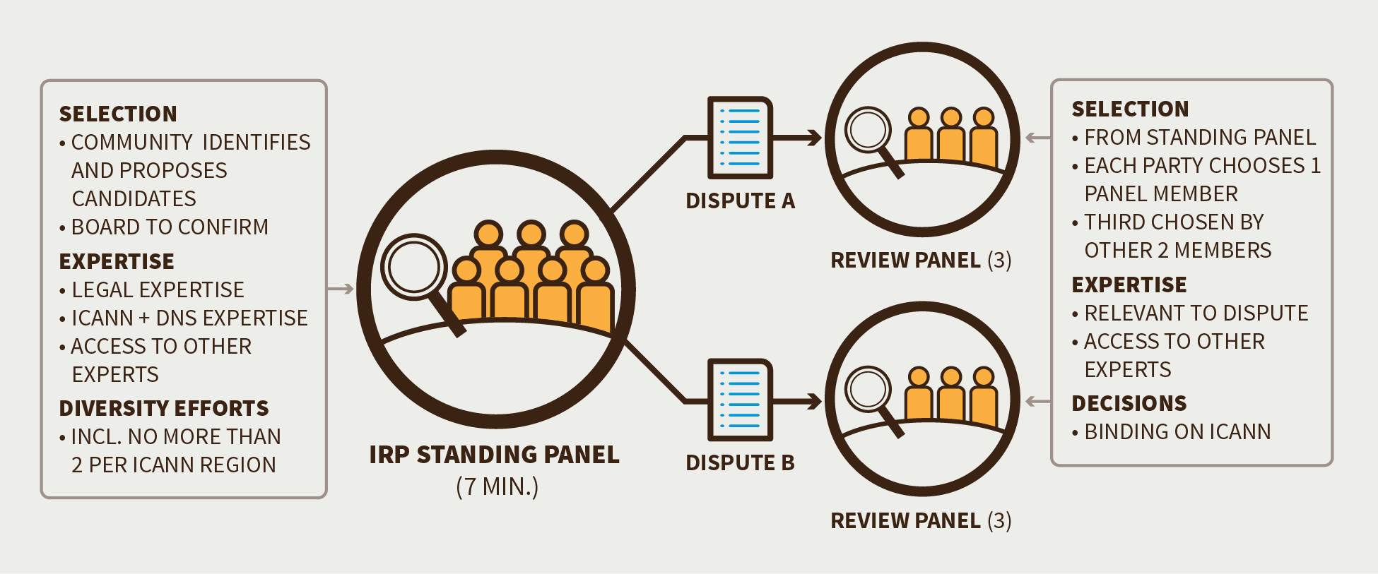

- Diversity
- English will be the primary working language with provision of translation services for claimants as needed. Reasonable efforts will be taken to achieve cultural, linguistic, gender, and legal diversity, with an aspirational cap on number of panelists from any single region (based on the number of members of the Standing Panel as a whole).

- Size of Panel
- Standing Panel: Minimum of seven panelists.
- Decisional Panel: Three panelists.

- Independence
- Panel members must be independent of ICANN, including ICANN SOs and ACs. Members should be compensated at a rate that cannot decline during their fixed term; no removal except for specified cause (corruption, misuse of position for personal use, etc.). To ensure independence, term limits should apply (five years, no renewal), and post-term appointment to Board, Nominating Committee, or other positions within ICANN would be prohibited for a specified time period. Panelists will have an ongoing obligation to disclose any material relationship with ICANN, SOs, and ACs, or any other party in an IRP.

- Selection and Appointment
- The selection of panelists would follow a four-step process:
- ICANN, in consultation with the community, will initiate a tender process for an organization to provide administrative support for the IRP, beginning by consulting the community on a draft tender document.
- ICANN will then issue a call for expressions of interest from potential panelists; work with the community and Board to identify and solicit applications from well-qualified candidates with the goal of securing diversity; conduct an initial review and vetting of applications; and work with ICANN and community to develop operational rules for IRP.
- The community would nominate a slate of proposed panel members.
- Final selection is subject to ICANN Board confirmation.

- Recall
- Appointments made for a fixed term of five (5) years with no removal except for specified cause (corruption, misuse of position for personal use, etc.). The recall process will be developed via the IRP Sub Group.

- Settlement Efforts
- Reasonable efforts, as specified in a published policy, must be made to resolve disputes informally prior to/in connection with filing an IRP case.
- Parties to cooperatively engage informally, but either party may inject independent dispute resolution facilitator (mediator) after an initial Cooperative Engagement Process (CEP) meeting. Either party can terminate informal dispute resolution efforts (CEP or mediation) if, after specified period, that party concludes in good faith that further efforts are unlikely to produce agreement.
- The process must be governed by clearly understood and pre-published rules applicable to both parties and be subject to strict time limits. In particular, the CCWG-Accountability will review the CEP as part of Work Stream 2.

- Decision-Making
- In each case, a three-member panel will be drawn from the Standing Panel. Each party will select one panelist, and those panelists will select the third. The CCWG-Accountability anticipates that the Standing Panel would draft, issue for comment, and revise procedural rules. The Standing Panel should focus on streamlined, simplified processes with rules that are easy to understand and follow.
- Panel decisions will be based on each IRP Panelist’s assessment of the merits of the claimant’s case. The panel may undertake a de novo review of the case, make findings of fact, and issue decisions based on those facts. All decisions will be documented and made public and will reflect a well-reasoned application of the standard to be applied.

- Decisions
- Panel decisions would be determined by a simple majority. Alternatively, this could be included in the category of procedures that the IRP Panel itself should be empowered to set.
- The CCWG-Accountability recommends that IRP decisions be precedential, meaning that panelists should consider and may rely on prior decisions. By conferring precedential weight on panel decisions, the IRP can provide guidance for future actions and inaction by ICANN decision-makers, which is valuable. It also reduces the chances of inconsistent treatment of one claimant or another, based on the specific individuals making up the Decisional Panel in particular cases.
- The CCWG-Accountability intends that if the panel determines that an action or inaction by the Board or staff is in violation of the Articles or Bylaws, that decision is binding and the Board and staff shall be directed to take appropriate action to remedy the breach. However, the Panel shall not replace the Board’s fiduciary judgment with its own judgment.
- It is intended that judgments of a Decisional Panel or the Standing Panel would be enforceable in the court of the United States and other countries that accept international arbitration results.

- Accessibility and Cost
- The CCWG-Accountability recommends that ICANN would bear all the administrative costs of maintaining the system (including panelist salaries), while each party should bear the costs of their own legal advice. The panel may provide for loser pays/fee shifting in the event it identifies a challenge or defense as frivolous or abusive. ICANN should seek to establish access, for example by access to pro bono representation for community, non-profit complainants and other complainants that would otherwise be excluded from utilizing the process.
- The panel should complete work expeditiously, issuing a scheduling order early in the process and in the ordinary course, should issue decisions within a standard time frame (six months). The panel will issue an update and estimated completion schedule in the event it is unable to complete its work within that period.

- Implementation
- The CCWG-Accountability proposes that the revised IRP provisions be adopted as Fundamental Bylaws. Implementation of these enhancements will necessarily require additional, detailed work. Detailed rules for the implementation of the IRP (such as rules of procedure) are to be created by the ICANN community through a CCWG-Accountability (assisted by counsel, appropriate experts, and the Standing Panel when confirmed), and approved by the Board, such approval not to be unreasonably withheld. They may be updated in the light of further experience by the same process, if required. In addition, to ensure that the IRP functions as intended, the CCWG-Accountability proposes to subject the IRP to periodic community review.

- Transparency
- The community has expressed concerns regarding the ICANN document/information access policy and implementation. Free access to relevant information is an essential element of a robust IRP, and as such, the CCWG-Accountability recommends reviewing and enhancing the ICANN Documentary Information Disclosure Policy as part of the accountability enhancements in Work Stream 2.

4. Changes from the “ThridDraft Proposal on Work Stream 1 Recommendations”
- Scope of IRP will be restricted to naming functions.
- Scope of IRP will include actions and inactions of PTI via the Board being bound in the Bylaws to ensure that PTI complies with its contractual obligations with ICANN. ICANN’s failure to enforce such obligations will be appealable via IRP as a Bylaws violation.
- Exclusion – the IRP will not be applicable to protocols and parameters
- Exclusion – An IRP cannot be lauched that challenges the result(s) of a supporting organization’s policy development process (PDP) may be launched without the support of the supporting organization that developed such PDP or, in the case of joint PDPs, without the support of the supporting organizations that developed such PDP.
- Limitation – An IRP challenge of expert panel decisions is limited to challenge of whether panel decision is consistent with ICANN’s Bylaws
- The legal fees of the Empowered Community associated with a Community IRP will be borne by ICANN.

5. Stress Tests Related to this Recommendation
- ST3 & 4
- ST5, 6, 7, 8
- ST11
- ST14
- ST19, 20
- ST10, 16, 24
- ST13
- ST22
- ST23
- ST25
- ST26
- ST29, 30

6. How does this meet the CWG-Stewardship Requirements?
- The recommendations as outlined above meet the CWG-Stewardship requirements by:
- Creating the IRP directly meets the requirement of the CWG-Stewardship for an IRP.
- Excluding ccTLD delegation/redelegation from the IRP.
- As requested by the CWG-Stewardship, decisions regarding country code top-level domains delegations or revocations would be excluded from standing, until the country code top-level domains community, in coordination with other parties, has developed relevant appeals mechanisms.
- Excluding Number Resources from the IRP. The ASO has indicated that disputes related to Internet Number Resources should be out of scope for the IRP. As requested by the ASO, decisions regarding numbering resources would be excluded from standing.

7. How does this address NTIA Criteria?
- Support and enhance the multistakeholder model.
- By enhancing ICANN’s appeals mechanisms and binding arbitration processes and further fortifying and expanding their remit, the community is further empowered.

- Maintain the security, stability, and resiliency of the Internet DNS.
- These accountability measures were designed to contribute to maintaining the operational functioning of organization

- Meet the needs and expectation of the global customers and partners of the IANA services.
- These accountability measures were designed to contribute to maintaining the operational functioning of organization.

- Maintain the openness of the Internet.
- The accountability measures help to mitigate the likelihood of problematic scenarios by ensuring that robust accountability mechanisms are in place.

- NTIA will not accept a proposal that replaces the NTIA role with a government-led or an inter-governmental organization solution.
- N/A

https://archive.icann.org/en/aso/aso-mou-29oct04.htm

