Annex 03 – Recommendation #3: Standard Bylaws, Fundamental Bylaws and Articles of Incorporation

1. Summary
- Currently, the Bylaws of the Internet Corporation for Assigned Names and Numbers (ICANN) have a single mechanism for amendment:
  - Any provision of the ICANN Bylaws can be changed by a 2/3 vote of all the Directors on the ICANN Board.
  - The Board is not required to consult the ICANN community or the wider public before amending the Bylaws, but has voluntarily done so up to this point.
- The CCWG-Accountability recommends classifying each of the ICANN Bylaws as either a “Fundamental Bylaw” or a “Standard Bylaw,” with Fundamental Bylaws being more difficult to change.
- Specifically, the CCWG-Accountability recommends that:
  - Public consultations be required on all changes to ICANN Bylaws, both Fundamental and Standard.
  - The requirement for public consultations is added to the ICANN Bylaws as a Fundamental Bylaw to ensure that ICANN must continue to engage with the community in the future.
  - Any changes to Fundamental Bylaws require approval from both the ICANN Board and Empowered Community as outlined in the respective Community Power (see Recommendation #4: Ensuring Community Involvement in ICANN Decision-making: Seven New Community Powers).
  - The threshold for ICANN Board approval for changing a Fundamental Bylaw is raised from 2/3 to 3/4.
  - Approval for changes to the Articles of Incorporation use the same process required for approving changes to Fundamental Bylaws including public consultations.
- Why is the CCWG-Accountability recommending this?
  - The CCWG-Accountability felt that it was crucial to ensure that ICANN Bylaws that embody the purpose of the organization (Mission, Commitments, and Core Values) and are meant to ensure the accountability of the ICANN Board cannot be changed by the ICANN Board acting alone.

2. CCWG-Accountability Recommendations
- The CCWG-Accountability recommends:
- Classifying each of the ICANN Bylaws as either a Fundamental Bylaw or a Standard Bylaw.
- The following CWG-Stewardship and CCWG-Accountability Recommendations be made Fundamental Bylaws:
  - The Empowered Community for enforcing Community Powers, including the role of sole designator of ICANN’s Directors, as described in Recommendation #1.
  - The escalation and enforcement mechanisms as described in Recommendation #2.
  - The process for amending Fundamental Bylaws and/or Articles of Incorporation, and for approving ICANN’s sale or other disposition of all or substantially all of ICANN’s assets, as described in Recommendation #3.
  - The seven Community Powers as described in Recommendation #4.
  - The Mission, Commitments, and Core Values as described in Recommendation #5.
  - The framework for the Independent Review Process (IRP) as described in Recommendation #7.
  - The IANA Function Review, Special IANA Function Review and the Separation Process, accountability mechanisms for the IANA naming functions that are required under the CWG-Stewardship Proposal.
  - The PTI Governance and Customer Standing Committee (CSC) structures, also required by the CWG-Stewardship Proposal.
  - The rights of investigation and inspection (as described in Recommendation #1: Establishing an Empowered Community for Enforcing Community Powers).

- Requiring ICANN to conduct public consultations on any proposed changes to Standard Bylaws, Fundamental Bylaws or the Articles of Incorporation.
- Requiring approval for any changes to Fundamental Bylaws and the Articles of Incorporation from both the ICANN Board and the Empowered Community as outlined in the Community Power (see Recommendation #4: Ensuring Community Involvement in ICANN Decision-making: Seven New Community Powers).
- Raising the threshold for ICANN Board approval for changing a Fundamental Bylaw or the Articles of Incorporation from 2/3 to 3/4 of all the Directors on the ICANN Board.

3. Detailed Explanation of Recommendations
- What is a Fundamental Bylaw?
- ICANN Bylaws describe how power is exercised in ICANN, including setting out the organization’s Mission, Commitments, and Core Values. Together with the Articles of Incorporation, the Bylaws are an essential part of ICANN because they set the scope of the organization’s corporate authority, determine its governance framework, and define working practices.
- Today, ICANN Bylaws can be changed by a resolution of the Board upon a 2/3 vote of all the Directors. The CCWG-Accountability believes that the set of key Bylaws fundamental to ICANN’s stability and operational continuity and essential for the community’s decision-rights should be given additional protection from changes by requiring Empowered Community approval of any amendments. These key Bylaws will be identified as Fundamental Bylaws.
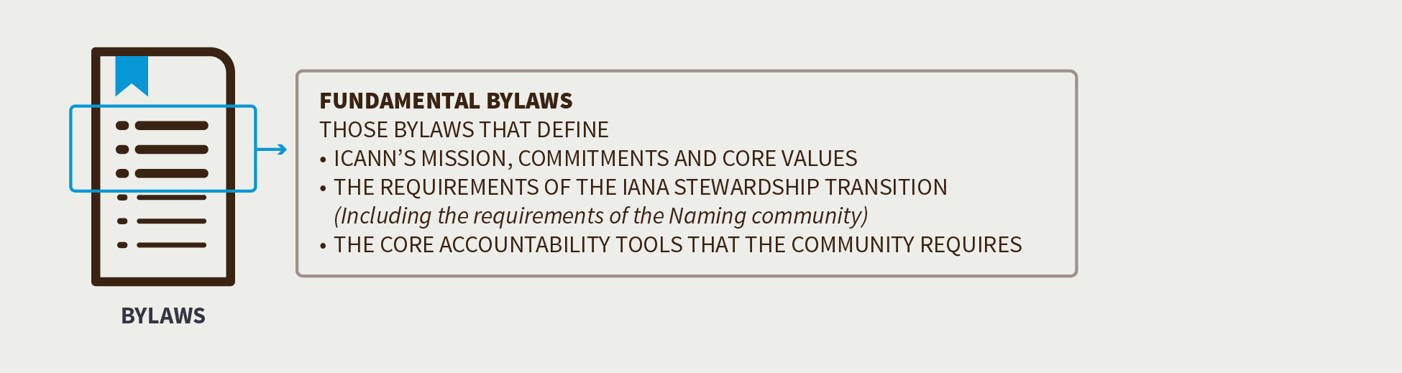

- As such, the CCWG-Accountability proposes to make Fundamental Bylaws harder to change than Standard Bylaws in two ways:
- By sharing the authority to authorize changes between the ICANN Board and the Empowered Community (organized through participating Supporting Organizations (SOs) and Advisory Committees (ACs), the “Decisional Participants” in the Empowered Community, as outlined in Recommendation #1: Establishing an Empowered Community for Enforcing Community Powers).
- By requiring a higher threshold of Board support to authorize changes to Fundamental Bylaws than for Standard Bylaws.
- The establishment of Fundamental Bylaws would indirectly enhance ICANN’s accountability to the global Internet community by sharing the authority of decision-making more widely and increasing the difficulty of amending these key aspects of ICANN.
- This recommendation is important in the context of the IANA Stewardship Transition because the historical contractual relationship with the U.S. Government provided assurance to the community that the fundamental nature of ICANN was unlikely to be changed without widespread agreement. Without that relationship in place, procedural protections and more widely shared decision-rights on core components of ICANN’s scope and authority should help maintain the community’s confidence in ICANN.

- Establishing Fundamental Bylaws
- To implement the establishment of Fundamental Bylaws, a new provision would be added to the Bylaws that sets out:
- Which sections of the Bylaws are Fundamental Bylaws (i.e., a list of the fundamental articles/sections/subsections).
- How new Fundamental Bylaws can be defined and how existing Fundamental Bylaws can be amended or removed.

- Adding New or Amending Existing Fundamental Bylaws
- While the CCWG-Accountability recommends fortifying certain aspects of the ICANN Bylaws, the global public interest would not be served if ICANN could not evolve in response to the changing Internet environment. Therefore, the CCWG-Accountability recognizes the importance of the ability to define new Fundamental Bylaws over time, or to amend or remove existing ones.
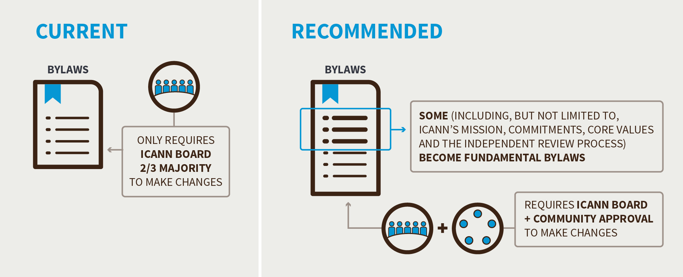

- The following steps would be required to establish a new Fundamental Bylaw or to amend or remove an existing one, where the ICANN Board (or the staff through the ICANN Board) is proposing the addition, amendment or removal:
- The Board proposes a new Fundamental Bylaw, amendment of a Fundamental Bylaw, or removal of a Fundamental Bylaw.
- The Board approves the addition, amendment, or removal of the Fundamental Bylaw with a 3/4 vote of all the Directors on the ICANN Board.
- The Empowered Community approves the addition, amendment, or removal of the Fundamental Bylaw (see Recommendation #4: Ensuring Community Involvement in ICANN Decision-making: Seven New Community Powers).

- If the addition, amendment, or removal of the Fundamental Bylaw is agreed upon by both the ICANN Board and the Empowered Community:
- The new/revised Fundamental Bylaw would be inserted in the Bylaws, and an appropriate reference to the text as a Fundamental Bylaw would be added (if needed) to the part of the Bylaws that lists them.
- In the case of an amendment to existing Bylaws text, the text would be updated.
- In the case of a removal, the text would be removed.
- The CCWG-Accountability does not propose that the community gain the power to directly propose changes to the Bylaws.

- Which of the Current Bylaws Would Become Fundamental Bylaws?
- The CCWG-Accountability recommends that only critical aspects of the ICANN Bylaws be classified as Fundamental Bylaws to avoid introducing unnecessary rigidity into ICANN’s structures. The CCWG-Accountability concluded that recommending that all changes to ICANN Bylaws should face the same thresholds that are proposed for Fundamental Bylaws would harm, not help, ICANN’s overall accountability.
- The CCWG-Accountability views “critical aspects” as those that define ICANN’s Mission, Commitments, and Core Values, the requirements of the CWG-Stewardship Proposal, and the core accountability tools the community requires.
- Accordingly, the CCWG-Accountability recommends that the following aspects be made Fundamental Bylaws as a part of Work Stream 1:
- The Empowered Community for enforcing Community Powers, including the role of sole designator of ICANN’s Directors, as described in Recommendation #1.
- The escalation and enforcement mechanisms as described in Recommendation #2.
- The process for amending Fundamental Bylaws and/or Articles of Incorporation, and for approving ICANN’s sale or other disposition of all or substantially all of ICANN’s assets, as described in Recommendation #3.
- The seven Community Powers as described in Recommendation #4.
- The Mission, Commitments, and Core Values as described in Recommendation #5.
- The framework for the Independent Review Process as described in Recommendation #7.
- The IANA Function Review, Special IANA Function Review and the Separation Process, accountability mechanisms for the IANA naming functions that are required under the CWG-Stewardship Proposal.
- The PTI Governance and Customer Standing Committee (CSC) structures, also required by the CWG-Stewardship Proposal.
- The rights of investigation and inspection (as described in Recommendation #1: Establishing an Empowered Community for Enforcing Community Powers).

- Articles of Incorporation

- The CCWG-Accountability legal counsel has advised the following when considering changes to the ICANN Articles of Incorporation:
“The constituent documents of a California nonprofit public benefit corporation such as ICANN are its Articles of Incorporation and its Bylaws. There is a hierarchy between these documents—the articles prevail to the extent that there is any conflict between the Articles and the Bylaws. This hierarchical relationship holds even if the conflict is between the Articles and a “fundamental” Bylaw that requires the consent of a third party (in the case of ICANN, the Empowered Community) to be amended.
Under California nonprofit corporation law, if a corporation has no statutory members, amendments to the articles may be adopted by the board. However, the amendment of articles may be made subject to the consent of a third party, just as the amendment of bylaws may be. In the case of ICANN, if the Empowered Community is not provided a right to approve amendments to the Articles, there is a risk that Fundamental Bylaw provisions could be undermined by amendment of the Articles by the ICANN Board, given the hierarchical relationship described above. Thus, we recommend including an approval right with respect to amendments to ICANN’s Articles in favor of the Empowered Community in the same way the Empowered Community has approval rights with respect to Fundamental Bylaws.”
- As such the CCWG-Accountability is recommending that changes to the ICANN Articles of Incorporation follow the same approval process and thresholds described above for approving changes to Fundamental Bylaws.
- It is important to note ICANN’s current Articles of Incorporation state that:
“9. These Articles may be amended by the affirmative vote of at least two-thirds of the directors of the Corporation. When the Corporation has members, any such amendment must be ratified by a two-thirds (2/3) majority of the members voting on any proposed amendment.”
- The CCWG-Accountability therefore recommends that the Articles of Incorporation be modified to remove the notion of members and reflect the need for a higher affirmative vote of at least three quarters of all the Directors on the ICANN Board, as well as approval by the Empowered Community using the same approval process and thresholds as for approving changes to Fundamental Bylaws.

- Does the location of ICANN’s principal office need to be a Fundamental Bylaw?
- The ICANN Articles of Incorporation and Bylaws address both the state of incorporation (or corporate domicile) of ICANN and the location of its principal office:
- ICANN’s present Articles of Incorporation state:
“3. This Corporation is a nonprofit public benefit corporation and is not organized for the private gain of any person. It is organized under the California Nonprofit Public Benefit Corporation Law for charitable and public purposes."

- ICANN’s present Bylaws Article XVIII Section 1 state:
“OFFICES. The principal office for the transaction of the business of ICANN shall be in the County of Los Angeles, State of California, United States of America. ICANN may also have an additional office or offices within or outside the United States of America as it may from time to time establish.”

- The Affirmation of Commitments paragraph 8(b) states:
“ICANN affirms its commitments to: (b) remain a not for profit corporation, headquartered in the United States of America with offices around the world to meet the needs of a global community…”

- As recommended by the CCWG-Accountability in the above section, the Articles of Incorporation would require that approval of any changes to the Articles of Incorporation use the same process and thresholds required for approving changes to Fundamental Bylaws. Thus, ICANN’s state of incorporation/corporate domicile could not be changed without the affirmative consent of the Empowered Community. However, to ensure that ICANN’s status as a California nonprofit public benefit corporation could not be changed via transfer of assets and/or dissolution without the affirmative consent of the Empowered Community, a provision will need to be added to the Articles of Incorporation requiring Empowered Community approval for a transfer of all or substantially all of the assets of ICANN.
- The Board could propose a change to the Bylaws provision requiring the location of ICANN’s “principal office” in California, but the Empowered Community could block the change. There was not a consensus to support making this provision a Fundamental Bylaw requiring the affirmative consent of the Empowered Community.
- Community Power: Approve Changes to Fundamental Bylaws and the Articles of Incorporation
- Establishing Fundamental Bylaws and requiring Empowered Community approval of amendments to the Articles of Incorporation would ensure that critical aspects of the powers and processes required to maintain ICANN’s accountability to the community, and the organization’s Mission, Commitments, and Core Values, can only be changed as a result of broad consensus of both the ICANN Board and the community.
- The Empowered Community would have to affirmatively consent to any change proposed and adopted by the ICANN Board before the amendment could become legally effective, as part of a joint decision process between the ICANN Board and the Empowered Community. By creating this special joint decision process, authority to change fundamental aspects of ICANN’s governing framework is shared more broadly than it is today.
- The CCWG-Accountability is working under the assumption that the Articles of Incorporation and the Bylaws provisions that are recommended to become Fundamental Bylaws are not likely to change frequently. Where changes are made, they are unlikely to arise on short notice or be needed to deal with short-term operational situations. The CCWG-Accountability therefore does not believe that this Community Power, as proposed, poses any challenges to ICANN’s ongoing operational viability, stability or efficiency.
- Such changes require a high degree of support from the Decisional Participants in the Empowered Community, as the purpose of this power is to make changing Fundamental Bylaws or the Articles of Incorporation possible only with very wide support from the community.
- For further information about the other Community Powers recommended by the CCWG-Accountability, see Recommendation #4: Ensuring Community Involvement in ICANN Decision-making: Seven New Community Powers.

4. Changes from the “Third Draft Proposal on Work Stream 1 Recommendations”
- Clarified that IFR provisions apply only to the IANA naming functions (CWG-Stewardship requirement).
- Clarified the process for changes of Articles of Incorporation to be similar to process for changes to Fundamental Bylaws, as well as the process for approving ICANN’s sale or other disposition of all or substantially all of ICANN’s assets.
- Added a specific recommendation that the current Articles of Incorporation be modified to remove the notion of members and reflect the need for an affirmative vote of at least three quarters of all the Directors on the ICANN Board, as well as approval by the Empowered Community.

5. Stress Tests Related to this Recommendation
- N/A

6. How does this meet the CWG-Stewardship Requirements?
- These recommendations meet the CWG-Stewardship requirement that the CCWG-Accountability recommend the creation of Fundamental Bylaws and that these include the following:
- ICANN Budgets and Strategic/Operating Plans and IANA Budgets: Community rights regarding the development and consideration of ICANN Budgets, Strategic/Operating Plans and IANA Budgets.
- ICANN Board: Community rights regarding the ability to appoint/remove Directors of the ICANN Board and recall the entire Board.
- ICANN Bylaws: Incorporation of the following into ICANN’s Bylaws: IANA Function Review, Special IANA Function Review, PTI Governance, Customer Standing Committee, and the Separation Process.
- Independent Review Process: Should be made applicable to IANA functions and accessible by managers of top-level domains.

7. How does this address NTIA Criteria?
- Support and enhance the multistakeholder model.
- Ensuring the multistakeholder model accountability mechanisms cannot be modified without the Empowered Community’s approval.

- Maintain the security, stability, and resiliency of the Internet DNS.
- Establishing Fundamental Bylaws that provide additional protections to ICANN Bylaws that are critical to the organization’s stability and operational continuity.

- Meet the needs and expectation of the global customers and partners of the IANA services.
- N/A

- Maintain the openness of the Internet.
- N/A

- NTIA will not accept a proposal that replaces the NTIA role with a government-led or an inter-governmental organization solution.
- N/A

