Annex 06 – Recommendation #6: Reaffirming ICANN's Commitment to Respect Internationally Recognized Human Rights as it Carries Out its Mission

1. Summary
- The subject of including a commitment to respect Human Rights in the ICANN Bylaws has been extensively discussed by the CCWG-Accountability.
- The CCWG-Accountability sought legal advice on whether, upon the termination of the IANA Functions Contract between ICANN and the U.S. National Telecommunications and Information Administration (NTIA), ICANN’s specific Human Rights obligations could be called into question. It was found that, upon termination of the Contract, there would be no significant impact on ICANN’s Human Rights obligations. However, the CCWG-Accountability reasoned that a commitment to respect Human Rights should be included in ICANN's Bylaws in order to comply with the NTIA criteria to maintain the openness of the Internet.
- This proposed draft Bylaw on Human Rights would reaffirm ICANN’s existing obligations within its Core Values, and would clarify ICANN’s commitment to respect Human Rights.
- Amendments to the proposed draft Bylaw text since the Second Draft Proposal aimed to prevent Mission expansion or “Mission creep,” and under the proposed draft Bylaw, ICANN commits to respect internationally recognized Human Rights “within its Core Values.”
- The proposed draft Bylaw does not impose any enforcement duty on ICANN, or any obligation on ICANN to take action in furtherance of the Bylaw.
- The proposed draft Bylaw also clarifies that no IRP challenges can be made on the grounds of this Bylaw until a Framework of Interpretation on Human Rights (FOI-HR) is developed and approved as part of Work Stream 2 activities. It further clarifies that acceptance of the FOI-HR will require the same process as for Work Stream 1 recommendations (as agreed for all Work Stream 2 recommendations).
- Additionally, the CCWG-Accountability has identified several work areas that need to be undertaken as part of Work Stream 2 in order to fully operationalize ICANN’s commitment to respect Human Rights.

2. CCWG-Accountability Recommendations
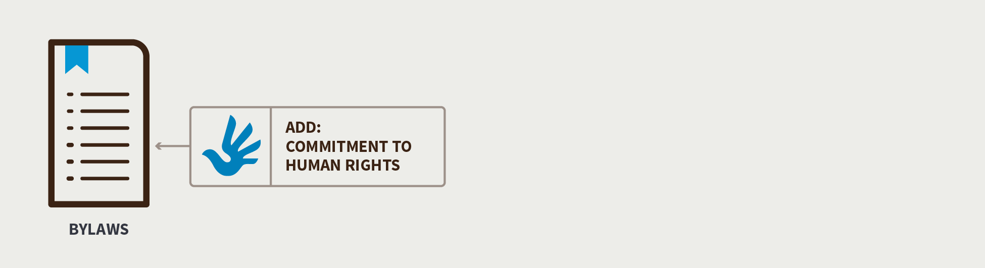

- Include a Bylaw with the following intent in Work Stream 1 recommendations:
  - “Within its Core Values, ICANN will commit to respect internationally recognized Human Rights as required by applicable law. This provision does not create any additional obligation for ICANN to respond to or consider any complaint, request, or demand seeking the enforcement of Human Rights by ICANN. This Bylaw provision will not enter into force until (1) a Framework of Interpretation for Human Rights (FOI-HR) is developed by the CCWG-Accountability as a consensus recommendation in Work Stream 2 (including Chartering Organizations’ approval) and (2) the FOI-HR is approved by the ICANN Board using the same process and criteria it has committed to use to consider the Work Stream 1 recommendations.”

  - Note: This proposed draft Bylaw will be reviewed by both CCWG-Accountability’s lawyers and ICANN’s legal department and then submitted to the CCWG-Accountability for approval before its submission to the Board for approval.

- Include the following in Work Stream 2 activities:
- The CCWG-Accountability identified several work areas that it recommends should be undertaken as part of Work Stream 2 in order to fully operationalize ICANN’s commitment to respect Human Rights:
- Develop an FOI-HR for the Human Rights Bylaw.
- Consider which specific Human Rights conventions or other instruments should be used by ICANN in interpreting and implementing the Human Rights Bylaw.
- Consider the policies and frameworks, if any, that ICANN needs to develop or enhance in order to fulfill its commitment to respect Human Rights.
- Consistent with ICANN’s existing processes and protocols, consider how these new frameworks should be discussed and drafted to ensure broad multistakeholder involvement in the process.
- Consider what effect, if any, this Bylaw will have on ICANN’s consideration of advice given by the Governmental Advisory Committee (GAC).
- Consider how, if at all, this Bylaw will affect how ICANN’s operations are carried out.
- Consider how the interpretation and implementation of this Bylaw will interact with existing and future ICANN policies and procedures.

3. Detailed Explanation of Recommendations
- As part of the discussion on the inclusion of a Human Rights Bylaw, the CCWG-Accountability requested analysis from its legal counsel about whether, upon the termination of the IANA Functions Contract between ICANN and the NTIA, ICANN’s specific Human Rights obligations could be called into question. The key aspects are as follows:
- Only nation states have direct Human Rights obligations under international law. However, private sector organizations are required to comply with all applicable laws, including those related to Human Rights.
- Upon termination of the Contract, there would be no significant impact on ICANN’s Human Rights obligations.

- However, the CCWG-Accountability reasoned that a commitment to respect Human Rights should be included in ICANN's Bylaws in order to comply with the NTIA criteria to maintain the openness of the Internet. These criteria include free expression and the free flow of information.
- Further, the CCWG-Accountability emphasized that adding a commitment to respect Human Rights to the ICANN Bylaws should not lead to an expansion of ICANN's Mission or scope. While there was general agreement that ICANN should commit to respect Human Rights within the limited scope of its Core Values, any type of external enforcement or regulatory activity would be wholly out of scope.
- The CCWG-Accountability also disagreed with any attempt to single out any specific Human Rights (such as “freedom of expression”) in the proposed draft Bylaw text on the basis that Human Rights cannot be selectively mentioned, emphasized, or applied since they are universal, indivisible, interdependent, and interrelated.
- The CCWG-Accountability considered comments received during the third public comment period which were overall in favor of including Human Rights language with a few exceptions which included the ICANN Board.
- The CCWG-Accountability engaged with the Board to specifically address its concerns through discussion and debate in three plenary calls. Additionally, ICANN’s legal team and CCWG-Accountability’s legal advisors discussed the concerns raised by ICANN legal regarding the possibility of having a significant number of IRP challenges initiated on the grounds of Human Rights claims and the problems this could create without having a Framework of Interpretation in place to properly implement the proposed Bylaw provision.
- The CCWG-Accountability developed compromise text based on a proposal by its legal advisors which it believed addressed these concerns. The ICANN Board maintained that this compromise text did not address its concerns but did not provide any specific examples of its concerns regarding the alleged unintended consequences.
- The Board responded with proposed changes to the draft Bylaw text, which reflected a compromise position and included a commitment to respect Human Rights within ICANN’s Core Values, which were accepted by the CCWG-Accountability.
- This proposed draft Bylaw on Human Rights reaffirms ICANN’s existing obligations within its Core Values and clarifies ICANN’s commitment to respect Human Rights.
- Amendments to the proposed draft Bylaw text since the Second Draft Proposal aimed to prevent Mission expansion or “Mission creep,” and under the proposed draft Bylaw, ICANN commits to respect internationally recognized Human Rights “within its Core Values.”
- The proposed draft Bylaw does not impose any enforcement duty on ICANN, or any obligation on ICANN to take action in furtherance of the Bylaw.
- The proposed draft Bylaw also clarifies that no IRP challenges can be made on the grounds of this Bylaw until an FOI-HR is developed and approved as part of Work Stream 2 activities. It further clarifies that acceptance of the FOI-HR will require the same process as for Work Stream 1 recommendations (as agreed for all Work Stream 2 recommendations).
- Additionally, the CCWG-Accountability has identified several work areas that need to be undertaken as part of Work Stream 2 in order to fully operationalize ICANN’s commitment to respect Human Rights, including the development of an FOI-HR.
- Draft Bylaw on Human Rights
- Responding to public comments received on the Third Draft Proposal the CCWG-Accountability presents the following proposed draft Bylaw for consideration:

- “Within its Core Values, ICANN will commit to respect internationally recognized Human Rights as required by applicable law. This provision does not create any additional obligation for ICANN to respond to or consider any complaint, request, or demand seeking the enforcement of Human Rights by ICANN. This Bylaw provision will not enter into force until (1) a Framework of Interpretation for Human Rights (FOI-HR) is developed by the CCWG-Accountability as a consensus recommendation in Work Stream 2 (including Chartering Organizations’ approval) and (2) the FOI-HR is approved by the ICANN Board using the same process and criteria it has committed to use to consider the Work Stream 1 recommendations.”

- Operationalizing the Commitment to Respect Human Rights
- To ensure that these Work Stream 2 activities are implemented, the CCWG-Accountability requires that a Bylaw be adopted as part of Work Stream 1. The Bylaw proposed for adoption as part of Work Stream 1 will not enter into force until the FOI-HR is approved.
- The CCWG-Accountability has identified several activities that it recommends be undertaken as part of Work Stream 2 that will fully operationalize ICANN’s commitment to respect Human Rights. Work Stream 2 focuses on accountability topics for which a timeline for developing solutions and full implementation may extend beyond the IANA Stewardship Transition.
- 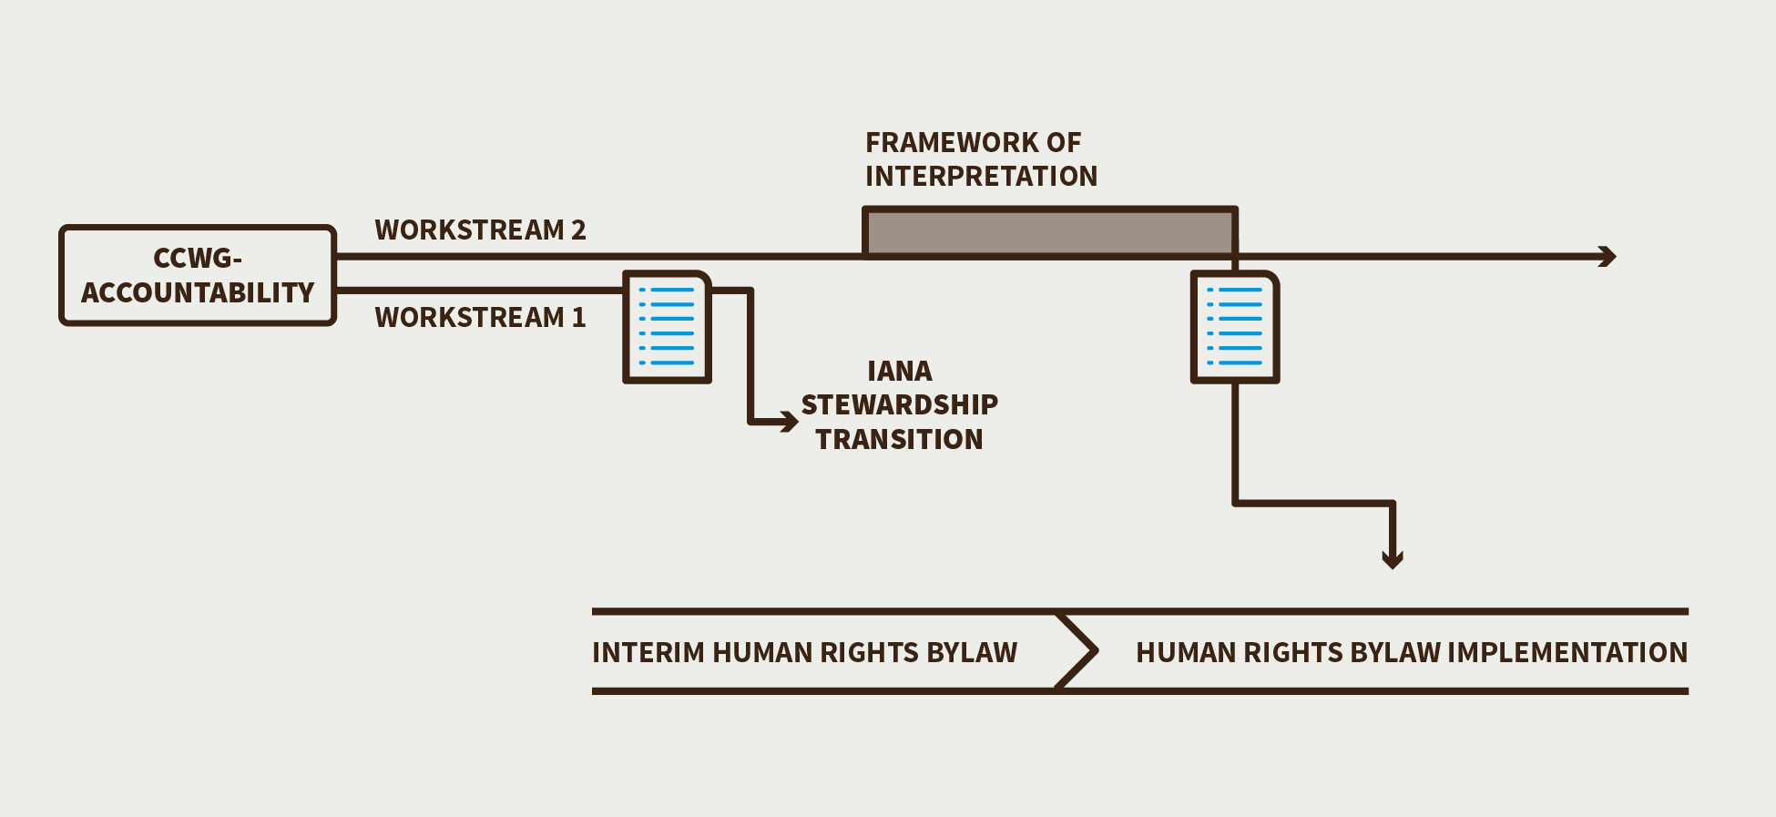

- The Human Rights-related activities to be addressed in Work Stream 2 are:
- Developing an FOI-HR for the Bylaw.
- Considering which specific Human Rights conventions or other instruments should be used by ICANN in interpreting and implementing the Bylaw.
- Considering the policies and frameworks, if any, that ICANN needs to develop or enhance in order to fulfill its commitment to respect Human Rights.
- Considering how these new frameworks should be discussed and drafted to ensure broad multistakeholder involvement in the process, consistent with ICANN’s existing processes and protocols.
- Considering what effect, if any, this Bylaw will have on ICANN’s consideration of advice given by the GAC.
- Considering how, if at all, this Bylaw will affect how ICANN’s operations are carried out once an FOI-HR is developed by the CCWG-Accountability as a consensus recommendation in Work Stream 2 (including Chartering Organizations’ approval) and the FOI-HR is approved by the ICANN Board using the same process and criteria it has committed to use to consider the Work Stream 1 recommendations.
- Considering how the interpretation and implementation of this Bylaw will interact with existing and future ICANN policies and procedures.

4. Changes from the “Third Draft Proposal on Work Stream 1 Recommendations”
- The CCWG-Accountability considered comments received during the third public comment period which were overall in favor of including Human Rights language with a few exceptions which included the ICANN Board.
- The CCWG-Accountability engaged with the Board to specifically address its concerns through discussion and debate in three plenary calls. Additionally, ICANN’s legal team and CCWG-Accountability’s legal advisors discussed the concerns raised by ICANN legal regarding the possibility of having a significant number of IRP challenges initiated on the grounds of Human Rights claims and the problems this could create without having a Framework of Interpretation in place to properly implement the proposed Bylaw provision.
- The CCWG-Accountability developed compromise text based on a proposal by its legal advisors which it believed addressed these concerns. The ICANN Board maintained that this compromise text did not address its concerns but did not provide any specific examples of its concerns regarding the alleged unintended consequences.
- The Board responded with proposed changes to the draft Bylaw text, which reflected a compromise position and included a commitment to respect Human Rights within ICANN’s Core Values, which were accepted by the CCWG-Accountability.

5. Stress Tests Related to this Recommendation
- N/A

6. How does this meet the CWG-Stewardship Requirements?
- N/A

7. How does this address NTIA Criteria?
- Support and enhance the multistakeholder model.
- N/A

- Maintain the security, stability, and resiliency of the Internet DNS.
- N/A
- Meet the needs and expectation of the global customers and partners of the IANA services.
- The global customers and partners of the IANA services have expectations with respect to Human Rights. The implementation of these recommendations will partially address these expectations.

- Maintain the openness of the Internet.
- Recommendation #6 is instrumental to meeting this requirement

- NTIA will not accept a proposal that replaces the NTIA role with a government-led or an inter-governmental organization solution.
- N/A

See the 29 July 2015 memorandum here: https://community.icann.org/download/attachments/53783718/Memo_%20%20%20ICANN%20%20Human%20Rights%20Obligations.pdf?version=1&modificationDate=1438504619000&api=v2. All other legal documents provided are available at https://community.icann.org/x/OiQnAw.

