FELLOWSHIP COACHING GUIDELINES
Updated: April 2017

This document is meant to be an evolving guide for ICANN Fellowship Coaches and Community Mentors; it is updated regularly using feedback from Coaches and Community Mentors of each ICANN Meeting. The guide is meant to ensure a harmonized and consistent approach amongst all Fellowship teams, as well as to make the coaching experience a successful worthwhile endeavor for both Coaches and their assigned team members.

BACKGROUND

With the success of the first ICANN Fellowship Program in 2007 and the positive feedback received for years afterwards in regard to its direct impact on the community, in 2011 the number of Fellowship slots for each ICANN Meeting increased. This made the Program available more accessible to eligible newcomers as well as providing opportunities for those who have already successfully completed a fellowship to return and coach their colleagues and newcomers as returning Program Alumni.

From the very beginning, the main goal of the ICANN Fellowship Coaching Program is to make those just starting their ICANN meeting journey (or becoming re-engaged) feel more prepared and comfortable participating at the Meeting, resulting in a more meaningful experience so that the fellow will want to remain in the ICANN community to support Policy Development as a working volunteer.

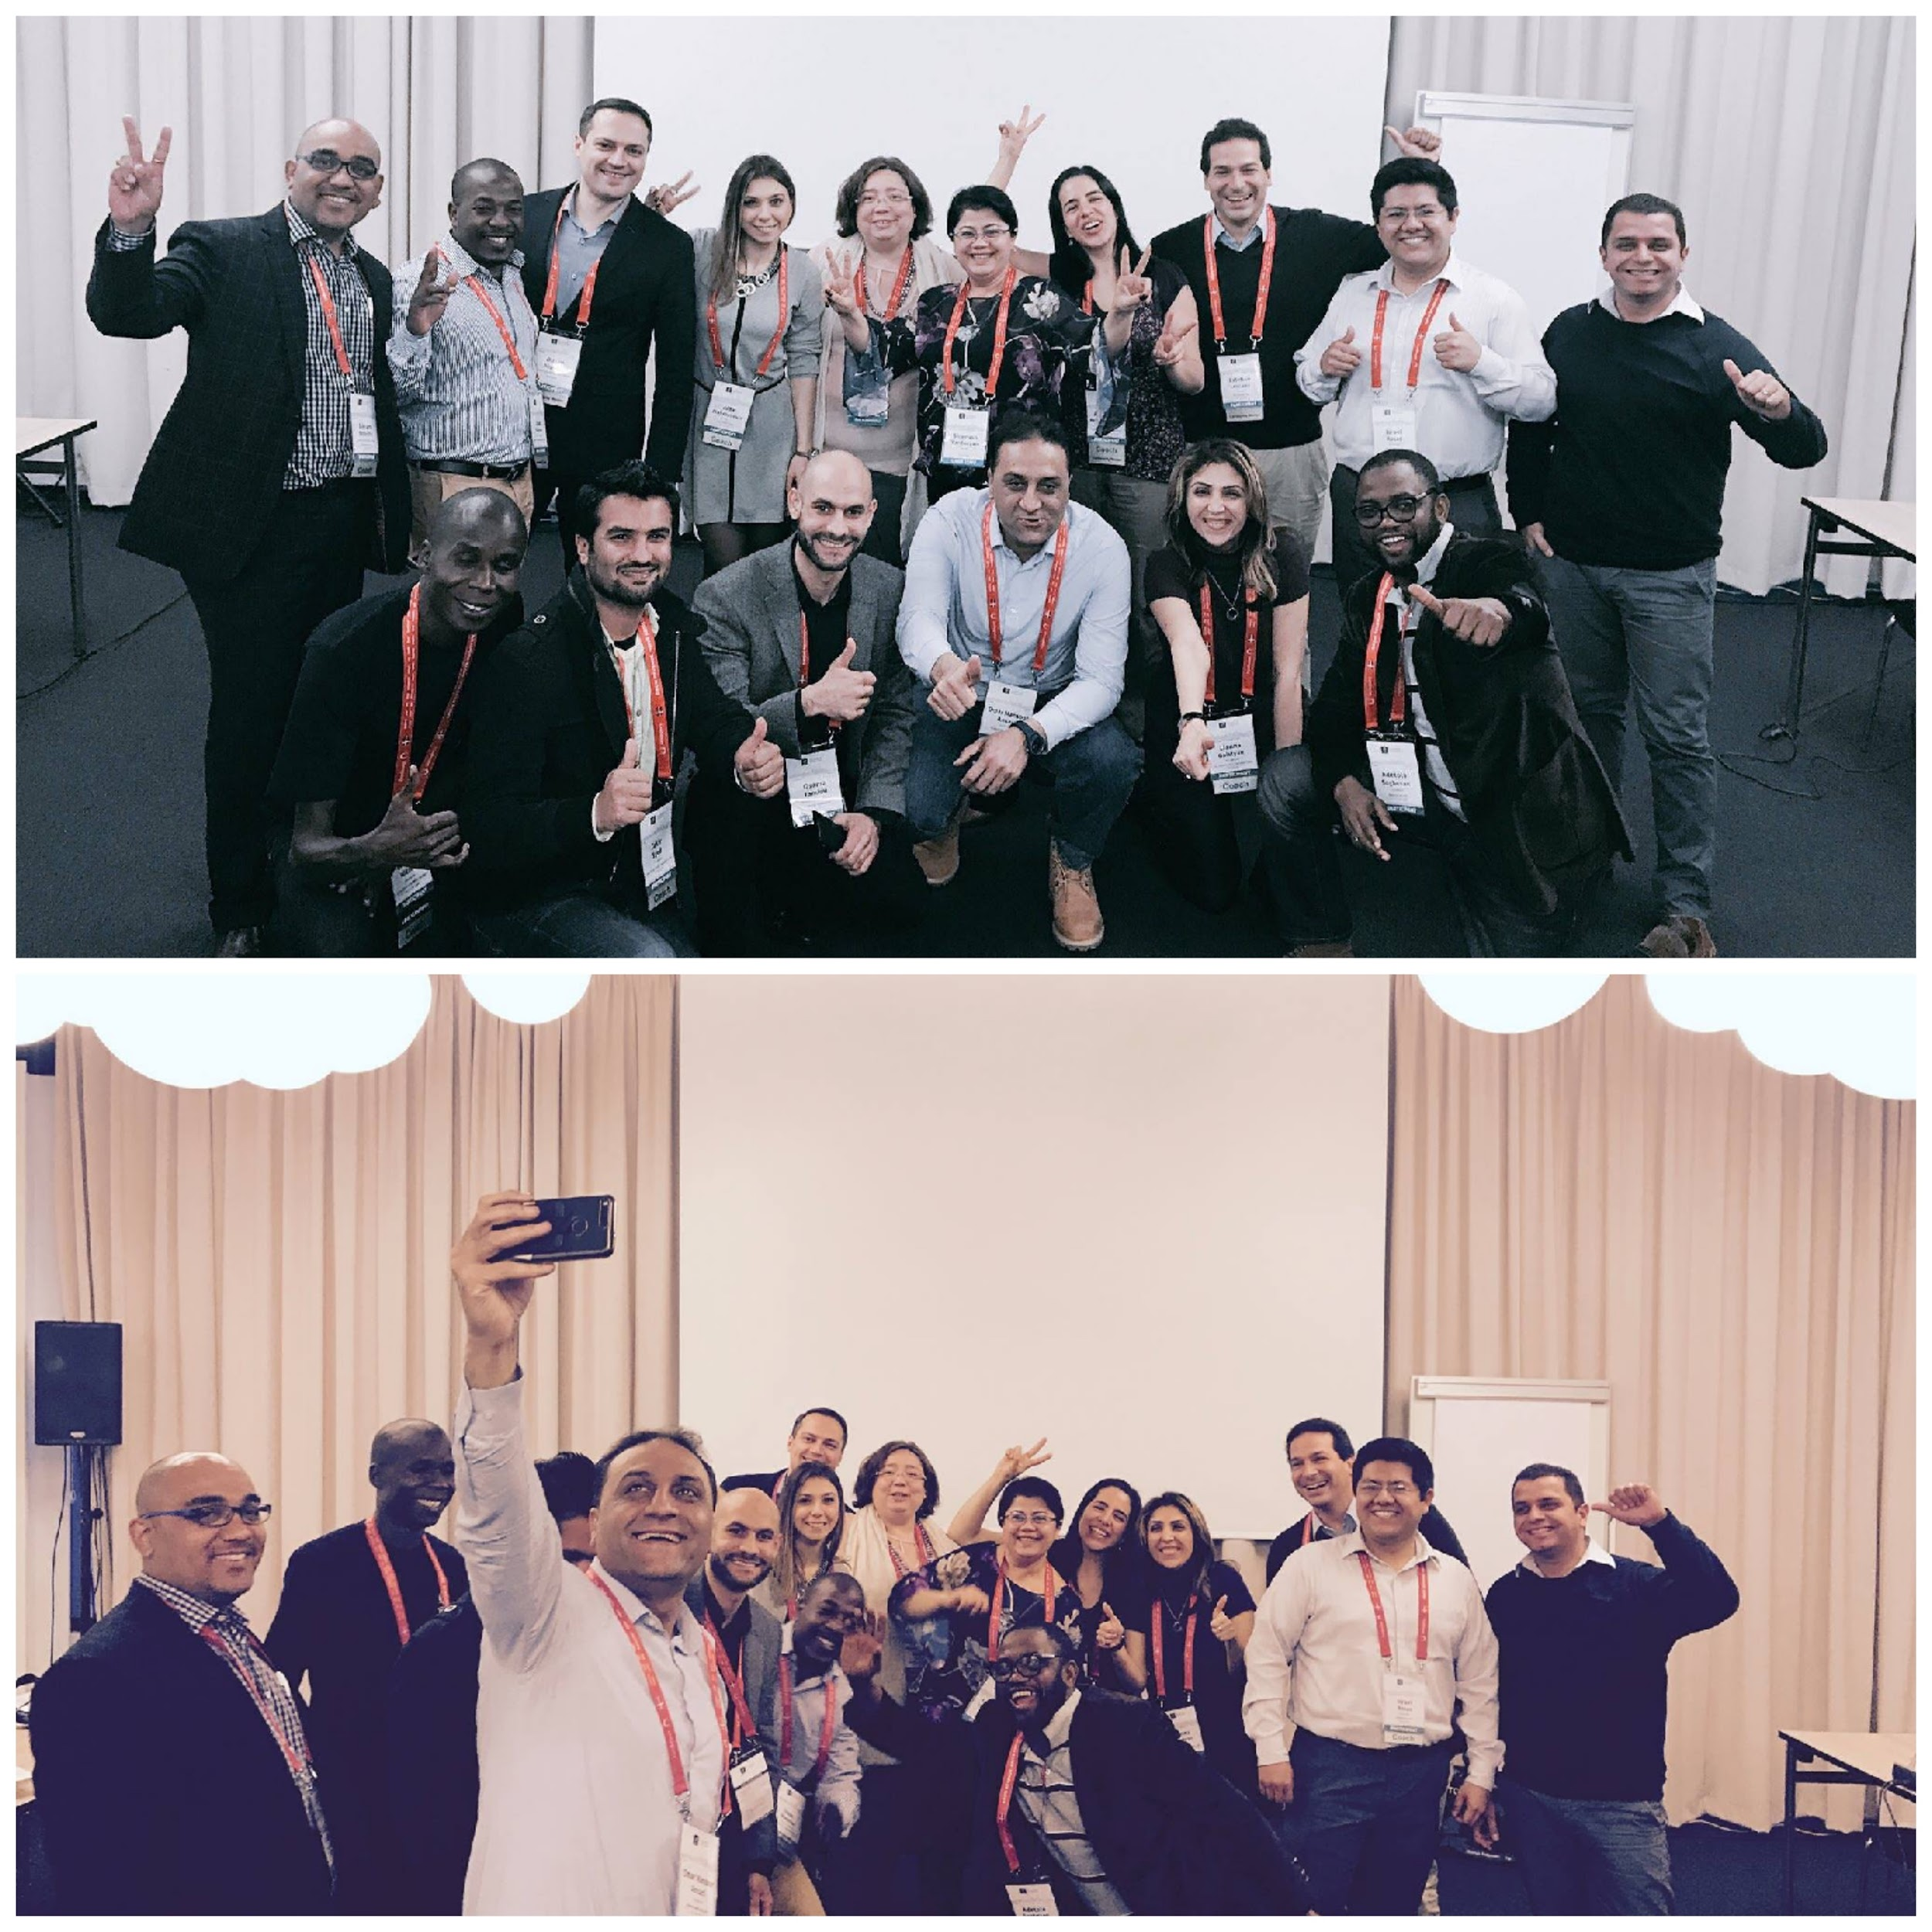

Coaches and Community Mentors meeting at ICANN 58, photos credit: A. Mahmutović

COACH PROFILE

An ICANN Fellowship Program alumni is selected for the Coach role after having fulfilled the following criteria:
- Completed minimum 1 Fellowship
- Received strong support from an ICANN Community (member and/or Regional ICANN Staff Member and/or Global Internet Leader)
- Possesses good understanding of ICANN, its mission and model
- Shown active engagement in one of the ICANN Communities
- Applied via Fellowship Program Application and clearly explained in the fellowship application form why they want to be a coach and what achievements demonstrate their “I can do it” attitude
- Has the time/bandwidth to perform the duties

After being selected for the Coach role, is aware and accepts:
- Duties should be performed continuously 2 months before the Meeting, at the Meeting itself, and post Meeting to summarize team reports as well as provide their own

COACH AND TEAM

The Coaching Program is aimed at helping the ICANN Fellows prepare for the ICANN Meeting experience through the Fellowship method of effective, fast track, immersed learning and interaction.
The following can describe a member (a Mentee) of any team that a Coach needs to be prepared to assist:
  - Newcomer to the I*world
  - Newcomer to ICANN, but familiar with the I* organizations
  - Aware of ICANN, but never attended an ICANN Meeting
  - Participated in an ICANN Meeting, but not as a Fellow / not immersed in the culture
  - Returning Fellows / participants who have yet to fully grasp the Multi-stakeholder concept, need more exposure and networking, or not yet committed to a certain Community
In addition:
  - Keep in mind that some mentees/members of a team, might have different abilities and/or require special needs - this requires the coach to be open to this and ready to use special techniques to communicate and guide

A team is comprised in average of 3 mentees and the Coach, to maximize the time and quality of the experience that can be provided to each fellow in this process. A team is initially created by the Fellowship Office, using the following guidelines for matching team members to a Coach:

- Sector of Interest
- Language in common
- Geographic proximity / regional profile
- Experience of the Coach
- Prior exposure to ICANN and/or Fellowship

ICANN Fellowship Staff will seek balance between the Coach’s experience and the mentee’s to avoid a big gap between them (which can sometimes be that the Mentee has more experience than Coach but not in ICANN community or Fellowship matters)

COACH IS EXPECTED TO

- Be accessible/approachable to mentees in his/her team through previously agreed upon social media channels and/or email for communication, at reasonable time frames throughout the experience (pre, during and post meeting)
- Be able to create a welcoming atmosphere of openness and understanding, and to show a desire to be helpful
- Be able to be a good listener and communicator
- Be a good team player, work with other Coaches to coordinate a consistent experience; and be ready to support other coaches in area of expertise when needed
- Be able to be unbiased during the training/coaching. Keep in mind: “This is their journey, not yours.”
- Provide help and feedback to mentees with their Agenda, once they set it up
- Update Fellowship Office whenever needed
- Copy ICANN Fellowship Manager in email communication *only* for urgent matters, or when the communication with mentee(s) is lacking

ROLES AND GOALS OF A COACH

The main role of the Fellowship Coach is to support other fellows in their learning process during the Fellowship Program: about ICANN, its Communities and work - while keeping in mind the various and diverse backgrounds that individual team members come from, in order for each to get similar benefits from the experience.
The goal is to prepare each individual to be able to quickly engage even if at most basic level once the meeting begins; to create a team bond, a support system, and to understand the meeting process itself.

This is expected to be done through:
- Guiding individuals through ICANN Learn online courses and other available resources before, the meeting, and be a guide AT the Meeting
- Disseminating relevant information in a simple manner that makes it easier to understand and retain
- Responding in a timely manner to any queries on the information provided
- Coordination with other coaches who have sector experience or background different from yours, in order to make sure all aspects for understanding ICANN are included, and that questions from every area can be answered
- Working to develop confidence through learning
- Prepare your mentees for good networking experiences through regular engagement, interaction, Q&A
- Facilitate introduction AT the meeting with ICANN Staff, Community Members and others = help them initiate networking.
Remember! - sharing your experiences and fellowship success stories could be fun and is helpful here

TIMELINES

Following the ICANN Meeting Fellowship Announcement on ICANN website is the 2 week confirmation period to finalize the Fellowship group for each meeting.
Once group is confirmed, another 2 weeks are required for ICANN Constituency Travel to send ‘Welcome and Information packages’ and for selected participants to react (register, invitation letters, travel portal, begin visa process…). During this time, ICANN Staff is developing and getting feedback on the teams from the coaches.
Preparation occurs through Guidelines, Coach Skype discussions, Facebook, WhatsApp, etc.
About a month or 5 weeks after the initial Fellowship announcement, the first Phase of Coaching begins.

- Phase 1: Approximately 2 weeks can be spent on basic groundwork: team introductions, set up communication methods/channels, expectations, deliverables and timeline

- Phase 2: This is 2-3 weeks of individual and/or team communications and deliverables related to ICANN, its mission, its work, its community, hot topics

- Phase 3: Last 2-3 weeks pre-Meeting are for Q&A in relation to the information provided, resources (including ICANN Learn and the website), as well as for preparing for the actual meeting experience - including preparing everyday work environment for absence, what to bring, weekly fellowship expectation and building an agenda based on the official schedule and interests of each individual.
- A weekly communication between coach and teams is suggested, but balance between everyone’s day job, their family and personal duties needs to be taken into account. It is recommended to have 2-3 online meetings before the in-situ meeting with each of the team members and/or entire team when possible, to build relationship.

- Phase 4: At the Meeting it is vital that the Coach remains connected with his/her team members, via any agreed communication mean - to answer questions and find ways to meet each day even for 10-15 minutes to check in (mandatory). This time is to be used for ‘quick download of the day’, to do a ‘course corrections’, see if there are some networking introductions that need to be made and to set up another successful day ahead.
- Encourage participation and networking; using time purposefully.
- The Coaches are advised to be proactive and keep their mentees informed about any relevant sessions (also any changes in the schedule in this regard), as Coaches will be better informed via mailing lists, messaging groups that already exist etc.

- Phase 5: Post Meeting Report is required from each Fellow; it needs to be submitted to theirCoach 3 weeks after the Meeting ends and uploaded into the Fellowship Application database. 4 weeks after the Meeting ends, Coaches should upload their report which includes a summary of the team reports, their own learning experience with the team and their own Meeting. Coaches send the summary report to Fellowship Manager and upload it into Application database.

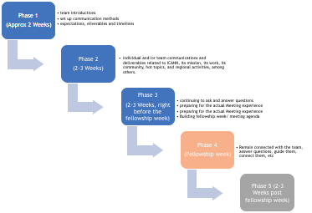

Photo: Z. Syed

WORKING METHODS: COMMUNICATION

The first communication between a Coach and a team occurs immediately after an introductory email sent by Fellowship Office (usually Fellowship Manager) to entire Fellowship group, regarding Coaches, teams and the process. The first intro* by a Coach should be done by an email: Introduce him/herself, share her/his background and experience in and out of ICANN, with some general information on how things will be happening. The coach will then invite her/his team members to introduce themselves by replying to the email (this is to be done within 48 hours after coach’s email)
*Sample of introduction template attached/provided by the ICANN Fellowship Program Staff

Structure of how and when communications from this point onward is happening is essential for a successful journey. Coaches and teams need to determine method(s) of work and means of communication that works best for them: (Google Hangout, Adobe Connect, Skype, WhatsApp, Email…). There is no ‘one size fits all’.
- Set up the groups and join social media platforms - all in timely manner.
- Communication between team members can be done in an individual level or a team level or (preferably) both. If team members are spread across the globe, working individually may be more time effective and easier to schedule, but do try to find some common space for all to meet and share.

Quick advice: Experience shows when strategic use of communication apps was in place, team collaboration was easy. Platform for communicating should be decided in accodrance with the whole team, such as for e.g.
- Email - for document sharing
- Skype - for online audio/video meetings
- Whatsapp - for quick and useful reminders, important things, brief questions&answers or some nice team bonding messages :)
Keep in mind app’s privacy concerns that may matter to any of your team members as well.

- Create collaborative online document(s) for your team (google doc, spreadsheet) which can be accessible and updated by the whole team on regular basis (using tracking changes and comment tools)
- For easier online meeting set up and for managing different times zones use Doodle Poll tool

WORKING METHODS: DELIVERABLES Pre-MEETING

As the coaching process continues, it is critical that a Coach provides information to team members in a consistent and progressive manner, asking for feedback along the way, stimulating interaction. Setting weekly progress deliverables and team expectations from the beginning is a key to the success of the program.
Again, all members of a team may not be in the same level of understanding ICANN, thus deliverables from a Coach and expectations may differ from person to person (accelerate for any individual who demonstrates understanding)
The key still is a clear, consistent approach to the learning regardless of the content or timing. Coaches will use similar steps of learning content so that each member of a team receives approximately the same preparation before the in-situ meeting.

Here’s what to do with your team members:
- ICANN Learn Courses: everyone needs to register on the ICANN Learn site, begin with the basics of ‘What is ICANN?’
- ICANN Mission: what ICANN Does and Doesn’t Do
  - Policy Process
  - Operation of Domain Name System
  - Security, Stability, Resiliency
- Multistakeholder Model: Understanding of who does the work at ICANN and How the work is accomplished
- Overview of ICANN Communities (here is where other Coaches, Staff, or community leaders can be helpful outside of your own area)
- Current Topics of ICANN (you don’t have to be an expert, just share resources of where to find this information; share webinars and policy reports that have either been archived or will occur pre-Meeting)
- Expectations of the Fellowship Program at the Meeting
- How to Network successfully at the Meeting; prepare your list of Who’s Who, use ICANN Website to “introduce” leadership photos
- How to Create an Agenda once schedule is posted
- Review their own Agendas, once they create them

WORKING METHODS: DELIVERABLES AT MEETING
- Be accessible through prior agreed means of communication
- Be approachable AT the meeting itself
- Find a bit of time every day to connect
- Encourage engagement and networking
- Facilitate introductions (online and in-situ)
- Encourage visits to the ICANN Booth for Q&A, meet-ups with others etc.
- Encourage making a diary or notes every day and taking photos to document meeting days, which will help in writing a Post Meeting report more easily

POST MEETING

Once the Meeting ends, Coach’s task is to work with her/his team on a Post Meeting Report. This is the time for recollection of the week and ideas on how to use the experience going forward.
Deadlines reminder: This is due within 3 weeks after the meeting close; coaches summary is due 4 weeks after the meeting close.
Coaches may have a team and/or individual call after the meeting, but this is up to each team; it is not required.

The format of the post-meeting report: While they are free to come up with whatever format they like, they still need to cover the following key point:

1. What were your expectations before the Meeting, based on your interaction with your Coach for 6 weeks, and on what you already knew?
2. How was your experience during the Fellowship week? Keep it simple? Were the topics and sessions easy to grasp, did you learn new things? How did the week go for you?
3. Takeaway: What are you taking from this point onward? How are you going to use this learning experience? We don’t necessarily need any commitments, but a near future plan would suffice.
4. Any Feedback on logistics, travel, etc.

*Photos, videos, drawings, poems...anything that responds to the post-report task and addresses the points above - IS GREAT!

Note: In the ‘Coaches Resources Available’ document provided to you by the ICANN Fellowship Staff, under the point ‘V. Post event reports’ you will find examples of reports done by fellows over the time that you might also want to share with your team, if needed.

Additional tools or links

- Coaching Profile: https://goo.gl/forms/b5ir1KAM9XO9eNln1
- Google Calendar - Fellowship phases: https://calendar.google.com/calendar/embed?src=gk1pm1kc7ors4t7359uujr9jqs%40group.calendar.google.com&ctz=America/Sao_Paulo
- Blog example for a team: https://engageig.wordpress.com/
- Guidelines for fellows - abridged version of coach document: https://docs.google.com/document/d/1JyVgcqTEBdExORY7hxuvKUoQ0OVxJW0lc5oBPUQLOFE/edit
- ICANN Coaches information: https://docs.google.com/document/d/1ZlnNUu3E_VBEM2ssTwxNZqoJEF2u4EddLfIyqYCb2uM/edit

