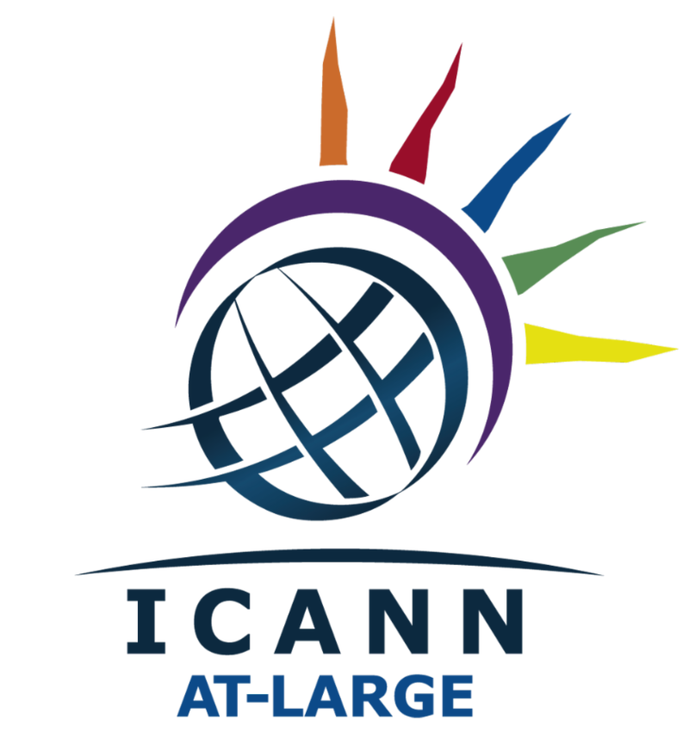

At-Large Advisory Committee (ALAC) Outreach & Engagement Subcommittee

ALAC / At-Large Outreach and Engagement Strategy v2

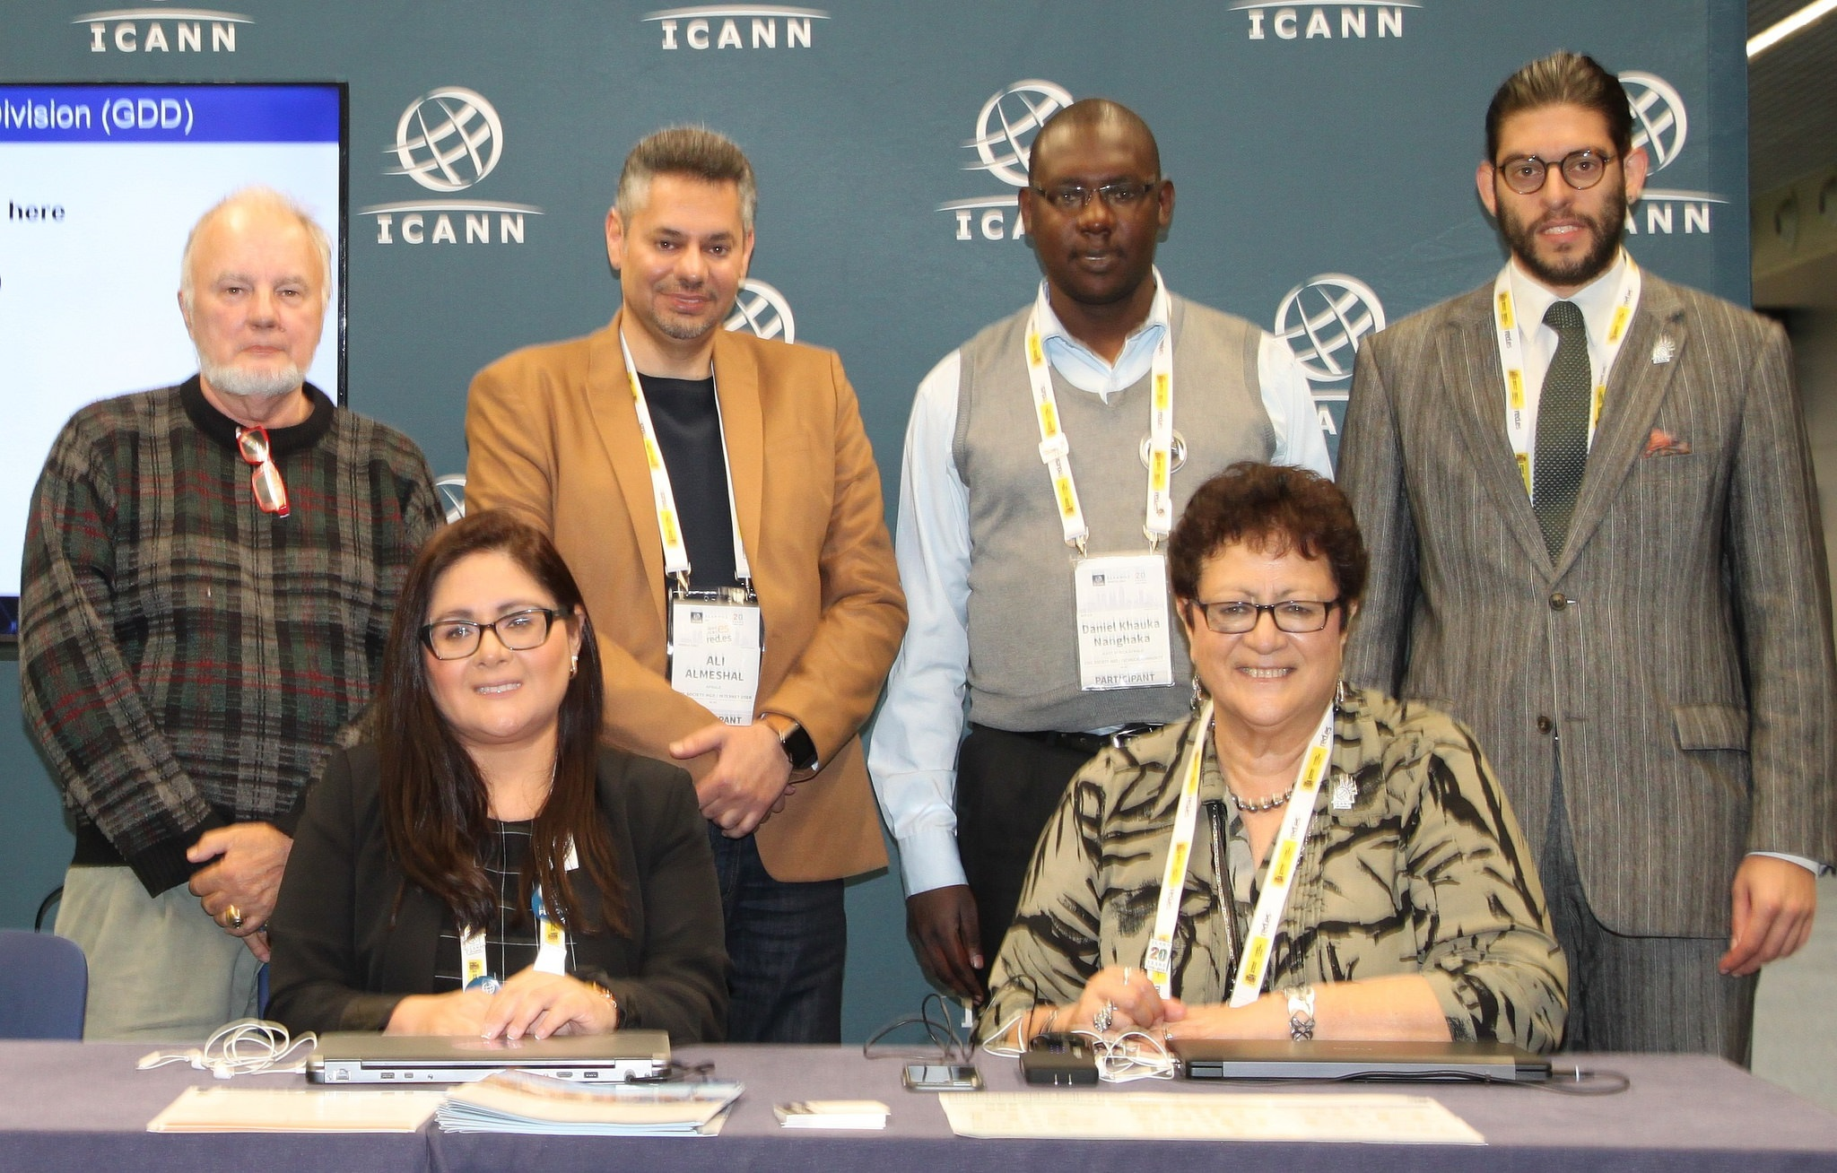

The O&E team after the meeting with the Co-Chairs, during ICANN63.
Seated (L-R): Maritza Y. Aguero (LACRALO Co-Chair) and Maureen Hilyard (ALAC Chair)
Standing (L-R): Glenn McKnight (NARALO Co-Chair), Ali Almeshal (APRALO Co-Chair), Daniel K. Nanghaka (O&E SC Chair), and Matthias Hudobnik (EURALO Co-Chair)

Introduction
The At-Large Outreach and Engagement Strategy was prepared by the ALAC Outreach and Engagement Subcommittee (O&E SC) in March 2019, with the purpose of enhancing outreach, communication and engagement.
The strategy was developed with reference to the ICANN Strategic Plan for Fiscal Years 2016-2020.
The first draft (v1) of the O&E Strategy was presented during the ICANN63 Annual General Meeting (AGM) in Barcelona, Spain. The first draft attracted input and comments from the At-Large community, leading to an updated O&E Strategy (v1.1).
The initiation of this draft was prompted by items in the At-Large Review Implementation Overview Proposal directly related to, and affecting, the O&E SC.
This O&E strategy builds a benchmark for other working groups to enhance engagement and participation within ICANN.
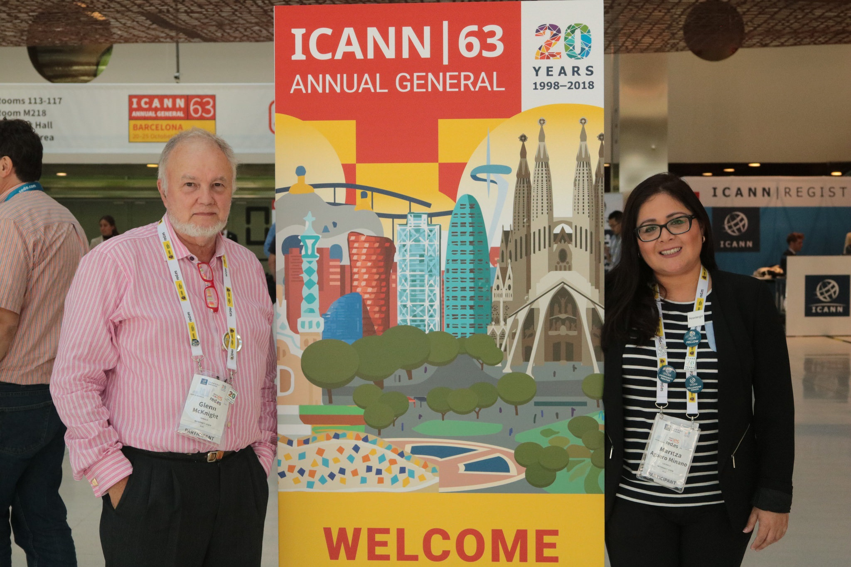
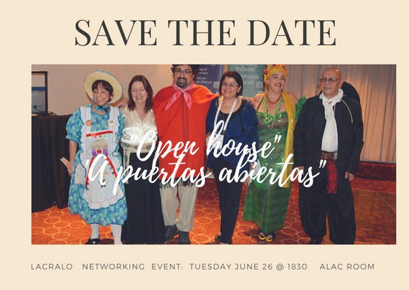
O&E Mission Statement
To drive and better facilitate participation of the At-Large community within ICANN and related ICANN policy activities, via an effective outreach and engagement strategy.

Strategic Objectives
- Influence the qualitative and quantitative growth of the At-Large community, through increased collaboration and engagement with At-Large Structures (ALSes) and Individual Members.
- Facilitate and promote informed participation within ICANN.
- Improve the collaboration between At-Large working groups, the ICANN Global Stakeholder Engagement Team (GSE), and At-Large staff on a monthly basis.
- Build and share collaboration best practices with other ICANN constituencies.
- Enhance collaboration between Regional At-Large Organizations (RALOs), the Regional Internet Registries (RIRs) and other MOU partners to build capacity and competency within ICANN.
- Use relevant metrics and performance indicators to enhance outreach and engagement, and produce an O&E Annual Report on opportunities, challenges and recommendations.

Key Communication Objectives
- Facilitate the support and development of strong communication, both within the At-Large community and within the broader ICANN community.
- Provide communication channels, tools and protocols, which promote the effective and efficient exchange of information among stakeholders.
- Synchronize promotion of activities on shared community calendars, wiki, website, blog and newsletters.
- To deliver a comprehensive communication and outreach action plan, in alignment with the ICANN Strategic Plan and other priorities identified by the ICANN Global Stakeholder Engagement Team (GSE).
Specifically, to:
- Build awareness of ICANN policy, among a wide but defined group of stakeholders and interest groups.
- Communicate ICANN policy both in draft, approved and amended versions, to build the capacity of the At-Large community in the ICANN policy workflow.
- Inform and influence specific policies and policymakers on trending ICANN policy discussions.
- Encourage community participation in the ICANN advisory process.
- Raise awareness of the Internet end user perspective in the context of the Domain Name System (DNS); with the need for participation in the ICANN multistakeholder model.
- Ensure periodic progress reports to identified stakeholders to enhance dialogue and understanding about ICANN policy issues.
This communication strategy has been developed in collaboration with At-Large staff and the Social Media Working Group (SMWG) to identify key stakeholders (target audiences), as well as key messages and suitable communication channels. The strategy proposes specific communication and stakeholder participation activities which focus on encouraging the engagement of regional communities and members in the work of At-Large.

Communication Channel
The O&E strategy aims to promote the use of the At-Large website as a single channel that offers maximum usability. This communication channel, should give general knowledge and news, and should inform its community about the work of At-Large, and in particular the role of At-Large Structures (ALSes) and their importance to the work of At-Large.
The channel would first of all simplify the application procedure, to increase the potential of attracting ALSes which are both knowledgeable about ICANN and are prepared to contribute to the work of At-Large. The channel should include explanatory content about the work that members of an accredited ALS will be involved in, and where necessary, introductory online training about At-Large activity.
It is important to note the At-Large website would be a focal point to facilitate a range of uses:
- The collection of regular feedback from ALSes on ICANN related issues, via an online feedback form.
- The promotion of standardized promotion materials for RALOs to use during their events.
- The use of a blog template to encourage informative blog on the website, authored by ALS and Individual Members about interesting activities within their regions as well as general information about the work of At-Large.
- RALOs could contribute to a centralized repository of presentations about local, regional and global events, which may be shared between RALOS and across ICANN to explain the work of At-Large and its policy work.
- The website should be the regular home of the calendar of events, which represent an overview of the matrix of O&E activities that are occurring across At-Large.
- One of the most effective ways to engage with the community is through face to face (F2F) meetings. RALO leaders become the authorized ambassadors for At-Large within their regions, and it is important that any messages that they convey to their regional partners and communities are consistent with the aims and objectives of At-Large.
Promotional Material
The provision of discretionary funding for RALOs supports the work of outreach and engagement into the 5 regions. For example, RALO banners, tabletop banners and brochures have been impactful at regional events, and uplift the presence of At-Large at events around the world. Small takeaways when available are a sure way to entice visitors to the table, but they should not be given away unless the receiver is a guaranteed sign-up. Where possible, they should display the logo of ICANN or ICANN At-Large.
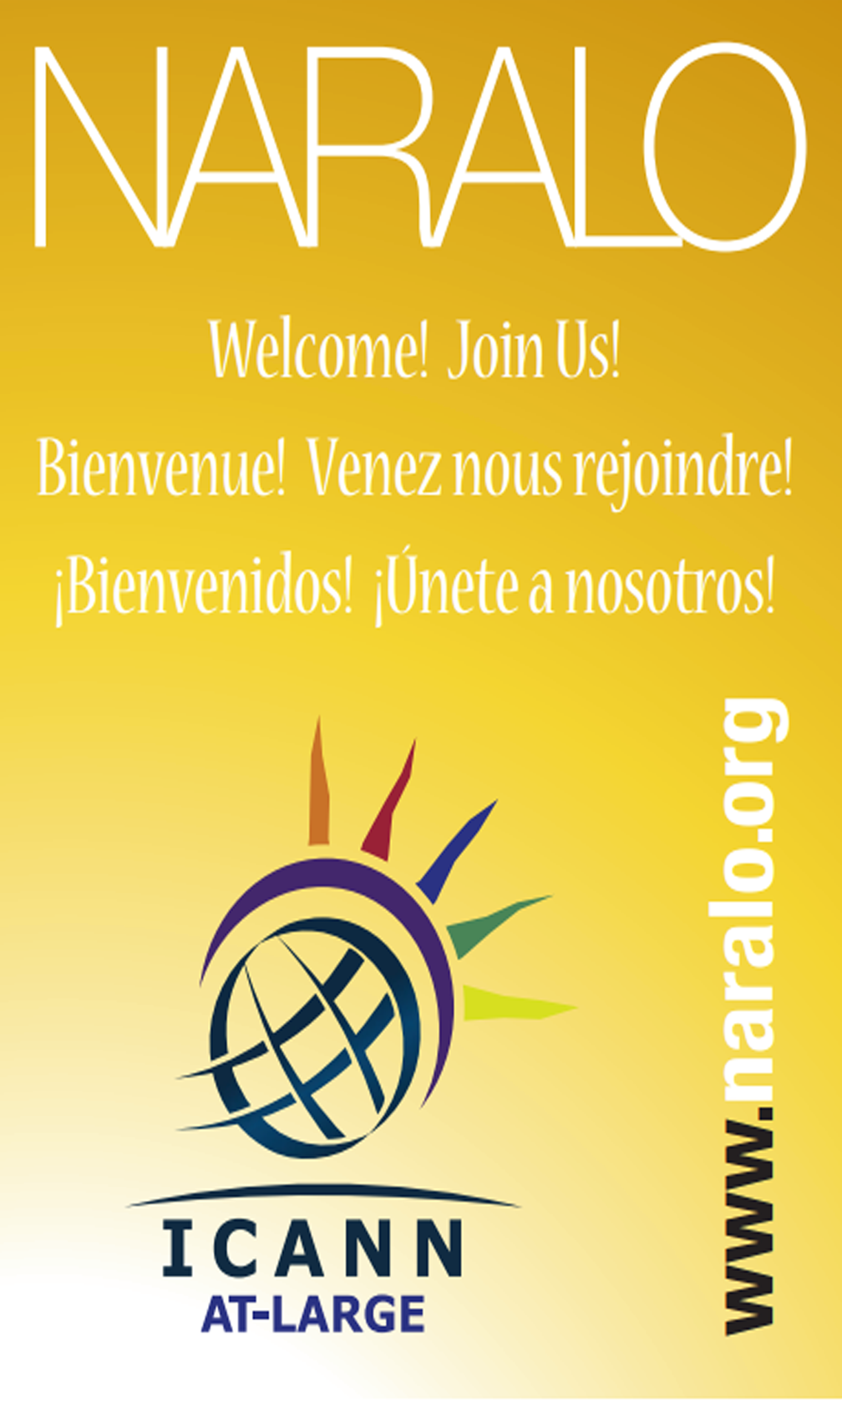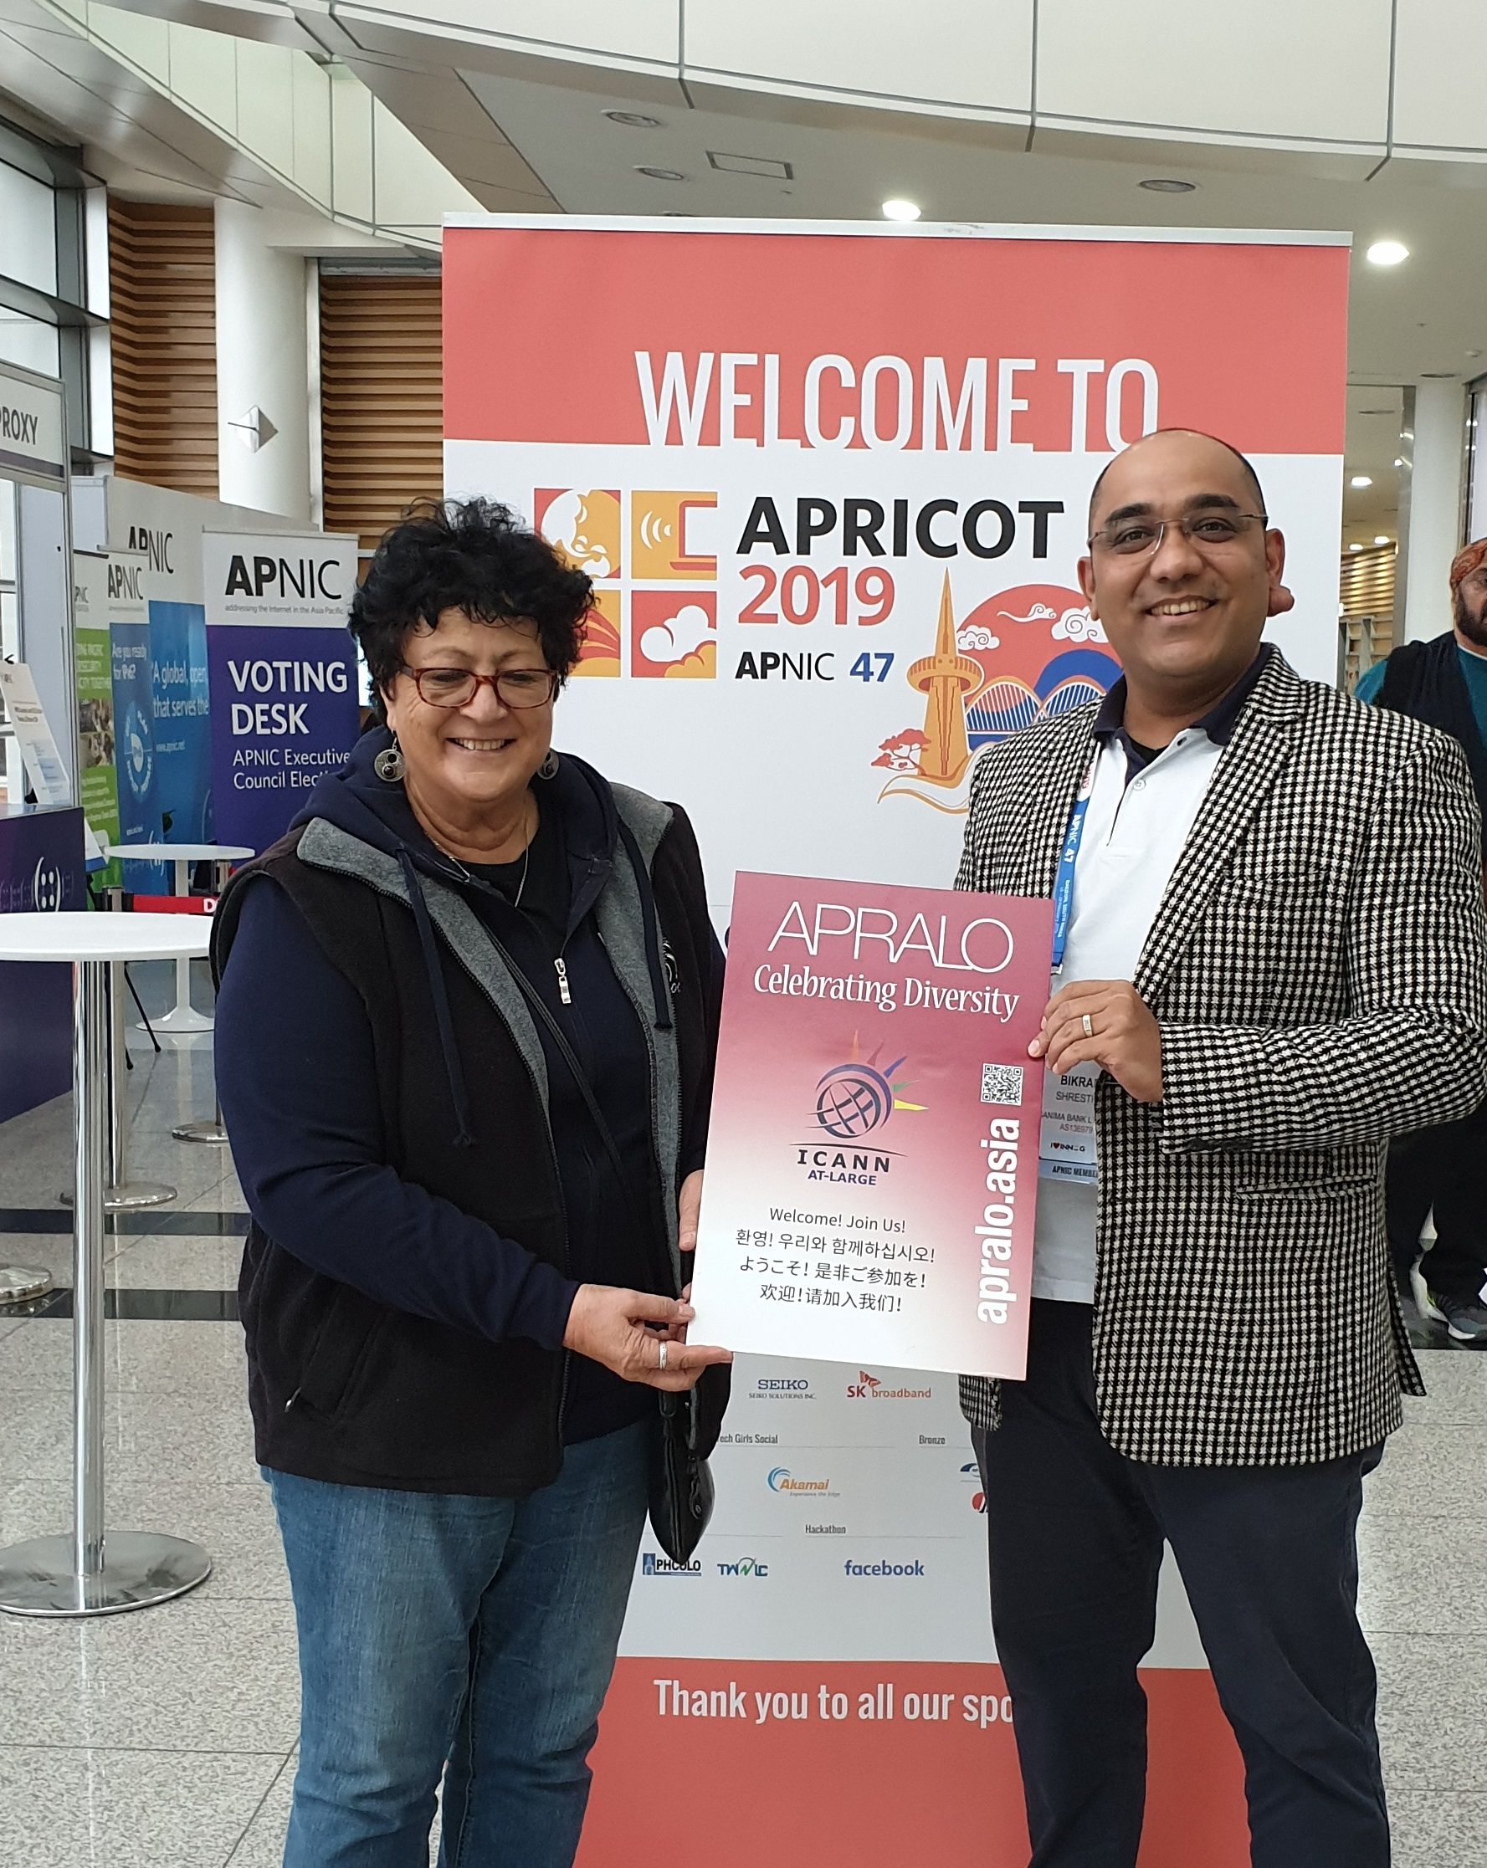
Details and Promotional Material Suggestions:
- Booth branding and banner with logo. RALO banners are the only banners that can be displayed at an At-Large booth. They are attractive and eye-catching and can be used to encourage visitors to “take a selfie” and then promote the RALO for inclusion into a blog post or about an event, or for distribution by social media to promote the event or the RALO.
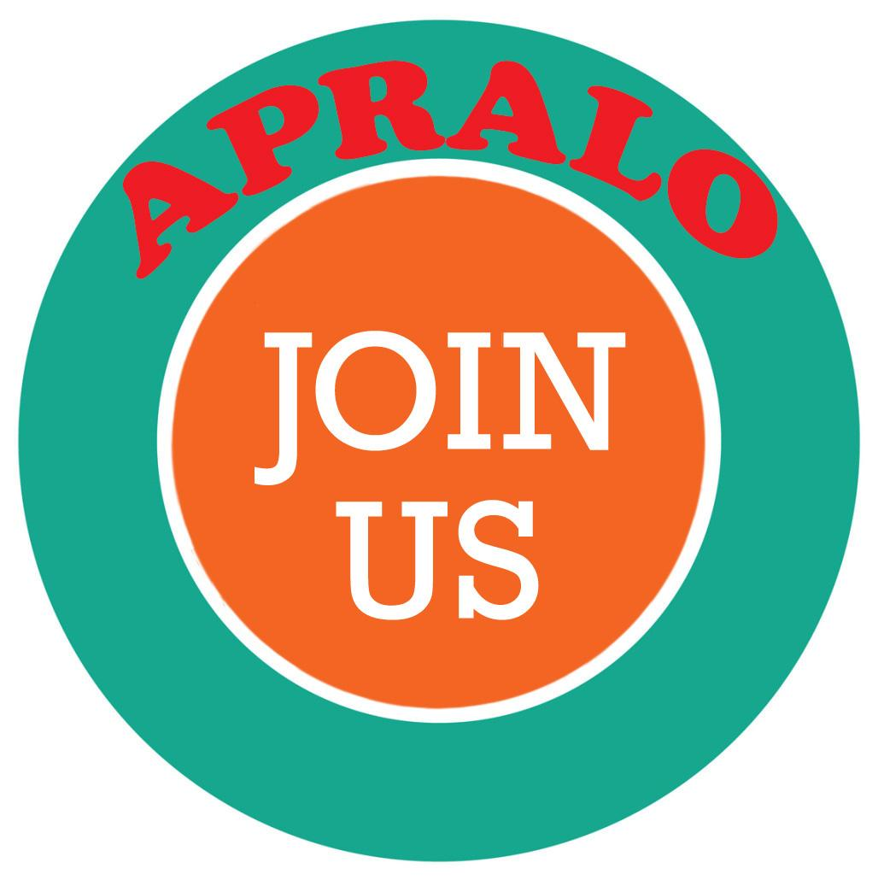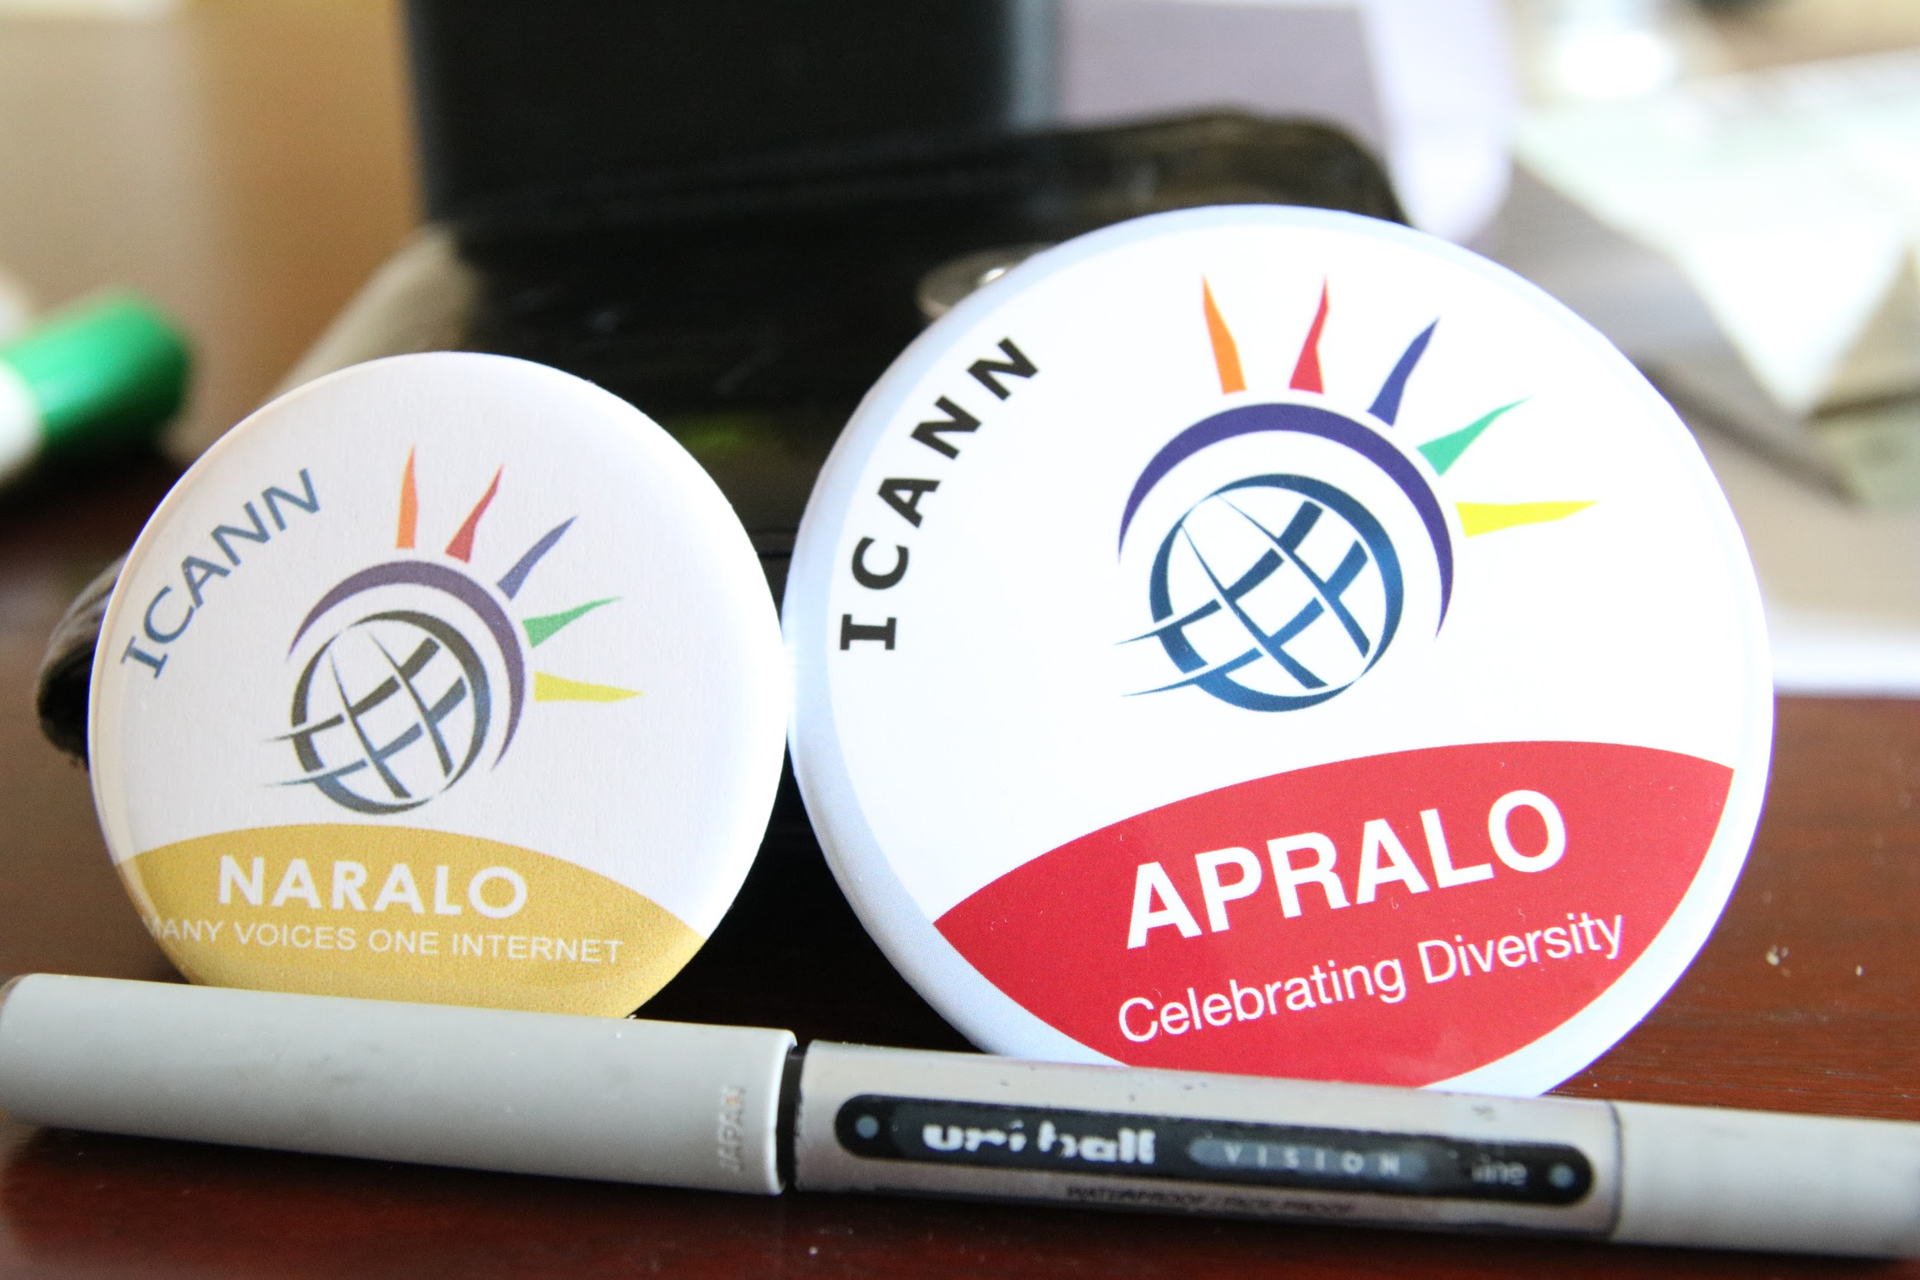

- An At-Large flash-card, pin or badge, featuring the At-Large logo.
- An At-Large barcode could be placed on the banner – which would directly access the At- Large website or another the RALO webpage.
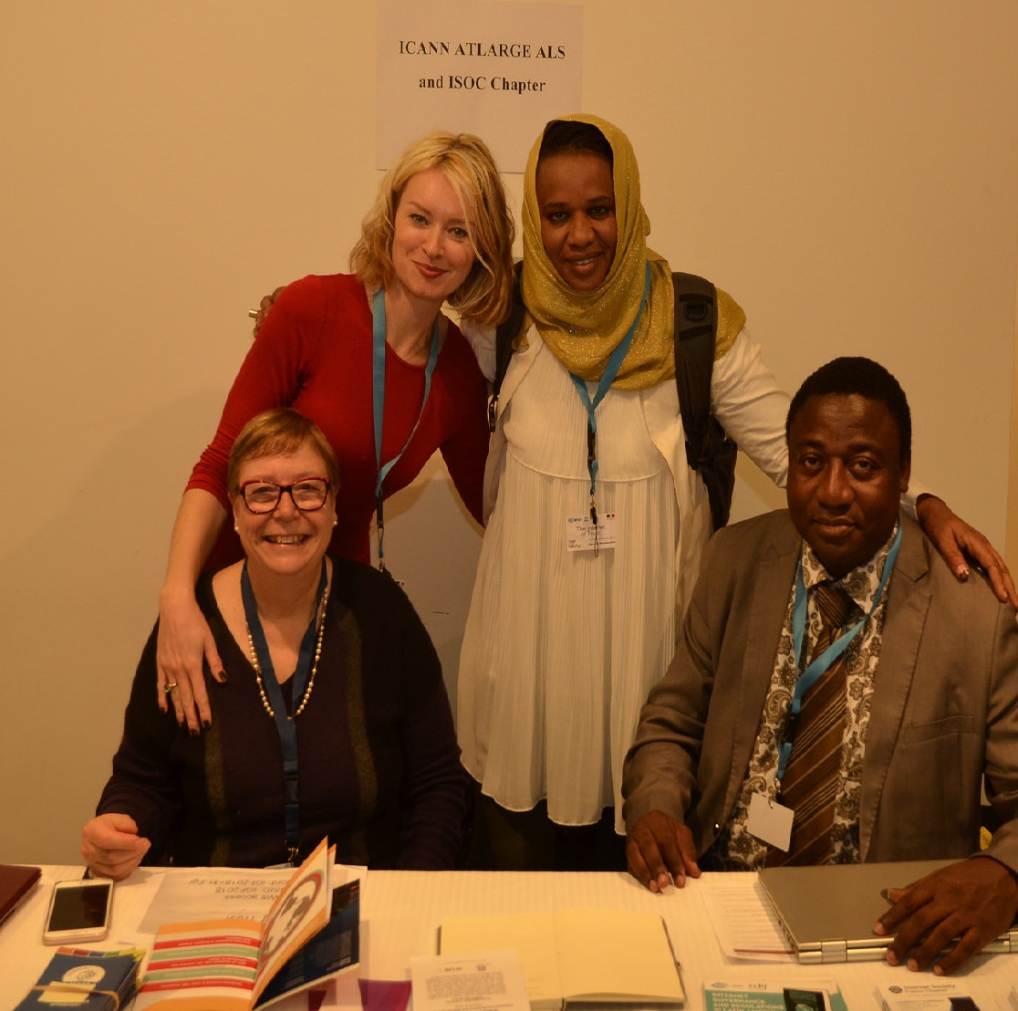
These and other ideas aim to help At-Large more positively engage with our current members as well as provide useful information and a basis for future involvement of new members within the community.

Metrics and Program Evaluation
The ALAC Outreach and Engagement (O&E) Subcommittee will work closely with the ALAC Subcommittee on Metrics for the evaluation of the efficiency and effectiveness of the work of the community in the 5 regions.
Template for Recording and Evaluating Event Activities
The following template covers the overall strategy and the activity calendar of the O&E
Subcommittee. This will be located on the community wiki.
Date | Event/Action | Participants | Details | RALO | Collaboration with ICANN structures | Comments

Conclusions
The evaluation process allows for a better understanding of how key stakeholders—both internal and external to the ICANN At-Large community —view the effectiveness of outreach and engagement activity.
More specifically, the evaluation will reveal the following:
- The effectiveness of the At-Large website and any other communication strategies employed by the O&E Subcommittee to implement the O&E strategy.
- The level of awareness of our At-Large community about the work of At-Large.
- The level of awareness of our At-Large community about ICANN policy issues.
- The effectiveness of the communication system to reach targeted stakeholder groups and the achievement of specific aims and objectives during outreach activities with this targeted group.
- The effectiveness of the communication system for appropriate recording purposes: checklists, task lists, inventory lists and spreadsheets to systematically measure outreach and engagement activities.
- The commitment of At-Large members to post and share the results of their O&E activities within their regions by various platforms which include but are not limited to newsletters, e-books, webinars, blogs, wiki and social media tools.
- The identification of initiatives and activities in the Outreach and Engagement Strategy which may be improved upon.

