Arabic Variant TLD Issues and Requirements
- Background
This document has been prepared by Arabic Script Variant Issues Project team constituted through an open call by ICANN. Baher, could you fill in appropriate text in the context of VIP. Some reference to RFC 5564; could somebody volunteer a summary of motivation and recommendations.
- Introduction to Arabic Script
Arabic script has been used across North Africa, Middle East, Central Asia South Asia and South East Asia to write multiple languages from Semitic, Indo-Iranian, Indo-European, Dravidian, Turkic, and Austronesian language families.
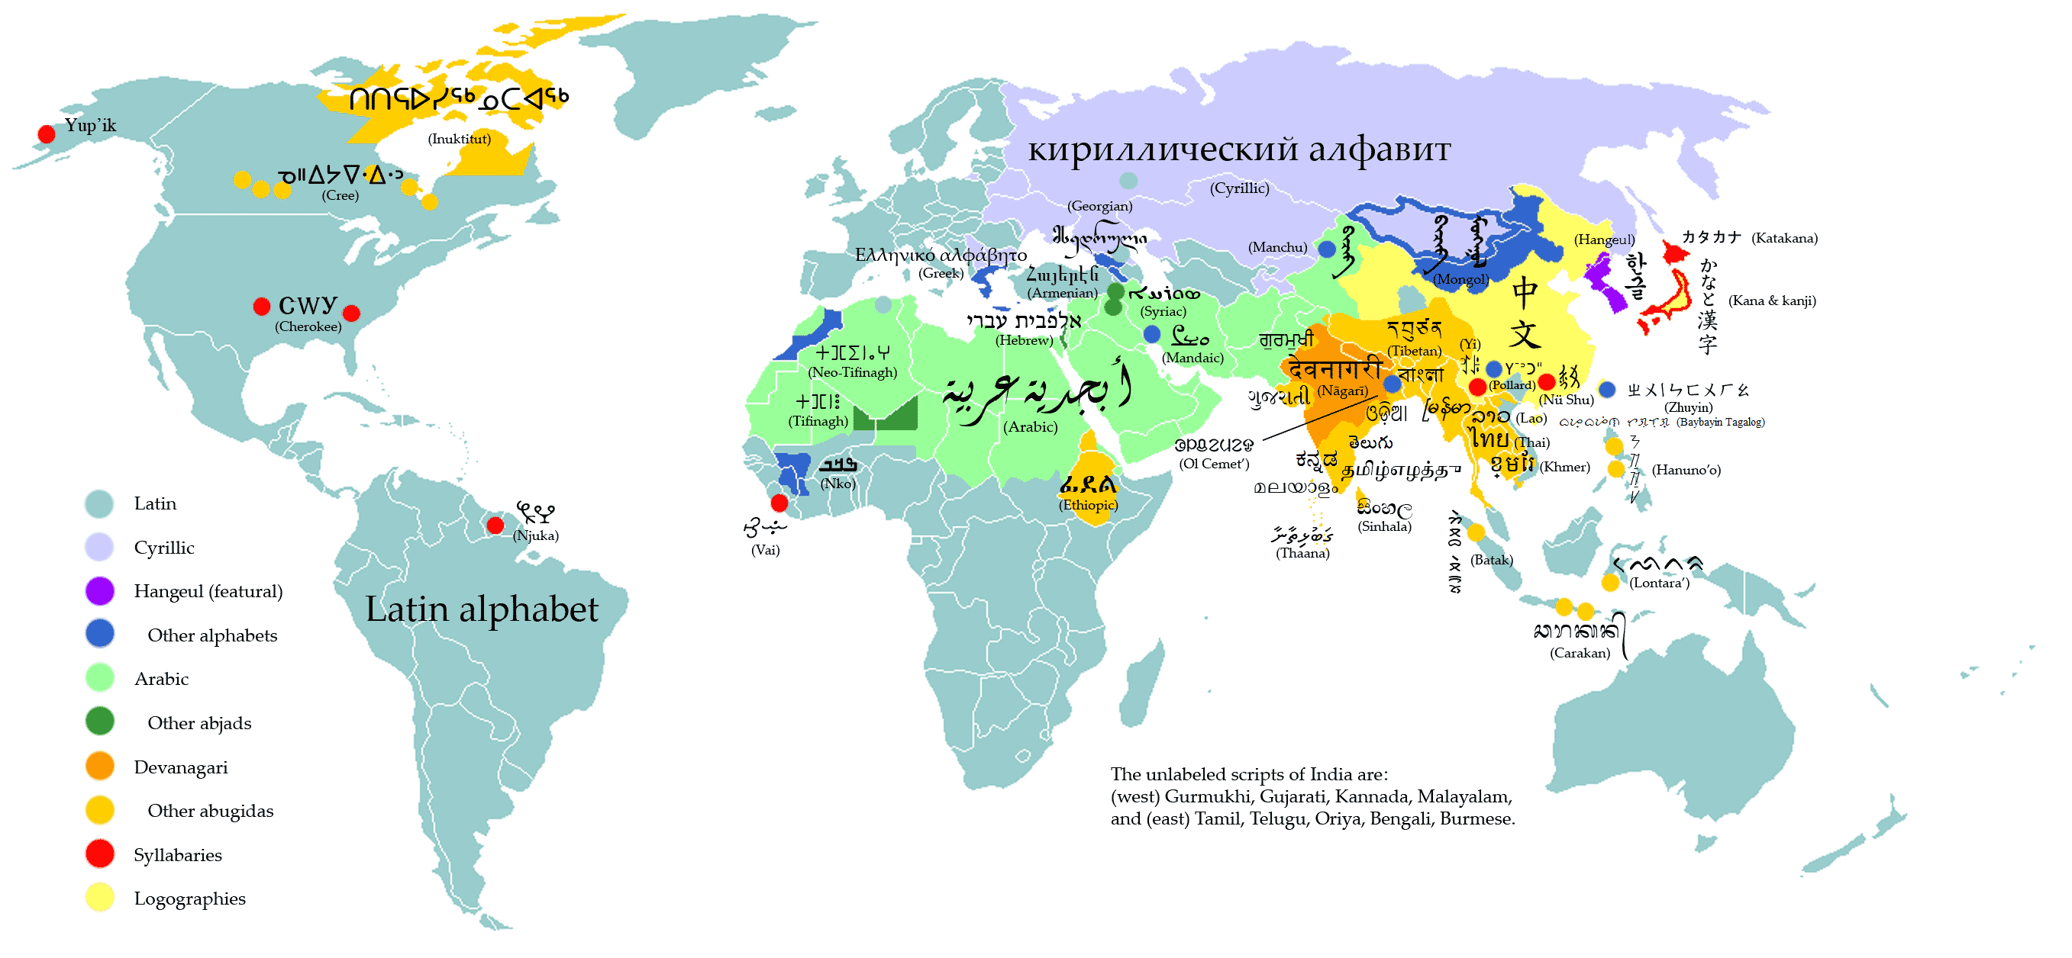
Figure 1: Writing Systems of the World
(Source: http://en.wikipedia.org/wiki/File:WritingSystemsoftheWorld4.png)

Arabic writing system is also referred to as Abjad system, in which consonantal sounds are represented as base characters and vowels are normally represented by optional combining marks on these base characters (except for long vowels, which are also represented by base characters). The writing system is cursive and each letter may have multiple shapes, generally categorized as initial, medial, final and isolated, based on where it occurs within the connected portion of a (sub)word, called a ligature, or whether it occurs by itself (not joined with any other letter). Though logically a letter may have these four shapes, in reality the shape of a letter may also vary with other letters it joins with (not just its position within a ligature) and may take up many different shapes (e.g. for illustration of context dependent shaping see www.cle.org.pk/Publication/papers/2006/context_sensitive_shape_substitution.pdf).

Arabic script has a variety of writing styles, with Naskh predominantly being used to write Arabic language and Nastalique being used for many of the other languages using Arabic script. Additional writing styles, which are used for stylistic reasons, include Thuluth, Diwani, Kufi, Riqa, etc. Some of these writing styles are illustrated in Figure 2 (with same Arabic language phrase written in different styles). The various styles show both the base characters and the optional combining marks. Thuluth and Diwani also include non-linguistic ornate marks. | 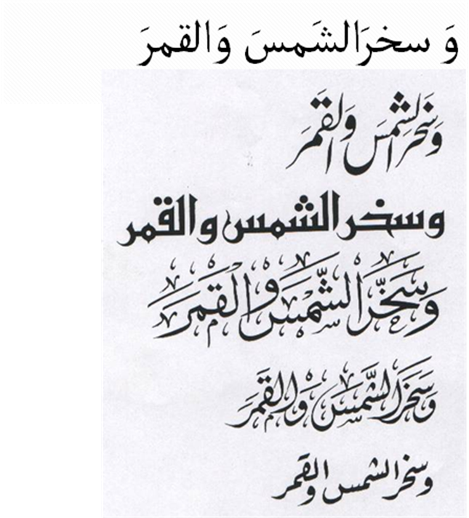
Figure 2: Arabic Script Writing Styles: Naskh, Nastalique, Qufi, Thuluth, Diwani and Riqa
(Source: Hussain 2004)

- Terminology
Terminology may go here or in a separate document, to be decided after terminology is finalized.

- Arabic Script PVALID Characters Valid for TLDs
Arabic script characters are listed in Unicode Arabic charts. The characters are encoded from U+0600 – U+06FF and U+0750 – U+077F. The following characters are allowed for use in Arabic script labels, as per RFC 5892.

200C..200D ; CONTEXTJ
0610..061A ; PVALID
0621..063F ; PVALID
0641..065E ; PVALID
0660..0669 ; CONTEXTO
066E..0674 ; PVALID
0679..06D3 ; PVALID
06D5..06DC ; PVALID
06DF..06E8 ; PVALID
06EA..06EF ; PVALID
06F0..06F9 ; CONTEXTO
06FA..06FF ; PVALID
0750..077F ; PVALID

- Types of Variants in Arabic Script and its Encoding in Unicode
Variant labels in Arabic script may occur due to reasons motivated by linguistics or encoding. The following are some ways labels could have variants. The current issues document lists all possible cases where variants may occur, for consideration and further stipulation of how variant sets may be constituted.

  - Same Shape

It is possible for two different Unicode code point sequences to render exactly the same string. This is caused due to two reasons given below.

    - Different Unicode code points have same shape in at least one of the four forms (beginning, middle, final and isolated). Examples from Arabic script are given in Appendix A.1. It is worthwhile to note that some letters may be written in two different ways but are considered equivalent by users even though the shapes may not be same (e.g. see final shape of Tay Marbuta in Appendix A.1).

    - Exactly same shapes can be rendered in composed and decomposed forms not covered through Unicode normalization process (Davis and Durst 1999). These composed and decomposed equivalents formed by one combining mark and two combining marks are given in Appendix A.2.1 and Appendix A.2.2 respectively.

  - Similar Shape

    - There are characters that may be distinct in particular language but they may be confusable for users of other languages. For example U+06A9 (ک) and U+06AA (ڪ) are distinct Sindhi letters but confusing for Urdu and Arabic language speakers. Similarly U+064A (ي) and U+06CC (ی) are distinct Pashto letters but may be confusing for Urdu speakers. A complete list of such confusable similar characters is given in Appendix B.1.

    - There are characters in different languages using Arabic script with slight variations in dots, e.g. vertical dots vs. horizontal dots, three dots pointing downwards vs. three dots pointing upwards, etc. These characters can also create confusions for users of other users of Arabic script. Such cases are listed in Appendix B.2.

    - Combining Hamza –In the Arabic language, the Arabic Letter Hamza (U+0621) can be used separately in words. It can also be combined with other letters (such as the Arabic Letter Alef, U+0627, Arabic Letter Yeh, U+064A, Arabic Letter Waw, U+0648, and Arabic Letter Alif Maksura, U+0649) to form either a variant or a completely new letter that may have it own usage.

For some countries using Arabic language, the Arabic Letter Hamza (U+0621) with the Arabic Letter Alef (U+0627) is not widely used in day-to-day writing, and thus they are considered as variants. On the other hand, combining the Arabic Letter Hamza (U+0621) with Arabic Letter Yeh (U+064A), Arabic Letter Waw (U+0648), or Arabic Letter Alif Maksura (U+0649) forms a new word that can never be considered a variant.

    - Madda Above (U+0653) is optional in Arabic language but is treated as a separate character (in combination with Alif) in Urdu and some other languages. Thus its use is not considered distinct in Arabic language and is not allowed in Arabic language labels. However, it is required for the other languages, as part of the inventory of distinct letters.

    - In Arabic language and many other languages using Arabic script Teh Marbuta (U+0629) and Heh (U+0647) are used interchangeably at the end of a word. They sound similar in the context and may cause variant labels.

  - Optional Marks

There are different kinds of optional marks in Arabic script, and their usage differs across languages, as discussed below. As they are optional and there can be multiple optional marks per letter in a label, their use may create a very high number of variants. Due to their small size (as glyphs) and optionality, they can also cause a high degree of user confusion and security issues. Their use should therefore be very carefully regulated.

    - Arabic vowel marks (called Tashkeel) are optional and may or may not be written. Arabic script users normally consider both versions of text same, and may only use these marks to highlight vowel differences. These marks include Fatha, Damma, Kasra, and Sukun. Using them differently would change the pronunciation and meaning of a base word.

    - Shadda (U+0651) is used optionally in Arabic script for geminating a consonant. However, Shadda is not considered in the same manner as the vowel marks, discussed above. Arabic language labels do not allow this letter.

    - There are other marks used in Arabic script to represent vowels and/or consonants, including Fathatan, Dammatan, Kasratan, Superscript Alef and Subscript Alef, which are not optional in all languages using Arabic script (for example they must be written in Urdu otherwise the words are considered mis-spelled) but are optional in Arabic language.

  - Contextual Characters

    - Zero Width Non Joiner is needed in domain names in Arabic script to separate multiple words within a label. Though there is a defined rule which allows ZWNJ only in contexts where its effect is visible, there are few contexts which ZWNJ may still not have a visible impact. This includes characters U+0637, U+0638 and U+069F. This is indicated by the two sequences, one with and one without the ZWNJ: طب ط‌ب. ZWNJ is not used in Arabic language labels, latter using hyphen to separate words within a label. This convention to use hyphen is not prevalent in other languages.

    - Zero Width Joiner is not needed for Arabic script and thus should be restricted in use as it may create unnecessary variants.

- IDN Variant Delegation Issues and Requirements
  - Delegating Variant TLDs
If the registry has variant(s) of their TLD label then how may they be allocated and delegated? Here are some relevant questions.

    - What are the possible delegation states and how will these be defined?
      - A variant is allocated
      - A variant is activated
        - A variant is delegated
        - A variant is reserved
        - A variant is blocked
      - Other?
    - How can status of a variant label change between these states?
    - When can status of a variant label change between these states?
    - Is there a limitation to the number of variants that can be allocated and activated for a given domain name? Is there a limit on how many of these may be delegated/reserved/blocked?
    - Is it necessary for a registry to request for allocation for all variants as per the variant table submitted or an arbitrary subset may be requested?
    - Can same practice of arbitrary bundles be followed for second and lower levels? If yes, can these bundles be different for different TLD variants?
    - Can a label/variant be composed of characters across the script?

    - Build zone file for each TLD variant or the variant(s) will share the same TLD label zone file?

    - Is it possible for the registry to have different set of NS registered with IANA? Or will they share the same TLD label info?

  - Management of Registry Supported Character Set and Variant Table
The registry should publish the supported character set along with the variant table for possible labels. Here are some questions around the character set and variant table:

    - Should a character set identify the set of language(s) it supports? This could be a single language, multiple languages or the entire script. Though need to identify a language is not necessary for labels, it does promote more consistent re-use of tables, for example, as has been encouraged by the ICANN’s Fast Track process.
    - Should variants be defined at the character positioning level (Beginning, Middle, End, Isolated) or at character level, or should this be left to the registry? Is there need to make this consistent across registries?
    - Does a registry need to compile a variant table for all variants across the script even if the registry supports only part of the script (certain languages)? Does this need to be consistent across registries?
    - Should there be a consistent format to publish a character set supported by a registry? Should there be a consistent format to publish the corresponding variant table?
    - Should there be a requirement for considering already existing character sets and variant tables, as has been given in the Fast Track process?

  - Other requirements

- Registration related issues
  - WHOIS
The registry may need to change how the WHOIS information is handled and displayed. For example, if someone searches for a string in the WHOIS tool and that string represents a variant for an already registered domain name then the registry may indicate the status of that variant (e.g. active or inactive) along with the WHOIS information for the domain name (which is the base for that variant).

Here are some questions about this issue.

    - Should the WHOIS information be the same for a domain name and its variant, or the WHOIS information may vary? If it may vary, then how?
    - Should the registry return the WHOIS information for a domain name when someone tries to query one of its variants, or only return a notice that indicates there is no WHOIS information for the variant but there is one for the domain?
    - Should the registry return WHOIS information for other domain name variants when someone tries to query its primary(?) label?

    - How does registry determine the language/script for a WHOIS information given an Arabic script label? Could WHOIS information be in multiple languages? Could different parts of WHOIS information be in different languages?
    - If a variant label is either added or changes its state later, how should this impact the WHOIS information?

  - Reserved Name List
The registry may need to block reserved names and their variants. Here are some questions related to the reserved name list.

    - If someone gets an exception to register a name from the reserved list, should s/he also get its variants? If yes, does this happen automatically or upon request?

    - Should the registry add all variants or some of them to the reserve list? How is it determined?

  - Registration Process
The registry should change the registration process when someone tries to register a string as a domain name. For example, if someone wants to register a string (as a domain) then a DB lookup should be done across all registered domain names and all of their possible variants in order to deny registering a variant for someone else. Here are some relevant issues.

    - Should the registry store all possible variants in a table and use it for registration lookup or use an optimized mechanism to make it simpler and faster (e.g. generating a unified/base string for each domain and use it for lookups – master key algorithm)?
    - Is it possible for the same set of variants to be registered/used by different registrants? In ccTLDs? In gTLDs?
    - Should there be a pre-defined list of variants for registration? If yes, can a registrant choose which variants to register? Else, how can a registrant register a variant bundle?
    - May other variants be added to the list? If yes, how will the registrants be informed about the additions?

    - Should the registry ask the registrant which language is used for writing the domain name?
    - When transferring or deleting a domain what will happen with its variants?
    - When a domain name expires what will happen to its variants?

- Issues related to Variants of labels (not at TLD level)
  - Fees
What would be the pricing scheme for variants?

    - Is there a fee for bundling? If yes, does it differ with the bundle size?
    - Is there a fee for activating?
    - Is there different fees for delegation/reservation/blocking?
    - Is there a fee for changing the status of a variant?

- Operations
  - EPP
The registry may need to add some extensions to the EPP in order to support variants and activated/bundled them. Here are some questions (about this issue) that each registry should consider.

    - What are the needed extensions, XML and DB fields (from EPP point of view)?
    - What are the needed variant's status for the domain life cycle (from EPP point of view)?

  - DNSSEC
The registry may need to think more about key management specially when they adopt variants.

    - Are the variants going to share the same signing-key or each variant will have its own signing-key?
    - What will happen if the signing-key is expired for a domain name or one of its variants?
    - When transferring a domain what will happen for the domain & variants signing-key(s)?
    - Should there be any limitations on the number of keys? If not, does this affect the performance? Does it affect the security?

  - Dispute Resolution
    - Filing a Complaint/Case
      - Are bundled domain names treated as one also with regards to dispute resolution?
      - Could a case exist where a complainer claims right over a member (a label) from within a bundle? Will the dispute differ if the disputed domain name is active, blocked or reserved? Will the whole bundle be somehow included in this case?
      - Could a case exist where a complainer claims right over a whole bundle? Will all bundle members be consolidated as one case?
      - Could a case exist where a complainer claims right over a bundle containing members/labels in different languages? Within the same script? Across different scripts?
      - How to prove ‘Bad Faith’ in case of inactive domain names (i.e. blocked or reserved within a bundle)?
      - May registrants be forced into disputes as a result of automated bundling?
      - Could a case be filed against a domain name that is still under request or does it have to be delegated?
    - Payment
      - How would the following different cases affect the fee scheme:
        - Filing a case regarding a whole bundle, one member/label that belongs to a bundle, more than one member/label that belongs to a bundle?

        - Could the fee differ according to the status of the disputed domain name whether it is active, blocked or reserved?
    - Decision
      - Could a case exist where a decision (such as cancellation or transfer of ownership) is applied to only one member/label of a bundle? If yes, what are the implications? In case the rest of the members were not active does this give the right to the registrant to activate any one or more members of the bundle? Or is the winner allowed to assume ownership of the whole bundle?
      - With respect to disputes, are blocked or reserved labels considered domain name in use?
      - Could a case exist where a domain name is added to an existing bundle, either because it was overlooked in the pre-defined sets or not opted by the original registrant?

Is it possible to have a single dispute spanning two different bundles?
      - Can a UDRP decision have implications on a language table (i.e. can a UDRP decision cause change changes to an existing variant table?)
      - Do the above cases assume extending the UDRP scope beyond trademarks?
      - Could a case exist where two trademarks in two different languages, within the same script (Arabic in our case), be confusingly similar; i.e. should be treated as a bundle according to our definition of a bundle whereas from a trademark perspective they have two different eligible owners?
      - Should a change in a domain name status, due to its being under dispute, be inherited by the rest of the bundle members
    - Technical Implementation of a Dispute Resolution Decision:
      - What are the implications of changes done on a variant set as a result of implementing a dispute resolution decision?
      - What are the implications of a dispute resolution decision on Variant Tables in terms of implementing changes to variant sets defined . Can a decision on a bundle have impact on other bundles due to implied changes in the variant table?

  - IPv6
  - Other requirements
- End-user and Application level requirements
  - Keyboard (soft) issues
    - Lack of standard keyboard for many languages using Arabic script (e.g. Kurdish; Iraq or Iran has different keyboards, including numerals). Same for Afghanistan. Urdu has many different keyboard layouts. This may cause variation in typing same labels
    - Digits may present an issue. But not relevant to TLDs.
  - Browser issues
  - Font issues
    - Two very different writing styles in use. Arabic language uses Naskh writing style and Persian, Urdu, Pashto, and many other languages in South Asia use Nastalique writing style. There are ;many other font styles in use, including Thuluth, Riqa, Qufi and others, for stylistic variation. Fonts may have implications on variant sets.
    - Font support may not be consistent across variants of the same label, as a font may not support all variant characters in a language table, causing strings to break during display or boxes or other unexpected characters to show up.
  - Mail, Web and other server administration
  - Use of Variants inline within end user content
  - Other issues
    - Operating System support may not be consistent across variants of the same label, as an OS may not support all variant characters in a language table, causing strings to break during display or boxes or other unexpected characters to show up.
- List of relevant stakeholders
- Concluding Remarks
- References
M. Davis and M. Durst (1999). Unicode Normalization Forms. Accessed from http://unicode.org/reports/tr15/tr15-18.html.
Appendices
Appendix A. Confusable Same Letters in Arabic Script

Appendix A.1. Same Shape in at least one Position

Unicode | Initial Form | Medial Form | Final Form | Isolated Form
Kaf Group
U+06A9 (ک) | کا | لکل | ٹک | ک
U+0643 (ك) | كا | لكل ل | ٹك | ك
Hay Group
U+0647 (ه) | هم | مها | له | ه
U+06BE (ھ) | ھم | مھا | للھ | ھ
U+06C1 (ہ) | ہم | مہا | کہ | ہ
U+06D5 (ە) | - | - | نە | ە
Yay Group
U+064A (ي) | يع | ميل | یلي | ي
U+06CC (ی) | یع | میل | یلی | ی
U+0649 (ى) | - | - | بى | ى
Fay Group
U+06A7 (ڧ) | ڧر | کڧر | ڧ | ڧ
U+0641 (ف) | فر | کفر | ف | ف
Tay Marbuta Group
U+0629 (ة) | - | - | بة | ة
U+06C3 (ۃ) | - | - | بۃ | ۃ
Hay with Hamza Group
U+06C0 (ۀ) | - | - | بۀ | ۀ
U+06C2 (ۂ) | - | - | بۂ | ۂ
Ttey/Rnoon Group
U+06BB (ڻ) | ڻا | بڻن | بڻ | ڻ
U+0679 (ٹ) | ٹا | مٹن | بٹ | ٹ
Noon Group
U+0646 (ن) | نا | بنن | بن | ن
U+06BA (ں) | ںا | مںن | بں | ں
Theh Group
U+06BD (ڽ)  (the initial and medial shapes seem to be erroneous in the font) | ڽا | مڽا | ڽ | ڽ
U+062B (ث) | ثا | بثا | ث | ث

Appendix A.2. Same Shape in Composed and Decomposed forms using one Composing Character, not covered through Unicode Normalization Process

Combining Mark | Composed Form | Decomposed Form | Unicode Normalized Form
ٓ  U+0653 | آ  U+0622 | ٓ ا  U+0627 U+0653 | Defined
ٔ  U+0654 | أ  U+0623 | ٔ◌ ا  U+0627 U+0654 | Defined
ٔ  U+0654 | ؤ  U+0624 | ٔ و  U+0648 U+0654 | Defined
ٔ  U+0654 | ئ  U+0626 | ٔ ي  U+064A U+0654 | Defined
ٔ  U+0654 | ئ  U+0626 | ىٔ  U+0649 U+0654 | Not Defined
ٔ  U+0654 | ئ  U+0626 | یٔ  U+06CC U+0654 | Not Defined
ٔ  U+0654 | ۀ  U+06C0 | ۀ  U+06D5 U+0654 | Defined
ٔ  U+0654 | ۀ  U+06C0 | هٔ  U+0647 U+0654 | Not Defined
ٔ  U+0654 | ۂ  U+06C2 | ۂ  U+06C1 U+0654 | Defined
ٔ  U+0654 | ۂ  U+06C2 | هٔ  U+0647 U+0654 | Not Defined
ٔ  U+0654 | ۓ  U+06D3 | ۓ  U+06D2 U+0654 | Defined
ٔ  U+0654 | ځ  U+0681 | حٔ  U+062D U+0654 | Not Defined
ٔ  U+0654 | 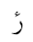  U+076C | رٔ  U+0631 U+0654 | Not Defined
ٕ  U+0655 | إ  U+0625 | ا◌ٕ  U+0627 U+0655 | Defined
ُ  U+064F | ۇ  U+06C7 | ُ و  U+0648 U+064F | Not Defined
ُ  U+064F | ۇ  U+06C7 | U+0648 U+0619 | Not Defined
ٰ  U+0670 | ۈ  U+06C8 | ٰ و  U+0648 U+0670 | Not Defined
۬  U+06EC | ۏ  U+06CF | ۬ و  U+0648 U+06EC | Not Defined
۬  U+06EC | غ  U+063A | ۬ ع  U+0639 U+06EC | Not Defined
۬  U+06EC | ض  U+0636 | ۬ ص  U+0635 U+06EC | Not Defined
۬  U+06EC | خ  U+062E | ۬ ح  U+062D U+06EC | Not Defined
۬  U+06EC | ڿ  U+06BF | ۬ چ  U+0686 U+06EC | Not Defined
۬  U+06EC | ذ  U+0630 | ۬ د  U+062F U+06EC | Not Defined
۬  U+06EC | ز  U+0632 | ۬ ر  U+0631 U+06EC | Not Defined
۬  U+06EC | ڶ  U+06B6 | ۬ ل  U+0644 U+06EC | Not Defined
۬  U+06EC | ڧ  U+06A7 | ٯ۬  U+066F U+06EC | Not Defined
۬  U+06EC | ف  U+0641 | ۬ ڡ  U+06A1 U+06EC | Not Defined
۬  U+06EC | ن  U+0646 | ۬ ں  U+06BA U+06EC | Not Defined
۬  U+06EC | ڬ  U+06AC | ۬ ك  U+0643 U+06EC | Not Defined
۬  U+06EC | 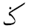  U+0762 | ۬ ک  U+06A9 U+06EC | Not Defined
۬  U+06EC | U+0765 | ۬ م  U+0645 U+06EC | Not Defined
U+0615 | 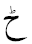  U+0772 | ح  U+062D U+0615 | Not Defined
 | ٹ  U+0679 | ٮ  U+066E U+0615 | Not Defined
 | ڑ  U+0691 | ر  U+0631 U+0615 | Not Defined
 | ڈ  U+0688 | د  U+062F U+0615 | Not Defined
 | U+0771 | ڗ  U+0697 U+0615 | Not Defined
 | U+0768 | ن  U+0646 U+0615 | Not Defined
 | ڋ  U+068B | ڊ  U+068A U+0615 | Not Defined
 | ڻ  U+06BB | ں  U+06BA U+0615 | Not Defined
U+065B | 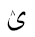  U+063D | ی  U+06CC U+065B | Not Defined
 | ۉ  U+06C9 | و  U+0648 U+065B | Not Defined
 | 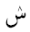  U+077E | س  U+0633 U+065B | Not Defined
 | U+06EE | د  U+062F U+065B | Not Defined
 | U+06EF | ر  U+0631 U+065B | Not Defined
 | U+06FF | ھ  U+06BE U+065B | Not Defined
 |  | U+0647 U+065B | Not Defined
ۛ  U+06DB | U+063F | ۛ ی  U+06CC U+06DB | Not Defined
ۛ  U+06DB |  | ۛ ى  U+0649 U+06DB | Not Defined
ۛ  U+06DB | ش  U+0634 | ۛ س  U+0633 U+06DB | Not Defined
ۛ  U+06DB | ڜ  U+069C | ۛ ڛ  U+069B U+06DB | Not Defined
ۛ  U+06DB | ث  U+062B | ٮۛ  U+066E U+06DB | Not Defined
ۛ  U+06DB | څ  U+0685 | ۛ ح  U+062D U+06DB | Not Defined
ۛ  U+06DB | ژ  U+0698 | ۛ ر  U+0631 U+06DB | Not Defined
ۛ  U+06DB | ڎ  U+068E | ۛ د  U+062F U+06DB | Not Defined
ۛ  U+06DB | ڠ  U+06A0 | ۛ ع  U+0639 U+06DB | Not Defined
ۛ  U+06DB | ڤ  U+06A4 | ۛ ڡ  U+06A1 U+06DB | Not Defined
ۛ  U+06DB | ڨ  U+06A8 | ٯۛ  U+066F U+06DB | Not Defined
ۛ  U+06DB | ڭ  U+06AD | ۛ ك  U+0643 U+06DB | Not Defined
ۛ  U+06DB | ڴ  U+06B4 | ۛ گ  U+06AF U+06DB | Not Defined
ۛ  U+06DB | ڷ  U+06B7 | ۛ ل  U+0644 U+06DB | Not Defined
ۛ  U+06DB | ڽ  U+06BD | ۛ ں  U+06BA U+06DB | Not Defined
ۛ  U+06DB | 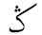  U+0763 | ۛ ک  U+06A9 U+06DB | Not Defined
  U+065C | ب  U+0628 | ٮ  U+066E U+065C | Not Defined
 | ڊ  U+068A | د  U+062F U+065C | Not Defined
 | ڋ  U+068B | ڈ  U+0688 U+065C | Not Defined
 | ڔ  U+0694 | ر  U+0631 U+065C | Not Defined
 | ڣ  U+06A3 | ف  U+0641 U+065C | Not Defined
 | ڹ  U+06B9 | ن  U+0646 U+065C | Not Defined
 | ۼ  U+06FC | غ  U+063A U+065C | Not Defined
 | ۻ  U+06FB | ض  U+0636 U+065C | Not Defined
 | 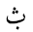  U+0751 | ث  U+062B U+065C | Not Defined
 | U+0766 | م  U+0645 U+065C | Not Defined
U+065A | ڵ  U+06B5 | ل  U+0644 U+065A | Not Defined
 | ۆ  U+06C6 | و  U+0648 U+065A | Not Defined
 | ێ  U+06CE | ی  U+06CC U+065A | Not Defined
 | ێ  U+06CE | ى  U+0649 U+065A | Not Defined
 | U+0756 | ٮ  U+066E U+065A | Not Defined
 | U+0769 | ن  U+0646 U+065A | Not Defined

Appendix A.2.2. Same Shape in Composed and Decomposed forms using two Composing Characters, not covered through Unicode Normalization Process

Composed Form | Decomposed Form
ښ  U+069A | س  U+0633 U+065C U+06EC
ڣ  U+06A3 | ڡ  U+06A1 U+065C U+06EC
ۺ  U+06FA | س ۛ  U+0633 U+06DB U+065C
ۻ  U+06FB | ص  U+0635 U+065C U+06EC
ۼ  U+06FC | ع  U+0639 U+065C U+06EC
ڹ  U+06B9 | ں  U+06BA U+065C U+06EC

Appendix B. Confusable Similar Letters in Arabic Script

Appendix B.1. Similar Shape in at least one Position

Unicode | Initial Form | Medial Form | Final Form | Isolated Form
Kaf Group
U+06A9 (ک) | کا | لکل | ٹک | ک
U+06AA (ڪ) | ڪ | لڪل | ٹڪ | ڪ
U+0643 (ك) | كا | لكل ل | ٹك | ك
Yay Group
U+064A (ي) | يع | ميل | یلي | ي
U+06CC (ی) | یع | میل | یلی | ی
U+0649 (ى) | - | - | بى | ى
Hamza and Wavy Hamza Groups
U+0623 (أ)  (Also see decomposed form) | - | - | بأ | أ
U+0672 (ٲ) | - | - | بٲ | ٲ
U+0625 (إ) | - | - | بإ | إ
U+0673 (ٳ) | - | - | بٳ | ٳ

Appendix B.2. Confusable Similar Shape with Difference in Dot Orientation

Unicode | Characters
- U+062A  - U+067A | - ت  - ٺ
- U+062B  - U+067D | - ث  - ٽ
- U+063C  - U+0764 | - 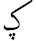  - ݤ
- U+064A  - U+06D0 | - ي  - ې
- U+067E  - U+0752 | - پ  - ݒ
- U+0683  - U+0684 | - ڃ  - ڄ
- U+0686  - U+0758 | - چ  - ݘ
- U+068E  - U+068F | - ڎ  - ڏ
- U+06A0  - U+075F | - ڠ  - ݞ
- U+06B2  - U+06B3 | - ڲ  - ڳ
- U+075D  - U+075E | - ݝ  - ݟ
- U+0697  - U+076B | - ڗ  - ݫ
- U+0649  - U+06CD  - U+06CC | - ى  - ۍ  - ی

Unicode standard also include Arabic Presentation forms in the ranges U+FB50 – U+FDFF and U+FE70 – U+FEFF, which are not recommended for use and are not PVALID.

