Arabic Variant TLD Issues and Requirements
- Background
This document has been prepared to identify issues about how variants may be defined, managed and implemented in new TLDs. Though the work has been motivated in the context of the new gTLD program, this is relevant in both IDN gTLD and IDN ccTLD implementations.

In 2009, an independent implementation working team was formed after discussions during the ICANN meetings in Mexico City and Sydney to study these issues. The team included linguistic and technical experts from various language communities, and was co‐chaired by two ICANN Board Directors who are well‐versed in the fields of IDN and DNS. The team recommended that variants not be delegated as TLDs at that time, and that if desired variants are to be delegated, certain conditions must be fulfilled.

To develop potential solutions for the delegation of IDN variant TLDs, the ICANN Board in its 2010 meeting in Norway directed the CEO to:

… develop (in consultation with the ICANN Board ES-WG) an issues report identifying what needs to be done with the evaluation, possible delegation, allocation and operation of IDN gTLDs containing variant characters, as part of the new gTLD process in order to facilitate the development of workable approaches to the deployment of gTLDs containing variant characters IDNs. The analysis of needed work should identify the appropriate venues (e.g., ICANN, IETF, language community, etc.) for pursuing the necessary work. The report should be published for public review.

Accordingly, ICANN in consultation with community has proposed to conduct as many as six case studies in the following scripts (Arabic, Chinese (Traditional and Simplified), Cyrillic, Devanagari, Greek, and Latin) to investigate the set of issues that need to be resolved to facilitate a good user experience for IDN variant TLDs. Each case study team has been requested to submit an Issues report for the script it is looking into. From these Issues report, a single Issues Report will be created.

This document presents the Issues report developed by the Arabic Case Study Team, and even though this document is intended for the TLD level, these issues may also be of some concern for the relevant registries.
- Introduction to Arabic Script
Arabic script has been used across North Africa, Middle East, Central Asia South Asia and South East Asia to write multiple languages from Semitic, Indo-Iranian, Indo-European, Dravidian, Turkic, African and and Austronesian language families. Some salient areas Arabic script is currently being used are highlighted in the illustration below.
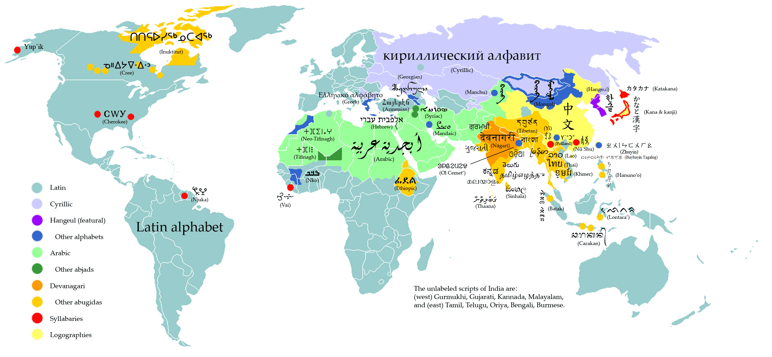
Figure 1: Writing Systems of the World
(Source: http://en.wikipedia.org/wiki/File:WritingSystemsoftheWorld4.png)

Arabic writing system is also referred to as Abjad system, in which consonantal sounds are represented as base characters and vowels are normally represented by optional combining marks on these base characters (except for long vowels, which may also represented by base characters). The writing system is cursive and each letter may have multiple shapes, generally categorized as initial, medial, final and isolated forms, based on where it occurs within the connected portion of a (sub)word, called a ligature, or whether it occurs by itself (not joined with any other letter). Though logically a letter may have these four shapes, in reality the shape of a letter may also vary with other letters it joins with (not just its position within a ligature) and may take up many different shapes.

An additional complexity in the Arabic script is the bi-directionality of the script. The script is generally written from right to left, however, the digits are written from left to right. Though this does not change the key-press order of input into computing devices, it may have significant impact on how the input is displayed. Further complexity is introduced if the (right to left) Arabic script is mixed with other (left to right) scripts, like Latin.

Arabic script has a variety of writing styles, with Naskh predominantly being used to write Arabic language and Nastaliq being used for many of the other languages using Arabic script. Additional writing styles, which are used for stylistic reasons, include Thuluth, Diwani, Kufi, Riqa, etc. Some of these writing styles are illustrated in Figure 2 (with same Arabic language phrase written in different styles). The various styles show both the base characters and the optional combining marks. Thuluth and Diwani also include non-linguistic ornate marks. | 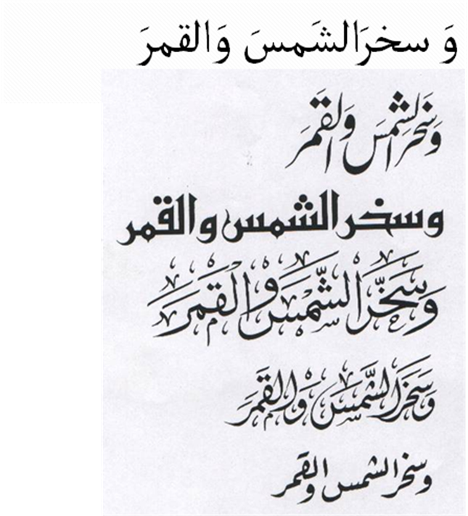
Figure 2: Arabic Script Writing Styles: Naskh, Nastaliq, Kufi, Thuluth, Diwani and Riqa
(Source: Hussain 2004)

- General Principles about the Report
While discussion, the Arabic Script Case Study Team deliberated on many issues and has generally agreed on the following three general principles for interpreting the eventual document.

As per the scope of the study, the Arabic Script Case Study Team agreed to talk generally for TLD space, without making the distinction between ccTLD or gTLD labels at the root.

The team also agreed to limit the scope of work to TLDs (not second or other level labels), unless the recommendations apply to all levels (where it has been made explicit).

Finally, though the team is generally confident on the identification of the issues and any corresponding recommendations, some issues may still need to be discussed with representatives of languages communities not represented in the committee (e.g. use of Arabic script in African languages). In such cases, it has been explicitly identified for further consultation.
- Terminology
Specific terminology has been used in this document, as presented in Appendix E. These terms are based on the initial set of definitions circulated by the IDN Variant Issues Project Team of ICANN, but have been specialized for Arabic Script Case Study, where necessary. Any relevant but missing terms have also been added to the list. It is recommended that the readers familiarize themselves with these terms, as defined, before reading the current document any further.

- TLD Label Valid Code Points for Arabic Script
The Arabic script characters are encoded from U+0600 – U+06FF and U+0750 – U+077F in the Unicode standard. Only a subset of these characters are PVALID, i.e. allowed for use in labels (e.g. see RFC 5892). The team suggests further limiting the use of these characters for TLDs, as per the following details.

- 200C (ZWNJ): Zero-Width-Non-Joiner (ZWNJ) is character used in Arabic script to allow for final shape of a dual-joining letter to appear in the middle of a word for correct orthographic representation of some words in some languages, e.g. when, in languages like Farsi and Urdu, the a suffix of a word does not join with the root as in فیض آباد instead of فیضآباد (“Faiz-Abad” in Urdu and Farsi). The community discussed both the need to allow ZWNJ and issues that may arise by using it in TLDs in great detail. Following is the summary of arguments which came out of the discussion:

  - Arguments in favor of allowing ZWNJ for TLDs
It is needed to correctly render a label where a non-final dual-joining letter occurs in the final form (making the word to appear disjoint, where it would be joined otherwise).
    - Linguistically this can occur in multiple cases:
a prefix which is disjoint with the root; a root which is disjoint with the suffix; arbitrary disjoint word due to orthographic convention (many times this occurs for borrowed words from English and other languages); transliteration of abbreviations like UN into at least some Arabic script based languages; one word followed by another word, where space is not allowed to separate these words (e.g. in labels)
    - The ZWNJ is visible in all these cases due to the significant change in letter shaping
    - This character is needed for many languages, including Farsi, Urdu, Kurdish, etc. It is in use by some language communities, e.g. Kurdish.
    - It is being proposed by various language communities to be used and added to their keyboards to write IDN labels, similar to adding ‘@’ sign to write email addresses. For e.g. national consensus and policy for .پاکستان IDN ccTLD requires ZWNJ to be added and available for use in the labels. It is already available on some other keyboards
    - It is required to render the brand names properly, e.g. پیپسی کولا (“Pepsi Cola”)

  - Arguments in favor of not allowing ZWNJ for TLDs
    - Labels need not capture linguistic conventions and may be treated as a string instead of a linguistic word, which makes word-based arguments redundant
    - The character is not visible, even though it changes the shape of the letters around and thus may be a security risk in some cases
    - It is not one with the general category of { Ll, Lo, Lm, Mn }, as per the requirement defined by the gTLD Applicant Guidebook (v 2011-09-19, Module 2, page 2-13, Section 2.2.1.3.2, Part II, Item 2.1.3.)
    - It is not generally familiar to and in use by end users and thus users may type <space> to try to type the character which will not resolve (or alternately resolve to a different result if the sub-string before the ZWNJ is registered as a separate TLD, e.g. if both فیض and آبادZWNJفیض are TLD labels, then آباد<SPACE>فیض may resolve to فیض )
    - It is not available on many keyboards
    - Root policy should be more conservative than labels for other levels
    - Use of ZWNJ may cause additional bidirectional display issues

  - Possible solutions
The solutions can be very conservative or very liberal. The right balance is needed, where maximal variety in Label Generation Policy is needed without compromising any security. The community needs to scrutinize this issue in greater detail to finalize the solution. For example, some possibilities include (liberal to conservative; there may also be other cases):

    - ZWNJ is allowed, however the string with it is considered a variant of the string without it. This addresses KB, confusability and security issues (but gives the users the choice and flexibility based on their language)

    - ZWNJ is allowed, however, if ZWNJ is allocated, then the variant without it must also be allocated

    - ZWNJ is allowed, however, if ZWNJ is allocated, then the variant without it must also be allocated. Additionally, the label with ZWNJ cannot be a fundamental label, but can only be a variant

    - ZWNJ is allowed only if the applicant can demonstrate convincingly that the string will not cause security risks, with additional restrictions as discussed above

    - ZWNJ is not allowed in a TLD label at this time

  - Additional restrictions

Though there is a defined rule which allows ZWNJ only in contexts where its effect is visible, there are few contexts which ZWNJ may still not have a visible impact.
    - This includes characters U+0637, U+0638 and U+069F. This is indicated by the two sequences, one with and one without the ZWNJ: طب ط‌ب (also see Appendix D). The ZWNJ should not be permitted following such characters, in addition to the constraint already put on its use by the IDNA 2008 protocol (see RFC 5893)
    - Similarly, use of ZWNJ after Heh (e.g. Heh group in Appendix A.1; also see Appendix D) should also be carefully analyzed to restrict ZWNJ from occurring in cases where the shape change due to its occurrence is not visible. Careful analysis is also needed as sometimes the shape of Heh Group rendering is also not correctly done in fonts (as confusion should be based on the canonical glyph shapes recommended by the Unicode standard)

- 200D (ZWJ): Not needed in Arabic script
- 0610-061A: an issue as they are PVALID but should not be allowed for TLDs as these are combining marks
- 0621-063F: OK, PVALID and needed for TLDs
- 0641-064A: OK, PVALID and needed for TLDs
- 064B-0659: an issue as they are PVALID but should not be allowed for TLDs as these are combining marks
- 065A-065F: an issue as they are PVALID but may not be allowed for TLDs as these are combining marks

General rule may be extracted that combining marks are not allowed for TLDs. This policy should be subject to revision depending on whether there are negative consequences for African and other languages, which use these marks (especially U+065A - U+065F), arising from this limitation.

- 0660-0669: an issue as they are permitted under a context rule, but should not be allowed for TLDs, because digits are not allowed in TLDs
- 066E-066F: an issue as they are PVALID but should not be allowed for TLDs because Archaic and not used in Arabic script based languages now
- 0670: an issue as they are PVALID but should not be allowed for TLDs as it is a combining mark
- 0671-0673: OK, PVALID and needed for TLDs
- 0674: an issue as it is PVALID but resembles a combining mark
- 0679-06D3: OK, PVALID and needed for TLDs
- 0674:
- 06D5: OK, PVALID and needed for TLDs
- 06D6-06DC: an issue as they are PVALID but should not be allowed for TLDs as they are Quranic marks which are not used in writing Arabic script based languages and are combining marks
- 06DF-06E8: an issue as they are PVALID but should not be allowed for TLDs as they are Quranic marks which are not used in writing Arabic script based languages and are combining marks
- 06EA-06ED: an issue as they are PVALID but should not be allowed for TLDs as they are Quranic marks which are not used in writing Arabic script based languages and are combining marks
- 06EE-06EF: OK, PVALID and needed for TLDs
- 06F0-06F9: an issue as they are permitted under a context rule, but should not be allowed for TLDs because digits are not allowed in TLDs
- 06FA-06FF: OK, PVALID and needed for TLDs
- 0750-077F: OK, PVALID and needed for TLDs
- FE73: an issue as they are PVALID but should not be allowed in any label (TLDs and other labels)

This list may get updated as Unicode standard changes and more characters are added to Arabic script, as per the IDNA 2008 protocol specifications. The list does not explicitly include ASCII letters a-z, digits 0-9 and hypen, which may additionally be permitted in a label, though restrictions on TLDs apply (e.g. digits are not allowed in TLDs).

- Character Variants in Arabic Script
Variant labels in Arabic script may occur due to reasons motivated by linguistics, stylistics of writing styles or encoding. The current issues document lists all possible cases where variants may occur, for consideration and further stipulation of how variant sets may be constituted. The current analysis distributes character variants into four categories: identical, confusingly similar, interchangeable and optional.

- Identical Cases
In these groups of letters, a letter exhibits an identical shape in at least one of their initial, medial, final or isolated forms with at least another letter in the group. The groups are formed transitively, i.e. if A is a character variant of B, and B is a character variant of C, then A is also considered a character variant of C, even if the condition of being identical is not met in A and C (e.g. see the Heh set). These groups are defined in Appendix A.1.

  - Kaf group – limit as one at TLD level; all are possible for TLD registration (no preferred over other, depends on registrant request)
  - Heh group – limit as one at TLD level; all are possible for TLD registration (no preferred over other, depends on registrant request)
  - Yeh group - limit as one at TLD level; all are possible for TLD registration (no preferred over other, depends on registrant request)
  - Feh group - limit as one at TLD level; all are possible for TLD registration (no preferred over other, depends on registrant request)
  - Veh group - limit as one at TLD level; all are possible for TLD registration (no preferred over other, depends on registrant request)
  - Tay marbuta group - limit as one at TLD level; all are possible for TLD registration (no preferred over other, depends on registrant request)
  - Heh hamza group - limit as one at TLD level; all are possible for TLD registration (no preferred over other, depends on registrant request)
  - Ttey/Rnoon group - limit as one at TLD level; all are possible for TLD registration (no preferred over other, depends on registrant request)
  - Noon group - limit as one at TLD level; all are possible for TLD registration (no preferred over other, depends on registrant request)
  - Theh group - limit as one at TLD level; all are possible for TLD registration (no preferred over other, depends on registrant request) (confusable with pay, not THeh)

In addition to those which have exactly the same shape, the identical character variants may also be caused by a letter combining with a combining mark. Such cases are given in Appendix A.2 (A.2.1 and A.2.2). Some of these cases are addressed automatically through the IDNA 2008 protocol specifications, which requires the characters to be composed (in Normalized Form C). However, such composition only takes place, where equivalence has been defined by the Unicode standard. In cases where composition has not been defined by Unicode (for various reasons), such cases would need to be explicitly managed as variants (status listed in the final column of Appendix A.2).

As per the previous section, combining characters are recommended not to be allowed for TLD labels. In such a case, these cases may be ignored. However, if the final solution allows these combining characters in TLDs, Appendix A.2 must then be taken into account. As discussed, this also depends on feedback from communities using the Arabic script for African languages, as encoded by the Unicode standard. Appendix A.2 may still be useful reference for non-TLD label formation.

- Similar Cases
In these groups of letters, a letter is confusably similar in shape in at least one of their initial, medial, final or isolated forms with at least another letter in the group. The groups are formed transitively and cause user confusion (and therefore considered a form of variants). These groups are defined in Appendix B.

  - Kaf group - limit as one at TLD level; all are possible for TLD registration (no preferred over other, depends on registrant request). This is needed as the Swash Kaf version is interchangeably used with other Kafs and the former is considered the same letter, with just stylistic variation. It is considered different from other Kafs only in Sindhi language, for which it has been encoded.
  - Yeh group - limit as one at TLD level; all are possible for TLD registration (no preferred over other, depends on registrant request). The addition Yeh in this case has very slight tail at its end which may be considered a stylistic variation and be confused with regular Yeh by most users of Arabic script, except speakers of Pashto who distinguish it from other Yehs.
  - Alif Hamza above group - limit as one at TLD level; all are possible for TLD registration (no preferred over other, depends on registrant request). The wavy Hamza is not distinguishable by most Arabic script users.
  - Alif Hamza below group - limit as one at TLD level; all are possible for TLD registration (none preferred over any other, and the choice depends on registrant). The wavy Hamza is not distinguishable by most Arabic script users.

Dot orientation could cause confusion among Arabic script users and thus can be a potential candidate for character variants. Such confusing cases have been listed in Appendix B.2. It should be investigated further with feedback from relevant language communities (not represented on the committee) for resolution.

Additionally there are some more cases, which are generally not confusable by Arabic script users, but may become confusable in small font size, especially in fonts which are not very accurate in shaping. These include the cases in Appendix B.3.

- Interchangeable Cases
In some cases, either similar sound or common alternate spellings sometimes cause different characters to be used interchangeably in some languages. This could cause user confusion and should be investigated as character variants.

  - In the Arabic and other languages, the Hamza marks (U+0654, U+0655) can be combined with other letters (such as the Arabic Letter Alef, U+0627, Arabic Letter Yeh, U+064A, Arabic Letter Waw, U+0648, and Arabic Letter Alef Maksura, U+0649, Arabic Letter Heh, etc.) to form letters that may be confused with the corresponding letters without Hamza marks and may be used interchangeably with these letters without the Hamza marks. Some of these letters are separately encoded in the Unicode (U+0623 – U+0626; U+06C0, U+06C2, U+06D3). Combined forms (if marks are allowed) and these separately encoded letters may be considered variants of the letters without Hamza marks.
  - In the Arabic language, the Madda marks (U+0653) can be combined with Arabic Letter Alef (U+0627) to form letter Alef with Madda that may be confused with Alef without Madda mark and may be used interchangeably with it. Alef with Madda is also separately encoded in the Unicode (U+0622). Combined form (if marks are allowed) and the separately encoded letter may be considered variants of Alef in Arabic language. However, Arabic with Madda is a separate character in other languages, e.g. Urdu.
  - In the Arabic language and many other languages using Arabic script Teh Marbuta (U+0629) and Heh (U+0647) are used interchangeably at the end of a word by speakers of these languages, because they sound same in the context. Thus, these may cause user confusion in the labels.
  - There are two sets of digits, Arabic digits and Arabic Indic digits. They may be used interchangeably, with each other and with ASCII digits. Though this is not relevant to TLDs, as digits are not allowed in TLDs, this may be a relevant issue for other labels. The subset of the Arabic sets from 1-3 and 8-9 are identical. 4-7 have different shapes.

- Optional Cases
There are different kinds of optional marks in Arabic script, and their usage differs across languages. As they are optional and there can be multiple optional marks per letter in a label, their use may create a very high number of variants. Due to their small size (as glyphs) and optionality, they can also cause a high degree of user confusion and security issues. Their use should therefore be very carefully regulated. It is recommended that they are not allowed for the TLDs. The list of optional marks is given below (reproduced from Section 5 above).

- 0610-061A: an issue as they are PVALID but should not be allowed for TLDs
- 064B-0659: an issue as they are PVALID but should not be allowed for TLDs
- 065A-065F: an issue as they are PVALID but may not be allowed for TLDs
- 0670: an issue as they are PVALID but should not be allowed for TLDs
- 06D6-06DC: an issue as they are PVALID but should not be allowed for TLDs
- 06DF-06E8: an issue as they are PVALID but should not be allowed for TLDs
- 06EA-06ED: an issue as they are PVALID but should not be allowed for TLDs
- Label Generation Policy
A registry supporting Arabic script labels would generally announce a Label Generation Policy, which it would use to determine if a label is valid and what variants a label may have. There may be a different label generation policy for each level, and the current document focuses on the Arabic TLD Label Generation Policy (though same concepts may apply to other levels).

The team agrees that the structure proposed in JET Guidelines (RFC 3743) is not appropriate for Arabic script. There are many differences, e.g. only a two column format may be sufficient and the relationship between variants is symmetric in Arabic script based labels. Thus a separate effort involving the Arabic Script community needs to be undertaken to consider the structure of Label Generation Policy for Arabic script. Defining the structure is important for effective use, reuse and derivative use of Label Generation Policy. The same structure should be valid for all levels of label generation, though the content may vary (as discussed) and lower level policies may become less conservative than TLDs.

The team further suggests that the policy at TLD level, which defines the label at the root, needs to be more conservative by comparison with the other levels. Further, the team also recommends that this single policy be applicable across all gTLDs and should also be considered for validating labels for ccTLDs (so that there is a consistent set of Arabic Script TLD Variant Labels for each fundamental label applied for gTLDs or ccTLDs).

However, when this Arabic Script TLD Label Generation Policy is defined, it should consider clearly stipulating: (i) who is the point of contact and owner of this policy, (ii) who participates in defining this policy, (iii) how will this policy will be maintained over time, e.g. as Unicode standard is updated, or there is an issue raised to change it by the community, (iv) what will be the process to raise issues to modify it, and (v) what will be the use of this table.

Though defining the structure in necessary for effective re-use of this information, it was considered beyond the scope of the current work on issues. However, it is suggested that such a structure should include the following information:

- List of label valid code points
- Character variants
- Additional rules and/or constraints on labels at that level, formally articulated using a context dependent syntax
- Meta information about the table, which may include optional information about language(s) the table supports, the contact information for the table owner, version of the table, and other relevant information

The community should also develop tools which allow for automatic verification of a suggested label as per the Label Generation Policy and each label being requested should be evaluated against this policy before further processing.

In the meta information provided, should the policy identify the set of language(s) it supports? This could be a single language, multiple languages or the entire script (script being the case for TLD Label Generation Policy).

Should variants be defined at the character positioning level (Initial, Medial, Final, Isolated) or at character level? This particular issue is relevant for both TLD and other levels. Positioning level gives more choices to the users, without making them any more confusable. The character level is a subset of positioning level. If the former is made available, the latter can be inherited as well (but not vice versa). This will have implications on the design of the structure for the Label Generation Policy.

Finally, should there be a requirement for considering already existing label general policies, as has been given in the Fast Track process? This is valid only for label generation policy for non-TLD labels.

- Variant Management for TLD Applicants
Introduction of variants causes more complexity in the application process, as there are many more strings which are generated as variant labels and not all of these may be eventually allocated or delegated. Should there be a limit on the size of the Variant Label Set, else otherwise the list may be quite long? If yes, how should the short-list be determined?

An applicant for a TLD label would normally request a Fundamental Label. However, now a Variant Label Set will be generated as per the Label Generation Policy (this is fixed by the registry policy and not determined by the applicant). All these labels, except the Blocked Variant Label Subset (which is also determined by registry policy), will be available for the applicant. As per the decision of the applicant and the policies of the registry, the available labels will be divided into Allocated Variant Label Subset and Reserved Variant Label Subset, former administratively associated with the registrant and latter not available to anybody else but not administratively associated to the registrant. All the Allocated Variant Labels may eventually be activated through delegation or other mechanisms (e.g. DNAME or any other methods available). If only a subset is activated then this also need to be defined. There may also be a Blocked Variant Label Subset, which is defined by the registry and not available to any applicant.

Also over time, the registrant may request for changing the status of one or more of the Variant Labels, e.g. from allocated to reserved, vice versa, etc. or registry may change status of some variants, e.g. from blocked to reserved, vice versa, etc.

It needs to be clearly defined what are the multiple states a Variant Label may take and what are the processes to transition from a state to another state, including administrative, technical and billing requirements. For example, it is recommended that the allocation and expiration of Variant Label Set be synchronized, and the transition process for individual labels should be possible within these time bounds. An associated question is whether history of such transitions should be maintained?

Another important consideration is about how this process will be different if the applicant requests change in status of a fundamental label? Will this be possible (should be, if the variants are symmetrical in Arabic script; are there cases where it may not be possible, e.g. in case ZWNJ is allowed)? This may be more complex to deal with as an alternate fundamental label will need to be defined and other variant labels will need to be re-associated (e.g. see the Domain Name Registration Data (WHOIS) section).

If the domain name expires or is transferred to somebody else, how will the Variant Label Set change its status? In the case of transfer, will the transferee get the option to choose of various subsets differently from what exist at this time (fundamental, allocated, reserved, etc.)? This is applicable to TLDs, in cases of re-delegation.

Additionally, the solutions need to be clearly articulated for applicants for TLDs for them to make informed decisions.

The current registration tools need to be extended to incorporate the entire process automatically, with no (or minimal) manual interaction.

Finally, it is possible that the Label Generation Policy may change. As it changes, it may modify the Variant Label Set. How will such changes and their impact be communicated to the stakeholders, e.g. the relevant TLD registries (e.g. additional variant labels may be needed as Unicode expands its repertoire).
- Domain Name Registration Data (WHOIS)
As the domain names become available in Arabic script, there is clear need for the Domain Name Registration Data to be in the same script. The current WHOIS Protocol (RFC 3912) does not support multilingual data. There are already some efforts in the community to come up with a more comprehensive protocol which also supports this aspect and this should be pursued and finalized.

In addition to the Domain Name Registration Data Protocol, it should also be clearly defined what Domain Name Registration Data is needed from the applicant/registrant and how much of that will be made available to the public.

It is also crucial to define what Domain Name Data Services are needed to make this non-ASCII data available publically.

As the protocol, data and service needs around the IDNs are being finalized, the support for variants must also be considered. There is a paradigm shift here, where although currently there is a one-to-one lookup for WHOIS against the domain name, henceforth the look up will have to deal with the following scenario, where Label X_{i} represents a variant of Label X.

Label 3₁  …  Label 3_{l} | Label 2₁  . …  Label 2_{m} | Label 1₁  . …  Label 1_{n}
There are multiple ways variants may be queried, and the possible domain names may have different statuses (e.g. reserved, allocated, delegated, activated, etc.).

It needs to be determined how a request for WHOIS information for a domain name Label3_{i}.Label2_{j}.Label1_{k} may respond (request to information for .Label1_{k} in case of TLDs).

The Arabic script case study team suggests the following:

- All allocated variants should have the same ownership
- It would be necessary to have the variant information available as part of the Domain Name Registration Data Services
- A query on an allocated or reserved label should return the fundamental label; though it is not clear at this time if the status of the queried label should also be returned along with the fundamental label.
- A query on the fundamental label would return the Domain Name Registration Data relevant to the query. Details of what is returned need to be defined (as discussed above).
- There is need for an additional query/service which returns the Label Variant Set against a requested domain name. Again it is not clear, if such a service should also return the status of each label in the set.
- Would the response against a blocked variant label different from responses to labels with other status (reserved, allocated, etc.)?
- Will the creation and expiration dates of the Variant Label Set be inherited from the fundamental label, as suggested? If yes, then if a variant label is either added or changes its state, how will this information be part of the Domain Name Registration Data? Would history be maintained and communicated for such changes?

- Blocked Variant Label Set (for Reserved Names)
The registry may need to block reserved names and their variants (e.g. geographic names). Here are some relevant questions.

- If someone gets an exception to register a name from the reserved list, should s/he also get its variants? If yes, does this happen automatically or upon request?
- Should the registry add all variants or some of them to the reserve list? How is it determined?
- Fees
As variant labels introduce a much more complex mechanism, with a process to change the status of various labels, the implication on pricing should also be developed. Relevant questions include the following:

  - Does the fee differ with the size of the Label Variant Set requested to be allocated?
  - If it is possible to activate differently, are there different fees for these processes, e.g. Delegation vs. DNAME, etc.
  - Is there a fee for changing the status of a variant from one status to another, e.g. from reserved to delegated, etc.?

- DNSSEC
The registry may need to think more about key management specially when they adopt variants. Delegation may require different keys, while DNAME like techniques may require a single key. A mixture of such processes may require a complex key management mechanism. This may also cause different expiry dates for different labels in the same Variant Label Set and may be needed to be looked carefully when transferring the domain or changing the status of a variant label.

- Dispute Resolution
This section deals with domain registrations to which ICANN/WIPO Dispute Resolution Policy apply.
    - Filing a Complaint/Case
      - Are all members of a variant set treated as one also with regards to dispute resolution?
      - Could a case exist where a complainer claims right over a subset of a variant set ? Will the dispute differ if the disputed domain name(-s) is/are active, blocked or reserved? Will the whole variant set be included in this case?
      - Could a case exist where a complainer claims right over a whole variant set? Will all the members be consolidated as one case?
      - May registrants be forced into disputes as a result of registry variant practice such as automated generation of a variant label set? If so, does the present dispute resolution process provide adequate protection for the registrant?
      - Is it possible to have a single dispute spanning two different variant sets?

    - Payment
      - If dispute resolution for a subset of a variant set is allowed, how does the number of labels under dispute affect the dispute resolution fee? Does consolidation apply?
      - Could the fee differ according to the status of the disputed domain name(-s) whether they are active, blocked or reserved?

    - Decision and Decision Process
      - Could a case exist where a decision (such as cancellation or transfer of ownership) is applied to only a a subset of a variant set? If yes, what are the implications? In case the rest of the members were not active does this give the right to the registrant to activate any one or more members of the variant set?
      - Could a case exist where, as a result of dispute resolution process, a label is added to an existing variant set, either because it was overlooked in the pre-defined sets or not opted for by the original registrant?
      - Can a dispute resolution decision have implications on the Label Generation Policy (i.e. can a dispute decision cause changes to an existing Label Generation Policy?) If so, how will that be managed?
      - Should a change in a domain name status, due to its being under dispute, be inherited by the rest of the bundle members?

    - Technical Implementation of a Dispute Resolution Decision:
      - What are the implications of changes done on a variant set as a result of implementing a dispute resolution decision?
      - What are the implications of a dispute resolution decision on Label Generation Policy in terms of implementing changes to variant sets defined? Can a decision on a bundle have impact on other bundles due to implied changes in the Label Generation Policy?

    - General
      - Do IDN variant considerations necessitate extending the purview of dispute resolution process beyond trademarks and service marks?

- End-user Requirements
Labels and their variants will need to be configured and used by administrators and users respectively. Appropriate tools and applications need to be developed to assist the process.
  - Keyboard (soft) issues
    - Lack of standard keyboard for many languages using Arabic script (e.g. for Kurdish, Urdu, Pashto, Sindhi and many other languages). This is also true when a user travels across different countries, trying to access, for example, Farsi domain name from an Arabic language country (with an Arabic KB available locally). This causes variation in typing same labels, and thus requires activation of labels for effective use for Arabic script.
    - Digits may also present an issue. But not relevant to TLDs.

  - Font issues
    - Two very different writing styles are in use by Arabic script community. Arabic language uses Naskh writing style and Persian, Urdu, Pashto, and many other languages in South Asia use Nastaliq writing style. There are many other font styles in use, including Thuluth, Riqa, Kufi and others, for stylistic variation. Fonts may have implications on variant label sets.
    - There may be variation within a writing style across different fonts, e.g. see variety in rendering of Heh in Naskh style in Appendix C.
    - Font support may not be consistent across variant label set, as a font may not support all characters variants, causing strings to break during display or boxes or other unexpected characters to show up. This may cause user confusion by not making different variants visible, and by making labels which are not variants to appear as same (e.g. two different letters mapped onto a box making them indistinguishable).

  - Concurrent Display of A-label and U-label for Administrative Purposes
    - There is a need to develop tools to manage variant labels. For example, currently there are no EPP extensions to handle variants during the registration process.
    - Similarly the administration tools only deal with ASCII, meaning that server administration will only be possible using A-Labels. Tools need to be developed to view these A-Labels along with the U-Labels to avoid management errors and to better identify the variants.
    - The two cases above only present first examples of many other tools which need to be developed for different functions and which use domain names and labels. A more exhaustive list needs to be worked out and eventually addressed. Though these are not relevant to TLDs, they are certainly relevant to their eventual use in the domain name system.
    - Most of the DNS management and resolving software – if not all – can resolve ASCII characters only. Thus, when creating new IDN entries in zone files, they must be entered in ASCII rather than Unicode. The same will apply to variants and variant TLDs.

  - Bidirectionality Issues
    - Arabic script domain name may have characters of different directionality (Arabic letters, Arabic digits, Arabic Indic digits, ASCII LDH, etc.) mixed within a label and across labels. This causes inconsistent display across various applications and may confuse users. Such cases need to be investigated and displayed in a consistent manner in applications.
  - Operating System Support Issues
    - Operating System support may not be consistent across variants of the same label, as an OS may not support all variant characters in a language table, causing strings to break during display or boxes or other unexpected characters to show up. This may cause user confusion by not making different variants visible, and by making labels which are not variants to appear as same (e.g. two different letters mapped onto a box making them indistinguishable).
  - Application Issues
    - Application may not be consistent across variants of the same label, as an application may not support all variant characters in a language table, causing strings to break during display or boxes or other unexpected characters to show up. This may cause user confusion by not making different variants visible, and by making labels which are not variants to appear as same (e.g. two different letters mapped onto a box making them indistinguishable).
    - While all of the latest web browsers have implemented IDNA2003, many of them have implemented IDNA2008 – if not all. Furthermore, while some old browsers do not support IDN extensions, some do support it, but do not display the U-Label format of an IDN (it breaks the label down into its ASCII format and displays it). Variants of TLDs should not be an issue for many of the web browsers as the user has to configure a language on the browser settings. However, some web browsers – such as Mozilla Firefox – require a special configuration in which a whitelist tag must be add as network.IDN.whitelist.<ASCII format of the TLD>. This means that for each variant, a new tag must be added.
    - Currently it’s not possible for the different e-mail systems to communicate and exchange e-mails with IDNaddresses. A working group within the IETF – E-Mail Address Internationalization (EAI) – is currently working to resolve this issue. Since e-mails under different TLDs will require independent setups at the server end, the same would apply to variants since each variant TLD has a different A-Label representation.
    - Currently no e-mail client application – whether PC based or web based – can support IDN addresses. The same issue will apply to variants and variant TLDs. Furthermore, for each IDN e-mail variant, a new setup must be configured so that e-mails received from the all configured variants of an e-mail account can be received.
    - Most of the office productivity tools – if not all – do not support IDNs; i.e. identifying and creating automatic hyperlinks for IDN domain names. The same issue willapplytothe variants and variant TLDs.
    - Most – if not all – of online blogs and content management systems “CMS” do not support IDNs. Some might support IDNs for certain languages; related to language communities that are active in the production of online content in their native languages, most of the social networks still does not recognize or display IDN domain names properly . The same applies to variants and variant TLDs.
    - None of the current lookup and networking tools supports IDN Unicode representations( U-Label format) . If an IDN is to be looked up, it should be converted into its A-Label format. The same will apply to variants and variant TLDs.
    - Most of the current mobile applications do not support IDNs.The same will apply to variants and variant TLDs.

  - Search Engines
    - Search engines must be optimized to cope with IDNs so that they offer IDN results. The same applies to variants and variant TLDs. Furthermore, even when search engines are optimized to provide IDN results, and assuming that an IDN has several variants across several languages within a script, which IDN would it return back, and in which language?
  - Hosting Service Providers
    - Many of the hosting service providers cannot deal with IDN U-Label , and many others do not understand the concept of IDNs. Furthermore, web hosting tools, such as the control panels can’t deal with IDNs.The same applies to variants and variant TLDs.
  - SSL Certificates
    - In order to configure a secure HTTP connection for a website, an SSL certificate must be added. If a website can be accessed using several domain names, each domain name will require an independent SSL certificate. And since each IDN variant holds a unique A-Label, each A-Label will require an independent SSL certificate. Thus, one will require n+1 SSL certificates if we assume an IDN and n variants for a certain domain name
- List of Contributors
- Concluding Remarks
Appendices
Appendix A. Identical Character Variants

Appendix A.1. Same Shape in at least one Position

Unicode | Initial Form | Medial Form | Final Form | Isolated Form
Kaf Group
U+06A9 (ک) | کا | لکل | ٹک | ک
U+0643 (ك) | كا | لكل ل | ٹك | ك
Heh Group
U+0647 (ه) | هم | مها | له | ه
U+06BE (ھ) | ھم | مھا | للھ | ھ
U+06C1 (ہ) | ہم | مہا | کہ | ہ
U+06D5 (ە) | - | - | نە | ە
Yeh Group
U+064A (ي) | يع | ميل | یلي | ي
U+06CC (ی) | یع | میل | یلی | ی
U+0649 (ى) | - | - | بى | ى
Feh Group
U+06A7 (ڧ) | ڧر | کڧر | یڧ | ڧ
U+0641 (ف) | فر | کفر | یف | ف
Veh Group
U+06A4 (ڤ) | ڤر | کڤر | یڤ | ڤ
U+06A8 (ڨ) | ڨر | کڨر | لڨ | ڨ
Tay Marbuta Group
U+0629 (ة) | - | - | بة | ة
U+06C3 (ۃ) | - | - | بۃ | ۃ
Heh with Hamza Group
U+06C0 (ۀ) | - | - | بۀ | ۀ
U+06C2 (ۂ) | - | - | بۂ | ۂ
Ttey/Rnoon Group
U+06BB (ڻ) | ڻا | بڻن | بڻ | ڻ
U+0679 (ٹ) | ٹا | مٹن | بٹ | ٹ
Noon Group
U+0646 (ن) | نا | بنن | بن | ن
U+06BA (ں) | ںا | مںن | بں | ں
Theh Group
U+06BD (ڽ) | ڽا | مڽا | ڽ | ڽ
U+067E (پ) | پا | بپا | پ | پ

Appendix A.2. Same Shape in Composed and Decomposed forms using Combining Marks

Combining Mark | Composed Form | Decomposed Form | Unicode Normalized Form
ٓ  U+0653 | آ  U+0622 | ٓ ا  U+0627 U+0653 | Defined
ٔ  U+0654 | أ  U+0623 | ٔ◌ ا  U+0627 U+0654 | Defined
ٔ  U+0654 | ؤ  U+0624 | ٔ و  U+0648 U+0654 | Defined
ٔ  U+0654 | ئ  U+0626 | ٔ ي  U+064A U+0654 | Defined
ٔ  U+0654 | ئ  U+0626 | ىٔ  U+0649 U+0654 | Not Defined
ٔ  U+0654 | ئ  U+0626 | یٔ  U+06CC U+0654 | Not Defined
ٔ  U+0654 | ۀ  U+06C0 | ۀ  U+06D5 U+0654 | Defined
ٔ  U+0654 | ۀ  U+06C0 | هٔ  U+0647 U+0654 | Not Defined
ٔ  U+0654 | ۂ  U+06C2 | ۂ  U+06C1 U+0654 | Defined
ٔ  U+0654 | ۂ  U+06C2 | هٔ  U+0647 U+0654 | Not Defined
ٔ  U+0654 | ۓ  U+06D3 | ۓ  U+06D2 U+0654 | Defined
ٔ  U+0654 | ځ  U+0681 | حٔ  U+062D U+0654 | Not Defined
ٔ  U+0654 | 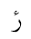  U+076C | رٔ  U+0631 U+0654 | Not Defined
ٕ  U+0655 | إ  U+0625 | ا◌ٕ  U+0627 U+0655 | Defined
ُ  U+064F | ۇ  U+06C7 | ُ و  U+0648 U+064F | Not Defined
ُ  U+064F | ۇ  U+06C7 | U+0648 U+0619 | Not Defined
ٰ  U+0670 | ۈ  U+06C8 | ٰ و  U+0648 U+0670 | Not Defined
۬  U+06EC | ۏ  U+06CF | ۬ و  U+0648 U+06EC | Not Defined
۬  U+06EC | غ  U+063A | ۬ ع  U+0639 U+06EC | Not Defined
۬  U+06EC | ض  U+0636 | ۬ ص  U+0635 U+06EC | Not Defined
۬  U+06EC | خ  U+062E | ۬ ح  U+062D U+06EC | Not Defined
۬  U+06EC | ڿ  U+06BF | ۬ چ  U+0686 U+06EC | Not Defined
۬  U+06EC | ذ  U+0630 | ۬ د  U+062F U+06EC | Not Defined
۬  U+06EC | ز  U+0632 | ۬ ر  U+0631 U+06EC | Not Defined
۬  U+06EC | ڶ  U+06B6 | ۬ ل  U+0644 U+06EC | Not Defined
۬  U+06EC | ڧ  U+06A7 | ٯ۬  U+066F U+06EC | Not Defined
۬  U+06EC | ف  U+0641 | ۬ ڡ  U+06A1 U+06EC | Not Defined
۬  U+06EC | ن  U+0646 | ۬ ں  U+06BA U+06EC | Not Defined
۬  U+06EC | ڬ  U+06AC | ۬ ك  U+0643 U+06EC | Not Defined
۬  U+06EC | 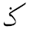  U+0762 | ۬ ک  U+06A9 U+06EC | Not Defined
۬  U+06EC | U+0765 | ۬ م  U+0645 U+06EC | Not Defined
U+0615 | 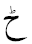  U+0772 | ح  U+062D U+0615 | Not Defined
 | ٹ  U+0679 | ٮ  U+066E U+0615 | Not Defined
 | ڑ  U+0691 | ر  U+0631 U+0615 | Not Defined
 | ڈ  U+0688 | د  U+062F U+0615 | Not Defined
 | U+0771 | ڗ  U+0697 U+0615 | Not Defined
 | U+0768 | ن  U+0646 U+0615 | Not Defined
 | ڋ  U+068B | ڊ  U+068A U+0615 | Not Defined
 | ڻ  U+06BB | ں  U+06BA U+0615 | Not Defined
U+065B | 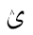  U+063D | ی  U+06CC U+065B | Not Defined
 | ۉ  U+06C9 | و  U+0648 U+065B | Not Defined
 | 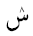  U+077E | س  U+0633 U+065B | Not Defined
 | U+06EE | د  U+062F U+065B | Not Defined
 | U+06EF | ر  U+0631 U+065B | Not Defined
 | U+06FF | ھ  U+06BE U+065B | Not Defined
 |  | U+0647 U+065B | Not Defined
ۛ  U+06DB | U+063F | ۛ ی  U+06CC U+06DB | Not Defined
ۛ  U+06DB |  | ۛ ى  U+0649 U+06DB | Not Defined
ۛ  U+06DB | ش  U+0634 | ۛ س  U+0633 U+06DB | Not Defined
ۛ  U+06DB | ڜ  U+069C | ۛ ڛ  U+069B U+06DB | Not Defined
ۛ  U+06DB | ث  U+062B | ٮۛ  U+066E U+06DB | Not Defined
ۛ  U+06DB | څ  U+0685 | ۛ ح  U+062D U+06DB | Not Defined
ۛ  U+06DB | ژ  U+0698 | ۛ ر  U+0631 U+06DB | Not Defined
ۛ  U+06DB | ڎ  U+068E | ۛ د  U+062F U+06DB | Not Defined
ۛ  U+06DB | ڠ  U+06A0 | ۛ ع  U+0639 U+06DB | Not Defined
ۛ  U+06DB | ڤ  U+06A4 | ۛ ڡ  U+06A1 U+06DB | Not Defined
ۛ  U+06DB | ڨ  U+06A8 | ٯۛ  U+066F U+06DB | Not Defined
ۛ  U+06DB | ڭ  U+06AD | ۛ ك  U+0643 U+06DB | Not Defined
ۛ  U+06DB | ڴ  U+06B4 | ۛ گ  U+06AF U+06DB | Not Defined
ۛ  U+06DB | ڷ  U+06B7 | ۛ ل  U+0644 U+06DB | Not Defined
ۛ  U+06DB | ڽ  U+06BD | ۛ ں  U+06BA U+06DB | Not Defined
ۛ  U+06DB | 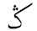  U+0763 | ۛ ک  U+06A9 U+06DB | Not Defined
  U+065C | ب  U+0628 | ٮ  U+066E U+065C | Not Defined
 | ڊ  U+068A | د  U+062F U+065C | Not Defined
 | ڋ  U+068B | ڈ  U+0688 U+065C | Not Defined
 | ڔ  U+0694 | ر  U+0631 U+065C | Not Defined
 | ڣ  U+06A3 | ف  U+0641 U+065C | Not Defined
 | ڹ  U+06B9 | ن  U+0646 U+065C | Not Defined
 | ۼ  U+06FC | غ  U+063A U+065C | Not Defined
 | ۻ  U+06FB | ض  U+0636 U+065C | Not Defined
 | 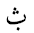  U+0751 | ث  U+062B U+065C | Not Defined
 | U+0766 | م  U+0645 U+065C | Not Defined
U+065A | ڵ  U+06B5 | ل  U+0644 U+065A | Not Defined
 | ۆ  U+06C6 | و  U+0648 U+065A | Not Defined
 | ێ  U+06CE | ی  U+06CC U+065A | Not Defined
 | ێ  U+06CE | ى  U+0649 U+065A | Not Defined
 | U+0756 | ٮ  U+066E U+065A | Not Defined
 | U+0769 | ن  U+0646 U+065A | Not Defined

Appendix A.2.2. Same Shape in Composed and Decomposed forms using Two Combining Marks

Composed Form | Decomposed Form
ښ  U+069A | س  U+0633 U+065C U+06EC
ڣ  U+06A3 | ڡ  U+06A1 U+065C U+06EC
ۺ  U+06FA | س ۛ  U+0633 U+06DB U+065C
ۻ  U+06FB | ص  U+0635 U+065C U+06EC
ۼ  U+06FC | ع  U+0639 U+065C U+06EC
ڹ  U+06B9 | ں  U+06BA U+065C U+06EC

Appendix B. Confusable Similar Letters in Arabic Script

Appendix B.1. Similar Shape in at least one Position

Unicode | Initial Form | Medial Form | Final Form | Isolated Form
Kaf Group
U+06A9 (ک) | کا | لکل | ٹک | ک
U+06AA (ڪ) | ڪ | لڪل | ٹڪ | ڪ
U+0643 (ك) | كا | لكل ل | ٹك | ك
Yeh Group
U+064A (ي) | يع | ميل | یلي | ي
U+06CC (ی) | یع | میل | یلی | ی
U+0649 (ى) | - | - | بى | ى
U+06CD (ۍ) | - | - | لۍ | ۍ
Hamza Above Group
U+0623 (أ) | - | - | بأ | أ
U+0672 (ٲ) | - | - | بٲ | ٲ
Hamza Below Group
U+0625 (إ) | - | - | بإ | إ
U+0673 (ٳ) | - | - | بٳ | ٳ

Appendix B.2. Confusable Similar Shape with Difference in Dot Orientation

Unicode | Characters
- U+062A  - U+067A | - ت  - ٺ
- U+062B  - U+067D | - ث  - ٽ
- U+063C  - U+0764 | - 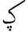  - ݤ
- U+064A  - U+06D0 | - ي  - ې
- U+067E  - U+0752 | - پ  - ݒ
- U+0683  - U+0684 | - ڃ  - ڄ
- U+0686  - U+0758 | - چ  - ݘ
- U+068E  - U+068F | - ڎ  - ڏ
- U+06A0  - U+075F | - ڠ  - ݞ
- U+06B2  - U+06B3 | - ڲ  - ڳ
- U+075D  - U+075F | - ݝ  - ݟ
- U+0697  - U+076B | - ڗ  - ݫ

Appendix B.2. Possibly Confusable Similar Shape with in Small Font Sizes

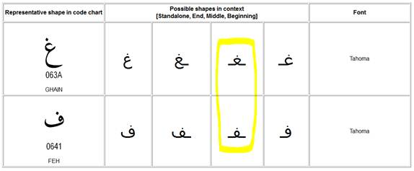
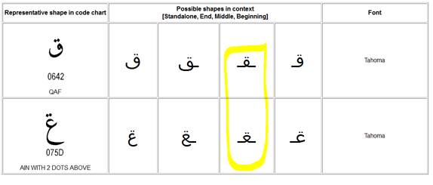
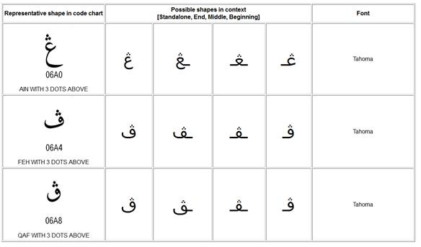
Appendix C: Shape Variations with Fonts

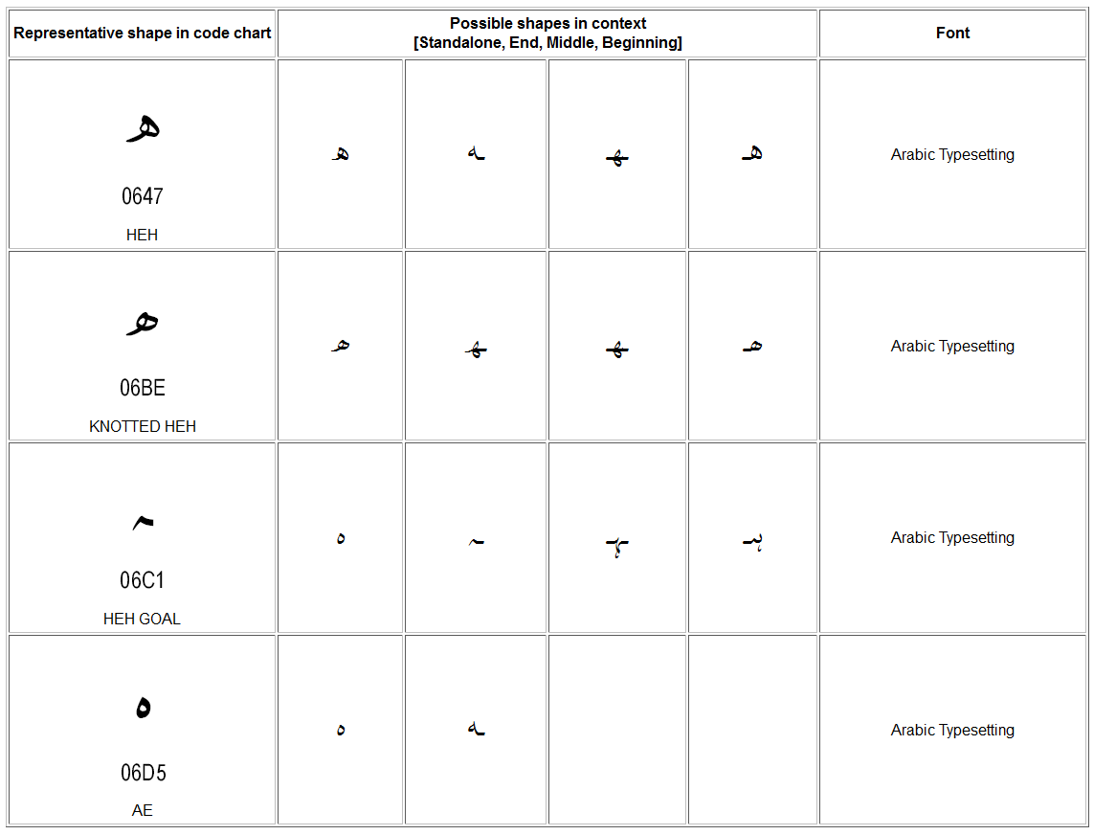

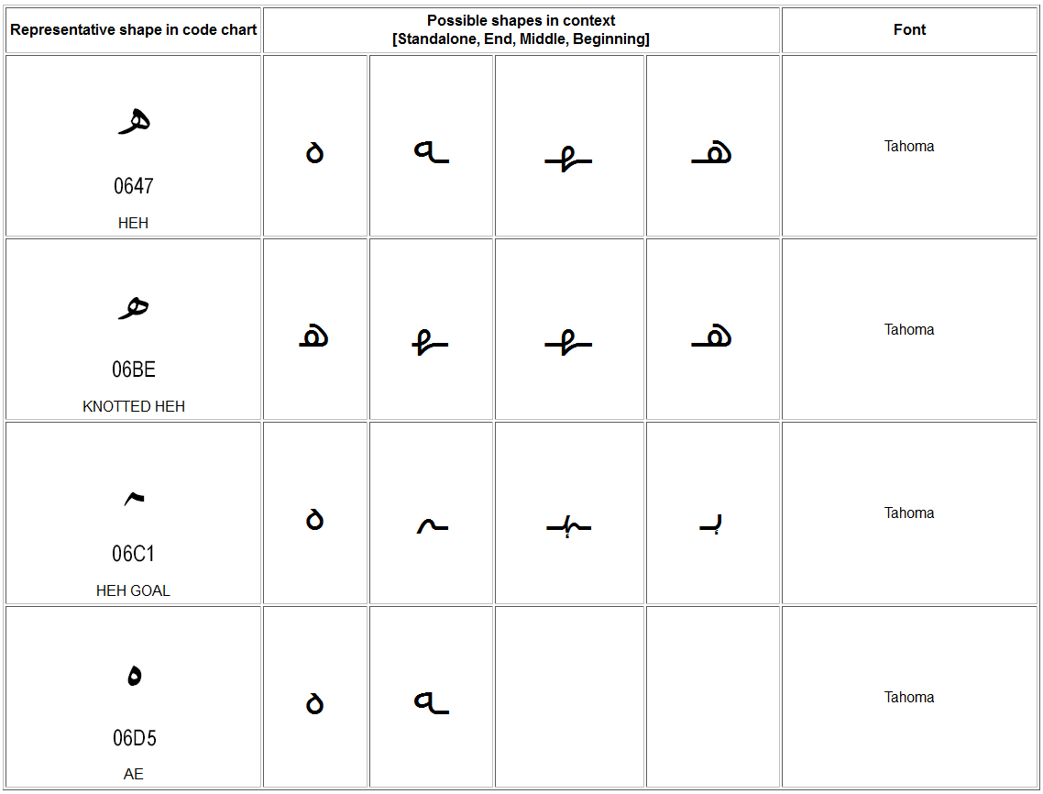

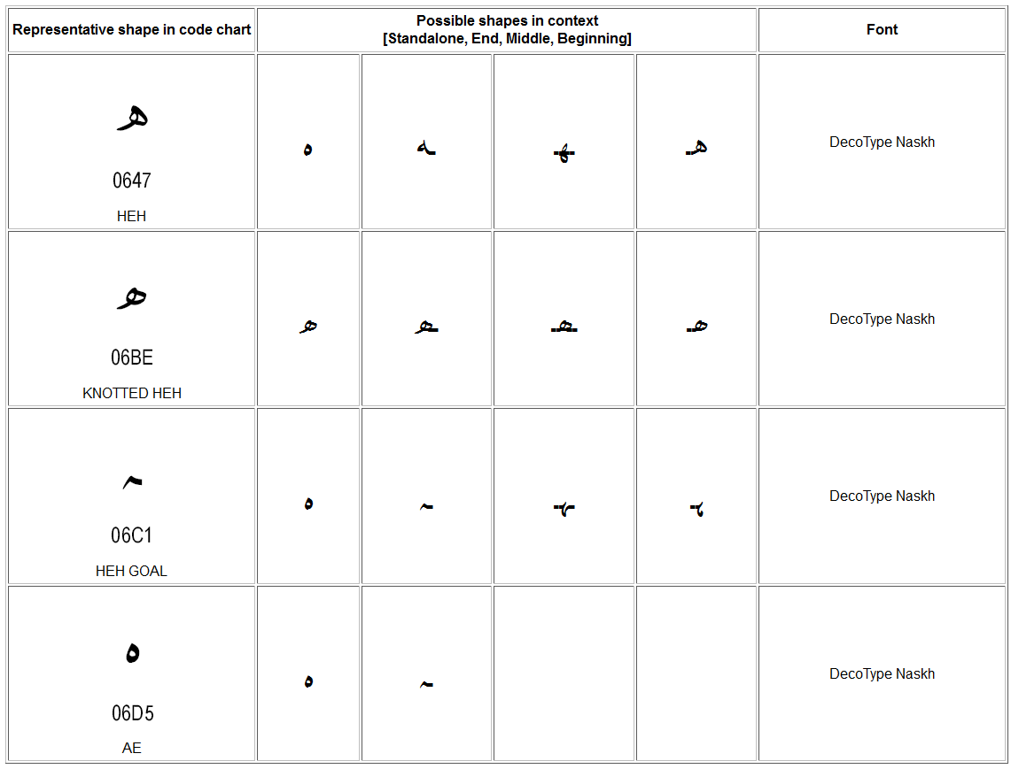

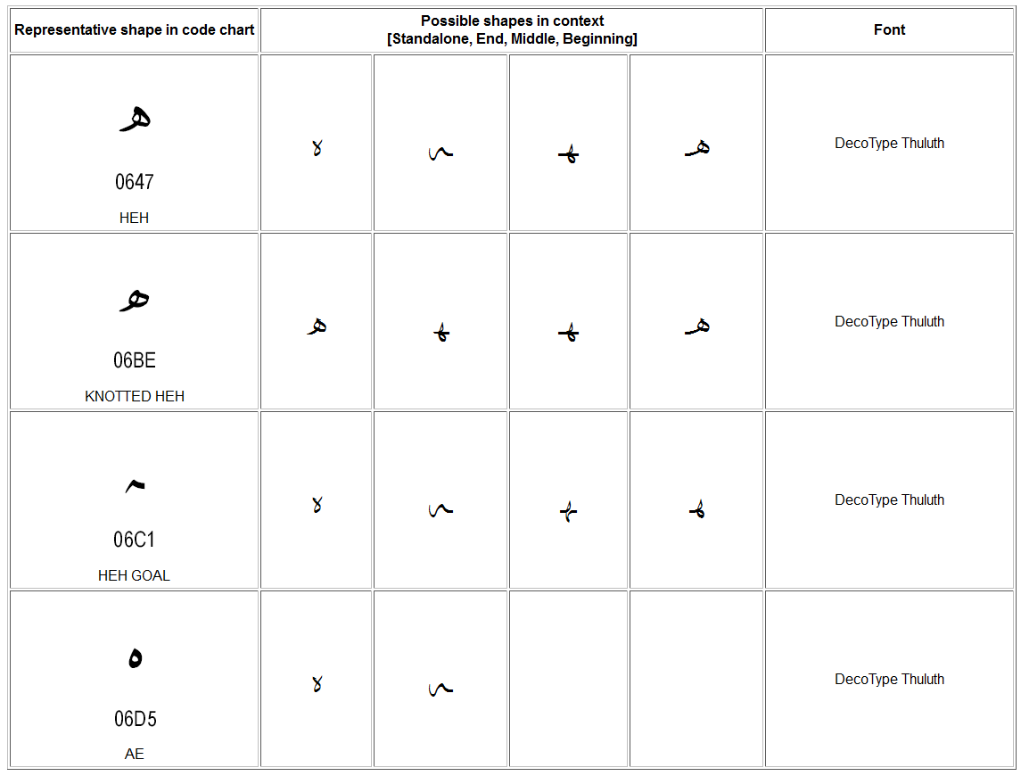

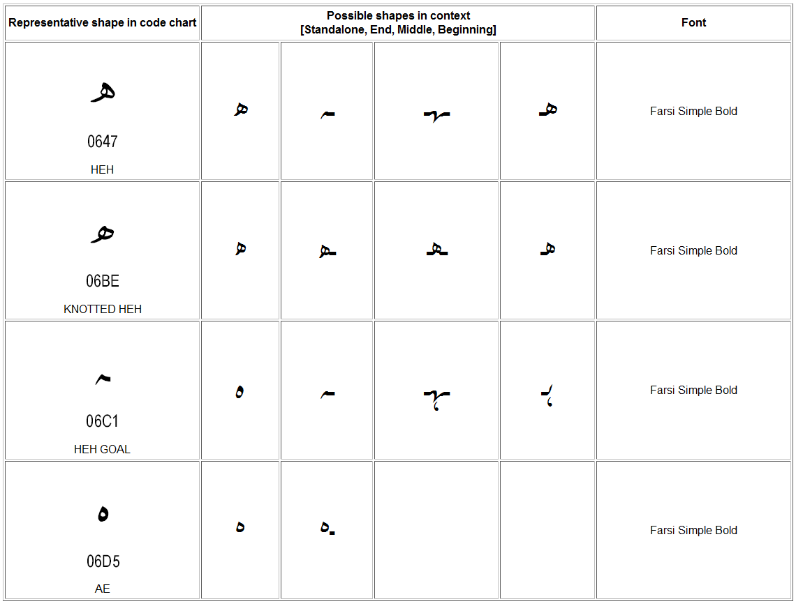
Appendix D: Additional Constraints for ZWNJ

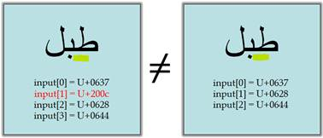
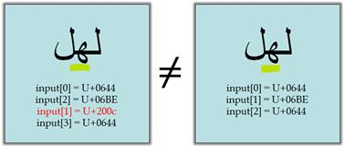
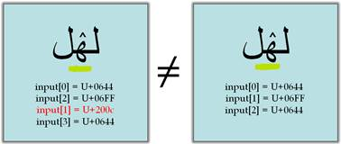

Appendix E: IDN Variant Issues Project – Arabic Script Case Study Definitions

This section includes all the terms needed and were used in the IDN Variant Issues Project - Arabic Script case study. The terms included in this section comprise a complete set of all the definitions needed in the context of Arabic Script IDN Variants and are either newly introduced or referenced from other existing resources, as elaborated below:

Newly defined terms:
Those are terms that are being introduced to address a certain need within the Arabic-Script-based language communities. It's worth noting that this need may or may not exist for other scripts case studies.

Already defined terms:
Those are terms that are already defined elsewhere, namely:
- Draft Definitions for the ICANN Variant Issues Project Document
- Unicode website
- RFC 6365
- RFC 5892
And are either used as is where they accurately describe the meaning intended by the Arabic Script case study or edited to accurately describe the Arabic script case and footnoted as 'Motivated from original source'.

Scope of Variants in the context of the Arabic Script case study:

Strings that when registered as TLDs would cause visual confusion that may result in:
- Unexpected end-user experience and end-user confusability
- DNS security and stability issues

Abstract Character:
A unit of information used for the organization, control, or representation of textual data. (Unicode Standard, section 3.4, D7)

Code Point:
A value in the Unicode code space. The meaning here is restricted to meaning D10 in the Unicode Standard, section 3.4.

Assigned Code Point:
A mapping from an Abstract Character to a particular Code Point in the code space. See Unicode Standard, section 2.4. Not to be confused with Valid Code Point.

Arabic Letter:
Characters that are part of Arabic alphabet and used to write words.
Non-Joining Characters:
Those characters that do not connect to letters before or after them; i.e. U+0621 LETTER HAMZA, U+0674 HIGH HAMZA, and U+200C ZWNJ.
Right-Joining Characters:
Those characters that connect to the letter before them; i.e. all letters based on Alef, Reh, Dal, and Waw, and a few other letters.
Dual-Joining Characters:
Those characters that connect to the letters before and after them; i.e. all other Arabic letters.
Join-Causing Characters:
Those characters that connect to the letters before and after them, but do not change shape themselves; i.e. only U+200D ZWJ and U+0640 TATWEEL.
With respect to those categories, Arabic Script Letters could be defined as follows:
Non-Joining Letters:
The group of characters in 1.1 which are letters (by Unicode's definition); i.e. U+0621 LETTER HAMZA and U+0674 HIGH HAMZA.
Joining Letter:
The union of Right-Joining Letters and Dual-Joining Letters which cursively join with letters following them.

Right-Joining Letters:
The group of characters in 1.2 which are letters; i.e. all letters based on Alef, Reh, Dal, and Waw, and a few other letters.
Dual-Joining Letters:
The group of characters in 1.3which are letters; i.e. all other Arabic letters.

Arabic-Indic Digits:
Forms of decimal digits commonly used along with Arabic script and comprised of two sets of digits. The set <U+0660-9> is commonly used in Arabic-speaking world, while the set <U+06F0-9>, often referred to as Eastern Arabic-Indic, is used in Iran and Pakistan. Although European digits (1, 2, 3,…) derive historically from these forms, they are visually distinct and are coded separately. (Arabic-Indic digits are sometimes called Indic numerals; however, this nomenclature leads to confusion with the digits currently used with the scripts of India.)

Arabic Digits:
The term "Arabic digits" may mean either the digits in the Arabic script (see above and Arabic-Indic digits) or the ordinary ASCII digits. When the term "Arabic digits" is used in Unicode specifications, it means Arabic-Indic digits.

Combining Marks:
A commonly used synonym for combining character; a character with the General Category of Combining Mark (M).

Label Valid Character:
An Abstract Character which can be used to form a label, and can be a Letter, Digit or another type.

Ligature:
A single glyph representing a combination of one or more Arabic Letters.

Form of a Letter - Arabic Script:
A Letter in Arabic Script can occur in up to four different forms within a ligature. These include the following:

Isolated form:
It is the standalone form of a Letter, i.e. when the letter does not join with any other letter, forming a single letter.

Initial form:
It is the form of a right-joining-letter when it occurs in the beginning of a ligature, joined with at least one more letter after it, to form a ligature.

Medial form:
It is the form of a right-joining-letter when it occurs in the middle of a ligature, joined with at least one letter on either side, to form a ligature.

Final form:
It is the form of a joining-letter when it occurs at the end of a ligature, joined with at least one more character before it, to form a ligature.

Glyph:
(1) An abstract form that represents one or more glyph images. (2) A synonym for glyph image. In displaying Unicode character data, one or more glyphs may be selected to depict a particular character. These glyphs are selected by a rendering engine during composition and layout processing.

Glyph Image:
The actual concrete image of a glyph representation having been rasterized or otherwise imaged onto some display surface.

Writing style:
Conventions of writing the same script in different styles. Different communities using the script may find text in different writing styles difficult to read and possibly unintelligible. For example, the Perso-Arabic Nastalique writing style and the Arabic Naskh writing style both use the Arabic script but have very different renderings and are not mutually comprehensible. Writing styles may have significant impact on internationalization; for example, the Nastalique writing style requires significantly more line height than Naskh writing style.

Font:
A collection of glyphs used for the visual depiction of character data. A font is often associated with a set of parameters (for example, size, posture, weight, and serifness), which, when set to particular values, generate a collection of imagable glyphs.

Valid Label:
A U-Label which is valid as per the Label Generation Policy.

Valid TLD Label:
A Label which is valid for Top Level Domain as per a TLD Label Generation Policy.

Protocol Valid Code Point:
A Code Point that is allowed to be used in IDNs. Code points with this property value are permitted for general use in IDNs. However, that a label consists only of code points that have this property value does not imply that the label can be used in any given zone.

Label Valid Code Point:
The subset of Protocol Valid Code Point listed in the Label Generation Policy, that may be used to form a label.

TLD Label Valid Code Point:
The subset of Label Valid Code Point that may be used to form a TLD label.

Preferred Variant

Arabic Script Character Variant:
A Label Valid Character which is equivalent and replaceable with another Label Valid Character within a label, as defined by a Label Generation Policy. The relationship is symmetric in Arabic script.

Label Generation Policy:
A formal specification which can be used to formulate or validate a label and determine whether two labels can be considered distinct for allocation. If two labels are not considered distinct for allocation, as per the policy, they are referred to as variants of each other. Variants are symmetric in Arabic script.

TLD Label Generation Policy
A formal specification which can be used to formulate or validate a TLD label and determine whether two TLD labels can be considered distinct for allocation.

Arabic Script Label Generation Policy
Policy specified to generate labels for Arabic script. For Arabic script, this would include at least a list of Protocol Valid Code Points allowed in forming labels, their Character Variants, additional Label formation constraints/rules and meta information (e.g. including script, owner, version, date, etc.).

Arabic Script TLD Label Generation Policy
Policy specified to generate TLD labels for Arabic script.

Variant Character Set
The set of code points consisting of a Valid Code Point and all of its variants.

Script Table:
A Script Table is a table of Unicode Code Points all having the same script property value. See Unicode Standard Annex #24.

A-label:
An ASCII-Compatible Encoding form of an IDNA-valid string. It must be a complete label: IDNA is defined for labels, not for parts of them and not for complete domain names. This means, by definition, that every A-label will begin with the IDNA ACE prefix, "xn--", followed by a string that is a valid output of the Punycode algorithm (RFC 3492) and hence a maximum of 59 ASCII characters in length. The prefix and string together must conform to all requirements for a label that can be stored in the DNS including conformance to the rules for LDH labels (See RFC 5390, Section RFC 2.3.1). If and only if a string meeting the above requirements can be decoded into a U-label is it an A-label. (RFC 5890)

U-label:
An IDNA-valid string of Unicode Code Points, in Normalization Form C (NFC) and including at least one non-ASCII character, expressed in a standard Unicode Encoding Form (such as UTF-8). It is also subject to the constraints about permitted characters that are specified in Section 4.2 of RFC 5891 and the rules in the Sections 2 and 3 of RFC 5892, the Bidi constraints in RFC 5893 if it contains any character from scripts that are written right to left, and the IDNA Symmetry Constraint. (RFC 5890)

Variant Label:
A U-label considered a variant of a Fundamental Label as per the Label Generation Policy.

Fundamental Label:
A Valid Label which is, in practice, the label received by the registry to be allocated and from which a registry or registrar may generate Variant Labels.

Activated Variant Label:
The Variant Label that is activated by a registry.

Allocated Variant Label:
A Variant Label that is allocated by a registry.

Reserved Variant Label:
A Variant Label that is reserved by a registry without allocation but may be allocated on request

Blocked Variant Label:
A Variant Label that is blocked by a registry (to avoid a conflict) and is not allowed to be allocated

Variant Label Set:
A set of U-labels consisting of one Fundamental Label and its zero or more Variant Labels.

Activated Variant Label Subset:
The subset of Variant Label Set that is activated, or alternatively, the set containing the Fundamental Label and all its Activated Variants.

Allocated Variant Label Subset:
The subset of Variant Label Set that is allocated, or alternatively, the set containing the Fundamental Label and all its Allocated Variants.

Reserved Variant Label Subset:
The subset of Variant Label Set that is reserved, or alternatively, the set containing all the Reserved Variants of a Fundamental Label (and the Fundamental Label, if it is not activated).

Blocked Variant Label Subset:
The subset of Variant Label Set that is blocked, or alternatively, the set containing all the Blocked Variants of a Fundamental Label.

Allocation:
In a DNS context, the first step on the way to Delegation. A registry (the parent side) is managing a zone. The registry makes an administrative association between a string and some entity that requests the string, making the string a label inside the zone, and a candidate for delegation. Allocation does not affect the DNS itself at all.

Delegation:
In a DNS context, the act of entering parent-side NS (nameserver) records in a zone, thereby creating a subordinate namespace with its own SOA (start of authority) record. See RFC 1034 for detailed discussion of how the DNS name space is broken up into zones.

Activation:
The process of making a domain name resolvable.

Reservation:
In Arabic Script IDN variants context, this is the process of having an unallocated variant label which relates to a Fundamental label that is allocated.

Blocking:
In Arabic Script IDN variants context, this is the process of having a variant label not allowed for allocation to anyone as long as its Fundamental label is allocated.

Definitions accessible at http://www.icann.org/en/topics/new-gtlds/idn-implementation-working-team-report-final-03dec09-en.pdf
See ICANN Board of Directors. (2010) Adopted Board Resolutions. Trondheim, Norway. Retrieved November 30, 2010, from http://www.icann.org/en/minutes/resolutions-25sep10-en.htm#2.5
For an illustration of context dependent shaping see www.cle.org.pk/Publication/papers/2006/context_sensitive_shape_substitution.pdf
Unicode standard also include Arabic Presentation forms in the ranges U+FB50 – U+FDFF and U+FE70 – U+FEFF, which are not recommended for use and are not PVALID.
E.g. in Kurdish there are 7 ZWNJ occurrences in 10 words in the first sentence at: http://ckb.wikipedia.org/wiki/%D8%B2%D9%85%D8%A7%D9%86%DB%8C_%DA%A9%D9%88%D8%B1%D8%AF%DB%8C
See http://www.cle.org.pk/IDN/IDN2009/download/minutesofsecondworkshop.pdf Section 5 (b).
In Windows 7, activate the "Arabic (Saudi Arabia)" keyboard and try Ctrl+Shift+2. This is the same method people should type in using Microsoft's Persian keyboard layout
The Arabic script community did not reach a consensus on any of these solutions
See Kashmiri language (e.g. http://www.omniglot.com/writing/kashmiri.htm)
See http://unicode.org/reports/tr15/
This has been referred to as a “language table” elsewhere, but we are not using this terminology as “table” is an implementation detail and in the future such information may also be represented in other forms, e.g. using XML and may contain additional information. Further, the term “language” is also limiting as the current use may be for multiple languages or sometimes for the entire script.
Following appropriate policy development processes at ICANN and protocol development processes at IETF
Though need to identify a language is not necessary for labels, it does promote more consistent re-use of tables. This could help use a consistent set of label valid code points, their character variants, and any additional rules and/or constraints to generate the labels for same language(s) across registries
This section is using the terminology being recommended by SSAC Report on Domain Name (WHOIS) Terminology and Structure (SSAC 051)
The above is a result from the following tool (need to have the fonts in order to display them correctly): http://arabic-domains.org/adn_tools/compareChars/arabic-script-list-all.php
From Draft Definitions for the ICANN Variant Issues Project Document
From Draft Definitions for the ICANN Variant Issues Project Document
From Draft Definitions for the ICANN Variant Issues Project Document
Motivated from: http://unicode.org/glossary/#L
Unicode book, Chapter8, table 8-3, page 248 of latest edition
Unicode book, Chapter8, table 8-3, page 248 of latest edition
Unicode book, Chapter8, table 8-3, page 248 of latest edition
Unicode book, Chapter8, table 8-3, page 248 of latest edition
Motivated from: http://unicode.org/glossary/#arabic_digits
Motivated from: http://unicode.org/glossary/#arabic_digits
Source: http://unicode.org/glossary/#C
Motivated from: http://unicode.org/glossary/#L
Source: http://unicode.org/glossary/#G
Source: http://unicode.org/glossary/#G
Source: http://www.rfc-editor.org/rfc/rfc6365.txt
Source: http://unicode.org/glossary/#F
Motivated from http://www.rfc-editor.org/rfc/rfc5892.txt
Motivated from Draft Definitions for the ICANN Variant Issues Project Document 'Valid Code Point'
Motivated from Draft Definitions for the ICANN Variant Issues Project Document 'Valid Code Point'
Not needed as currently defined. Decision will be revisited when things become clearer after Label Generation Policy is defined.
Motivated from Draft Definitions for the ICANN Variant Issues Project Document 'Character Variant'
This term is being suggested as a replacement for “Language Table” as the latter has been found inappropriate as it “Language Table” is not limited to a single language and may represent many languages or an entire script, and “table” represents an implementation level decision (as eventually an XML based or other specification could also be used. Also, language table seems to be a binding, if not insufficient, mechanism to specify additional rules/constraints needed and does not clearly specify method or contents for meta information required to promote unambiguous use and reuse of the information.
Motivated from Draft Definitions for the ICANN Variant Issues Project Document 'Variant Character Collection'
Motivated from Draft Definitions for the ICANN Variant Issues Project Document 'Script Table'
Motivated from Draft Definitions for the ICANN Variant Issues Project Document 'A-label'
Motivated from Draft Definitions for the ICANN Variant Issues Project Document 'U-label'
Motivated from Draft Definitions for the ICANN Variant Issues Project Document 'Fundamental Label'
Motivated from Draft Definitions for the ICANN Variant Issues Project Document 'Variant Label Set'
From Draft Definitions for the ICANN Variant Issues Project Document
From Draft Definitions for the ICANN Variant Issues Project Document

