Case Studies of PDPs and Processes with regard to ATRT1 advice (Avri)
Case Studies
Terms of Reference for Expert assistance

The idea is that the practice for ATRT1 of doing case studies should be continued. They offer a snapshot of practices and situations that are current. In addition to the benefit they offer those doing the current AT review the have a longitudinal value by allowing a comparison of case studies across multiple ATRT reviews allows for logitud

In the case of picking case studies they should come from events that took place during the period intervening between the publication of the previous ATRT report and the creation of the subsequent ATRT. They case studies should be done from the perspective how how they were affected, if they were affected, by the recommendations coming out of the previous ATRT report.
● Where they aware of the recommendations and did they take them into acount
● If they did were they helpful or a hindrance
● If they weren’t take into acount did they show characteristics that were noticed in the previous set of case studies.
● Where do they fall in the continuity of change between the time before the AOC reviews
and the current time.
● other?

Some candidate processes that occurred between ATRT report in Dec 2010 and April 2013 and would be suitable for case studies include:

● Applicant Support program including the policy creation in the Joint Applicant Support (JAS) Working Group and the implementation of the Support Applicant Review Panel (SARP).
● ICANN Travel policy; policy creation, implementation and administration
● .xxx external review and reconsideration
● IDN ccTLD Policy Development Process
● ASO Global Policy for Post Exhaustion IPv4 Allocation Mechanisms by the IANA
● Cross Community Working Groups; their modalities and success factors as exhibited in some or all of the following:
○ Rec 6 CWG-Morality and Public Order
○ Ad-Hoc ccNSO/GNSO Joint IDN Working Group (JIG)
○ Joint ALAC/GNSO Application support WG (JAS)
○ ccNSO-GAC Liaison Working Group
○ TradeMark Clearinghouse (AIG)
○ Joint DNS Security and Stability Analysis Working Group
○ IDN Variant TLDs Community Project
○ other?
● Other?

ATRT2 11 May 2013

Whistle-blower program – Effectiveness and adherence to standards (Avri)

Given the current issue of whistleblowing at ICANN. And given the difficulty even this group might have at delving into it in a fully open and neutral manner, perhaps bring in an outside expert to act as a Special Investigator into the ICANN Whistleblower program and employee morale might be a good use of an outside expert.

The ICANN Whistleblower program is known as the Hotline program. All of the information on this program, except for a memo seems to be only available on ICANN internal web pages. While the ICANN Board Audit committee seems to have responsibility for reviewing reports of a financial nature, it is unclear what mechanisms are being used for any other reports that might be received by this hotline.

Some of the information that an Outside Expert could research includes:

● Produce a synthesis report on the ICANN hotline process and how it operates as a whistleblower mechanism.
● Do all employees know about hotline. E.g. are there signs up in the cafeteria encouraging employees to use the hotline?
● Do employees think that it is an effective mechanism? Why or why not?
● Do employees feel safe using this mechanism? Why or why not?
● Have any hotline reporting employees been discovered and disciplined (or had coincidental bad performance reviews)?

Other issues that the Outside Expert could research include:

● How many hotline issue are recorded each year?
● What are the categories of employee concern?
● How have these been handled, specifically?
● What dispositions?
● Have any resulted in management changes or the creation of new internal policies?

ICANN Finances (Lise)
Proposal for external review/case study to the ATRT2

ICANN finances

Introduction

ICANN is a private not-for-profit multi-stakeholder organization. One of the fundamental principles for being a multi-stakeholder organization is to be a transparent and accountable organization.

At the moment ICANN as an organization is growing rapidly, partly because of a new management which is aiming for a global outreach and partly because of the new gTLD program. At the same time, ICANN income has grown significantly and with this the complexity of the organization and its finances have also grown.

This changes the scope of ICANN from being an organization with a limited number of fairly fixed TLDs, which might provide growth in the number of second level domain names, to an organization that aims to expand the numbers of its gTLDs. This puts pressure on an organization that is not-for-profit and multi-stakeholder because it expands both its business and its stakeholder groups. This is why it is important to ensure that the organization’s finances are managed in an accountable, transparent and non- discriminatory way. A case study like this is best done by external experts, rather than by the ATRT2 group.

The study

This paper proposes that a study be made of ICANN finances, of how ICANN uses its finances, and whether this is done in an accountable, transparent and non-discriminatory way. The case study should take into account the fact that ICANN is operating according to the multi-stakeholder model and the not-for-profit paradigm, and that every year it publishes an operating plan. When an evaluation of transparency is completed, the external experts might also assess the timing of publication of the operating plan to the internet society.

The study could also make an evaluation of whether reporting back to the international internet society has been done in an accountable and transparent way. The reporting should be measured according to the operating plan and the yearly financial statements, and a comparison made with other international not-for-profit organizations.

It is proposed that the study focus on three main questions:

1. Are the finances used in an accountable, transparent and non-discriminatory way?

2. Are the finances used according to the published operating plan?

3. Is the reporting to the international internet society done in an accountable and transparent way?

Lise Fuhr, May 19 2013

Case Study re: effectiveness of PDP process (Alan)
Proposal: A Review of the gTLD Policy Development
Process (PDP) based on case-studies

If you take an informal survey of people in the ICANN ecosystem, and ask about the health of
the gTLD PDP, you will receive answers covering the range from “it is working exactly as it was designed to and should” to “it is VERY broken”.

My personal position is that its ability to address policy development varies based on the type of problem it is addressing.

Issues that may be difficult and important, but there are few ICANN participants who have a large financial stake in the outcome.

The PDP works very well for this class of problem. Dedicated people who have an interest in the subject, and a vested interest in “fixing” the problem or making a process run better get together, investigate and debate the issues, and try to do the best thing for the Internet.

Issues where one group of stakeholders have either significant financial interest in the outcome or a vested interest in seeing either no change or very specific change. Other “interested parties” have no real personal or corporate stake.

Those with a strong financial or other reason for wanting a specific outcome invest a lot of time (ie multiple Working Group members attending regularly) in this type of PDP. Those without personal or corporate success at stake have a hard time devoting sufficient resources to the PDP. The result is either the first group gets exactly what they want, or the end results are a watered down least-common denominator, not really worth the amount of effort that went into the process.

Issues where a lot is at stake, financial, some other form of status or principle - on both sides.

This type of PDP is likely to result in either a deadlock, or a least-common denominator result that will not be acceptable to the larger Internet community or the Board or the GAC.

There are many examples of the first type of PDP, with several Inter-Registrar Transfer Protocol (IRTP) PDPs being good examples.

The best example of the second class of PDP that I am familiar with is one that I ran. The PDP on Post Expiration Domain Name Recovery – a PDP attempting to establish rights for registrants ensuring that they can reasonably renew expiring or expired domain names, rights that originally existed but were eroded by changes in registrar practices. This was a long painful process that achieved some, but really minimal, registrant rights – far below those that most registrants expected or deserved (based on their historical rights).

An example of the third type is the PDP on Vertical Integration, which stalemated and ended up with the Board deciding on the outcome. The current PDP on protecting Inter-Governmental and International Non-Governmental Organization names is, in my opinion, likely to have one of the results predicted above.

Proposal
I propose that we contract with an external agency to do case studies on a number of PDPs and report on whether the process works well and meets ICANN’s needs, or what its weaknesses and failure modes are. To the extent possible, alternatives could be recommended, but I think that
this might be too much to achieve given the limited time-line and the fact that an investigative body might not be the best organization to recommend alternatives. Including this as a target also, to some extent, presupposes the conclusions of the investigation and I think that ICANN would be better served with doing this, if needed, in a later stage.

Alan Greenberg, 2013-05-19

Public Interest – ecosystem value chain (Carlos)
On the compliance function (top down): on differentiated levels of (external) accountability along the «Ecosystem Value-Chain» , ICANNs values have to be brought into perspective and development in the revision of RA and RAAs taken into account. Output should be a team mapping exercise.
•do we look at Accountability and Transparency at the highest ICANN level only (global public interest principles) vs. operational issues of the implementation at-, and feedbacks from-, lower levels of the value chain (which at some point/interface becomes private, regional and for profit in most cases)?
•how do we bring into perspective of the ATRT» the fact that some powers/resources are delegated to other entities that have DIFFERENT perspectives on the public interest, or that are driven by the profit motive alone

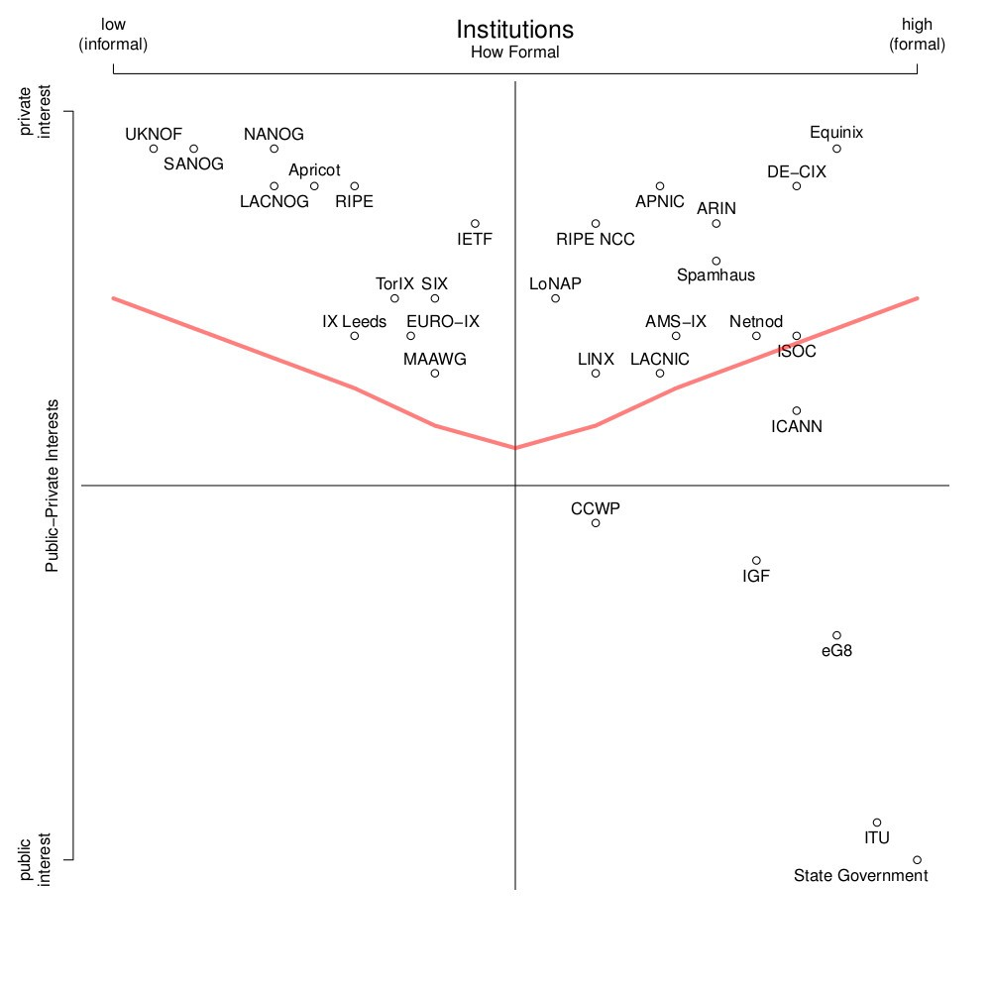

Metrics (Brian)

To: Accountability and Transparency Review Team 2 From: Brian Cute
Re: Potential engagement of Independent Expert
Date: May 19, 2013

The Accountability and Transparency Review Team 2 (ATRT2) will consider whether it will engage an Independent Expert to assist in its task of assessing ICANN’s accountability and transparency under the Affirmation of Commitments (AoC) para. 9.1. ATRT2 has identified “metrics” as an issue that is critical to ICANN and the community to benchmark and measure improvements to accountability and transparency from both a quantitative and qualitative perspective. Other than providing target dates for some of its recommendations, ATRT1 did not offer,
suggest or recommend specific metrics for ICANN to implement deferring the task of
developing performance measures to the organization.

In its initial interaction with ICANN staff, ATRT2 observed that, to a large degree,
development of specific metrics to measure accountability and transparency (and forward going improvements) has not yet occurred. At the first face-­‐to-­‐face meeting in Los Angeles between ATRT2 and ICANN staff, ICANN CEO, Fadi Chehade, made a commitment that metrics would be developed by ICANN to measure progress going forward.

An independent expert could provide a benefit to the ATRT2 and to ICANN in a number of ways: 1) work with ATRT2 to provide a third party assessment of ICANN with respect to accountability and transparency to establish benchmarks to measure against going forward. 2) provide specific guidance to ATRT2 and ICANN concerning the use of metrics specifically tailored to the issue of accountability and transparency; 3) provide tools that ICANN could employ going forward to measure accountability and transparency and more effectively communicate to the community on these issues; 4) provide future audits of ICANN’s accountability and transparency.

Organizations that focus on accountability and transparency practices and metrics exist. For example, ICANN worked with One World Trust in 2007to undertake an independent review of standards of accountability and transparency within ICANN http://www.icann.org/en/news/announcements/announcement-­‐4-­‐29mar07-­‐ en.htm. Other organizations provide guidance and tools to measure accountability and transparency of organizations. http://www.charitynavigator.org/index.cfm?bay=content.view&cpid=1283 Other resources focused on accountability and transparency in both the public and private sector exist as potential points of reference for ATRT2 on this issue.

