Home
This is the homepage as we’ve envisioned the first phase of WHOIS. It has a simple design that aggregates some of the most important sections of the site. Future iterations would include a global WHOIS lookup capability that would be included on this page.

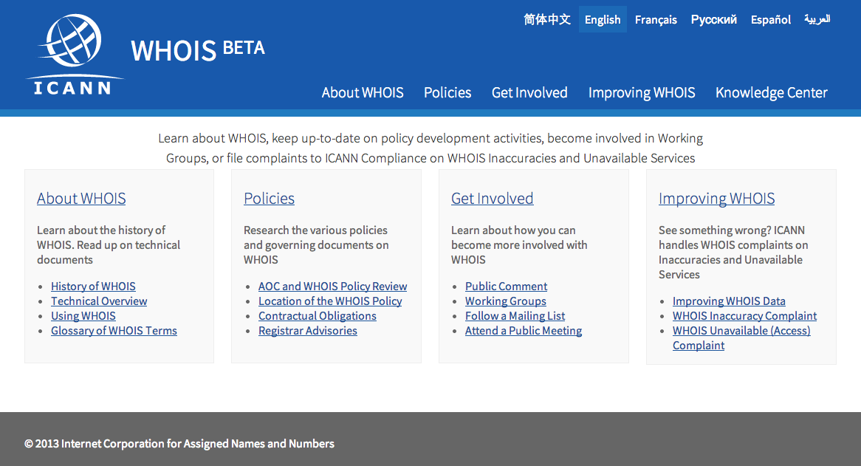

About WHOIS
This is the About WHOIS section of the site which would include topics that introduce the topic of WHOIS to novices, provide a historical account of WHOIS and its evolution and expand on where it may head in the future. There is also content intended for gaining a more in depth technical understand of how WHOIS works and how it can be used. Lastly, there is a page dedicated to the WHOIS site itself to provide updates on progress of future phases.

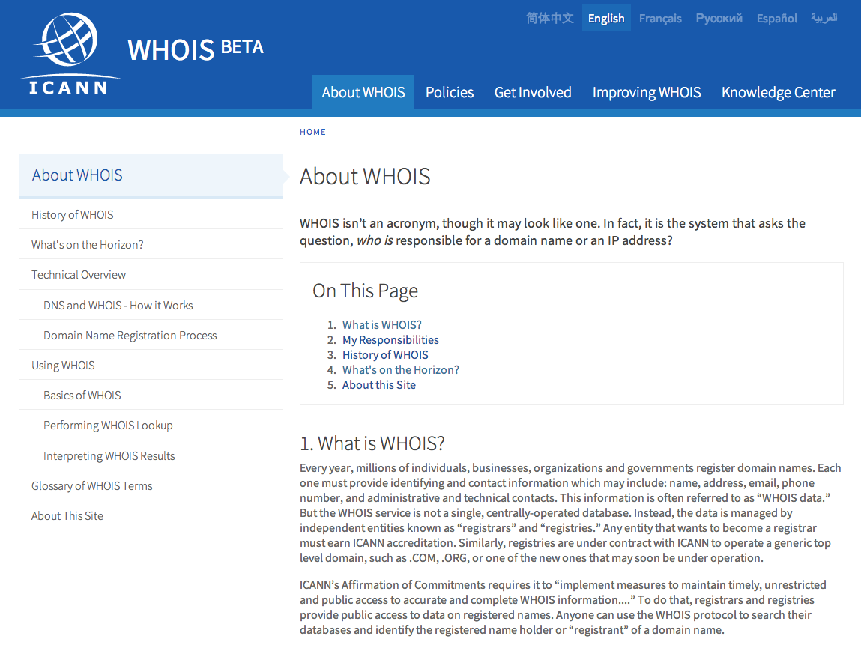

Policies
The Policies section of the site is dedicated towards being the single consolidated source of information on WHOIS related policy and obligations of various parties.
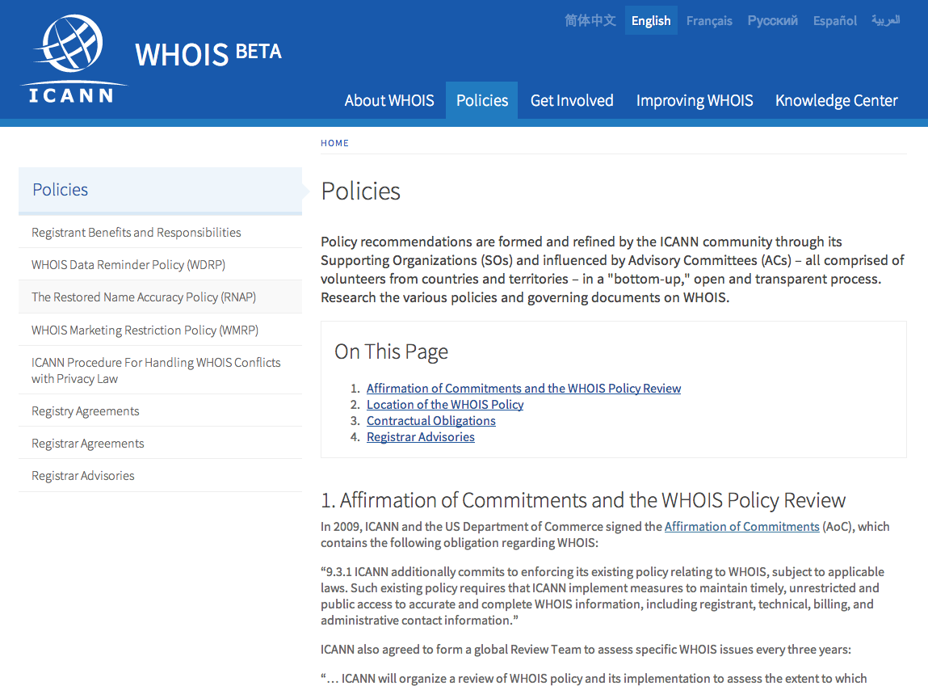

Get Involved
Get Involved is a section of the site that is intended to direct site visitors to various resources that are available for individuals or organizations to become more involved with WHOIS related topics and work.
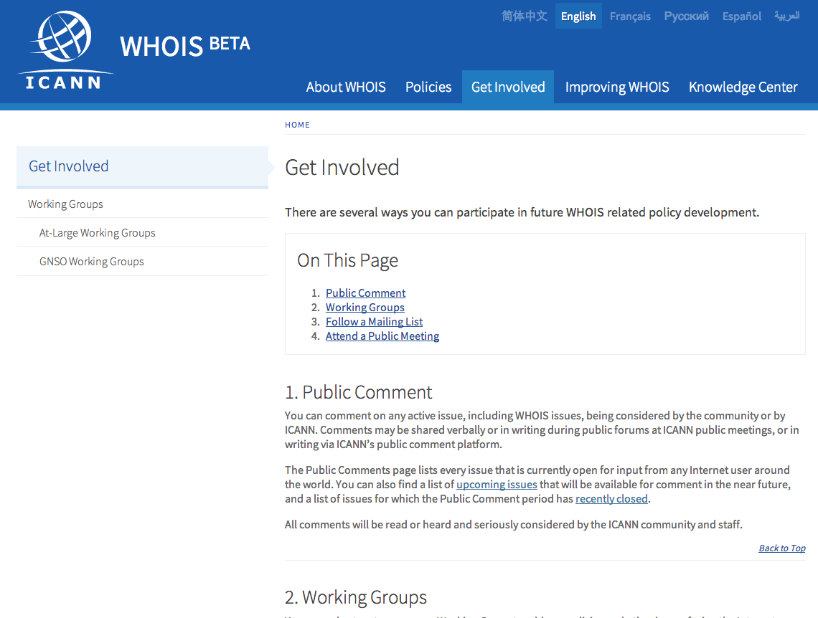

Improving WHOIS
Currently Improving WHOIS is handling Compliance related submission of complaints on WHOIS Inaccuracies as well as Service Unavailable, however it is envisioned to become the location within the site where all analytical studies and reports on WHOIS accuracy can be maintained.
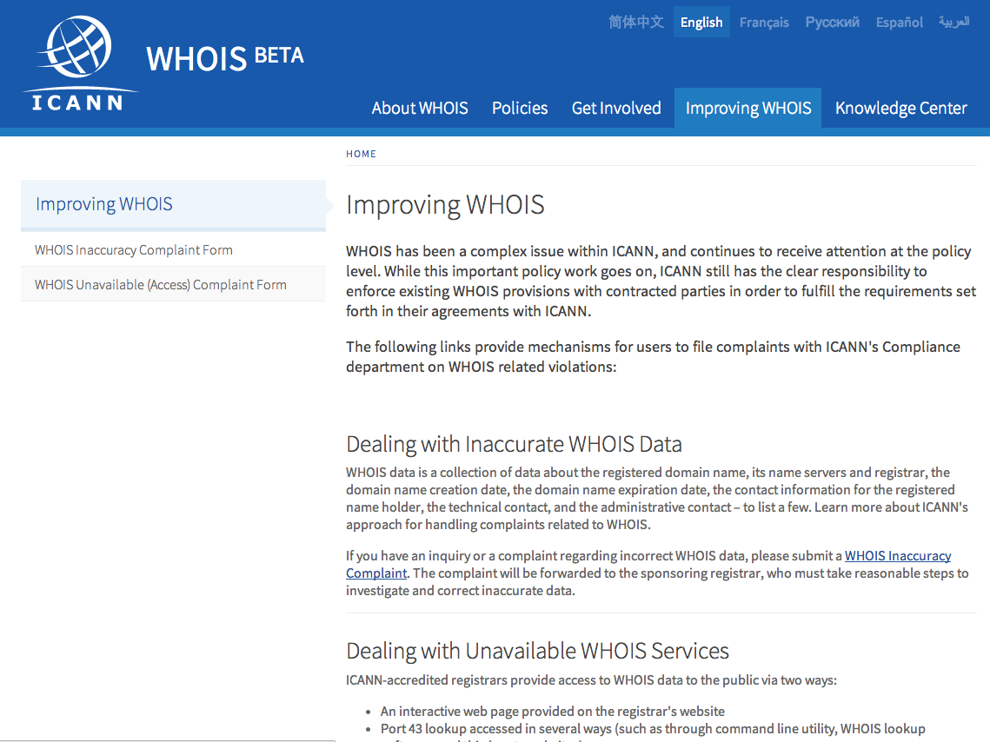

Knowledge Center
The Knowledge Center is an aggregation of content stored across multiple ICANN sites that is important in the discussion of WHOIS, whether that be on Policy Development, Compliance, Technical… it should be a single location to find the authoritative documentation on WHOIS. We expect feedback from the community on content that they feel should be represented here.
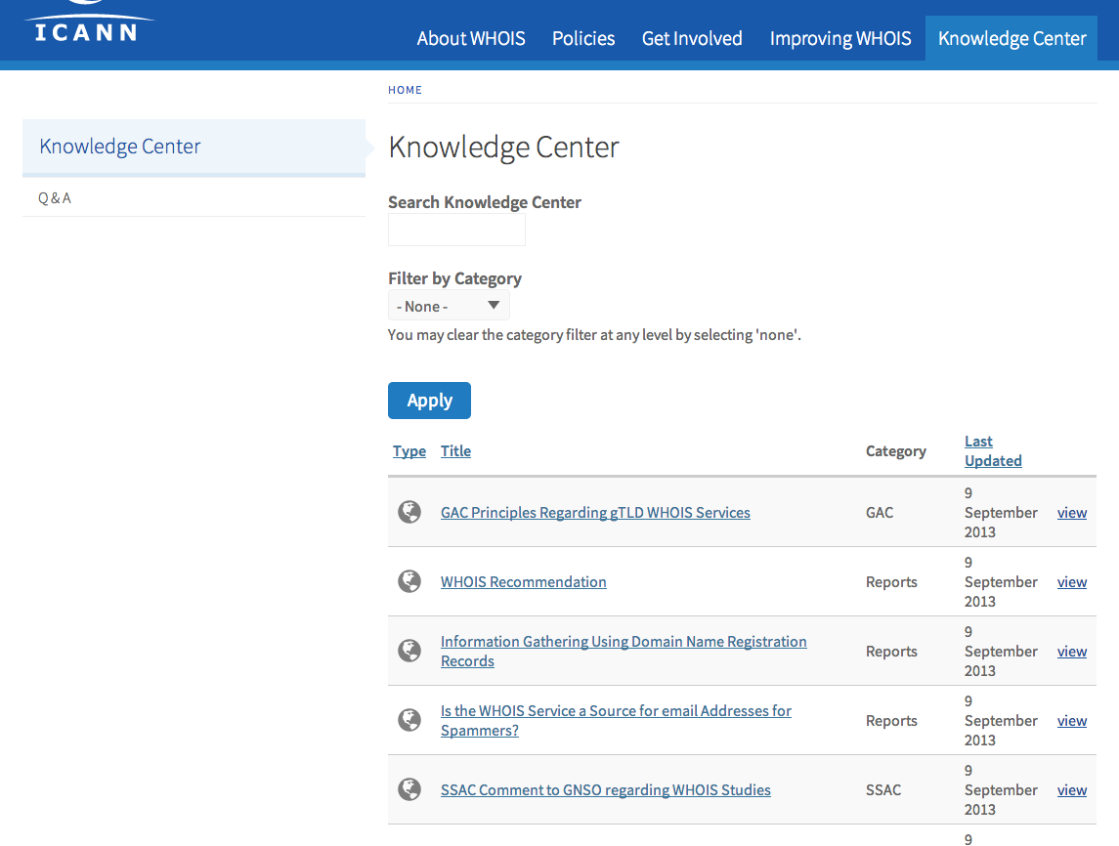

QA
The Q & A section of the site is for questions that have been asked of ICANN in the past that is related to WHOIS, whether directly or indirectly. It is a quick resource for users to search and filter by topic and find answers to questions that had been previously hard to get.

