ATRT2 Templates
Finance Accountability and Transparency

B. Proposed new recommendations

- Hypothesis of problem

ICANN is a non-profit privately organized institution. The services delivered by ICANN are delivered without any other institutions or bodies competing with ICANN. The political decisions of the Board of Directors and in the broader context to the multi-stakeholder mechanism will - in the absence of competition - be the only factors that determine how ICANN should prioritize its resources, its revenue and its spending.

Being a non-profit organization ICANN should strike a balance between revenue and expenses. In a situation with increasing revenue one option is to increase activities corresponding to this additional income. Another option is to lower the prices paid by ICANN’s customers. Of course the two options can be combined.

In recent years ICANN’s activities and corresponding revenues and expenses have grown significantly. Revenues increased from $18 million in 2005 to $72 million in 2012. Accordingly, expenses increased from $14 million in 2005 to $70 million in 2012. During the same period, staff increased from 36 in 2005, (to 149 in 2012 and 220 in 2013) to a planned increase to approximately 284 in 2014.

In the budget approved on 22 August 2013 the forecast for the financial year 2013 ICANN is expected revenue and income and other net assets ICANN of more than $80 million and ICANN is expected to end the year 2013 with a net result of nearly $32 million. When adding the balance of the new gTLD program in 2013 the net result for ICANN in the financial year of 2013 is expected to be $92 million. http://www.icann.org/en/about/financials/adopted-opplan-budget-fy14-22aug13-en.pdf

In total the new gTLD program (as of status of April 2013) will generate fees of $315 million and is expected to generate a total of operating expenses of $197 million thus creating a net remaining balance of $118 million.

The combination of a more complex organization as shown in the ICANN organization chart https://www.icann.org/en/about/staff/management-org-09sep13-en , increased income and expenses and the increased complexity of a business going from approximately 20 gTLDs to more than 1.500 gTLDs highlight the importance to increase accountability and transparency of ICANN’s financial governance and the decisions related to activities, prices, expenses and investments.

- Background research undertaken

  - Summary of ICANN input

At the conference call Thursday 29 August this issue was touched upon during a dialogue between ATRT2 members and ICANN’s CFO Xavier Calvez. The conversation with Xavier Calvez was very informative and it is evident that ICANN has improved their level of financial reporting during the last couple of years. Xavier informed ATRT2 that there were ideas of eg. doing a benchmark comparing ICANN to other non-profit organizations but this was not definitely decided. Furthermore separating the expense and budgets for the AC/SOs was difficult to do and this is not planned or projected yet. When asked for the plans or principles for using any surplus from the new gTLD program to lower the fees collected by ICANN, Xavier replied that a five year strategy could enable the suggested principles.

Transcript from call 10, Thursday 29 August contains some of the issues raised in this paper. The full conversation with CFO Xavier Calvez is described in page 11 to 19. Discussion on expenses and budget for AC/SO is on page 14, discussion on benchmark is on page 15, and discussion on balancing the income, expenses and fees collected by ICANN is on page 17.

At the ATRT2 meeting in August in Los Angeles ICANN Board Chair Steve Crocker pointed to the appropriateness of improving accountability and transparency with respect to planned activities of ICANN and the implemented activities as well as corresponding expenses.
[Links to be inserted]

  - Summary of community input

GAC Comments
In particular GAC has on various occasions (meetings in Toronto October 2012, Beijing April 2013 and Durban July 2013) recommended that the issue of Accountability and Transparency regarding ICANN’s Finances is further looked into.

The need to analyze improvements to ICANN’s financial accountability mechanisms was specifically emphasized by the participants at the High Level GAC meeting in Toronto October 2012.

Public comments
The Public comments to the FY14 Draft Operating Plan and Budget (as collected and replied by ICANN staff) contain remarks from the different constituencies regarding financial issues that need clarification or a different approach.
http://www.icann.org/en/news/public-comment/summary-comments-op-budget-fy14-30aug13-en.pdf

- Issues regarding “Expenses and budgets for AC/SOs”
ref # 4, 7, 8, 26, 75, 78, 79

- Issues regarding “Income and expenses”
ref. # 2, 6, 73, 76, 77, 105, 106, 107

- Issues regarding “Time to comment on the Operating Plan and Budget and for ICANN to incorporate comments”
ref. # 23, 24

  - Summary of other relevant research

- Relevant ICANN bylaws/published policies/published procedures

Within the procedure of the board approval of the budget the Finance Committee of the Board of Directors of ICANN is responsible for:
- Providing oversight on the annual budget process of the Corporation;
- Reviewing and making recommendations on the annual budget submitted by the President (the CEO of ICANN);
- Developing and recommending short and long-range strategic financial objectives for the corporation; and
- Providing strategic oversight on financial matters for the Corporation.
http://www.icann.org/en/groups/board/finance/charter

- ATRT2 analysis & rationale

ICANN’s present budgetary procedures
To quote ICANN’s webpage on the operating plan and budget for the financial year 2014 (FY14): Consistent with our multi-stakeholder model, this budget is the result of input from ICANN constituency groups, stakeholders, the Board of Directors and the ICANN Staff. The involvement of the various ICANN stakeholders in the operating plan and budget building process is a corner stone to the success of the multi-stakeholder model.
https://www.icann.org/en/news/public-comment/op-budget-fy14-10may13-en.htm
(Under Section I: Description, Explanation, and Purpose)

The FY14 Draft Operating Plan and Budget was posted for public comment on 10 May 2003. It was stated at the start of the consultation that the FY14 Draft Operation Plan and Budget may be modified as a result of feedback from the community, ICANN's staff and Board during the comment period. It was intended to be presented to the ICANN Board for final approval in June 2013.

Comment / Reply Periods
Comment Open Date: 10 May 2013
Comment Close Date: 31 May 2013
Reply Open Date: 1 June 2013
Reply Close Date: 21 June 2013

http://www.icann.org/en/news/public-comment/op-budget-fy14-10may13-en.htm

Current Status of the FY14: The public comment period has been re-opened until August 4, 2013 to allow the community to post comments related to the FY14 Draft Budget changes presented during the Finance Session at ICANN 47 in Durban. The budget was approved on 22 August 2013.

As stated in comments from among others ISPCP and ALAC it would be relevant for ICANN to consider if the time limits for the public consultation allows for qualified analysis and input to the budgetary process and simultaneously provide ICANN and the Board with sufficient time to consider the responses.

The need for more transparency and accountability in the ICANN finances
The present and future financial situation of ICANN where substantial financial surpluses are foreseeable there is a need for providing the basis for discussion on how to develop ICANN and prioritize the work to the benefit of the participant within the multi-stakeholder model.

The discussion entails three elements:

- The revenue side. How should the revenue in general develop and how should the future fee structure of ICANN be. One pressing question is: Can ICANN continue the present fee structure when ICANN is a non-profit organization and can foresee increasing annual surpluses amounting to more than 1/3 of the annual revenue? Should ICANN in general reduce the annual fees in order to balance revenue and spending?

- The expenditure side. ICANN has expanded its activities as an example the staff of ICANN will nearly double over a two years period. Is this a trend that should be continued? When has ICANN reached it mature size and organizational setup?

FY14 Draft Operating Plan & Budget Headcount Growth (presentation on 10 May 2013)

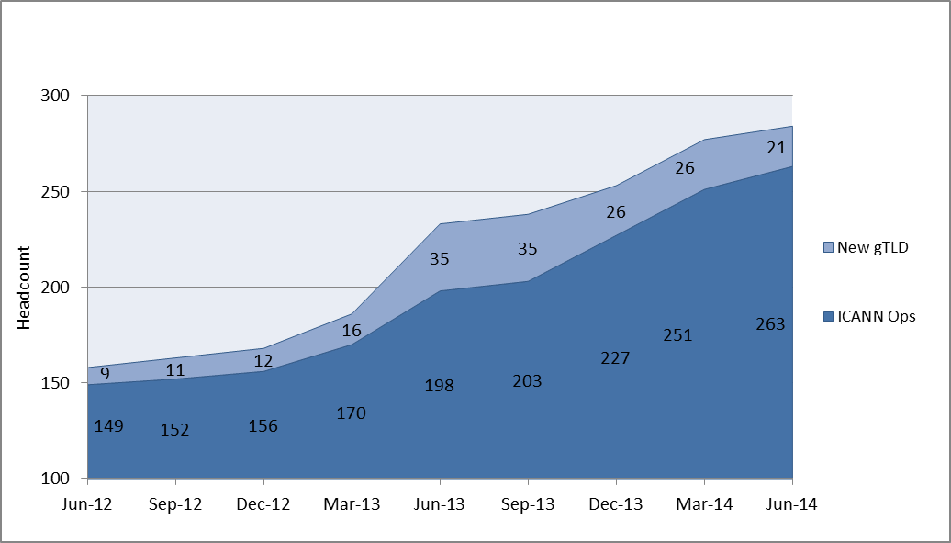

- The prioritization of the work of ICANN. ICANN is in the very fortunate situation that the financial prospects are very positive and promising, but this should not lead to a lack of or unclear prioritization of strategic outlook and work undertaken. In all organizations the resources are scarce either because of competition or because of constrains from the granting authority. This might have negative effects, but it helps keeping the organizations agile and focused on outcome and that there must be effective matches between the resources spent and the effects achieved. ICANN should develop new transparent and accountable mechanisms that combine the effective resource allocation and use with the involvement of all the parties within the multi-stakeholder model.

Draft recommendation

In any organization careful considerations about the strategic financial priorities are crucial for the efficiency of the organization. In a non-profit organization as ICANN it is imperative that the financial governance constituted between the CEO, CFO, and the Board make effective use of the checks and balances represented in the multi-stakeholder model to ensure that the financial priorities truly benefit the global Internet community. To this end, the ATRT2 recommends that in light of the significant growth in the organization ICANN undertakes a special scrutiny of its financial governance structure regarding the overall principles, the methods applied and the decision-making procedure including engaging stakeholders.

a) The Board should implement new financial procedures in ICANN that can effectively ensure that the Internet Community, including ICANN’s Supporting Organizations (SO) and Advisory Committees (AC) can participate and assist the Board of Directors in the planning and prioritizing the work and development of ICANN

b) Being a non-profit organisation operating and delivering its services in a non-competitive environment, ICANN should when preparing its budget for the coming year explicitly consider the cost-effectiveness of its operations, including how expected increases in the income of ICANN should be reflected in the priority of activities and pricing of services. These considerations should be subject of a separate consultation.

c) Being a non-profit organisation operating and delivering its services in a non-competitive environment ICANN should every three years carry out a benchmark study on relevant parameters e.g. levels of compensation to staff members, benefits to staff, costs of housing, size of organization etc.

d) In order to improve accountability and transparency and facilitate the work of the Review Teams ICANN’s Board should base the yearly budgets on a multiannual financial framework [covering e.g. a two-year period] reflecting the planned activities and the corresponding expenses. The following year a report should be drafted describing the actual implementation of the framework, including activities and the related expenses. This includes specified budgets for the AC/SOs

e) The financial reporting should include specification of cost for each AC/SO.

f) The Finance Committee of the Board of Directors shall submit the budget to the Supporting Organization and Advisory Committees for a 30 days consultation and 21 days reply period.

g) After the close of the consultation period the Board of Directors shall prepare a report stating to what extent it will accommodate the community input and give reasons if and why it decides not to accommodate proposals. The Board of Directors shall hold an open meeting with the Supporting Organizations and Advisory Committees to discuss the financial decisions in the report.

h) The Board of Directors shall send the revised budget for a final public 21 days consultation period after which the budget will be subject to approval by the Board of Directors.

- Public Comment on Draft Recommendations (to be completed later)

- Final recommendation (to be completed later)

Note: Links to relevant documents can be included, provided the link refers to a specific section of a given document. Alternatively, relevant section of other documents may be copies and pasted.

http://www.icann.org/en/about/annual-report
http://www.icann.org/en/about/financials/fiscal-30jun05-en.htm - discussion and analysis paper of significant variances between the reported financial statements for the two fiscal years 2004 and 2005.
End of page 3, last bullit. https://gacweb.icann.org/download/attachments/27132072/Summary%20of%20the%20HLM%20Chair%20v%20final.pdf?version=1&modificationDate=1360614203000&api=v2
Page 2, Section III.1 https://gacweb.icann.org/download/attachments/27132037/Beijing%20Communique%20april2013_Final.pdf?version=1&modificationDate=1365666376000&api=v2
Page 1 , Section II.2 https://gacweb.icann.org/download/attachments/27132037/Final_GAC_Communique_Durban_20130718.pdf?version=1&modificationDate=1375787122000&api=v2
End of page 3, last bullit. https://gacweb.icann.org/download/attachments/27132072/Summary%20of%20the%20HLM%20Chair%20v%20final.pdf?version=1&modificationDate=1360614203000&api=v2
https://www.icann.org/en/about/financials/proposed-opplan-budget-fy14-16may13-en.pdf

