The release of the “Draft FY12 Operating Plan and Budget” on the 17th May 2011 provides the community with its first opportunity to review the Draft FY12 budget and review ICANN response to the framework budget comments

BC welcomes this opportunity to comment on the “Draft FY12 Operating Plan and Budget” http://www.icann.org/en/financials/proposed-opplan-budget-v1-fy12-17may11-en.pdf
as many of our members have a deep interest in this subject.

The BC comments are divided into four specific areas:
Comments on the process and FY12 budget cycle process enhancements.
Comments as part of the SO/ACs leadership requests.
Comments on the SO/AC support requests.
Comments on draft Budget.

Comments on the process and FY12 budget cycle process enhancements.
The FY11 budget development and approval process was frustrating , not only for the BC but several other groups in the non contracted parties house. This cost cutting budget appeared to cater excessively to the Contracted Parties house. The issue was raised repeatedly at the public forum in Brussels in June 2010.
Although the BC and its members submitted comments on the website and voiced concerns at the public forum the Draft Budget was approved by the Board in its entirety leaving amongst many of our members that commenting was a waste of time. We were advised by Kevin Wilson that substantive comments would need to be raised earlier in the budget cycle.
With this in mind the BC was delighted to attend presentation in Cartagena outlining process enhancements for FY12.

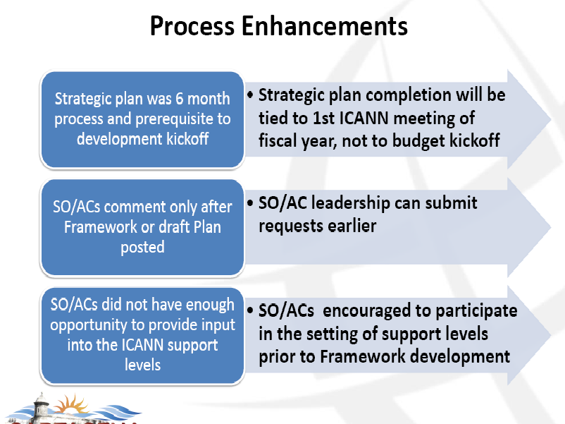

First process enhancement: Strategic plan
This was completed in draft (27 November 2010) for first of Cartagena Meeting and open for comment. Redline published 21 Feb 2011. Board approved in Silicon Valley with a significant number of updates (which later appeared in the published board minutes) Final Plan published 28th March dated June 2011 – June 2014.
The BC asks the community and staff to ask “Has this objective been achieved?” since the only element of FY12 comment that can receive input from the final strategic plan is the current public forum which closes a week before board vote on FY12?
Second process enhancement: “SO/AC comment”
The BC welcomes the opportunity for the SO/AC leadership to submit early comments on the most important issues. The BC submitted three comment specifically relating to Compliance, Staff Support, & Whois.
This process enhancement appears to not to have been taken up by other SO/AC leaders and also constituency or followed through by staff. The BC believes this is a sound initiative and should be given a ‘second chance’ next year rather than quietly dropped.
We ask that all the constituency comments be published under this process.

Comments on Compliance
The BC is please to see that the FY12 Draft budget increase this organizational activity item to 4,250 m$ after a low FY11 current forecast 3,163 m$ and budget 3,399) and Fy10 actual 3,525 m$.
In Section 4.5 of the Operating plan we are please to read that the work in FY12 will focus on, amongst other things a replacement consumer complaint intake ticket system.
In section 5.2.1 we note that the staff levels are going to return to 15 in FY12.
Comments on Staff Support
The BC is please to see that the FY12 Draft budget increase the Policy development support (Operating Plan item 4.8 to 6,825 m$ after a low FY11 current forecast 6,241 m$ and budget 6,421) and FY10 actual 5,641 m$.
In section 4.8 of the operational plan action items or specific projects are explained although no financial numbers are given to the community.
We note that the “Toolkit” of services comes under this budget item. (page 22)
The BC is also please to see that in the “ICANN response” to our comments on staff support to the framework Plan provide for a route for unseen workload:
“ICANN’s response is that if staff expertise, additional analysis or emergency council meetings are required, and the FY12 proposed budget does not already accommodate this request, the Policy staff can formally request additional funding to be drawn from ICANN’s overall Contingency fund. In addition, the entire policy team participates at all three ICANN meetings as well other venues as needed. That support will continue in FY12, with additional resources made available as needed.”
The BC thanks staff for the “ICANN response” and explanations of rational both positive and negative contained in the FY12 framework budget summery of comments. This is a new initiative. FY11 was a mechanical summary.
Comments on Whois
We note that the community-developed Whois studies is also contained under the 4.8 “Policy Development Support” this budget as a sub item in the explanation without any financials to comment on.
Under project work page 30 there are four project with costs declared. One is Whois improvements $672,000 (not including AOC review) . The BC is pleased to see this project included.
On page 48 under professional services. “Whois and other studies has been allocated 1m $. Are the other studies 328k$? If so what are they?
Third process enhancement: “SO/AC support request”
This entire improvement budget cycle process appears to have migrated from this wider opportunity for SO/AC budget comment input to only individual SO/AC support requests.

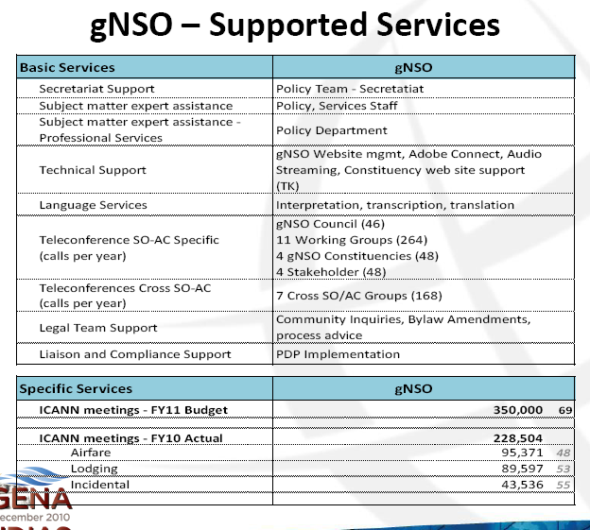

When public comment on framework budget was announced on the 4th Feb http://www.icann.org/en/financials/so-ac-sg-requests-summary-fy12-en.pdf
A brief staff summary of all the SO/AC support” requests was published. The BC request that all the actual requests are published.
We resubmitted our budget comments and support requests on 6th April writing part of the Budget Framework public forum comments
http://forum.icann.org/lists/op-budget-fy2012/pdfgYKGGi2DIr.pdf
Public comment closed on the 6 April.

The public comment summary was posted on the 17th May. Along side was published a copy of the SO/AC support request summary, whether the request was granted or rejected and a not of the rational.
http://forum.icann.org/lists/op-budget-fy2012/msg00011.html

The BC made two requests Toolkit and Outreach
Toolkit – was a simple copy summary of the BC application that we were already making in the separate Tool kit project that was a GNSO Support staff initiative originating from the GNSO improvement process.
We now understand that the toolkit item is part of ‘4.8 Policy development support’ and not the “Additional service requests” (page 18) which are part of 4.7 Community Support. We look forward to hearing about the Toolkit process at the Singapore meeting.
This list of support requests and schedule of whether the request was granted or rejected with rationales and the budget costs on page 19,20 makes interesting reading to say the least.
Looking across the SO/AC/SG we are concerned greatly at the lack of sustainability to ICANN in that different constituencies are being treated very differently.
We understand that this published list was not the final document version so the BC should perhaps refrain from commenting here until the correct version is published.
Unless incorrect we note that many constituencies have been sanctioned for additional travel support. The BC considers that BC officer travel also meets this strategic plan objective.
We will now apply for this on the same grounds as well as this is very useful funding for BC policy development. We understand from the Cartagena presentation that “More requests can be received through the public comment period.” We understand that other constituencies would like to apply for this as well. We assert this even though officer travel does not appear on the slide “supported services”
We also note with concern that GAC Travel funding of 210k plus 500k (or 250k on original application) plus all request approval has been tied to policy outcomes “Support will cover this request upon approval of the new gTLD program”.

This leaves the BC extremely disappointed to discover that our only request under this process that proposed a pilot project to a cross constituency outreach projects costing only 20.000 $ per constituency was rejected. It was based on a proposal with objectives and activities and end of year report on outcomes. BC strongly urges ICANN to reconsider this request.

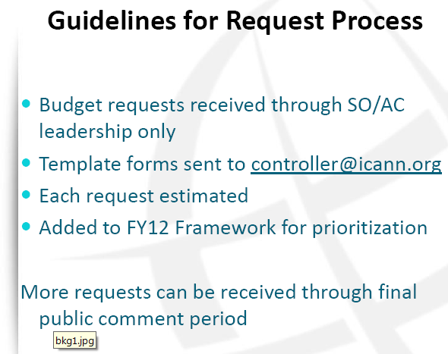

Comments on draft Budget.

Community request for more detail has accepted but never happened. At the public forum the board nodded yes to this request but it must have meant no. There is less detail in FY12 than FY11. The entire financials can be reduced to about 20 lines. (See attached spreadsheet TODO) In FY11 the written explanations of the Organisational Activities Contain some financials. In the FY12 there is almost none.
Is there a lower level of financial detail at ICANN?
Is there a lower level of financial detail at ICANN but it has not been authorized for release to the to the community?
or
Is there a lower level of financial detail at ICANN but the numbers are not reliable and con not be published?
The new format framework 17 slides certainly had less detail than 39 pages in 2011. This was heavily commented on in the framework Budget comment. Whilst we appreciate a rational that demonstrated that the framework is not a ‘already baked’ plan. The lack of detail makes it very difficult to comment effectively.
The framework appears to be an independent document form the plan. As the breakdowns are very different it is very difficult to lay the documents alongside and follow the progress of items. The FY12 framework core operations list and projects list of 11 projects which totaled 11.1m$ in cost. In the Budget on page 30 only four budgets are listed and headline costed. How do we cross reference one to another?
Page 48 Professional Services - language services of 1.6$ has been broken down into four areas. This is the most detail breakdown in the plan. The BC supports the live transcribing services of meeting and the prompt turnround of transcription of call. The minimum delay is this area will have an impact on our members.

Appendix A BC request for pilot outreach project.

Proposed: Constituency support Fund: allocation of $20,000 per Constituency/SG based on a proposal with objectives and activities. End of year report on outcomes. Treat as a pilot for 2012 budget year.

A single allocation per constituency/stakeholder group of $20,000 which can be used either for events, or secretariat support, based on a proposal from the constituency, with agreed deliverables creates a level playing field, defines the parameters of ICANN’s funding to such initiatives, and ensures that the focus is on the bottom up participation, not driven by staff.

We are making a specific proposal that in the BC case, we will present a proposal to ICANN for a pilot business fellowship initiative that we would jointly fund with ICANN, and manage, with the collaborative interaction of the present ICANN Fellowship program, as suitable. This would allow us to spend our limited BC members budget on the management of our constituency, policy development, website development, and materials to support our members policy interests. At the same time, we can undertake a suitable outreach initiative to focus on developing countries business executive participation in a limited and focused pilot. We would incorporate aspects and cooperation with the present Fellowship program into our initiative.

We prefer that support provided is featured as support to the constituency/SG, rather than centralized in permanent ICANN staff, and believe that is more consistent with the appropriate model for staff interaction within the SGS and Constituencies.

Temp Appendix – Remove from Final document.
Notes from Discussion during work team call 3 June CC, MC, Anders H, Mikey OC.

Examine specific comments by BC and community to FY11 dreaf plan:
Second level of detail is missing. Does this level exist? Is is reliable. Last year in calls with KWilson he recognized that certain items were under incorrect headings. New softward was going to resolve this. How is the new software going?
No detail on SSR. What is it? Tell us more?
Make it easy and effective to comment on.
Does not leave out the comments at that level of detail.
Playing Strategic Plan.
Suggestion for half day budget session for the Chairs to work on the budget.
Request equal treatment for support requests.
Copy of the original constituency requests to be published for transparency.
DSSA How much?
Research WHOIS funding as it is not apparent.
Suggest compromise 25% (what? CC)
CC asked MOC and AH to examine FY12 and proved a unordered list of any comments or quieries from document.

