DRAFT 19-December-2013

New gTLD Program Committee:

We urge you to take immediate action to avoid the significant problems of allowing both singular and plural forms of the same TLD string. Fortunately, the ICANN Board has just created a precedent for taking a “second look” at string confusion decisions, as we explain below.

First, consider the obvious problem of allowing a single travel company to control .hotels while another applicant had met Community priority for the .hotel TLD – a result that would discredit the Community Priority program that all of us at ICANN supported. Another troubling example is to allow both .car and .cars TLDs, since registrants and users would likely be confused as to which domain they heard in an advertisement. The .car / .cars situation is especially problematic since conflicting decisions by the International Center for Dispute Resolution (ICDR) undermine the credibility of ICANN’s gTLD program.

The Business Constituency (BC) wrote you in October to describe these troubling inconsistencies in string confusion decisions by the ICDR. (see Exhibit B for letter). As seen in the timeline below, the first three string confusion decisions went against the objector, followed by 5 decisions for the objector. Then another decision (.cars) went against the objector, followed by another decision against the objector.

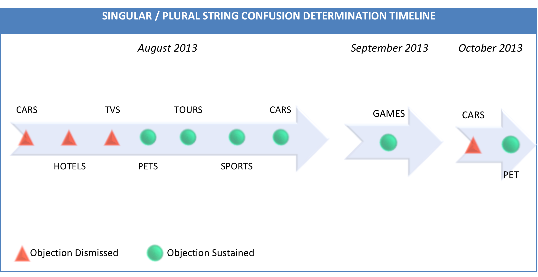
(See Exhibit A for details of these string confusion determinations )

This inconsistency in decisions on precisely the same issue should be adequate justification to revisit all of the objections regarding string confusion between singular and plural forms of the same TLD, and certainly at least the very proceedings where the inconsistencies occurred. In its October letter, the BC suggested two ways the NGPC could proceed:

First, we request that ICANN publish any evidence considered by expert panels, arbitration providers, and ICANN staff in its evaluation of these decisions.

Second, we ask that ICANN publish more specific objective criteria used to judge string similarity, and then allow for an appeal system where applicants can challenge prior ICDR decisions on singular-plural TLDs based on this specific criteria.

An officer of the Business Constituency reiterated these suggestions at the public forum in Buenos Aires.

While the agenda for your committee’s 20-Nov-2013 meeting included a “Report on string confusion expert determinations,” the meeting report shows you postponed the discussion for a future meeting.

Then, on 4-Dec-2013, ICANN published the Final Implementation Plan for the IDN ccTLD Fast Track, which includes a “two-panel string similarity review process”. While the IDN ccTLD process is not an exact fit, it is the type of implementation improvement that could resolve inconsistent objection determinations that have occurred with new gTLDs.

Consider Section 4.3 of the IDN ccTLD process: (link)

4.3 Extended Process Similarity Review Panel Function
The Extended Process Similarity Review Panel (EPSRP) can be called on to perform a second and final confusing similarity assessment of the requested IDN ccTLD string if: (1) The DNS Stability Panel, in performing its string similarity review, deems the string to be invalid; and (2) if the requester seeks review by the EPSRP within three months of ICANN’s notification of the DNS Stability Panel’s determination.

We strongly encourage you to use the EPSRP decision as a precedent for taking action now, by adopting a similar two-panel process for gTLD string confusion objections.

There is still time to do this right, and thereby avoid an embarrassing mistake that will undermine ICANN’s credibility at a time when ICANN must demonstrate it is serving the public interest of registrants and Internet users.

Sincerely,
Elisa Cooper
Chair, ICANN Business Constituency

Exhibit A

SINGULAR / PLURAL STRING CONFUSION DETERMINATION DATA
DATE | DECISION | OBJECTOR | APPLICANT | PANELIST
Aug. 7, 2013 | Dismissed | Google  (CAR) | Koko Castle, LLC  (CARS) | Paul E. Mason
Aug. 8, 2013 | Dismissed | Hotel TLD S.a.r.L  (HOTEL) | Booking.com BV  (HOTELS) | Bruce W. Belding
Aug. 8, 2013 | Dismissed | Verisign  (TV) | TV Sundram Lyengar & Sons Limited  (TVS) | Stephen S. Strick
Aug. 14, 2013 | Sustained | Google  (PET) | John Island, LLC  (PETS) | Robert W. Page
Aug. 16, 2013 | Sustained | Google  (TOUR) | Sugar Station, LLC  (TOURS) | Robert M. Nau
Aug. 20, 2013 | Sustained | SportAccord  (SPORT) | Steel Edge, LLC  (SPORTS) | M. Scott Donahey
Aug. 27, 2013 | Sustained | Google  (CAR) | DERCars, LLC  (CARS) | John A.M. Judge
Sep. 19, 2013 | Sustained | Google  (GAME) | Foggy Beach, LLC  (GAMES) | Earl A. Cherniak, Q.C.
Oct. 10, 2013 | Dismissed | Google  (CAR) | Uniregistry, Corp.  (CARS) | Neil Anthony Brown Q.C.
Oct. 20, 2013 | Sustained | Afilias Limited  (PET) | John Island, LLC  (PETS) | Urs Laeuchli, Esqu
Sep. 25, 2013 | Settlement | Google  (HOME) | DERHomes, LLC  (HOMES) | n/a
Due Jan. 2014 | Pending | Web.com Group, Inc.  (WEB) | VistaPrint  (WEBS) | Prof. Ilhyung Lee
Due Jan. 2014 | Pending | Web.com Group, Inc.  (WEB) | VistaPrint  (WEBS)  (Consolidated Objections) | Prof. Ilhyung Lee
n/a | Withdrawn | Lucy Ventures, LLC  (GIFTS) | Dot Gift Limited  (GIFT) | n/a
n/a | Withdrawn | Lucy Ventures, LLC  (GIFTS) | Uniregistry, Corp  (GIFT) | n/a
n/a | Default | Google  (KID) | Amazon EU S.a.r.L  (KIDS) | n/a
n/a | Default | Google  (KID) | DotKids Foundation Limited  (KIDS) | n/a

Exhibit B

29-October-2013

Dear New gTLD Program Committee,

As we move towards the launch of the first new gTLDs this year, the Business Constituency is extremely concerned about ICANN’s intention to delegate both singular and plural versions of the same string.

We believe that allowing singular and plural versions of the same TLD string will confuse users and frustrate efforts by registrants to build awareness of new domains in new TLDs. The existence of identical second-level domains and their corresponding email addresses on nearly identical TLDs could also create vulnerability to spoofing and phishing fraud. Moreover, conflicting decisions are generating predictably negative reaction and will undermine the credibility of ICANN and our multi-stakeholder model.

Looking further ahead, launching both singular and plural versions of the same string would set a troubling precedent for future gTLD rounds, where applicants could file for plural versions of existing TLDs or new TLDs approved during the present expansion. It’s inconceivable that ICANN would allow this in future Guidebooks, but that would require a reversal of today’s policy and expose the entirely avoidable mistake of allowing singulars and plurals in the current round.

An ideal opportunity to reconsider the singular/plural decisions of ICANN’s string similarity panels was provided in March through the Beijing GAC Communiqué:

The GAC believes that singular and plural versions of the string as a TLD could lead to potential consumer confusion. Therefore the GAC advises the ICANN Board to: Reconsider its decision to allow singular and plural versions of the same strings.

However, ICANN’s Board disregarded GAC Advice and stuck by existing mechanisms and prior expert decisions. The rationale given by the Board revealed concern that making changes in singular/plural TLDs “would cause a ripple effect and re-open the decisions of all expert panels.” While this is a valid concern, we believe it is far outweighed by the Board’s obligation to ensure that TLD expansion validates the effectiveness of the ICANN model in serving the public interest of global Internet users.

In its arbitration decisions over the past several weeks, the International Center for Dispute Resolution (ICDR) has ruled in certain cases that singular and plural versions of the same string are indeed confusingly similar (.sport/.sports, .pet/.pets, .game/.games, .tour/.tours). But in other cases, ICDR ruled in the opposite way (.car/.cars, .hotel/.hotels). Such inconsistent findings on precisely identical legal issues run contrary to the notions of fairness, transparency, and non-discrimination underlying the policy recommendations of the GNSO on the introduction of new gTLDs. They also cast doubt on the appropriate implementation of Applicant Guidebook Section 3.5.1, which states that “[s]tring confusion exists where a string so nearly resembles another that it is likely to deceive or cause confusion.”

ICANN’s Vice President of gTLD Operations acknowledged inconsistencies and process problems in her 17-September video interview. When discussing string confusion evaluations, Ms. Willett said,
"There isn't an appeal process, but Staff is working diligently with dispute resolution service providers to ensure that all procedures have been followed and to look at the expert determinations — we’re looking at these consistency issues."

And as Ms. Willett explained it to GNSO Council on 10-October,
"Staff are considering multiple options to ensure consistent and understandable results."

Given this problematic lack of consistency in ICDR decisions, we have two requests:

First, we request that ICANN publish any evidence considered by expert panels, arbitration providers, and ICANN staff in its evaluation of these decisions.

Second, we ask that ICANN publish more specific objective criteria used to judge string similarity, and then allow for an appeal system where applicants can challenge prior ICDR decisions on singular-plural TLDs based on this specific criteria.

Time is of the essence as the first registries are slated to launch later this year, so we ask that immediate steps are taken to address this important issue.

Sincerely,
Elisa Cooper
Chair, ICANN Business Constituency

