At Large Capacity Building Strategy (2019)
Introduction
During the previous years, webinars have been used as a primary resource for building the capacity of members of At-Large to be able to contribute to the policy development process. From the Outreach and Engagement meeting that took place on the 20th of December 2018 it was found out that the webinars, although successful, could be supplemented by other capacity building measures, to be identified in this draft Capacity Building Strategy.
Aims:
- Building collaborative approaches of capacity building to enhance engagement in the policy development process in ICANN At-Large
- Develop innovative approaches and tools to capacity building in At-Large including a new process for topics calls
- Provide coherence across all community outreach and capacity development activities, on- and off-the record (“What is representing end users all about?”)
- Mobilize At-Large community to produce a coherent capacity building implementation strategy and outreach approach (“How should we increase awareness of end-user issues?”)
- Ensure coordination with ICANN org in shared outreach activities (“How can we benefit from existing programmes? What new initiatives can be put forward for the benefit of end users?)”
Capacity Building Tools
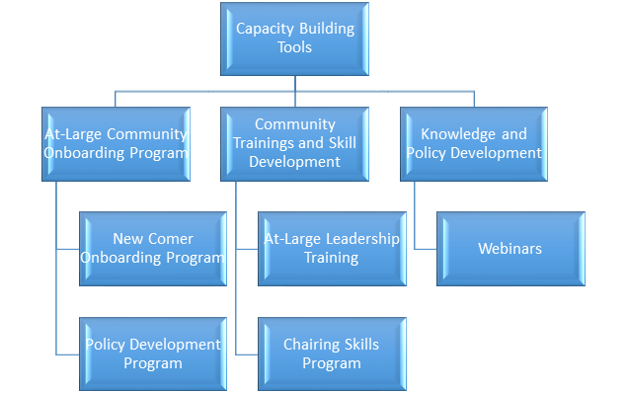
Action items to be pursued in 2019:
- Community Onboarding Program to be updated and further developed [https://community.icann.org/display/atlarge/At-Large+Community+Onboarding]
- ICANN Learn courses and webinars to be updated and reviewed for accuracy and relevance. These include in particular:
  - Approach for Community Onboarding: Promoting, Understanding, Joining, Engaging + historical background to At-Large - an update and ICANN Learn course to be used in interaction with users [seeking ways to transform webinar records into more user friendly materials] [https://docs.google.com/presentation/d/1EaHxaqbxcpSbWRYHhEm7NB1KmKo39LfXw3G_Tudszws/edit?usp=sharing]
  - What is the DNS? / Intro to Domain Names / DNS Demystified - Introduce the concepts of the DNS and introduce entities like ICANN the corporation, and ICANN the community; alternatively: an Intro to At-Large course that includes different modules to provide Newcomers and interested individuals information on the the scope of the mission of At-large as an AC organization.
  - Key Policy Issues of the At-Large Community - slidedeck to help new or potential At-Large Community members to learn about the various ICANN policy issues of interest to end users, why end users should care about these issues, and how as part of the ICANN At-Large Community they can become involved on these issues.
  - Presentation on Introduction to ICANN At-Large - - slidedeck about the At-Large Community, its key activities, and how to engage with the At-Large Community
- Mentoring and consolidating hot topics across regions. The other part (active) is a direct dialogue with currency and potential members. More direct messages (even if in social media) from community leaders, we not only attract attention and give an authoritative opinion on our list of hot topics. It is impossible to overestimate the importance of personality. It is always better than the most informative presentations.
- Navigating At-Large - for existing At-Large Community members, how to find relevant information and participate in At-Large activities, getting existing At-Large members to become more involved in At-Large, providing resources on the skills needed (policy writing, chairing, etc) as well as learn the workflow of At-Large.
Applicable to all action items above:
Topics preferably to be covered in various forms: 1) online (audio-video) 2) slidedeck with a sketch (minimal information to share) available to all members for the purpose of outreach, engagement and capacity building. The content can also be used for the At-Large website or lessons for ICANN Learn for persons to self learn at their own pace. The content can also be translated.
The goal is to have this base of At-Large material that can be used anytime, shared on social media whenever the content is updated, and discoverable by anyone searching.
Overall message should be uniform and consistent in all communications.
Producing/updating content will require a sustained, collaborative effort. There’s lot of work for everyone to help develop content.

