Stress Tests -- Analysis of public comments on 2nd draft (version 3)

From CCWG 2nd Draft Proposal
The CCWG 2nd draft proposal describes Stress Tests on pages 83 thru 119. Between the first and second draft proposal, we added 10 Stress Tests, per requests from public comment, a Board/Legal letter, and NTIA’s 16-Jun Statement.
Public Comments: We had 20 public commenters on Stress Tests.

Areas of Consensus
None of the commenters expressed any overall concern with our application of Stress Testing to CCWG proposed mechanisms.

Areas Needing Clarification/Refinement
1. Stress Tests on capture or unintended consequences of changes (12, 13, NTIA’s 33 - 35).
A few commenters said that our analysis should dig deeper – particularly on CMSM voting. CyberInvasion’a comment said:
“We express concern over the potential rebalancing of power between the SO/AC community as defined by the method of participation in the community mechanism. We respectfully suggest that Stress Test 35 (NTIA-4) may not have fully examined the potential impact of operationalising the advisory committees into roles that may not have been envisaged for them during their creation.”
We asked James Gannon at CyberInvasion to elaborate on the negative impact of letting ACs indicate their preference on exercising community powers. And if ACs just gave advice, without indicating a yes/no vote, how would that mitigate the negative impact? James replied:
Impact of operationalising AC’s as voting entities in the SMCM – Clarification and additional information, Cyber Invasion Ltd

ALAC
The At-large community is representative of a broad and diverse range of views and opinions. These opinions are well expressed in their current advisory role via the ALAC which allow for a broad range of positions to be expressed through advisory documents. We feel that by putting the ALAC in a position of operational responsibility it may have the following negative effects:
- Politicise the ALACs position as the representative group of at-large, by adding this additional role that was not envisaged during the creation of the ALAC structure there may be the possibility for unknown bad actors to attempt to utilise the new found power of the voting role of the ALAC for negative purposes.
- Introduce a new form of structure within ICANN with unknown consequences, an AC whose remote extends beyond that which is defined for it in the bylaws and the created structure for ICANN, we believe that the correct place for such a structure change is via a structural review of all ACSOs and not via the CCWG, we feel that this may have negative consequences on the perception of the work of the CCWG and potentially on ALACs role as a chartering organisation.
- Create internal conflict within the ICANN structure, as the outcome of operationalising any of the ACs would represent a shift in the balance of power within ICANNs community we feel that this may have a negative effect on the inter-community relationships that have been forged over the past 17 years of operation. Such an effect may have a destabilising effect in the post transition period as each community rebuilds itself within this newly created power dynamic.

SSAC+RSSAC
While distinct advisory committees we will address issues related to the operationalisation of the two ‘technical’ AC’s as one as they have similar issues in our analysis.We feel that by putting the ALAC in a position of operational responsibility it may have the following negative effects:
- Forcing a set of stakeholders into a role which they have expressed a wish not to be placed into may degrade the goodwill of these stakeholders who operate within ICANN on a voluntary basis sharing their expertise in a specific manner as has been the case since their inception
- Introducing political aspects to the work of a set of technical communities. This will provide an additional administration burden and workload for these small and tight knit communities of experts.
- On the matter of the SSAC we have serious concern that changing the role of the SSAC may lessen the perceived independence and impartiality of the critical reports that this group provides for the ICANN community. Future reports may be ‘tarnished’ by previous voting decisions taken by the SSAC via the CMSM. We feel that this is a critical SSR concern and one that cannot be understated.
- Potential conflict of interest concerns, as the SSAC is appointed by the board there may be a potential conflict of interest, either perceived or in reality, in participating in certain community powers.
- Create internal conflict within the ICANN structure, as the outcome of operationalising any of the ACs would represent a shift in the balance of power within ICANNs community we feel that this may have a negative effect on the inter-community relationships that have been forged over the past 17 years of operation. Such an effect may have a destabilising effect in the post transition period as each community rebuilds itself within this newly created power dynamic.

GAC
We feel that operationalising the GAC with a voting role may place the GAC in a position of drastically increased power due to the existence of the ‘special’ bylaw, this would elevate the GAC to a role of increased power and we feel that this may place the work of the CCWG at risk of failing the NTIA criteria relating to governmental power within ICANN. Additionally similar to the previous AC’s we feel that the following negative effects may occur
- Create internal conflict within the ICANN structure, as the outcome of operationalising any of the ACs would represent a shift in the balance of power within ICANNs community we feel that this may have a negative effect on the inter-community relationships that have been forged over the past 17 years of operation. Such an effect may have a destabilising effect in the post transition period as each community rebuilds itself within this newly created power dynamic.

We would like to see the above issues examined as part of Stress Test 35 (NTIA-4) or referenced to where other stress tests may detail responses to our concerns, we recognise that our view is one amongst many and we feel that the ST-WP would be a good venue for our concerns to be examined in an analytical and unbiased environment.
Please feel free to contact us for any further clarifications,
-James Gannon, Security and Privacy, Cyber Invasion.
4 commenters (Cyberinvasion, Internet NZ, Lee Bygrave, NCSG) were opposed to giving ACs voting roles.
The ST team notes that a small minority of commenters opposed giving ACs voting roles, but will nonetheless revisit its analysis of AC voting in Stress Tests 12, 13, 33-35.

Requests for New Stress Tests
1. ELIG (law firm) suggested stress testing on a “deadlock” over approving changes to Fundamental bylaws, and blocking changes to regular bylaws: "We believe that it would be helpful to also explain the details of the legislation procedures in case of a deadlock during the amendment/enactment of a bylaw."
Any other new stress tests requested?
Areas of Concern/Divergence
1. Stress Tests 29 and 30: (pp 112-13) These STs were added in response to public comment from New America Foundation. 7 commenters object to ST 29 and 30 (CoA, RIAA, IPC, ITI, US Chamber, USCIB, BC). Staff summarized objections as:
submissions were concerned about conflation with content regulation. To quote the US Chamber of Commerce on the topic: “We are concerned with the framing of Stress Tests # 29 and 30, which seems to conflate the enforcement of certain mutually-agreed to contractual obligations with that of “content regulation.” ICANN has a duty to enforce and enter into mutually agreeable contractual provisions, that are aimed at preventing malicious, abusive, or illegal conduct and the CCWG should add language clarifying this this obligation is not altered by ICANN’s revised Mission statement. We have a concern that the by-laws can be interpreted to limit ICANN’s ability (or willingness) to enforce existing contract terms and Public Interest Commitments with Registrars, agree to new contracts with strong protection provisions or otherwise participate in other programs designed to promote public interest goals.”
As to whether the ST team properly analyzed the Stress Tests, we said the IRP could potentially find that contract enforcement could be tested against bylaws requirement for bottom-up policy and ICANN’s mission statement. (We have no idea what an IRP would say). Commenters in Los Angeles said that we should not have accepted the Consequence text from New America: “ICANN effectively becomes a regulator of conduct and content on registrant websites”
The ST analysis as succeeded in focusing attention on the need to clarify whether limited mission and B-Up process bylaws would interfere with contract enforcement. We note that WP2 is considering new text for the mission statement draft.
ST team recommends that the “consequence” stated in ST 29 and ST 30 be replaced with ”ICANN’s enforcement of registry and registrar contract terms might be blocked by an IRP ruling citing amended Mission and Core Values. “
Also, the ST team recommends that the conclusion of ST 29 and 30 be replaced with “Proposed measures would be adequate to challenge ICANN enforcement actions, but it is unlikely that IRP panels would block enforcement of voluntary contract terms and consensus policies”

2. Stress Test 21, regarding revocation and re-assignment of a ccTLD manager. (p.94)
We did not propose a specific review & redress mechanism for this, per request by CWG-Stewardship
We concluded that neither existing or CCWG proposals adequately address this scenario, and that ccNSO is developing policy per the FoI (Oct-2014)
The Govt of NZ suggests that IRP should be available for this scenario.
While not part of the public comment, this ST was discussed at the CCWG meeting in Los Angeles. Dot-NZ suggested a moratorium on re-delegations of ccTLD managers during the “gap” while ccNSO does its policy development. Chris Disspain said ccNSO should say what to do in the gap period.
ST Team believes we should retain current ST 21 analysis and not recommend other actions, pending policy development by the ccNSO.

3. Stress Test 33 (NTIA-2) (p.116)
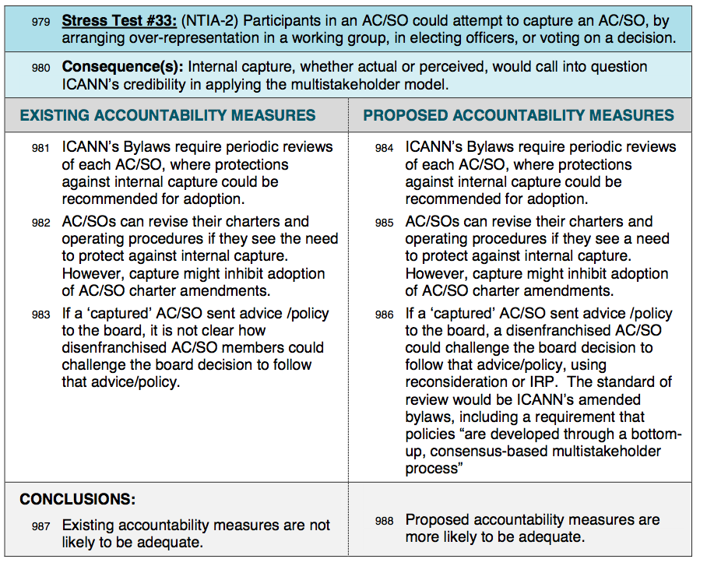
The IPC challenged this analysis, saying:
The risk of “internal capture” is real, and in fact may be a reality already within the GNSO, whose structure ensures dominance by contracted parties. The responses propounded by CCWG in paras. 984-86 seem inadequate, especially if the trend continues of excluding “structural” considerations from the periodic reviews undertaken. The chance that the Board would effectively reconsider a decision to follow the recommendation, adopted through facially valid procedures, of a “captured” AC or SO seems slight. Whether the IRP would provide an adequate accountability mechanism could depend on the willingness and capacity of arbitrators to look past procedural compliance to assess whether that captured entity actually exhibits a “bottom-up, consensus-based, multistakeholder process.”
The ST team recommends that we amend the conclusion of ST 33 (para 988) to
“ Proposed accountability measures would be adequate, provided that the bylaws requirement for a “bottom-up, consensus-based, multistakeholder process” is interpreted by the board and IRP panelists to include assessment of how decisions were reached in an AC or SO.”

Options for Consideration by full CCWG
1. Stress Test 18: (p.85 and p.103)
Of the 36 comments listed in the GAC tab and 20 in the Stress Test tab of the PC tool:
16 explicitly in favor (BC, Internet NZ, Cyberinvasion, New Zealand, UK, i2Coalition, ICANN Board, ITI, Intel, Internet Association, IPC, Registries SG, SIIA, USCIB, CoA, US Chamber)
4 explicitly opposed ( Argentina, Brazil, France, Spain ).
That’s 80% — and doesn’t count the NTIA, who considers ST 18 a requirement for transition.
Staff summarized the public comments this way:
Of the Stress Tests, ST18 received the most comments. Argentina, Brazil, France and Spain were opposed to ST18. To quote France on the issue: “[…] the French Government shall formally object to any approval by GAC of a final proposal that would not leave Bylaws Article XI.2.1.j unchanged.” There were 5 submissions against: COA, IFPI & RIAA, IPC, US Chamber of Commerce, and USCIB.
While not part of the public comment, this ST was discussed at the CCWG meeting in Los Angeles:
Olga Cavalli said several more GAC reps are concerned about ST 18, so the total is 12 against.
Steve DelBianco apologized for the example used in setting-up ST 18, since it apparently was offensive to some governments. Steve and Cheryl proposed removing the following text in para 611 and 832: “A majority of government’s could thereby approve GAC advice that restricted free online expression, for example”. This example is not necessary to analyze the stress test.
Several GAC reps asked for more rationale for this bylaws change.
GAC Chair and US GAC Rep said they are considering new text for ST 18. Nothing seen yet.
ST team recommends removing the example text used to describe ST 18 (“A majority of government’s could thereby approve GAC advice that restricted free online expression, for example”.)
The ST team has drafted this rationale for ST 18, to appear before para 618 on p. 85:
Stress Test 18 was among the plausible scenarios that could test how and whether the ICANN community could challenge actions taken by the ICANN corporation. The rationale to develop this stress test involves two factors:
First, ICANN community members were aware that some GAC members had expressed a desire to change the GAC’s historical method of using consensus for its decision-making, where “consensus is understood to mean the practice of adopting decisions by general agreement in the absence of any formal objection”. Moreover, it would take only a simple majority of GAC members to change its decision-making methods to a lesser standard, such as majority voting.
Second, the CCWG realized that ICANN’s present bylaws obligate the board to seek “a mutually acceptable solution” if it decided not to follow GAC advice. That level of required deference is unique to the GAC and not required for advice from other AC and SOs. More important, the board’s obligation to seek a mutually acceptable solution applies to all GAC advice, even if that advice were not supported by GAC consensus, and even if that advice were opposed by a significant minority of GAC members.
For these reasons, CCWG added Stress Test 18 to the draft proposal, and the stress test working party concluded that existing accountability measures were not adequate to let the community hold the ICANN board accountable for its actions if the board were obliged to seek a negotiated solution with the GAC.
In order to address Stress Test 18, CCWG proposed an amendment to ICANN bylaws regarding the board’s obligations with respect to GAC advice. The amendment would preserve the requirement for ICANN’s board to seek a mutually acceptable solution, but only for GAC advice that was supported by consensus among GAC members.
The rationale for proposing this bylaws amendment in response to Stress Test 18 is two-fold.
First, CCWG wants to reserve ICANN’s board’s obligation to negotiate with the GAC for only that advice which is supported by a consensus of governments. GAC advice that is opposed by a significant minority of governments should not trigger the board’s obligation to enter bi-lateral negotiations with the GAC on a matter that affects the global Internet community. A negotiation between ICANN board and GAC should be reserved for resolving differences between ICANN and governments – not to resolve differences among governments themselves.
Second, the proposed bylaws change would provide a strong incentive for the GAC to continue seeking consensus for the advice it provides to ICANN, which is the practice presently used by the GAC. While the GAC could at any time change its decision-making methods, this bylaws change would continue to elevate the influence of GAC advice that was supported by consensus of GAC members. Similar incentives for consensus policy and advice are already present in the ICANN bylaws, which require supermajority support for policy recommendations coming from GNSO and ccNSO.
The rationale above is meant to explain why Stress Test 18 was developed, and to explain why CCWG proposes a bylaws amendment to preserve ICANN board’s obligation to seek a mutually acceptable solution when GAC advice is supported by consensus.

