CJK Ideographic Variant Definition
for Top level Domain Names

DATE: 2014-08-30~2014-09-01~2014-09-02
To: ICANN/CGP, KGP,JGP and Whom it may concern
Written By: Zhang Zhoucai , Revised By: Chris Dillon

CJK Ideographic Variants are those separately encoded Chinese Hanzi, Korean Hanja or Japanese Kanji with different shapes and coding but with the same basic meanings. Hereafter this is abbreviated to “CJK Variant”.

参考中译：
CJK变体汉字是字形不同编码不同而主要字义相同的中日韩汉字。
Note:

- Unlike the definition in the Chinese VIP Report in 2011, the current CJK Variant Definition emphases the following points:
  - The variants may cross CJK language contexts, and are not limited to a single language context.
  - The concept of BASIC meaning sameness is added ignoring pronunciation since ideographic variants may have totally different pronunciations. Nevertheless, the variants must have the same pronunciations within one language context.
  - The wording “visual different shapes” is no longer used since many visual differences of ideographs have been unified in CJK.
  - The variants are not-unified ideographs for various reasons:
    - Simplification ( Mainland China 汉字简化)
    - Glyphs Normalization (Mainland China, 规范汉字，汉字正形)
    - New or Old Forms （Japan 新旧字体, China 新旧字形）
    - Source code separation rule （ISO/IEC 10646, Unicode）
    - Other Government policies/regulations
- The CJK Variant definition is based on the following assumptions:
  - All related partied agree to establish a UNIFIED Repertoire of COMMON and MODEN CJK Ideographs for TLDs.
  - The CJK Variants here and their transcriptions in Chinese (CHS and CHT), Japanese or Korean, 异体字，異體字and 異体字 are regarded as purely neutral terms, a lexical alternate only, not implying any derogatory or negative sense corresponding to their official or normalized counterparts. （Variants-中性無貶義）
- A CJK variant may have 3 separate variant groups, the relationship amongst them shall be determined via coordinated discussion according to their usage frequency or other preferences respectively. In most cases, K could refer to CHT. e.g.
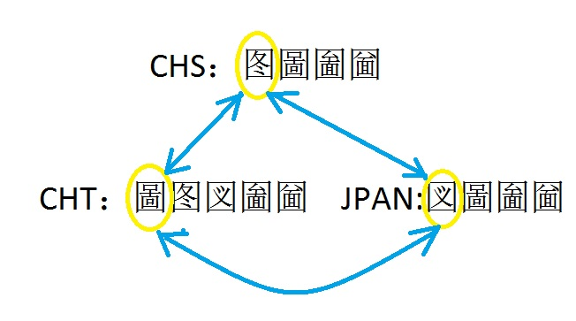
The mapping, blocking/allocating rules are outside the scope of this article.

