Dear [XXXX],

My name is Hiro Hotta, Chair of Japanese Generation Panel (JGP).

JGP intensively works to define RootLGR for Japanese labels. In addition, JGP has collaborated with Chinese Generation Panel (CGP) and Korean Generation Panel (KGP) in defining Kanji (Han) script Label Generation Ruleset

On behalf of JGP, I'm sending this letter to request ICANN to investigate the feasibility and appropriateness of upgrading the algorithm (RootLGR) to the one that takes one or more original input labels and generates allocatable/blocked/invalid labels as output, where original input labels are marked as ‘allocatable’ in the output. Refer to the figures of this proposed model, here I call it “super RootLGR”.

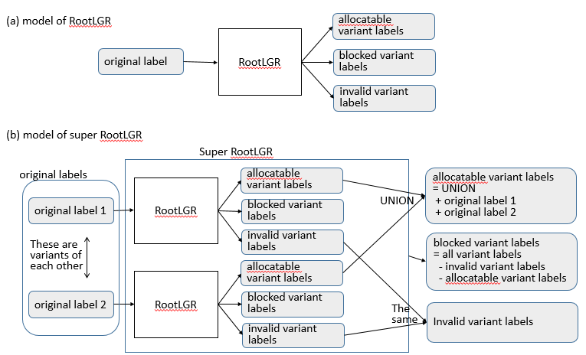

The background of this request is explained below :

JGP defines Japanese language Kanji repertoire as a set of about 6,000 characters. Virtually any combinations of the characters in the repertoire is not prohibited to express a Japanese word in daily use. This means all the variants (of any combination of the characters in the repertoire) are expected to be marked as ‘allocatable’ in the outcome of LGR. However, if some rules are imposed on the definition of allocatability (e.g., by importing other language’s definition of variants and their usage), some labels may be blocked (non-allocatable).

However, usually the applicant knows which string he/she wants to use when he/she applies for TLDs, and that’s why he/she applies for a TLD of such a string. And in some cases, applicant wants to use one or more variant labels when he/she applies for a TLD. Therefore, if applied-for labels are all marked as ‘allocatable’, he/she will not demand delegation of more variant labels in general. In most cases, only applied-for labels are demanded and other variants will never be demanded by the applicant in the future. This is the background of the request for “super RootLGR”.

Please note that this issue may be more smartly solved by concurrent use of the scheme proposed by CGP Co-Chair Wang Wei in his letter to ICANN dated xx/xx/xx in addition to the requested model “super RootLGR” in this letter.

I hope ICANN will give eye-to-eye investigation on our request in this letter as well as Wang Wei’s request.

Looking forward to your positive response.

Hiro Hotta
JGP Chair.

