Dear [XXX]

My name is Wei WANG, Co-Chair of CGP and board member of CDNC (Chinese Domain Name Consortium). During the past 2 years, CDNC and CGP were committed to developing Chinese LGR for root zone, together with JGP and KGP, under the framework given by IP.

We acknowledge that LGR (P2.2) is supposed to work as an automatic machine or AI，together with P1 and P7, which outputs appropriate allocatable variant labels when inputted applied TLD labels, as well as the blocked labels. This pre-disposition mechanism will help the evaluation panel to delegate root labels more efficiently by reducing the number and complexity of variant labels.

However, after analyzing the complicated SLD variant cases and C/J/K coordination cases, especially the different semantics in different language contexts, CDNC and CGP would like to indicate that it is hardly possible to design an ideal full-automatic LGR which could handle all TLD applications perfectly without necessary human interventions. Instead, LGR should work as an assistant tool in the whole application-evaluation-delegation processes, as in the following graph.

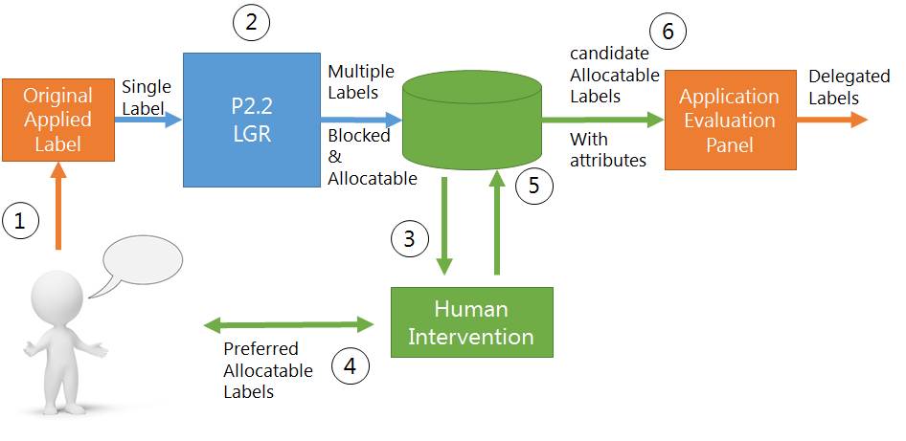
As illustrated in the very graph, LGR only works as a part of the whole label generation and valuation process. It generates possible allocatable labels and unqualified blocked labels in step2. In the green human intervention parts (step3~step5), the applicant will engage to select a sub set of allocatable labels, a set which reflect the applicant’s real expectation and will be marked as candidate labels. The rest of the very allocatable labels are still allocatable but marked as reserved. Then in step6, the candicate labels are therefore submitted to application evaluation panel for final decisions.

The reasons of this proposal are as follows:
- It is hard to predict all the desired Chinese variant labels without human interventions
For most Chinese [language] “Chinese[script] variants”, there exists definite one-to-one mapping relationship, generally refered as simplified and traditional pair. Among over 19000 CGP code points, there are still hundreds exceptions, like发(53D1) VS 發(767C)髮(9AEE).
Both 767C and 9AEE are traditional forms of 53D1, but their meanings are different.
When someone submits an application like simplified label “理发”(haircut), two traditional variant labels will be both generated, “理發” and “理髮”. Only Chinese speakers know exactly which one should be allocatable. Things will get much more complicated if the applied label is “发发理发”, eight different variant combinations will be generated. Maybe only the origin applicant knows which one should be allocatable.

- Cross-language context application needs more human interventions
Every New gTLD application is rooted in the basis of rationality and practical considerations. The Generation Panel’s responsibility is to treat the IDN variant labels cautiously and provide supporting information as much as possible, to help Application Evaluation Panel (AEP) to make the final decision, instead of simply giving a bunch of seemingly anonymous “allocatable labels”.
机(673A) and機(6A5F) are variant and both mean “Machine” in Chinese language. But in Japanese and Korean, 673A means “Desk”, only 6A5F means “Machine”. Even though JGP would compromise and adopt the “Chinese” variant definition to reach a CJK consensus, the inherent contradiction between the comprehending will cause ambiguity tremendously in the cases like “飞机”(airplane). This kind of language and culture difference is too complicated for LGR to judge which variant label should be blocked or allocatable, and brings potential abusing risk for Japanese language TLD. Thus, human intervention should play a vital role in this circumstance, which correspondingly suggests that the LGR output labels carry not only “allocatalbe” or “blocked” attribute, but also more detailed attributes such as the variant type, sub-type and etc.

Considering all the above situations, we need a sophisticated and smart LGR which is intelligent and knowledgeable enough to distinguish the subtle difference in every character semantic and all languages contexts. It is obvious that this ideal full-automatic LGR will be a most complicated system that we can imagine. Or, in another way, we might need to resort to a delicate half human half machine process to address these complicated issues.

I have discussed this issue with experts of CGP, JGP and KGP. We all agree that a rational LGR workflow design (how LGR works in the whole IDN application-generation-evaluation-delegation process) will help IDN community reduce the disputes tremendously. I hope ICANN would kindly give us a face-to-face investigation or hearing to our request in this letter.

Looking forward to your positive response.

Wei WANG
CGP Co-Chair

