Dear [XXXX],

My name is Hiro Hotta, Chair of Japanese Generation Panel (JGP).

JGP intensively works to define RootLGR for Japanese labels. In addition, JGP has collaborated with Chinese Generation Panel (CGP) and Korean Generation Panel (KGP) in defining Kanji (Han) script Label Generation Ruleset

On behalf of JGP, I'm sending this letter to request ICANN to investigate the feasibility and appropriateness of creating a tool (so-called ‘super RootLGR’) to enhance the function of RootLGR. ‘super LGR’ takes one or more original labels and generates variant labels that are categorized into following three groups.
1: allocatable variant labels, which are equivalent to original labels
2: invalid variant labels, which are variant labels that include characters out of repertoire
3: blocked labels, which are all variant labels that are not allocatable or invalid

‘super RootLGR’ is useful especially when RootLGR marks ‘block’ to a subset of variant labels but the TLD applicant needs one or more ‘block’ed labels to be delegated. For example, let’s consider the case where mixed use of simplified Han characters and traditional Han characters in a single TLD string is prohibited. In this case, 国立大学 and 國立大學 are marked ‘allocatable’ but ‘国立大學’ and ‘國立大学’ are marked ‘block’ by RootLGR, because 国 and 学 are simplified while 國 and 學 are traditional. But, for some justifiable reasons, an applicant may want to have both ‘国立大學’ and ‘國立大学’ delegated.

This situation can be solved by introducing a mechanism that wraps one or more RootLGR execution, each of which corresponds to each original input label. Such a mechanism, called ‘super RootLGR’ here, takes one or more original input labels and generates allocatable/blocked/invalid labels as output, where original input labels are marked as ‘allocatable’ in the output. Refer to the figures of this proposed mechanism “super RootLGR”.

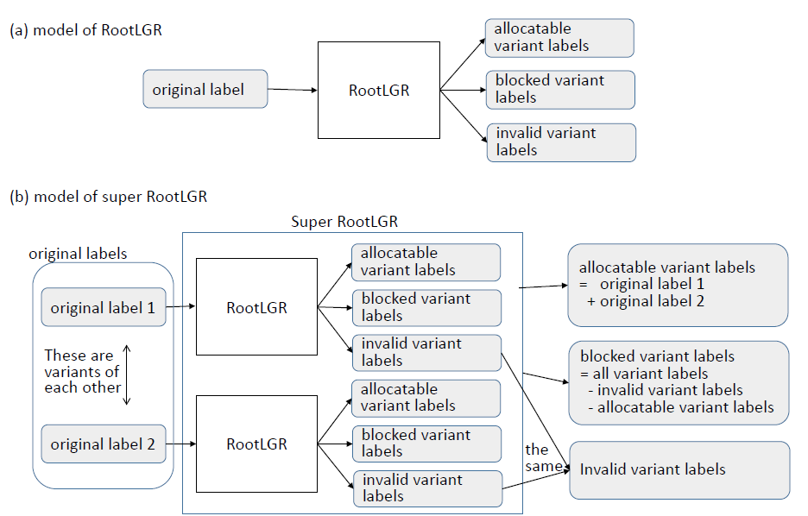

In general, the applicant knows which string he/she wants to use when he/she applies for TLDs, and that’s why he/she applies for a TLD of such a string. And in some cases, applicant wants to use one or more variant labels when he/she applies for a TLD. Therefore, in general, if applied-for labels are all marked as ‘allocatable’, he/she will not demand further delegation of more variant labels in the future. This is the background of the request for “super RootLGR”.

Please note that this issue may be more smartly and flexibly solved by parallel use of the scheme proposed by CGP Co-Chair Wang Wei in his letter to ICANN dated xx/xx/xx in addition to the requested model “super RootLGR” in this letter. Or Wang Wei’s method and this letter method may be considered to be alternative.

I hope ICANN will give eye-to-eye investigation on our request in this letter as well as Wang Wei’s request.

Looking forward to your positive response.

Hiro Hotta
JGP Chair.

