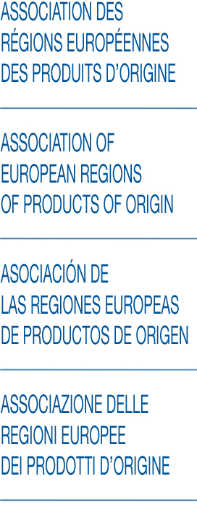

Bordeaux, le 29 janvier 2019

**AREPO’s Input on “Supplemental Report on the new gTLD Subsequent Procedures Policy Development Process (Work Track 5 on Geographic Names at the Top Level)”**

On behalf of the AREPO, **association of European regions for origin products**\*, we would like to thank you for the opportunity to comment on the abovementioned supplemental report and offer the following comments:

*\*AREPO joins 32 regions in 8 EU countries and 800 European registered PGI and PDO food products.*

**1. General comments.**

The rules applicable to geonames as TLDs in the 2012 Applicant Guidebook (AGB) worked generally well and struck an appropriate balance between the different interests at stake. Therefore **they should be maintained**, subject to the comments below.

The **exclusion of country names and variations thereof** is consistent with the fact that such names are not “generic” TLDs, and should be under the policy authority of the respective national communities, in analogy to ccTLDs.

The **“non-objection” framework** established e.g. for capital city names, subnational and supranational regions, etc. **worked well and should be maintained**.

In the case of **non-capital city names** the rule according to which the “non-objection” framework is not applicable when the alleged **“intended use”** is non-geographic **should be suppressed** as it ignores the unique character of the TLDs and creates wrong incentives to circumvent (i.e. “game”) the requirement to contact and obtain the non-objection from the relevant public authorities.

Accordingly, we also **disagree with any proposals that suggest to extend the “intended use” rule** to any other categories of geonames.

Issues have been identified for **geonames as TLDs not covered by the 2012 AGB** – the lack of a “non-objection” framework for such names has generated conflicts between the different interested parties. This should be avoided in future expansions of the TLD space. **Extending the “non-objection” framework to such cases would be advisable**.

The **“non-objection” framework as such can be further improved** by establishing reasonable deadlines for issuing the “non-objection”, by providing a default implied “non-objection” if the public authority does not react within the given deadline, by establishing a geonames advoisory panel, whom applicants may consult before even filing their string, and by establishing a mediation process for cases where an objection by a public authority is not accepted by the interested applicant.

**2. Specific comments.**

* Questions e1-e4: see general comments above
* Question e5: ICANN is bound by its Articles of Incorporation and Bylaws to respect relevant principles of international law and applicable local law. ICANN also has to consider the public policy advice from the GAC. Furthermore, the evidence included in the report shows clearly that many national legislations provide for protections of geonames and that they are applied and enforced regarding domain names. Hence, both international law, national law and relevant public policy input from GAC and Governments should be considered.
* Question e6: no factual explanation is contained in the report that would support the need to reduce the number of languages. If any limitation is made it should still afford protection to all official and relevant national, regional and community languages.
* Question e7: see general comments above.
* Question e8: see answer to question e6.
* Question e9: see general comments, i.e.: “In the case of non-capital city names the rule according to which the “non-objection” framework is not applicable when the alleged “intended use” is non-geographic should be suppressed at it creates wrong incentives to circumvent the application of the requirement to contact and obtain the non-objection from the relevant public authorities.”
* Question e10: see answer to question e9.
* Question e11: see general comments, i.e.: “Issues have been identified for geonames as TLDs not covered by the 2012 AGB – the lack of a “non-objection” framework for such names has generated conflicts between the different interested parties. This should be avoided in future expansions of the TLD space. Extending the “non-objection” framework to such cases would be advisable.”
* Proposal 1: support.
* Proposal 2: support.
* Proposal 3: support.
* Proposal 4: support.
* Proposal 5: support. The deadline needs to be reasonable.
* Proposal 6: not supported.
* Proposal 7: not supported.
* Proposal 8: support.
* Proposal 9: no position.
* Proposal 10: no position.
* Proposal 11: not supported.
* Proposal 12: not supported.
* Proposal 13: not supported.
* Proposal 14: unclear what the intent is. No position.
* Proposal 15: the burden should not be on the country alone – the determination can be made prima facie by the geographic names panel.
* Proposal 16: support.
* Proposal 17: not supported.
* Proposal 18: not supported.
* Proposal 19 and variants: not supported.
* Proposal 20: not supported.
* Proposal 21: support.
* Proposal 22: no position.
* Proposal 23: not supported.
* Proposal 24: support. Consistent with its Bylaws ICANN should defer to applicable local laws and policies, including on the definition of what is considered as a city. The Geonames Panel could assist in this.
* Proposal 25: not supported.
* Proposal 26: support.
* Proposal 27: not supported.
* Proposal 28: not supported.
* Proposal 29: not supported.
* Proposal 30: not supported.
* Proposal 31: not supported.
* Proposal 32: not supported
* Proposal 33: not supported.
* Proposal 34: support.
* Proposal 35: support.
* Proposal 36: support.
* Proposal 37: support.
* Proposal 38: support.

January 2019, 29th, on behalf of Theano Vrentzou-Skordalaki

Chairwoman of AREPO



P/O Laurent GOMEZ, General Secretary of AREPO