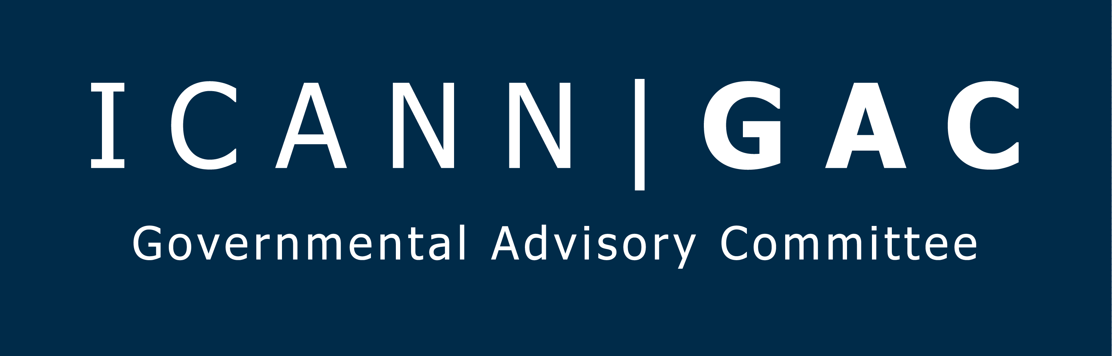

5 February 2018

GAC INPUT TO PUBLIC COMMENT PROCESS: DRAFT OPERATING STANDARDS FOR SPECIFIC REVIEWS

The GAC appreciates this opportunity to comment on the draft Operating Standards for Specific Reviews.
Principles
The GAC views these Special Reviews (“reviews”) as an integral part of ICANN’s accountability mechanisms. In recognition of this, the GAC agrees that Operating Standards are necessary to ensure that the reviews are conducted in a transparent, consistent, efficient, and predictable manner. Furthermore, the GAC believes principles of transparency, consistency, efficiency, and predictability need to also be taken into consideration when identifying and articulating the roles to be played in the conducting of these reviews, including that of the ICANN Board.
Role of ICANN
Using the October 28th announcement by the ICANN Board that it would suspend the activities of the Security and Stability Review Team (SSRT) as an example, actions taken by the Board that are not explicitly defined or otherwise anticipated have the potential to undermine ICANN’s accountability. The October 28th action appeared to have been done with little notice given and no clear rationale provided to the ICANN community. The ICANN Bylaws express no actual role for the ICANN Board in the workings of a Review Team outside those associated with designating a Board Liaison and the actions the Board should take in cases in which it decides not to accept recommendation(s) in the final Review Team’s report. Furthermore, there is nothing currently articulated in the draft Operating Standards for Specific Reviews that articulates a role for ICANN or its Board to suspend or otherwise disrupt a review. Everything documented to date about these reviews stresses the importance of openness, transparency, and community consultation. Unfortunately, it seems that with the October 28th action, the ICANN Board violated these principles by substituting its judgement for that of the community.
While there may have been reasons for this work to be suspended, such standalone action by the Board calls into question the transparency and accountability of ICANN as an organization and marginalizes the ICANN community. Suggestions by the Board that a discussion with the leadership of ICANN’s supporting organizations and advisory committees are a sufficient work method of community consultation, misunderstands the role and purpose of those in these leadership positions. They are not a substitute for the ICANN community. The GAC’s concerns are compounded by the fact that review teams, such as the SSRT, are a critical accountability tool in the post IANA stewardship transition phase of ICANN, something all stakeholders are watching closely in the post-transition environment.
Therefore, the GAC strongly recommends that ICANN and the community consider how best to articulate the role of ICANN and the ICANN Board that remove any ambiguity with respect to the conducting of the reviews. In order for these reviews to be a successful accountability tool, the GAC further recommends that the role of ICANN and the Board remain limited when possible to ensure impartiality on matters pertaining to the actions of ICANN as dealt with in the reviews.
Raising reasonable concerns
There is also a need for an appropriate framework to deal with exceptional situations where members of the community and/or the Board wish to raise reasonable concerns about significant aspects of a review after that review has started. The recent case of the SSRT is relevant in this regard.
Scope of Reviews
Section 2.1, of the draft Operating Standards provides for an entirely separate team to define and draft the scope of review for the By-Law specified reviews and also states that "[i]f the Scope Drafting Team has not completed its work in time for the scope to be adopted prior to the Board’s convening of the review, the scope of the review shall be limited to the scope provisions detailed in the ICANN Bylaws for that review. This does not negate the review team’s ability to amend the scope as per section 3.22 of these Operating Standards."
The idea that an entirely separate team will determine the scope of review for a future review team raises some concerns. At the very least, actual review team members should have a meaningful opportunity to participate in the scoping process, either via the Scope Drafting Team or via an effective and efficient opportunity for review team members to endorse or modify the scope of the review. Experience has shown that it is often only during the review process itself, that the team becomes aware of issues that must be dealt with in order to conduct an effective and meaningful review. The current proposed procedures set forth in Section 2.1 (Separate Scope Drafting Team) and Section 3.22 (Changes to Scope while Review is Underway) neither allow for continuity of membership between Scope Drafting and Review Team members nor provide for an efficient and timely method to modify the scope once the review has commenced. Practically speaking, these draft procedures make it very difficult for the review team to weigh in on one of the most pivotal issues in the review process – determining the proper scope. Moreover, the idea that the scope of the review team would be determined solely by the Bylaws in the event that the scoping team fails to reach consensus on the scope within a given time frame is problematic.
Hence, the GAC suggests instead to task the Review Team with determining the scope, as was recently the case in the ongoing RDS review. This has proven to be an effective approach to tackling the issue and should be considered as a general best practice for reviews. Sufficient time could be added to the review team process in order to facilitate the scoping activity and ensure that the multistakeholder community has a reasonable opportunity to comment on the proposed scope of review.
Administrative Overload
The GAC would also like to raise concerns about the administrative burden associated with the review team process. The process has become very cumbersome, especially in the early stages of a review, where a lot of work is focused on discussing terms of reference, scope, conflict of interest statements, progress tracking tables, etc. This causes reviews to lose steam and has had a negative impact on commitment and engagement on the substance, despite the very good support provided by staff in dealing with these administrative requirements.
Conduct of Reviews
For meeting and call facilitation, the draft Operating Standards set out that the Chair of a Review Team provides facilitation starting with his or her appointment. The GAC suggests that this could be set as the default solution but left to the Review Team to determine, e.g., if another member of the Team or an ICANN Staff Support facilitator is better placed to chair one, several or most meetings and calls.
The reporting possibility under 3.16 is not sufficient if only based on "publicly available information". The nominating SO/ACs may need to be involved in making decisions on the position to take in the Review Team; a Review Team member thus needs to be able to provide the necessary level of detail on current discussions to enable this decision-making process.
Conclusion
Thank you again for this opportunity to comment. It is in all our interests to ensure these reviews are conducted in the most transparent, consistent, efficient, and predictable manner. The GAC looks forward to the continued enhancement of these and other ICANN accountability processes.

