Community Support at ICANN
Community Consultation Process to Review Current ICANN Community Travel Support Guidelines

Background and Rationale

The ICANN organization supports the work of the ICANN volunteer community to ensure the Internet remains interoperable, resilient and secure. Volunteer participation comes in many forms—through working groups, attending ICANN Public Meetings, joining a stakeholder community. The ICANN organization is committed to providing the necessary resources to invest in a sustainable community. This includes capacity development, administrative and travel support, outreach and engagement.

Supporting diverse, global participation in ICANN’s policy-making work is a key part of the ICANN mission. Demands are growing over time, driven by many factors including but not limited to increasing cross-community work, robust policy development and implementation, growth in working groups, and expansion of reviews.

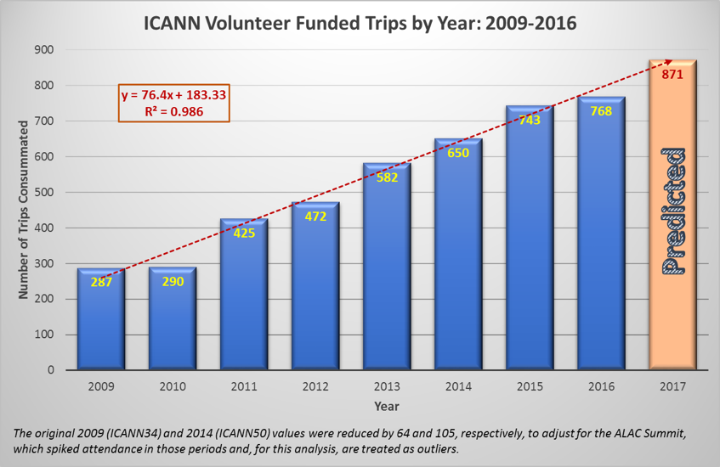

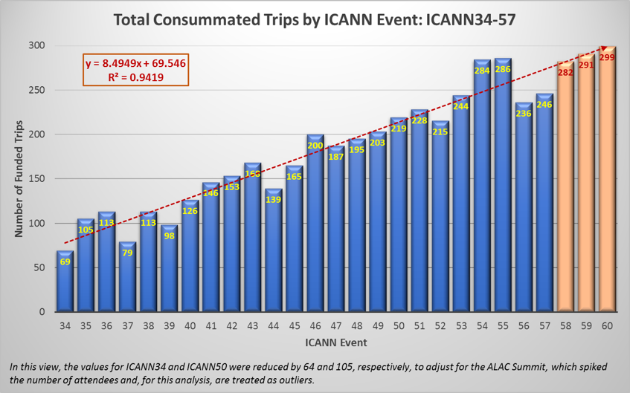
As part of delivering these contributions, the ICANN organization recognizes the significant value provided to its mission and work by community leaders and contributing participants at ICANN Public Meetings. Likewise, the ICANN organization recognizes that individual community requests to increase permanent travel support levels at ICANN Public Meetings are important and strategic, requiring consideration as part of the overall Operating Plan and Budget.

As the community grows, we need to examine whether the current ICANN Community Travel Support Guidelines are still fit for purpose. For example, over the past few years, several communities have experimented with increased levels of funding through the Additional Budget Request process. In a number of those cases, increased travel support was later incorporated into the Operating Plan and Budget.

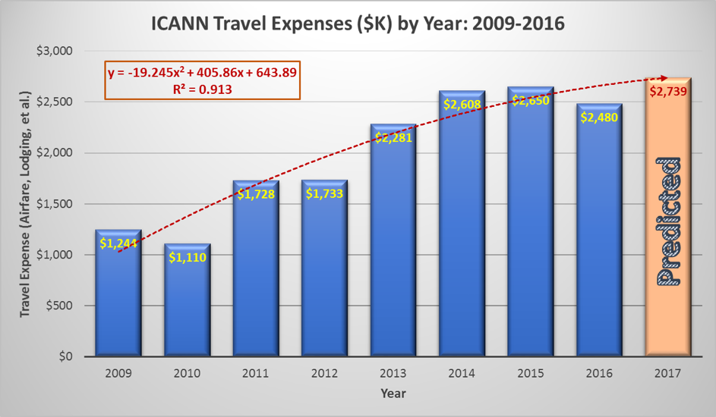

These experiences and growing demand have revealed that the guidelines for community travel support are no longer comprehensive and need updating. The ICANN Community Travel Support Guidelines were last updated in 2013 for fiscal year 2014 and published on the Community Travel Support page. In the spirit of greater accountability and transparency, the ICANN organization seeks to begin strategic conversations with the community about travel support and community resources.

The long-term sustainability of community travel support requires strategic consideration by the entire community. As part of these strategic conversations, the ICANN organization is initiating a community consultation to examine and assess the best approach to review the purpose, value, and resources needed to continue supporting the community in its deliberations at ICANN Public Meetings. Through this process, the ICANN organization will collect feedback and views from the Supporting Organizations and Advisory Committees and their constituent groups. This information will guide resource planning for future Operating Plans and Budgets.

Proposed Consultation Plan and Timeline

As a first step, Patrick Jones and Carlos Reyes from the Global Stakeholder Engagement and Policy Development Support teams, respectively, have drafted a questionnaire to begin the community consultation. Patrick and Carlos are available to speak with community groups about the current ICANN Community Travel consultation and the questionnaire. This questionnaire explores community travel support at a high-level.

The answers to these questions will inform more targeted engagements in the near future. Potential engagements may include a focus group at ICANN60 and a public comment proceeding on the current ICANN Community Travel Support Guidelines. Patrick and Carlos will build on feedback from these engagements and the questionnaire to revise the current ICANN Community Travel Support Guidelines, consulting with relevant ICANN organization departments and community groups as necessary. The goal is to have draft guidelines by the end of 2017.

Patrick and Carlos will then share the draft guidelines in January 2018 with all community groups for initial feedback. Patrick and Carlos will capture this initial input and update the draft guidelines as necessary. The draft guidelines will then be posted for public comment in February 2018 following the standard 40-day (minimum) process.

Once all feedback is received from the community groups and the public comment proceeding, Patrick and Carlos will prepare the final draft of the new ICANN Community Travel Support Guidelines in coordination with the relevant ICANN organization departments and recommend a target implementation date. Patrick and Carlos will brief all community groups on the updated ICANN Community Travel Support Guidelines and the target implementation date through a webinar and at ICANN61 in March 2018 if requested.

After ICANN61, Patrick and Carlos will work with the relevant ICANN organization department to prepare for implementation of the updated ICANN Community Travel Support Guidelines.

On behalf of the GNSO Council, we wish to thank ICANN for the opportunity to comment on the community travel support guidelines.

We understand the questionnaire is the first step of an overall review of ICANN’s Travel Support Guidelines as the ICANN organization seeks to begin strategic conversations with the community about travel support and community resources.

The Council agrees that the long-term sustainability of community travel support requires strategic consideration by the entire community and to that end we support community-wide consultation to examine and assess the best approach to review the purpose, value, and resources needed to continue supporting the community in its deliberations at ICANN Public Meetings.

Questionnaire

We have responded to your questions, in line, below.

- What guidelines does your group have for supported travelers? How do these differ from the ICANN Community Travel Support Guidelines?

Each stakeholder group and constituency of the GNSO has their own methodology for assigning travel support slots to their members, however most groups would provide partial or full support to GNSO Council members from their allocation in order to effectively progress the work of the GNSO.

The Chair of the GNSO Council receives travel support directly from the Council.

The GNSO Council recently received funding to trial a pilot program that would enable PDP WG Chairs or PDP WG leadership team members to be considered for travel support. Up to 4 slots are available per meeting. This is a competitive selection process in that interested recipients make a request to their WG Chairs who in turn make recommendations to the GNSO Council Leadership.

The GNSO Council will hold a three-day Strategic Planning Session in January 2018. All GNSO Council members will be eligible to have their airfare and accommodation costs covered and can receive a daily stipend. All travelers will be required to arrange their travel etc. in accordance with ICANN’s Travel Guidelines.

- What aspect of the current ICANN Community Travel Support Guidelines work well for your group?

Being able to get travel support, be that flights and or accommodation, helps to offset the time and commitment made by volunteers who may not have a direct commercial interest of benefit in policy development and levels the playing field. Community volunteers from smaller organisations might not be able to actively contribute to ICANN processes without assistance, which may bring into question the legitimacy of the multistakeholder model.

- What specific area of the ICANN Community Travel Support Guidelines affect your group the most?

The deadlines for submitting lists of travelers can be challenging, for example the deadline for Puerto Rico will make selection of travel recipients under the PDP WG Pilot challenging because the PDP WGs will not be in a good position to understand their requirements for a meeting in March until much closer to the date. That aside, it is acknowledged that given the large number of travel recipients these deadlines are important for administrative and processing purposes.

Another important area is visa support. While it is a responsibility of a sponsored traveller to obtain a visa, ICANN and its travel agents handle supporting documentation which is necessary for the visa applications. Some of our community members require visas to go to almost every ICANN meeting. We would like to thank ICANN for a significant improvement in issuing itineraries, hotel confirmation and visa invitation letters in a timely manner, and we would like to ask that these efforts be sustained. Furthermore, it would be helpful to provide travel itineraries that do not require sponsored travellers to obtain additional transit visas.

- What area might be added to the ICANN Community Travel Support Guidelines to provide additional support to your group?

Our participants travel frequently and have many professional and personal obligations outside of ICANN. They need to be able to work on the day of arrival in a city.
Providing slightly more flexibility and reasonable accommodations within the travel support policy would help alleviate some of the concerns and issues raised by participants.

The visa reimbursement guidelines might require more consideration. The current limit for the visa costs reimbursement is 200 USD. However, for some of the sponsored travellers, the costs of obtaining visa is higher, especially for those who live in more rural areas and have to travel to the embassy or visa centers to a big city across the country. Sometimes there is no embassy or visa centre, and to obtain a visa one has to fly abroad. In this case, the money spent on travel to get a visa could be higher than the costs of the visa itself, and definitely higher than the current reimbursement threshold. We believe that travel support guidelines might be amended to consider possible remedies for this kind of situations.

- How does your group allocate its community travel support slots? How are members prioritized? How are newcomers to ICANN considered?

The GNSO Council members, as previously noted, generally receive travel funding from their respective stakeholder groups and constituencies. However there is funding provided directly by Council to assist with the onboarding and upskilling of new Councillors. In January 2018, for example, Council is availing of travel support to hold a 3 day strategic planning meeting in the ICANN offices in Los Angeles.

- What, if any, educational and informational activities does your group conduct to inform participants of ICANN community resources?

The GNSO Council is provided support by the ICANN Policy team who work with Councillors and leaders of the various working groups to prepare information for the broader ICANN community.

- What are actionable and measurable expectations your group or leadership has for members who receive travel support? Are there follow-up reporting requirements for members who attend ICANN Public Meetings and/or receive Community Regional Outreach Program (CROP) funding?

GNSO Councillors in receipt of travel funding from their respective groups are expected to participate fully in all Council activities and to liaise with their groups. There are no formal reporting requirements.

Recipients of the PDP WG pilot are expected to be actively involved in their respective PDP WG meetings and lead some of these efforts.

- Instead of reimbursement for travel-related expenses, would your members prefer to receive a stipend or per diem from the ICANN organization?

The members of our community would like to continue to receive per diem, as they do in accordance with the current travel guidelines. Managing expenses while attending meetings would be a massive burden on ICANN’s resources, whereas with the per diem system the daily rates are fixed.

- Are there categories of travel and events that you are not presently able to support?

Currently all GNSO councillors are able to attend the ICANN meetings as supported travellers. If there are events and travel that our respective stakeholder groups and constituencies cannot cover or support, we hope this would be reflected in their feedback to this questionnaire.

- How does your group plan for upcoming events? What is your planning cycle for deciding on whether ICANN community or organization resources might be used?

The GNSO Council works closely with ICANN Staff and the broader community throughout the year on planning our activities. As previously mentioned we will be holding a face to face meeting in early 2018 to conduct deeper strategic planning for the year.

You are welcome to append any general comments on the community resource consultation.

While we appreciate the importance of active participants being able to attend meetings in person the number of supported travellers has mushroomed over the last couple of years, whereas the number of active participants has not. There is a need for effective measurements for active participation to maximise the return of investment and to properly retain active volunteers participating in policy activities.

What ROI is there with each supported traveller? While measuring ROI and creating KPIs may not be simple the amount of money being spent is such that there needs to be a measurable benefit.

.

