Update on the Internationalized Domain Name (IDN) Program for GNSO
ICANN 63, Barcelona
12 October 2018

There are multiple ongoing projects under the IDN Program at ICANN. Some of the relevant work and its status is summarized below. You are also encouraged to participate in the IDN Program Update session at ICANN63 for additional details.

IDN Top-Level Domain (TLD) Program
IDN TLD program includes the following projects: (i) Root Zone Label Generation Rules (RZ-LGR) Development, (ii) LGR Toolset Development, and (iii) IDN Variant TLD Implementation. Maximal Starting Repertoire (MSR) is the starting point for developing Root Zone Label Generation Rules (RZ-LGR). Third version of MSR has been published after public comment, which covers 28 scripts. The community has organized into various Generation Panels (GPs) for the different scripts and actively involved in developing the rules for determining valid and unique labels for the top-level domains using the MSR. These rules are called the Root Zone Label Generation Rules (RZ-LGR). The status of the work by GPs is summarized in the infographic below. A total of 18 GPs have already finalized and published their RZ-LGR proposals.
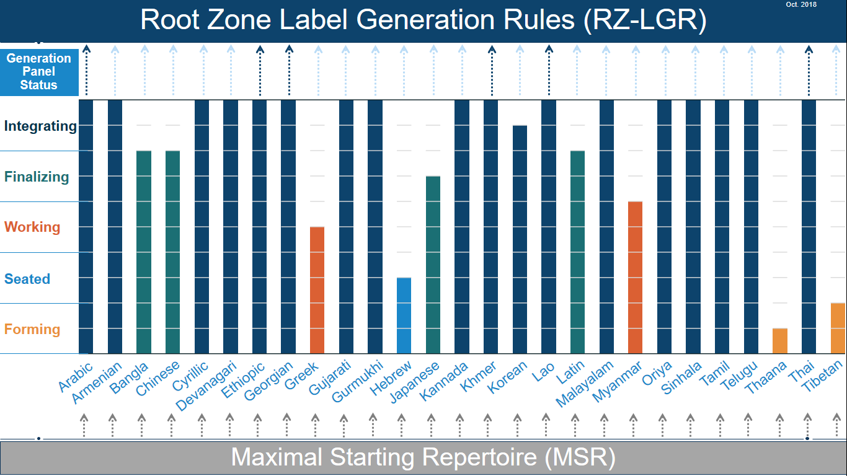
The third release of LGR Toolset has been deployed after testing. In addition to the existing functions to create, use and manage LGRs, this version allows to harmonize variant sets across multiple LGRs and supports MSR-3 and all Unicode versions till 10.0. The LGR tool is available online and also released as open source for the community to use. A detailed user guide for the tool has also been published.
To allow for variant labels for the IDN TLDs, multiple reports covering recommendations and their analysis for the implementation of IDN Variant TLDs were released for public comment. The feedback from the community is being synthesized. These reports will be updated based on the input from the community and presented to the ICANN Board for further consideration during ICANN64 in Kobe, Japan.

IDN Implementation Guidelines
IDN Guidelines are for the second level IDN registration policies and practices, designed to address end-user confusion. These are contractually binding for the gTLD registries and registrars offering IDNs at the second level. The Guidelines were last updated in 2011. At ICANN 50, the GNSO community asked to update these Guidelines to incorporate the IDN development since 2011. A working group was formed, which finalized and published version 4.0 of IDN Guidelines in May 2018. ICANN org is currently analyzing the requirements on gTLD registries and registrars put by these guidelines and aims to present them to the ICANN Board in January 2019 for approval.

Communication and Outreach
IDN Program has been regularly reaching out to the community to update it on the progress being made and to involve them in the IDN Program work. IDN program undertook the following direct outreach since ICANN 61: (i) Neo-Brahmi GP F2F meeting, April 2018, India, (ii) Myanmar GP kick off meeting, June 2018, Myanmar (iii) Neo-Brahmi GP F2F meeting for Bangla script, July 2018, Bangladesh, (iv) Africa DNS Forum, July 2018, Cotonou Benin, (v) APTLD74, September, Uzbekistan, (vi) Latin GP F2F meeting, October 2018, Belgium (vii) ICANN - WATRA - ITU Workshop, October 2018, Burkina Faso.
In addition, the IDN Program continues to hold update sessions at ICANN meetings and publish its activities at IDN web pages at icann.org/idn. For queries about IDN Program, email to IDNProgram@icann.org.

