Governmental Advisory Committee

24 June 2015

Lise Fuhr
Jonathan Robinson
Co-Chairs
CWG-Stewardship

Dear Lise and Jonathan

I am writing to advise you that the GAC has adopted the following position with regard to the CWG-Stewardship Final Proposal.

The GAC takes note of the CWG-Stewardship Final Proposal, and states support for its submission to the ICG, without prejudice to comments made publicly by individual delegations.

The GAC notes and recognizes the provisions of paragraph 106 of the CWG Final Proposal which states that the CWG-Stewardship proposal is significantly dependent and expressly conditioned on the implementation of ICANN-level accountability mechanisms by the Cross Community Working Group on Enhancing ICANN Accountability (CCWG-Accountability). If any element of these ICANN level accountability mechanisms is not implemented as contemplated by the CWG-Stewardship proposal, this CWG-Stewardship proposal will require revision.

The final CCWG proposal will be assessed on its own merits by the GAC and considered by GAC as a Chartering Organisation.

The GAC wishes to express its sincere appreciation of the diligent and productive work performed by the CWG-Stewardship, its Co-Chairs, its members and all its contributors.

Best regards,

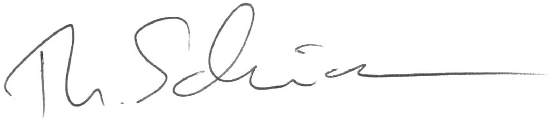

Mr Thomas Schneider
Chair, Governmental Advisory Committee

