SERVICE LEVEL EXPECTATIONS FOR IANA ROOT ZONE MANAGEMENT
Current and Post Transition.

Background

The Service Level Expectation (SLE) Design Team group is comprised of 3 gTLD Registry representatives and 3 ccTLD Representatives. We have been in contact with ICANN staff and they have been helpful where permitted.

The Design Team was asked review the current IANA root management operations, to record where ICANN is performing well and identify any gaps and issues that it considered in need of further clarification, these carry a “?” notation.

Due to the non-disclosure requirement placed upon ICANN by NTIA, we are able to receive answers to specific questions to ICANN once NTIA have given their approval. So the intent is to discuss this document in the CWG in Istanbul, identify and collect specific questions that the community would welcome being answered and present those question all together and obtain the appropriate concession so ICANN can address these questions.

In the interim period, the SLE Group conducted historical analysis based on two factors. The first was an analysis of the current Service Level Agreement that NTIA has with IANA and the second was to undertake analysis of real world transaction activity. The source of this second data set was based on two categories: published IANA performance reports, and transaction logs provided by ccTLD registries interacting with the IANA root management function.

The historical analysis used to determine actual transaction times resulted in the SLE Group analysing data from September 2013 to January 2015 which provided approximately 565 total data points – only 27 transactions took longer than 9 days and 13 took longer than 12 days. It should also be highlighted that some/much of the delay is as a result of the Registry not responding to IANA to authorise the change request – so the delay is not necessarily within IANA's control. 4 transactions took longer than 1 year and that is not necessarily a bad thing if the stability of the DNS is assured.

For efficient service delivery the following is intended to assist our discussions, identify where more work and information is needed and assist Registry operators be assured of efficient and predictable IANA service.

Regarding Escalations: The Design Team endorses the concept of an IANA Customer Group specifically to monitor and also to fulfil escalation path for breach of service expectations. The role and remit of the CSC is outside of DT-A’s remit, so the escalation path described in this document is rudimentary and designed to support Registry operations. We hand over to our CWG colleagues to better describe the recommended escalation path.

Capturing the current status quo for IANA Root Zone Management
Introduction
Service Level Expectations (SLEs) for a registry are normally based on specific transactions sent by a client to the registry. The metric for that transaction is generally of the form of “Transaction A must complete within X period Y percent of the time measured over Z”, for example, “a root zone update must complete within 72 hours 95% of the time measured on a monthly basis”. These SLE metrics are based on the following current assumptions:
- The current process is simplified to five key stages for all change requests (notification is implicit in each stage):
- Confirm the details of the change;
- Verify the change complies with documented technical standards and policies and all applicable checks pass;
- Obtain authorization to proceed with the change;
- Implement the change
- Notify the change requester of completion of the change.
- Root Zone Management processes for routine change requests are largely automated. This automation includes:
- A web based interface for submitting change requests to the IANA Function Operator (IFO). The web based interface authenticates the credentials presented by the change requester and facilitates the creation of root zone file and root zone database change requests.
- Near-real time confirmation email to the initiator of the change request of its safe receipt by the IANA system.
- Automated technical checks conducted by the IANA system on the change request. Once compliance with documented technical requirements is verified, an email is sent to both the admin and technical contacts at the Registry for both parties to validate the update. (Note: Some contacts are slow to respond which creates inefficiency in the validation process)
- Change requests being documented in a template for NTIA review – shown in red shading below (12 to 18 on the flow chart – to be removed for post transition).
- The verified change request is transmitted to NTIA for authorization. For changes that impact the root zone file, the change request is also transmitted to the Root Zone Maintainer (RZM). This is performed via online APIs – shown in red shading below (12 to 18 on the flow chart - now removed for post transition).
- Once confirmed, notification is sent by NTIA to IANA, and for changes that impact the root zone file, to the RZM authorising the change request for implementation.– shown in red below (12 to 18 on the flow chart - now removed for post transition).
- Prior to implementation, the RZM repeats automated technical compliance checks on the request and once verified, implements the change within the root zone file. This file is typically published twice daily.
- On publication of updates to the root zone file, RZM notifies IANA, who verifies the changes match the requested changes, and notifies the Registry.

- The processing role previously undertaken by the NTIA no longer exists and those steps are no longer undertaken. This means that IANA communicates directly with the RZM and not through the NTIA.

D. IANA’s online systems operate 24x7 365 days a year, except for maintenance periods, as befits a service that has customers in every time zone.

E. A change request that fails checks must be resubmitted rather than any changes made to the request by IANA to correct the detected failures. If the requestor is allowed to correct a request then that counts as a new request for SLE compliance purposes.

The fields in the following tables are as follows:

- Service Definition and Availability
- Credential Verification
- Process. The business process that IANA is requested to perform.
- Metric. The individual metric that will be measured as part of the completion of the business process.
- Target. The specified target for each individual change request.
- Type. Whether the target specified is a minimum target (compliance must be less than the target) or a maximum target (compliance must not be more than the target).
- Escalation Path
- Breach. The percentage limit of change requests within the specified period that fail to meet the metric, which if reached is deemed a breach in the SLE.
- Continuous Improvement
- Period. The period over which SLE compliance is measured.
Initially we wish to ensure the process has been correctly identified – please see the table below.
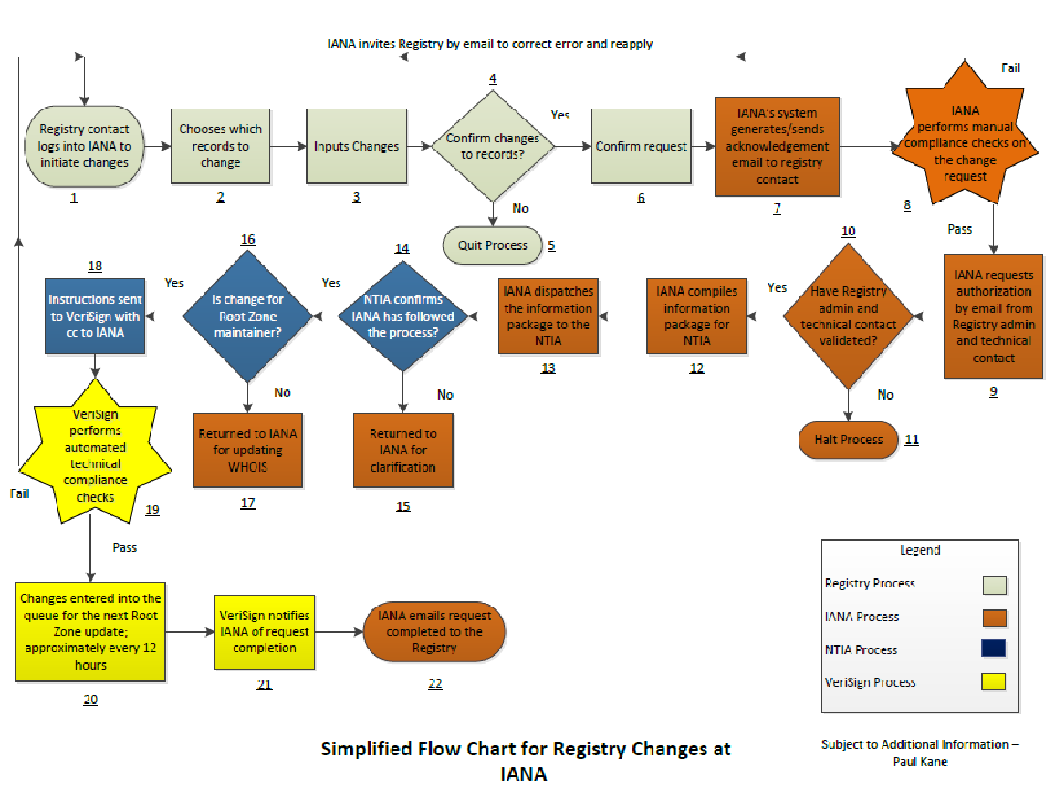
Online Services — Definition and Availability
Availability is calculated and reported over a month.
Service Area | # | Service | Availability
Root Database (Register of TLDs) | 1a | Online web publication of the authoritative database of TLDs | 99.9%
 | 1b | An online interactive web service for credentialed customers to submit change requests to their root zone database entries | 99.0%
 | 1c | A service to accept new customers and allow them to populate a new entry | 95.0%
 | 1d | A service to remove the entry of a departing customer | 95.0%
 | 1x | Online publication of the complete root zone file for download | ?
Root Zone³ | 2a | A service for customers to make changes to their zone data | 99.9%
 | 2b | A service to allow new customers to populate new zone data | 95.0%
 | 2c | A service to remove the zone data of a departing customer | 95.0%
IDN Table Repository | 3a | Online web publication of the repository of IDN tables | 99.9%
 | 3b | A service for customers to make changes to their IDN tables | 99.0%
 | 3c | A service for new customers to populate new IDN tables | 95.0%
 | 3d | A service to remove the IDN tables of a departing customer | 95.0%
RDAP Bootstrap Service | 4a | Publication of the RDAP endpoints | 100%
 | 4b | A service for customers to make changes to their RDAP endpoint | 99.9%
 | 4c | A service for new customers to populate a new RDAP endpoint | 95.0%
 | 4d | A service to remove the RDAP endpoint of a departing custome | 95.0%

Credential Verification
Process | Metric | Design Team A Target | Type | Breach | Period
Two factor authentication of login | Time to receive email or SMS text of unique code for secondary verification. | <60s | max | 100% | day
Issuance of new username or password | Time to dispatch confirmation email of forgotten username | 5m | max | 95% | month
 | Time to dispatch confirmation email with link to change the password | 5m | max | 95% | month
 | Time to implement new password within the system | 5m | max | 95% | month

Process Performance
Process | Metric | Design Team A Proposal  (6) | Type  (7) | Breach  (8)
Changes to NS records for existing TLD | Time for automated email confirmation requests to be sent to authorising contacts following receipt of change request via the automated submission interface | 30 minutes | Max | <95%¹
 | Time to complete manual technical compliance checks and dispatch validation email to Admin and Tech contacts | 2 hours | Max | <95%¹
 | Time to pass change to the root zone maintainer following completion of satisfactory technical checks | 4 hours | max | <95%¹
 | Time for the RZM to undertake technical compliance checks and place in the queue for the next Root Zone generation | 12 hours | max | <95%¹
 | Time to notify the Registry that the change request has been completed | 2 hours | max | <95%¹
Changes to DS records for existing TLD | Time for confirmation requests to be sent to authorising contacts following receipt of change request | 30 minutes | Max | <95%¹
 | Time to complete technical compliance checks and dispatch validation email to Admin and Tech contacts | 2 hours | Max | <95%¹
 | Time to pass change to the root zone maintainer following completion of satisfactory technical checks | 4 hours | max | <95%¹
 | Time for the RZM to process the request and place it in the queue for the next Root Zone generation cycle | 12 hours | max | <95%¹
 | Time to notify the registry that the request has been completed | 2 hours | max | <95%¹
Change to technical authorisation contact | Time to implement change – this is a new feature. | 30 minutes | max | <95%¹
Updating WHOIS Records | Time for automated email confirmation requests to be sent to authorising contacts following receipt of change request via the automated submission interface | 2 hours | max | <95%¹
 | Time to receive from the Registry contact(s) validation of compliant update request (Validation email) | ???
 | Time for IANA to complete the change to the root zone database following a change request meeting the validation criteria | 2 hours | max | <95%¹
 | Time to notify the requester that the change request has been completed following implementing of a change to the root zone database. | 2 hours | max | <95%¹
Change to root DB that is not a re-delegation | Time for confirmation requests to be sent to authorising contacts following receipt of change request | 30 minutes | max | <95%¹
 | Time to check that  - request is not a stealth re-delegation  - specified organisation exists (if changed) | 2 weeks | max | <95%
 | Time to implement once satisfied this is not a stealth re-delegation | 4 hours | max | <95%
Non-hostile re-assignment/re-delegation of a ccTLD | Time for confirmation requests and notifications to be sent out to affected parties. | 5 days | max | <75%
 | Time for staff to make determination whether request can proceed | 110 days | max | <75%
 | Time to implement re-delegation by changing root DB | 5 days | max | <75%
 | Time to receive independent confirmation that existing domain registration data has been ported to new ccTLD registry operator | 7 days | max | <95%¹
 | RZM receives and automatically checks the request for technical compliance | 12 hours | max | <95%¹
 | Technical compliance checks approved by RZM and notifies IANA | 2 hours | max | <95%¹
 | RZM places transfer data to Root Zone Generation queue | 2 hours | max | <95%¹
 | Time to notify both the old and new registries that the request has been completed | 2 hours | max | <95%¹
Hostile re-delegation of a ccTLD | ??
Delegation of a new TLD | Time to request administrative and technical details for root DB and root zone | 2 days | max | <85%
 | Time to check details once provided | 10 days | max | <85%
 | Time to send root zone data for new TLD to root zone maintainer | 2 days | max | <85%
Re-delegation of a gTLD | Time for confirmation requests and notifications to be sent out to affected parties. | 2 days | max | <85%
 | Time to confirm re-delegation can proceed | 25 days | max | <85%
 | Time to implement re-delegation by changing root DB | 3 days | max | <85%
Change to IDN tables | Time for confirmation requests to be sent to authorising contacts following receipt of change request | 1 day | Max | <95%
 | Time to complete technical checks | 10 days | Max | <95%
 | Time to notify initiator following completion of authorisation process (Validation Email) | 2 hours | max | <95%¹
 | Time for IANA to complete the change | 10 days | Max | <95%
 | Time to notify the Registry that the change request has been completed | 2 hours | max | <95%¹
All measurement periods are monthly
¹Except during maintenance periods

Process Correctness
Process | Metric | Design Team A Proposal | Type | Breach
Changes to NS records for existing TLD | Accuracy of data as sent to RZM compared to that specified in change request | 100% | min | <100%
 | Number of NS changes sent to RZM that have not been through all the technical checks | 0% | max | >0%
 | Number of NS changes sent to RZM that fail any technical check | 0% | max | <100%
Changes to DS records for existing TLD | Accuracy of data as sent to RZM compared to that specified in change request | 100% | min | <100%
 | Number of DS changes sent to RZM that have not been through all the technical checks | 0% | max | >0%
 | Number of DS changes sent to RZM that fail any technical check | 0% | max | <100%
Change to authorising contact | Accuracy of data as sent to RZM compared to that specified in change request | 100% | min | <100%
Change to root DB that is not a re-delegation | Accuracy of data as entered into root DB compared to that specified in change request | 100% | min | <100%
 | Number of stealth re-delegations | 0% | max | >0%
 | Specified organisations exist | 100% | min | <100%
 | Specified contact details are genuine | 100% | min | <90%
Non-hostile re-assignment/re-delegation of a ccTLD | Affected parties identified | 100% | min | <100%
 | Views of the affected parties accurately recorded and represented | 100% | min | <100%
 | Independent confirmation received that existing domain registration data has been ported to new ccTLD registry operator | 100% | min | <100%
 | Accuracy of data ported to new ccTLD registry operator | 100% | min | <100%
 | Accuracy of data as entered into root DB compared to that specified in change request | 100% | min | <100%
Hostile re-assignment/re-delegation of a ccTLD | ???
Re-delegation of a gTLD | Affected parties identified | 100% | min | <100%
 | Views of the affected parties accurately recorded and represented | 100% | min | <100%
 | Independent confirmation received that existing domain registration data has been ported to new ccTLD registry operator | 100% | min | <100%
 | Accuracy of data ported to new ccTLD registry operator | 100% | min | <100%
 | Accuracy of data as entered into root DB compared to that specified in change request | 100% | min | <100%
Delegation of a new TLD | ???

Process Reporting
IANA is required to provide the following reporting mechanisms:
Public:
- Dashboard. Real-time dashboard of
  - process volumes;
  - current SLE metrics;
  - alerts of breaches or near misses.
- SLE report. The formal report detailing
  - performance against metrics;
  - notification of breaches;
  - explanations of any breaches.
- Request database. This data is of sufficient detail to verify the metric calculations use for the SLE report. It contains details of
  - every request made (that is accepted as a genuine request);
  - what stage in the process it is;
  - timestamps of key points in the request lifecycle;
  - what policies apply in the processing of the request;
  - the results of the request.
Private viewing to update the requesting TLD of progress:
- Status tracker. Showing
  - every request made for the TLD;
  - the current status;
  - timestamps of key events;
  - what action, if any, the TLD is required to do to move it to the next step.
Process | Metric | Design Team A Target | Type | Breach | Period
Dashboard | Update frequency | 30 mins | max | >30 mins | Month
 | Correctness | 100% | min | <100% | Month
 | Availability | 99%¹ | min | <99% | Month
SLE reports | Production frequency | Monthly |  |  | -
 | Published on web site | <10 days after month end | max | >10 days | Month
 | Notification of publication (delivery to contracted parties) | <2 hours after publish | max | >2 hours | Month
 | Availability | 99%¹ | min | <99% | Month
Request database | Update frequency | Daily |  |  | -
 | Correctness | 100% | min | <100% | Month
 | Availability | 99%¹ | min | <99% | Month
Status tracker | Update frequency | 30 mins | max | >30 mins | Month
 | Correctness | 100% | min | <100% | Month
 | Availability | 99%¹ | min | <99% | Month
Ad-hoc requests | Acknowledgement of receipt | 1 hour | max | <100% | Month
 | Initial response to Urgent priority requests | 2 hours | max | <90% | Month
 | Full response to Urgent priority requests | 12 hours | max | <90% | Month
 | Initial response to High priority requests | 8 hours | max | <95% | Month
 | Full response to High priority requests | 48 hours | max | <95% | Month
 | Initial response to Normal priority requests | 5 days | max | <95% | Month
 | Full response to Normal priority requests | 15 days | max | <95% | Month

Escalation Path
Level | Contact | Method | Response Time | Expectation
1 | IANA Help Desk | Email/Telephone | 4 Hours (working hours) | Response/Resolution
2 | IANA General Manager | Email/Telephone | Within 24 Hours | Resolution
3 | Registry Representative on Customer Service Committee (CSC) | Email/Telephone |  | Log of incident and Resolution
We hand further escalation over to the CSC/Escalation DT for their input.

Breaches (We are struggling with penalties. If they are financial penalties how to financially qualify a breach and who pays? – Discussion by CWG members)
Priority | Definition | Remediation

Continuous Improvement (this is a placeholder – we need to ensure continuous improvements as part of SLE, so once again the guidance of the CWG is welcome).
Process | Previous SLE | New SLE

Notes
General:
Days are not working days but contiguous days. This reflects the 24x7 nature of IANA.

Specific:
¹ Except during maintenance periods.

² This assumes that there is a separate SLE for the RZM that addresses the issue of security and stability of the root zone by limiting the number of zone updates that can be pushed to the root servers in a single day.

³ This is an end-to-end service that includes delivery of the changes to the RZM.

APPENDIX A

CHART A
Delegation and Re-delegations for Country-Code TLDs
TLD | Request received | Request validated | Request dispatched | Request completed |  | Days to Validate | Days to Dispatch | Days To complete | End-to-End
Ø§ÛŒØ±Ø§Ù†** | 7/8/2013 | 9/18/2013 | 10/5/2013 | 10/9/2013 |  | 72 | 17 | 4 | 93
zm | 7/9/2013 | 7/30/2013 | 4/4/2014 | 4/4/2014 |  | 21 | 248 | 0 | 269
vg | 10/11/2013 | 4/8/2014 | 4/9/2014 | 4/10/2014 |  | 179 | 1 | 1 | 181
gw | 1/23/2014 | 2/25/2014 | 7/9/2014 | 7/10/2014 |  | 33 | 134 | 1 | 168
mk | 4/10/2014 | 4/23/2014 | 10/22/2014 | 10/22/2014 |  | 13 | 182 | 0 | 195
Ð¼ÐºÐ´** | 4/10/2014 | 4/23/2014 | 10/22/2014 | 10/22/2014 |  | 13 | 182 | 0 | 195
áƒ’áƒ”** | 7/22/2014 | 8/5/2014 | 10/22/2014 | 10/24/2014 |  | 14 | 78 | 2 | 94
*Data acquired from IANA published matrices.
** During automated data acquisition from IANA website, native language did not convert.
BASED UPON CHART A
Request Validated – Fastest time – 13 days
Request Dispatched – Fastest time – 1 days
Request Completed – Fastest time – 0 days
Theoretical End-to-End (fastest) – 14 days
Actual Fastest End-to-End – 94 days

APPENDIX B

CHART B
Delegation/Re-Delegation of gTLDs
 | Average Number of Days | Minimum Number of Days | Maximum Number of Days
Days to Validate | 2.932 | 0 | 32 | Includes time for gTLD to respond to validation email.
Days to Dispatch | 3.255 | 0 | 13 | Time for IANA to dispatch to NTIA
Days To complete | 4.9519 | 0 | 15 | Time is from Validation email to confirmation.

