Escalation Mechanisms (DT M)

The CWG recommends requiring the continuation, with minor modifications, of a progressive set of escalation steps that can be performed for Emergency situations as well as Customer Service Complaints and a new Problem Management Process for Critical, Persistent or Systemic Failures, as applicable, for individual TLD registry operators, or others with relevant IANA functions operational issues. Three processes are recommended:
- Root Zone Emergency Process
This process is for TLD managers in cases where expedited handling is required and is essentially the same as the process currently used by ICANN.
- Customer Service Complaint Resolution Process
This process is for anyone who has a complaint about IANA services. It is modified somewhat from the current process used by ICANN with some added steps at the end.
- Problem Management Escalation Process
This is a new process for critical, persistent or systemic failures of IANA services.

The details of these processes, including proposed modifications to the existing processes to reflect the transition, can be found in Annexes X (Root Zone Emergency Process), Y (Customer Service Complaint Resolution Process) and Z (Problem Management Escalation Process).
Annex X- Root Zone Emergency Process

As well as general staff availability during standard business hours, ICANN the IANA Functions Operator will continue to provide TLD managers with a 24×7 emergency contact number that allows TLD managers to quickly reach ICANN IANA Functions Operator to declare an emergency and seek to expedite a Root Zone change request. ICANN IANA Functions Operator will execute such changes in accordance with the obligations of the standard root zone management workflow as expeditiously as possible. This prioritization will include performing emergency reviews of the request as the first priority, out of ordinary business hours if necessary, and informing its contacts at NTIA and Verisign the Root Zone Maintainer of any pending changes that will require priority authorization and implementation.

Figure 1.2-41. 24x7 Emergency Process

[Note, terminology will need to be updated to ensure consistency, i.e. IANA Root Zone Operator, Root Zone Maintainer]
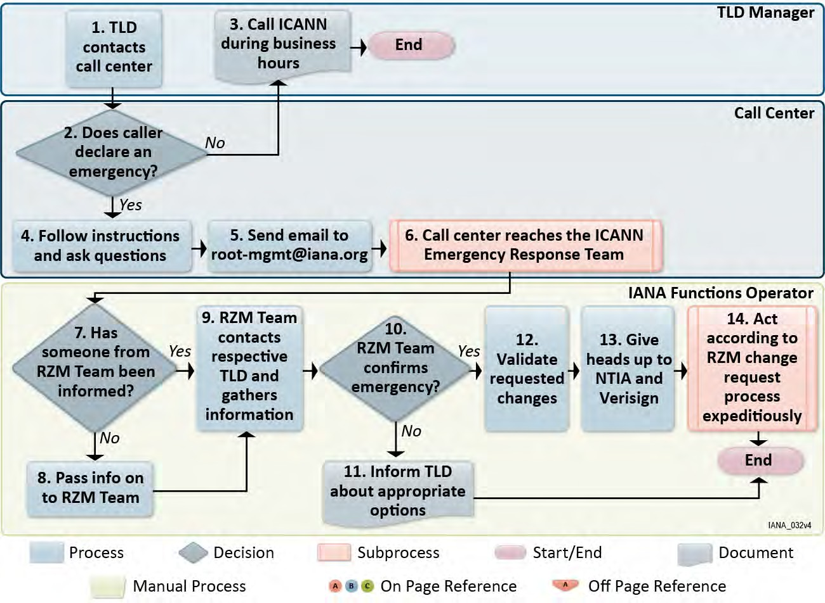

Figure 1.2-42. 24x7 Emergency Process Step-by-Step Description

[Note, terminology will need to be updated to ensure consistency, i.e. IANA Root Zone Operator, Root Zone Maintainer]

1 TLD CONTACTS CALL CENTER
Description | All TLD managers are provided with an emergency contact telephone number that will reach a 24x7 call center.
2 | DOES CALLER DECLARE AN EMERGENCY?
Description | The caller is asked if the issue is an emergency that requires an urgent root zone change, and can not wait until regular business hours.
3 | CALL ICANN DURING BUSINESS HOURS
Description | In the event the caller decides it is not an emergency, their contact details are logged and they are advised to speak to ICANN’s IANA Function staff during regular business hours.
4 | FOLLOW INSTRUCTIONS AND ASK QUESTIONS
Description | Call center staff follow a set of instructions to solicit relevant information relating to the nature of the emergency, and the contact details of the TLD manager.
5 | SEND EMAIL TO ROOT-MGMT@IANA.ORG
Description | The particulars of the emergency call are sent by the call center staff to the ticketing system. This opens a ticket and starts an audit log of the specific request.
6 CALL CENTER REACHES THE ICANN EMERGENCY RESPONSE TEAM
Description | The call center has the emergency roster of ICANN’s IANA Functions staff, as well as escalation points for ICANN senior management. The call center will call through the roster until they contact a person to hand the issue to. The ICANN staff member that receives the issue will be the primary person responsible for resolution of the issue.
7 | HAS SOMEONE FROM THE ROOT ZONE MANAGEMENT (RZM) TEAM BEEN INFORMED?
Description | The primary person responsible checks if the Root Zone Management team within the ICANN’s IANA Functions staff is aware of the issue.
8 | PASS INFO ON TO RZM TEAM
Description | If necessary, information relating to the emergency request is communicated to the Root Zone Management team.
9 | RZM TEAM CONTACTS TLD MANAGER
Description | The IANA Functions staff performing the root zone management functions contact the TLD manager using the contact details provided to the call center. The nature of the issue is discussed in more detail, and a plan is devised to resolve the issue.
10 | RZM TEAM CONFIRMS EMERGENCY
Description | Following dialog with the TLD manager, the RZM team confirms the particulars of the issue and the need to perform an emergency root zone change to resolve the issue.
11 | INFORM TLD ABOUT APPROPRIATE OPTIONS
Description | In the event the TLD manager and RZM team deem that an emergency root zone change can not resolve the issue, ICANN will inform the TLD manager about what other options they have to resolve the issue.
12 | VALIDATE REQUESTED CHANGES
Description | ICANN validates the request in accordance with the standard procedures described in the Root Zone Change process, including performing technical checks and performing contact confirmations. ICANN takes steps to conduct these as quickly as possible.
13 | GIVE HEADS UP TO NTIA AND VERISIGN
Description | ICANN takes all available steps to inform personnel at NTIA and Verisign that there is an active emergency change request being conducted, and encourages NTIA and Verisign to process the request as quickly as possible.
14 | ACT ACCORDING TO ROOT ZONE CHANGE REQUEST PROCESS EXPEDITIOUSLY
Description | ICANN executes the root zone change request as quickly as possible according to all standard policies and procedures. ICANN prioritizes the rapid implementation of the request above other requests at normal priority.

Annex Y – IANA Customer Service Complaint Resolution Process

(Modified Procedure)

Refer to the existing ICANN IANA process at http://www.iana.org/help/escalation-procedure.
If anyone experiences an issue with the IANA Function Operator’s delivery of the IANA services, then it should be reported to the IANA Functions Operator as follows. This process should be used in cases where response has been too slow, where a possible mistake has been made or when there appears to have been inequitable service delivery.
Step 1 – Initial Escalation Process for IANA Naming Functions
Send an e-mail to escalation@iana.org and provide the ticket numbers of the requests where the problem arose. If the problem is not resolved, IANA staff will escalate the problem to the following team members in this order as applicable:
- IANA Function Liaison for Root Zone Management
- IANA Functions Program Manager
- ICANN Ombudsman
Efforts are made to resolve complaints as soon as possible but the structured process above allows escalation of complaints to the IANA management team. If, at any point, you are not satisfied with the resolution process you can use the IANA Functions Operator’s Ombudsman or similar process instead.

Who can use the process?
This process is open to anyone using the IANA Functions. The functions include:
- Protocol Parameters management, including the management of the .ARPA TLD
- Root Zone Management
- Root DNS Key Signing Key Management
- Internet Number Resources Allocation
- Management of the .INT TLD

What information must be provided?
In addition to providing the ticket numbers for the requests where the problem arose, any other information that may be needed to understand and resolve the complaint should be provided.

What is the expected time line?
Receipt of the complaint will be acknowledged within one business day and a substantive response will be sent within two business days. Efforts will be made to resolve complaints as soon as possible.

Is there another resolution process?
The IANA Function Operator’s Ombudsman or similar service can help resolve problems using Alternative Dispute Resolution techniques. (In the case of the current IANA Functions Operator, the ICANN Ombudsman web pages have more details.)

Escalation Contact Information for the current IANA Functions Operator (ICANN)
Role | Name | Email Address
IANA | IANA Staff | iana@iana.org
IANA Function Liaison for Technical Protocol Parameters Assignment | Michelle Cotton | michelle.cotton@icann.org
IANA Function Liaison for Root Zone Management | Kim Davies | kim.davies@icann.org
IANA Function Liaison for Internet Number Resource Allocation | Naela Sarras | Naela.sarras@icann.org
IANA Functions Program Manager | Elise Gerich | elise.gerich@icann.org
ICANN Ombudsman | Chris LaHatte | ombudsman@icann.org

In case the issue is escalated to members of the IANA team and/or to the Ombudsman or equivalent, the Customer Standing Committee (CSC) is notified for information purposes only.

Step 2

Should the issue not be resolved through the involvement of the IANA Functions Team and/or the ICANN Ombudsman, the following escalation mechanisms will be made available:
- Involve CSC to mediate
- If issue is not addressed, CSC to involve a mediator
- If issue is not addressed, CSC to consider whether issue is problem (critical, persistent or systematic failure) and escalates to problem management procedure
- If issue is not addressed and not considered to be a problem (critical, persistent or systematic failure), registry operator could decide to initiate an Independent Review Process

Annex Z – IANA Problem Management Escalation Process

(New procedure)

Problem Management (Critical, Persistent or Systemic Failures)

The Customer Standing Committee is empowered to determine a significant failure of the IANA Functions Operator either due to the outcome of periodic audits or the CSC’s evaluation of a rising number of TLD registry operator complaints.

- CSC reports significant failure to the IANA Functions Operator and requests response in a predetermined number of days.
- If CSC determines the IANA Functions Operator response to be inadequate, the CSC directs remedial action in a specified period of time.
- CSC confirms completion of remedial action.
- If remediation is unsatisfactory, CSC involves a mediator.
- If mediation fails, a binding Independent Appeals Panel is initiated.

