Privacy and Proxy Service Provider Accreditation Program Applicant Guide
Implementation Review Team Discussion Draft v2
ICANN Global Domains Division
8 September 2017

Table of Contents
Executive Summary 3
Initial Application Window 4
Program Maintenance Phase 5
Service Provider Accreditation Criteria 5
Summary: Accreditation Evaluation by Track 6
Applicant and Provider Financial Obligations 8
Application for Privacy/Proxy Service Provider Accreditation 9
Appendix A: Accreditation Process Diagram 16

Executive Summary

The ICANN organization is implementing a Privacy and Proxy Service Provider Accreditation Program pursuant to Final Policy Recommendations developed by the community Policy Development Process. These recommendations were approved by the ICANN Board of Directors in August 2016.

Privacy and proxy services provide a mechanism for entities to register and utilize domain names without listing personal contact information in the public Registration Data Directory Service (RDDS).

-A proxy service is a service through which a service provider, as a registered name holder, licenses use of a registered name to a customer in order to provide the customer use of such registered name, and the service provider’s contact information is displayed in the RDDS rather than the customer’s contact information.
-A privacy service is a service by which a registered name is registered to a customer as the registered name holder, but for which alternative, reliable contact information is provided by a service provider for display in lieu of the customer’s contact information in the RDDS.

Any entity that provides these services is considered a privacy and/or proxy service provider.

Prior to the launch of this accreditation program, the 2013 Registrar Accreditation Agreement (RAA) included a limited set of requirements for privacy and proxy service providers that registrars are required to follow and pass down to their affiliates and resellers. Once this new accreditation program is fully implemented, the interim requirements in the RAA will be replaced with the new accreditation program requirements. ICANN-accredited registrars will be prohibited from knowingly accepting registrations from privacy and proxy service providers that are not accredited by the ICANN organization. This program creates uniform requirements for privacy and proxy service providers related to (a) the relay of communications to customers from third parties; (b) abuse reporting; (c) provider terms and conditions; (d) RDDS labeling; and (e) responses to requests from law enforcement authorities and intellectual property holders.

This accreditation program is modeled after the ICANN organization’s gTLD Registrar Accreditation Program. Privacy and proxy services are frequently offered by registrars and their affiliates.

This guidebook explains the processes and criteria for provider accreditation. The accreditation program will be launched in two phases: (1) the initial application phase, followed by (2) the program maintenance phase.

On the implementation effective date (to be determined at the conclusion of the Implementation Review Team’s work), the ICANN organization will begin accepting applications from entities that are interested in becoming accredited privacy and proxy service providers during the initial application window. At the close of this phase, ICANN will announce a list of newly accredited providers. Following this announcement, the program will transition to the program maintenance period, when applications for accreditation will be received and evaluated on an ongoing basis. For additional information, please consult the ICANN website: https://www.icann.org/resources/pages/pp-services-2017-08-31-en

Initial Application Window

During the initial application window, entities wishing to become accredited privacy and proxy service providers will be permitted to apply for accreditation during a time-limited application submission period.

The ICANN organization will announce the list of newly accredited privacy and proxy service providers after all applications submitted during the initial application window have been evaluated by (a) posting a list of the providers on ICANN.org and (b) notifying all ICANN-accredited registrars of the newly accredited providers. If a particular application cannot be processed during the preliminary application window due to incomplete or incorrect answers, or due to an applicant’s failure to adequately respond to follow-up questions within the required time period, the applicant may elect to re-apply during--or defer the processing of its application to--the program maintenance phase.

A proposed schedule for the initial application window is as follows. The time required to process individual applications for accreditation is expected to be longer during the initial application window than during the continual application processing of the program maintenance phase, because increased application volume is expected during the initial application phase:

Month 0: Final accreditation program requirements, including Policy, Accreditation Agreement, and questions to be included in application for accreditation; effective date announced.

Month 3: Initial application window opens. Providers may apply for accreditation during 90-day window. As successful completion of educational program is required to proceed to accreditation during this phase Applicants are encouraged to apply as early as possible.

Month 6: Deadline for applications to be submitted during early application window. The ICANN organization continues evaluation of applications received during initial application window.

Month 9: Application processing status update (number of applications submitted, number of applications completed, estimated evaluation completion date) to be shared with community.

Month 12: Target date for the ICANN organization to announce list of first group of accredited providers. Actual date could be earlier or later, depending on processing time.

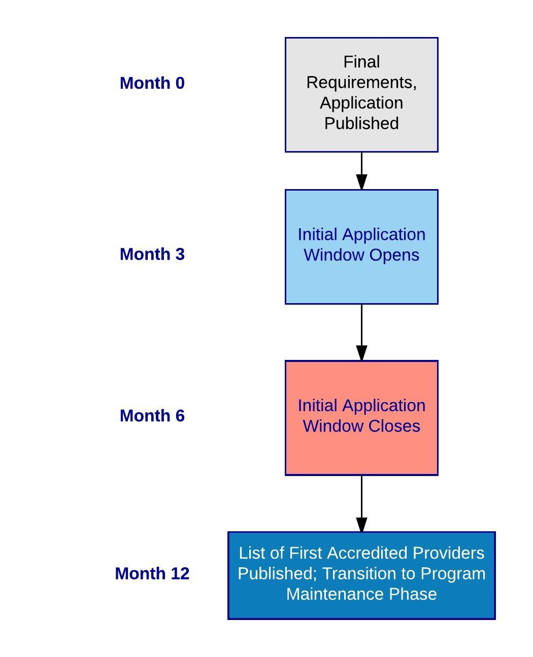

Program Maintenance Phase

Following the ICANN organization’s announcement of the list of the first group of accredited providers, the accreditation program will transition to the program maintenance phase.

The program maintenance phase will entail ongoing program management, including:
  - Continual receipt and rolling processing of applications for accreditation;
  - Privacy/proxy service provider account management and relevant services;
  - Ongoing outreach, engagement and education; and
  - Launch of the privacy and proxy service provider compliance program.

Service Provider Accreditation Criteria

The privacy/proxy service provider accreditation application process will include four tracks:

- Track 1: Applicants that are affiliated (as the term is defined in Section 1.3 of the Privacy and Proxy Service Provider Accreditation Agreement (PPAA), with an ICANN organization-accredited privacy and/or proxy service provider. The PPAA defines "affiliate" as "a person or entity that, directly or indirectly, through one or more intermediaries, Controls, is controlled by, or is under common control with, the person or entity specified.

- Track 2: Applicants that are affiliated (as the term is defined in the PPAA) with one or more ICANN organization-accredited registrars (but no other privacy and/or proxy service provider).

- Track 3: Applicants that are affiliated (as the term is defined in the PPAA) with a gTLD registry operator (but no ICANN organization-accredited registrar or privacy and/or proxy service provider).

- Track 4: Providers that have no affiliation with any other ICANN organization-contracted party.

An application process diagram is included in Appendix A.

Summary: Accreditation Evaluation by Track

The process through which an applicant meets the required accreditation criteria varies by track, as noted in the table below. The processes for meeting the accreditation criteria differ because, depending on the affiliate relationship involved, the applicant may have already demonstrated its ability to comply with the relevant requirements and may not need to be reevaluated on these criteria.

For example, an ICANN-accredited registrar will have already been evaluated for its operational and financial capacity to comply with accreditation requirements, as well as its understanding of the relevant policy and contractual obligations. As a result, it would be duplicative to require an affiliate, using the same systems with the same staff, to demonstrate these same abilities again. Though a gTLD registry operator's knowledge of the relevant contractual requirements will not have been screened, it will have already been required to demonstrate its ability to comply with technical requirements that go far beyond those needed to operate a privacy and/or proxy service.

Accreditation Criteria | Track 1: Provider Affiliate | Track 2: Registrar Affiliate | Track 3: Registry Affiliate | Track 4: No Affiliate Relationship
Satisfactory Compliance History of Affiliated Entity(ies) | Criteria Met Via Check at Time of Application | Criteria Met Via Check at Time of Application | Criteria Met Via Check at Time of Application | N/A
Applicant Has at Least One Current Employee Who Has Completed Educational Program | Criteria Met Via Check at Time of Application | Criteria Met Via Check at Time of Application | Criteria Met Via Check at Time of Application | Criteria Met Via Check at Time of Application

Satisfactory Results of Background Checks and Additional Due Diligence | Criteria Met Via Check at Time of Application* | Criteria Met Via Check at Time of Application* | Criteria Met Via Check at Time of Application* | Criteria Met Via Check at Time of Application
Demonstrated Understanding of Policy and Contractual Requirements | Criteria Met Via Demonstration That Applicant Is Affiliated With Entity That Previously Met This Criteria | Criteria Met Via Evaluation of Answers to Application Questions and Demonstration That Applicant Is Affiliated With Entity That Previously Satisfied Met This Criteria | Criteria Met Via Evaluation of Answers to Application Questions | Criteria Met Via Evaluation of Answers to Application Questions
Evidence of Adequate Capital | Criteria Met Via Demonstration That Applicant Is Affiliated With Entity That Previously Met This Criteria | Criteria Met Via Demonstration That Applicant Is Affiliated With Entity That Previously Met This Criteria | Criteria Met Via Demonstration That Applicant Is Affiliated With Entity That Previously Met This Criteria | Criteria Met Via Check at Time of Application
Tier III Datacenter Certification | Criteria Met Via Demonstration That Applicant Is Affiliated With Entity That Previously Met This Criteria | Criteria Met Via Demonstration That Applicant Is Affiliated With Entity That Previously Met This Criteria | Criteria Met Via Demonstration That Applicant Is Affiliated With Entity That Previously Met This Criteria | Criteria Met Via Check at Time of Application
Reliable and readily usable data backup and archival solution | Criteria Met Via Demonstration That Applicant Is Affiliated With Entity That Previously Met This Criteria | Criteria Met Via Check at Time of Application | Criteria Met Via Check at Time of Application | Criteria Met Via Check at Time of Application
Planning for the occurrence of security breaches, natural disasters, infrastructure and/or business failure. | Criteria Met Via Demonstration That Applicant Is Affiliated With Entity That Previously Met This Criteria | Criteria Met Via Check at Time of Application | Criteria Met Via Check at Time of Application | Criteria Met Via Check at Time of Application
* Where an applicant is affiliated with an existing contracted party, ICANN may elect not to screen entities and individuals named in an application if the same entities and/or individuals have undergone a recent ICANN background screening.

Applicant and Provider Financial Obligations

The following fee structure is proposed for this accreditation program. The proposed fees are based on the expected costs associated with evaluating applications for accreditation and providing account management services to accredited providers:

Entity | One-Time Application (USD) | Annual Accreditation (USD)
Non-Affiliated* | $3500.00 | $4000.00
Affiliated | $2000.00 | $4000.00
* not affiliated with an accredited privacy and/or proxy service provider, registrar or registry operator
**no transaction fees

Application for Privacy/Proxy Service Provider Accreditation

Applicant Instructions

This Application for privacy and proxy service provider accreditation is divided into eight sections. You may or may not have to provide substantive answers in each section, depending upon your application track.

Step 1: Identify your application track based on the criteria below and compile all necessary supporting documents to demonstrate the affiliate relationship, if one exists.

- Track 1: Applicants that are affiliated (as the term is defined in Section 1.3 of the Privacy and Proxy Service Provider Accreditation Agreement (PPAA), with an ICANN-accredited privacy and/or proxy service provider. The PPAA defines "Affiliate" as "a person or entity that, directly or indirectly, through one or more intermediaries, Controls, is controlled by, or is under common control with, the person or entity specified.
- Track 2: Applicants that are affiliated (as the term is defined in the PPAA) with one or more ICANN-accredited registrars (but no other privacy and/or proxy service provider).
- Track 3: Applicants that are affiliated (as the term is defined in the PPAA) with a gTLD registry operator (but no ICANN-accredited registrar or privacy and/or proxy service provider).
- Track 4: Providers that have no affiliation with an ICANN organization-accredited privacy and/or proxy service provider, registrar or gTLD registry operator.

If you are unsure which application track to use, please contact ICANN for assistance.

Step 2: Review the application below to determine which sections you must complete, based on your application track identified in Step 1. Compile all supporting documents needed to respond to the required questions.

Step 3: Complete the provider educational program, if required for your application track. Save the certificate of completion (you must submit this with your application).

Step 4: Complete the application sections below that are required for your application track.

Step 5: Submit your application to ICANN for evaluation.

Application Questions

Note: Sections 1-4 are required for all Application Tracks.

Section 1: General Information

1.1 Legal Name of Applicant for Privacy and Proxy Service Provider Accreditation (hereinafter, “Applicant”), including any fictitious/”DBA” names used:

1.2 Designated primary contact person for application, and Service Provider (if different):

1.3 Business address:

1.4 Jurisdiction and type of entity (e.g. California non-profit corporation):

1.5 Telephone number:

1.6 Email address:

Section 2: Affiliate Relationship(s) With Existing Contracted Party(ies)

2.1 Is the Applicant Affiliated (as the term is defined in the Privacy and Proxy Service Provider Accreditation Agreement) with an ICANN-accredited Provider(s), Registrar(s) and/or Registry Operator(s)?

2.2 If the answer to Question 2.1 is yes, please provide the following for each Affiliated entity:
              - Entity's full legal name;
              - Entity's ICANN identifier (and/or relevant gTLD, for Affiliated Registry Operators);
              - Documentation demonstrating the required Affiliate relationship, including a description and/or diagram of the corporate structure.

Section 3: Background Screening

(Note: background checks may be conducted on any or all entities and individuals identified in this section. The background check requirements may be waived, at ICANN’s discretion, for entities and/or individuals that have been screened within the last 12 months pursuant to an Affiliated entity's application for accreditation.)

3.1 If you believe that any persons or entities identified in Section 3.2 should be excluded from background screening based on the criteria above, please provide supporting information here, including information about the most recent background check(s) that have been conducted by ICANN on the person and/or entity.

3.2 Provide the full names of all owners/shareholders of the Applicant that own at least 5% of the company, as well as all directors, officers, and managers who will be involved in providing privacy/proxy services:

3.3 Within the last ten (10) years, has the Applicant or any of the people or entities listed above been convicted of any crime related to financial or corporate governance activities, or has been judged by a court to have committed fraud or breach of fiduciary duty, or has the Applicant or any of the people or entities listed above been the subject of a judicial determination that ICANN deems as the substantive equivalent of any of these? If so, identify them:

3.4 Within the last ten (10) years, has the Applicant or any of the people or entities listed above been convicted of any crime related to financial or corporate governance activities, or has been judged by a court to have committed fraud or breach of fiduciary duty, or has the Applicant or any of the people or entities listed above been the subject of a judicial determination that ICANN deems as the substantive equivalent of any of these? Is so, identify them:

3.5 Within the last ten (10) years, has the Applicant or any of the people or entities listed above been convicted of perjury, forswearing, failing to cooperate with a law enforcement investigation, or making false statements to a law enforcement agency or representative? If so, identify them:

3.6 Within the last ten (10) years, has the Applicant or any of the people or entities listed above ever been convicted of any crime involving the use of computers, telephone systems, telecommunications or the Internet to facilitate the commission of crimes? If so, identify them:

3.7 Has the Applicant or any of the people or entities listed above ever been convicted of any crime involving the use of computers, telephone systems, telecommunications or the Internet to facilitate the commission of crimes? If so, identify them:

3.8 Has the Applicant or any of the people or entities listed above ever been convicted of any crime involving the use of a weapon, force, or the threat of force? If so, identify them:

3.9 Has the Applicant or any of the people or entities listed above ever been convicted of any violent or sexual offense victimizing children, the elderly, or individuals with disabilities? If so, identify them:

3.10 Has the Applicant or any of the people or entities listed above ever been convicted of the illegal sale, manufacture, or distribution of pharmaceutical drugs, or been convicted or successfully extradited for any offense described in Article 3 of the United Nations Convention Against Illicit Traffic in Narcotic Drugs and Psychotropic Substances of 1988? If so, identify them:

3.11 Has the Applicant or any of the people or entities listed above ever been convicted or successfully extradited for any offense described in the United Nations Convention against Transnational Organized Crime (all Protocols)? If so, identify them:

3.12 Has the Applicant or any of the people or entities listed above ever been convicted, within the respective timeframes, of aiding, abetting, facilitating, enabling, conspiring to commit, or failing to report any of the listed crimes above (i.e., within the past 10 years for crimes listed in 3.3-3.6 above, or ever for the crimes listed in 3.7 – 3.11 above)? If so, identify them:

3.13 Has the Applicant or any of the people or entities listed above entered a guilty plea as part of a plea agreement or has a court case in any jurisdiction with a disposition of Adjudicated Guilty or Adjudication Withheld (or regional equivalents), within the respective timeframes listed above for any of the listed crimes (i.e. within the past 10 years for crimes listed in 3.3 -3 .6 above, or ever for the crimes listed in 3.7 - 3.11 above)? If so, identify them:

3.14 Is the Applicant or any of the people or entities listed above the subject of a disqualification imposed by ICANN and in effect at the time the application is considered? If so, identify them:

3.15 Has the Applicant or any of the people or entities listed above been involved in a pattern of adverse, final decisions indicating that the applicant or individual named in the application was engaged in cybersquatting as defined in the Uniform Domain Name Dispute Resolution Policy (UDRP), the AntiCybersquatting Consumer Protection Act (ACPA), or other equivalent legislation, or was engaged in reverse domain name hijacking under the UDRP or bad faith or reckless disregard under the ACPA or other equivalent legislation? Three or more such decisions with one occurring in the last four years will generally be considered to constitute a pattern. If so, identify them:

3.16 Has the Provider or any of the people or entities listed above been declined by ICANN of registrar accreditation?

Section 4: Provider Educational Program

4.1 Does the Applicant have at least one employee who has completed the Provider Educational Program?

4.2 If the answer to 4.1 is yes, please provide:
                - Employee's/Employees' name(s) and position(s);
                - Date the educational program was completed;
                - Certificate of completion.

4.3. If the answer to 4.1 is no, the Applicant must have at least one employee complete the program before submitting this Application. Once the training is completed, please provide the information required in Section 4.2.

Section 5: Risk Mitigation and Transition Planning (Required for Tracks 2-4)

5.1 Check this box (if applicable) to certify that the Applicant is affiliated with an ICANN organization-accredited privacy and/or proxy service provider, and is thus not required to be re-evaluated on these substantive criteria.

              - The Applicant is affiliated with an ICANN organization-accredited privacy and/or proxy service provider.

5.2 If the Applicant provided privacy and/or proxy services prior to the implementation of the new Accreditation Program, how will the Applicant notify existing customers of new requirements, processes and/or contractual provisions implemented as a result of this Accreditation Program?

5.3 How will the Applicant ensure that customer data is escrowed in compliance with its Accreditation Agreement and Policy requirements?

5.4 Describe the arrangements the Applicant will make to transfer operations and data and the steps the Applicant will take to ensure (a) continued operations for its customers and (b) privacy for customer data in the event the Applicant discontinues the privacy and/or proxy service or is de-accredited.

5.5 Describe the steps the Applicant will take to ensure the security of its customers’ information, including identifying and account information and other data, including payment information.

5.6 Provide a link to the webpage where third parties, including Law Enforcement Authorities and Intellectual Property holders, can initiate a request for relay, disclosure or publication of your customers’ contact information. Note, this location should also include a mechanism for a third party to escalate or follow up on a request.

Section 6: Questions Required for Accreditation Tracks 3 and 4

6.1 Check this box (if applicable) to certify that the Applicant is affiliated with an ICANN organization-accredited privacy and/or proxy service provider or registrar, and is thus not required to be re-evaluated on these substantive criteria.

              - The Applicant is affiliated with an ICANN organization-accredited privacy and/or proxy service provider and/or registrar.

Operations

6.2 Provide a description of the services the Applicant intends to offer using this Accreditation. (e.g. Is the Provider going to offer privacy services, proxy services, or both?

6.3 Describe the Applicant’s processes for maintaining records on the number and type of relay, disclosure and publication requests received, and the number honored.

Policy and Contractual Requirements

6.4 Describe how the Applicant will comply with the ICANN Transfer Policy when the privacy/proxy service is activated and/or terminated for a customer.

6.5 How will the Applicant ensure that domain name registrations utilizing your service are clearly labeled as such in the Registration Data Directory Service?

6.6 Identify the steps (in detail) the Applicant will take to validate and verify customer contact information.

6.7 Describe the process and criteria the Applicant will use to determine whether or not to relay communications from a third party to the privacy/proxy customer.

6.8 Describe the processes the Applicant will follow when it receives a request for disclosure from an intellectual property holder.

6.9 Describe the processes the Applicant will follow when it receives a request for disclosure from law enforcement.

6.10 Describe, in detail, the Applicant’s process for managing claims of abuse.

6.11 Provide a link to the page where privacy/proxy service contact information is displayed on your website.

6.12 Provide a link to the page where your privacy/proxy service terms of service are displayed on your website.

6.13 Provide a link to the page where your privacy/proxy service pricing information is available on your website.

6.14 Identify where, in the Applicant's customer agreement/terms of service the following terms appear:

(a) any specific requirements applying to transfers and renewals of a domain name;

(b) the specific grounds under which a customer’s details may be disclosed or published;

(c) the specific grounds under which a customer’s privacy/proxy service may be suspended or terminated, including publication in the event of a customer’s initiation of a transfer of the underlying domain name;

(d) clarification as to whether or not a customer will be notified when the privacy/proxy service provider receives a request for disclosure or publication and whether the customer may opt to cancel the domain registration in lieu of disclosure or publication;

Section 7: Appendices Required for All Applicants

7.1 Documentation that Applicant is legally-established and in good standing. These documents should include:

(a) Articles of Incorporation (or equivalent document); and

(b) Certificate of Good Standing that is no more than 6 months old.

Section 8: Appendices Required for Track 4

8.1 Check this box (if applicable) to certify that the Applicant is affiliated with an ICANN organization-accredited privacy and/or proxy service provider, registrar and/or gTLD registry operator and is thus not required to be re-evaluated on these substantive criteria.

              - The Applicant is affiliated with an ICANN organization-accredited privacy and/or proxy service provider, registrar and/or gTLD registry operator.

8.2 Verified financial statement

8.3 Documentation of datacenter Tier III certification

Appendix A: Accreditation Process Diagram
