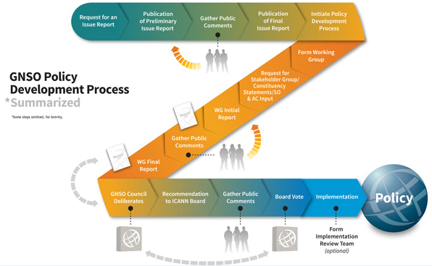
Final Issue Report
Charter
Input Request
Final Report

The boxes highlighted in red indicate the primary work product(s) output from the Policy Development Process (PDP) as a result of working group deliberations on an issue approved for consideration by the GNSO Council. Boxes noted with dashes represent the drafting stages of the Issue Report and WG’s Final Report.
The following pages detail the sub-phases of the PDP. Note that non-PDP working groups utilize this same process despite not making any consensus policy recommendations.

