Triage Report
Expedited Policy Development Process on the Temporary Specification for gTLD Registration Data

Status of This Document
This is the EPDP’s final Triage Report on ICANN’s Temporary Specification for gTLD Registration Data.

Preamble
The objective of this Triage Report is to document the EPDP’s level of agreement on specific provisions within the current Temporary Specification for gTLD Registration Data. Although not the original objective, the development of this report has assisted the EPDP Team to prioritize in formulating consensus recommendations to affirm, modify or replace the Temporary Specification adopted by the ICANN Board with an effective date of 25 May 2018.
Table of Contents

Table of Contents
1 Executive Summary 4
2 Triage Report Requirements 6
3 Methodology for Collection of Input 7
4 Triage Summary of Input 8

Executive Summary
The first deliverable of the EPDP Team is a “triage” document of the Temporary Specification, which includes items that have the Full Consensus support of the EPDP Team: that these should be adopted as is (with no further discussion or modifications needed). (See the EPDP Charter at https://gnso.icann.org/sites/default/files/file/field-file-attach/temp-spec-gtld-rd-epdp-19jul18-en.pdf.)

Based on the results of a section-by-section survey completed by the EPDP Team, there are very few areas where the consensus opinion of the EPDP Team agrees with the current language in the Temporary Specification. However, there were several areas of agreement with the underlying principles in several sections of the Temporary Specification. Where a constituency / stakeholder group / advisory committee did indicate support for a certain section of the Temporary Specification, edits were often also suggested, meaning that essentially no section of the Temporary Specification will be adopted without modifications.

That does not mean that this Triage report and the surveys and discussion that formed the basis for the report are without value. There are several takeaways that will inform the EPDP Team’s work on the Initial Report:
- Several comments made by the EPDP Team members indicated how the sections should be ordered for the next round of discussion; this should serve as a basis for a more efficient discussion going forward.
- The rationale provided by EPDP Team members in support / opposition of each section can be used in some cases to narrow the discussion to particular issues. Similarly, specific suggestions were made in some cases for how sections could be modified, which could form a basis for further deliberation.
- The EPDP Team now has a library of each group’s positions on and issues with a variety of topics.

Some of the major themes that were raised during the discussion include:
- The Temporary Specification is “GDPR-centric” and the consensus policy developed by the EPDP Team should take into account or make allowance for emerging privacy regulations in other jurisdictions.
- The effect of GDPR compliance requirements on entities outside the EEA requires better understanding and handling.
- The Temporary Specification refers to “processing” data but, to be clear, subsequent policy should consider further delineating among the different processing options such as collection, use and disclosure
- There is some confusion regarding the transition from a temporary specification to its replacement and the effect of that on time-sensitive sections of the Temporary Specification: e.g., the implementation date, reference to an Interim model and other clauses that would not belong in the replacement specification.
- Recent and ongoing advice received from EDPB may cause the team to reconsider the language in Section 4.4 et. seq., the purposes for processing data.
- Some believe that the sections are considered too prescriptive where actual implementation depends on business model, evolving GDPR interpretation and privacy regimes in other jurisdictions. Others believe it is not prescriptive enough. In some instances, compliance with GDPR will differ among data controllers.
- There is a difference among registration data (Whois data), data used to register domains and zone file data. The successor specification should recognize that distinction and deal with them appropriately.
- ICANN relies on its mission and bylaws to justify the requirement that registration data be disclosed in certain circumstances, but certain members of the EPDP team seeks supplemental information from ICANN to make it clear whether or not the mission and bylaws make such disclosures necessary, while other members are satisfied that the Temporary Specification is within the scope of ICANN’s mission and Bylaws.
- There was general agreement that the GDPR-replacement dispute resolution (URS and UDRP) and transfer processes were operating well and small or no changes were expected in the Temporary Specification. An examination regarding which personal data elements are required for those services will occur in the “access” portion of the EPDP.

What follows are:
- The requirement from the EPDP Team Charter
- A brief description of the methodology for compiling information for this report
- A summary chart indicating each team’s opinion regarding Temporary Specification sections
- A section-by-section report of the full comments provided by each group

Triage Report Requirements
The requirement from the EPDP Team Charter
(see, https://gnso.icann.org/sites/default/files/file/field-file-attach/temp-spec-gtld-rd-epdp-19jul18-en.pdf )

The first deliverable of the EPDP Team shall be a triage document of the Temporary Specification, which includes items that have the Full Consensus support of the EPDP Team that these should be adopted as is (with no further discussion or modifications needed). These items need to be:
- In the body of the Temporary Specification (not in the Annex)
- Within the "picket fence" (per limitations on Consensus Policy as set out in the Contracts)
- Not obviously in violation of the GDPR / Assumed to be compliant with GDPR [Presumed to be legal according to the members’ best knowledge of GDPR]
- Consistent with ICANN’s Bylaws

Deliberations of this first deliverable should include at least one round of elimination of clauses, if appropriate, and a second round of Full Consensus approval of a whole set of clauses.

Methodology for Collection of Input
The EPDP Team members completed a survey that, on a section-by-section basis of the Temporary Specification, indicated whether they:
- agreed with the section as written
- disagreed with the section as written
- had no strong opinion

Implementation notes:
- Some similar sections were combined in the survey for efficiency.
- Each constituency / stakeholder group / advisory committee completed one survey.
- The survey sections were divided into four separate surveys so that first inputs could be received and reviews could begin sooner.

Each constituency / stakeholder group / advisory committee was then asked to provide rationale or reasoning for their opinion, at least in cases where they disagreed with the language. They were afforded the opportunity to suggest alternate language.

The EPDP Leadership and Support team reviewed the responses and rationale, and created an “issue summary” for each survey section. The issue summaries and the text of each of the responses were published prior to each Team meeting. During EPDP Team meetings the comments and issue summaries were reviewed to ensure written comments were correctly understood. The EPDP Team was also furnished with a summary chart (see below) indicating which teams supported individual Temporary Specification sections.

Despite having been required by the EPDP charter to provide a "Full consensus support" triage report, after the first meeting, it was realized there would be few areas of consensus that sections were supported as written so it was decided to not spend time attempting to reach consensus on any section during the triage stage. Hence this document should not be treated as a document describing a consensus result for regarding any of the policy issues discussed.

Triage Summary of Input
Acknowledging that consensus is not achieved by vote, it is instructive to graphically portray when the groups agreed (or not) with each report section.

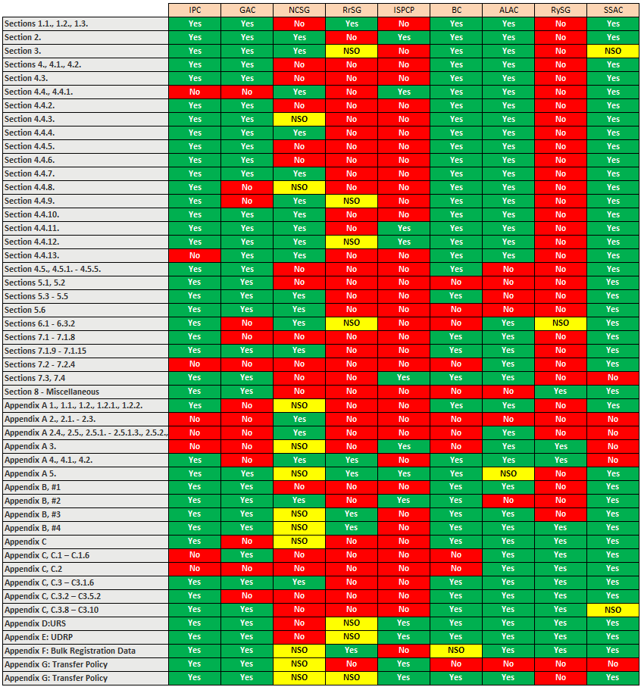

Any such chart requires explanation.
- Importantly, there was often agreement on broad principles, but those areas of agreement are hidden in this chart where the combination of sections into one line item or suggested minor edits resulted in “not supporting the language as written, i.e., where the combination of sections into one line item or suggested minor edits resulted in “not supporting the language as written.”
- The Registry Stakeholder Group thought the Temporary Specification should be revisited given recent correspondence from the European Data Privacy Board and the effect that has had on preconceived notions of compliance vs. non-compliance.
- The Intellectual Property and Business Constituencies and the At-Large Advisory Committee, when agreeing with a section, often proposed revised wording.
- The Registry Stakeholder Group, when indicating “not supporting” with a section, often reflected general agreement in their written comment but with certain changes recommended.

Therefore, the color-coding is not precisely or well-correlated to the degree of support.

For convenience, the definition of “Full Consensus” is: "Full consensus - when no one in the group speaks against the recommendation in its last readings. This is also sometimes referred to as Unanimous Consensus."

