M  22 October | ICANN PURPOSE:  Coordinate the development and implementation of policies for resolution of disputes regarding the registration of domain names (as opposed to the use of such domain names). (ICANN bylaws Annex G and 1(1) section I(a))  Coordinate, operationalize and facilitate policies for resolution of disputes regarding or relating to the registration of domain names (as opposed to the use of such domain names), namely, the UDRP, URS, PDDRP, RDDRP and future-developed domain name registration-related dispute procedures for which it is established that the processing of personal data is necessary. (ICANN bylaws Annex G and 1(1) section I(a)  (Purposes by Actor (M))(TempSpec – URS-4.4.12, 5.6, Appx D; UDRP-Appx E)
Purpose Rationale:
1) If the purpose is based on an ICANN contract, is this lawful as tested against GDPR and other laws?

Yes, as detailed in the Lawfulness of Processing section below, this purpose is lawful:
- under Article 6(1)(b) with regard to the URS and UDRP for registrars because this mechanism and policy, respectively, are incorporated into the data subject’s contract with the registrar;
- under Article 6(1)(f) with regard to the RDDRP and PDDRP for registrars, registries, and ICANN, because the processing is necessary for the purposes of pursued legitimate interests that are not overridden by the interests or fundamental rights and freedoms of the data subject; and
- under Article 6(1)(f) with regard to the URS and UDRP for registries and ICANN, because the processing is necessary for the purposes of pursued legitimate interests that are not overridden by the interests or fundamental rights and freedoms of the data subject. With regard to this balancing test, we note that the contacts are important to ensure due process for the registrant so that they have notice of the proceedings and can avoid losing their domain name through a default.
.

ICANN Org to provide EPDP Team with copy of agreements with UDRP/URS providers in relation to data protection / transfer of data as well as the relevant data protection policies that dispute resolution providers have in place.

[Rights Protection Mechanisms (RPMs) provisions exist within both the Registry and Registrar agreements as connected to ICANN Bylaws. This purpose is connected to Rights Protection Mechanisms of Uniform Dispute Resolution Mechanism (UDRP) and Uniform Rapid Suspension (URS), but it does not preclude RPMs that could be created or modified in the future. The]

2) Is the purpose in violation with ICANN's bylaws?

No.

ICANN bylaws, Section 1.1(a)(i), as a part of “Mission” refer to Annexes G1 and G2. Annex G-1 contains a provision for Registrars, “resolution of disputes regarding the registration of domain names (as opposed to the use of such domain names, but including where such policies take into account use of the domain names)” Annex G-2 also contains, “resolution of disputes regarding the registration of domain names (as opposed to the use of such domain names)”.

3) Are there any “picket fence” considerations related to this purpose?

Resolution of disputes regarding or relating to the registration of domain names (as opposed to the use of such domain names) are considered within the picket fence for the development of consensus policies. The purpose and the processing hereunder, as specified by the collection, transmission and disclosure of the data elements identified, are considered within the picket fence based upon the coordination, operationalization and facilitation of the dispute resolution mechanisms listed.

The Temp Spec (Appendix D & E) now makes reference to who an RPM provider must contact based on Thick or Thin RDS to obtain registration data for the complaint.]

Lawfulness of Processing Test:
Processing Activity: | Responsible Party:  (Charter Questions 3k, 3l, 3m) | Lawful Basis: (Is the processing necessary to achieve the purpose?)
M-PA1: Collection of registration data to implement the UDRP and URS  (Charter Question 2b) | Registrars - Processor | This is a 6(1)(b) purpose because it is necessary to collect registration data in order to facilitate/implement a UDRP or URS decision. For example, in the case of a UDRP/URS proceeding, the Registrant must agree to be bound by the UDRP/URS in order to register a domain name, so the collection of data for this purpose is necessary to fulfill the registration agreement.
 | ICANN – Controller  Registries - Processor | This is a 6(1)(f) purpose because ICANN and Registries do not have a direct contract with the registrant. The Registry must process data to fulfill its obligations regarding the RPMs, compliance with which are incorporated into the Registry Agreement.
M-PA2: Collection of registration data to implement the RDDRP and PDDRP | ICANN - Controller  Registries - Processor  Registrars - Processor | This is a 6(1)(f) purpose because although there may be a legitimate interest in collecting registration data for implementation of the RDDRP and PDDRP, this collection is not technically necessary to perform the registration contract.
M-PA3: Transmission of registration data from Registrar to Registry  (Charter Questions 2c, 2d, 2e, 2i) | Registrars – Processor | This is a 6(1)(b) purpose because transmission of (at least minimal) registration data from the Registrar to the Registry is necessary to identify the Registrant for purposes of dispute resolution.
 | ICANN - Controller  Registries - Processor | This is a 6(1)(f) purpose because although there is a legitimate interest in transmitting registration data to the Registry, this transmission is not technically necessary to perform the registration contract. The Registry must process data to fulfill its obligations regarding the RPMs and DRPs, compliance with which are incorporated into the Registry Agreement.
M-PA4: Transmission of registration data to dispute resolution provider and complainants to implement the UDRP, URS, RDDRP, and PDDRP  (Charter Questions 2c, 2d, 2e, 2i) | ICANN - Controller  Registries - Processor  Registrars – Processor  Dispute Resolution Provider – Processor | This is a 6(1)(f) purpose because although there may be a legitimate interest in transmitting registration data to Dispute Resolution Providers.  This is also 6(1)(b) purpose because transmission of the registration data is necessary to identify the registrant in advance of filing a dispute resolution procedure, and under Section 3.7.11 of the RAA, registration agreements with the registrant must include the following:  3.7.7.11 The Registered Name Holder shall agree that its registration of the Registered Name shall be subject to suspension, cancellation, or transfer pursuant to any Specification or Policy, or pursuant to any registrar or registry procedure not inconsistent with any Specification or Policy, (1) to correct mistakes by Registrar or the Registry Operator in registering the name or (2) for the resolution of disputes concerning the Registered Name.
M-PA5: Disclosure of registration data used for complaints on dispute provider sites  (Charter Questions 2f (gating questions), 2j) | Dispute Resolution Provider – Processor | TBD
M-PA6: Retention of registration data used for complaints  (Charter Questions 2g, ??) | TBD | TBD  The EPDP Team is not aware of any currently data retention requirements by dispute resolution providers.  [Data retention requirement for registrars should be uniform with other requirements.]  Proposed Policy Recommendation: ICANN Org should enter into data processing agreements with Dispute Resolution Providers in which the data retention period is addressed, considering the interest in having publicly available decisions.

Data Elements Map:
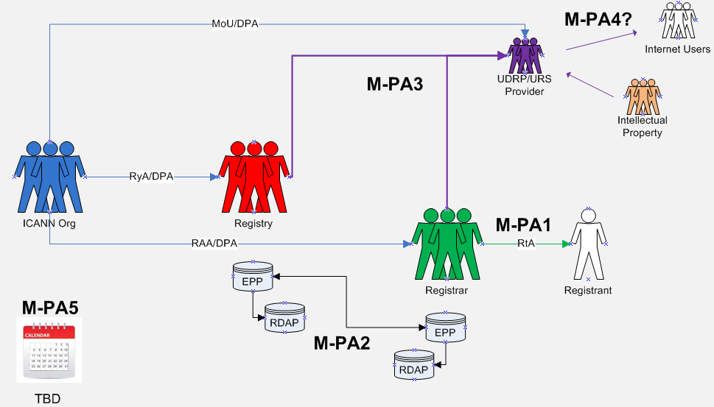

Data Elements Matrix:
“1” = Required “(1)” = Optional “-“ = Not Required or Optional

Data Element | Collection  M-PA1 | Collection  M-PA2 | Transmission  M-PA3 | Transmission  M-PA4 | Disclosure  M-PA5 | Retention  M-PA6
Domain Name | 1 | 1 | 1 | 1 | 1 | -
Registry Domain ID | - |  |  | - | - | -
Registrar Whois Server | 1 | 1 | 1 | 1 | - | -
Registrar URL | 1 | 1 | 1 | 1 | - | -
Updated Date | 1 | 1 | 1 | 1 | - | -
Creation Date | 1 | 1 | 1 | 1 | - | -
Registry Expiry Date | 1 | 1 | 1 | 1 | - | -
Registrar Registration Expiration Date | 1 | 1 | 1 | 1 | - | -
Registrar | 1 | 1 | 1 | 1 | - | -
Registrar IANA ID | 1 | 1 | 1 | 1 | - | -
Registrar Abuse Contact Email | 1 | 1 | 1 | 1 | - | -
Registrar Abuse Contact Phone | 1 | 1 | 1 | 1 | - | -
Reseller | 1 | 1 | 1 | 1 | - | -
Domain Status | 1 | 1 | 1 | 1 | - | -
Registry Registrant ID | - |  |  | - | - | -
Registrant Fields
• Name | 1 | 1 | 1 | 1 | 1 | -
• Organization (opt.) | (1) | (1) | (1) | (1) | 1 | -
• Street | 1 | 1 | 1 | 1 | - | -
• City | 1 | 1 | 1 | 1 | - | -
• State/province | 1 | 1 | 1 | 1 | - | -
• Postal code | 1 | 1 | 1 | 1 | - | -
• Country | 1 | 1 | 1 | 1 | 1 | -
• Phone | (1) | (1) | (1) | (1) | - | -
• Phone ext (opt.) | (1) | (1) | (1) | (1) | - | -
• Fax (opt.) | (1) | (1) | (1) | (1) | - | -
• Fax ext (opt.) | (1) | (1) | (1) | (1) | - | -
• Email | 1 | 1 | 1 | 1 | - | -
2nd E-Mail address | - | - | - | - | - | -
Admin ID | - | - | - | - | - | -
Admin Fields
• Name | - | - | - | - | - | -
• Organization (opt.) | - | - | - | - | - | -
• Street | - | - | - | - | - | -
• City | - | - | - | - | - | -
• State/province | - | - | - | - | - | -
• Postal code | - | - | - | - | - | -
• Country | - | - | - | - | - | -
• Phone | - | - | - | - | - | -
• Phone ext (opt.) | - | - | - | - | - | -
• Fax (opt.) | - | - | - | - | - | -
• Fax ext (opt.) | - | - | - | - | - | -
• Email | - | - | - | - | - | -
Tech ID | - | - | - | - | - | -
Tech Fields
• Name | - | - | - | - | - | -
• Organization (opt.) | - | - | - | - | - | -
• Street | - | - | - | - | - | -
• City | - | - | - | - | - | -
• State/province | - | - | - | - | - | -
• Postal code | - | - | - | - | - | -
• Country | - | - | - | - | - | -
• Phone | - | - | - | - | - | -
• Phone ext (opt.) | - | - | - | - | - | -
• Fax (opt.) | - | - | - | - | - | -
• Fax ext (opt.) | - | - | - | - | - | -
• Email | - | - | - | - | - | -
NameServer(s) | - | - | - | - | - | -
DNSSEC | - | - | - | - | - | -
Name Server IP Address | - | - | - | - | - | -
Last Update of Whois Database | - | - | - | - | - | -
Other Data:
• Field 1 | - | - | - | - | - | -
• Field 2 | - | - | - | - | - | -

Chain of Custody:
- RAA - https://www.icann.org/resources/pages/approved-with-specs-2013-09-17-en
  - 3.8
- RyA - https://newgtlds.icann.org/sites/default/files/agreements/agreement-approved-31jul17-en.html
  - Spec 7
- Temp Spec: Sections URS-4.4.12, 5.6, Appx D; UDRP-Appx E

