Summary of changes made as a result of EPDP Team Meeting on 8 Nov 2018

- Purpose M – maintain transfer of data elements, including registrant contact details, from Registrar to Registry for URS, in line with current practice and expectations. Note, consider recommending that the RPM WG reviews issue of inconsistency in how UDRP/URS providers interact with Contracted Parties for the acquisition of registration data as well as the implementation of domains locks and the outcome of UDRP/URS complaints.
- Purpose E Registry Escrow – As a result of Purpose M transfer of data from registrar to registry (see previous item), those data elements will also be available for Registry Escrow purposes (as the EPDP Team previously agreed that any data elements transferred from Registrar to Registry for any purpose, as those that should be available for Registry Escrow). As such, there is no need to mark additional data elements under Purpose A, although it should be factored in that the EPDP Team noted that a registry may request additional data from a registrar, for example under Purpose A (under lawful basis 6(1)b), but is not required to do so.
- Optional data elements – in order to create consistency across the data elements workbooks, data elements marked as optional for purposes A and C will also be marked optional for other purposes.
- Generated vs. collected – a note will be added to clarify that the data elements considered by the EPDP Team are either generated or collected. Similarly, updates will be made that a number of ID related data elements will be generated automatically upon registration by either the registrar or registry. In line with the Temporary Specification, these ID related data elements have been marked as redacted.

To facilitate your review of the data elements matrix, these changes have been applied in red for now. For further details on the rationale and action taken, please see below.

Introduction:
In consolidating the data elements matrix based on the data elements contained in each of the Purpose workbooks, the support team encountered the following issues / inconsistencies. For each of those, a proposed path forward is described. If there are any concerns about these proposed solutions, please indicate this in advance of Thursday’s meeting so it can be discussed during the call.

Please scan the Data Elements Matrix_20181107.pdf before reviewing the issues. There are three pages as viewed from the Responsible Party:
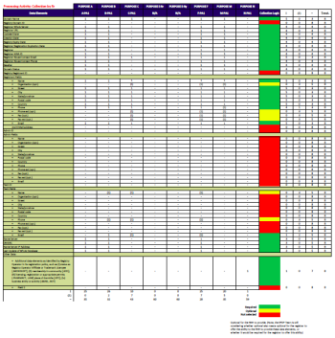
- Collection of data from the Registrar (page 1)
- Transfer of data from the Registrar to the Registry (page 2)
- Disclosure of data to Internet Users (page 3)
Each column is an extract of the data elements identified within each of the Purpose workbooks. The field is similarly marked as “1” for Required, “(1)” for Optional or “-“ for Not Selected. The Collection Logic column on the far right with (Green, Yellow, Red) contains a conditional formula where it detects a data element marked as Required “1” (Green) or Optional “(1)” (Yellow). If so, this column reflects the comprehensive data elements for that Processing Activity by Responsible Party.

Issues:

- Purpose M – Dispute Resolution

Issue: The Purpose M data elements workbook includes a number of data elements required for transfer from Registrar to Registry that the original small team that developed Purpose M put in with a question mark as it was not clear whether or not data gets transferred from a registrar to a registry for UDRP or URS. In a subsequent discussion, the ICANN Contractual Compliance team indicated that this transfer from registrar to registry is not required for the purpose of UDRP or URS.

Question for the EPDP Team:
- In post-May 2018 operation, is the Compliance Team assessment correct, or is data transfer to the Registry for UDRP and/or URS required, and if so, why?
- If the Provider always contacts the Registrar for the disclosure of registration data, both in the case of UDRP and URS, can the transfer of data from registrar to registry (M-PA3 in the data matrix) for this purpose be removed?
- For PDDRP, RRDRP complaints where registration data is required to be disclosed and considered PII, can the access to that data be accomplished via the Registrar as needed?

Proposed approach to address the issue: The M-PA3 Transfer Processing Activity remains as documented in the Purpose M workbook.
- Possible recommendation: Refer to the RPM Working Group the issue of inconsistency in how UDRP/URS providers interact with Contracted Parties for the acquisition of registration data as well as the implementation of domains locks and the outcome of UDRP/URS complaints. Known inconsistencies:
  - UDRP has not been revisited in a “thick Whois” model as current state has RPM Providers interacting with Registrars only
  - URS was developed with “thick Whois” in mind where current state has RPM Providers interacting with Registries for the locking/unlocking of the domain, suspension and change of NameServers which also includes inconsistent interaction of providers to Registries and/or Registrars in the acquisition of registration data to process a complaint.
  - Examine the PDDRP and RRDRP process and procedures to better understand the processing activities of registration data of Registrants/Data Subjects.

- Purpose E – Registry Escrow

Issue: During the previous meeting, the EPDP Team discussed that for the purpose of Registry Escrow, data elements would need to be escrowed that would be transferred from Registrar to Registry. However, based on a review of the data elements matrix (and presuming a resolution of the previous issue), it means that only the “Domain Name” and “Name Servers” field is required for transfer by registrar to registry. Is this sufficient from the perspective of Registry Escrow (factoring in that non-personal data elements will be publicly available)? If not, why not?

Question for the EPDP Team, and especially Registry reps:
- What data elements, if any, are needed to be escrowed in addition to those data elements that are recommended to be publicly available to restore registry operations in case of failure?

Proposed approach to address the issue: if additional data elements are identified beyond those publicly available, these should be marked as needing to be transferred for the purpose of escrow from registrar to registry under Purpose A. Yes, as discussed at the 8 Nov. EPDP call. The Purpose A workbook makes a distinction of the two data elements (Domain Name & Name Server) that have a lawful basis for 6(1)(b) while other domains “can be requested by the Registry” based on 6(1)(f). Like other workbooks where this lawful basis distinction is made, this change brings the Purpose A workbook into alignment.

Refer to the proposed Data Elements Matrix, page 2 for transfer of data from the registrar to the registry. Entries marked in red (1, (1),-) are a staff suggestion for updating the workbooks. Note that the workbooks will not be updated until this change is agreed upon. Summary of changes:
- Page 2 – Purpose A data elements (marked in red) are suggested to be added to the Purpose A, A-PA2 Processing Activity in the workbook and also confirm the existing 6(1)(b) and 6(1)(f) lawful basis language as currently documented in the workbook:
“Certain data elements (domain name and nameservers) would be required to be transferred from the Registrar to Registry. The lawful basis would be 6(1)b, should personal data be involved.

The transfer of the registration data, apart from the aforementioned data elements, from Registrar to Registry, where the Registry operates a “Thick Whois,” is lawful under Art. 6(1)(f) of the GDPR.

**Full registrant data CAN be requested by the Registry based on Art. 6(1)(f), for example, for the purpose of administering the application of a Registry Acceptable Use Policy (AUP) (or equivalent); such processing is considered justifiable under the Art. 6(1)(f) balancing test when considering the nature of the data, the envisaged limited use of the data, and the likelihood of the impact on the privacy rights of the Registered Name Holder when weighed against the safety and integrity of the zone.

* However, members of the BC and IPC expressed the view that Purpose A is 6(1)(b) for all processing activities, including registries checking on patterns of abuse as protecting against abuse is considered necessary for performance of a contract.”
- Page 2 – Take the data elements under the Transmission Logic column and populate the Purpose E-Ry Registry Escrow workbook under E-PA2 Processing Activity identifying which data elements of the working set should be included in the escrow deposit.

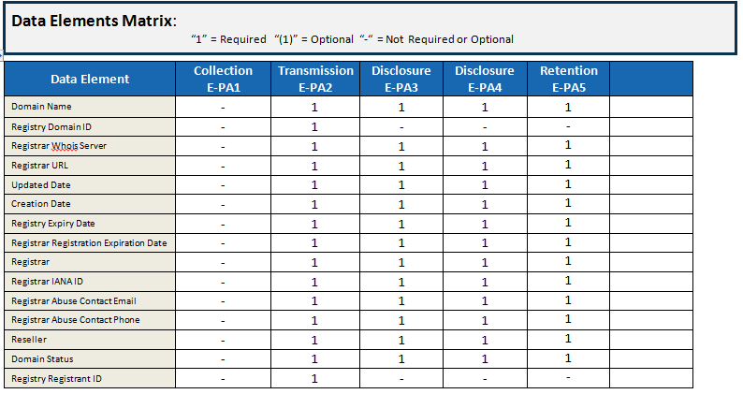
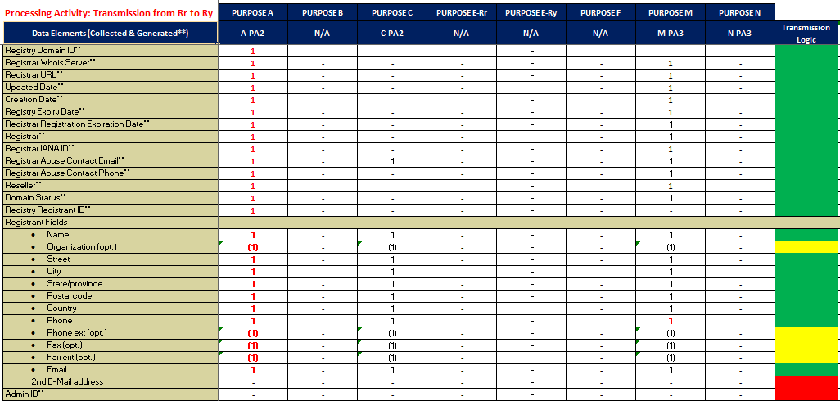
- Optional Data Elements

Issue: There are some inconsistencies in the use of the term “optional” for some of the data elements. I.e., in Purpose B (Access by Third Parties), the tech contact email is not marked as optional. Our understanding is that purpose A (Rights of a Domain Registrant) and C (Tech Contact) provide the baseline for describing which elements are optional.

Proposed approach to address the issue: Ensure that the use of optional for all data elements for all purposes is consistent with Purposes A and C., i.e., that Tech Contact is indicated as optional. As marked in red:
- Page 1 – Collection from Registrar
  - Across Purposes A, B, F - DNSSEC converted to “(1)” as per the discussion on 8 Nov. this will only be generated if the Registered Name Holder configures the domain as such.
  - Purpose B - Tech Email changed to “(1)” in line with Purposes C & F
  - Purpose M – Registrant Phone changed to “1” in line with Purposes A, B, C & F
- Page 2 – Transfer from Registrar to Registry
  - Purpose A – as addressed in the Issue #2 above
  - Purpose M – Registrant Phone changed to “1” in line with Purposes A & C

- Collected vs. Generated Data Elements

Issue: The current consolidated list of data elements does not distinguish between data elements that are collected and data elements that are generated, e.g., Registry Domain ID and Registry Registrant ID. Similarly, some of the generated data elements are no longer listed as being needed / required; however, there are RFCs that currently require this information to be generated for a variety of purposes and so should be addressed in our analysis.

Question for the EPDP Team:
- Which of these, if any, contain potential Personally Identifiable Information?

Proposed approach to address the issue: Add a clarification to the data elements workbooks that the workbook includes data elements that are collected from the registrant and data elements that are automatically generated by the registrar and/or registry. For Purpose A, indicate that currently known generated data elements, Registry Domain ID and Registry Registrant ID, will continue to be generated and contain Personally Identifiable Information (with these data elements being redacted, consistent with the current requirements in the Temporary Specification).
- Refer back to the proposed solution for Issue #2 above on Purpose A
- Data Elements Matrix contains an example of how generated vs. collected registration data elements are presented in the column headers as well as the data elements.
- Generated data elements are now accounted for in the Transmission Processing Activity A-PA2.
- Refer to Page #1 for Collection, Tech ID fields are included as Optional “(1)” for Purposes B & C as they will be generated should the Tech fields be populated.
- Refer to page 3 of the data elements matrix for Disclosure. Note that Registry Domain ID and Registry Registrant ID are marked as Redacted.

Optional for the RNH to provide. (Note, the EPDP Team is still considering whether optional also means optional for the registrar to offer the ability to the RNH to provide these data elements, or whether it would be required for the registrar to offer this ability)

