Annex D – Data Elements Workbooks
Table of Contents:
# | Purpose | Link
1 | As subject to Registry and Registrar terms, conditions and policies, and ICANN Consensus Policies:  - To establish the rights of a Registered Name Holder in a Registered Name;  - To ensure that a Registered Name Holder may exercise its rights in the use and disposition of the Registered Name; and  - To activate a registered name and allocate it to a Registered Name Holder | LINK
2 | Maintaining the security, stability and resiliency of the Domain Name System in accordance with ICANN’s mission through the enabling of lawful access for legitimate third-party interests to data elements collected for other purposes identified herein | LINK
3 | Enable communication with and/or notification to the Registered Name Holder and/or their delegated agents of technical and/or administrative issues with a Registered Name | LINK
4 | Provide mechanisms for safeguarding Registered Name Holders' Registration Data in the event of a business or technical failure, or other unavailability of a Registrar or Registry Operator | Rr – LINK  Ry – LINK
5 | Handle contractual compliance monitoring requests, audits, and complaints submitted by Registry Operators, Registrars, Registered Name Holders, and other Internet users | LINK
6 | Coordinate, operationalize and facilitate policies for resolution of disputes regarding or relating to the registration of domain names (as opposed to the use of such domain names), namely, the UDRP, URS, PDDRP, RRDRP and future-developed domain name registration-related dispute procedures for which it is established that the processing of personal data is necessary. | LINK
7 | Enabling validation to confirm that Registered Name Holder meets optional gTLD registration policy eligibility criteria voluntarily adopted by Registry Operator. | LINK

In this document, the term “ICANN Purpose” is used to describe purposes for processing personal data that should be governed by ICANN Org via a Consensus Policy. Note there are additional purposes for processing personal data, which the contracted parties may pursue, such as billing customers, but these are outside of what ICANN and its community should develop policy on or contractually enforce. It does not necessarily mean that such purpose is solely pursued by ICANN Org.

For those data elements marked as “(optional)”, these are optional for the RNH to provide. (Note, the EPDP Team is still considering whether optional also means optional for the registrar to offer the ability to the RNH to provide these data elements, or whether it would be required for the registrar to offer this ability).

Note that data elements are either collected from the data subject, or automatically generated by the registrar or registry.

Note, the Responsible Party (as denoted in columns for Processing Activity) is not necessarily the party carrying out the processing activity.
1 | ICANN PURPOSE:  As subject to Registry and Registrar terms, conditions and policies, and ICANN Consensus Policies:  - To establish the rights of a Registered Name Holder in a Registered Name;  - To ensure that a Registered Name Holder may exercise its rights in the use and disposition of the Registered Name; and  - To activate a registered name and allocate it to a Registered Name Holder.
Purpose Rationale:
1) If the purpose is based on an ICANN contract, cite the relevant section of the ICANN contracts that corresponds to the above purpose, if any.

- RAA - https://www.icann.org/resources/pages/approved-with-specs-2013-09-17-en

Yes, this purpose is lawful based on ICANN’s mission to coordinate the allocation and assignment of names in the root zone of the Domain Name System. Specifically, Section 3.2 of the RAA “Submission of Registered Name Holder Data to Registry” refers to what data elements must be placed in the Registry Database as a part of the domain registration (https://www.icann.org/resources/pages/approved-with-specs-2013-09-17-en).

2) Is the purpose in violation with ICANN's bylaws?

No, it is not in violation of ICANN’s Bylaws. Specifically, Article 1, Section 1.1 Mission (a)(i) Coordinates the allocation and assignment of names in the root zone of the Domain Name System ("DNS") and coordinates the development and implementation of policies concerning the registration of second-level domain names in generic top-level domains ("gTLDs"). In this role, ICANN's scope is to coordinate the development and implementation of policies https://www.icann.org/resources/pages/governance/bylaws-en/#article1.

Further, Articles G-1 and G-2 stipulate, “issues for which uniform or coordinated resolution is reasonably necessary to facilitate interoperability, security and/or stability of the Internet, registrar services, registry services, or the DNS;” and “Examples of the above include, without limitation: principles for allocation of registered names in a TLD (e.g., first-come/first-served, timely renewal, holding period after expiration);”

3) Are there any “picket fence” considerations related to this purpose?

This purpose is related to WHOIS, which is within the Picket Fence. Specifically, Specification 1 of the Registry Agreement and Specification 4 of the Registrar Accreditation Agreement both refer to categories of issues and principles of allocation of registered names in a TLD.

Lawfulness of Processing Test:
Processing Activity: | Responsible Party:  (Charter Questions 3k, 3l, 3m) | Lawful Basis: (Is the processing necessary to achieve the purpose?)
1-PA1: Collection of registration data establishing registrant rights and allocating string to registrant  (Charter Question 2b) | ICANN  Registrars  Registries | 6(1)(b) for Registrars  This is a 6(1)(b) purpose for Registrars because it is necessary to collect registrant data to allocate a string to a registrant. Without collecting minimal registrant data, the contracted party has no way of tracing the string back to registrant and is not able to deliver its side of the contract.  Purpose E-Rr, Escrow for Registrars (and by extension for data transferred to Registries, Purpose E-Ry) depends on the collection of registration data as part of this Processing Activity where Registrars collect registration data from the Registrant (Data Subject). Transparency of collection to the Registrant (Data Subject) is a requirement for purpose of escrow.  **6(1)(f) for Registries and ICANN  This is a 6(1)(f) purpose for Registries because a Registry does not have a contractual relationship with the Data subject. ICANN and Registry have a contract with the Registrar, however this is not a valid basis for these two parties to process the data subject’s data.  Registries, at the behest of ICANN (per the RyA) must gather data in order to enter a domain name, as per a Registrar request (not a data subject request).  *However, members of the BC and IPC expressed the view that Purpose A is 6(1)(b) for all processing activities, including registries checking on patterns of abuse as protecting against abuse is considered necessary for performance of a contract.
1-PA2: Transmission of registration data from Registrar to Registry  (Charter Questions 2c, 2d, 2e, 2i) | Registrars  Registries | Certain data elements (Domain Name and Name Servers) would be required to be transferred from the Registrar to Registry. The lawful basis would be 6(1)b, should personal data be involved, for Registrars and 6 (1)(f) of the GDPR for Registries.  The transfer of the registration data, apart from the aforementioned data elements, from Registrar to Registry, where the Registry operates a “Thick Whois,” is lawful under Art. 6(1)(f) of the GDPR.  **Full registrant data CAN be requested by the Registry based on Art. 6(1)(f), for example, for the purpose of administering the application of a Registry Acceptable Use Policy (AUP) (or equivalent); such processing is considered justifiable under the Art. 6(1)(f) balancing test when considering the nature of the data, the envisaged limited use of the data, and the likelihood of the impact on the privacy rights of the Registered Name Holder when weighed against the safety and integrity of the zone.  * However, members of the BC and IPC expressed the view that Purpose A is 6(1)(b) for all processing activities, including registries checking on patterns of abuse as protecting against abuse is considered necessary for performance of a contract.
1-PA3: Disclosure of registration data  (Charter Questions 2f (gating questions), 2j) | Registrars  Registries | Certain data elements (domain name and nameservers) would be required to disclosed. The lawful basis would be 6(1)b, should personal data be involved, for Registrars and 6 (1)(f) of the GDPR for Registries.  6(1)(f)
1-PA4: Retention of registration data by Registrar  (Charter Questions 2g) | ICANN | Yes. 6(1)(f)  This is a 6(1)(f) purpose because although there is likely a legitimate interest in providing mechanisms for safeguarding Registered Name Holders' Registration Data in the event of a dispute over ownership or an improper transfer, it is not technically necessary to retain the data in order to allocate a string to a registered name holder, and is therefore not necessary to perform the registration contract.  The EPDP Team tentatively agreed to a registration plus one-year retention period in order to conform with the Transfer Dispute Resolution Policy requirements.  Note that certain jurisdictions may have requirements in place that have resulted in some Registrars requesting data retention waivers which may result in different retention period requirements.

Data Flow Map:
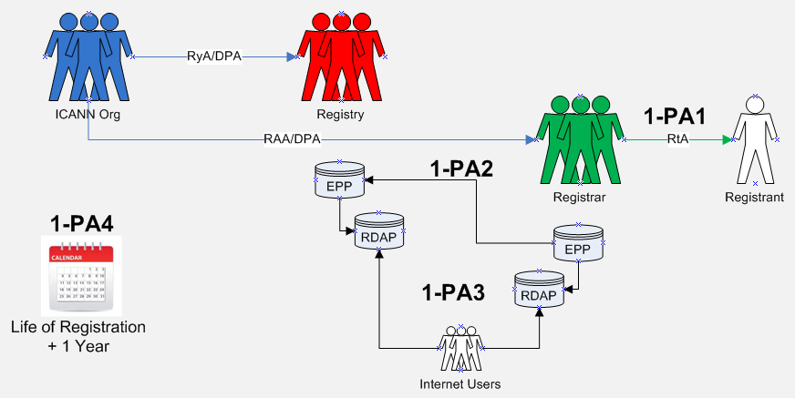

Data Elements Matrix:
“1” = Required “(1)” = Optional “-“ = Not Required or Optional

Data Elements  (Collected & Generated*) | Collection  1-PA1 | Transmission  1-PA2 | Disclosure  1-PA3 | Retention  1-PA4
Domain Name | 1 | 1 | 1 | 1
Registry Domain ID* | 1 |  | 1 | 1
Registrar Whois Server* | 1 | 1 | - | 1
Registrar URL* | 1 | 1 | - | 1
Updated Date* | 1 |  | - | 1
Creation Date* | 1 |  | - | 1
Registry Expiry Date* | 1 |  | - | 1
Registrar Registration Expiration Date* | (1) | (1) | - | (1)
Registrar* | 1 |  | - | 1
Registrar IANA ID* | 1 |  | - | 1
Registrar Abuse Contact Email* | 1 | 1 | - | 1
Registrar Abuse Contact Phone* | 1 | 1 | - | 1
Reseller* | 1 | (1) | - | 1
Domain Status(es)* | 1 | 1 | - | 1
Registry Registrant ID* | 1 |  | 1 | 1
Registrant Fields
• Name | 1 | - | - | 1
• Organization (opt.) | - | - | - | -
• Street | 1 | - | - | 1
• City | 1 | - | - | 1
• State/province | 1 | - | - | 1
• Postal code | 1 | - | - | 1
• Country | 1 | - | - | 1
• Phone | 1 | - | - | 1
• Phone ext (opt.) | - | - | - | -
• Fax (opt.) | - | - | - | -
• Fax ext (opt.) | - | - | - | -
• Email | 1 | - | - | 1
2nd E-Mail address | - | - | - | -
Admin ID* | - | - | - | -
Admin Fields
• Name | - | - | - | -
• Organization (opt.) | - | - | - | -
• Street | - | - | - | -
• City | - | - | - | -
• State/province | - | - | - | -
• Postal code | - | - | - | -
• Country | - | - | - | -
• Phone | - | - | - | -
• Phone ext (opt.) | - | - | - | -
• Fax (opt.) | - | - | - | -
• Fax ext (opt.) | - | - | - | -
• Email | - | - | - | -
Tech ID* | - | - | - | -
Tech Fields
• Name | - | - | - | -
• Organization (opt.) | - | - | - | -
• Street | - | - | - | -
• City | - | - | - | -
• State/province | - | - | - | -
• Postal code | - | - | - | -
• Country | - | - | - | -
• Phone | - | - | - | -
• Phone ext (opt.) | - | - | - | -
• Fax (opt.) | - | - | - | -
• Fax ext (opt.) | - | - | - | -
• Email | - | - | - | -
NameServer(s) | 1 | 1 | 1 | 1
DNSSEC | (1) |  | - | (1)
Name Server IP Address | 1 | 1 | - | 1
Last Update of Whois Database* | 1 |  | - | 1

2 | ICANN PURPOSE:  Contributing to the maintenance of the security, stability, and resiliency of the Domain Name System in accordance with ICANN’s mission through enabling responses to lawful data disclosure requests.
Purpose Rationale:
1) If the purpose is based on an ICANN contract, cite the relevant section of the ICANN contracts that corresponds to the above purpose, if any.

- RAA - https://www.icann.org/resources/pages/approved-with-specs-2013-09-17-en

Yes, this purpose is lawful based on ICANN’s mission to coordinate the allocation and assignment of names in the root zone of the Domain Name System. Specifically, ICANN contracts reference the requirement for the maintenance of and access to accurate and up-to-date information concerning domain name registrations.

2) Is the purpose in violation with ICANN's bylaws?

No, it is not in violation of ICANN’s Bylaws, see ICANN Bylaws - Section 1.1(d)(ii), Section 1.2(a), Section 4.6(e)(i), Annex G1 and G2.

3) Are there any “picket fence” considerations related to this purpose?

This is within the Picket Fence, as the purpose specially refers to data already collected.

The WHOIS system, including 3rd party access, is within the Picket Fence, note specifically the Consensus Policies and Temporary Policies specification in the Registrar Accreditation Agreement (RAA) and Registry Agreement (RAA - 1.3.4. maintenance of and access to accurate and up-to-date information concerning Registered Names and name servers; Registry Agreement - maintenance of and access to accurate and up-to-date information concerning domain name registrations).

Lawfulness of Processing Test:
Processing Activity: | Responsible Party::  (Charter Questions 3k, 3l, 3m) | Lawful Basis: (Is the processing necessary to achieve the purpose?)
2-PA1: Collection of registration data  Note: as this purpose refers to data already collected, please refer to Purpose A Workbook for further information.  (Charter Question 2b) | ICANN  Registrars  Registries | The lawful basis for this processing activity is Art.6(1)(f) of the GDPR because although there may be a legitimate interest in disclosing non-public RDDS/WHOIS to third parties (such as law enforcement, IP interests, etc.), this disclosure is not technically necessary to perform the registration contract between the registrant and registrar.
2-PA2: Transmission of registration data from Registrar to Registry  (Charter Questions 2c, 2d, 2e, 2i) | N/A | N/A
2-PA3: Disclosure of non- public, already collected, RDDS/WHOIS to third parties  (Charter Questions 2f (gating questions), 2j) | ICANN | This is a 6(1)(f) processing activity because although there may be a legitimate interest in disclosing non-public RDDS/WHOIS to third parties (such as law enforcement, IP interests, etc.), this disclosure is not technically necessary to perform the registration contract between the registrant and registrar. (Note: the requisite balancing test must be performed for each third-party type of disclosure.)
2-PA4: Retention of registration data by registrar  (Charter Questions 2g)  Note: as this purpose refers to data already collected, please refer to Purpose A Workbook for further information. (This purpose does not call for additional retention periods.) | ICANN | TBD

Data Flow Map:
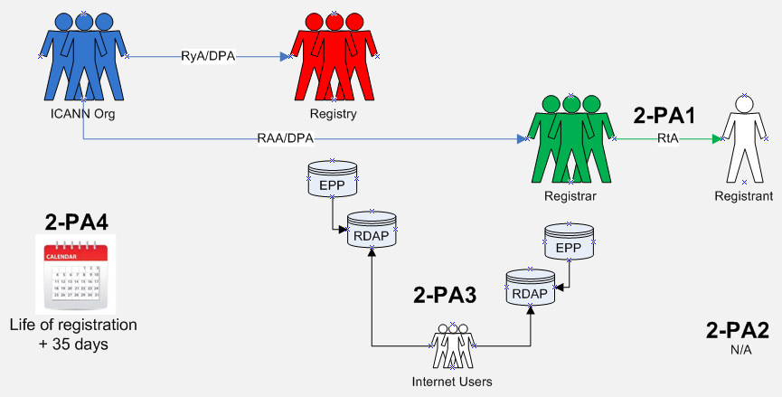

Data Elements Matrix:
“1” = Required “(1)” = Optional “-“ = Not Required or Optional

Data Element  (Collected & Generated*) | Collection  2-PA1 | Transmission  2-PA2 | Disclosure  2-PA3 | Retention  2-PA4 | Redacted  2-PA5
Domain Name | 1 | - | 1 |  | No
Registry Domain ID* | 1 | - | 1 | - | Yes
Registrar Whois Server* | 1 | - | 1 | - | No
Registrar URL* | 1 | - | 1 | - | No
Updated Date* | 1 | - | 1 | - | No
Creation Date* | 1 | - | 1 | - | No
Registry Expiry Date* | 1 | - | 1 | - | No
Registrar Registration Expiration Date* | 1 | - | 1 | - | No
Registrar* | 1 | - | 1 | - | No
Registrar IANA ID* | 1 | - | 1 | - | No
Registrar Abuse Contact Email* | 1 | - | 1 | - | No
Registrar Abuse Contact Phone* | 1 | - | 1 | - | No
Reseller* | 1 | - | 1 |  | No
Domain Status(es)* | 1 | - | 1 | - | No
Registry Registrant ID* | 1 | - | 1 | - | Yes
Registrant Fields
• Name | 1 | - | 1 | - | Yes
• Organization (opt.) | - | - | - | - | No
• Street | 1 | - | 1 | - | Yes
• City | 1 | - | 1 | - | Yes
• State/province | 1 | - | 1 | - | No
• Postal code | 1 | - | 1 | - | Yes
• Country | 1 | - | 1 | - | No
• Phone | 1 | - | 1 | - | Yes
• Phone ext (opt.) | - | - | - | - | -
• Fax (opt.) | - | - | - | - | -
• Fax ext (opt.) | - | - | - | - | -
• Email | 1 | - | 1 |  | No
2nd E-Mail address | - | - | - | - | -
Admin ID* | - | - | - | - | -
Admin Fields
• Name | - | - | - | - | -
• Organization (opt.) | - | - | - | - | -
• Street | - | - | - | - | -
• City | - | - | - | - | -
• State/province | - | - | - | - | -
• Postal code | - | - | - | - | -
• Country | - | - | - | - | -
• Phone | - | - | - | - | -
• Phone ext (opt.) | - | - | - | - | -
• Fax (opt.) | - | - | - | - | -
• Fax ext (opt.) | - | - | - | - | -
• Email | - | - | - | - | -
Tech ID* | (1) | - | - | - | -
Tech Fields
• Name | (1) | - | (1) | - | Yes
• Organization (opt.) | - | - | - | - | -
• Street | - | - | - | - | -
• City | - | - | - | - | -
• State/province | - | - | - | - | -
• Postal code | - | - | - | - | -
• Country | - | - | - | - | -
• Phone | (1) | - | (1) | - | Yes
• Phone ext (opt.) | - | - | - | - | -
• Fax (opt.) | - | - | - | - | -
• Fax ext (opt.) | - | - | - | - | -
• Email | (1) | - | (1) | - | No
NameServer(s) | 1 |  | 1 | - | No
DNSSEC | (1) | - | (1) | - | No
Name Server IP Address | 1 | - | 1 | - | No
Last Update of Whois Database* | 1 | - | 1 | - | No

3 | ICANN PURPOSE:  Enable communication with the Registered Name Holder on matters relating to the Registered Name.
Purpose Rationale:
1) If the purpose is based on an ICANN contract, cite the relevant section of the ICANN contracts that corresponds to the above purpose, if any.

Yes, this purpose is lawful based on ICANN’s mission to coordinate the allocation and assignment of names in the root zone of the Domain Name System. Specifically, section 3.7.7.3 of the RAA refers to providing and updating contact information to facilitate timely resolution of any problems that arise in connection with the Registered Name.

2) Is the purpose in violation with ICANN's bylaws?

No, it is not in violation of ICANN’s Bylaws. Specifically, Article 1, Section 1.1 Mission (a)(i) Coordinates the allocation and assignment of names in the root zone of the Domain Name System ("DNS") and coordinates the development and implementation of policies concerning the registration of second-level domain names in generic top-level domains ("gTLDs"). In this role, ICANN's scope is to coordinate the development and implementation of policies https://www.icann.org/resources/pages/governance/bylaws-en/#article1.

Further, Articles G-1 and G-2 stipulate, “issues for which uniform or coordinated resolution is reasonably necessary to facilitate interoperability, security and/or stability of the Internet, registrar services, registry services, or the DNS;” and “Examples of the above include, without limitation: principles for allocation of registered names in a TLD (e.g., first-come/first-served, timely renewal, holding period after expiration);”.

3) Are there any “picket fence” considerations related to this purpose?

This purpose is related to WHOIS, which is within the Picket Fence. Specifically, Specification 1 of the Registry Agreement and Specification 4 of the Registrar Accreditation Agreement both refer to categories of issues and principles of allocation of registered names in a TLD.

Lawfulness of Processing Test:
Processing Activity: | Responsible Party:  (Charter Questions 3k, 3l, 3m) | Lawful Basis: (Is the processing necessary to achieve the purpose?)
3-PA1: Collection of registration data for contactability/notification purposes  (Charter Question 2b) | ICANN  Registrar  Registries | For Registrars  6(1)(b) - For registrars: This is a 6(1)(b) purpose because it is necessary to collect registrant data so that the registrar can contact the registrant in the event a communication is necessary to maintain the domain operation.  For Registries  6(1)(f) - For third parties who would like to report technical issues to a technical contact: This would be a 6(1)(f) purpose because while there may be a legitimate interest in third parties contacting the registrant (for example, to inform the registrant or designee of a technical issue with the domain name), this is not necessary for the performance of the contract.
3-PA2: Transmission of registration data from Registrar to Registry  (Charter Questions 2c, 2d, 2e, 2i) | ICANN  Registries | This would be a 6(1)(f) processing activity because while there may be a legitimate interest in third parties contacting the registrant (for example, to inform the registrant or designee of a technical issue with the domain name), this is not necessary for the performance of the contract from a registry perspective.
3-PA3: Disclosure of registration data  (Charter Questions 2f (gating questions), 2j) | TBD | TBD
3-PA4: Retention of registration data  (Charter Questions 2g) | ICANN | N/A – see A-PA4

Data Flow Map:
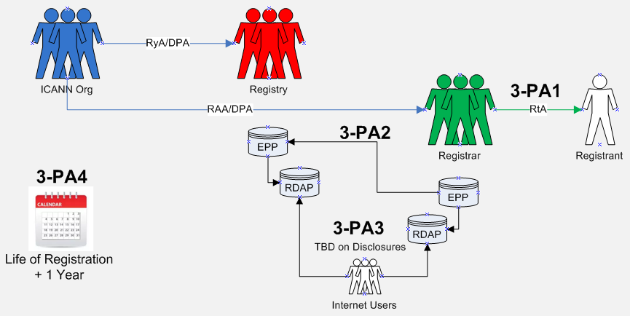
Data Elements Matrix:
“1” = Required “(1)” = Optional “-“ = Not Required or Optional

Data Element  (Collected & Generated*) | Collection  3-PA1 | Transmission  3-PA2 | Disclosure  3-PA3 | Retention  3-PA4
Domain Name | 1 | 1 | - | 1
Registry Domain ID* | - | - | - | -
Registrar Whois Server* | - | - | - | -
Registrar URL* | - | - | - | -
Updated Date* | - | - | - | -
Creation Date* | - | - | - | -
Registry Expiry Date* | - | - | - | -
Registrar Registration Expiration Date* | - | - | - | -
Registrar* | - | - | - | -
Registrar IANA ID* | - | - | - | -
Registrar Abuse Contact Email* | 1 | 1 | - | 1
Registrar Abuse Contact Phone* | - | - | - | -
Reseller* | - | - | - | -
Domain Status(es)* | - | - | - | -
Registry Registrant ID* | - | - | - | -
Registrant Fields
• Name | 1 | 1 | - | 1
• Organization (opt.) | (1) | (1) | - | (1)
• Street | 1 | 1 | - | 1
• City | 1 | 1 | - | 1
• State/province | 1 | 1 | - | 1
• Postal code | 1 | 1 | - | 1
• Country | 1 | 1 | - | 1
• Phone | 1 | 1 | - | 1
• Phone ext (opt.) | (1) | (1) | - | (1)
• Fax (opt.) | (1) | (1) | - | (1)
• Fax ext (opt.) | (1) | (1) | - | (1)
• Email | 1 | 1 | - | 1
2nd E-Mail address | - | - | - | -
Admin ID* | - | - | - | -
Admin Fields
• Name | - | - | - | -
• Organization (opt.) | - | - | - | -
• Street | - | - | - | -
• City | - | - | - | -
• State/province | - | - | - | -
• Postal code | - | - | - | -
• Country | - | - | - | -
• Phone | - | - | - | -
• Phone ext (opt.) | - | - | - | -
• Fax (opt.) | - | - | - | -
• Fax ext (opt.) | - | - | - | -
• Email | - | - | - | -
Tech ID* | (1) | - | - | -
Tech Fields
• Name | (1) | (1) | - | (1)
• Organization (opt.) | - | - | - | -
• Street | - | - | - | -
• City | - | - | - | -
• State/province | - | - | - | -
• Postal code | - | - | - | -
• Country | - | - | - | -
• Phone | (1) | (1) | - | (1)
• Phone ext (opt.) | - | - | - | -
• Fax (opt.) | - | - | - | -
• Fax ext (opt.) | - | - | - | -
• Email | (1) | (1) | - | (1)
NameServer(s) | - | - | - | -
DNSSEC | - | - | - | -
Name Server IP Address | - | - | - | -
Last Update of Whois Database* | - | - | - | -

4A | ICANN PURPOSE:  --For Registrars Only--  Provide mechanisms for safeguarding Registered Name Holders’ Registration Data in the event of a business or technical failure of a Registrar or Registry Operator, or unavailability of a Registrar or Registry Operator, as described in the RAA and RA, respectively.
Purpose Rationale:
1) If the purpose is based on an ICANN contract, cite the relevant section of the ICANN contracts that corresponds to the above purpose, if any.

- Registrar Data Escrow Program: https://www.icann.org/resources/pages/registrar-data-escrow-2015-12-01-en
- Data Fields Source: https://www.icann.org/en/system/files/files/rde-specs-09nov07-en.pdf

Escrowing the data is supported by ICANN’s mandate to provide for security and stability in the DNS and this purpose is primarily protecting the registrant’s rights. Escrow exists because Registrants have a reasonable expectation of business continuity.

It is reasonable to expect that a DPA would consider the escrow of customer data critical to the delivery of the service being provided to be common business practice and legal under GDPR provided appropriate contractual relationships are in place with the escrow agent to ensure that the data, once transferred to the escrow agent is afforded appropriate protection.

While technical and business resiliency could be achieved via other mechanisms, the escrow of data necessary to deliver the service is a generally accepted practice that is likely to be considered necessary to achieve the purpose of “…safeguarding registered name holder’s registration data in the event of a business or technical failure, or other unavailability…”

While all contracted parties that have to be compliant with GDPR need to make sure there are protections against data loss and mechanisms to enable swift data recovery, ICANN is operating at the global level where customers can register domain names with registrars globally and the registry operators are based in numerous jurisdictions, it is important to have interoperability of escrow agents. Requiring all contracted parties to use the same policies for both escrowing data and applying the same standards to escrow agents for making data available, is necessary for contingency planning at the global level.

2) Is the purpose in violation with ICANN's bylaws?

No, providing a safety net for registrants in the event of registry technical of business failure seems within ICANN’s remit.

1.1(a)(i) Coordinates the allocation and assignment of names in the root zone of the Domain Name System ("DNS") and coordinates the development and implementation of policies concerning the registration of second-level domain names in generic top-level domains ("gTLDs"). In this role, ICANN's scope is to coordinate the development and implementation of policies:
- For which uniform or coordinated resolution is reasonably necessary to facilitate the openness, interoperability, resilience, security and/or stability of the DNS including, with respect to gTLD registrars and registries, policies in the areas described in Annex G-1 and Annex G-2; and
- That are developed through a bottom-up consensus-based multistakeholder process and designed to ensure the stable and secure operation of the Internet's unique names systems.
The issues, policies, procedures, and principles addressed in Annex G-1 and Annex G-2 with respect to gTLD registrars and registries shall be deemed to be within ICANN's Mission.

3) Are there any “picket fence” considerations related to this purpose?

Only with respect to the data model(s) defined within RDDS/Whois consensus policies. Agreements between ICANN and escrow providers are not within scope of the picket fence.

Lawfulness of Processing Test:
Processing Activity: | Responsible Party:  (Charter Questions 3k, 3l, 3m) | Lawful Basis: (Is the processing necessary to achieve the purpose?)
4A-PA1: Collection of registration data for escrow  (Charter Question 2b) | ICANN | 6(1)(f)  This Processing Activity of Collection is not required to be documented within the Purpose for Registrar Escrow because the processing activity for transmission of registration data to the Data Escrow Agent (as noted below) has already been collected or generated from other ICANN Purposes that also contain processing activities for the collection of registration data.  However, the transparency of collection to the Registrant/Data Subject for the purpose of escrow is required. Refer to the Purpose for establishing the rights of the Registered Name Holder.
4A-PA2: Transmission of registration data to Data Escrow Agent  (Charter Questions 2c, 2d, 2e, 2i) | ICANN | This is a 6(1)(f) lawful basis because although there is likely a legitimate interest in providing mechanisms for safeguarding Registered Name Holders' Registration Data in the event of a business or technical failure, or other unavailability of a Registrar or Registry Operator, it is not technically necessary to transmit data to an escrow agent in order to allocate a string to a registered name holder, and is therefore not necessary to perform the registration contract.
4A-PA3: Disclosure of registration data to Gaining Registrar  (Charter Questions 2f (gating questions), 2j) | ICANN | This is a 6(1)(f) lawful basis because although there is likely a legitimate interest in providing mechanisms for safeguarding Registered Name Holders' Registration Data in the event of a business or technical failure, or other unavailability of a Registrar or Registry Operator, it is not technically necessary to transmit data to an escrow agent in order to allocate a string to a registered name holder, and is therefore not necessary to perform the registration contract.  Data is not made public for escrow purposes, but a transfer to the escrow agent and - in case of contingencies - the transfer to a Gaining Registrar is required to ensure that operations are not impaired.  How and who ICANN choses as the Gaining Registrar may have additional implications to the lawfulness should the Gaining Registrar not reside within the EU when the Losing Registrar did reside within the EU.
4A-PA4: Retention of registration data by Data Escrow Agent  (Charter Questions 2g) | ICANN | This is a 6(1)(f) lawful basis due to the connection of Retention with Transmission of registration data to the Data Escrow Agent from the Registry.  From the Escrow Specification (3.3.1.6), deposits to Third-Party Escrow Agents two copies are held for one year.  Questions about the validity of the one year for TPP, noting that no retention is listed for ICANN approved vendors, given that once a new deposit occurs and is verified, it renders prior deposits useless.  The EPDP also discussed that perhaps some minimal retention could be necessary from an overall continuity perspective.

Data Flow Map:
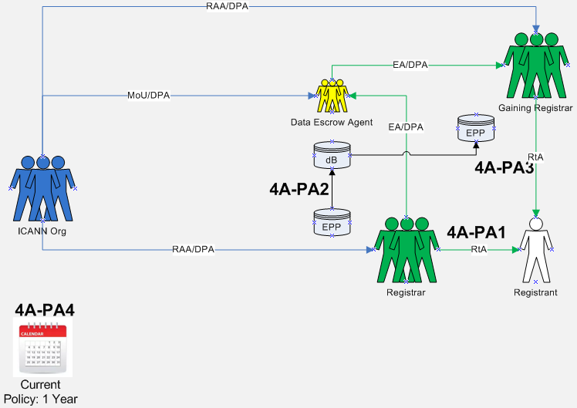

Data Elements Matrix:
“1” = Required “(1)” = Optional “-“ = Not Required or Optional

Data Element  (Collected & Generated*) | Collection  4A-PA1 | Transmission  4A-PA2 | Disclosure  4A-PA3 | Retention  4A-PA4
Domain Name | - | 1 | 1 | 1
Registry Domain ID* | - | - | - | -
Registrar Whois Server* | - | - | - | -
Registrar URL* | - | - | - | -
Updated Date* | - | - | - | -
Creation Date* | - | - | - | -
Registry Expiry Date* | - | - | - | -
Registrar Registration Expiration Date* | - | 1 | 1 | 1
Registrar* | - | 1 | 1 | 1
Registrar IANA ID* | - | - | - | -
Registrar Abuse Contact Email* | - | - | - | -
Registrar Abuse Contact Phone* | - | - | - | -
Reseller* | - | 1 | 1 | 1
Domain Status(es)* | - | - | - | -
Registry Registrant ID* | - | - | - | -
Registrant Fields
• Name | - | 1 | 1 | 1
• Organization (opt.) | - | - | - | -
• Street | - | 1 | 1 | 1
• City | - | 1 | 1 | 1
• State/province | - | 1 | 1 | 1
• Postal code | - | 1 | 1 | 1
• Country | - | 1 | 1 | 1
• Phone | - | 1 | 1 | 1
• Phone ext (opt.) | - | - | - | -
• Fax (opt.) | - | - | - | -
• Fax ext (opt.) | - | - | - | -
• Email | - | 1 | 1 | 1
2nd E-Mail address | - | - | - | -
Admin ID* | - | - | - | -
Admin Fields
• Name | - | - | - | -
• Organization (opt.) | - | - | - | -
• Street | - | - | - | -
• City | - | - | - | -
• State/province | - | - | - | -
• Postal code | - | - | - | -
• Country | - | - | - | -
• Phone | - | - | - | -
• Phone ext (opt.) | - | - | - | -
• Fax (opt.) | - | - | - | -
• Fax ext (opt.) | - | - | - | -
• Email | - | - | - | -
Tech ID* | - | - | - | -
Tech Fields
• Name | - | - | - | -
• Organization (opt.) | - | - | - | -
• Street | - | - | - | -
• City | - | - | - | -
• State/province | - | - | - | -
• Postal code | - | - | - | -
• Country | - | - | - | -
• Phone | - | - | - | -
• Phone ext (opt.) | - | - | - | -
• Fax (opt.) | - | - | - | -
• Fax ext (opt.) | - | - | - | -
• Email | - | - | - | -
NameServer(s) | - | - | - | -
DNSSEC | - | - | - | -
Name Server IP Address | - | - | - | -
Last Update of Whois Database* | - | - | - | -

4B | ICANN PURPOSE:  --For Registries Only--  Provide mechanisms for safeguarding Registered Name Holders’ Registration Data in the event of a business or technical failure of a Registrar or Registry Operator, or unavailability of a Registrar or Registry Operator, as described in the RAA and RA, respectively.
Purpose Rationale:
1) If the purpose is based on an ICANN contract, cite the relevant section of the ICANN contracts that corresponds to the above purpose, if any.

- Registry EBERO Program - https://www.icann.org/resources/pages/ebero-2013-04-02-en
- Registry Data Escrow Specification: https://newgtlds.icann.org/sites/default/files/agreements/agreement-approved-31jul17-en.html#specification2
- Data Fields Sources:
  - http://tools.ietf.org/html/draft-arias-noguchi-registry-data-escrow
  - https://tools.ietf.org/html/draft-arias-noguchi-dnrd-objects-mapping-09

Escrowing the data is supported by ICANN’s mandate to provide for security and stability in the DNS and this purpose is primarily protecting the registrant’s rights. Escrow exists because Registrants have a reasonable expectation of business continuity.

It is reasonable to expect that a DPA would consider the escrow of customer data critical to the delivery of the service being provided to be common business practice and legal under GDPR provided appropriate contractual relationships are in place with the escrow agent to ensure that the data, once transferred to the escrow agent is afforded appropriate protection.

While technical and business resiliency could be achieved via other mechanisms, the escrow of data necessary to deliver the service is a generally accepted practice that is likely to be considered necessary to achieve the purpose of “…safeguarding registered name holder’s registration data in the event of a business or technical failure, or other unavailability…”

While all contracted parties that have to be compliant with GDPR need to make sure there are protections against data loss and mechanisms to enable swift data recovery, ICANN is operating at the global level where customers can register domain names with registrars globally and the registry operators are based in numerous jurisdictions, it is important to have interoperability of escrow agents. Requiring all contracted parties to use the same policies for both escrowing data and applying the same standards to escrow agents for making data available, is necessary for contingency planning at the global level.

Within the Temporary Specification, EBERO is mentioned as Processing Activity under Appendix C. The Charter Question, Part 2i, tasks the EPDP to consider if this Processing Activity should be eliminated or adjusted. Based on initial research of the EBERO process, Registry Escrow is invoked as a component of the overall process with no indication that registration data other than what is identified here is transferred within any of the other EBERO components. The EPDP concluded that documentation of EBERO can be satisfied within the processing activities defined for this purpose of Registry Escrow.

2) Is the purpose in violation with ICANN's bylaws?

No, providing a safety net for registrants in the event of registry technical of business failure seems within ICANN’s remit.

1.1(a)(i) Coordinates the allocation and assignment of names in the root zone of the Domain Name System ("DNS") and coordinates the development and implementation of policies concerning the registration of second-level domain names in generic top-level domains ("gTLDs"). In this role, ICANN's scope is to coordinate the development and implementation of policies:
- For which uniform or coordinated resolution is reasonably necessary to facilitate the openness, interoperability, resilience, security and/or stability of the DNS including, with respect to gTLD registrars and registries, policies in the areas described in Annex G-1 and Annex G-2; and
- That are developed through a bottom-up consensus-based multistakeholder process and designed to ensure the stable and secure operation of the Internet's unique names systems.
The issues, policies, procedures, and principles addressed in Annex G-1 and Annex G-2 with respect to gTLD registrars and registries shall be deemed to be within ICANN's Mission.

3) Are there any “picket fence” considerations related to this purpose?

Only with respect to the data model(s) defined within RDDS/Whois consensus policies. Agreements between ICANN and Data Escrow Providers are not within scope of the picket fence.

Lawfulness of Processing Test:
Processing Activity: | Responsible Party:  (Charter Questions 3k, 3l, 3m) | Lawful Basis: (Is the processing necessary to achieve the purpose?)
4B-PA1: Collection of registration data for escrow  (Charter Question 2b) | ICANN | 6(1)(f)  This Processing Activity of Collection is not required to be documented within the Purpose for Registry Escrow because the processing activity for transmission of registration data to the Data Escrow Agent (as noted below) has already been collected or generated from other ICANN Purposes that also contain Processing Activities for the transfer of registration data from the Registrar to the Registry.  However, the transparency of collection to the Registrant/Data Subject for the purpose of escrow is required. Refer to the Purpose for establishing the rights of the Registered Name Holder.
4B-PA2: Transmission of registration data to Data Escrow Agent  (Charter Questions 2c, 2d, 2e, 2i) | ICANN | This is a 6(1)(f) lawful basis because although there is likely a legitimate interest in providing mechanisms for safeguarding Registered Name Holders' Registration Data in the event of a business or technical failure, or other unavailability of a Registrar or Registry Operator, it is not technically necessary to transmit data to an escrow agent in order to allocate a string to a registered name holder, and is therefore not necessary to perform the registration contract.
4B-PA3: Disclosure of registration data to EBERO Provider  (Charter Questions 2f (gating questions), 2j) | ICANN | This is a 6(1)(f) lawful basis because although there is likely a legitimate interest in providing mechanisms for safeguarding Registered Name Holders' Registration Data in the event of a business or technical failure, or other unavailability of a Registrar or Registry Operator, it is not technically necessary to transmit data to an escrow agent in order to allocate a string to a registered name holder, and is therefore not necessary to perform the registration contract.  Specification 2, Part B “Legal Requirements”, #6 under “Integrity and Confidentiality” stipulates how the release of a deposit is made.  How and who ICANN chooses as the EBERO Provider may have additional implications to the lawfulness should the EBERO Provider not reside within the EU when the Losing Registry did reside within the EU.
4B-PA4: Disclosure of registration data to Gaining Registry  (Charter Questions 2f (gating questions), 2j) | ICANN | This is a 6(1)(f) lawful basis because although there is likely a legitimate interest in providing mechanisms for safeguarding Registered Name Holders' Registration Data in the event of a business or technical failure, or other unavailability of a Registrar or Registry Operator, it is not technically necessary to transmit data to an escrow agent in order to allocate a string to a registered name holder, and is therefore not necessary to perform the registration contract.  Specification 2, Part B “Legal Requirements”, #6 under “Integrity and Confidentiality” stipulates how the release of a deposit is made.
4B-PA5: Retention of registration data by Data Escrow Agent  (Charter Questions 2g) | ICANN | This is a 6(1)(f) lawful basis due to the connection between the Retention processing activity with that of the Transmission of registration data to the Data Escrow Agent from the Registry.  Specification 2, Part B “Legal Requirements”, #4 under “Integrity and Confidentiality” stipulates “(iii) keep and safeguard each Deposit for one (1) year.”  Once a full escrow deposit has been successfully received and validated by the escrow agent, any previous deposits are obsolete and of no value. In the event of differential deposits, a 1-week retention would be required. The working group recommends that a 1 month minimum retention period by the escrow agent be established to provide an additional buffer against technical failure by the escrow agent.

Data Flow Map:
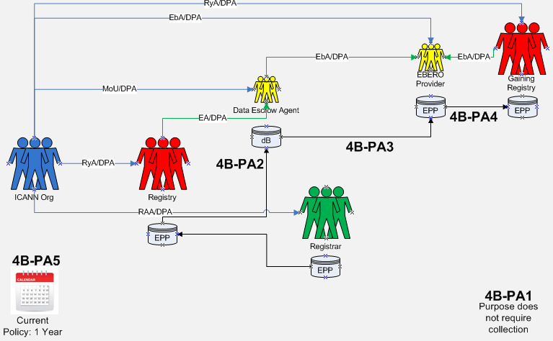

Data Elements Matrix:
“1” = Required “(1)” = Optional “-“ = Not Required or Optional

Data Element  (Collected & Generated*) | Collection  4B-PA1 | Transmission  4B-PA2 | Disclosure  4B-PA3 | Disclosure  4B-PA4 | Retention  4B-PA5
Domain Name | - | 1 | 1 | 1 | 1
Registry Domain ID* | - | 1 | 1 | 1 | 1
Registrar Whois Server* | - | 1 | 1 | 1 | 1
Registrar URL* | - | 1 | 1 | 1 | 1
Updated Date* | - | 1 | 1 | 1 | 1
Creation Date* | - | 1 | 1 | 1 | 1
Registry Expiry Date* | - | 1 | 1 | 1 | 1
Registrar Registration Expiration Date* | - | 1 | 1 | 1 | 1
Registrar* | - | 1 | 1 | 1 | 1
Registrar IANA ID* | - | 1 | 1 | 1 | 1
Registrar Abuse Contact Email* | - | 1 | 1 | 1 | 1
Registrar Abuse Contact Phone* | - | 1 | 1 | 1 | 1
Reseller* | - | 1 | 1 | 1 | 1
Domain Status(es)* | - | 1 | 1 | 1 | 1
Registry Registrant ID* | - | 1 | 1 | 1 | 1
Registrant Fields
• Name | - | 1 | 1 | 1 | 1
• Organization (opt.) | - | (1) | (1) | (1) | (1)
• Street | - | 1 | 1 | 1 | 1
• City | - | 1 | 1 | 1 | 1
• State/province | - | 1 | 1 | 1 | 1
• Postal code | - | 1 | 1 | 1 | 1
• Country | - | 1 | 1 | 1 | 1
• Phone | - | 1 | 1 | 1 | 1
• Phone ext (opt.) | - | (1) | (1) | (1) | (1)
• Fax (opt.) | - | (1) | (1) | (1) | (1)
• Fax ext (opt.) | - | (1) | (1) | (1) | (1)
• Email | - | 1 | 1 | 1 | 1
2nd E-Mail address | - | - | - | - | -
Admin ID* | - | - | - | - | -
Admin Fields
• Name | - | - | - | - | -
• Organization (opt.) | - | - | - | - | -
• Street | - | - | - | - | -
• City | - | - | - | - | -
• State/province | - | - | - | - | -
• Postal code | - | - | - | - | -
• Country | - | - | - | - | -
• Phone | - | - | - | - | -
• Phone ext (opt.) | - | - | - | - | -
• Fax (opt.) | - | - | - | - | -
• Fax ext (opt.) | - | - | - | - | -
• Email | - | - | - | - | -
Tech ID* | - | - | - | - | -
Tech Fields
• Name | - | (1) | (1) | (1) | (1)
• Organization (opt.) | - | - | - | - | -
• Street | - | - | - | - | -
• City | - | - | - | - | -
• State/province | - | - | - | - | -
• Postal code | - | - | - | - | -
• Country | - | - | - | - | -
• Phone | - | (1) | (1) | (1) | (1)
• Phone ext (opt.) | - | - | - | - | -
• Fax (opt.) | - | - | - | - | -
• Fax ext (opt.) | - | - | - | - | -
• Email | - | (1) | (1) | (1) | (1)
NameServer(s) | - | 1 | 1 | 1 | 1
DNSSEC | - | 1 | 1 | 1 | 1
Name Server IP Address | - | 1 | 1 | 1 | 1
Last Update of Whois Database* | - | 1 | 1 | 1 | 1

5 | ICANN PURPOSE:  1) Handle contractual compliance monitoring requests and audit activities consistent with the terms of the registry agreement and the registrar accreditation agreements and any applicable data processing agreements, by processing specific data only as necessary;  2) Handle compliance complaints initiated by ICANN, or third parties consistent with the terms of the registry agreement and the registrar accreditation agreements.
Purpose Rationale:
1) If the purpose is based on an ICANN contract, cite the relevant section of the ICANN contracts that corresponds to the above purpose, if any.

RA - https://newgtlds.icann.org/sites/default/files/agreements/agreement-approved-31jul17-en.html
Registry:
2.2 Compliance with Consensus Policies and Temporary Policies
2.11 Contractual and Operational Compliance Audits
Specification 4, 3.1 Periodic Access to Thin Registration Data
Specification 11 Public Interest Commitments

RAA - https://www.icann.org/resources/pages/approved-with-specs-2013-09-17-en
Registrar:
Registrar Obligations - 3.4.3, 3.7.7
3.15 Registrar Self-Assessment and Audits
4.1 Compliance with Consensus Policies and Temporary Policies
Data Retention Specification, 2.

If a contractual compliance complaint is filed, the complainant provides certain information regarding the issue, which may contain personal data. Depending on the nature of the issue, ICANN Compliance may ask the Registrar or Registry Operator for the minimum data needed to investigate the complaint. Compliance may also look at the public WHOIS to supplement its review or processing.

For ICANN Contractual Compliance audits, ICANN sends audit questionnaires to Registry Operators and Registrars. In responding to the questionnaire, the Registry Operator and Registrar could include personal data in its responses.

Also, as part of Registry Operator audits, ICANN Contractual Compliance requests escrowed data to cross-reference information between data escrow and zone file and bulk registration data access for a sample of 25 domain names to ensure consistency.

2) Is the purpose in violation with ICANN's bylaws?

No. Per ICANN’s Mission, Section 1.1(a)(i):
“..In this role, ICANN's scope is to coordinate the development and implementation of policies:
....That are developed through a bottom-up consensus-based multistakeholder process and designed to ensure the stable and secure operation of the Internet's unique names systems.
..The issues, policies, procedures, and principles addressed in Annex G-1 and Annex G-2 with respect to gTLD registrars and registries shall be deemed to be within ICANN's Mission.”

3) Are there any “picket fence” considerations related to this purpose?

No. Registration Directory Services is within the “picket fence” as noted in ICANN Mission and Bylaws and contracts with ICANN to Registries and Registrars.

Lawfulness of Processing Test:
Processing Activity: | Responsible Party:  (Charter Questions 3k, 3l, 3m) | Lawful Basis: (Is the processing necessary to achieve the purpose?)
5-PA1: Collection of registration data for compliance with ICANN contracts  (Charter Question 2b) | ICANN | This is a 6(1)(f) purpose because although there may be a legitimate interest in collecting registration data for ICANN org compliance to confirm compliance with the RAA/RA, this collection is not technically necessary to perform the registration contract.  The BC and IPC disagree that Purpose F is a 6(1)(f) purpose. The Team tentatively agreed to the following: (a) 6(1)(f) is an appropriate legal basis for the compliance purpose; (b) Some (BC and IPC) believe Purpose F may be a 6(1)(b); (c) There are concerns that 6(1)(f) may cause issues where the controller determines that the privacy rights outweigh the legitimate interest and therefore data cannot be provided.
5-PA2: Transmission of registration data to ICANN org compliance  (Charter Questions 2c, 2d, 2e, 2i) | ICANN | This is a 6(1)(f) purpose because although there may be a legitimate interest in transmitting registration data to ICANN org compliance to confirm compliance with the RAA/RA, this transmission is not technically necessary to perform the registration contract.
5-PA3: Disclosure of registration data  (Charter Questions 2f (gating questions), 2j) | N/A | N/A
5-PA4: Retention of registration data by ICANN Compliance  (Charter Questions 2g) | ICANN | Must go beyond the life of registration for a certain time period in order for ICANN Contractual Compliance to be able to enforce various ICANN contracts and policies.

Data Flow Map:
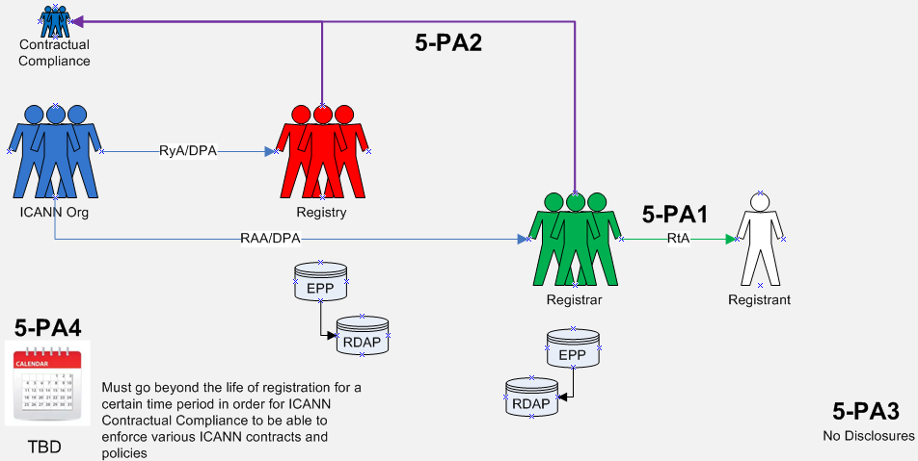

Data Elements Matrix:
“1” = Required “(1)” = Optional “-“ = Not Required or Optional

Data Element  (Collected & Generated*) | Collection  5-PA1 | Transmission  5-PA2 | Disclosure  5-PA3 | Retention  5-PA4
Domain Name | 1 | 1 | - | 1
Registry Domain ID* | 1 | 1 | - | 1
Registrar Whois Server* | 1 | 1 | - | 1
Registrar URL* | 1 | 1 | - | 1
Updated Date* | 1 | 1 | - | 1
Creation Date* | 1 | 1 | - | 1
Registry Expiry Date* | 1 | 1 | - | 1
Registrar Registration Expiration Date* | 1 | 1 | - | 1
Registrar* | 1 | 1 | - | 1
Registrar IANA ID* | 1 | 1 | - | 1
Registrar Abuse Contact Email* | 1 | 1 | - | 1
Registrar Abuse Contact Phone* | 1 | 1 | - | 1
Reseller* | 1 | 1 | - | 1
Domain Status(es)* | 1 | 1 | - | 1
Registry Registrant ID* | 1 | 1 | - | 1
Registrant Fields
• Name | 1 | 1 | - | 1
• Organization (opt.) | (1) | (1) | - | (1)
• Street | 1 | 1 | - | 1
• City | 1 | 1 | - | 1
• State/province | 1 | 1 | - | 1
• Postal code | 1 | 1 | - | 1
• Country | 1 | 1 | - | 1
• Phone | 1 | 1 | - | 1
• Phone ext (opt.) | (1) | (1) | - | (1)
• Fax (opt.) | (1) | (1) | - | (1)
• Fax ext (opt.) | (1) | (1) | - | (1)
• Email | 1 | 1 | - | 1
2nd E-Mail address | - | - | - | -
Admin ID* | - | - | - | -
Admin Fields
• Name | - | - | - | -
• Organization (opt.) | - | - | - | -
• Street | - | - | - | -
• City | - | - | - | -
• State/province | - | - | - | -
• Postal code | - | - | - | -
• Country | - | - | - | -
• Phone | - | - | - | -
• Phone ext (opt.) | - | - | - | -
• Fax (opt.) | - | - | - | -
• Fax ext (opt.) | - | - | - | -
• Email | - | - | - | -
Tech ID* | (1) | (1) | - | (1)
Tech Fields
• Name | (1) | (1) | - | (1)
• Organization (opt.) | - | - | - | -
• Street | - | - | - | -
• City | - | - | - | -
• State/province | - | - | - | -
• Postal code | - | - | - | -
• Country | - | - | - | -
• Phone | (1) | (1) | - | (1)
• Phone ext (opt.) | - | - | - | -
• Fax (opt.) | - | - | - | -
• Fax ext (opt.) | - | - | - | -
• Email | (1) | (1) | - | (1)
NameServer(s) | 1 | 1 | - | 1
DNSSEC | 1 | 1 | - | 1
Name Server IP Address | 1 | 1 | - | 1
Last Update of Whois Database* | 1 | 1 | - | 1

6 | ICANN PURPOSE:  Operationalize policies for the resolution of disputes regarding or relating to the registration of domain names (as opposed to the use of such domain names, but including where such policies take into account use of the domain names), namely the UDRP, URS, PDDRP, RRDRP, and the TDRP.
Purpose Rationale:
1) If the purpose is based on an ICANN contract, cite the relevant section of the ICANN contracts that corresponds to the above purpose, if any.

- RAA - https://www.icann.org/resources/pages/approved-with-specs-2013-09-17-en
  - Section 3.8
- RyA - https://newgtlds.icann.org/sites/default/files/agreements/agreement-approved-31jul17-en.html
  - Specification 7

ICANN Org to provide EPDP Team with copy of agreements with UDRP/URS providers in relation to data protection / transfer of data as well as the relevant data protection policies that dispute resolution providers have in place.

Rights Protection Mechanisms (RPMs) provisions exist within both the Registry and Registrar agreements as connected to ICANN Bylaws. This purpose is connected to Rights Protection Mechanisms of Uniform Dispute Resolution Mechanism (UDRP) and Uniform Rapid Suspension (URS), but it does not preclude RPMs that could be created or modified in the future.

RRDRP and PDDRP RPMs were also considered whether they should be connected to this purpose. While there was not agreement as to whether these RPMs involve registration data, they have been included in this workbook for purposes of the Initial Report.

2) Is the purpose in violation with ICANN's bylaws?

No.

ICANN bylaws, Section 1.1(a)(i), as a part of “Mission” refer to Annexes G1 and G2. Annex G-1 contains a provision for Registrars, “resolution of disputes regarding the registration of domain names (as opposed to the use of such domain names, but including where such policies take into account use of the domain names)” Annex G-2 also contains, “resolution of disputes regarding the registration of domain names (as opposed to the use of such domain names)”.

3) Are there any “picket fence” considerations related to this purpose?

Resolution of disputes regarding or relating to the registration of domain names (as opposed to the use of such domain names) are considered within the picket fence for the development of consensus policies. The purpose and the processing hereunder, as specified by the collection, transmission and disclosure of the data elements identified, are considered within the picket fence based upon the coordination, operationalization and facilitation of the dispute resolution mechanisms listed. The Temp Spec (Appendix D & E) now makes reference to who an RPM provider must contact based on Thick or Thin RDS to obtain registration data for the complaint.

Lawfulness of Processing Test:
Processing Activity: | Responsible Party:  (Charter Questions 3k, 3l, 3m) | Lawful Basis: (Is the processing necessary to achieve the purpose?)
6-PA1: Collection of registration data to implement the UDRP and URS  (Charter Question 2b) | ICANN  Registrars | This is a 6(1)(b) purpose because it is necessary to collect registration data in order to facilitate/implement a UDRP or URS decision. For example, in the case of a UDRP/URS proceeding, the Registrant must agree to be bound by the UDRP/URS in order to register a domain name, so the collection of data for this purpose is necessary to fulfill the registration agreement.
 | ICANN  Registries | This is a 6(1)(f) purpose because ICANN and Registries do not have a direct contract with the registrant. The Registry must process data to fulfill its obligations regarding the RPMs, compliance with which are incorporated into the Registry Agreement.  Under Article 6(1)(f) with regard to the URS and UDRP for registries and ICANN, because the processing is necessary for the purposes of pursued legitimate interests that are not overridden by the interests or fundamental rights and freedoms of the data subject. With regard to this balancing test, we note that the contacts are important to ensure due process for the registrant so that they have notice of the proceedings and can avoid losing their domain name through a default.
6-PA2: Collection of registration data to implement the RDDRP and PDDRP | ICANN  Registries  Registrars | This is a 6(1)(f) with regard to the RDDRP and PDDRP for registrars, registries, and ICANN, because the processing is necessary for the purposes of pursued legitimate interests that are not overridden by the interests or fundamental rights and freedoms of the data subject.
6-PA3: Transmission of registration data from Registrar to Registry  (Charter Questions 2c, 2d, 2e, 2i) | ICANN  Registrars | This is a 6(1)(b) purpose because transmission of (at least minimal) registration data from the Registrar to the Registry is necessary to identify the Registrant for purposes of dispute resolution.
 | ICANN  Registries | This is a 6(1)(f) purpose because although there is a legitimate interest in transmitting registration data to the Registry, this transmission is not technically necessary to perform the registration contract. The Registry must process data to fulfill its obligations regarding the RPMs and DRPs, compliance with which are incorporated into the Registry Agreement.
6-PA4: Transmission of registration data to dispute resolution provider to administer the UDRP, URS, RDDRP, and PDDRP  (Charter Questions 2c, 2d, 2e, 2i) | ICANN  Registries  Registrars  Dispute Resolution Provider – Processor or independent controller | 6(1)(b) for Registrars  6(1)(f) for Registries and ICANN  This is a 6(1)(f) purpose because although there may be a legitimate interest in transmitting registration data to Dispute Resolution Providers, this transmission is not technically necessary to perform the registration contract.
6-PA5: Disclosure of registration data used for complaints on dispute provider sites  (Charter Questions 2f (gating questions), 2j) | Dispute Resolution Provider – Processor or independent controller | TBD
6-PA6: Retention of registration data used for complaints  (Charter Questions 2g) | TBD | TBD  The EPDP Team is not aware of any currently data retention requirements by dispute resolution providers.  Data retention requirement for registrars should be uniform with other requirements.

Data Flow Map:
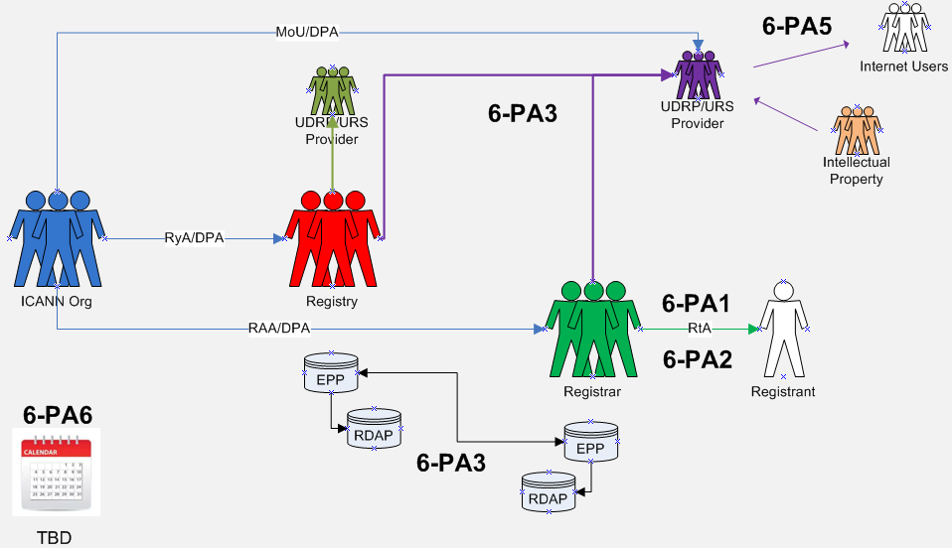

Data Elements Matrix:
“1” = Required “(1)” = Optional “-“ = Not Required or Optional

Data Element  (Collected & Generated*) | Collection  6-PA1 | Collection  6-PA2 | Transmission  6-PA3 | Transmission  6-PA4 | Disclosure  6-PA5 | Retention  6-PA6
Domain Name | 1 | 1 | 1 | 1 | 1 | -
Registry Domain ID* | - |  |  | - | - | -
Registrar Whois Server* | 1 | 1 | 1 | 1 | - | -
Registrar URL* | 1 | 1 | 1 | 1 | - | -
Updated Date* | 1 | 1 | 1 | 1 | - | -
Creation Date* | 1 | 1 | 1 | 1 | - | -
Registry Expiry Date* | 1 | 1 | 1 | 1 | - | -
Registrar Registration Expiration Date* | 1 | 1 | 1 | 1 | - | -
Registrar* | 1 | 1 | 1 | 1 | 1 | -
Registrar IANA ID* | 1 | 1 | 1 | 1 | - | -
Registrar Abuse Contact Email* | 1 | 1 | 1 | 1 | - | -
Registrar Abuse Contact Phone* | 1 | 1 | 1 | 1 | - | -
Reseller* | 1 | 1 | 1 | 1 | - | -
Domain Status(es)* | 1 | 1 | 1 | 1 | - | -
Registry Registrant ID* | - |  |  | - | - | -
Registrant Fields
• Name | 1 | 1 | 1 | 1 | 1 | -
• Organization (opt.) | (1) | (1) | (1) | (1) | 1 | -
• Street | 1 | 1 | 1 | 1 | - | -
• City | 1 | 1 | 1 | 1 | 1 | -
• State/province | 1 | 1 | 1 | 1 | 1 | -
• Postal code | 1 | 1 | 1 | 1 | - | -
• Country | 1 | 1 | 1 | 1 | 1 | -
• Phone | (1) | (1) | (1) | (1) | - | -
• Phone ext (opt.) | (1) | (1) | (1) | (1) | - | -
• Fax (opt.) | (1) | (1) | (1) | (1) | - | -
• Fax ext (opt.) | (1) | (1) | (1) | (1) | - | -
• Email | 1 | 1 | 1 | 1 | - | -
2nd E-Mail address | - | - | - | - | - | -
Admin ID* | - | - | - | - | - | -
Admin Fields
• Name | - | - | - | - | - | -
• Organization (opt.) | - | - | - | - | - | -
• Street | - | - | - | - | - | -
• City | - | - | - | - | - | -
• State/province | - | - | - | - | - | -
• Postal code | - | - | - | - | - | -
• Country | - | - | - | - | - | -
• Phone | - | - | - | - | - | -
• Phone ext (opt.) | - | - | - | - | - | -
• Fax (opt.) | - | - | - | - | - | -
• Fax ext (opt.) | - | - | - | - | - | -
• Email | - | - | - | - | - | -
Tech ID* | - | - | - | - | - | -
Tech Fields
• Name | - | - | - | - | - | -
• Organization (opt.) | - | - | - | - | - | -
• Street | - | - | - | - | - | -
• City | - | - | - | - | - | -
• State/province | - | - | - | - | - | -
• Postal code | - | - | - | - | - | -
• Country | - | - | - | - | - | -
• Phone | - | - | - | - | - | -
• Phone ext (opt.) | - | - | - | - | - | -
• Fax (opt.) | - | - | - | - | - | -
• Fax ext (opt.) | - | - | - | - | - | -
• Email | - | - | - | - | - | -
NameServer(s) | - | - | - | - | - | -
DNSSEC | - | - | - | - | - | -
Name Server IP Address | - | - | - | - | - | -
Last Update of Whois Database* | - | - | - | - | - | -

7 | ICANN PURPOSE:  Enabling validation to confirm that Registered Name Holder meets gTLD registration policy eligibility criteria voluntarily adopted by Registry Operator and that are described or referenced in the Registry Agreement for that gTLD.
Purpose Rationale:
1) If the purpose is based on an ICANN contract, is this lawful as tested against GDPR and other laws?

Yes. Registry Agreement allows Registry Operators to establish, publish, and adhere to clear registration policies (e.g., Spec. 11, 3(d); Spec. 12; Spec. 13). See also ICANN Bylaws (Art. 1.1(a)(i) and Annex G-2).
Enabling validation to confirm that Registered Name Holder meets registration policy eligibility criteria introduces innovation and differentiation in the gTLD space.

2) Is the purpose in violation with ICANN's bylaws?

No. This purpose is consistent with ICANN’s Mission of coordinating the development and implementation of policies concerning the registration of second-level domain names in gTLDs (Introduction of New gTLDs and Applicant Guidebook), and principles for allocation of registered names in a TLD (Annex G-2)

3) Are there any “picket fence” considerations related to this purpose?

Within picket fence.

Lawfulness of Processing Test:
Processing Activity: | Responsible Party:  (Charter Questions 3k, 3l, 3m) | Lawful Basis: (Is the processing necessary to achieve the purpose?)
7-PA1: Collecting specific data for Registry Agreement-mandated eligibility requirements  (Charter Question 2b) | Registries | 6(1)(b) (for ICANN, registrars- or Registry-mandated eligibility requirements) because it is necessary to collect specific Registrant data to confirm the registrant meets the specific requirements of the registration agreement, i.e., registrar needs to verify the registrant is a licensed attorney to register a .abogado domain name.  6(1)(f) for Registries, which are not parties to the registration agreement, but process the data in accordance with the obligations under the Registry-Registrar Agreement to allocate and activate domain names for registered name holders that meet the registration policy eligibility requirements
7-PA2: Collecting specific data for Registry Operator-adopted eligibility requirements  (Charter Question 2b) | Registries | 6(1)(b) for Registrars because it is necessary to collect specific registrant data to confirm the registrant meets the specific requirements of the registration agreement, i.e., registrar needs to verify the registrant is a licensed attorney to register a .abogado domain name  6(1)(f) for Registries, which are not parties to the registration agreement, but process the data in accordance with the obligations under the Registry-Registrar Agreement to allocate and activate domain names for Registered Name Holders that meet the registration policy eligibility requirements
7-PA3: Transfer of registration data from registrar to registry  (Charter Questions 2c, 2d, 2e, 2i) | RA-mandated eligibility requirements  Registries | 6(1)(b) for Registrars because transfer from Registrar to Registry of registration data elements that demonstrate satisfaction of registration policy eligibility criteria is necessary so that the registry may validate satisfaction of eligibility criteria, and comply with ICANN audit requests.  6(1)(f) for Registries. The transfer is necessary so that the Registry may validate satisfaction of eligibility criteria and comply with ICANN audit requests.
7-PA4: Transfer of registration data from registrar to registry  (Charter Questions 2c, 2d, 2e, 2i) | Registry-adopted eligibility requirements  Registries | 6(1)(b) for registrars because transfer from registrar to registry of registration data elements that demonstrate satisfaction of registration policy eligibility criteria is necessary so that the registry may validate satisfaction of eligibility criteria.  6(1)(f) for registries. The transfer is necessary so that the registry may validate satisfaction of eligibility criteria and comply with ICANN audit requests.
7-PA5: Disclosure of registration data  (Charter Questions 2f (gating questions), 2j) | Registries | N/A
7-PA6: Retention of registration data  (Charter Questions 2g) | Registries | 6(1)(f)  Life of registration.

Data Flow Map:
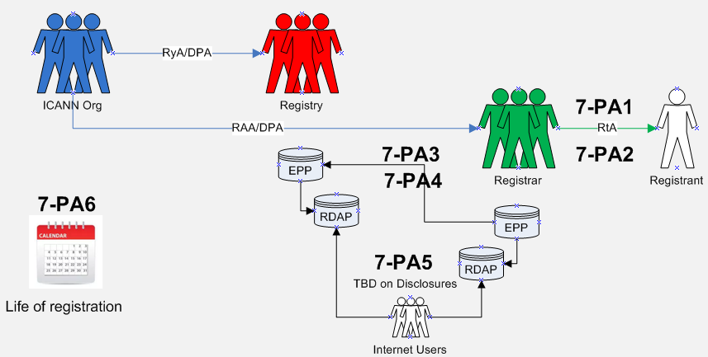

Data Elements Matrix:
“1” = Required “(1)” = Optional “-“ = Not Required or Optional

Data Element  (Collected & Generated*) | Collection  7-PA1 | Collection  7-PA2 | Transmission  7-PA3 | Transmission  7-PA4 | Disclosure  7-PA5 | Retention  7-PA6
Domain Name | - | - | - | - | - | -
Registry Domain ID* | - | - | - | - | - | -
Registrar Whois Server* | - | - | - | - | - | -
Registrar URL* | - | - | - | - | - | -
Updated Date* | - | - | - | - | - | -
Creation Date* | - | - | - | - | - | -
Registry Expiry Date* | - | - | - | - | - | -
Registrar Registration Expiration Date* | - | - | - | - | - | -
Registrar* | - | - | - | - | - | -
Registrar IANA ID* | - | - | - | - | - | -
Registrar Abuse Contact Email* | - | - | - | - | - | -
Registrar Abuse Contact Phone* | - | - | - | - | - | -
Reseller* | - | - | - | - | - | -
Domain Status(es)* | - | - | - | - | - | -
Registry Registrant ID* | - | - | - | - | - | -
Registrant Fields
∙ Name | - | - | - | - | - | -
∙ Organization (opt.) | - | - | - | - | - | -
∙ Street | - | - | - | - | - | -
∙ City | - | - | - | - | - | -
∙ State/province | - | - | - | - | - | -
∙ Postal code | - | - | - | - | - | -
∙ Country | - | - | - | - | - | -
∙ Phone | - | - | - | - | - | -
∙ Phone ext (opt.) | - | - | - | - | - | -
∙ Fax (opt.) | - | - | - | - | - | -
∙ Fax ext (opt.) | - | - | - | - | - | -
∙ Email | - | - | - | - | - | -
2nd E-Mail address | - | - | - | - | - | -
Admin ID* | - | - | - | - | - | -
Admin Fields
∙ Name | - | - | - | - | - | -
∙ Organization (opt.) | - | - | - | - | - | -
∙ Street | - | - | - | - | - | -
∙ City | - | - | - | - | - | -
∙ State/province | - | - | - | - | - | -
∙ Postal code | - | - | - | - | - | -
∙ Country | - | - | - | - | - | -
∙ Phone | - | - | - | - | - | -
∙ Phone ext (opt.) | - | - | - | - | - | -
∙ Fax (opt.) | - | - | - | - | - | -
∙ Fax ext (opt.) | - | - | - | - | - | -
∙ Email | - | - | - | - | - | -
Tech ID* | - | - | - | - | - | -
Tech Fields
∙ Name | - | - | - | - | - | -
∙ Organization (opt.) | - | - | - | - | - | -
∙ Street | - | - | - | - | - | -
∙ City | - | - | - | - | - | -
∙ State/province | - | - | - | - | - | -
∙ Postal code | - | - | - | - | - | -
∙ Country | - | - | - | - | - | -
∙ Phone | - | - | - | - | - | -
∙ Phone ext (opt.) | - | - | - | - | - | -
∙ Fax (opt.) | - | - | - | - | - | -
∙ Fax ext (opt.) | - | - | - | - | - | -
∙ Email | - | - | - | - | - | -
NameServer(s) | - | - | - | - | - | -
DNSSEC | - | - | - | - | - | -
Name Server IP Address | - | - | - | - | - | -
Last Update of Whois Database* | - | - | - | - | - | -
Other Data:
∙ Additional data elements as identified by Registry Operator in its registration policy, such as (i) status as Registry Operator Affiliate or Trademark Licensee [.MICROSOFT]; (ii) membership in community [.ECO]; (iii) licensing, registration or appropriate permits (.PHARMACY, .LAW] place of domicile [.NYC]; (iv) business entity or activity [.BANK, .BOT] | (1) | (1) | (1) | (1) | (1) | (1)

“Registrar Whois Server”, “Registrar URL”, “Registrar Abuse Contact Email” and “Registrar Abuse Contact Phone” are not transmitted to the registry with each registration in EPP; they are provided to the registry once by each registrar and used for each registration a registrar has. I’m not sure if you want to flag this or not.
“Domain Status” (which is a field that can appear multiple times) may or may not be set by the registrar; some status are set by the registrar, some are set by the registry.
Per the current temp spec requirement: 2.5.1. Registrar MUST provide an email address or a web form to facilitate email communication with the relevant contact, but MUST NOT identify the contact email address or the contact itself.
The current temp spec requirement: 2.5.1. Registrar MUST provide an email address or a web form to facilitate email communication with the relevant contact, but MUST NOT identify the contact email address or the contact itself.
Idem
Addressed as part of Purpose B
Optional data elements for the Registered Name Holder (RNH) to provide, but required for the registrar to offer as data elements the RNH may provide.
The GAC representatives are of the view that physical address should also be requested by the registrar (but optional for the RNH to provide)
Refer to the preliminary recommendation on Retention of Purpose E-Ry. A retention change should be validated to ensure technical requirements are not jeopardized by lowering the retention duration.
Draft Recommendation: Data processing agreements are necessary to ensure GDPR compliance. Recognizing that different escrow agreements exist depending on the TLD, the working group recommends that ICANN and/or the registry review the applicable escrow agreement and where necessary negotiate new GDPR compliant escrow agreements.
This preliminary recommendation should be validated to ensure technical requirements are not jeopardized by lowering the retention duration.
“optional” fields must be escrowed if data exists
To be updated in line with what is decided for Purpose C – if this information is optional to provide, in those cases where it is provided, Compliance will need to be able to request those data fields if relevant for compliance requests.
Idem.
Draft Recommendation: Data processing agreements are necessary to ensure GDPR compliance. Recognizing that different agreements exist depending on the TLD, the working group recommends that ICANN and the RPM providers review the applicable agreement and where necessary negotiate new GDPR compliant data processing agreements.
Certain registrant contact information may be needed (e.g., in the UDRP context) for due process purposes in the registrant’s benefit.
WIPO’s GDPR FAQ: Paragraph 4(j) of the UDRP mandates that “[a]ll decisions under this Policy will be published in full over the Internet, except when an Administrative Panel determines in an exceptional case to redact portions of its decision.” In this respect, through their acceptance of the applicable registration terms and conditions, domain name registrants subject to a UDRP proceeding are bound by this provision as well as the other UDRP terms. Publication of party names in UDRP decisions is essential to the overall functioning of the UDRP in that it helps to explain the panel’s findings, supports jurisprudential consistency, facilitates the conduct of other cases as appropriate, and furthermore can provide a deterrent effect. Against the background of the above-mentioned purposes, any request to redact a party’s name from a decision should normally be submitted for the panel’s consideration during the UDRP proceeding. Also in light of the above-mentioned reasons for full decision publication, any such request should be appropriately motivated.
The EPDP Team’s approval of Purpose 7 does not prevent and should not be interpreted as preventing Registry Operators from voluntarily adopting gTLD registration policy eligibility criteria that are not described or referenced in their respective Registry Agreements.

