1.b  07 January | AS SUBJECT TO REGISTRY AND REGISTRAR TERMS, CONDITIONS AND POLICIES, AND ICANN CONSENSUS POLICIES:  (i) ESTABLISH THE RIGHTS OF A REGISTERED NAME HOLDER IN A REGISTERED NAME, AND  (ii) ENSURE THAT A REGISTERED NAME HOLDER MAY EXERCISE ITS RIGHTS IN THE USE AND DISPOSITION OF THE REGISTERED NAME.
Purpose Rationale:
1) If the purpose is based on an ICANN contract, cite the relevant section of the ICANN contracts that corresponds to the above purpose, if any.

- RAA - https://www.icann.org/resources/pages/approved-with-specs-2013-09-17-en

Yes, this purpose is lawful based on ICANN’s mission to coordinate the allocation and assignment of names in the root zone of the Domain Name System. Specifically, Section 3.2 of the RAA “Submission of Registered Name Holder Data to Registry”, Spec. 4, section 1.5 and Spec. 2 of the RA, all refer to what data elements must be placed in the Registry Database as a part of the domain registration (https://www.icann.org/resources/pages/approved-with-specs-2013-09-17-en & https://www.icann.org/resources/pages/registries/registries-agreements-en ).

2) Is the purpose in violation with ICANN's bylaws?

No, it is not in violation of ICANN’s Bylaws. Specifically, Article 1, Section 1.1 Mission (a)(i) Coordinates the allocation and assignment of names in the root zone of the Domain Name System ("DNS") and coordinates the development and implementation of policies concerning the registration of second-level domain names in generic top-level domains ("gTLDs"). In this role, ICANN's scope is to coordinate the development and implementation of policies https://www.icann.org/resources/pages/governance/bylaws-en/#article1.

Further, Articles G-1 and G-2 stipulate, “issues for which uniform or coordinated resolution is reasonably necessary to facilitate interoperability, security and/or stability of the Internet, registrar services, registry services, or the DNS;” and “Examples of the above include, without limitation: principles for allocation of registered names in a TLD (e.g., first-come/first-served, timely renewal, holding period after expiration);”

3) Are there any “picket fence” considerations related to this purpose?

This purpose is related to WHOIS, which is within the Picket Fence. Specifically, Specification 1 of the Registry Agreement (Section 3.1(b)(iv) and (v) and Specification 4 of the Registrar Accreditation Agreement both refer to categories of issues and principles of allocation of registered names in a TLD.

Lawfulness of Processing Test:
Processing Activity: | Responsible Party:  (Charter Questions 3k, 3l, 3m) | Lawful Basis: (Is the processing necessary to achieve the purpose?)
A-PA1: Collection of registration data to establish registrant’s rights in a domain name string  (Charter Question 2b) | ICANN – Joint Controller  Registrars – Joint Controller  Registries – Joint Controller (where applicable) | 6(1)(b) for Registrars and applicable Registries  This is a 6(1)(b) purpose for Registrars because it is necessary to collect registrant data to allocate a string to a registrant. Without collecting minimal registrant data, the contracted party has no way of tracing the string back to registrant and is not able to deliver its side of the contract.  For Registries that require the collection of data to fulfill their terms, conditions and policies, this is a 6(1)(f) purpose. (note that registries collection of the data occurs only when the data is disclosed to them by the registrar as per A-PA2)
A-PA2: Transmission of registration data from Registrar to Registry  (Charter Questions 2c, 2d, 2e, 2i) | ICANN – Joint Controller  Registrars – Processor  Registries – Processor / Joint Controller (where applicable) | (NOTE: the Registry’s receipt of this data is the collection , as per A-PA1)  Registries may direct a Registrar to provide a limited data set, (i.e. data set that differs from the from the Minimum Data Set as required as per the relevant consensus policy), where such a Registry Operator , due to varying business model and legal interpretations of obligations, require an alternate data set to fulfill, in their subjective evaluation, their specific policies, terms and conditions (for example, for the purpose of administering the application of a Registry Acceptable Use Policy (AUP)) in cases where such policies exist.  The disclosure of the data by the registrar to the registry is justified under 6(1)b (vis á vis the registrar’s processing) for the valid purpose of enabling the registry to then, where necessary, directly enforce the registration terms or acceptable use policy of the registry, where such a registry chooses to do so.  Note: Joint controllership results in a required element of the RA (Spec 11) vs. the interpretation of the Registry, where in some instances this is not considered to be required as this is a RA pass on. It is also accepted that some registry operators have the ability to ‘choose’ how to interpret their obligations under Spec 11, and therefore this additional exercising of control would tend to suggest that registries retain a relationship closer to a Joint Controller in the realization of purpose 1(b).
A-PA3: Disclosure of registration data  (Charter Questions 2f (gating questions), 2j) | ICANN – Controller  Registries (Joint Controller)  Registrars – Processor | Establishing the rights of a RNH, and ensuring, subject to T&Cs, that a RNH may exercise such benefits, may require disclosure of certain data elements, namely registrant details, IP addresses, domain names and name servers. The lawful basis would be 6(1)f, should personal data be involved.
A-PA4: Retention of registration data by Registrar  (Charter Questions 2g) | ICANN – Controller  Registrar (ICANN mandated)– Processor Retention in excess of ICANN minimum (see recommendation 7 ) Controller | This is a 6(1)(f) purpose because although there is likely a legitimate interest in providing mechanisms for safeguarding Registered Name Holders' Registration Data in the event of a dispute over ownership or an improper transfer, it is likely necessary for the registrar to retain the data to enforce their terms and conditions, however after the expiration of a domain, this retention is as per the register’s own controllership.

Data Elements Map:
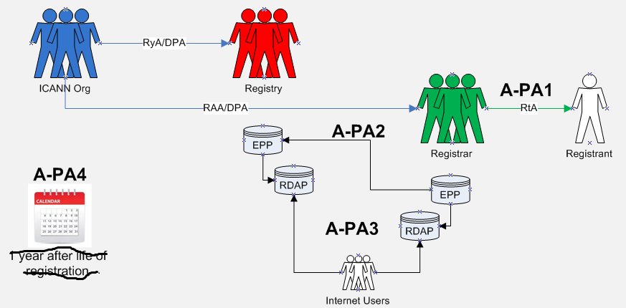

Data Elements Matrix:
“1” = Required “(1)” = Optional “-“ = Not Required or Optional

Data Element | Collection  (Registry and Registrar)  A-PA1 | Transmission  A-PA2 | Disclosure  A-PA3 | Retention  (Registrars)  A-PA4
Domain Name | 1 | 1 | - | 1
Registry Domain ID | - | - | - | -
Registrar Whois Server | 1 | - | - | 1
Registrar URL | 1 | - | - | 1
Updated Date | 1 | - | - | 1
Creation Date | 1 | - | - | 1
Registry Expiry Date | 1 | - | - | 1
Registrar Registration Expiration Date | 1 | - | - | 1
Registrar | 1 | - | - | 1
Registrar IANA ID | 1 | - | - | 1
Registrar Abuse Contact Email | 1 | - | - | 1
Registrar Abuse Contact Phone | 1 | - | - | 1
Reseller | 1 | - | - | 1
Domain Status | 1 | - | - | 1
Registry Registrant ID | - | - | - | -
Registrant Fields
∙ Name | 1 | (1) | 1 | 1
∙ Organization (opt.) | - | (1) | - | -
∙ Street | 1 | (1) | 1 | 1
∙ City | 1 | (1) | 1 | 1
∙ State/province | 1 | (1) | 1 | 1
∙ Postal code | 1 | (1) | 1 | 1
∙ Country | 1 | (1) | 1 | 1
∙ Phone | 1 | (1) | 1 | 1
∙ Phone ext (opt.) | - | (1) | - | -
∙ Fax (opt.) | - | (1) | - | -
∙ Fax ext (opt.) | - | (1) | - | -
∙ Email | 1 | (1) | 1 | 1
2nd E-Mail address | - | - | - | -
Admin ID | - | - | - | -
Admin Fields
∙ Name | - | - | - | -
∙ Organization (opt.) | - | - | - | -
∙ Street | - | - | - | -
∙ City | - | - | - | -
∙ State/province | - | - | - | -
∙ Postal code | - | - | - | -
∙ Country | - | - | - | -
∙ Phone | - | - | - | -
∙ Phone ext (opt.) | - | - | - | -
∙ Fax (opt.) | - | - | - | -
∙ Fax ext (opt.) | - | - | - | -
∙ Email | - | - | - | -
Tech ID | - | - | - | -
Tech Fields
∙ Name | - | - | - | -
∙ Organization (opt.) | - | - | - | -
∙ Street | - | - | - | -
∙ City | - | - | - | -
∙ State/province | - | - | - | -
∙ Postal code | - | - | - | -
∙ Country | - | - | - | -
∙ Phone | - | - | - | -
∙ Phone ext (opt.) | - | - | - | -
∙ Fax (opt.) | - | - | - | -
∙ Fax ext (opt.) | - | - | - | -
∙ Email | - | - | - | -
NameServer(s) | 1 | 1 | - | 1
DNSSEC | 1 | - | - | 1
Name Server IP Address | 1 | - | - | 1
Last Update of Whois Database | 1 | - | - | 1
Other Data:
∙ Field 1 | - | - | - | -
∙ Field 2 | - | - | - | -

