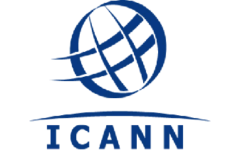 Governmental Advisory Committee

29 April 2015

To: Philip Corwin and Petter Rindforth, Co-Chairs, GNSO Working Group on IGO-INGO Access to Curative Rights Protection Mechanisms

Dear Philip and Petter

Thank you for your letter of 12 December 2014, which posed several questions to the GAC on issues your working group is addressing. I apologize for the delay in responding and trust that the GAC responses below are helpful.

Question 1: What is the GAC’s view on the WG’s decision to exclude INGOs from further consideration in this PDP?
The GAC does not have a position to share with the GNSO IGO-INGO PDP Working Group. We do welcome the Working Group’s recognition of the special protections afforded by ICANN to the International Olympic Committee and the International Red Cross and Red Crescent Movement (and its respective national and international components) and of the volume and particular risk of cybersquatting of these names, a risk shared with IGO names and acronyms.
Question 2: If it is the GAC’s position that an entirely new curative rights mechanism must be created, is it the GAC’s understanding that the protections afforded to qualifying IGOs under Article 6ter of the Paris Convention would be the criteria for establishing standing under any dispute resolution procedure that may apply to IGOs?
GAC advice to the ICANN Board has repeatedly emphasized that IGOs are in an objectively different category to other rights holders and that governments support the implementation of appropriate protections of IGO names and acronyms on public policy grounds. This is the basis for the inclusion of IGOs on the reserved names list for gTLDs.

Question 3: In opposing [amendments to the UDRP and URS] does the GAC thus advise the GNSO to preclude any possible change to its “Mutual Jurisdiction” provisions to address specific sovereign immunity concerns of IGOs? How should a curative rights process appropriately deal with this problem while also ensuring adequate due process protections for registrants?
The GAC notes that the IGOs, in their communication to you of 16 January 2015, have advised that they consider their claimed immunity from national jurisdiction to be fundamental to their role as international bodies. There are non-judicial means to ensure due process, such as arbitration, which the GAC believes should be considered in more detail.
Question 4: Does the GAC consider the current fees charged by URS and UDRP providers to be nominal? If the GAC considers those charges to be in excess of nominal, then what source of funding or other support mechanism would the GAC suggest to fully pay or subsidize the fees charged by dispute resolution providers?
The GAC is not in a position to assess the current fees charged by URS and UDRP providers as being nominal or not, nor has the GAC discussed other possible sources of funding. Again, the GAC is happy to participate in further discussions that should ideally include the IGOs.
Other Issues
With regard to the other issues in your correspondence on which you sought comment, the GAC believes they could be addressed in a joint discussion at a future ICANN meeting, as they do not appear to be directly germane to the issue of implementing protections for IGO names and acronyms at the second level in new gTLDs. I look forward to continued dialogue between the GAC and the GNSO IGO-INGO PDP Working Group as a constructive means of providing, to the extent possible, a coordinated response to the NGPC’s request for input/guidance.

Best regards,

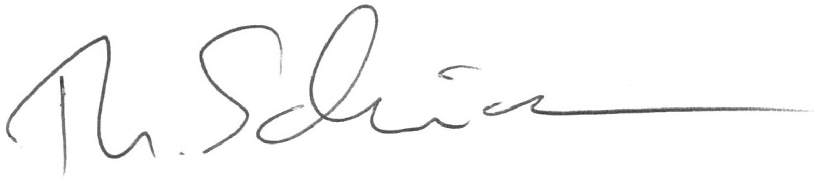

Mr Thomas Schneider
Chair, Governmental Advisory Committee

