ICANN Thick Whois Implementation Project
Consistent Labeling & Display Outcome (CL&D)
Detailed Impact Assessment

1. Purpose of this document 1
2. Revisions 1
3. Relevant Policy Recommendations 1
4. Summary of Impact Assessment 3
5. Coordination of Impact and implementation with other relevant Whois-related initiatives 11
6. Relevant Resources 15

Purpose of this document

This detailed impact assessment is meant to help both the Thick Whois Implementation Project Team (ICANN) and the Implementation Review Team (GNSO) develop an implementation plan that takes into account the nature and scale of the work required from all affected parties on the Consistent Labeling & Display aspect of the Policy Recommendations.

Once refined, this impact assessment will lead to the development of appropriate requirement documentation, timeframes for implementation by affected parties and relevant supporting measures.

Revisions

- Version 1 – 17 Nov. 2014 – First Draft by ICANN Staff Implementation Project Team (J. Denison, E. Lewis, B. Cobb, F. Betremieux)
- Version 2 – 3 Feb. 2015 – Revision after input by and discussion with IRT (J. Denison, F. Betremieux, K. Papac)

Relevant Policy Recommendations

The relevant Policy recommendation is recommendation #1 of the Thick WHOIS Final Report (http://gnso.icann.org/en/issues/whois/thick-final-21oct13-en.pdf):

Recommendation #1: The provision of thick Whois services, with a consistent labelling and display as per the model outlined in specification 3 of the 2013 RAA, should become a requirement for all gTLD registries, both existing and future.

The understanding of “consistent labeling and display” was discussed during the meeting between the Implementation Project Team (IPT) and the Implementation Review Team (IRT) on 4 December 2014 (Recording and transcript available here: https://community.icann.org/display/TWCPI/4+Dec+2014).

Some members of the IRT shared the view that the understanding of “consistent” as “identical” was an unintended consequence of the policy recommendation as it was written, and the additional requirements of adding Registrar data such as Abuse Contact and Reseller (see Impact Assessment below) inherent to that understanding, were not contemplated when the Thick Whois PDP was initiated. In particular, it was argued that in the context of the Inter-Registrar Transfer Policy (IRTP B), from which the Thick WHOIS PDP originated, the primary concern was access to Registrant contact data.

Upon further review of PDP documentation by the IPT, however, the conception of interpreting “consistent” as requiring the consistent display of all the required WHOIS Output fields (or label/value pairs) is supported by the following references:

- The IRTP B Final Report (http://gnso.icann.org/issues/transfers/irtp-b-final-report-30may11-en.pdf) planned for considerations beyond the context of IRTP

Section “7. Conclusion and next steps” (p. 50) : Recommendation #3 - The WG recommends requesting an Issues Report on the requirement of ‘thick’ WHOIS for all incumbent gTLDs. The benefit would be that in a thick registry one could develop a secure method for a gaining registrar to gain access to the registrant contact information. Currently there is no standard means for the secure exchange of registrant details in a thin registry. In this scenario, disputes between the registrant and admin contact could be reduced, as the registrant would become the ultimate approver of a transfer. Such an Issue Report and possible subsequent Policy Development Process should not only consider a possible requirement of 'thick' WHOIS for all incumbent gTLDs in the context of IRTP, but should also consider any other positive and/or negative effects that are likely to occur outside of IRTP that would need to be taken into account when deciding whether a requirement of 'thick' WHOIS for all incumbent gTLDs would be desirable or not.

- The Thick WHOIS Issue Report (http://gnso.icann.org/issues/whois/final-report-thick-whois-02feb12-en.pdf) saw consistent response as an issue to be considered

Section “4.5 Potential positive and/or negative effects” (p. 14) : [….] Consistent response – a ‘thick’ Registry can dictate the labeling and display to be sure the information is easy to parse, and all Registrars/clients would have to display accordingly, which could be considered a benefit but also a potential cost. This might also be a benefit in the context of internationalized registration data as even with the use of different scripts, uniform data collection and display standards could be applied.

- The Thick WHOIS Final Report (http://gnso.icann.org/en/issues/whois/thick-final-21oct13-en.pdf) made several references to benefits of uniformity of WHOIS in terms of accessibility and response consistency

Section “3.2 – Situation of incumbent gTLDs”: Many commenters on the proposed registry agreement have requested a change to the agreement to mandate thick Whois for all new registries. The commenters have suggested that such a requirement would be in line with the status quo since most gTLD agreements require thick Whois output (all except com, net and jobs, as noted above). Comments have suggested substantial benefits from mandating thick instead of thin Whois, including enhanced accessibility and enhanced stability.

Section “5.2 – Response Consistency” (p. 19-21):
[…] Currently there are no labelling or display requirements for thin or thick gTLD registries. As a result, registrars, even for the same gTLD, may currently display data in inconsistent ways, which affects efficiency in accessing and using the information.
[…] In advance of possible changes to the Registry Agreement, the WG recommends that all thick gTLD registries follow the same labelling and display requirements, as per the model outlined in Specification 3 of the 2013 RAA (See Annex E). The WG recognizes that this recommendation will require special consideration of the timing, cost and implementation implications for existing Thick Whois Registries.
[…] Establishing requirements such as collecting uniform sets of data, and display standards, would improve consistency across all gTLDs at all levels and result in better access to Whois data for all users of Whois databases.
[…] The WG received comments suggesting that the opportunity for innovation and ingenuity may be lost in the pursuit of response consistency. For example registrar innovation in the handling and processing of different scripts might overcome barriers and challenges that centralized systems organizations may not see or know. The working group concluded that on balance the opportunities for improved response consistency dramatically outweighed these opportunities missed.
[…] Conclusion: The working group finds that requiring thick Whois would improve response consistency.

Unless the IRT compels otherwise, the IPT recommends that implementation of the Thick WHOIS Policy Recommendation #1 aligns with the understanding of “consistent labeling and display” as requiring the consistent display of all the required WHOIS Output fields (or label/value pairs), and include relevant and necessary measures to minimize and mitigate the impact on affected parties.

Summary of Impact Assessment

The following table is a summary of the analysis conducted for all the affected parties identified. With concern to registries and registrars, a detailed analysis was conducted by comparing the differences between the respective party's current output requirements and the expected Thick Whois Consistent Output. The detailed analysis is contained in a spreadsheet file annexed to this document.

For the purpose of this analysis, the level of impact is outlined below:
- High impact: new data to be gathered by a party from another, potential distributed development required (such as changes to EPP interface requiring development in both Registries and Registrars software systems)
- Medium impact: changes that would be required with some software development to the systems of the affected party only
- Low impact: changes that would only be a matter of configuration to output or static values in software systems of the affected party only
- Directly/Indirectly: this is specific to Registrars and either means that a Registrar will become an affected party directly (if subject of the policy recommendation – see outstanding questions), or it will become an affected party indirectly due to the fact that its relevant Registries may need new data to be sent over through the Registry/Registrar EPP interface

  - Impact on Registries

Affected Parties | High Impact | Medium Impact | Low Impact
New gTLD Registries  (post-2012) | - Adding of new Registrar Data (Registrar Abuse Contact, Reseller) [1] |  | - Renaming of various fields to match RAA 2013 field names
Pre-2012 gTLD Registries  under Thick registration model | - Adding of new Registrar Data (IANA ID, Registrar Abuse Contact, Reseller) [1]  - Adding of new Registrant Data (ex: DNSSEC delegation, Phone/Fax ext, etc.) | - May need change of format of field values (ex: domain status, telephone numbers, etc.) | - Renaming of various fields to match RAA 2013 field names  - Reordering of fields in Whois output  - Appending of custom fields not included in RAA 2013 at the end of the output
Pre-2012 gTLD  Registries  under Thin Registration model | No impact. Thin Registries not involved in the implementation of Consistent Labeling and Display as decoupled from the transition of .COM, .NET and .JOBS from thin to thick WHOIS.  Discussion with the IRT led to the conclusion that it would be more appropriate to make changes to thin Registries’s WHOIS output when these registries are transitioning to thick WHOIS.

[1] Discussion of IRT feedback on Registrar Abuse Contact and Reseller information

Input from the IRT included the following statement by Marc Anderson referring to the Registrar Abuse Contact and Reseller information:
“I don’t believe these fields were discussed or even considered during the Thick WhoIs PDP discussions, nor are they considered required for a TLD to be “thick”. My recommendation is for the implementation team to clarify that these fields are not required for Registries (at most optional). Making these fields required is likely to result in delays as the technical community would need to update EPP specifications, Registrars and Registries would have to update their systems to support and subsequently manage the transition.”

This statement includes 4 discussion items, which we address below:

- Consideration or discussion of these fields in the Thick Whois PDP

Because the addition of the Abuse contact and reseller information in the RAA 2013 occurred while or after Consistent Labeling & Display was discussed in the Thick Whois, the IPT recognizes that this information may not have been specifically considered in the discussion. However, it should be noted that the Thick Whois PDP Final Report does reference the 2013 RAA Registration Data Directory Service (Whois) Specification, which includes the Abuse Contact and Reseller fields (Thick Whois Final Report, Annex E, p.71).

In any event, through the discussion of this Impact Assessment, the IPT is aiming at clarifying and considering with the IRT the impact of these fields on the implementation of Thick Whois Consistent Labeling & Display.

- Relevance of these fields to the thick WHOIS model

No definitive and universally recognized definition of thick WHOIS exists. However, as part of the Thick Whois PDP, the Final Issue Report addressed the “Difference between ‘thick’ and ‘thin’ Whois” by proposing a distinction of two sets of data both to be displayed by thick Registries (as opposed to only the first one for thin Registries): “one set of data is associated with the domain name, and a second set of data is associated with the registrant of the domain name”. It further described the set of data associated with the domain name to include ”data sufficient to identify the sponsoring registrar, status of the registration, creation and expiration dates for each registration, name server data, the last time the record was updated in its Whois data store, and the URL for the registrar’s Whois service”.

The IPT views the Abuse Contact and Reseller information as valuable additions to the set of data associated with the domain name and aligns with the spirit of both Thick WHOIS and Consistent Labeling and Display, that is providing a centralized location for an interested party to identify the entities responsible for sponsoring the registration as well as report abuse, if necessary.

- Recommendation to make these fields optional for Registries

From the IPT’s perspective, making these fields optional for Registries would defeat the purpose of Consistent Labeling and Display: some gTLD registries would display this information while others would not.

However, consistently with the WHOIS Clarification Advisory, if no data exists in the Shared Registration System (SRS) for these fields, registries would be expected to implement either of: 1) the key (i.e., the string to the left of the colon) MUST be shown with no information in the value section (i.e., right-hand side of the colon) of the field; or 2) no field MUST be shown. If data exist for these fields, it would be required to be shown.

- Implementation delays if these fields are required in the Registries Output

Compared to other labeling and display requirement in Registries WHOIS output, the IPT agrees that Reseller information creates a unique challenge, in particular with the need to create a specific EPP extension. Our estimate, as reflected in the draft implementation timeline in this document (see section 6 below), is that this would require a specific effort of 6 months before Registries and Registrars can proceed to updating their systems and transferring the relevant data.

  - Impact on Registrars

Affected Parties | High Impact | Medium Impact | Low Impact
Registrars under RAA 2013  indirectly | - Provide Registrar Abuse Contact and Reseller information to Registries (via EPP at least for the Reseller information)
Registrars under RAA 2009 for Pre-2012 Thick gTLDs indirectly [1] | - Provide Abuse Contact, Reseller Information to registries | - Communicate Registrant Phone, Fax and Email information to registries, to collected if needed
Registrars under  RAA 2013  directly | As per discussion with the IRT, it has been confirmed that Registrars are out of scope of the Thick WHOIS Policy implementation. There for all corresponding row have been greyed out and need no be considered in the implementation effort.
Registrars under RAA 2009 for Pre-2012  Thick gTLDs  directly | - Registry Object ID (Domain, Registrant/Admin/Tech contact ID) to be retrieved through Registry SRS via EPP  - DNSSEC delegation status to collected from Registrant  - Registrant Phone/Fax/Email | - Domain statuses  - Reseller  - Depending on registrar, some format of field values could be needed | - Registrar IANA ID  - Registrar Abuse Contact  - Reordering of fields  - URL of ICANN Whois Data Problem Reporting System  - Depending on the Registrar (room for interpretation in RAA 2009 spec) Renaming of various fields to match RAA 2013 field names & Appending of custom fields not included in RAA 2013 at the end of the output
Registrars under RAA 2009 for Pre-2012  Thin gTLDs | If Registrars are subject to the Thick Whois Policy Recommendations, should the thin gTLD Registrars on RAA 2009 be required to conform to Consistent Labeling and Display even if they are due to be involved in the transition from thin to thick ?

[1] Discussion of IRT feedback on impact to RAA 2009 registrars

The IRT requested that actual 2009 RAA renewal data be considered. As of 26 January 2015, a total of 274 registrars are accredited under the terms of the 2009 RAA, and the distribution of renewals over time is as follows:
- 2015: 73 registrars
- 2016: 147 registrars
- 2017: 34 registrars
- 2018: 20 registrars

This indicates that transition into the RAA 2013 may only become an effective tool for mitigating the impact on most 2009 RAA registrars after 2016 when about 4/5 of the registrars have transitioned. This will therefore need to be considered in connection with the final implementation plan and its projected Policy Effective Date.

  - Impact on Other Parties

Affected Parties | High Impact | Medium impact | Low Impact
Registrants |  |  | - Low to no impact on registrant
Third Parties  accessing Whois data |  | - Modification of output may require adaptation of automated systems or manual processes

Coordination of Impact and implementation with other relevant Whois-related initiatives

As suggested by IRT feedback, while considering the specific impact of Thick WHOIS Consistent Labeling and Display, other potential impacts on the WHOIS output of affected parties from additional WHOIS-related initiatives should be considered, as well. ICANN should also ensure that implementation timelines are synchronized to the extent necessary.

At the time of this writing, three initiatives are relevant for consideration:

- Additional WHOIS Information Policy (AWIP): https://www.icann.org/resources/pages/policy-awip-2014-07-02-en

  - Impact to affected Parties

In our classification of impact above (section Summary of Impact Assessment), AWIP would qualify as a low to medium impact to Registries and Registrars:

    - Registries and Registrars (who include registration statuses in Whois Output)
      - only refer to the statuses by their respective EPP status codes;
      - provide a link or URL next to each EPP status code that directs to an ICANN web page describing and defining the respective EPP status code
      - include in their Whois output the following message: "For more information on Whois status codes, please visit https://icann.org/epp”
    - Registries only
      - Registries must include the ICANN-issued Globally Unique Registrar Identification number (GURID, commonly known as the IANA ID) in their Whois output in the form of: “Sponsoring Registrar IANA ID: 99999”
    - Registrars only
      - Registrars shall not remove the links and message described above when providing Whois data from its own or another registrar or registry's Whois service.

  - Timeline of implementation:

Effective date has yet to be announced officially, it is envisioned for 31 July 2015 (as of 27 Jan 2015) after suspension of the initial Effective Date. However, this will be further discussed during ICANN 52.

- Advisory: Clarifications to the New gTLD‬ ‬Registry Agreement, Specification 4; ‬and the 2013 Registrar Accreditation Agreement (RAA‬), Registration Data Directory‬ Service ‬(WHOIS‬) Specification ‬‬‬‬‬‬(‬also ‬referred to as Whois Clarifications Advisory): https://www.icann.org/resources/pages/registry-agreement-spec4-raa-rdds-2014-09-12-en‬‬‬

  - Impact to affected Parties

In our classification of impact above (section Summary of Impact Assessment), the Whois Clarification Advisory has components that would likely qualify as low to medium impact.

However, it should be noted that the advisory published on 12 September 2014 is currently being revised and discussed with affected parties. As a consequence, the exact scope for implementation is not finalized yet.

  - Timeline of implementation

Effective date has yet to be announced officially, envisioned for 31 July 2015 (as of 27 Jan 2015), after suspension of the initial Effective Date. However, this will be further discussed during ICANN 52.

- Remote Data Access Protocol (RDAP): http://tools.ietf.org/wg/weirds/

  - Impact to affected Parties

When RDAP replaces WHOIS as the protocol supporting the Registry Data Directory Services in gTLDs, all implementations of WHOIS would progressively be retired over a period of time (to be determined) during which WHOIS output would still be relevant.

  - Timeline of implementation

As standardization of the protocol seems to be making headway at IETF, it is anticipated that the protocol and its related policies could be implemented by the ICANN community by 2016-2017.
The above consideration lead to 2 potential scenarios in terms of implementation timeline for Thick Whois Consistent Labeling & Display
(please refer to the attached .pptx file for full resolution timelines) :

Scenario 1: No synchronization with other initiatives

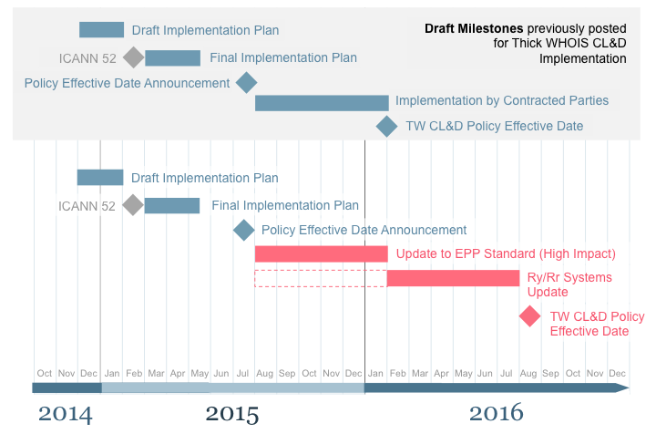
Assumption:
timing of initiatives not compatible

Benefits:
follow an independent implementation path, which cannot be influenced by dependencies on other initiatives

Drawbacks:
no synergies with other WHOIS related implementation efforts, no particular efficiency gains for affected parties

Scenario 2: Synchronization with AWIP, Whois Clarifications and RDAP

Assumptions:

- AWIP+Whois Clarification effective date confirmed after ICANN 52 to August 2015
- RDAP Implementation starting in March 2015 and completed within 12 months
- Compatibility of timeline with TW CL&D ensured through decoupling implementation of CL&D Requirements:
  - Low and medium impact changes: align the implementation schedule with implementation of AWIP and WHOIS Clarifications
  - High impact changes (such as Registrar Abuse Contact/Reseller information): follow their own schedule, concurrent with RDAP implementation
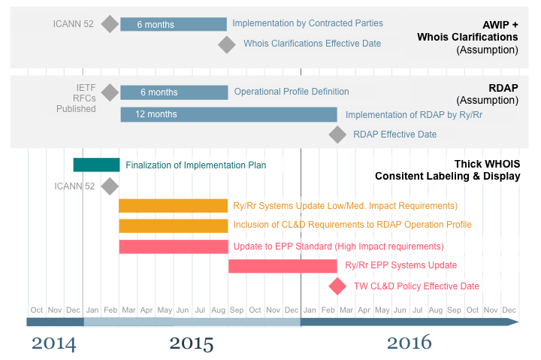

Benefits:

- Efficiency gains for affected parties as synergies are created with WHOIS systems updates required by AWIP and Whois Clarifications
- Preservation of effort on update of current WHOIS systems while new systems required by RDAP are developed (for High Impact changes)

Drawbacks:

- Need to advance delivery of CL&D final implementation plan
- Delaying implementation of high impact changes until RDAP is implemented

Relevant Resources

- Registration Data Directory Service (WHOIS) Specification of 2013 RAA: https://www.icann.org/resources/pages/approved-with-specs-2013-09-17-en - whois
- Registry Agreements: https://www.icann.org/resources/pages/registries-2012-02-25-en
- New gTLD Registry Agreement: http://newgtlds.icann.org/sites/default/files/agreements/agreement-approved-09jan14-en.htm
- Advisory: Clarifications to the New gTLD Registry Agreement, Specification 4; and the 2013 Registrar Accreditation Agreement (RAA), Registration Data Directory Service (WHOIS) Specification: https://www.icann.org/resources/pages/registry-agreement-spec4-raa-rdds-2014-09-12-en
- 2009 Registrar Accreditation Agreement: https://www.icann.org/resources/pages/ra-agreement-2009-05-21-en

Advisory: Clarifications to the New gTLD‬ ‬Registry Agreement, Specification 4; ‬and the 2013 Registrar Accreditation Agreement (RAA‬), Registration Data Directory‬ Service ‬(WHOIS‬) Specification ‬‬‬‬‬‬(‬also ‬referred to as Whois Clarifications Advisory): https://www.icann.org/resources/pages/registry-agreement-spec4-raa-rdds-2014-09-12-en ‬‬‬
For a definition of registrars indirectly or directly affected, please refer to the introduction of section 4.
833 Registrars under RAA 2013 as of 12 Oct 2014
While AWIP and WHOIS Clarification 41 refer to: “Sponsoring Registrar IANA ID”, Spec 3 of the RAA 2013 mandates : “Registrar IANA ID". One of the goals of synchronizing implementation of these two initiatives with Thick Whois Labeling and Display would be to avoid registries having to duplicate efforts and only update their output once. Registries would be required to reference "Registrar IANA ID” in their WHOIS Outputs and not “Sponsoring Registrar IANA ID”.

