Existing 2012 Applicant Guidebook provisions related to translations

- In the 2012 Applicant Guidebook, a string was considered unavailable if it was a translation in any language of the following categories of country and territory names: long-form name listed in the ISO 3166-1 standard; short-form name listed in the ISO 3166-1 standard; separable component of a country name designated on the “Separable Country Names List.”
- In the 2012 round, applicants were required to obtain letters of support or non-objection from the relevant governments or public authorities for “An application for any string that is a representation, in any language, of the capital city name of any country or territory listed in the ISO 3166-1 standard.”

Proposed change

WT5 has discussed the following proposal as an alternative to the “in any language” standard, and two possible additions. The tables below capture pros and cons mentioned for each option.

Base Proposal: translations in UN and official languages
→ For those countries that have no official language, include “de-facto” official languages (a list would need to be identified for this)
→ Supplement with a curative mechanism that allows for objections in the case of commonly used languages

Possible addition 1: transliteration into ASCII and conversion to DNS labels

Pros | Cons
From one perspective, this allows names such as Den Haag or São Tomé to be protected with denhaag/den-haag or sao-tome/saotome. | From one perspective, ASCII is not a language but  an encoding of a set of (alphabetic) glyphs so transliterating into ASCII doesn't make sense.
From one perspective, this can be a limited and clearly defined list. | From one perspective, for the same source language one can easily have different transliterated forms depending on the target language. This provision may cause confusion and uncertainty because there is a lack of standardization for transliteration.

Proposed re-wording of addition 1: The transposition of accented and diacritic characters in Latin-based scripts to their equivalent ASCII root. This would protect for example sao-tome as a DNS-Label of São Tomé along-side the IDN version of the name (xn--so-tom-3ta7c).

Pros | Cons
From one perspective, this allows names such as Den Haag or São Tomé to be protected with denhaag/den-haag or sao-tome/saotome. | To be discussed.
From one perspective, this can be a limited and clearly defined list.

Possible addition 2: languages spoken by X% of people in the country/territory/capital city (to represent relevant national, regional and community languages)

Pros | Cons
From one perspective, some communities and groups strongly identify with translations of names in non-official languages and this proposal would offer protection for names translated into those languages. | From one perspective, there is no standard definition of relevant national, regional and community languages and no existing list from which to draw. The term would have to be clearly defined so that it can be effectively implemented.
From one perspective, it should be possible to create a list of relevant national, regional and community languages in implementation, especially if the group provides a definition to use. ICANN Org or the Geographic Names Panel should be able to create definitions. | From one perspective, it is unclear if there is an official, objective data source available that can be used in implementation.

Base proposal – examples to support discussion

Translations proposal as it applies to country and territory names

Example: For the country Singapore, the name in national official languages and UN official languages would be reserved and unavailable for delegation. If, for example, the resource used for reference for this list was the United Nations Group of Experts on Geographical Names Working Paper No. 54, as suggested by previously by WT5 members, the following would be reserved and translations in other languages would be available for delegation:

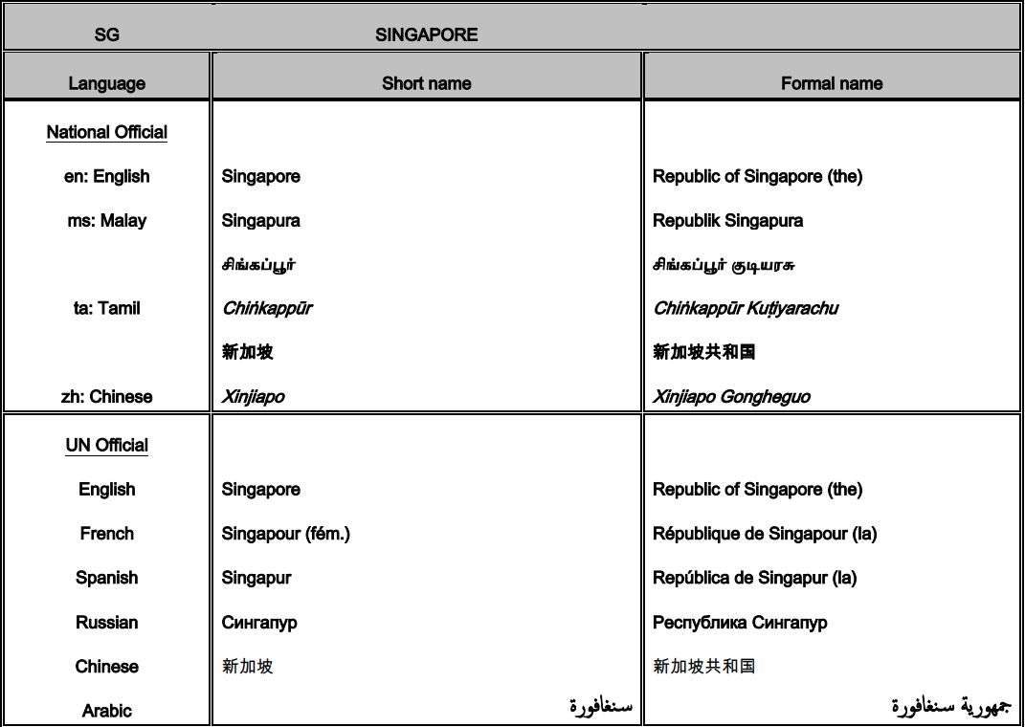

Translations proposal as it applies to capital city names

Example: For Brussels, the capital city of Belgium, an application for the following would require a letter of support/non-objection from the relevant government or public authority:

- The capital city name in the official languages: Bruxelles (French), Brussel (Flemish), Brüssel (German)
- Translations of the capital city name in UN languages: Brussels (English), Bruxelles (French, also official language), Bruselas (Spanish), بروكسل (Arabic), Брюссель (Russian), 布鲁塞尔 (Chinese)

Strings corresponding to the name of this city in other languages would not require a letter of support or non-objection, for example: Bryssel (Swedish), Bruxelas (Portuguese), Βρυξέλλες (Greek), etc.

In both cases, additional curative measures could be available for strings representing translations in additional languages.

