Deletion of a domain

Goal/Scenario -
Deletion of an expired domain name

Brief Format Use Case

Use Case: If someone wants to know when a lapsed domain is due to drop they can check the expiry date and the domain’s status. Using this information they can tell when it will drop.

Main Use Case: Monitoring a domain due to drop

Casual Format Use Case

Title: Domain expiry and deletion information

Primary Actor: Registrant

Other stakeholders: registry and registrar
Scope: Interacting with a registrar

Level: User Task

Data Elements: Domain status, expiration date

Story: For domains which have not been renewed it is possible to monitor their status as they approach deletion. The domain will be cancelled in the stages listed below which are visible as the domain’s status;
- Clientransferprohibited
- Redemptionperiod
- Pendingdelete

It will also tell a prospective registrant if the domain has been renewed by the current registrant.

This information can be found immediately when performing the lookup on the domain. Such as with the image below;

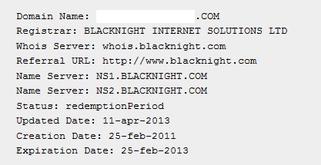

Following the information above the date of the domains drop can be approximated for the prospective new registrant.

