Why are we doing this?
The purpose of this Plan is to get broad participation of the GNSO community, other SO/ACs and the extended ICANN community in the GNSO Review process.
This is important because the quality, validity and acceptance of the GNSO Review and the resulting improvements depend on relevant and useful feedback from a diverse and representative group of people. This is the cornerstone of ICANN’s bottom-up multi-stakeholder model.

When do we need feedback?
Feedback is critical at each phase of the review.

What is the message? Why should someone take the time to provide feedback?
GNSO serves an important function – it is responsible for developing and recommending to the ICANN Board substantive policies relating to generic top-level domains.
This review is part of ICANN’s commitment to continuous improvement, accountability and transparency. It uses mechanisms and measures to maintain public confidence in the viability, reliability and accountability of ICANN.
The purpose of the review is to evaluate organizational effectiveness of the GNSO, acknowledge areas that are working well, identify areas that need improvement and affect needed changes.
The quality, validity and acceptance of the GNSO Review and the resulting improvements depend on relevant and useful feedback from a diverse and representative group of people. This is the cornerstone of ICANN’s bottom-up multi-stakeholder model.
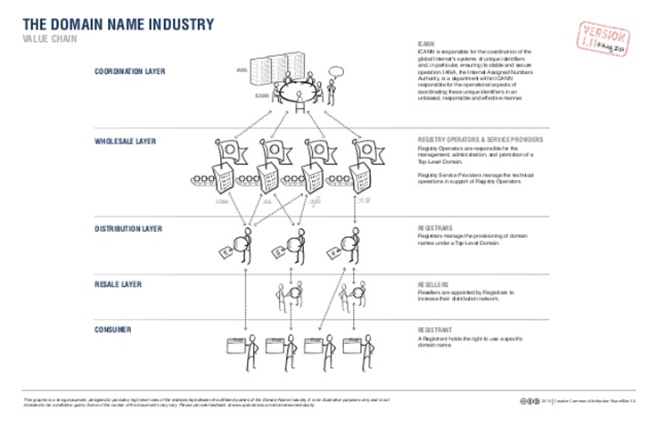
Click to view in larger format.
Make your voice heard. Here is how.
 | Interested SOs/ACs | Interested Individuals
GNSO Review Working Party | - Appoint an observer - gnso.secretariat@gnso.icann.org  - Follow the work here  - Send your comment to gnso-review-dt@icann.org | - Follow the work here  - Send your comment to gnso-review-dt@icann.org
360 Assessment | Encourage your members to take part in the online 360 Assessment – to be announced | Take part in the online 360 Assessment – to be announced
Independent Examiner | Provide feedback to independent examiner – contact information to be announced | Provide feedback to independent examiner – contact information to be announced
Public Comment | Public comment period in November-December 2014 – to be announced | Public comment period in November-December 2014 – to be announced
Structural Improvements Committee | Provide feedback here | Provide feedback here
Staff | Provide feedback – larisa.gurnick@icann.org | Provide feedback – larisa.gurnick@icann.org

How will comments be handled?
In general, comments will be captured, catalogued and summarized by ICANN staff and Independent Examiner, as applicable and these summaries will be publically available to ensure accuracy. Comments will be analyzed and considered by the Independent Examiner in formulating his/her findings and recommendations. The GNSO Review Working Party will consider comments provided to it during the course of its work, as relevant. The SIC and the Board will consider overall public feedback at relevant points during the GNSO Review (i.e. at the time the final report is accepted and recommendations made to the Board and at the time that implementation plans are accepted and recommendations made to the Board).
In providing responses to the 360 Assessment and to the Independent Examiner, responders will need to provide their identity and affiliation (if representing an organization) in order for their comments to be considered, in line with ICANN Expected Standards of Behavior and Public Comment Rules and Procedures. They would have the option of requesting that their identity and affiliation not be included in the public summaries.

How will we engage diverse participants?
The plan is to use a combination of tactics, taking advantage of the upcoming ICANN50 to spread information about the GNSO review using consistent, clear and compelling messaging.

What | Where | When
Frequently Asked Questions | Community wiki | Now
QR code card with link to the GNSO Review wiki | ICANN50 - London | June 2014
GNSO Review Brochure | ICANN50 – London | June
Briefing sessions/communications with SOs/ACs | Virtual; ICANN50 – London | June
Briefing session/communications with ICANN staff | Pre-meeting briefings | June
Blog post | ICANN blog | July
Video/podcast | ICANN blog | July
Community webinar |  | 4 Sept (tentative)
Briefing session/communications with ICANN staff | Pre-meeting briefings | September
Briefing sessions/communications with SOs/ACs | Virtual; ICANN51 – LA | October
Community session | ICANN51 - LA | October
Updated Fact Sheet | ICANN51 - LA | October
Blog post | ICANN blog | November
Video/podcast | ICANN blog | November
Community webinar |  | January 2015
Outreach through all community touch points |  | Throughout
Social media support | Facebook, Twitter, YouTube | Throughout

Article X of ICANN Bylaws provides further detail.
ICANN’s Bylaws require that its structures, including the GNSO, be reviewed on a five-year cycle. According to the Bylaws, the goal of the review is “to determine (i) whether that organization has a continuing purpose in the ICANN structure, and (ii) if so, whether any change in structure or operations is desirable to improve its effectiveness.”
Translations will be available on 9 June 2014

