SUMMARY TABLE OF URS “CLAIMS DENIED” CASES
Prepared by ICANN staff for the URS Documents Sub Team – UPDATED on 28 August 2018
Task:
URS Documents Sub Team to review the 59 58 cases where a Respondent prevailed, in particular in relation to grounds/defenses mentioned in URS Procedures Sections 5.7 and 5.8 (bad faith vs. use) to determine how Respondent prevailed, and if not under one of the grounds/defenses mentioned, then what was the specific reason(s) and what proof was provided.
Statistical Extract:
- Of the 59 58 cases, 28 27 saw a Response filed.
- Of the 28 27 (out of 59 58) cases where a Response was filed, 6 were filed after the initial 14-day response period but before the 6-month time frame expired.
- Of the 6 cases where a Response was filed before the 6-month period expired, 5 cases saw the Complainant fail on both “no legitimate right/interest” and “bad faith” (only 1 saw the Respondent prevailing simply on the Complainant’s inability to prove bad faith).
Claim-Denied Cases w/ Response |  |  |  |  |  | Claim-Denied Cases W/O Response
Case | Determination | Response w/in 14 Days | Response w/in 6 Months | Result (Determination) |  | Case | Determination
1548656 | Final | Yes | No | Complainant failed to prove no legitimate interests and bad faith: “disputed domain name was only registered on March 5, 2014, and … Complaint in this proceeding was filed just nine days later … explanation from Respondent is plausible”. |  | 1545807 | Default
1553139 | Final | Yes | No | Complainant failed on first element: “no evidence, let alone clear and convincing evidence, of any relationship between Complainant and [TM holder] and therefore no evidence before the Examiner that Complainant has any rights in the WOLFRAM trademark”; unnecessary therefore to proceed to consider the other two elements. |  | 1547394 | Default
1554808 | Final | Yes | No | This case should be removed from this table as the Claim was initially UPHELD (not denied); the Respondent appears to have prevailed on APPEAL. |  | 1547419 | Default
1558494 | Final | Yes | No | Complainant failed on 2nd & 3rd elements: “generic nature of the word Finn and the content of the website to which the domain name resolves militate against any finding that Respondent intended to take advantage of the trademark significance of that name”. |  | 1571371 | Default
1562562 | Final | Yes | No | Complainant failed on all 3 elements: “Complainant possesses no relevant trade mark rights”. |  | 1579170 | Default
1563944 | Final | Yes | No | Complainant failed on 2nd & 3rd elements: “no evidence in the record to suggest that Respondent is attempting to create or exploit a connection between its use of the domain names and Complainant’s [business] … Moreover, Respondent has presented a colorable rationale for a legitimate commercial use of the domain names”. |  | 1593539 | Default
1570171 | Final | Yes | No | Complainant failed on 2nd & 3rd elements: “Complainant has provided no evidence of such, and without clear and convincing evidence, there is not a presumption of such”. |  | 1609616 | Default
1570539 | Final | Yes | No | Complainant failed on 2nd & 3rd elements: “mark at issue is a dictionary word with several established meanings unrelated to Complainant’s services … On balance, the facts presented do not convince this Examiner, by clear and convincing evidence, that the Registrant has no legitimate right or interest to the domain name or that the domain was registered and is being used in bad faith”. |  | 1611647 | Default
1570598 | Final | No | Yes | Complainant failed to prove no legitimate interests and bad faith; commonly used, generic term “principal” has multiple meanings; parking per se not bad faith (disputed domains: <principal.center> and <principal.services>) |  | 1644112 | Default
1575592 | Final | Yes | No | Complainant failed on 2nd & 3rd element: “Complainant has NOT demonstrated by clear and convincing evidence that the domain was registered or is being used in bad faith”. |  | 1652110 | Default
1580834 | Final | Yes | No | Complainant failed on all 3 grounds: “Complainant has NOT demonstrated all three elements of the URS by a standard of clear and convincing evidence” (NOTE: Complainant’s TM was a figurative, not word, mark incorporating the acronym “FCB” that was in the domain). |  | 1652584 | Default
1593524 | Final | Yes | No | Complainant failed on 2nd & 3rd element: “Respondent holds the domain name as inventory, which is not inherently wrongful and can represent a legitimate interest” and intended use not in bad faith. |  | 1659646 | Default
1598840 | Final | No | Yes | Complainant failed to prove no legitimate interest and bad faith; Examiner found that Respondent’s raising of these issues is more properly determined under the UDRP or in court (disputed domains: <dana.parts> and <spicer.parts>) |  | 1661429 | Default
1618256 | Final | Yes | No | Complainant failed on 3rd element: “Complainant failed to establish that respondent registered and used the disputed domain name in bad faith because mere assertions of bad faith are insufficient” (NOTE: supplemental filings were rejected by Examiner as they disclosed no new circumstances beyond what was already in the Response). |  | 1676542 | Default
1639486 | Final | Yes | No | Complainant failed on 3rd element: “evidence is not clear and convincing that the domain name is being used in bad faith”. |  | 1676556 | Default
1639527 | Final | Yes | No | Complainant failed on 2nd & 3rd element: “record raises, but does not provide adequate information to conclude whether or not Respondent has a legitimate right or interest to the domain name, I must find for the Respondent on this element” (on basis that this is a genuine issue of material fact); and “evidence is not clear and convincing that the domain name is being used in bad faith”. |  | 1683953 | Default
1647952 | Final | No | Yes | Although Complainant won on no legitimate interest (name for a blog-based personal website does not constitute a legitimate right or interest), failed to prove bad faith in accordance with clear and convincing standard (disputed domain: <thinkpink.today>) |  | 1690435 | Default
1659117 | Final | Yes | No | Complainant failed on all 3 elements: no TM on Principal Registry and “no evidence of actual harm to the Complainant, or that Respondent is not operating an actual business, as opposed to seeking to interfere with Complainant’s business”. |  | 1690633 | Default
1659358 | Final | No | Yes | Complainant failed to prove no legitimate right/interest (plausible that Respondent plans to use domain for a writing project at a recognized educational institution in an advertised program of study); also failed to prove bad faith (trademark is fanciful and distinct for computers but merely descriptive regarding astronomy and cosmology; Respondent did not acquire domain for primary purpose of resale)  (disputed domain: <supercluster.space>) |  | 1704288 | Default
1680964 | Final | Yes | No | Complainant failed on 3rd element: “While Examiners have accepted various types of evidence showing cumulative bad faith indications with evidence of lack of use, leading to a finding of bad faith registration and use, the burden lies with the Complainant to provide such clear and convincing evidence to show such indications and to argue the same. In this instant case, the Complainant failed to meet this burden”. |  | 1720989 | Default
1680990 | Final | No | Yes | Complainant failed to prove no legitimate right/interest (“eastbay” can also refer to a geographical area) and bad faith (no evidence of such) (disputed domain: <eastbay.xyz>) |  | 1721683 | Default
1681062 | Final | Yes | No | Complainant failed on 1st element: “Complainant has not present adequate evidence to substantiate its trademark rights in the domain name and rejects the Complaint”. |  | 1728186 | Default
1684058 | Final | Yes | No | Complainant failed on 3rd element: “no clear and convincing evidence that the domain name in question was registered in bad faith … there are no facts supporting the assertion that the Respondent knew or should have known of the Complainant’s prior relevant rights since Complainant’s trademark is not famous or particularly distinctive or fanciful but relates to a descriptive term in the marketing sector. The Panel further finds that there is no clear and convincing evidence that the domain name was used in bad faith as there is no clear indication that it was knowingly used by Respondent in order to conduct business in a setting that resembles, without copying, that of the Complainant for the purpose of competing with Complainant directly”. |  | 1730300 | Default
1687117 | Default  Final | No | Yes | Complainant failed to prove no legitimate right/interest (Respondent provided Certificate of Incorporation showing it was doing business as Benchmark Consulting Global Ltd, Examiner noted that abbreviating corporate names using initials is standard business practice) and bad faith (Respondent making legitimate fair use of domain, no intent to tarnish or for commercial gain)  (disputed domain: <bcg.ltd>) |  | 1733940 | Default
1701189 | Final | Yes | No | Complainant failed on 1st element: “Complaint did not provide any evidence of a word trademark to which the disputed domain name would be identical or confusingly similar” (NOTE: Complainant had a figurative mark). |  | 1737246 | Default
1721574 | Final | Yes | No | Complainant failed on 3rd element; evidence did not satisfy clear and convincing standard. |  | 1738392 | Default
1749615 | Final | Yes | No | Complainant failed on 2nd & 3rd element: “rights or legitimate interests in a domain name can be found based on its dictionary meaning, in particular if the domain name is genuinely used in connection with the relied-upon dictionary meaning” and “Complainant has failed to satisfy its burden of providing clear and convincing evidence to support its allegations to the effect that Respondent has engaged in a pattern of registering domain names in order to prevent the trademark holder or service mark from reflecting the mark in a corresponding domain name”. |  | 1739009 | Default
HKS-1500021 | Final | Yes | No | [Not yet reviewed - ADNDRC search function currently not working] |  | 1739824 | Default
28 27 |  |  |  |  |  | 1748589 | Default
 |  |  |  |  |  | 1755479 | Default
 |  |  |  |  |  | D5C230DE | Default
 |  |  |  |  |  | 31

An extract of the tables from the Staff compilation report - updated URS data_v1.1 - 9 July 2018.docx is on the following pages:
Professor Tushnet’s coding sheet: CLICK HERE
The research assistants coded the cases in considering the following:
- (Col AG) If a Response was filed, what Defense(s) or facts were submitted to refute bad faith allegation?
  - (Col AH) Additional Notes on Response (if required)
- (Col AI) If Determination was in Complainant’s favor, what constituted bad faith conduct?
** AG and AI contain a set of codes as options:
  - AG:
    - [1] Registrant's use of domain is for bona fide offering of goods/services
    - [2] Registrant is commonly known by domain name
    - [3] Registrant making fair use of domain without profiting from misleading consumers;
    - [4] Domain is generic/ descriptive, and Registrant is making fair use;
    - [5] Domain is operated in tribute/ criticism;
    - [6] ----not used
    - [7] The domain name is not part of a wider pattern of abusive registration;
    - [8] Examiner did not provide detail
    - [9] Other
  - AH: Free form text
  - AI:
    - [1] Registrant acquired domain to sell/ rent/ transfer to complainant for more than out-of-pocket costs;
    - [2] Registrant registered domain to keep mark holder from reflecting mark (as part of larger pattern);
    - [3] Registrant used domain primarily to disrupt business of competitor;
    - [4] Registrant intentionally attempted to attract traffic for commercial gain by creating confusion with complainant’s mark;
    - [5] Registrant holds large portfolios of domains;
    - [6] Registrant is using domain for pay-per-click traffic;
    - [7] Respondent was engaged in passive use and had notice of mark (possibly with other procedural failures, e.g., failure to respond)
    - [8] Examiner did not provide detail;
    - [9] Other

TABLE 12: Analysis of URS Cases where the Claim was Denied:
From Column AG - If a Response was filed, what Defense(s) or facts were submitted to refute bad faith allegation?
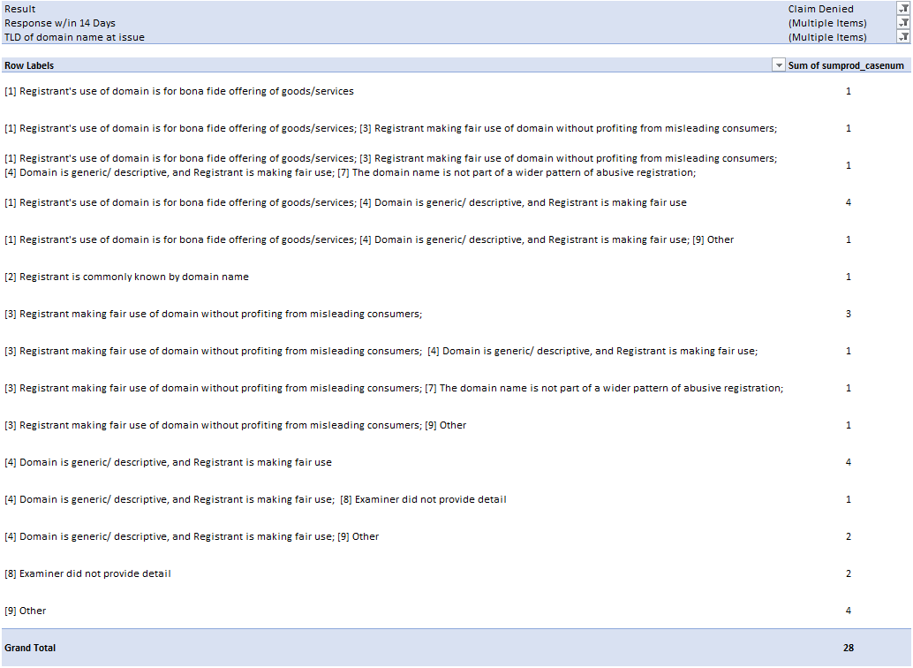
Cases marked with “Other” that included additional comments (Col AI):
- Examiner did not detail response to bad faith because complainant failed on "confusingly similar to valid TM" prong
- Examiner does not specify what respondent alleged with respect to bad faith, as the complainant's case failed to show the registered domain was confusingly similar to a mark the complainant owned.
- Respondent argued that this was a good faith purchase for their business model, that the word was generic, and that the mark was different because Respondent's domain did not include an exclamation point.
- Respondent provided evidence of an Arizona District Court decision (with a different party than Complainant) showing that his business was lawful.
- Respondent argued that he was no longer the owner of the domain (though this was contradicted by other evidence) though the domain had in the past been used for a help site for movie fans.
- Respondent argued he registered the disputed domain with innocent motive after a promotion at <West.cn>. He says he chose the disputed domain name without knowing it is related to the complainant. Respondent asserts he bought the disputed domain name to develop a blog, and he does not intend to sell the domain.
- Respondent claims East Bay refers to a geographic region in the US or several geographic regions throughout the globe. Respondent claims hundreds of companies are using East Bay in their domain name(s) to signify products or services offered to people in the East Bay area. Respondent argues .xyz refers to generations x, y, and z. Respondent argues that it has not tried to confuse the public with regard to the Complainant's brands or products, and that it has not added links to any items related to the Complainant’s registered trademarks.
- Respondent asserts the domain name is a commonly used term in marketing. Respondent argues that he did not purchase the domain with the intention of competing with complainant, and he had no bad faith intentions.

URS Cases Denied where no Response was Filed:
From Column AK - If complainant is unsuccessful, where did complainant fail?
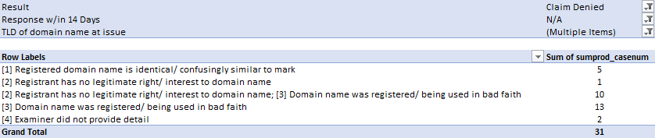
Conclusion: ??

