2012 New gTLD Program Round – Uniform Rapid Suspension (URS) Cases & Initial Metrics
I. GTLD DELEGATION NUMBERS
The following shows the number of gTLDs delegated by year from the 2012 New gTLD Program round; it helps to provide context for the URS data contained elsewhere in this draft report. This introductory information was also presented to the Working Group for Sunrise Registration metrics for the same purpose of context. .
CHART 1: gTLDs Delegated by Year by Type (as of Dec 2017):
** Based on delegation date as noted on the ICANN 2012 New gTLD Program microsite: https://newgtlds.icann.org/en/program-status/delegated-strings

2012 New gTLD Program gTLDs are all considered “generic” from the perspective of IANA (see: https://www.iana.org/domains/root/db). However, the Applicant Guidebook and subsequent implementation of the round further distinguished generic TLDs from Geographic TLDs that required approval from the respective authority and Brands that qualified for Specification 13. Thus, of the 1227 gTLDs from the 2012 round delegated to date, 694 are considered generic for the purposes of this report, and are not assigned a designation of either a geographic or Specification 13 gTLD.

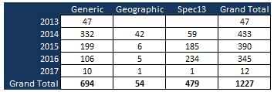
II. URS Definition and Data
The Uniform Rapid Suspension System (URS) is a rights protection mechanism developed for the 2012 New gTLD Program round. Its substantive requirements are based on those in the existing Uniform Domain-Name Dispute Resolution Policy (UDRP), with the most significant differences being the standard of proof required and the remedies permitted. It complements (but does not replace) the UDRP by offering a lower-cost, faster path to relief for rights holders experiencing the most clear-cut cases of infringement.

Resource Documents:
- URS Procedure (Published 01 March 2013) - Explains how to file a claim, what fees will be incurred and other information.
- URS Rules (Published 28 June 2013) - Describes how service providers will implement the Uniform Rapid Suspension System in a consistent manner.
- URS Technical Requirements 1.0 (Published 17 October 2013) - Describes how Registries and Registrars will implement the Uniform Rapid Suspension System technical requirements in a consistent manner.

Data set characteristics:
- Three URS providers (note: data for this exercise is provided by GDD staff, who as part of the CCT-RT work scrape the data from URS provider websites on a quarterly basis):
  - The National Arbitration Forum (FORUM) – Announced 20 Feb 2013
  - Asian Domain Name Dispute Resolution Centre (ADNDRC) – Announced 19 Apr 2013
  - MFSD Srl (MFSD) – Announced 15 Dec 2015
- Scope: Feb 2014 - Dec 2017
  - 12 cases are not included in this dataset due to being in “Pending” status as of 29 Dec 2017
    - 9 Pending at FORUM
    - 1 Pending at MFSD
    - 2 Pending at ADNDRC
- Included in dataset but filtered out from charts and results in this report:
  - .CN - one case; withdrawn (this is a country-code TLD)
  - .COM - one case; withdrawn (this is a legacy TLD)
  - .PRO - two cases; one suspended, one denied (this is a legacy TLD)
  - .PW - four cases; all suspended (this is a country-code TLD)

TABLE 1: URS Macro Statistics:
 | Stat
Scope | Feb 2014 - Dec 2017
Count of Cases | 827
Total Domains | 1861
Avg. Domain/Case | 2.25
Median Domain/Case | 1.00

TABLE 2: URS Statistics by Provider (showing total quantity of cases and domains in dispute handled by each Provider):
 | Cases | Domains
ADNDRC | 29 | 54
ADR Forum | 784 | 1792
MFSD | 14 | 15
Total | 827 | 1861

TABLE 3, CHART 2: URS Cases by Provider (showing total quantity of disputes handled by each Provider by Year):
 | ADR Forum | ADNDRC | MFSD | Grand Total
2014 | 214 | 20 |  | 234
2015 | 209 | 8 |  | 217
2016 | 214 | 1 | 10 | 225
2017 | 147 |  | 4 | 151
Grand Total | 784 | 29 | 14 | 827

TABLES 4 & 5 – Number of URS Cases and Number of Disputed Domains Within Those Cases, Categorized by gTLD (top 25):
Note: The following tables list the top 25 TLDs by total number of cases filed (left side) and the total number of disputed domains within those cases (right side). Thus, for .xyz, a total of 69 cases were filed concerning a total of 582 domains. The tables also show whether the commencement date of each URS proceeding occurred during the mandatory 90-days Trademark Claims period for that gTLD. In reviewing this data, it is important to note the fact that a case was commenced within a particular gTLD Trademark Claims window does not prove that the disputed domain(s) match(es) a record within the TMCH (i.e. it is not a definitive indication that an underlying trademark matching that domain was registered in the TMCH) – for example, some URS cases may have been filed even though the trademark holder did not enter its trademark in the TMCH (one possibility being that the trademark holder may have used a brand monitoring service and thus did not rely on the TMCH or the Trademark Claims service of a Notification of Registered Name). Furthermore, some gTLDs ran indefinite claims periods and did not record a closing date for Claims.
gTLD | Cases not in Window | Cases w/in Window | Grand Total |  | gTLD | Domains not in Window | Domains w/in Window | Grand Total
xyz | 67 | 2 | 69 |  | xyz | 580 | 2 | 582
club | 42 | 11 | 53 |  | win |  | 93 | 93
top | 38 | 9 | 47 |  | party |  | 81 | 81
wang | 28 | 6 | 34 |  | store | 68 | 9 | 77
online | 23 | 5 | 28 |  | shop | 24 | 46 | 70
store | 16 | 9 | 25 |  | club | 58 | 12 | 70
website | 21 | 2 | 23 |  | top | 46 | 9 | 55
email | 17 | 4 | 21 |  | wang | 32 | 6 | 38
vip | 9 | 5 | 14 |  | faith |  | 37 | 37
site | 14 |  | 14 |  | online | 29 | 5 | 34
space | 13 |  | 13 |  | email | 24 | 6 | 30
link | 10 | 2 | 12 |  | website | 24 | 2 | 26
guru | 2 | 9 | 11 |  | link | 17 | 3 | 20
paris | 8 | 3 | 11 |  | site | 19 |  | 19
shop | 2 | 8 | 10 |  | vip | 13 | 5 | 18
international | 10 |  | 10 |  | space | 15 |  | 15
cloud | 7 | 3 | 10 |  | paris | 12 | 3 | 15
click | 8 | 1 | 9 |  | today | 11 | 1 | 12
nyc | 5 | 4 | 9 |  | guru | 3 | 9 | 12
global | 7 | 1 | 8 |  | international | 12 |  | 12
reviews | 8 |  | 8 |  | cloud | 7 | 3 | 10
pub | 8 |  | 8 |  | sale | 8 | 2 | 10
xn--ses554g | 8 |  | 8 |  | reviews | 10 |  | 10
london | 4 | 3 | 7 |  | nyc | 6 | 4 | 10
careers | 2 | 5 | 7 |  | technology | 4 | 5 | 9

TABLE 6, CHART 3: Quantity of URS cases, categorized by Result (e.g. Suspension) and Determination Type (e.g. Default Determination), and listed by Provider:

Category | ADNDRC | ADR Forum | MFSD | Grand Total | Description
Suspended | 24 | 686 | 13 | 723 | Domain Suspended Subtotal
Default | 17 | 502 | 12 | 531 | Default Determination Sub-Subtotal
(blank) | 17 | 501 | 12 | 530 | Default Determination (i.e. without a Response or an Appeal)
Appeal |  | 1 |  | 1 | Appeals from Default Determination
Final | 7 | 170 | 1 | 178 | Final Determination Sub-Subtotal
(blank) | 7 | 160 | 1 | 168 | Final Determination without Appeals
Appeal |  | 10 |  | 10 | Appeals from Final Determination
Default / Final |  | 14 |  | 14 | Default / Final Sub-Subtotal
(blank) |  | 14 |  | 14 | Default & Final Determinations where both are published
Claim Denied | 1 | 57 | 1 | 59 | Claim Denied Subtotal
Default | 1 | 30 | 1 | 32 | Default Determination Sub-Subtotal of Denied Claims
(blank) | 1 | 30 | 1 | 32 | Default Determination of Denied Claims, without Appeals
Final |  | 26 |  | 26 | Final Determination Sub-Subtotal of Denied Claims
(blank) |  | 24 |  | 24 | Final Determination of Denied Claims, without Appeals
Appeal |  | 2 |  | 2 | Appeals from Final Determinations with Denied Claims
Default / Final |  | 1 |  | 1 | Default / Final Sub-Subtotal of Denied Claims
(blank) |  | 1 |  | 1 | Default & Final Determination of Denied Claims where both are published
Split Decision |  | 1 |  | 1 | Split Decision from Appeal Subtotal
Final |  | 1 |  | 1 | Split Decision in an Appeal from Final Determination Sub-Subtotal
Appeal |  | 1 |  | 1 | Appeals where the claim ended with a split decision
Complaint Withdrawn | 4 | 40 |  | 44 | Complaint Withdrawn Subtotal
(blank) | 4 | 40 |  | 44 | Complaint Withdrawn Sub-Subtotal
(blank) | 4 | 40 |  | 44 | Complaints Withdrawn
Grand Total | 29 | 784 | 14 | 827 | Grand Total of Four Primary Categories

Outcome Types:
- Claim Denied – This is the result where the Examiner finds that there is no genuine issue of material fact. Where, however, there is any genuine contestable issue as to whether a domain name registration and use of a trademark are in bad faith, the Complaint will be denied and the URS proceeding will be terminated without prejudice. The URS is not intended for use in any proceedings with open questions of fact, but only clear cases of trademark abuse.
- Split Decision – This refers to the result where a 3-member Appeal panel does not reach a unanimous decision.
- Suspended – This refers to a ruling in favor of the Complainant whereby the domain is suspended for the remainder of the registration period (note: the Complainant may extend this period for an additional year by paying the applicable renewal fee).
- Complaint Withdrawn – This refers to a situation where the Complainant withdraws the complaint, and the case does not proceed to a Determination on examination.

Determination Types:
- Default – Where, at the expiration of the 14-day Response period (or extended period if granted), the Respondent does not submit an answer, the Complaint proceeds to Default status. All Default cases nevertheless proceed to Examination for review on the merits of the claim.
- Final – This describes the Determination that is made when a Response is filed (which can be before or after the Default period). A Final Determination that changes a Default Determination outcome for the same case replaces the Default Determination on the Provider’s website, unless the Examiner determines both are to be made available and so states in its Final Determination. A Final Determination that upholds a Default Determination outcome for the same case may be published together on the Provider’s website, or the Final Determination may replace the Default Determination, at the Examiner’s discretion.
- Default / Final – This term is used for specific cases where the examiner chooses to publish both the Default and Final Determination.
- Appeal – This refers to a case where a party files an appeal from the initial Determination.
- (blank) – This is only a designation result of a blank field from Excel pivot tables and not a determination type as set in the URS Rules and Procedures.

TABLE 7: Average URS Case Duration in Number of Days, by Domains within Cases:
 | Average of Duration
ADNDRC | 18.46
ADR Forum | 17.29
MFSD | 25.78
Total Average | 17.39

TABLES 8 & 9: Domain Disposition of URS Cases as of May 2018

SUMMARY OF INITIAL FINDINGS
Of the 827 URS cases decided through end-2017 (as of May 2018):
- 28% of the cases (59% of domains disputed) – disposition is “Suspended”.
- 27% of the cases (17% of the domains disputed) - domain no longer registered where most were suspended after the Complainant prevailed.
- 30% of the cases (16% of the domains disputed) - Complainant uses brand protection from a provider, a protected marks list, or reserved the name with the Registry

 | Count of Domains |  |  | Count of Cases
Claim Denied | 63 |  | Claim Denied | 59
Registered = YES | 49 |  | Registered = YES | 49
Brand Protection | 12 |  | Brand Protection | 11
Parked | 11 |  | Parked | 11
Brand Protection - UDRP | 10 |  | Brand Protection - UDRP | 10
Does not Resolve | 7 |  | Does not Resolve | 7
Forwards | 6 |  | Forwards | 5
Website | 4 |  | Website | 4
Suspended | 1 |  | Suspended | 1
Registered = NO | 12 |  | Registered = NO | 10
Not Registered | 9 |  | Not Registered | 7
DPML | 2 |  | DPML | 2
Reserved | 1 |  | Reserved | 1
Split Decision | 1 |  | Split Decision | 1
Registered = NO | 1 |  | Registered = NO | 1
DPML | 1 |  | DPML | 1
Suspended | 1745 |  | Suspended | 723
Registered = YES | 1381 |  | Registered = YES | 463
Suspended | 1093 |  | Suspended | 232
Brand Protection | 167 |  | Brand Protection | 138
Does not Resolve | 69 |  | Does not Resolve | 50
Parked | 39 |  | Parked | 34
Website | 6 |  | Forwards | 6
Forwards | 6 |  | Website | 2
Re-Registered by Respondent | 1 |  | Re-Registered by Respondent | 1
Registered = NO | 364 |  | Registered = NO | 260
Not Registered | 298 |  | Not Registered | 210
DPML | 58 |  | DPML | 42
Reserved | 8 |  | Reserved | 8
Withdrawn | 52 |  | Withdrawn | 44
Registered = YES | 46 |  | Registered = YES | 40
Brand Protection | 35 |  | Brand Protection | 33
Parked | 5 |  | Does not Resolve | 4
Does not Resolve | 4 |  | Suspended | 1
Brand Protection - UDRP | 1 |  | Brand Protection - UDRP | 1
Suspended | 1 |  | Parked | 1
Registered = NO | 6 |  | Registered = NO | 4
Not Registered | 6 |  | Not Registered | 4
Grand Total | 1861 |  | Grand Total | 827

Methodology:
- Tables 8 & 9 provide a snap-shot of the current status of all domains involved (i.e. “domain disposition”) in URS cases through 2017 at a specific point in time. An important caveat: due to the dynamic nature of the domain lifecycle, results can change at any other point, due to factors such as expiring registrations, new registrations, or renewals by either the same or a different Registrant. In some cases, staff found it difficult to determine the ultimate ownership and current use of certain domains based on the parties mentioned in the URS proceeding.
- To determine Registrant identity and the assigned name servers, a fresh query of Whois data was fetched from a 3rd-party provider with execution of a script to parse the necessary fields. Another set of Whois records for almost 400 domains was extracted manually as the provider did not have full access to the TLD information.
- How the tables are arranged:
  - The table on the left shows domain disposition based on total number of domains involved in all 827 URS cases, with the table on the right reflecting the same data based on the number of cases.
  - In both tables, the data is categorized by the result in the URS proceeding (e.g. “Claim Denied”, “Split Decision” etc.)
  - In each category, the data is sorted by whether the domain came back as registered; “YES” or “NO”, followed in either case by the domain disposition.
  - By way of example, in the URS case involving the domain wolfram.ceo (Forum case number 1554143), the panel decided in favor of the Complainant and the domain was suspended. The tables reflect this outcome as assigned as “NO”, “Claim Denied”, and its ultimate disposition as “Not Registered”.
- Disposition descriptions:
  - “Suspended” – the domain is assigned this category if the status of the domain, assigned name servers, and/or resolution result in the presentation of the URS Suspension page as defined in the URS procedure and rules. This assignment was confirmed either by the Whois record and/or resolution of the domain via a browser.
  - “Not Registered” – the domain’s Whois response was returned as “NO” and no other Whois information was available
  - “Brand Protection”, “DPML”, and “Reserved” - this terminology indicates that the Complainant/Trademark Owner ultimately recovered the domain, either by registration via a brand protection Registrar or reservation at the Registry. This assignment was mostly confirmed via the Whois record as to the status of the Registration or the assigned name servers.
  - “Brand Protection - UDRP” – the same definition as above applies to this group as it relates to the disposition of the domain, with the difference that these were ultimately resolved via a UDRP filing and decision.
  - “Does Not Resolve”, “Parked”, “Website”, and “Forwards” are a group of disposition types to determine its current use. While some Whois data was reviewed in determining the disposition, the browser was the tool used for final confirmation.
    - “Does Not Resolve” means there was no resolution of the domain and the Whois information did not appear to reflect the Complainant/Trademark Owner.
    - “Parked” is a somewhat loose term; it is used here to indicate a Registrar landing page, or that the domain was for sale, or the website content did not appear to reflect a functioning site or be related to the brand.
    - “Website” was assigned where a typical website was found, but it did not appear to be associated with the Complainant/Trademark Owner. If it did appear as such, the assignment would be “Brand Protection”.
    - “Forwards” was assigned where the domain resolution forwarded to a different URL that did not appear to be associated with the Complainant/Trademark Owner.

TABLE 10: Multiple URS Cases Against the Same Domain:
Domain | Case # | Case Outcome | Case Date | Comments
wolfram.ceo  wolfram.ceo | 1553139 | Claim Denied | April 2014 | Lack of evidence of any relationship between Complainant and Wolfram Group LLC
 | 1554143 | Final / Suspended | April 2014 | same Registrant; Case appealed w/ Complainant prevailing; no longer registered
staralliance.flights | 1562639 | Final / Suspended | June 2014 | Suspended and then deleted
staralliance.flights | 1665072 | Default / Suspended | March 2016 | Different Rt Mar. 2016; Suspended then deleted; Registered new by Brand
astonmartin.parts | 1571374 | Withdrawn | July 2014 | No case information
astonmartin.parts | 1577822 | Withdrawn | September 2014 | Brand Protection October 2014
oliverwyman.consulting | 1573916 | Default / Suspended | August 2014 | Suspended and renewed to 2016 then deleted
oliverwyman.consulting | 1725066 | Withdrawn | April 2017 | Different Rt Mar. 2017; Brand Protection May 2017
morganstanley.top | 1591049 | Final / Suspended | December 2014 | Unable to determine if name was suspended; renewed in 2015; deleted in 2016
morganstanley.top | 1734288 | Default / Suspended | June 2017 | Different Rt. May 2017; Unable to determine if name was suspended; Pending Del
skx.science | 1609616 | Claim Denied | March 2015 | Lack of evidence to demonstrate why Rt. does not have legitimate right or interest
skx.science | 1614750 | Default / Suspended | April 2015 | Same Respondent, Suspended & deleted; Registered new 2018, appears legit use
meguiars.cleaning | 1611647 | Claim Denied | March 2015 | Lack of evidence of any relationship between Complainant and Meguiar's Inc
meguiars.cleaning | 1614952 | Default / Suspended | April 2015 | Same Respondent, Renewed Apr 2016 & 2017 & 2018
sanofi.space | 1631734 | Final / Suspended | August 2015 | Suspended and then deleted
sanofi.space | 1710313 | Default / Suspended | May 2016 | Different Rt. Nov. 2016; Suspended and then deleted
balenciaga.xyz | 1635443 | Default / Suspended | August 2015 | Registered 2014, Renewed 2015; Suspended & deleted
balenciaga.xyz | 1676548 | Default / Suspended | May 2016 | Different Rt. May 2016; Suspended & deleted; Brand Protection Jul. 2017
boucheron.pub | 1635446 | Default / Suspended | August 2015 | Suspended and then deleted
boucheron.pub | 1676556 | Claim Denied | May 2016 | Different Respondent; Brand Protection Jul. 2016
virginmedia.site | 1649592 | Default / Suspended | November 2015 | Suspended and then deleted (under WHOIS Guard)
virginmedia.site | 1741569 | Default / Suspended | July 2017 | Different Rt. Mar. 2017; No avail. WhoWas; Domain available for registration
lufthansa.vip | 1676147 | Final / Suspended | May 2016 | Suspended and then deleted
lufthansa.vip | 1750675 | Default / Suspended | September 2017 | Different Rt. Sep. 2017; domain remains Suspended
lufthansa.store | 1679906 | Default / Suspended | June 2016 | Suspended and then deleted
lufthansa.store | 1755570 | Default / Suspended | October 2017 | Different Rt. Oct. 2017; domain remains Suspended
bnpparibasfortis.expert | 1721891 | Withdrawn | March 2017 | No case information
bnpparibasfortis.expert | 1726997 | Default / Suspended | April 2017 | Suspended and then deleted; Domain available for registration
genzyme.online | 1737246 | Claim Denied | June 2017 | Insufficient evidence of a word trademark
genzyme.online | 1739824 | Claim Denied | July 2017 | Failed to prove bad faith use - two different examiners
raywhite.property | HKS-1500027 | Withdrawn | April 2015 | No case information
raywhite.property | HKS-1500028 | Default / Suspended | May 2015 | Suspended and then deleted; Brand Protection May 2016
alibaba.website | HKS-1500020 | Withdrawn | November 2014 | No case information
alibaba.website | HKS-1500021 | Claim Denied | July 2015 | Failed to prove bad faith use; UDRP filed and prevailed Jul 2015
juhuasuan.wang | HKS-1400015 | Withdrawn | October 2014 | No case information
juhuasuan.wang | HKS-1400016 | Default / Suspended | October 2014 | Unable to determine if suspended, later deleted; Brand Protection Aug. 2015
tmall.wang | HKS-1400011 | Withdrawn | September 2014 | No case information
tmall.wang | HKS-1400014 | Final / Suspended | October 2014 | Unable to determine if suspended, later deleted; Brand Protection Aug. 2015

TABLE 11: URS Case Response Analysis

SUMMARY OF INITIAL FINDINGS:
Of the 827 cases decided through end-2017:
27% of the cases saw a Response filed to the Complaint
23% of the cases saw a Response filed within the 14-day period specified in the URS procedure and rules
13% of the cases with a Response resulted in the claim being denied

 | Response w/in 14d | Response w/in 6mo | N/A | Grand Total
Claim Denied | 22 | 6 | 31 | 59
Default |  |  | 31 | 31
Default / Final |  | 1 |  | 1
Final | 22 | 5 |  | 27
Suspended | 167 | 24 | 531 | 722
Default |  |  | 531 | 531
Default / Final | 1 | 13 |  | 14
Final | 166 | 11 |  | 177
Suspended (Split decision) | 2 |  |  | 2
Final | 2 |  |  | 2
Withdrawn |  |  | 44 | 44
(blank) |  |  | 44 | 44
Grand Total | 191 | 30 | 606 | 827

Methodology:
- The table is first sorted by the outcome of the URS cases and then further categorized by the Determination. Responses are categorized as follows:
  - “Response w/in 14d” mean those cases where the Respondent replied to the Complaint within the 14 days as defined in the URS rules and procedures.
  - “Response w/in 6mo” mean those cases where the Respondent did not respond within the 14-day period but later responded within the permitted 6 month window (which in effect means the panel performs a de novo review).
  - “N/A” was used where the data indicated that no response was filed.
    - However, input from FORUM to the URS Providers sub-team noted that an extension of time to respond was filed in 36 cases.

TABLE 12: Analysis of URS Cases where the Claim was Denied:
From Column AG - If a Response was filed, what Defense(s) or facts were submitted to refute bad faith allegation?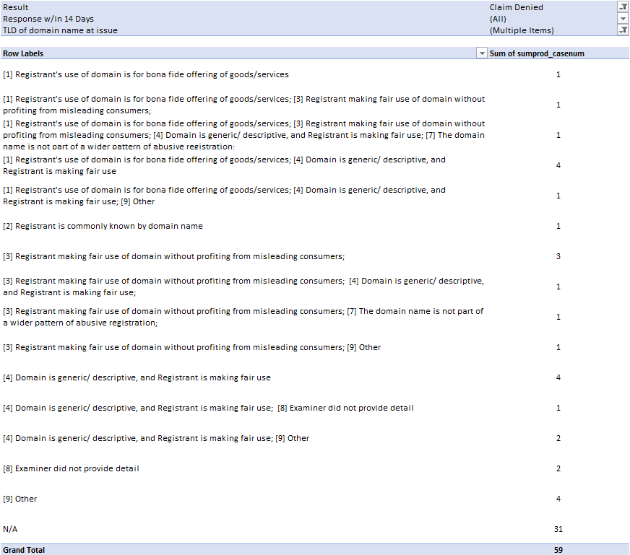

URS Cases Denied where no Response was Filed:
From Column AK - If complainant is unsuccessful, where did complainant fail?
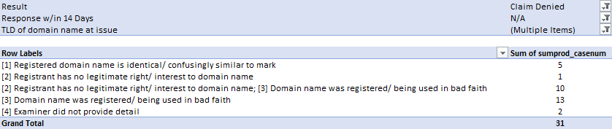
Conclusion: ??

URS Cases Denied where a Response was Filed:
From Column AG - If a Response was filed, what Defense(s) or facts were submitted to refute bad faith allegation?
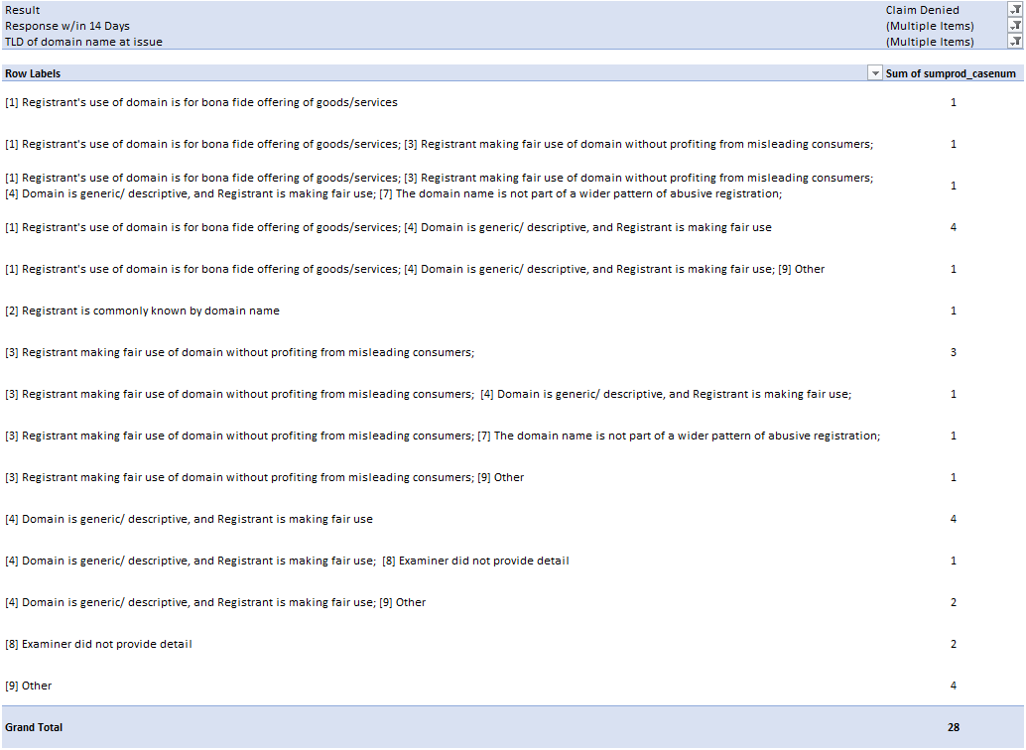
Conclusion: ??
Cases marked with “Other” that included additional comments:
- Examiner did not detail response to bad faith because complainant failed on "confusingly similar to valid TM" prong
- Examiner did not detail response to bad faith because complainant failed on "confusingly similar to valid TM" prong
- Examiner does not specify what respondent alleged with respect to bad faith, as the complainant's case failed to show the registered domain was confusingly similar to a mark the complainant owned.
- Respondent argued that this was a good faith purchase for their business model, that the word was generic, and that the mark was different because Respondent's domain did not include an exclamation point.
- Respondent provided evidence of an Arizona District Court decision (with a different party than Complainant) showing that his business was lawful.
- Respondent argued that he was no longer the owner of the domain (though this was contradicted by other evidence) though the domain had in the past been used for a help site for movie fans.
- Respondent argued he registered the disputed domain with innocent motive after a promotion at <West.cn>. He says he chose the disputed domain name without knowing it is related to the complainant. Respondent asserts he bought the disputed domain name to develop a blog, and he does not intend to sell the domain.
- Respondent claims East Bay refers to a geographic region in the US or several geographic regions throughout the globe. Respondent claims hundreds of companies are using East Bay in their domain name(s) to signify products or services offered to people in the East Bay area. Respondent argues .xyz refers to generations x, y, and z. Respondent argues that it has not tried to confuse the public with regard to the Complainant's brands or products, and that it has not added links to any items related to the Complainant’s registered trademarks.
- Respondent asserts the domain name is a commonly used term in marketing. Respondent argues that he did not purchase the domain with the intention of competing with complainant, and he had no bad faith intentions.

TABLE 13: Analysis of URS Cases where an Appeal was filed:

Placeholder until further direction of analysis is provided.

- Undertaken an analysis of the 14 cases (involving 16 domain names) for which an appeal was filed under the URS. A summary of the Sub Team’s findings is included below, and the Excel spreadsheet that was compiled by ICANN staff and used by the Sub Team is attached to this report. The URS Documents Sub Team:

  - does not believe additional work on these 14 appeals cases is needed unless the full Working Group requests that further analysis be done on specific aspects of these cases;
  - wishes to report that, from its assessment of these cases, it appeared that overall the URS was functioning as intended, and no clear problems were identified; and
  - would like to suggest to the URS Providers Sub Team that they consider including a question to the providers about whether procedural anomalies or mistakes have been raised by any party following the issuance of a Determination (one example that was noted during the URS Documents Sub Team’s discussion was the resolution of a domain name to particular Name Servers following issuance of a Determination).

II. Summary of Findings on the 14 Appeal Cases
  - Out of 14 appeals, 7 were related to the .email gTLD
- In 6 of these 7 cases, the respondent was yoyo.email.
- Of the 6 yoyo.email appeals, only 1 saw the Respondent prevail on appeal (for the domain “stuartweitzman.email” – the losing complainant subsequently filed a UDRP proceeding and won on a preponderance of the evidence standard, with the result that the domain was ordered to be transferred).
- The only .email case not related to yoyo.email was for “grey.email” (here, the Respondent was i-content Ltd and prevailed on appeal; the appeal panel found that the Complainant had not satisfied the clear and convincing standard in relation to the requirements of legitimate interests and bad faith).

- In total, out of 14 appeal cases, the Complainant ultimately prevailed in 12 of them; there were only 2 where the Respondent prevailed (the “stuartweitzman.email” and the “grey.email” cases)

  - Out of 14 appeal cases, 9 were heard by 3-member appeal panels.

  - The following numbers show the final disposition of all the domains that were in dispute (16 domains in 14 appeals) following the appeal:
  - 1 in control of Respondent (the outcome of the “grey.email” case)
  - 7 in control of Complainant (owned or via brand protection)
  - 3 Reserved by Registry or protected under DPML
  - 2 available for registration
  - 3 resolve to suspension page

  - Out of 14 appeals, there were 8 initial cases where the Complainant first prevailed which were later appealed by the Respondent
- 7 out of these 8 appeals resulted in the Complainant prevailing (the 8th being the “stuartweitzman.email” case noted above)

- Out of 14 appeals, there were 6 initial cases where the Respondent first prevailed which were later appealed by the Complainant
  - 5 out of these 6 appeals resulted in the Complainant prevailing (the 6th being the grey.email case)

As depicted in table form:
Type of Appeal |  | Result | Comments
Complainant first prevailed, Respondent appealed | 8 | Complainant ultimately prevailed: 7 | Respondent (yoyo.email) prevailed in “stuartweitzman.email” appeal
Respondent first prevailed, Complainant appealed | 6 | Complainant ultimately prevailed: 5 | Respondent (i-content ltd) prevailed in “grey.email” appeal
TOTAL | 14 | 12 (Complainant prevailed) | 2 (Respondent prevailed)

New gTLD Microsite: https://newgtlds.icann.org/en/applicants/urs
URS Procedure, Section 8.
URS Rules, Sections 11 & 12.
URS Rules, Sections 13 & 15.
URS Procedure, Section 12; URS Rules, Section 19.
457 Domains are from one case for “Ashley Furniture” and 202 domains are from another case for “Cialis”; all of which are still suspended.

