List of marks to ask Deloitte about:

Parents (registered for magazines)
Word Mark PARENTS
Mark Drawing Code (5) WORDS, LETTERS, AND/OR NUMBERS IN STYLIZED FORM
Registration Number 2654160

Fruit of the Loom (in oval)
FRUIT OF THE LOOM
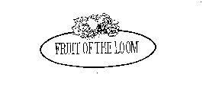
Mark Drawing Code (3) DESIGN PLUS WORDS, LETTERS, AND/OR NUMBERS
Regis. 1234708

Cars
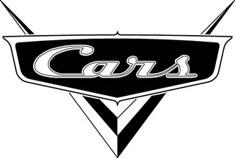
Regis. No. 3419857
Mark drawing type: 3 - AN ILLUSTRATION DRAWING WHICH INCLUDES WORD(S)/ LETTER(S)/NUMBER(S)
Description of Mark: The mark consists of the word "CARS" in stylized lettering, surrounded by a dark oblong and superimposed over a stylized "V".
https://tsdr.uspto.gov/#caseNumber=78538954&caseType=SERIAL_NO&searchType=statusSearch

