Questions by GNSO Review of all RPMs for all gTLD PDP WG members on summary of INTA Cost Impact Study Analysis (31 August 2017):

- George Kirikos and Kurt Pritz: Questions about the non-randomized nature of the results, the small sample size, and associated questions about confidence indicator, error margins and overall statistical validity
  - Question for Nielsen – what are the margins for error?
Nielsen: this will vary based on assumptions and question type, and as we stated given the small sample size we would treat this as directional, but assuming a 90% confidence interval, the worst case MOE is +/-14%--as responses move away from a 50/50 distribution, the MOE will get smaller. We feel that the total sample is sufficient to give directional information about those trends, but the exact numbers would still be subject to a high margin of error (the +/- percentage you always hear about with polls).

- George Kirikos: For each survey result (percentage, average, etc.) that INTA is presenting and purporting to be statistically valid, I request that INTA also publish the error margins and confidence level attached to each and every figure (e.g. +/- X, 19 times out of 20, or whatever), and also how they derived that confidence level. The standard calculations require that the sample be random, too. So please also point out any adjustments to, if any, that were made to the standard calculations that back up the figures.

This basically repeats Q1. INTA has not commented on statistically validity. INTA has noted the small number of respondents and has cautioned that the result may indicate trends but do not dispositively identify trends.
Nielsen: totally agree. It is highly unlikely that the INTA membership in total would present findings that negated this research, but the level and degree of these findings will likely vary as more members provide information. How much they would vary, we cannot know.

- Paul Tattersfield (referring to Slide 22 on the Nielsen deck): Question about the two charts showing domains registered in new gTLDs or ccTLDs that are duplicates of registrations in legacy gTLDs, i.e. why isn’t the chart labeled “not primarily to prevent name from being used by another registrant” be the exact reverse of the chart labeled “primarily to prevent name from being used by another registrant”? This question is for Nielsen.
Nielsen: the question asked was “For the (RESPONSE FROM Q720_3) domains that duplicated a registration in a legacy TLD or ccTLD, how many registrations were intended primarily to prevent the name from being used by another registrant and how many were not?” The title reflects that one chart is showing the numbers of those register specifically TO prevent, while the other shows the distribution of those NOT specifically registered to prevent.
- Louise Marie Hurel: Does Nielsen have the breakdown of respondents by country as well as region?
Nielsen: Yes, this is the first table in the printouts provided to INTA, here is a screen snip:
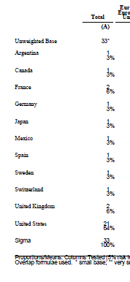

- Michael Flemming: The average total defense costs per company on slide 13 (I think), is that inclusive of individual worker's salaries or only the cost of the defensive action itself? (Note: Michael was referring to the slides presented during the WG call in this question)
Nielsen: Cost calculations are explained on slide 4 of the deck, specifically: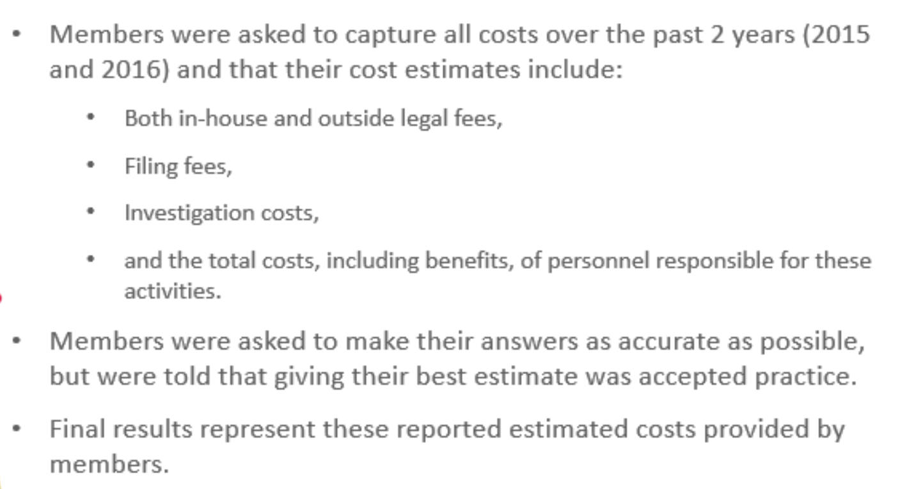
- Phil Corwin: What if anything does this study tell us about efficacy of the new RPMs and whether and how they should be modified? Study only focuses on cost.

Nielsen: we did ask about perceived effectiveness of RPMs. See slide 51
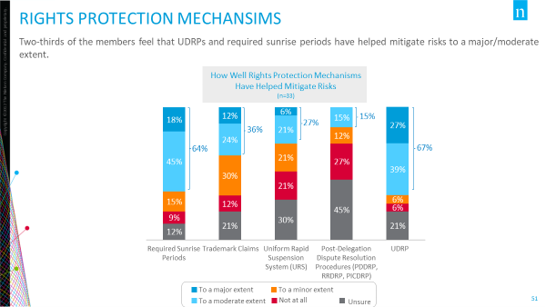

- Phil Corwin: I don't see anything in these slides regarding use of private RPMs such as DPML and whether that affected use of sunrise. Were any questions asked about that?

There were no questions related to private RPMs.
Nielsen: Correct

- Maxim Alzoba: It would be interesting to see composition of numbers from page 10 (of full report) on price of defensive actions. Do we have this data?
Nielsen: I’m not sure what he is asking for, but if it is a breakdown of the component costs that go into each category shown on this slide, yes, we have that. Worksheet attached to email.

- Paul Tattersfield (referring to the INTA Cost Impact Analysis Report slides – Nielsen deck): I think the survey may be useful as long as we recognize those filling out the survey are mostly from the largest members of the INTA. I think INTA did well getting such substantive replies from these participants. These replies may be helpful as the benefits and problems they have with new gTLDs are likely to be very different from medium sized and smaller enterprises. It may be when considering just the largest members the statistical significance of the survey changes? With this in mind I think it would be helpful if an extra column could be added to each of the tables on page 6. And in that column, show the Total INTA members percentages i.e. the percentages of the 6,600 next to the each of the %ages from the 33 that replied.
Nielsen. We do not have those stats for either the 1046 valid contacts we were provided with nor the 6600 referenced in the question above, which I assume includes duplicate membership within entities.

