OVERVIEW MATERIALS REGARDING REMOVING SLA METRICS FROM ANNEX A

Table of Contents
Overview: Documents/Materials Required 2
Overview: Process for Amending Annex A 3
Project Management Plan 4
Calendar Plan 6

Overview: Documents/Materials Required for Contract Amendment Regarding SLAs

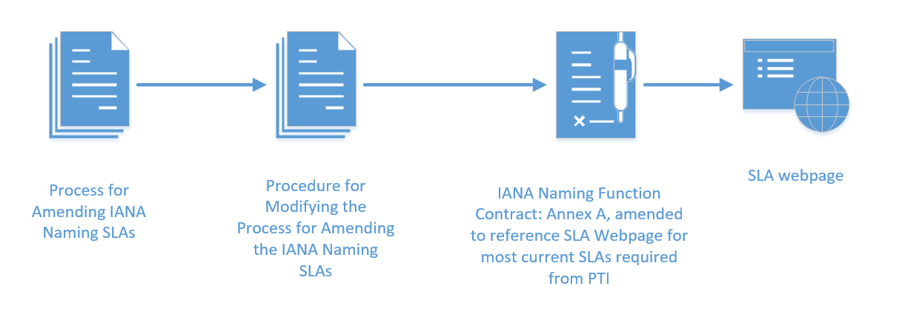

Overview: Process for Amending Annex A
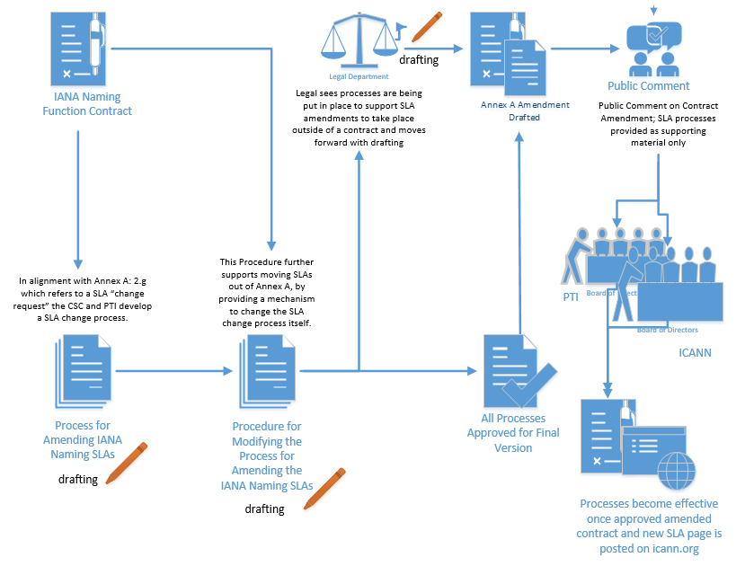
Project Management Plan leading to ICANN & PTI Board Ratification of IANA SLA Amendment Process, etc.
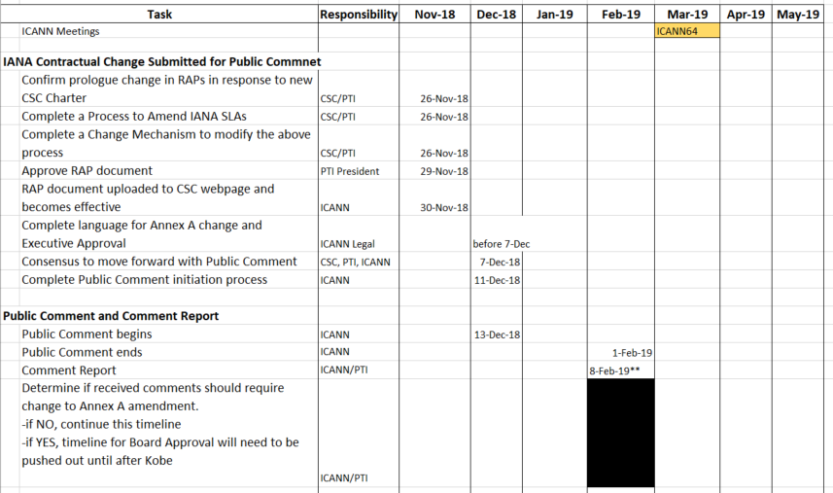
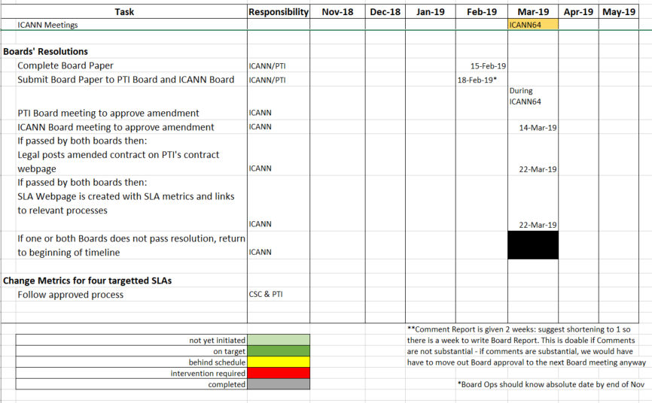

Calendar Plan leading to ICANN & PTI Board Ratification of IANA SLA Amendment Process, etc.
