Memorandum
TO:  From: | ICANN CCWG-Accountability IRP IoT  Holly J. Gregory  Ed McNicholas  Rebecca Grapsas  Sidley Austin LLP
Re: | Time for Filing Facial Challenges in the  Draft Updated Supplementary Procedures for IRP
Date: | January 4, 2017

Question Certified
You have asked whether the current draft language of Section 4 (Time for Filing) in the Draft Updated Supplementary Procedures for Internet Corporation for Assigned Names and Numbers (ICANN) Independent Review Process (“Draft Supplemental Rules”) as posted for public comment (https://www.icann.org/en/system/files/files/draft-irp-supp-procedures-31oct16-en.pdf) captures in a clear and appropriate way the following “agreement in principle” on timing of claims (the “Agreement in Principle”):
“An action/inaction by ICANN that is facially invalid (i.e. it could not be implemented in a way that did not violate the Articles or Bylaws) could be challenged anytime. . . . Otherwise, the 45 days/1-year-overall time limit applies from the time a claimant is actually materially harmed by an action/inaction.”
You have also asked that, if the Agreement in Principle is not expressed in a clear and appropriate way, we provide draft language for your consideration.
We note that the last sentence of the Agreement in Principle set forth above is internally inconsistent if read literally, as the 45-day and 1-year time limits cannot both commence at the time of harm. (If both time periods are triggered by the same event, then the outer limit of 1 year will never be needed. It will be redundant since it will be impossible to satisfy the 45-day filing requirement without always easily satisfying the 1-year requirement.) We have therefore interpreted the reference to the “1-year-overall time limit” as meaning a 1-year time limit that commences at the time of the action or inaction, rather than commencing at the time of harm. References in this memorandum to the “Agreement in Principle” refer to the Agreement in Principle as modified in accordance with this interpretation.
Executive Summary
As currently drafted, Section 4 of the Draft Supplemental Rules does not capture the Agreement in Principle described above. The current draft language is more limited than the Agreement in Principle in that it allows only for challenges that are brought within 45 days of the date the claimant becomes aware of material harm by an invalid action or inaction and in any event within 12 months of the action or inaction giving rise to the claim. Therefore, as currently drafted, a facially invalid action or inaction could not be challenged by a claimant if the material impact to the claimant (harm or injury) arose at a time such that the claim could not be filed within 12 months from the ICANN decision that created the facial invalidity.
ICANN’s Amended Bylaws (“Bylaws”) control the drafting of the Supplemental Rules. The CCWG-Accountability Final Report (“CCWG Report”) also provides helpful guidance. We note that while neither the Bylaws nor the CCWG Report distinguish between IRP challenges on grounds of facial invalidity versus other grounds, the Agreement in Principle described above does not appear to be facially inconsistent in significant respects with the Bylaws. However, we also note that the Bylaws do not specifically contemplate a 12-month limit on any claims and appear to require that any time limit run from the time at which the claimant became aware of or reasonably should have become aware of the material impact, which the Agreement in Principle does not address. (The CCWG Report also contemplated that the time limit would run from the time at which the claimant became aware of the alleged violation and how it affected them.)
As requested, we have drafted a proposed amendment to Section 4 of the Draft Supplemental Rules for your consideration, attached as Annex A. In addition to reflecting the Agreement in Principle, the proposed amendments add a 45-day time limit to challenges on grounds of facial invalidity and suggest language for consideration that would conform Section 4 more closely with the Bylaws.
Analysis
- Relevant Provisions
Section 4 of the Draft Supplemental Rules as currently drafted provides that IRP challenges may only be brought within a strictly limited period:
- “A CLAIMANT shall file a written statement of a DISPUTE with the ICDR no more than 45 days after a CLAIMANT becomes aware of the material effect of the action or inaction giving rise to the DISPUTE; provided, however, that a statement of a DISPUTE may not be filed more than twelve (12) months from the date of such action or inaction.”
This time limit applies to all Disputes, and the definition of Dispute in the Draft Supplemental Rules does not mention or appear to consider facial challenges.
Neither the Bylaws nor the CCWG Report contemplate distinct timing rules for various types of Disputes, but neither is there any limitation on providing such distinct timing rules. Rather, as set forth below and within fairly broad parameters the IRP Subgroup has been charged with proposing appropriate rules.
The Bylaws provide that time limits on seeking IRP redress will run from when a claimant became aware or reasonably should have become aware of the action or inaction giving rise to the dispute:
- “The Rules of Procedure are intended to ensure fundamental fairness and due process and shall at a minimum address the following elements: The time within which a Claim must be filed after a Claimant becomes aware or reasonably should have become aware of the action or inaction giving rise to the Dispute.”
The current provision in the Draft Supplemental Rules that a claim of dispute be brought within 45 days of the claimant becoming “aware of the material effect of the action or inaction giving rise to the Dispute” would be consistent with the Bylaws if the terms “or reasonably should have become aware” are added to the time-for-filing limitation. This 45-day time limitation should also apply to challenges on the grounds of facial invalidity, to ensure consistency with the Bylaw requirement that claims be brought within a specified time after the claimant became aware or reasonably should have become aware of the alleged invalidity.
The Agreement in Principle is more closely aligned with the Bylaws than is the current provision in the Draft Supplemental Rules, because the Agreement in Principle allows for challenges of facial invalidity to be brought within a set period (45 days) after the facial invalidity becomes known to the claimant (due to a material effect on the claimant) but without a strict 12-month limit from the time of the ICANN action or inaction. The Agreement in Principle would be more closely aligned to the Bylaws if it (a) included the concept of “reasonably should have known” and (b) did not apply the strict 12-month limit to any type of IRP claim. Applying a strict 12-month limit to any IRP claim that commences at the time of the ICANN action or inaction and without regard to when the invalidity and material impact became known to the claimant, is inconsistent with the Bylaws (and is inconsistent with the terms of Annex 7 of the CCWG Report). It may be that the IRP Subgroup has determined that 12 months is the period in which a claimant reasonably should have known of the action or inaction giving rise to the Dispute in all circumstances (or in all circumstances other than where the challenge is on facial invalidity grounds); however, we think such a determination would be subject to criticism and it could result in claims being foreclosed before an injury, and hence knowledge of any injury, had ever arisen.
The language that we propose to more fully reflect our understanding of the Agreement in Principle is set forth in Annex A. It would allow a claimant to challenge an action or inaction by ICANN that was facially invalid at any time within 45 days of the claimant becoming aware of a material effect, but would leave in place the 45-day/12-month limit for “as applied” challenges. Consideration should be given to including the “should have known” concept provided in the Bylaws.

- Facial Versus As Applied Challenges
Distinctions between “facial” versus “as applied” challenges are not uncommon in suits challenging the constitutionality of a U.S. law, and there is a developed body of jurisprudence in this area. Generally, a claimant who argues that an action is “facially” invalid is alleging that the action/rule could not be implemented in a way that did not violate the law or here, articles of incorporation and bylaws. In other words, a facial challenge alleges that in all circumstances -- regardless of the context or specific facts -- the action (or inaction) is invalid. In contrast, an “as applied” challenge asserts that the challenged action has injured the claimant but may not cause injury to all others in all circumstances. If an invalidity allegation is correct, the challenged action or rule could continue to cause injury for many years after the action or rule came into being. Therefore, rather than imposing a time limit that runs from the time the action came into being or took effect, the typical means to protect against misuse of avenues of redress is to require, regardless of whether a claimant makes a facial or as applied argument, that the claimant must first allege that they have actually been injured by the action.
Typically in U.S. courts, jurisdictional limits, such as ripeness and time-to-file requirements (statute of limitations) apply to “facial invalidity” challenges just as they would for “as applied” challenges. Claimants must first establish that they have standing, are within the statute of limitations and meet similar procedural requirements, and then they may make arguments about the invalidity of the law on the merits, whether due to facial invalidity or invalidity as applied to their circumstances.
In contrast to the Agreement in Principle, time-to-file limitations applied by U.S. courts are tied to the date that the claimant knew or should have known about the injury. Plaintiffs may challenge an action’s validity -- for example, a challenge to the enactment of a law -- any time within the limitations period after the law injured them, regardless of whether they argue that the law was facially invalid or invalid as applied to them.

- Conclusion
As currently drafted, the Draft Supplemental Rules strictly bar any IRP challenge from being brought more than 12 months after the action or inaction giving rise to the Dispute. Allowing an action or inaction to be challenged as facially invalid within 45 days of the time the claimant became aware of the material effect on the claimant would be consistent with the Bylaws (in addition to the CCWG Report) if such time limit could also be triggered by a “reasonably should have known” standard. We also note that applying a strict 12-month limit to “as applied” claims is inconsistent with the Bylaws for the same reasons discussed above.
Exempting facial challenges from the 12-month rule would not create limitless jurisdiction. The IRP would still have significant restrictions on time to file, because even claims of facial invalidity would be bound by the 45-day period from discovery of the material impact or injury and thus would need to be brought in a timely fashion. Claimants who brought challenges based on “as applied” arguments could still be subject to both the 45-day and 12-month limitations, assuming that the IRP Subgroup and commentators are satisfied that the 12-month limitation is an appropriate measure of when a claimant “reasonably should have known” of the action or inaction giving rise to the Dispute. This may be a difficult standard to support in circumstances where “as applied” the impact or injury does not arise within a year of the action or inaction at issue. (One option is to consider an amendment to the Bylaws to avoid assertions that the IRP Rules are not in full compliance.)
As requested, we attach proposed language for amendments to the Draft Supplemental Rules to better capture the Agreement in Principle. We have included in brackets additional edits that you may wish to consider to bring the provision in line with the Bylaws and the CCWG Report.

Annex A
A CLAIMANT shall file a written statement of a DISPUTE with the ICDR no more than 45 days after a CLAIMANT becomes aware of [or reasonably should have become aware of] the material eaffect of the action or inaction giving rise to the DISPUTE; provided, however, that a statement of a DISPUTE may not be filed more than twelve (12) months from the date of such action or inaction. Challenges which allege that a COVERED ACTION is invalid for all applications (“facially invalid”) may be brought at any time within 45 days after CLAIMANT becomes aware of [or reasonably should have become aware of ]the material effect of the COVERED ACTION giving rise to the DISPUTE without regard to the 12-month limitation.

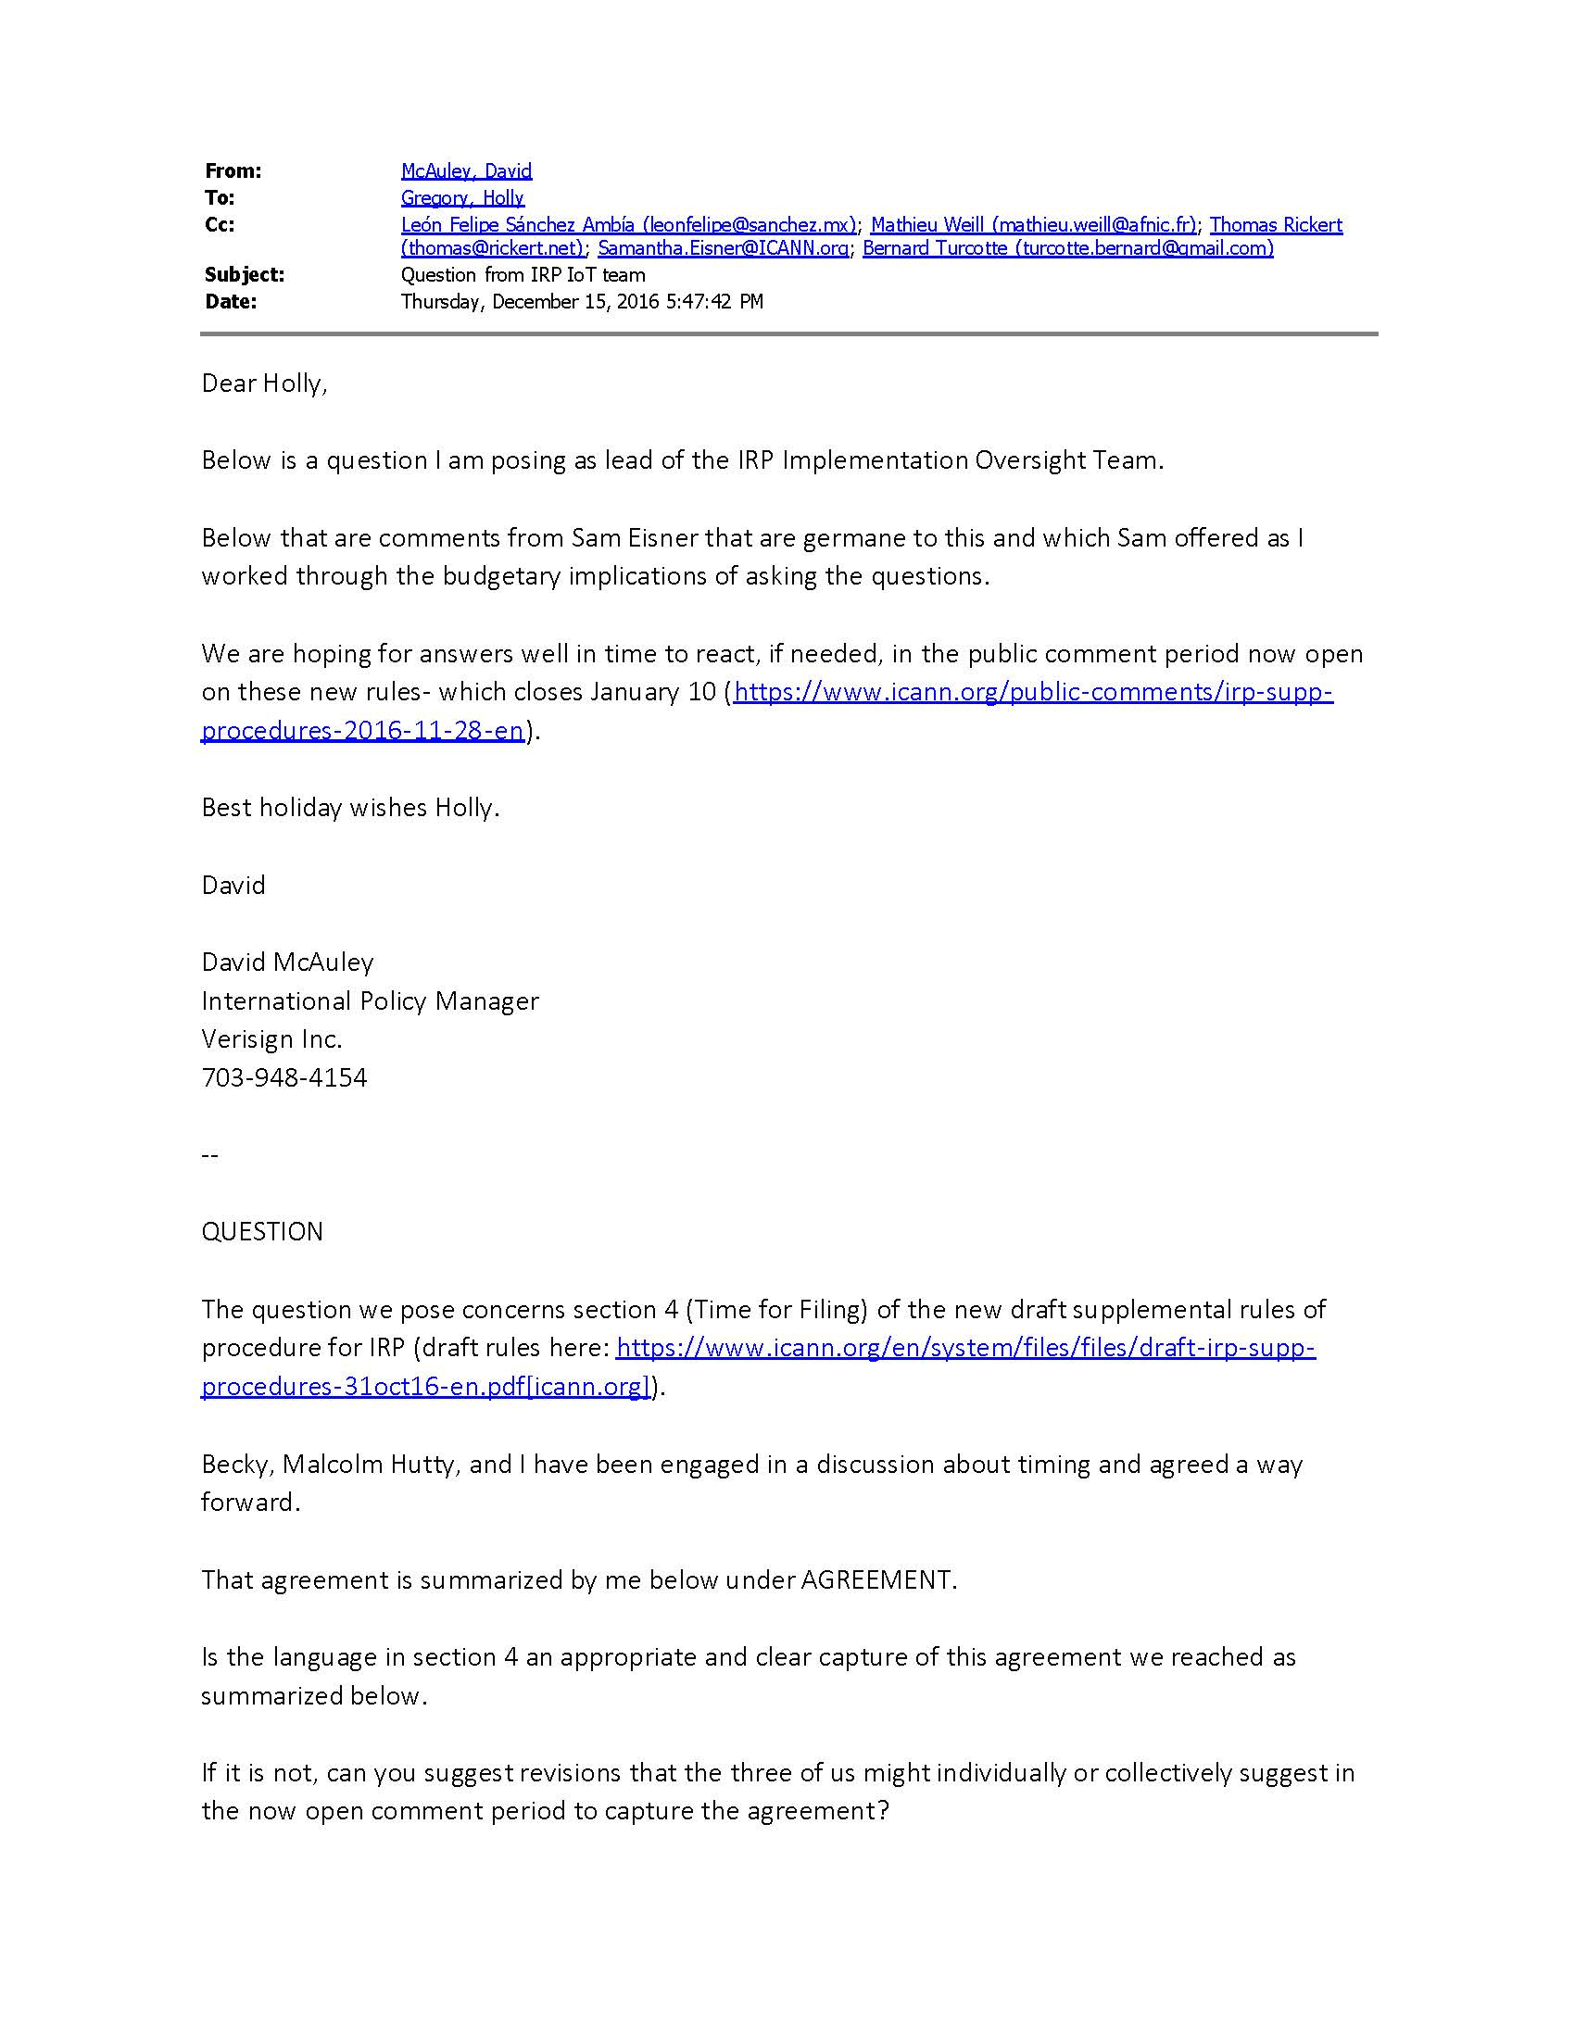

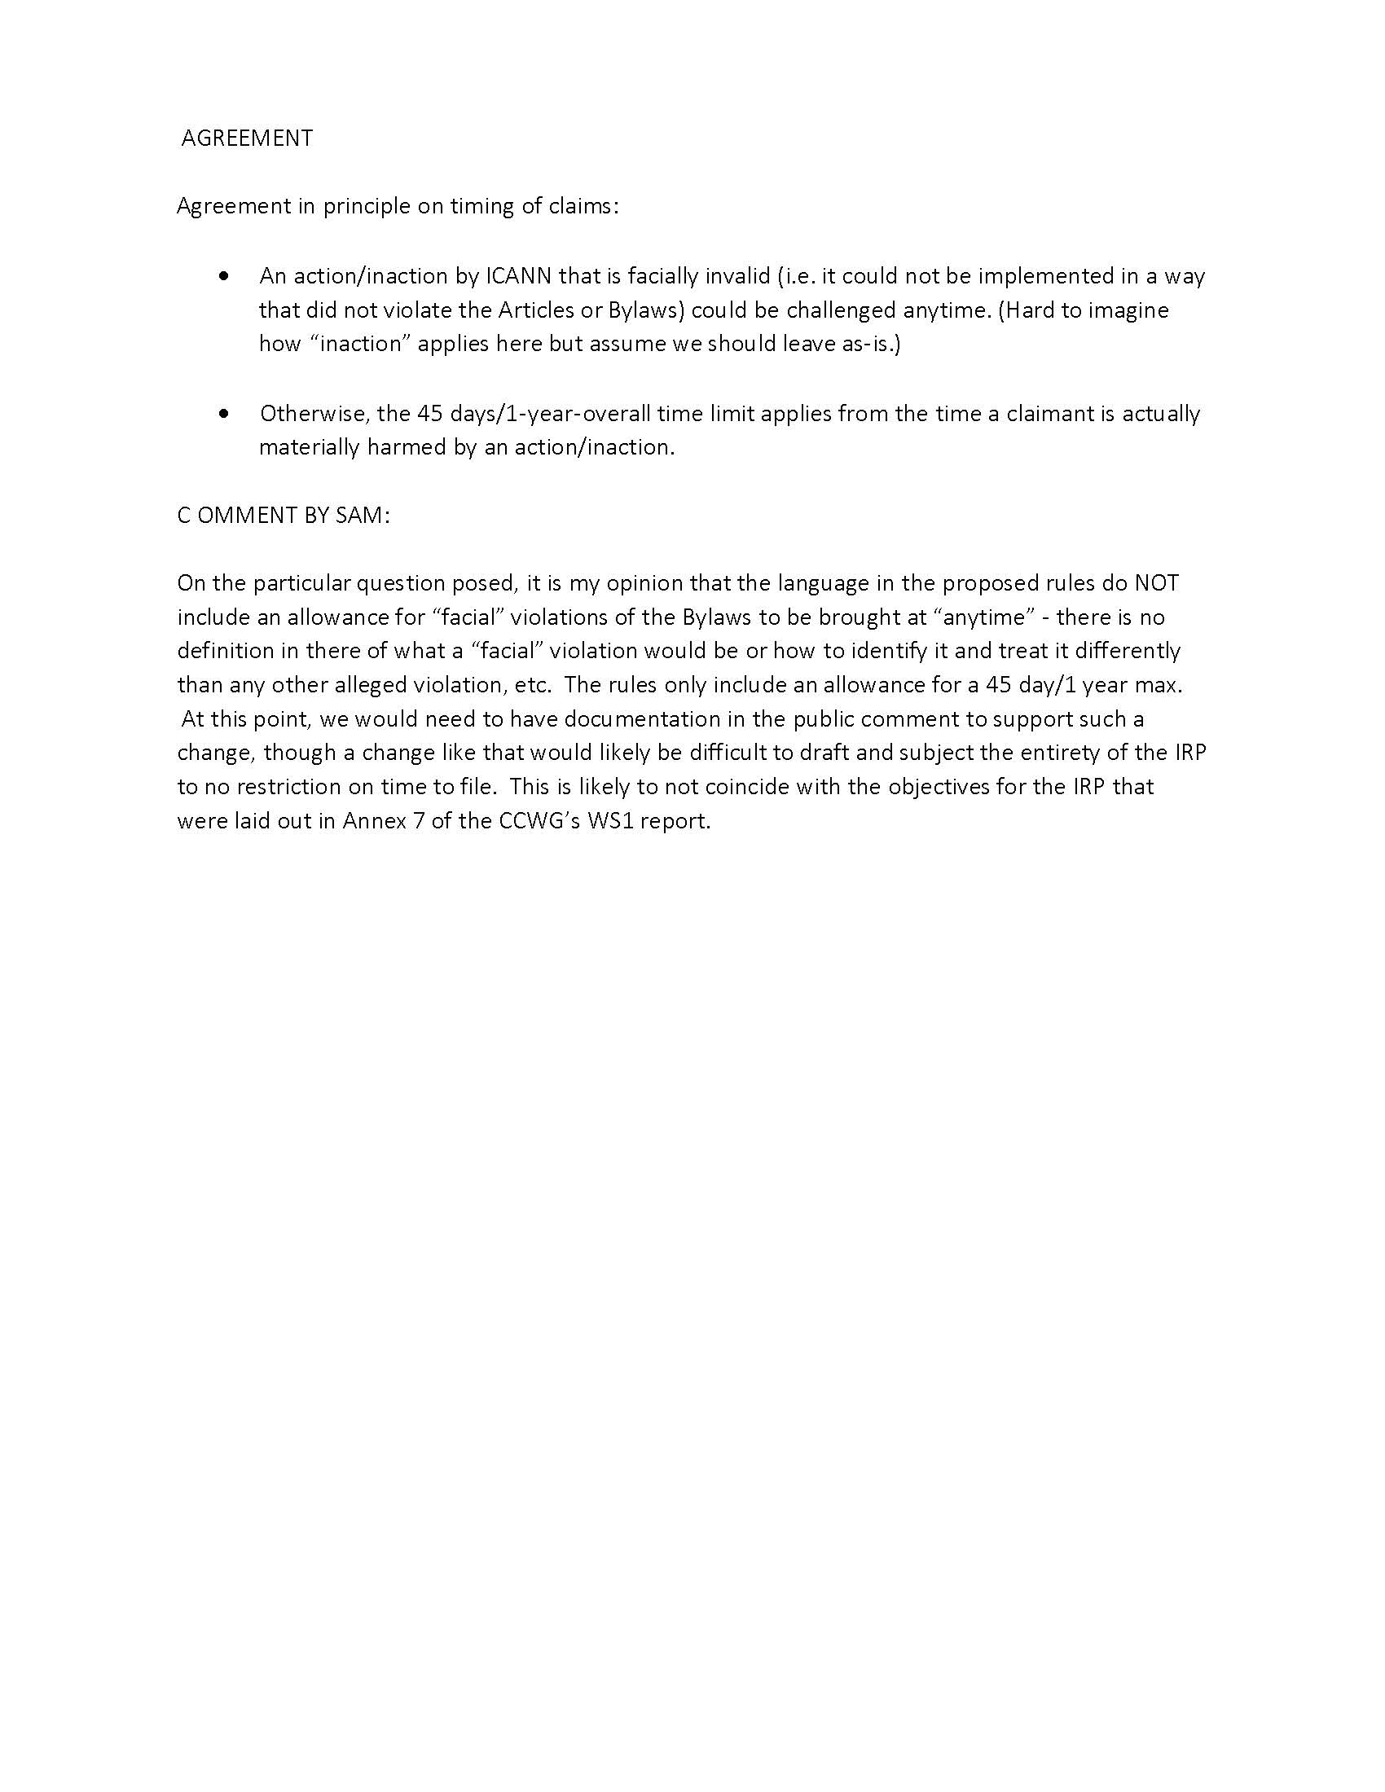

A copy of the email certifying this question to us is attached. Note as a general matter that our legal analysis is provided on a level in keeping with the question posed. Our legal analysis is tailored to the context in which the particular question arises. It is provided to inform and help facilitate your consideration of the issues under discussion and should not be relied upon by any other persons or groups for any other purpose. In our effort to respond in a limited time frame, we may not have completely identified, researched and addressed all potential implications and nuances involved.
ICANN Bylaws (as amended October 1, 2016), Article IV, § 4.3 (“Independent Review Process for Covered Actions”) (“Bylaws”).
CCWG-Accountability Supplemental Final Proposal on Work Stream 1 Recommendations (23 February 2016) (“CCWG Report”)
Draft Supplemental Rules, § 4 (“Time for Filing”). (footnotes omitted)
Draft Supplemental Rules, § 1 (“Definitions”). The Draft Supplemental Rules define Disputes as “(A) Claims that COVERED ACTIONS violated ICANN’s Articles of Incorporation or Bylaws, including, but not limited to, any action or inaction that: 1) exceeded the scope of the Mission; 2) resulted from action taken in response to advice or input from any Advisory Committee or Supporting Organization that are claimed to be inconsistent with the Articles of Incorporation or Bylaws; 3) resulted from decisions of process-specific expert panels that are claimed to be inconsistent with the Articles of Incorporation or Bylaws; 4) resulted from a response to a DIDP (as defined in Section 22.7(d) [of the Bylaws]) request that is claimed to be inconsistent with the Articles of Incorporation or Bylaws; or 5) arose from claims involving rights of the EC as set forth in the Articles of Incorporation or Bylaws; (B) Claims that ICANN, the Board, individual Directors, Officers or Staff members have not enforced ICANN’s contractual rights with respect to the IANA Naming Function Contract; and (C) Claims regarding the Post-Transition IANA entity service complaints by direct customers of the IANA naming functions that are not resolved through mediation.” Id. (footnotes omitted) “COVERED ACTIONS are any actions or failures to act by or within ICANN committed by the Board, individual Directors, Officers, or Staff members that give rise to a Dispute.” Id. (footnotes omitted) The CCWG Report, including its Annex 7, emphasizes that: - “The purpose of the Independent Review Process (IRP) is to ensure that ICANN does not exceed the scope of its limited technical Mission and complies with its Articles of Incorporation and Bylaws.” (CCWG Report ¶174; Annex 7 ¶1.) - “Any person/group/entity ‘materially affected’ by an ICANN action or inaction in violation of ICANN’s Articles of Incorporation and/or Bylaws shall have the right to file a complaint under the IRP and seek redress.” (CCWG Report ¶178 (Standing); Annex 7 ¶¶4 (Standing) & 18.) - A claimant must seek redress “within a certain number of days (to be determined by the IRP Subgroup) after becoming aware of the alleged violation and how it allegedly affects them.” (CCWG Report, Annex 7 ¶¶18–19.)
Bylaws, § 4.3(n)(iv)(A). Note that the CCWG also intended that the Rules of Procedure be “informed by international arbitration norms.” (CCWG Report, Annex 7 ¶52; Bylaws, § 4.3(n)(ii).) While the ICANN rules have traditionally incorporated tight limitations, international arbitration norms do not normally apply the time limitations on initial filing. None of the major international arbitration bodies we reviewed -- Arbitration Institute of the Stockholm Chamber of Commerce, International Centre for Dispute Resolution, International Court of Arbitration, International Institute for Conflict Prevention & Resolution, JAMS or World Intellectual Property Organization -- imposes a time limit for filing in addition to any standard statute of limitations or contractual time limitations that might apply. Most of the rules for these bodies are silent on such limitations. The JAMS Comprehensive Arbitration Rules & Procedures state that the date of commencement is governed by “legal requirements such as the statute of limitations, any contractual limitations period or claims notice requirements.” (JAMS Comprehensive Arbitration Rules & Procedures, Rule 5(d) (July 1, 2014).) For JAMS and other arbitration rules, any applicable statute of limitations would be covered by the rules’ choice of law provision.
Several U.S. cases may help to illustrate: In Lawrence v. Texas, 539 U.S. 558 (2003), the plaintiff argued that a law enacted in the 1970s and amended in 1993 was unconstitutional. See also Lawrence v. State, 41 S.W.3d 349, 350 (Tex. App. Houston 14th Dist. 2001) (noting that Lawrence was arguing that the law was facially unconstitutional). Even though the plaintiff alleged that the law was facially unconstitutional when it was enacted, the statute of limitations for that claim did not begin with the law’s enactment, or even its amendment, but began when the plaintiff was prosecuted under the law and thus injured by it. Id. Similarly, in Brown v. Barry, 710 F. Supp. 352 (D.D.C. 1989), the plaintiff challenged the constitutionality of a law that had been on the books for almost 100 years. The plaintiff alleged the law was facially unconstitutional from the day it was passed, but the statute of limitations only began to run when the plaintiff’s injury accrued—when he learned of the special licensing requirement the law placed on him. Id. Again, in RK Ventures, Inc. v. City of Seattle, 307 F.3d 1045, 1059 (9th Cir. 2002), a U.S. federal court held that nightclub owners wishing to challenge the city’s nightclub ordinance as vague, overbroad, and facially unconstitutional could do so within the statute of limitations, which began to run not when the ordinance was passed but when the city informed the nightclub owners of its intention to prosecute them under the ordinance.
This phrase is added to conform to the language in the Bylaws. As discussed above, consideration should be given to whether the 12-month limitation is consistent with Section 4.3(n)(iv)(A) of the Bylaws.
This phrase is added to conform to the language in the Bylaws.

