Post-Transition IANA (PTI)
For Discussion
24 May 2016

1. Overview
The IANA Stewardship Transition Coordination Group (“ICG”) proposal states “PTI would perform all of the IANA functions currently covered by the NTIA contract, with the necessary staffing and resources to do so.”

The approach to implement this ICG requirement is based on discussions with the Implementation Oversight Task Force (IOTF), which resulted in the agreement that Post-Transition IANA (PTI) will perform all three IANA functions and IANA staff may be seconded to PTI to perform the functions.

2. Implementation Approach

2.1 LEGAL FORMATION of THE AFFILIATE
Consistent with the ICG proposal, PTI will be incorporated as an affiliate of ICANN, domiciled in the State of California, and with ICANN being the sole member. Drafts of the affiliate’s bylaws and articles of incorporation have been circulated to the IOTF for review.
ICANN will select a name for the affiliate and share it with the community once all of the necessary preparations are made.
Once incorporated, the affiliate will apply for 501(c)(3) tax-exempt status.
Timeline for the legal formation of the affiliate is provided in section 3 of this document.
2.2 GOVERNANCE OF THE AFFILIATE

Board of Directors

As per the ICG proposal and called for in the ICANN Bylaws, the affiliate will have a Board comprised of five directors, three to be selected by the ICANN Board from ICANN staff, and two nominated via a rigorous nominating process. The discussion on IOTF call number 1 resulted in an agreement that the rigorous nominating process referenced in the CWG-Stewardship proposal shall be the ICANN Nominating Committee process.

Because the 2016 Nominating Committee process is already well underway, the IOTF also reached an agreement on call number 1 that the CWG-Stewardship Co-Chairs, Jonathan Robinson and Lise Fuhr, will serve as the two non-ICANN-staff directors until these positions can be filled by the 2017 ICANN Nominating Committee process.

The ICANN Board will formally appoint and seat all five directors.

Officers

It is expected that the affiliate will have the following officers:

- President
- Treasurer
- Secretary

The President will be a seconded IANA staff.

The other officers will be direct shared resources provided by ICANN. A description of direct shared resources is provided in appendix 4.1 of this document. The affiliate’s Board will appoint the affiliate’s officers.

Personnel changes to these positions will require consent of the affiliate’s Board.

2.3 STAFFING AND OPERATIONS OF THE AFFILIATE

Staffing

ICANN will second the existing IANA department employees to the affiliate to perform the three IANA functions, names, numbers, and protocol parameters. ICANN will continue to provide all employee benefits for the seconded employees. The seconded employees will continue to have all legal rights afforded to them under their employment contract with ICANN. All performance or disciplinary actions will be dealt with in accordance with ICANN’s policies and procedures. Performance reviews and career development will follow ICANN’s processes. The terms of the secondment will be reflected in an inter-company services agreement between ICANN and PTI.

In the event of separation, ICANN commits to an effectuating an orderly transition, including providing the seconded employees the option of employment with the affiliate, the successor, or ICANN. This commitment will be reflected in the naming function contract between ICANN and PTI.

ICANN-Affiliate Contracts

There will be four contracts between ICANN and PTI:

- Naming function contract: This contract sets out the terms for the performance of the naming function. A draft summary of section headers for this contract has been shared with the IOTF.
- Protocol parameters function sub-contracting agreement: This sub-contracting agreement allows the affiliate to perform the protocol parameters function as specified in the IETF Memorandum of Understanding (MoU) and Supplemental Agreement between the IETF and ICANN.
- Number function sub-contracting agreement: This sub-contracting agreement allows the affiliate to perform the number function as specified in the Service Level Agreement for the IANA Numbering Services between the Regional Internet Registries and ICANN.
- Inter-company services agreement: This agreement contains the terms of secondment, provision of other resources, and funding commitments from ICANN to support the affiliate’s operations.

Figure 2.i provides a graphical depiction of the four contracts. Figure 2.ii provides a graphical view of the staffing and resources arrangement between ICANN and the affiliate.

Figure 2.i: ICANN-Affiliate Contracts

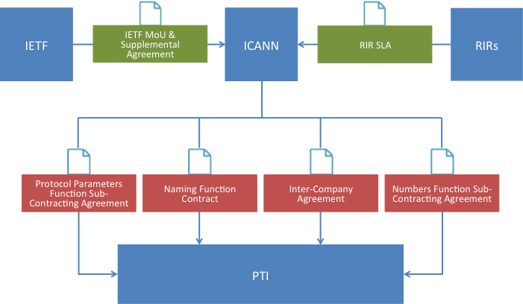

Figure 2.ii: Staffing and Resources

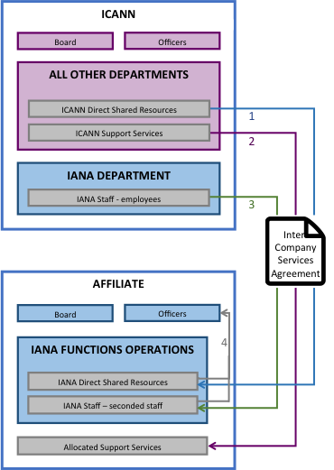

- IANA direct shared resources are ICANN staff in ICANN departments other than the IANA department that perform activities directly contributing to the IANA functions and also support other ICANN activities or functions. A detailed description is provided in Appendix 4.1. These resources will be provided to the affiliate to support its operations. These resources may also be appointed as officers of the affiliate. If appointed, the resource will serve as both an officer of the affiliate, and in the position that the resource holds within ICANN.

- Support services are the IANA functions portion of the services provided by support functions to all or most ICANN departments. A detailed description is provided in Appendix 4.1. These support services will be allocated to the affiliate.

- The IANA staff will be seconded to the affiliate to perform the IANA functions.

- The affiliate’s Board will appoint officers from seconded staff and direct shared resources pool.

On a monthly basis, ICANN will invoice the affiliate for all seconded staff, resources and allocated support services. Also on a monthly basis, the affiliate will invoice ICANN for all of the affiliate’s expenses, resulting in a balanced statement of activity.

IANA Functions Operations

The IANA functions operations include 13 major activities performed to deliver services to the Names, Numbers and Protocol Parameters client groups. The IANA personnel and resources are shared across the activities by operational communities with several positions supporting multiple communities. A list of the 13 major activities are below. A full description of each activity is provided in Appendix 4.3.

- Stakeholder Reports
- Request Handling
- Stakeholder Engagement
- Internal Reports
- Systems/Tools Enhancements
- Dept. Management Responsibilities
- Key Signing Ceremonies
- KMF Facility Management
- Customer Surveys
- Third-party Systems Audits
- Risk, Security, Continuity Plans
- Consultation to Policy Groups
- Organizational Meetings (Corporate & Departmental)

3. Timeline

An estimated timeline for PTI formation activities is illustrated below.

Figure 3.i: PTI formation timeline

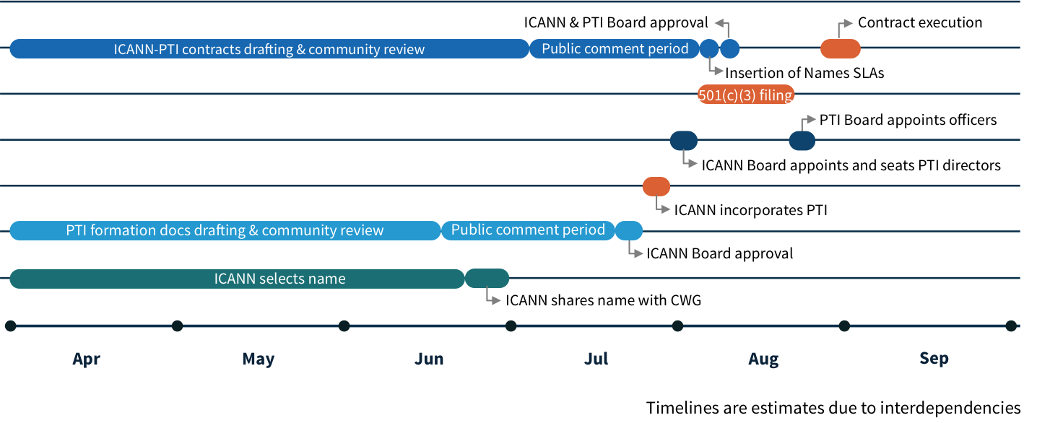

4. Appendix

4.1 IANA FUNCTIONS DIRECT, SHARED RESOURCES AND SUPPORT SERVICES COST DESCRIPTION

IANA Activity | Description & Methodology
[A]  Direct Costs | These costs cover direct and dedicated personnel (13 employees) and associated costs assigned to delivering the IANA functions: registration and maintenance of protocol parameter registries; allocation of Internet numbers and the maintenance of the Internet number registries; validation and processing of root zone change requests as well as maintenance of the root zone registry; management of the .int and .arpa domains; and holder of the root zone key signing key for the security of the DNS root zone.
[B]  Direct Shared Resources Costs | Within ICANN, other departments than the IANA department perform or participate to processes directly related to the delivery of the IANA functions.  The costs of the activities carried out by other departments to perform the IANA Operations were evaluated by each department's budget owners by identifying the direct external costs (professional services, infrastructure,...), and estimating the time spent by personnel from the department on the identified activities valued at the annual cost of each employee (base+benefits).  See in Appendix 1.4.2 the full description of the activities that are carried out by those departments, which are summarized below:  - Request processing - IT  - Root Key Signing - IT, Registry technical Services, SSR, GSE  - IANA Website - IT, Legal, Web-admin  - Protection of data and systems - IT, Security, Legal  - Continuity and Contingency of service - IT  - Conflict of Interest assertions - IT, Legal  - Monthly reporting of performance - IT, Legal, Gov. Engagement  - Annual updates to Agreements - Legal  The Direct costs of shared resources also include a placeholder estimate for the depreciation costs of capital assets of 0.5m.
[C]  Support Services Allocation | Support services, which organize the ability for operational activities to be carried out.  The total costs of these functions [D], after excluding the shared from those functions included in [B], were divided by the total costs of operational functions [E], to determine a percentage of support functions ([D]+[E]= total costs of ICANN Operations).  This percentage was then applied to the total costs of IANA (both IANA department direct costs and shared resources direct costs as defined above), to determine a cost of support function allocated to IANA. This cost [C] is additive to [A] and [B].  List of functions includes:  - Executive  - Communications  - Operations (HR, Finance, Procurement, ERM, PMO/BI, HR development, Operations Executive, Administrative / Real Estate)  - IT (cyber-security, admin, infrastructure, PMO, Staff facing solutions)  - Governance support (Legal, Board support, Nomcom)

4.2 [B] Direct costs (shared resources), associated with operations of the IANA functions and dependencies on other ICANN departments

- Request processing
  - RT trouble ticketing system supported and provided by IT
  - RZMS software development, support and maintenance by IT
  - Email system provided and supported by IT
  - On-line connectivity provided and supported by IT
  - OFAC checks supported by Legal
  - Board resolutions reviewed by Legal/sometimes drafted by Legal. Delegation/Redelegation Reports reviewed by Legal on as as-needed basis
  - All hardware and infrastructure provided and supported by IT
  - Support from GSE to gather information for ccTLD requests
- Root Key Signing
  - Roles in ceremonies by IT, Registry Technical Services, SSR, Strategy, GSE, and program department
  - Suite of Security documents reviewed and adopted by SSR and IT departments
  - Facility rent and connectivity to the Key Management Facility (KMF) provided by IT
  - DNSSEC SysTrust Audit requires work samples from IT, Legal, and SSR
  - Third Party Contract/RFP prepared by Procurement and reviewed by Legal
- IANA Website
  - Hardware provided, administered, and supported by IT
  - Contract compliance requirements reviewed by Legal
  - Web-admin support to post reports and documents on ICANN website
- Security to protect data and systems
  - Security plan reviewed and accepted by IT and SSR
  - Reviewed by Legal prior to submission to NTIA
- Continuity and Contingency of service
  - Dependent on IT and Finance
  - Plan reviewed by IT, SSR, HR, Legal, and Finance prior adoption
- Conflict of Interest compliance
  - Annual report prepared by HR and Legal
- Monthly reporting of performance
  - Posted on hardware maintained and administered by IT
  - Contract compliance requirements reviewed by Legal
- Customer Service Survey
  - RFP prepared by Procurement
  - Final report from 3rd party reviewed by Legal prior to posting
- Annual updates to Agreements
  - Legal review of annual Supplemental Agreement to the IETF MOU

4.3 IANA FUNCTIONS OPERATIONS BY ACTIVITY

IANA Activity | Description & Methodology
Stakeholder Reports | Names Community Stakeholder Reports:  Create the following reports:  - Monthly DNSSEC report – this is a report to NTIA and is marked confidential  - Monthly Root Zone Processing Time report – this is a report to NTIA and is published on ICANN’s IANA website  - Monthly Root Zone Audit report – this is a report to NTIA and is published on ICANN’s IANA website  - Monthly Performance Standards Metric report – this is a report to NTIA and is published on ICANN’s IANA website. It includes metrics for the names and numbers functions  - Periodic reports on delegation and transfers of Top Level Domains published on ICANN’s IANA website  - C.4.2 Monthly Performance Progress Report – this is a report to NTIA and is marked confidential. The report includes metrics for the names and numbers functions  Numbers Community Stakeholder Reports:  - Create monthly Performance Standards Metric report – this is a report to NTIA and is published on ICANN’s IANA website. The report includes metrics for the names and numbers functions.  - C.4.2 Monthly Performance Progress Report – this is a report to NTIA and is marked confidential. The report includes metrics for the names and numbers functions  Protocol Parameters Customer Reports: Create the following reports:  - Monthly IETF SLA report  - Status of IETF Internet Draft Daily report – automated report posted on IANA website  - Monthly reports to the IAB about IANA activities  - Monthly Expiration of Early Allocations Report to the IESG
Request Handling | Names Community Request Handling:  - Handle requests from the Name Community  - Write reports for the Board and NTIA related to TLD change of control (for example, delegations)  - Establish new processes and procedures for introducing new services such as EBERO  - Handle root zone and names issues and address technical or policy clarifications needed in order to handle a request  - Manage escalations for unresolved issues  - Compliance with applicable laws (for example, Office of Foreign Assets Control)  Numbers Community Request Handling:  - Handle requests from the Numbers Community  - Manage escalations for unresolved issues  - Compliance with applicable laws (for example, Office of Foreign Assets Control)  Protocol Parameters Request Handling:  - Handle requests from the Protocol Parameters Community including new registrations, modifications to existing registrations and the removal of existing registrations  - Introduce new processes and procedures for handling requests  - Define new processes and procedures for creating new protocol parameter registries as per the IANA Considerations of an RFC  - Manage escalations for unresolved issues  - Compliance with applicable laws (for example, Office of Foreign Assets Control)
Stakeholder Engagement | Names Community Stakeholder Engagement:  - Preparation, planning and attendance for three ICANN and three regional TLD meetings, and one Registrar & Registry meeting  - Includes drafting, renewing and finalizing annual SLA  - Drafting and reviewing documents for Public Comments  Numbers Community Stakeholder Engagement:  - Preparation, planning and attendance for 10 RIR meetings and 12 ASO (Address Supporting Organization) teleconferences  - Includes drafting, renewing and finalizing annual SLAs, and reviewing policy documents adopted by the RIRs  Protocol Parameters Community Stakeholder Engagement:  - Attendance for three IETF meetings and periodic teleconferences with IPROC  - Includes drafting, renewing and finalizing annual Service Level Agreements  - Participation in twice-monthly IESG teleconferences and monthly IAB business meetings. Formal review of Internet-Drafts during IETF Last Call, IESG Evaluation, Document Approval and Final publication  - Contract with expert for technical review of Internet-Drafts
Internal Reports | Names, Numbers and Protocol Parameters Community Internal Reports:  - Conduct annual EFQM assessments to identify strengths and implement improvements to processes, services, people, leadership and customer results across all three functions  - Development of KPI dashboards  - Quarterly reports for the Board  - Quarterly reports for Global Stakeholder Engagement  - Reports for ICANN GDD Operations  - Reports for internal staff meetings  - Reports for the ICANN annual report  - Materials for ICANN meetings
Systems/Tools Enhancements | Names, Numbers and Protocol Parameters Community Systems/Tools Enhancements:  Perform the following across all three functions:  - Develop dedicated systems/tools enhancements to improve performance of services provided by the IANA department  - Develop tools required to implement new community mandated processes  - Consult about enhancements for registry workflow  - Architect and implement website improvements, and administer ICANN’s IANA website including oversight of contractors and developers  - Provide general management oversight for website tools and enhancements  - Architect and implement system improvements for the registry workflow  - Provide requirements and propose improvements to the registry workflow, as well as engage in User Acceptance testing  - Provide general management oversight for system enhancements  Includes software licenses and materials for ICANN’s IANA website development, outsourced development to implement projects (for example, RDAP) and transition related web development.  Names Community Systems/Tools Enhancements:  Outsourced development for tools to monitor uptime of systems and software to report on SLEs defined by CWG.  Protocol Parameters Community Systems/Tools Enhancements:  Provide website improvement criteria and requests specifically for protocol parameters. Includes outsourced development for XML format registries, development of reporting tools, and enhancements to XML format registries.
Dept. Management Responsibilities | Names, Numbers and Protocol Parameters Community Department Management Responsibilities:  - Membership and participation in ICANN’s Technology and Operations Senior Management Teams, representing all three functions  - Represent IANA Functions Operator at I-Star meetings. I-Star is a loosely coordinated group including ICANN, the IETF, W3C, regional ccTLD groups, the RIRs, and the Internet Society.  - Management responsibilities related to post-transition bodies (for example, CSC)  The VP of IANA Functions owns and manages FY17 budget for the 15 staff supporting all three functions:  - Five senior staff with management responsibilities  - Two Cryptographic Key Managers  - Five IANA Specialists  - One Audit Associate  - One Project Manager/Technical Writer  - One Sr. Administrative Assistant
Key Signing Ceremonies | Names Community Root Zone Key Signing Ceremonies:  Four Root Zone Key Signing Key Ceremonies (both East and West Coast) each year, including ceremony preparation and post-ceremony processing of the logs, video, and ceremony notes, then posting of material on ICANN’s IANA website. Includes:  - Consultation with ceremony participants in reviewing and revising ceremony scripts  - Reviewing and revising DNSSEC policy documentation with the Policy Management Authority  - Collaboration with Verisign, the Root Zone Maintainer, which manages Zone Signing Keys  - Manage relationships with Trusted Community Representatives  Numbers and Protocol Parameters functions do not apply
KMF Facility Management | Names KMF facilities:  - Manage the Key Management Facilities (KMF) and the Root Zone Key Signing Ceremonies  - Manage and oversee plans to maintain and upgrade the KMF facilities, including related travel  - Capital expense includes furniture, computer equipment, audit camera replacement, signing software development and service contracts for alarm system and the facilities  Numbers and Protocol Parameters functions do not apply.
Customer Surveys | Names, Numbers and Protocol Parameters Communities Customer Satisfaction Surveys:  - Involves selecting, contracting, and overseeing the third-party vendor that administers and analyzes the annual survey, as well as writing the final report which is posted on ICANN.ORG and IANA.ORG  - The procurement office issues the RFP and reviews the responses for compliance to the criteria in the RFP and negotiates the best price for the contract  - There is only one RFP for the customer satisfaction survey since all the functions are surveyed by a single contractor and at the same time
Third-party Systems Audits | Names Community third-party System Audits:  - Two staff members lead the selection, contracting and oversight of the third-party vendor. Staff reviews the status of internal controls, and meets with control owners on a quarterly basis to ensure no changes have occurred to in-scope processes and systems. Staff also leads the internal review of the final report and assertion letter.  - The procurement office reviews the contract and negotiates the best price/terms with the vendor. The IT department as well as the HR, Security and Facilities departments are instrumental in providing evidence related to systems that are in-scope of the audits.  - Legal reviews the final audit reports and ICANN’s assertion and representation letters prior to signing by the President of GDD and submission to NTIA.  - Two ICANN Cryptographic Key Managers are instrumental in providing evidence related to systems that are in-scope of the audits.  - IANA department personnel are interviewed and tender evidence to the auditor in response to inquiries, perform visits to remote facilities to collect audit-related material, and perform audit-related reviews  Numbers Community third-party System Audits:  Although the current controls for the SOC2 audit were not specifically designed to address the Numbers processes, the evidence provided to the vendor demonstrates that ICANN remains compliant with the Process Operations controls. The controls involve reviewing the monthly reports that are published on ICANN’s IANA website, as well as the list of documented processes for all of the IANA Functions.  Protocol Parameters Community third-party System Audits:  In addition to the above explanation under “Names Community third-party Systems Audit,” a third staff member is involved in establishing the controls for the audit of the protocol parameter systems. Two of the seven Process Operations controls are specifically related to the protocol parameters function.
Risk, Security, Continuity Plans | Names, Numbers and Protocol Parameters Community Risk/Security/Continuity Plans:  Review and revise the department’s Continuity and Security Plans each year
Consultation to Policy Groups | Names Community Consultation to Policy Groups:  Consulting with the policy department regarding ccNSO, gTLD, IDN and ISO-3166 updates, policy recommendations, implementations and reports  Numbers Community Customer Consultation to Policy Groups:  Consulting with the RIR CEOs or ASO regarding allocations of IP and AS numbers, and reviewing ASO teleconference minutes and confirming there are no new Global Policies to be implemented.  Protocol Parameters Consultation to Policy Groups:  Consulting with the IETF/IAB leadership regarding IANA Considerations and the resulting implementation implications of those RFCs, as well as the relationship between ICANN and the Protocol Parameters Community. Also consulting internally regarding implications of the IANA Considerations detailed in RFCs that impact how IANA services are delivered.
Organizational Meetings (Corporate & Departmental) | Names Organizational Meetings:  Includes immigration activities and services as needed for volunteer Trusted Community Representatives and staff, as well as administration (support and facilities) costs for DNSSEC meetings including security, rent, Internet access, phone and registration costs  Names, Numbers and Protocol Parameters Organizational Meetings:  Training provided to Audit Associate and IANA Specialists across all three functions, as well as administration costs for team lunches, transportation, postage, home Internet connectivity, tuition reimbursement, training courses and recognition awards for staff members. Provide IANA cross-training across ICANN organization. Attend for semi-annual Senior Management Team (SMT) meetings. Contribute to weekly SMT Operations meetings. Represent IANA functions at weekly GDD meetings.

One World, One Internet
ICANN.ORG
ICANN.ORG

IANA Stewardship Transition Coordination Group (ICG). (October 2015) Proposal to Transition the Stewardship of the Internet Assigned Numbers Authority (IANA) Functions from the U.S. Commerce Department’s National Telecommunications and Information Administration (NTIA) to the Global Multistakeholder Community. Paragraph X009. Retrieved from https://www.ianacg.org/icg-files/documents/IANA-transition-proposal-v9.pdf
IANA Stewardship Transition Coordination Group (ICG). (October 2015) Proposal to Transition the Stewardship of the Internet Assigned Numbers Authority (IANA) Functions from the U.S. Commerce Department’s National Telecommunications and Information Administration (NTIA) to the Global Multistakeholder Community. Paragraph 1109. Retrieved from https://www.ianacg.org/icg-files/documents/IANA-transition-proposal-v9.pdf
IANA Stewardship Transition Coordination Group (ICG). (October 2015) Proposal to Transition the Stewardship of the Internet Assigned Numbers Authority (IANA) Functions from the U.S. Commerce Department’s National Telecommunications and Information Administration (NTIA) to the Global Multistakeholder Community. Paragraph 1108. Retrieved from https://www.ianacg.org/icg-files/documents/IANA-transition-proposal-v9.pdf
IANA Stewardship Transition Coordination Group (ICG). (October 2015) Proposal to Transition the Stewardship of the Internet Assigned Numbers Authority (IANA) Functions from the U.S. Commerce Department’s National Telecommunications and Information Administration (NTIA) to the Global Multistakeholder Community. Paragraph 1112. Retrieved from https://www.ianacg.org/icg-files/documents/IANA-transition-proposal-v9.pdf

